popV configuration
Versions of all Python packages were constant over the course of the experiments and are attached as requirements.txt file that can be used to recreate Conda environment. Python version - 3.11.13
During the time of the experiments popV package itself was still being updated and improved, so to ensure reproducibility, we started our own branch of popV that is published and available at: https://github.com/dorzhey/popV
We ran popV with the parameters:
Highly Variable Genes: 4000
We modified random cell sampling to be not only by cell type but also by health condition, as we require diverse representation of cell states within each cell type.
Number of cells per label and health condition: 500. Used to randomly sample cells for Random Forest, OnClass, SVM, Celltypist, XGboost – each used same subset of cells.
Algorithms, all popV default hyperparameters:
KNN with Harmony batch correction,
KNN with Scanorama batch correction,
KNN with BBKNN batch correction,
Celltypist,
SVM,
XGboost,
Random Forest,
OnClass
Note: KNN with SCVI batch correction and SCANVI showed suboptimal performance on general region-specific runs. Grid search over hyperparameters did not help significantly. Probable reasons: preQC query data and no HIV pathologies in reference data.
Note 2: Some of the algorithms are inherently non-deterministic, hence they can provide slightly different results.
Note 3: It is 7 algorithms for our cross-validation experiments. We excluded SCANORAMA for speed, as it is a big legacy code that is not easily optimizable for GPU.

Quality Control
Manual labels and query data went through minimal QC. Each cell had to have minimum 200 expressed genes, minimum 500 total counts, maximum 50,000 total counts, and maximum 10% of mitochondrial genes.

Annotated reference datasets
Reference Total 1,184,745 cells
Our manual annotation – 314,153 cells from 21 samples excluding 6800127569_VST
It was mainly used to include HIV infected cells into the final dataset.
297,437 cell after QC.
Our manual labels were mapped to Cell Ontology labels to ensure compatibility of the datasets:
Manual Label | Mapped Cell Ontology Label
Neurons 4 | neuron
Oligo Precursor Cells | oligodendrocyte precursor cell
Neurons 1 | neuron
Microglia | central nervous system macrophage
Oligodendrocytes | oligodendrocyte
Astrocytes 1 | astrocyte
Immune / Leukocytes | leukocyte
Neurons 5 | neuron
Neurons 2 | neuron
Neurons 7 | neuron
Endothelial / Vascular cells | endothelial cell
Neurons 3 | neuron
Astrocytes 2 | astrocyte
Neurons 6 | neuron

Human Brain Cell Atlas v1.0
BRAIN Initiative, CZI Cell Science, link: https://cellxgene.cziscience.com/collections/283d65eb-dd53-496d-adb7-7570c7caa443
Total 779.876 cells from 17 dissections (hippocampus, cortex, basal nuclei and cerebellum), healthy, only white race or unknown.
Downloaded following dissection dataset from CELLXGENE on 10/17/2025:
Body of hippocampus (HiB) - Rostral DG-CA4,
Body of hippocampus (HiB) - Rostral CA1-CA3
Precentral gyrus (PrCG) - Primary motor cortex - M1C
Middle Temporal Gyrus (MTG)
Inferior frontal gyrus (IFG) - Ventrolateral prefrontal cortex - A44-A45
Caudal Cingulate Gyrus (CgGC) - A23
Cingulate Gyrus, Retrosplenial (CgGrs) - A29-A30
Middle Frontal Gyrus (MFG) - A46
Gyrus Rectus (ReG) - Medial orbitofrontal cortex - A14
Body of the Caudate - CaB
Globus pallidus (GP) - External segment of globus pallidus - GPe
Globus pallidus (GP) - Internal segment of globus pallidus - Gpi
Nucleus Accumbens - NAC
Putamen - Pu
Cerebellum (CB) - Cerebellar Vermis – CBV,
Cerebellum (CB) - Cerebellar deep nuclei – CbDN,
Cerebellum (CB) - Lateral hemisphere of cerebellum – CBL.

Human Microglia Atlas
HuMicA has 90.716 cells across 6 health conditions (Alzheimer’s disease, autism spectrum disorder, epilepsy, multiple sclerosis, Lewy body diseases, COVID-19, and healthy controls).
We transformed published HuMicA.rds file into popV-compatible Python object using Seurat v5 and R 4.3.3 (versions provided by authors) and SeuratDisk v0.0.0.9015

Only 28251 genes were programmatically translated into ENSEMBLE IDs. The authors were informed about problems with gene names. However, most of the highly variable genes were included in that translated set. Overall, we suppose that this problem did not affect the performance of the method.
All cells were assigned “central nervous system macrophage” label as closest Cell Ontology label from Human Brain Atlas.
Paper: https://www.nature.com/articles/s41467-025-56124-1
Downloaded on 10/6/2025 from https://zenodo.org/records/14697727

OnClass algorithm requires ontology compatible cell type naming, so all cell type were manually mapped to relevant cell types provided in https://huggingface.co/datasets/popV/ontology/tree/main
Downloaded 10/1/2025

Query overview:
283 human samples from SCORCH. Total 2.852.602 cells, detected 1739 HIV+ cells
2,649,768 cells after QC; 1,685 HIV+ cells

5-fold Cross-Validation
We took each of the 3 sources of reference data listed above, shuffled cells and split into 5 parts for cross-validation. Here is the breakdown of HIV- and HIV+ counts across data components, approximately same for each of the 5 experiments.
origin | Source | HIV_infection | Count
Query | SCORCH | HIV+ | 1,685
 | SCORCH | HIV- | 2,648,083
Part of reference data used as part of the query (ref_test) | HuMicA | N/A | 18,144
 | Human Brain Atlas | N/A | 155,976
 | Manual Labels | HIV+ | 46
 | Manual Labels | HIV- | 59,442
Reference | HuMicA | N/A | 72,572
 | Human Brain Atlas | N/A | 623,900
 | Manual Labels | HIV+ | 209
 | Manual Labels | HIV- | 237,740

Compliance of predictions (1)

on hold-out data with original annotation per experiment, represented in classification metrics. Macro averaging by cell type in each experiment and by experiments in TOTAL.
experiment | accuracy | precision | recall | f1 | n_cells
experiment_1 | 0.99 | 0.95 | 0.96 | 0.95 | 233608
experiment_2 | 0.99 | 0.93 | 0.98 | 0.95 | 233606
experiment_3 | 0.99 | 0.96 | 0.98 | 0.97 | 233605
experiment_4 | 0.99 | 0.96 | 0.98 | 0.97 | 233605
experiment_5 | 0.99 | 0.96 | 0.97 | 0.96 | 233605
TOTAL | 0.99 | 0.95 | 0.97 | 0.96 | 1168029

Compliance of predictions (2)

on hold-out data with original annotation per cell type, represented in classification metrics. Macro averaging over experiments.

cell type | precision | recall | f1 | accuracy
Bergmann glial cell | 0.99 | 0.99 | 0.99 | 0.99
astrocyte | 0.99 | 0.99 | 0.99 | 0.99
central nervous system macrophage | 0.99 | 0.99 | 0.99 | 0.99
choroid plexus epithelial cell | 0.87 | 0.99 | 0.92 | 0.99
endothelial cell | 0.94 | 0.93 | 0.94 | 0.93
ependymal cell | 0.89 | 0.98 | 0.93 | 0.98
fibroblast | 0.96 | 0.99 | 0.98 | 0.99
leukocyte | 0.91 | 0.95 | 0.93 | 0.95
neuron | 0.99 | 0.99 | 0.99 | 0.99
oligodendrocyte | 0.99 | 0.99 | 0.99 | 0.99
oligodendrocyte precursor cell | 0.98 | 0.99 | 0.99 | 0.99
pericyte | 0.98 | 0.99 | 0.99 | 0.99
vascular associated smooth muscle cell | 0.86 | 0.84 | 0.85 | 0.84
Breakdown by Source:
On our manual labels:
Cell type | precision | recall | f1 | accuracy
Bergmann glial cell | N/A | N/A | N/A | N/A
astrocyte | 0.98 | 0.98 | 0.98 | 0.98
central nervous system macrophage | 0.97 | 0.97 | 0.97 | 0.97
choroid plexus epithelial cell | N/A | N/A | N/A | N/A
endothelial cell | 0.94 | 0.92 | 0.93 | 0.92
ependymal cell | N/A | N/A | N/A | N/A
fibroblast | N/A | N/A | N/A | N/A
leukocyte | 0.91 | 0.94 | 0.92 | 0.94
neuron | 0.99 | 0.99 | 0.99 | 0.99
oligodendrocyte | 0.99 | 0.99 | 0.99 | 0.99
oligodendrocyte precursor cell | 0.98 | 0.98 | 0.98 | 0.98
pericyte | N/A | N/A | N/A | N/A
vascular associated smooth muscle cell | N/A | N/A | N/A | N/A

On Human Brain Atlas:
cell type | precision | recall | f1 | accuracy
Bergmann glial cell | 0.99 | 0.99 | 0.99 | 0.99
astrocyte | 0.99 | 0.99 | 0.99 | 0.99
central nervous system macrophage | 0.99 | 0.99 | 0.99 | 0.99
choroid plexus epithelial cell | 0.99 | 0.99 | 0.99 | 0.99
endothelial cell | 0.95 | 0.99 | 0.97 | 0.99
ependymal cell | 0.99 | 0.98 | 0.99 | 0.98
fibroblast | 0.99 | 0.99 | 0.99 | 0.99
leukocyte | 0.96 | 0.96 | 0.96 | 0.96
neuron | 0.99 | 0.99 | 0.99 | 0.99
oligodendrocyte | 0.99 | 0.99 | 0.99 | 0.99
oligodendrocyte precursor cell | 0.99 | 0.99 | 0.99 | 0.99
pericyte | 0.99 | 0.99 | 0.99 | 0.99
vascular associated smooth muscle cell | 0.99 | 0.84 | 0.91 | 0.84

On HuMicA:
cell type | precision | recall | f1 | accuracy
central nervous system macrophage | 1 | 0.99 | 0.99 | 0.99

Cross-Validation experiment agreement

majority_prediction | agree_2 | agree_3 | agree_4 | agree_5
Bergmann glial cell | 0.965925 | 0.949801 | 0.938576 | 0.929574
astrocyte | 0.989223 | 0.984102 | 0.980898 | 0.978601
central nervous system macrophage | 0.978768 | 0.969393 | 0.964213 | 0.960797
choroid plexus epithelial cell | 0.929955 | 0.898979 | 0.877924 | 0.861816
endothelial cell | 0.967427 | 0.952084 | 0.941958 | 0.934351
ependymal cell | 0.6 | 0.4 | 0.272727 | 0.181818
fibroblast | 0.654348 | 0.483043 | 0.386087 | 0.326087
leukocyte | 0.968344 | 0.95333 | 0.94444 | 0.938483
neuron | 0.992564 | 0.988991 | 0.98645 | 0.984432
oligodendrocyte | 0.994769 | 0.99224 | 0.990612 | 0.989457
oligodendrocyte precursor cell | 0.994475 | 0.99175 | 0.989948 | 0.988619
pericyte | 0.651799 | 0.477698 | 0.37554 | 0.309353
vascular associated smooth muscle cell | 0.670975 | 0.509297 | 0.417234 | 0.360544
TOTAL | 0.990302 | 0.985739 | 0.98276 | 0.980549

agree_2 is average of all pairwise agreements of 5 experiments
agree_3 average of combinations of 3, same for agree_4
agree_5 is agreement between all 5 experiments
We explain low agreement in some cell types with low number of cells in those cell types, which might result in higher prevalence of outliers.

Heatmaps
Along with the cell type predictions popV gives the prediction scores. popV prediction score indicates how many annotation methods support a cell’s final consensus type, including votes propagated to ancestor types in the ontology. In cross-validation, by combining these scores across experiments we compute weighted final cell type predictions.

Only on out manual labels subset:
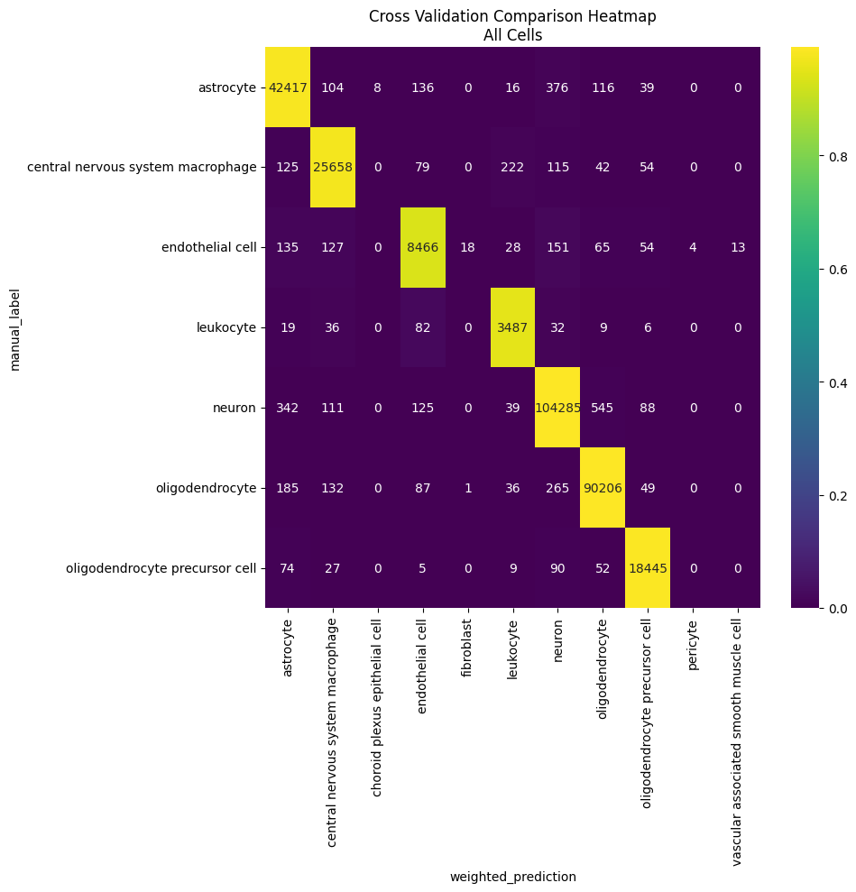
Per experiment of the held-out part of reference
