Stress Biology
Plant growth promotion and biocontrol by novel thermotolerant strains isolated form an active volcano crater
Martirena-Ramírez A¹, Claribel Orquídea Zenteno- Alegría^{2,3}, Yordanis Pérez-Llano⁴, José Germán Serrano-Gamboa¹, Mario León Iza-Arteaga¹, Alexis Ricardo Becerril-Cuevas⁶, Ramón-Batista B^{2,5*}, Folch-Mallol J^{1*}
¹Centro de Investigación en Biotecnología, Universidad Autónoma del Estado de Morelos, Cuernavaca 62209, Morelos, México.
²Centro de Investigación en Dinámica Celular, Instituto de Investigación en Ciencias Básicas y Aplicadas. Universidad Autónoma del Estado de Morelos, México.
³Facultad de Ciencias Químicas e Ingeniería, Universidad Autónoma del Estado de Morelos, Cuernavaca 62209, Morelos.
⁴Centro de Ciencias Genómicas, Universidad Autónoma del Estado de Morelos, Cuernavaca 62209, Morelos.
⁵Departamento de Biología Animal, Biología Vegetal y Ecología, Facultad de Ciencias Experimentales, Universidad de Jaén, 23071 Jaén, Spain; amocana@ujaen.es
⁶ Laboratorio Nacional de Microscopía Avanzada, Instituto de Biotecnología, Universidad Nacional Autónoma de México, Cuernavaca, Morelos, Mexico

*Correspondence: rabg@uaem.mx or rabg@ujaen.es (R.A.B.-G.); jordi@uaem.mx (J.L.F.-M.)

Table S1 Culture media used for the morphological characterization of strains of rhizosphere-extreme fungi
PDA | g/L
Papa (infusion) | 200
Dextrose | 20
Agar | 15
MEA
Malt | 20
Glucose | 20
Peptone | 1
Agar | 15
CYA
Saccharose | 30
Yeast extract | 5
K₂HP0₄ | 1
NaNO₃ | 0.3
KCl | 0.05
MgSO₄ | 0.05
FeSO₄ | 0.001
ZnSO₄ | 0.001
CuSO₄ | 0.0005
Agar | 15

Table S2 List of species and GenBank accession numbers of sequences used in the multi-locus phylogenetic analysis conducted in this study
Species | Strain | GenBank accession numbers
Species | Strain | ITS | β-Tub | TEF1- α
Trichoderma asperelloides | CEN1514 | OM515026.1 |  | ON101428.1
Trichoderma asperelloides | CEN1533 | OM515028.1 |  | ON101430.1
Trichoderma asperelloides | CEN277 | OM515032.1 |  | ON101434.1
Trichoderma asperellum | T1 | MZ823612.1 |  | LC155108.1
Trichoderma asperellum | TDM11 | PP837620.1 |  | PP727542.1
Trichoderma atroviride | 18ASMA013 | MT520633.1 |  | MT671874.1
Trichoderma atroviride | 18AATH004 | MT520552.1 |  | MT671919.1
Trichoderma anaharzianum | YMF 1.00241 ^{T} | MH262584 |  | MH236493
Trichoderma hamatum | DAOM 167057 ^{T} | NR_134371.1 |  | AF456911.1
Trichoderma harzianum | CBS 226.95 ^{T} | AY605713 |  | AF348101
Trichoderma harzianum | 041BV | PV139196.1 |  | PV339465.1
Trichoderma koningii | ATCC 64262 ^{T} | NR_138456.1 |  | AY376046.1
Trichoderma koningiopsis | 005BV | PV139174.1 |  | PV339463.1
Trichoderma lentinulae | CGMCC 3.19847 ^{T} | MN594469 |  | MN605878
Trichoderma lieckfeldtiae | GJS 00-14 | DQ109528.1 |  | EU856326.1
Trichoderma pollinicola | LC11686 ^{T} | MF939593 |  | MF939620
Trichoderma pubescens | DAOM 166162 ^{T} | NR_077179.1 |  | EU279963.1
Trichoderma tlahuicanensis | BMH-0061 | OR710780 |  | OR711908
Trichoderma yunnanense | CBS 121219 ^{T} | NR_134419.1 | - | GU198243.1
Protocrea pallida | CBS 299.78 ^{T} | NR_111329 |  | EU703900
Aspergillus dunkleyae | BRIP 72551a ^{T} | NR_191334.1 | OR964959.1 | -
Aspergillus felis | CBS 130245 ^{T} | NR_138341.1 | MN969363.1
Aspergillus felis | DTO_327G4 | KX903292.1 | KX903288.1 | -
Aspergillus frankstonensis | CBS DTO_341-E7 | KY808756.1 | KY808594.1 | -
Aspergillus parafelis | CBS DTO_176-F1 | KY808742.1 | KY808581.1
Aspergillus parafelis | CBS DTO_175-H3 | KY808741.1 | KY808580.1
Aspergillus parafelis | CBS DTO_341-F2 | KY808760.1 | KY808598.1
Aspergillus pseudofelis | CBS DTO_316-C8 | KY808750.1 | KY808587.1
Aspergillus pseudoviridinutans | CBS DTO_303-A1 | KY808745.1 | KY808585.1
Aspergillus udagawae | CBS DTO_308-H6 | KY808746.1 | KY808586.1
Aspergillus udagawae | CBS DTO_283-D3 | KY808744.1 | KY808584.1
Penicillium chrysogenum | CBS 306.48 ^{T}
Aspergillus brasiliensis | DSM 1988 |  | MF281957.1 | MF288897.1
Aspergillus brasiliensis | CBS 101740 |  | AY820006.1 | XM_067619933.1
Aspergillus eucalypticola | CBS 122712 | - | KC796360.1 | XM_025532307.1
Aspergillus luchuensis | P1 |  | ON064999.1 | XM_041687714.1
Aspergillus neoniger | CBS 115656 |  | KC796361.1 | XM_025622602.1
Aspergillus niger | ITEM 7496 | - | FN394677.1 | FN665657.1
Aspergillus piperis | A5 |  | KJ469441.1 | XM_025660682.1
Aspergillus pulverulentus | CBS 558.65 |  | HE984408.1 | HE984395.1
Aspergillus tubingensis | GASPT-3 | - | PP941123.1 | PP941121.1
Aspergillus vadensis | CBS 113365 |  | AY585531.1 | XM_025702074.1
Aspergillus welwitschiae | CBS 139.54 |  | MN969369.1 | XM_026766727.1
Penicillium chrysogenum | CBS 306.48 ^{T} | NR_077145.1 | JF909955.1 | XM_056711856.1
Penicillium corylophilum | CBS 129789 | MH865544.1 | PV057850.1 | -
Penicillium diabolicalicense | KAS 1726 ^{T} | KT887840.1 | KT887801.1 | -
Penicillium fagi | CBS 689.77 | NR_163678.1 | KJ834449.1
Penicillium maclennaniae | CBS 197.81 | MH861327.1 | PV058264.1
Penicillium maclennaniae | CBS 198.81 ^{T} | MH861328.1 | KJ834468.1
Penicillium melinii | E-13 | PQ460571.1 | PQ468957.1 | -
Penicillium raciborskii | NRRL 2150 ^{T} | NR_121234.1 | JX141069.1
Penicillium smithii | CBS:276.83 ^{T} | MH861587.1 | KJ834492.1
Penicillium terrenum | CBS:313.67 ^{T} | NR_163675.1 | KJ834496.1 | -
Penicillium velutinum | NRRL 2069 ^{T} | NR_121235.1 | JX141170.1
Penicillium velutinum | KMM 5002 | PP217404.1 | PV916746.1
Talaromyces marneffei | CBS 388.87 ^{T} | NR_103671.2 | JX091389.1
ITS: internal transcribed spacer regions; B-Tub: beta-tubulin gen; TEF1- α: translation elongation factor-1α; outgroup data are indicated in bold. ^{T} from TYPE material.

Fig. S1 Phylogenetic tree generated by multilocus phylogeny of R_10. The tree was inferred from concatenated nucleotide sequences of the ITS and β-tubulin markers. Outgroup: Penicillium chrysogenum

Fig. S2 Phylogenetic tree generated by multilocus phylogeny of R_31. The tree was inferred from concatenated nucleotide sequences of the ITS and β-tubulin markers. Outgroup: Talaromyces mameffei

Fig. S3 Phylogenetic tree generated by multilocus phylogeny of R_34. The tree was inferred from concatenated nucleotide sequences of the ITS and EF1 markers. Outgroup: Protocrea pallida

Fig. S4 Phylogenetic tree generated by multilocus phylogeny of R_40. The tree was inferred from concatenated nucleotide sequences of the EF1 and β-tubulin markers. Outgroup: Penicillium chrysogenum

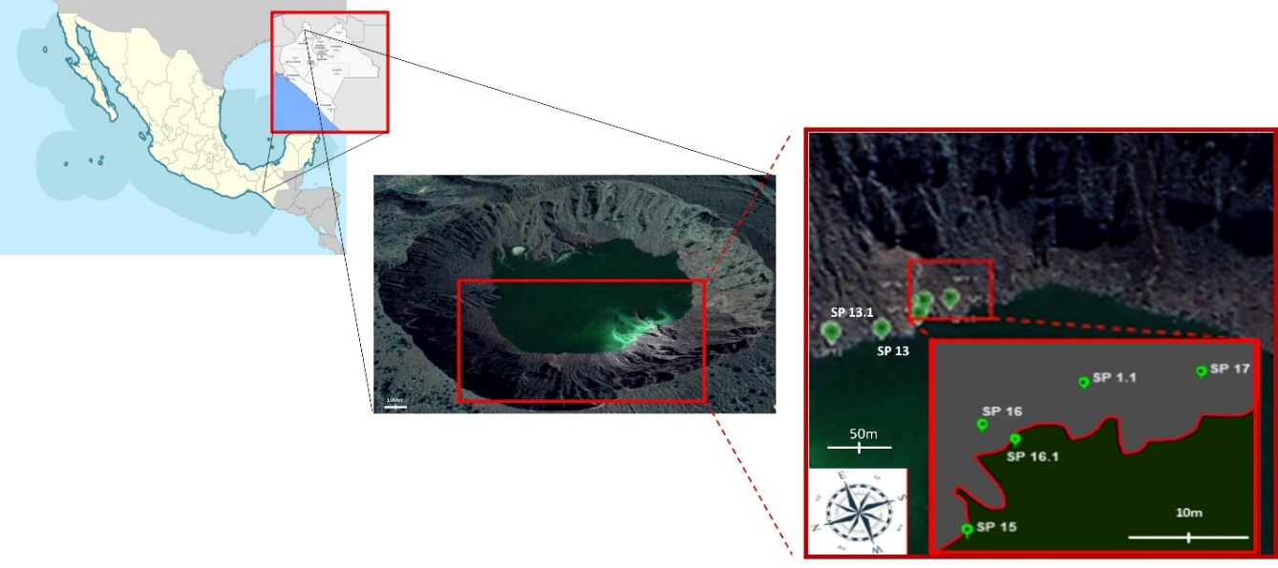
Fig. S5 Satellite image of the Chichonal volcano crater obtained from Google Earth, along with higher-resolution graphics indicating the sample collection sites

