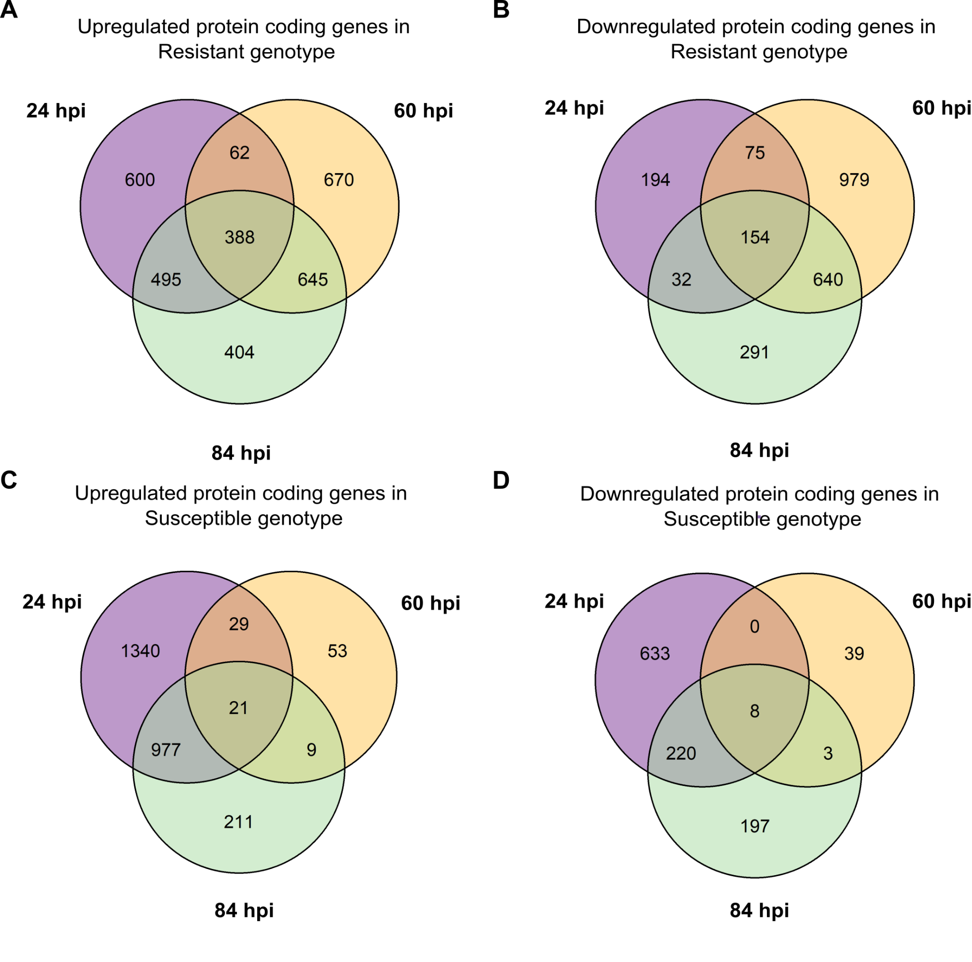
Fig. S1. Venn diagrams of differentially expressed protein-coding genes in the L. luteus resistant and susceptible genotype across C. lupini infection. (A,B) Up and down regulated protein-coding genes in the resistant genotype, respectively. (C,D) Up and downregulated protein-coding genes in the susceptible genotype. Hpi: hours post infection.
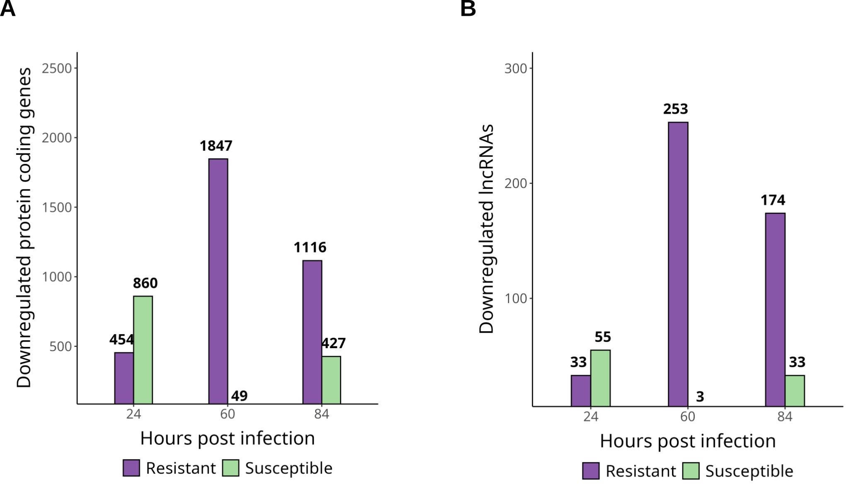
Fig. S2. Downregulated protein-coding and lncRNAs genes in the L. luteus resistant and susceptible genotype across C. lupini infection. (A) Downregulated protein-coding genes for both genotypes throughout different times post infection. (B) Downregulated lncRNAs for both genotypes throughout different hours post infection.
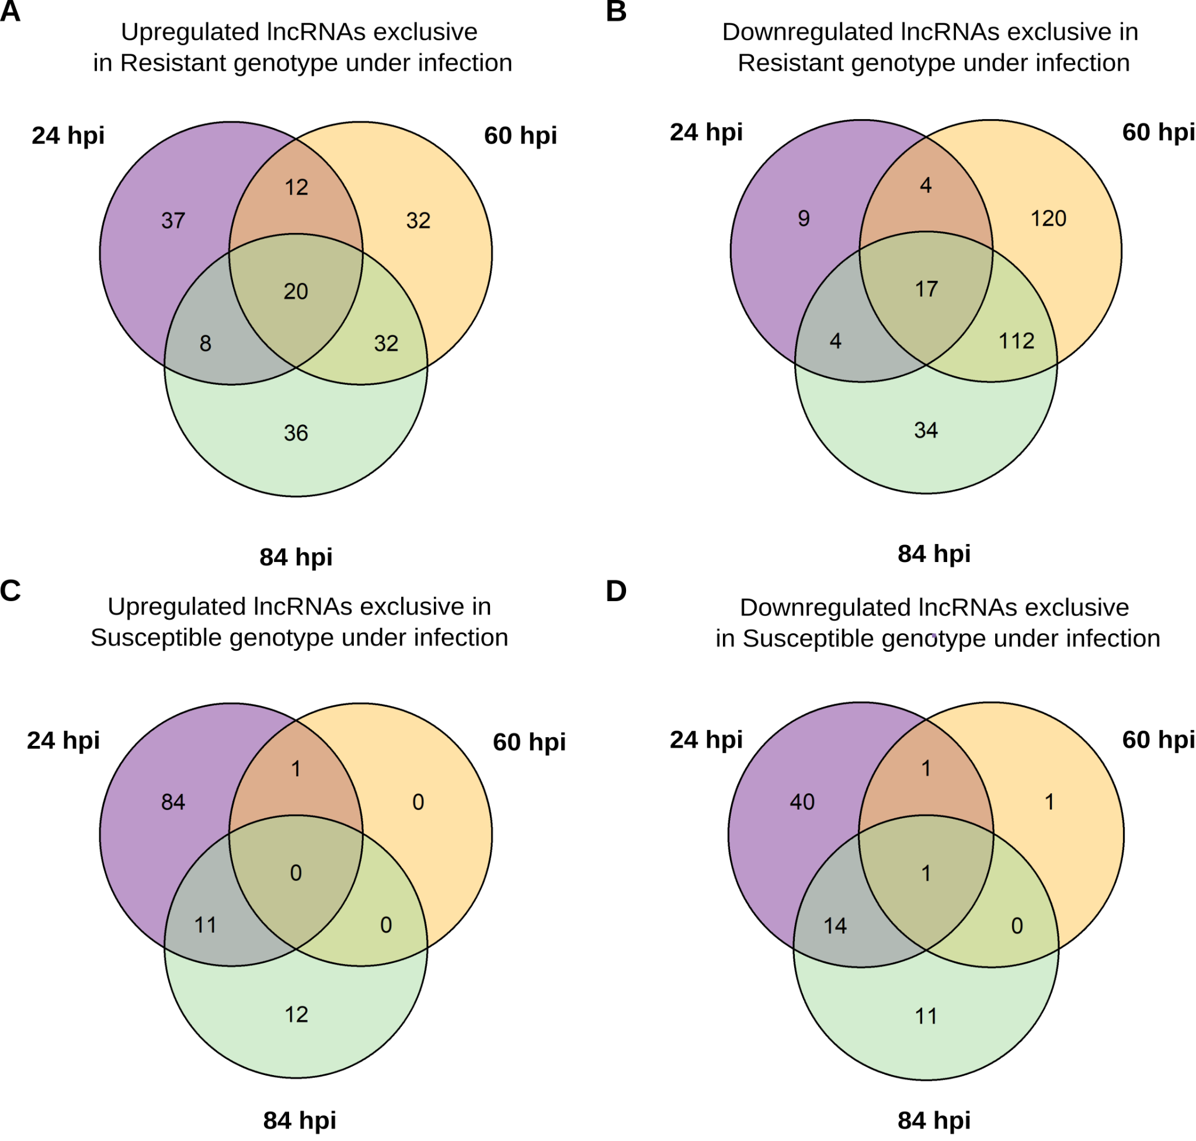
Fig. S3. Venn diagrams of exclusive differentially expressed lncRNAs genes in the L. luteus resistant and susceptible genotype under C. lupini infection. (A,B) Up and down regulated exclusive lncRNAs in the resistant genotype, respectively. (C,D) Up and downregulated exclusive lncRNAs in the susceptible genotype. Hpi: hours post infection.

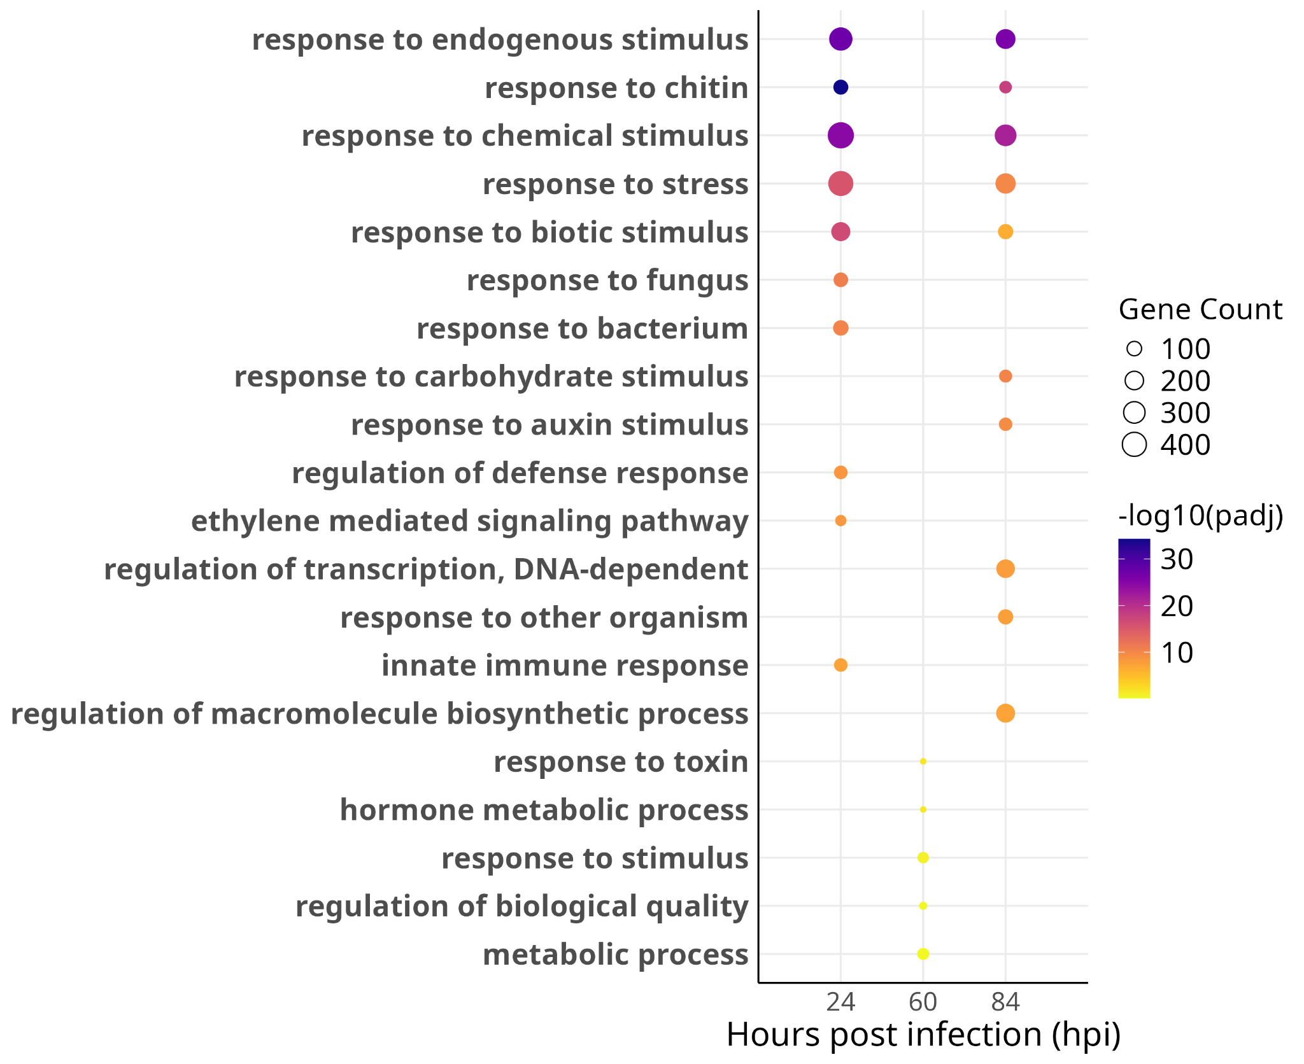
Fig. S4. Enriched biological processes of upregulated protein-coding genes detected in the susceptible genotype. padj: adjusted p-value.

