Supplementary Table S1 | Distribution of Banff lesion scores across study cohorts. Numbers are reported in n (%).
Banff lesion score | Derivation cohort N=415 |  |  |  |  | European validation cohort N=471 |  |  |  |  | Us validation cohort N=1190
Banff lesion score | 0 | 1 | 2 | 3 | Missing | 0 | 1 | 2 | 3 | Missing | 0 | 1 | 2 | 3 | Missing
g | 322 (80.0) | 68  (16.4) | 17 (4.1) | 8  (1.9) | 0  (0) | 456 (96.8) | 11 (2.3) | 3  (0.6) | 1  (0.2) | 0  (0) | 777 (65.2) | 93 (8.0) | 100 (8.4) | 220 (18.5) | 0  (0)
ptc | 380 (91.6) | 14 (3.4) | 13 (3.1) | 8  (1.9) | 0  (0) | 429 (91.1) | 25 (5.3) | 17 (3.6) | 0  (0) | 0  (0) | 524 (44.0) | 179 (15.4) | 301 (25.3) | 186  (15.6) | 0  (0)
t | 131 (31.6) | 207 (49.9) | 61 (14.7) | 6  (1.4) | 0  (0) | 364 (77.3) | 79 (16.8) | 24 (5.1) | 3  (0.6) | 1  (0.2) | 434 (36.4) | 165 (13.8) | 262 (22.0) | 329 (19.4) | 0  (0)
i | 293 (70.6) | 85 (20.5) | 28 (6.7) | 9  (2.2) | 0  (0) | 397 (84.3) | 54 (11.5) | 17 (3.6) | 3  (0.6) | 0  (0) | 454 (38.1) | 156 (13.1) | 307 (25.8) | 272 (23.0) | 1  (0.1)
v | 350 (84.3) | 60 (14.5) | 3  (0.7) | 2  (0.5) | 0  (0) | 453 (96.2) | 13 (2.8) | 0  (0) | 1  (0.2) | 4  (0.8) | 1037 (87.1) | 108 (9.1) | 32 (2.7) | 10 (0.9) | 3  (0.3)
thrombi | 402  (96.9) | 13 (3.1) | 0  (0) | 0  (0) | 0  (0) | 465 (98.7) | 4  (0.8) | 0  (0) | 0  (0) | 2  (0.4) | 0  (0) | 0  (0) | 0  (0) | 0  (0) | 1190 (100)
C4d | 298 (71.8) | 88 (21.2) | 9  (2.2) | 20  (4.8) | 0  (0) | 462 (98.1) | 4  (0.8) | 0  (0) | 4  (0.8) | 1  (0.2) | 851 (71.6) | 14 (1.2) | 101 (8.5) | 224 (18.8) | 0  (0)
cg | 394 (94.9) | 13  (3.1) | 3  (0.7) | 5  (1.2) | 0  (0) | 457 (97.0) | 13 (2.8) | 1  (0.2) | 0  (0) | 0  (0) | 946 (79.5) | 64 (5.4) | 70 (5.9) | 110 (9.2) | 0  (0)
ci | 178 (42.9) | 130 (31.3) | 63 (15.2) | 44 (10.6) | 0  (0) | 249 (52.9) | 162 (34.4) | 43 (9.1) | 14 (3.0) | 3  (0.6) | 402 (33.8) | 492 (41.4) | 236 (19.8) | 53 (4.4) | 8  (0.7)
ct | 56  (13.5) | 283  (68.2) | 61 (14.7) | 15  (3.6) | 0  (0) | 24 (5.1) | 385 (81.7) | 45 (9.6) | 14 (3.0) | 3  (0.6) | 363 (30.5) | 516 (43.4) | 248 (20.8) | 59 (4.9) | 4  (0.3)
cv | 163 (39.3) | 146 (35.2) | 111 (26.7) | 5  (1.2) | 0  (0) | 335 (71.1) | 87 (18.5) | 42 (8.9) | 2  (0.4) | 5  (1.1) | 521 (43.8) | 294 (24.7) | 186 (15.6) | 185 (15.5) | 4  (0.3)
ti | 223 53.7) | 93 (22.4) | 39 (9.4) | 22  (5.3) | 38  (9.2) | 330 (70.1) | 94 (20.0) | 38 (8.1) | 8  (1.7) | 1  (0.2) | 367 (30.8) | 212 (17.8) | 288 (24.2) | 323 (27.3) | 0  (0)
i-IFTA | 120 (28.9) | 18 (4.3) | 9  (2.2) | 20  (4.8) | 248 (59.8) | 323 (68.6) | 102 (21.7) | 34 (7.2) | 9  (1.9) | 3  (0.6) | 498 (41.9) | 272 (22.8) | 217 (18.2) | 202 (16.9) | 1  (0.1)

Supplementary Table S2 | Distribution of molecular AMR/MVI, TCMR/TI, activity and chronicity index values across Banff phenotypes in derivation cohort (N=415).
Molecular score | Median [IQR] | Pairwise comparisons
AMR index | Median [IQR] | PyVAN | Isolated v | Borderline TCMR | TCMR | Probable AMR | DSAneg C4dneg MVI | AMR | Mixed rejection
No rejection | 0.30 [-0.07-0.76] | 0.49 | 0.21 | 0.32 | 0.008 | 0.01 | <0.001 | <0.001 | <0.001
PyVAN | 0.51 [0.23-0.76] | - | 0.94 | 0.80 | 0.30 | 0.08 | <0.001 | <0.001 | <0.001
Isolated v | 0.49 [0.05-0.83] |  | - | 0.58 | 0.31 | 0.09 | <0.001 | <0.001 | <0.001
Borderline TCMR | 0.37 [0.002-0.73] |  |  | - | 0.04 | 0.03 | <0.001 | <0.001 | <0.001
TCMR | 0.55 [0.38-1.36] |  |  |  | - | 0.28 | <0.001 | <0.001 | <0.001
Probable AMR | 1.07 [0.55-2.38] |  |  |  |  | - | 0.28 | 0.17 | 0.24
DSAneg C4dneg MVI | 1.74 [1.46-2.59] |  |  |  |  |  | - | 0.58 | 0.78
AMR | 2.12 [1.45-2.71] |  |  |  |  |  |  | - | 0.71
Mixed rejection | 1.98 [1.30-2.54]
TCMR index
No rejection | 0.95 [0.49-1.43] | 0.04 | <0.001 | <0.001 | <0.001 | 0.44 | <0.001 | <0.001 | <0.001
PyVAN | 1.18 [0.90-1.62] | - | 0.07 | 0.02 | 0.001 | 0.59 | 0.17 | 0.08 | <0.001
Isolated v | 1.81 [1.23-2.07] |  | - | 0.80 | 0.002 | 0.26 | 0.85 | 0.72 | <0.001
Borderline TCMR | 1.70 [1.37-2.26] |  |  | - | 0.001 | 0.11 | 0.74 | 0.95 | <0.001
TCMR | 2.37 [2.09-2.97] |  |  |  | - | 0.009 | 0.01 | 0.02 | 0.02
Probable AMR | 1.05 [0.79-1.91] |  |  |  |  | - | 0.28 | 0.17 | 0.001
DSAneg C4dneg MVI | 1.70 [1.15-2.08] |  |  |  |  |  | - | 0.75 | <0.001
AMR | 1.77 [1.34-2.32] |  |  |  |  |  |  | - | <0.001
Mixed rejection | 3.04 [2.77-3.75]
Activity index
No rejection | 1.32 [0.64-2.00] | 0.01 | <0.001 | <0.001 | <0.001 | 0.02 | <0.001 | <0.001 | <0.001
PyVAN | 2.17 [1.29-2.82] | - | 0.99 | 0.39 | 0.07 | 0.84 | 0.01 | 0.01 | <0.001
Isolated v | 1.95 [1.55-2.70] |  | - | 0.24 | 0.01 | 0.72 | 0.001 | <0.001 | <0.001
Borderline TCMR | 2.39 [1.74-3.14] |  |  | - | 0.08 | 0.89 | 0.004 | 0.002 | <0.001
TCMR | 2.74 [2.32-4.04] |  |  |  | - | 0.17 | 0.18 | 0.25 | <0.001
Probable AMR | 1.99 [1.67-3.29] |  |  |  |  | - | 0.046 | 0.08 | 0.002
DSAneg C4dneg MVI | 3.93 [2.55-4.52] |  |  |  |  |  | - | 0.73 | 0.01
AMR | 3.30 [2.66-4.34] |  |  |  |  |  |  | - | 0.002
Mixed rejection | 5.19 [4.39-6.08]
Chronicity index
No rejection | 2.84 [1.80-3.96] | 0.96 | 0.06 | 0.58 | 0.06 | 0.54 | 0.97 | 0.01 | 0.62
PyVAN | 2.66 [2.23-3.75] | - | 0.17 | 0.88 | 0.21 | 0.48 | 0.95 | 0.07 | 0.98
Isolated v | 2.19 [1.40-3.30] |  | - | 0.06 | 0.01 | 0.90 | 0.27 | 0.002 | 0.12
Borderline TCMR | 3.02 [1.83-4.17] |  |  | - | 0.13 | 0.53 | 0.81 | 0.02 | 0.95
TCMR | 3.40 [2.37-5.23] |  |  |  | - | 0.15 | 0.13 | 0.42 | 0.33
Probable AMR | 2.05 [1.36-3.86] |  |  |  |  | - | 0.75 | 0.10 | 0.50
DSAneg C4dneg MVI | 2.96 [1.64-4.31] |  |  |  |  |  | - | 0.06 | 0.78
AMR | 4.89 [2.61-5.35] |  |  |  |  |  |  | - | 0.16
Mixed rejection | 3.15 [1.82-4.04]

Supplementary Table S3 | Precision–recall performance of molecular indices in derivation and validation cohorts. Table shows raw and prevalence-adjusted AUPRCs for molecular AMR/MVI, TCMR/TI, activity and chronicity indices.
Molecular index | Discrimination | Metric | Derivation cohort N=415 | European validation cohort N=471 | US validation cohort N=1192
AMR/MVI index | AMR vs. no AMR | AUPRC | 0.53 | 0.26 | 0.80
AMR/MVI index | AMR vs. no AMR | AUPRC adj | 0.94 | 0.25 | 0.68
AMR/MVI index | AMR/MVI vs. no AMR/MVI | AUPRC | 0.72 | 0.55 | 0.80
AMR/MVI index | AMR/MVI vs. no AMR/MVI | AUPRC adj | 0.67 | 0.53 | 0.68
AMR/MVI index | Probable AMR/AMR/MVI vs. no probable AMR/AMR/MVI | AUPRC | 0.74 | 0.53 | NA*
AMR/MVI index | Probable AMR/AMR/MVI vs. no probable AMR/AMR/MVI | AUPRC adj | 0.69 | 0.51 | NA*
TCMR/TI index | TCMR vs. No TCMR | AUPRC | 0.55 | 0.29 | 0.85
TCMR/TI index | TCMR vs. No TCMR | AUPRC adj | 0.50 | 0.25 | 0.72
TCMR/TI index | Isolated v/borderline TCMR/TCMR vs. no isolated v/borderline TCMR/TCMR | AUPRC | 0.75 | 0.37 | 0.88
TCMR/TI index |  | AUPRC adj | 0.61 | 0.29 | 0.74
TCMR/TI index | PyVAN vs. no PyVAN | AUPRC | 0.06 | 0.24 | 0.05
TCMR/TI index | PyVAN vs. no PyVAN | AUPRC adj | 0.01 | 0.21 | -0.01
Activity index | No rejection vs. any abnormal biopsy | AUPRC | 0.80 | 0.55 | 0.99
Activity index | No rejection vs. any abnormal biopsy | AUPRC adj | 0.63 | 0.46 | 0.93
Activity index | No rejection vs. AMR/MVI/TCMR/mixed rejection | AUPRC | 0.64 | 0.46 | 0.95
Activity index | No rejection vs. AMR/MVI/TCMR/mixed rejection | AUPRC adj | 0.55 | 0.41 | 0.82
Activity index | No rejection vs. mixed rejection | AUPRC | 0.51 | 0.38 | 0.27
Activity index | No rejection vs. mixed rejection | AUPRC adj | 0.48 | 0.37 | 0.20
Chronicity index | No rejection vs. any abnormal biopsy | AUPRC | 0.50 | 0.29 | 0.92
Chronicity index | No rejection vs. any abnormal biopsy | AUPRC adj | 0.09 | 0.14 | 0.59
Chronicity index | No rejection vs. AMR/MVI/TCMR/mixed rejection | AUPRC | 0.31 | 0.20 | 0.85
Chronicity index | No rejection vs. AMR/MVI/TCMR/mixed rejection | AUPRC adj | 0.15 | 0.14 | 0.42
Chronicity index | No rejection vs. mixed rejection | AUPRC | 0.05 | 0.01 | 0.15
Chronicity index | No rejection vs. mixed rejection | AUPRC adj | 0.01 | 0.01 | 0.07
NA* Not applicable, as the probable AMR phenotype was not observed in validation cohort 2.
Abbreviations: AMR, antibody-mediated rejection; AUC, area under the ROC curve; AUPRC, area under the precision-recall curve; bTCMR, borderline TCMR; MVI, microvascular inflammation without DSA or C4d; pAMR, probable AMR; PyVAN, polyomavirus-associated nephropathy; TCMR, T cell-mediated rejection.
Supplementary Table S4 | Discriminative performance of molecular indices by biopsy type in derivation and European validation cohort. Reported metrics include AUC with 95% confidence intervals, raw and prevalence-adjusted AUPRCs for AMR/MVI, TCMR/TI, activity and chronicity indices, stratified by protocol versus indication biopsies.
Molecular index | Discrimination | Metric | Derivation cohort N=415 |  | European validation cohort N=471
Molecular index | Discrimination | Metric | Protocol N=261 | Indication N=154 | Protocol N=367 | Indication N=104
AMR index | AMR vs No AMR | AUC [95% CI] | 0.95 [0.90-1.00] | 0.89 [0.84-0.95] | 0.99 [0.94-1.00] | 0.88 [0.78-0.97]
AMR index | AMR vs No AMR | AUPRC | 0.39 | 0.62 | 0.23 | 0.30
AMR index | AMR vs No AMR | AUPRC adj | 0.38 | 0.53 | 0.22 | 0.24
AMR index | MVI/AMR vs no MVI/no AMR | AUC | 0.91 [0.83-0.99] | 0.92 [0.88-0.97] | 0.92 [0.82-1.00] | 0.93 [0.86-1.00]
AMR index | MVI/AMR vs no MVI/no AMR | AUPRC | 0.57 | 0.75 | 0.23 | 0.72
AMR index | MVI/AMR vs no MVI/no AMR | AUPRC adj | 0.54 | 0.67 | 0.21 | 0.68
AMR index | pAMR/MVI/AMR vs no pAMR/MVI/AMR | AUC | 0.85 [0.76-0.94] | 0.93 [0.89-0.97] | 0.92 [0.82-1.00] | 0.89 [0.79-0.99]
AMR index | pAMR/MVI/AMR vs no pAMR/MVI/AMR | AUPRC | 0.50 | 0.83 | 0.23 | 0.67
AMR index | pAMR/MVI/AMR vs no pAMR/MVI/AMR | AUPRC adj | 0.46 | 0.77 | 0.21 | 0.63
TCMR index | TCMR vs No TCMR | AUC | 0.91 [0.84-0.98] | 0.87 [0.80-0.94] | 0.94 [0.90-0.98] | 0.81 [0.68-0.93]
TCMR index | TCMR vs No TCMR | AUPRC | 0.42 | 0.61 | 0.17 | 0.44
TCMR index | TCMR vs No TCMR | AUPRC adj | 0.39 | 0.52 | 0.16 | 0.34
TCMR index | Isolated v and (b)TCMR vs no isolated v and (b)TCMR | AUC | 0.83 [0.74-0.92] | 0.77 [0.69-0.85] | 0.83 [0.74-0.91] | 0.78 [0.66-0.90]
TCMR index | Isolated v and (b)TCMR vs no isolated v and (b)TCMR | AUPRC | 0.39 | 0.67 | 0.29 | 0.45
TCMR index | Isolated v and (b)TCMR vs no isolated v and (b)TCMR | AUPRC adj | 0.32 | 0.51 | 0.23 | 0.33
TCMR index | PyVAN vs no PyVAN | AUC | 0.45 [0.43-0.67] | 0.76 [0.57-0.95] | 0.75 [0.63-0.88] | 0.82 [0.54-0.1.00]
TCMR index | PyVAN vs no PyVAN | AUPRC | 0.06 | 0.07 | 0.13 | 0.46
TCMR index | PyVAN vs no PyVAN | AUPRC adj | 0.002 | 0.04 | 0.10 | 0.34
Activity index | No rejection vs any abnormal biopsy | AUC | 0.78 [0.73-0.84] | 0.85 [0.78-0.91] | 0.79 [0.71-0.86] | 0.77 [0.68-0.87]
Activity index | No rejection vs any abnormal biopsy | AUPRC | 0.65 | 0.90 | 0.46 | 0.70
Activity index | No rejection vs any abnormal biopsy | AUPRC adj | 0.47 | 0.73 | 0.39 | 0.53
Activity index | No rejection vs AMR/MVI/TCMR/mixed rejection | AUC | 0.84 [0.76-0.92] | 0.84 [0.77-0.90] | 0.88 [0.79-0.97] | 0.83 [0.73-0.93]
Activity index | No rejection vs AMR/MVI/TCMR/mixed rejection | AUPRC | 0.46 | 0.73 | 0.29 | 0.64
Activity index | No rejection vs AMR/MVI/TCMR/mixed rejection | AUPRC adj | 0.40 | 0.59 | 0.26 | 0.53
Activity index | No rejection vs mixed rejection | AUC | 0.99 [0.97-1.00] | 0.88 [0.79-0.97] | 0.99 [0.97-1.00] | 0.99 [0.96-1.00]
Activity index | No rejection vs mixed rejection | AUPRC | 0.55 | 0.52 | 0.60 | 0.37
Activity index | No rejection vs mixed rejection | AUPRC adj | 0.55 | 0.47 | 0.60 | 0.35
Chronicity index | No rejection vs any abnormal biopsy | AUC | 0.61 [0.54-0.68] | 0.57 [0.48-0.66] | 0.58 [0.47-0.68] | 0.51 [0.39-0.64]
Chronicity index | No rejection vs any abnormal biopsy | AUPRC | 0.44 | 0.63 | 0.20 | 0.47
Chronicity index | No rejection vs any abnormal biopsy | AUPRC adj | 0.14 | -0.02 | 0.09 | 0.17
Chronicity index | No rejection vs AMR/MVI/TCMR/mixed rejection | AUC | 0.71 [0.61-0.81] | 0.55 [0.45-0.65] | 0.79 [0.63-0.94] | 0.52 [0.38-0.67]
Chronicity index | No rejection vs AMR/MVI/TCMR/mixed rejection | AUPRC | 0.25 | 0.44 | 0.11 | 0.36
Chronicity index | No rejection vs AMR/MVI/TCMR/mixed rejection | AUPRC adj | 0.17 | 0.16 | 0.08 | 0.17
Chronicity index | No rejection vs mixed rejection | AUC | 0.83 [0.55-1.00] | 0.52 [0.37-0.67] | 0.91 [0.80-1.00] | 0.78 [0.40-1.00]
Chronicity index | No rejection vs mixed rejection | AUPRC | 0.10 | 0.10 | 0.03 | 0.01
Chronicity index | No rejection vs mixed rejection | AUPRC adj | 0.09 | -0.01 | 0.02 | -0.01

Abbreviations: AMR, antibody-mediated rejection; AUC, area under the ROC curve; AUPRC, area under the precision-recall curve; bTCMR, borderline TCMR; MVI, microvascular inflammation without DSA or C4d; pAMR, probable AMR; PyVAN, polyomavirus-associated nephropathy; TCMR, T cell-mediated rejection.

Supplementary Table S5 | Diagnostic performance of molecular AMR/MVI and TCMR/TI indices across decision thresholds (N=2076). Sensitivity, specificity, positive predictive value (PPV), negative predictive value (NPV), and overall accuracy are reported for classification of AMR/MVI versus no AMR/MVI using the molecular AMR/MVI index, and TCMR versus no TCMR using the molecular TCMR/TI index, across a range of score thresholds. Counts of true positives (TP), true negatives (TN), false positives (FP), and false negatives (FN) are shown for each threshold. Thresholds were evaluated descriptively and were not optimized against phenotype or outcome labels.
Molecular AMR/MVI index
Threshold | TP | TN | FP | FN | Sens | Spec | PPV | NPV | Accuracy
0.0 | 483 | 539 | 1023 | 31 | 0.94 | 0.35 | 0.32 | 0.95 | 0.49
0.5 | 454 | 964 | 598 | 60 | 0.88 | 0.62 | 0.43 | 0.94 | 0.68
1.0 | 385 | 1291 | 271 | 129 | 0.75 | 0.83 | 0.59 | 0.91 | 0.81
1.5 | 303 | 1455 | 107 | 211 | 0.59 | 0.93 | 0.74 | 0.87 | 0.85
2.0 | 202 | 1529 | 33 | 312 | 0.39 | 0.98 | 0.86 | 0.83 | 0.83
2.5 | 106 | 1548 | 14 | 408 | 0.21 | 0.99 | 0.88 | 0.79 | 0.80
3.0 | 47 | 1559 | 3 | 467 | 0.09 | 0.99 | 0.94 | 0.77 | 0.77
3.5 | 19 | 1562 | 0 | 495 | 0.04 | 1.00 | 1.00 | 0.76 | 0.76
4.0 | 9 | 1562 | 0 | 505 | 0.02 | 1.00 | 1.00 | 0.75 | 0.75
4.5 | 5 | 1562 | 0 | 509 | 0.01 | 1.00 | 1.00 | 0.75 | 0.75
5.0 | 2 | 1562 | 0 | 512 | 0.00 | 1.00 | 1.00 | 0.75 | 0.75
Molecular TCMR/TI index
Threshold | TP | TN | FP | FN | Sens | Spec | PPV | NPV | Accuracy
0.0 | 614 | 161 | 1298 | 3 | 0.99 | 0.11 | 0.32 | 0.98 | 0.37
0.5 | 597 | 469 | 990 | 20 | 0.97 | 0.32 | 0.38 | 0.96 | 0.51
1.0 | 554 | 838 | 621 | 63 | 0.90 | 0.57 | 0.47 | 0.93 | 0.67
1.5 | 473 | 1135 | 324 | 144 | 0.77 | 0.78 | 0.59 | 0.89 | 0.77
2.0 | 349 | 1310 | 149 | 268 | 0.57 | 0.90 | 0.70 | 0.83 | 0.80
2.5 | 220 | 1397 | 62 | 397 | 0.36 | 0.96 | 0.78 | 0.78 | 0.78
3.0 | 104 | 1438 | 21 | 513 | 0.17 | 0.99 | 0.83 | 0.74 | 0.74
3.5 | 45 | 1454 | 5 | 572 | 0.07 | 0.99 | 0.90 | 0.72 | 0.72
4.0 | 11 | 1457 | 2 | 606 | 0.02 | 0.99 | 0.85 | 0.71 | 0.71
4.5 | 1 | 1459 | 0 | 616 | 0.00 | 1.00 | 1.00 | 0.70 | 0.70
5.0 | 0 | 1459 | 0 | 617 | 0.00 | 1.00 | - | 0.70 | 0.70
Molecular activity index
Threshold | TP | TN | FP | FN | Sens | Spec | PPV | NPV | Accuracy
0.0 | 1,204 | 231 | 615 | 26 | 0.98 | 0.27 | 0.66 | 0.90 | 0.69
0.5 | 1,166 | 359 | 487 | 64 | 0.95 | 0.42 | 0.71 | 0.85 | 0.73
1.0 | 1,114 | 499 | 347 | 116 | 0.91 | 0.59 | 0.76 | 0.81 | 0.78
1.5 | 1,009 | 627 | 219 | 221 | 0.82 | 0.74 | 0.82 | 0.74 | 0.79
2.0 | 881 | 722 | 124 | 349 | 0.72 | 0.85 | 0.88 | 0.67 | 0.77
2.5 | 709 | 776 | 70 | 521 | 0.58 | 0.92 | 0.91 | 0.60 | 0.72
3.0 | 550 | 817 | 29 | 680 | 0.45 | 0.97 | 0.95 | 0.55 | 0.66
3.5 | 388 | 838 | 8 | 842 | 0.32 | 0.99 | 0.98 | 0.50 | 0.59
4.0 | 248 | 841 | 5 | 982 | 0.20 | 0.99 | 0.98 | 0.46 | 0.52
4.5 | 132 | 842 | 4 | 1,098 | 0.11 | 1.00 | 0.97 | 0.43 | 0.47
5.0 | 59 | 842 | 4 | 1,171 | 0.05 | 1.00 | 0.94 | 0.42 | 0.43
5.5 | 34 | 844 | 2 | 1,196 | 0.03 | 1.00 | 0.94 | 0.41 | 0.42
6.0 | 15 | 846 | 0 | 1,215 | 0.01 | 1.00 | 1.00 | 0.41 | 0.41
6.5 | 6 | 846 | 0 | 1,224 | 0.00 | 1.00 | 1.00 | 0.41 | 0.41
7.0 | 1 | 846 | 0 | 1,229 | 0.00 | 1.00 | 1.00 | 0.41 | 0.41
7.5 | 0 | 846 | 0 | 1,230 | 0.00 | 1.00 | - | 0.41 | 0.41
Molecular chronicity index
Threshold | TP | TN | FP | FN | Sens | Spec | PPV | NPV | Accuracy
0.0 | 1,198 | 24 | 822 | 32 | 0.97 | 0.03 | 0.59 | 0.43 | 0.59
0.5 | 1,171 | 60 | 786 | 59 | 0.95 | 0.07 | 0.60 | 0.50 | 0.59
1.0 | 1,111 | 112 | 734 | 119 | 0.90 | 0.13 | 0.60 | 0.48 | 0.59
1.5 | 1,019 | 176 | 670 | 211 | 0.83 | 0.21 | 0.60 | 0.45 | 0.58
2.0 | 925 | 264 | 582 | 305 | 0.75 | 0.31 | 0.61 | 0.46 | 0.57
2.5 | 806 | 373 | 473 | 424 | 0.66 | 0.44 | 0.63 | 0.47 | 0.57
3.0 | 673 | 479 | 367 | 557 | 0.55 | 0.57 | 0.65 | 0.46 | 0.55
3.5 | 541 | 577 | 269 | 689 | 0.44 | 0.68 | 0.67 | 0.46 | 0.54
4.0 | 425 | 655 | 191 | 805 | 0.35 | 0.77 | 0.69 | 0.45 | 0.52
4.5 | 320 | 726 | 120 | 910 | 0.26 | 0.86 | 0.73 | 0.44 | 0.50
5.0 | 219 | 768 | 78 | 1,011 | 0.18 | 0.91 | 0.74 | 0.43 | 0.48
5.5 | 140 | 795 | 51 | 1,090 | 0.11 | 0.94 | 0.73 | 0.42 | 0.45
6.0 | 73 | 820 | 26 | 1,157 | 0.06 | 0.97 | 0.74 | 0.41 | 0.43
6.5 | 37 | 841 | 5 | 1,193 | 0.03 | 0.99 | 0.88 | 0.41 | 0.42
7.0 | 16 | 843 | 3 | 1,214 | 0.01 | 1.00 | 0.84 | 0.41 | 0.41
7.5 | 8 | 846 | 0 | 1,222 | 0.01 | 1.00 | 1.00 | 0.41 | 0.41
Abbreviations: AMR, antibody-mediated rejection; MVI, microvascular inflammation; TCMR, T cell–mediated rejection; TI, tubulointerstitial inflammation; TP, true positives; TN, true negatives; FP, false positives; FN, false negatives; Sens, sensitivity; Spec, specificity; PPV, positive predictive value; NPV, negative predictive value.

Supplementary Table S6 |Joint distribution of Banff phenotypes and molecular AMR/MVI and TCMR/TI index groups in the combined cohort (N=2076). For each Banff 2022 phenotype, counts of biopsies are shown according to joint molecular AMR/MVI and TCMR/TI index groups, defined using 75th- and 95th-percentile thresholds derived from no-rejection biopsies in the derivation cohort.
Phenotype | Molecular AMR index group | Molecular TCMR index group | N
No rejection N=846 | Low (<0.76) | Low (<1.43) | 605
No rejection N=846 | Low (<0.76) | Intermediate (1.43-2.22) | 49
No rejection N=846 | Low (<0.76) | High (>2.22) | 15
No rejection N=846 | Intermediate (0.76-1.43) | Low (<1.43) | 108
No rejection N=846 | Intermediate (0.76-1.43) | Intermediate (1.43-2.22) | 24
No rejection N=846 | Intermediate (0.76-1.43) | High (>2.22) | 5
No rejection N=846 | High (>1.43) | Low (<1.43) | 30
No rejection N=846 | High (>1.43) | Intermediate (1.43-2.22) | 8
No rejection N=846 | High (>1.43) | High (>2.22) | 2
PyVAN N=92 | Low (<0.76) | Low (<1.43) | 43
PyVAN N=92 | Low (<0.76) | Intermediate (1.43-2.22) | 15
PyVAN N=92 | Low (<0.76) | High (>2.22) | 13
PyVAN N=92 | Intermediate (0.76-1.43) | Low (<1.43) | 7
PyVAN N=92 | Intermediate (0.76-1.43) | Intermediate (1.43-2.22) | 4
PyVAN N=92 | Intermediate (0.76-1.43) | High (>2.22) | 7
PyVAN N=92 | High (>1.43) | Low (<1.43) | 1
PyVAN N=92 | High (>1.43) | Intermediate (1.43-2.22) | 1
PyVAN N=92 | High (>1.43) | High (>2.22) | 1
Isolated v N=31 | Low (<0.76) | Low (<1.43) | 11
Isolated v N=31 | Low (<0.76) | Intermediate (1.43-2.22) | 10
Isolated v N=31 | Low (<0.76) | High (>2.22) | 3
Isolated v N=31 | Intermediate (0.76-1.43) | Low (<1.43) | 1
Isolated v N=31 | Intermediate (0.76-1.43) | Intermediate (1.43-2.22) | 3
Isolated v N=31 | Intermediate (0.76-1.43) | High (>2.22) | 1
Isolated v N=31 | High (>1.43) | Low (<1.43) | 0
Isolated v N=31 | High (>1.43) | Intermediate (1.43-2.22) | 1
Isolated v N=31 | High (>1.43) | High (>2.22) | 2
Borderline TCMR N=95 | Low (<0.76) | Low (<1.43) | 27
Borderline TCMR N=95 | Low (<0.76) | Intermediate (1.43-2.22) | 33
Borderline TCMR N=95 | Low (<0.76) | High (>2.22) | 11
Borderline TCMR N=95 | Intermediate (0.76-1.43) | Low (<1.43) | 7
Borderline TCMR N=95 | Intermediate (0.76-1.43) | Intermediate (1.43-2.22) | 5
Borderline TCMR N=95 | Intermediate (0.76-1.43) | High (>2.22) | 4
Borderline TCMR N=95 | High (>1.43) | Low (<1.43) | 2
Borderline TCMR N=95 | High (>1.43) | Intermediate (1.43-2.22) | 1
Borderline TCMR N=95 | High (>1.43) | High (>2.22) | 5
TCMR N=487 | Low (<0.76) | Low (<1.43) | 98
TCMR N=487 | Low (<0.76) | Intermediate (1.43-2.22) | 101
TCMR N=487 | Low (<0.76) | High (>2.22) | 125
TCMR N=487 | Intermediate (0.76-1.43) | Low (<1.43) | 9
TCMR N=487 | Intermediate (0.76-1.43) | Intermediate (1.43-2.22) | 26
TCMR N=487 | Intermediate (0.76-1.43) | High (>2.22) | 59
TCMR N=487 | High (>1.43) | Low (<1.43) | 5
TCMR N=487 | High (>1.43) | Intermediate (1.43-2.22) | 13
TCMR N=487 | High (>1.43) | High (>2.22) | 51
TCMR + PyVAN N=2 | Low (<0.76) | Low (<1.43) | 0
TCMR + PyVAN N=2 | Low (<0.76) | Intermediate (1.43-2.22) | 0
TCMR + PyVAN N=2 | Low (<0.76) | High (>2.22) | 1
TCMR + PyVAN N=2 | Intermediate (0.76-1.43) | Low (<1.43) | 0
TCMR + PyVAN N=2 | Intermediate (0.76-1.43) | Intermediate (1.43-2.22) | 0
TCMR + PyVAN N=2 | Intermediate (0.76-1.43) | High (>2.22) | 1
TCMR + PyVAN N=2 | High (>1.43) | Low (<1.43) | 0
TCMR + PyVAN N=2 | High (>1.43) | Intermediate (1.43-2.22) | 0
TCMR + PyVAN N=2 | High (>1.43) | High (>2.22) | 0
Probable AMR N=4 | Low (<0.76) | Low (<1.43) | 2
Probable AMR N=4 | Low (<0.76) | Intermediate (1.43-2.22) | 0
Probable AMR N=4 | Low (<0.76) | High (>2.22) | 0
Probable AMR N=4 | Intermediate (0.76-1.43) | Low (<1.43) | 2
Probable AMR N=4 | Intermediate (0.76-1.43) | Intermediate (1.43-2.22) | 0
Probable AMR N=4 | Intermediate (0.76-1.43) | High (>2.22) | 0
Probable AMR N=4 | High (>1.43) | Low (<1.43) | 0
Probable AMR N=4 | High (>1.43) | Intermediate (1.43-2.22) | 0
Probable AMR N=4 | High (>1.43) | High (>2.22) | 0
Probable AMR + borderline TCMR N=2 | Low (<0.76) | Low (<1.43) | 0
Probable AMR + borderline TCMR N=2 | Low (<0.76) | Intermediate (1.43-2.22) | 0
Probable AMR + borderline TCMR N=2 | Low (<0.76) | High (>2.22) | 0
Probable AMR + borderline TCMR N=2 | Intermediate (0.76-1.43) | Low (<1.43) | 0
Probable AMR + borderline TCMR N=2 | Intermediate (0.76-1.43) | Intermediate (1.43-2.22) | 0
Probable AMR + borderline TCMR N=2 | Intermediate (0.76-1.43) | High (>2.22) | 0
Probable AMR + borderline TCMR N=2 | High (>1.43) | Low (<1.43) | 0
Probable AMR + borderline TCMR N=2 | High (>1.43) | Intermediate (1.43-2.22) | 1
Probable AMR + borderline TCMR N=2 | High (>1.43) | High (>2.22) | 1
Probable AMR + TCMR N=3 | Low (<0.76) | Low (<1.43) | 0
Probable AMR + TCMR N=3 | Low (<0.76) | Intermediate (1.43-2.22) | 2
Probable AMR + TCMR N=3 | Low (<0.76) | High (>2.22) | 1
Probable AMR + TCMR N=3 | Intermediate (0.76-1.43) | Low (<1.43) | 0
Probable AMR + TCMR N=3 | Intermediate (0.76-1.43) | Intermediate (1.43-2.22) | 0
Probable AMR + TCMR N=3 | Intermediate (0.76-1.43) | High (>2.22) | 0
Probable AMR + TCMR N=3 | High (>1.43) | Low (<1.43) | 0
Probable AMR + TCMR N=3 | High (>1.43) | Intermediate (1.43-2.22) | 0
Probable AMR + TCMR N=3 | High (>1.43) | High (>2.22) | 0
DSAnegC4dneg MVI N=12 | Low (<0.76) | Low (<1.43) | 1
DSAnegC4dneg MVI N=12 | Low (<0.76) | Intermediate (1.43-2.22) | 0
DSAnegC4dneg MVI N=12 | Low (<0.76) | High (>2.22) | 0
DSAnegC4dneg MVI N=12 | Intermediate (0.76-1.43) | Low (<1.43) | 2
DSAnegC4dneg MVI N=12 | Intermediate (0.76-1.43) | Intermediate (1.43-2.22) | 1
DSAnegC4dneg MVI N=12 | Intermediate (0.76-1.43) | High (>2.22) | 0
DSAnegC4dneg MVI N=12 | High (>1.43) | Low (<1.43) | 2
DSAnegC4dneg MVI N=12 | High (>1.43) | Intermediate (1.43-2.22) | 6
DSAnegC4dneg MVI N=12 | High (>1.43) | High (>2.22) | 0
DSAnegC4dneg MVI + PyVAN N=3 | Low (<0.76) | Low (<1.43) | 0
DSAnegC4dneg MVI + PyVAN N=3 | Low (<0.76) | Intermediate (1.43-2.22) | 0
DSAnegC4dneg MVI + PyVAN N=3 | Low (<0.76) | High (>2.22) | 0
DSAnegC4dneg MVI + PyVAN N=3 | Intermediate (0.76-1.43) | Low (<1.43) | 0
DSAnegC4dneg MVI + PyVAN N=3 | Intermediate (0.76-1.43) | Intermediate (1.43-2.22) | 0
DSAnegC4dneg MVI + PyVAN N=3 | Intermediate (0.76-1.43) | High (>2.22) | 0
DSAnegC4dneg MVI + PyVAN N=3 | High (>1.43) | Low (<1.43) | 1
DSAnegC4dneg MVI + PyVAN N=3 | High (>1.43) | Intermediate (1.43-2.22) | 1
DSAnegC4dneg MVI + PyVAN N=3 | High (>1.43) | High (>2.22) | 1
DSAnegC4dneg MVI + borderline TCMR N=9 | Low (<0.76) | Low (<1.43) | 1
DSAnegC4dneg MVI + borderline TCMR N=9 | Low (<0.76) | Intermediate (1.43-2.22) | 1
DSAnegC4dneg MVI + borderline TCMR N=9 | Low (<0.76) | High (>2.22) | 1
DSAnegC4dneg MVI + borderline TCMR N=9 | Intermediate (0.76-1.43) | Low (<1.43) | 0
DSAnegC4dneg MVI + borderline TCMR N=9 | Intermediate (0.76-1.43) | Intermediate (1.43-2.22) | 0
DSAnegC4dneg MVI + borderline TCMR N=9 | Intermediate (0.76-1.43) | High (>2.22) | 0
DSAnegC4dneg MVI + borderline TCMR N=9 | High (>1.43) | Low (<1.43) | 1
DSAnegC4dneg MVI + borderline TCMR N=9 | High (>1.43) | Intermediate (1.43-2.22) | 3
DSAnegC4dneg MVI + borderline TCMR N=9 | High (>1.43) | High (>2.22) | 2
DSAnegC4dneg MVI + TCMR N=10 | Low (<0.76) | Low (<1.43) | 0
DSAnegC4dneg MVI + TCMR N=10 | Low (<0.76) | Intermediate (1.43-2.22) | 2
DSAnegC4dneg MVI + TCMR N=10 | Low (<0.76) | High (>2.22) | 0
DSAnegC4dneg MVI + TCMR N=10 | Intermediate (0.76-1.43) | Low (<1.43) | 0
DSAnegC4dneg MVI + TCMR N=10 | Intermediate (0.76-1.43) | Intermediate (1.43-2.22) | 0
DSAnegC4dneg MVI + TCMR N=10 | Intermediate (0.76-1.43) | High (>2.22) | 3
DSAnegC4dneg MVI + TCMR N=10 | High (>1.43) | Low (<1.43) | 1
DSAnegC4dneg MVI + TCMR N=10 | High (>1.43) | Intermediate (1.43-2.22) | 0
DSAnegC4dneg MVI + TCMR N=10 | High (>1.43) | High (>2.22) | 4
AMR N=262 | Low (<0.76) | Low (<1.43) | 52
AMR N=262 | Low (<0.76) | Intermediate (1.43-2.22) | 4
AMR N=262 | Low (<0.76) | High (>2.22) | 0
AMR N=262 | Intermediate (0.76-1.43) | Low (<1.43) | 38
AMR N=262 | Intermediate (0.76-1.43) | Intermediate (1.43-2.22) | 8
AMR N=262 | Intermediate (0.76-1.43) | High (>2.22) | 3
AMR N=262 | High (>1.43) | Low (<1.43) | 107
AMR N=262 | High (>1.43) | Intermediate (1.43-2.22) | 39
AMR N=262 | High (>1.43) | High (>2.22) | 11
AMR + PyVAN N=3 | Low (<0.76) | Low (<1.43) | 1
AMR + PyVAN N=3 | Low (<0.76) | Intermediate (1.43-2.22) | 0
AMR + PyVAN N=3 | Low (<0.76) | High (>2.22) | 0
AMR + PyVAN N=3 | Intermediate (0.76-1.43) | Low (<1.43) | 1
AMR + PyVAN N=3 | Intermediate (0.76-1.43) | Intermediate (1.43-2.22) | 1
AMR + PyVAN N=3 | Intermediate (0.76-1.43) | High (>2.22) | 0
AMR + PyVAN N=3 | High (>1.43) | Low (<1.43) | 0
AMR + PyVAN N=3 | High (>1.43) | Intermediate (1.43-2.22) | 0
AMR + PyVAN N=3 | High (>1.43) | High (>2.22) | 0
AMR + borderline TCMR N=100 | Low (<0.76) | Low (<1.43) | 11
AMR + borderline TCMR N=100 | Low (<0.76) | Intermediate (1.43-2.22) | 6
AMR + borderline TCMR N=100 | Low (<0.76) | High (>2.22) | 0
AMR + borderline TCMR N=100 | Intermediate (0.76-1.43) | Low (<1.43) | 11
AMR + borderline TCMR N=100 | Intermediate (0.76-1.43) | Intermediate (1.43-2.22) | 6
AMR + borderline TCMR N=100 | Intermediate (0.76-1.43) | High (>2.22) | 3
AMR + borderline TCMR N=100 | High (>1.43) | Low (<1.43) | 23
AMR + borderline TCMR N=100 | High (>1.43) | Intermediate (1.43-2.22) | 30
AMR + borderline TCMR N=100 | High (>1.43) | High (>2.22) | 10
AMR + TCMR N=114 | Low (<0.76) | Low (<1.43) | 2
AMR + TCMR N=114 | Low (<0.76) | Intermediate (1.43-2.22) | 18
AMR + TCMR N=114 | Low (<0.76) | High (>2.22) | 3
AMR + TCMR N=114 | Intermediate (0.76-1.43) | Low (<1.43) | 1
AMR + TCMR N=114 | Intermediate (0.76-1.43) | Intermediate (1.43-2.22) | 12
AMR + TCMR N=114 | Intermediate (0.76-1.43) | High (>2.22) | 10
AMR + TCMR N=114 | High (>1.43) | Low (<1.43) | 11
AMR + TCMR N=114 | High (>1.43) | Intermediate (1.43-2.22) | 28
AMR + TCMR N=114 | High (>1.43) | High (>2.22) | 39
AMR + TCMR + PyVAN N=1 | Low (<0.76) | Low (<1.43) | 0
AMR + TCMR + PyVAN N=1 | Low (<0.76) | Intermediate (1.43-2.22) | 0
AMR + TCMR + PyVAN N=1 | Low (<0.76) | High (>2.22) | 0
AMR + TCMR + PyVAN N=1 | Intermediate (0.76-1.43) | Low (<1.43) | 0
AMR + TCMR + PyVAN N=1 | Intermediate (0.76-1.43) | Intermediate (1.43-2.22) | 0
AMR + TCMR + PyVAN N=1 | Intermediate (0.76-1.43) | High (>2.22) | 0
AMR + TCMR + PyVAN N=1 | High (>1.43) | Low (<1.43) | 0
AMR + TCMR + PyVAN N=1 | High (>1.43) | Intermediate (1.43-2.22) | 0
AMR + TCMR + PyVAN N=1 | High (>1.43) | High (>2.22) | 1

Abbreviations: AMR, antibody-mediated rejection; TCMR, T cell–mediated rejection; MVI, microvascular inflammation; TI, tubulointerstitial inflammation; DSA, donor-specific antibodies; C4d, complement split product C4d; PyVAN, polyomavirus-associated nephropathy; P75, 75th percentile; P95, 95th percentile.

Supplementary Table S7 | Initial molecular AMR/MVI and TCMR/TI index groups and subsequent biopsy phenotypes. This table summarizes the distribution of subsequent biopsy phenotypes according to initial molecular index groups defined by the AMR/MVI and TCMR/TI indices. Biopsies initially classified as no rejection (N=377) and with available follow-up were stratified into low, intermediate, and high molecular index groups based on percentile thresholds derived from no-rejection biopsies in the derivation cohort (<75th percentile, 75th–95th percentile, and >95th percentile). Counts and row-wise percentages of subsequent biopsy phenotypes are shown for each initial molecular risk group, including no rejection, borderline TCMR, TCMR, and antibody-mediated phenotypes (DSAnegC4dneg MVI or AMR).
 |  | Subsequent biopsy phenotype
AMR/MVI molecular index group in initial biopsy | N | No rejection (%) | Borderline TCMR (%) | TCMR (%) | DSAnegC4dneg MVI or AMR (%)
Low | 275 | 245 (89.1%) | 19 (6.9%) | 8 (2.9%) | 3 (1.1%)
Intermediate | 78 | 68 (87.2%) | 4 (5.1%) | 4 (5.1%) | 2 (2.6%)
High | 24 | 14 (58.3%) | 1 (4.2%) | 1 (4.2%) | 8 (33.3%)
TCMR/TI molecular index group in initial biopsy | N | No rejection (%) | Borderline TCMR (%) | TCMR (%) | DSAnegC4dneg MVI or AMR (%)
Low | 320 | 284 (88.8%) | 21 (6.6%) | 7 (2.2%) | 8 (2.5%)
Intermediate | 44 | 32 (72.7%) | 3 (6.8%) | 5 (11.4%) | 4 (9.1%)
High | 13 | 11 (84.6%) | 0 (0.0%) | 1 (7.7%) | 1 (7.7%)

Abbreviations: AMR, antibody-mediated rejection; DSA, donor-specific antibodies; MVI, microvascular inflammation; NR, no rejection; TCMR, T cell–mediated rejection; TI, tubulointerstitial inflammation.

Supplementary Table S9 | Time-to-event associations between molecular indices in initial no-rejection biopsies and subsequent rejection. Cox proportional-hazards models were used to evaluate the association between molecular indices measured in initial biopsies classified as no rejection and time to subsequent rejection. Analyses were restricted to biopsies with available follow-up (N=377; 50 rejection events). Hazard ratios (HRs) are shown per one-unit increase for continuous molecular indices and relative to the low index group for percentile-based molecular index groups (low, intermediate, high). Time to event was defined as the interval (days) from the index biopsy to the first subsequent biopsy showing any rejection phenotype; biopsies without rejection were censored at last follow-up.
Predictor | Comparison | HR (95% CI) | p-value
AMR/MVI index | Per 1-unit increase | 1.55 (1.02-2.36) | 0.04
AMR/MVI index group | High vs. low | 2.39 (1.13-5.06) | 0.02
AMR/MVI index group | Intermediate vs. low | 1.15 (0.56-2.36) | 0.71
TCMR/TI index | Per 1-unit increase | 1.31 (0.87-1.98) | 0.20
TCMR/TI index group | High vs. low | 2.05 (1.03-4.09) | 0.04
TCMR/TI index group | Intermediate vs. low | 1.45 (0.35-6.03) | 0.61

Abbreviations: AMR, antibody-mediated rejection; CI, confidence interval; HR, hazard ratio; MVI, microvascular inflammation; TCMR, T cell–mediated rejection; TI, tubulointerstitial inflammation.

Supplementary Table S9 | Histologic features of Banff-defined rejection biopsies stratified by molecular index group. Histologic and diagnostic features of biopsies meeting Banff 2022 criteria for antibody-mediated rejection (AMR/MVI) or T cell–mediated rejection (TCMR), stratified by low versus high molecular index group. For AMR/MVI, biopsies with low (<0.76) and high (>1.43) molecular AMR/MVI indices are compared; for TCMR/TI, biopsies with low (<1.43) and high (>2.22) molecular TCMR/TI indices are compared.
Biopsy characteristics | AMR/MVI index <0.76 (low) N=87 | AMR/MVI index >1.43 (high) N=299
Derivation cohort | 1 (1.1%) | 27 (9.0%)
EU validation cohort | 0 (0.0%) | 7 (0.7%)
US validation cohort | 86 (98.9%) | 265 (88.6%)
g0 | 16 (18.4%) | 14 (4.7%)
ptc0 | 21 24.1%) | 21 (7.0%)
g+ptc=0 | 11 (12.6%) | 7 (2.3%)
g+ptc=1 | 1 1.1%) | 7 (2.3%)
g+ptc≥2 | 75 (86.2%) | 285 (95.3%)
Median g+ptc (IQR) | 3 (2-5) | 5 (4-6)
HLA-DSA positive | 45 (51.7%) | 115 (38.5%)
C4d positive | 61 (70.1%) | 216 (72.2%)
C4d positive with g+ptc=0–1 | 12 (13.8%) | 7 (2.3%)
 | TCMR/TI index <1.43 (low) N=127 | TCMR/TI index >2.22 (high) N=298
Derivation cohort | 2 (1.6%) | 31 (10.4%)
EU validation cohort | 5 (3.9%) | 10 (3.4%)
US validation cohort | 120 (94.5%) | 257 (86.2%)
t+i=2 | 5 (3.9%) | 9 (3.0%)
t+i>2 | 122 (961%) | 289 (97.0%)
Median t+i (IQR) | 4 (4-5) | 5 (4-6)
v≥1 | 16 (12.6%) | 113 (37.9%)
v≥1 with t+i=2 | 4 (3.1%) | 7 (2.3%)

Abbreviations: AMR, antibody-mediated rejection; DSA, donor-specific antibodies; MVI, microvascular inflammation; NR, no rejection; TCMR, T cell–mediated rejection; TI, tubulointerstitial inflammation.
AMR, antibody-mediated rejection; C4d, complement split product C4d; DSA, donor-specific antibodies; g, glomerulitis; i, interstitial inflammation; IQR, interquartile range; MVI, microvascular inflammation; t, tubulitis; TCMR, ptc, peritubular capillaritis; T cell–mediated rejection; TI, tubulointerstitial inflammation; v, intimal arteritis;

Supplementary Table S10 |Association of continuous molecular indices with 5-year graft failure. Cox proportional-hazards models evaluating the association between four continuous molecular indices—antibody-mediated rejection/microvascular inflammation (AMR/MVI), T cell–mediated rejection/tubulointerstitial inflammation (TCMR/TI), inflammatory activity, and chronicity—and graft failure within five years after biopsy. Analyses were performed in the combined derivation and European validation cohorts (N=886 biopsies from N=660 kidney transplant recipients). Hazard ratios (HRs) and 95% confidence intervals (CIs) are reported per one–standard deviation increase in each molecular index for univariable models and for models adjusted for time from transplantation to biopsy. To account for multiple biopsies per transplant, analyses were repeated using three biopsy selection strategies: first available biopsy, a randomly selected biopsy, and the last available biopsy. Results are shown for all biopsies combined, as well as stratified by biopsy phenotype (no rejection versus any rejection).
Biopsy phenotype | Biopsy timing | Molecular index | Univariable HR (95%CI) | p-value | Multivariable* HR (95% CI) | p-value
All biopsy phenotypes | First biopsy N=660 | AMR/MVI index | 2.00 (1.60-2.50) | <0.001 | 1.89 (1.49-2.39) | <0.001
All biopsy phenotypes | First biopsy N=660 | TCMR/TI index | 1.78 (1.45-2.19) | <0.001 | 1.82 (1.47-2.26) | <0.001
All biopsy phenotypes | First biopsy N=660 | Activity index | 1.52 (1.34-1.73) | <0.001 | 1.52 (1.33-1.74) | <0.001
All biopsy phenotypes | First biopsy N=660 | Chronicity index | 1.37 (1.20-1.57) | <0.001 | 1.26 (1.07-1.47) | 0.005
All biopsy phenotypes | Random biopsy N=660 | AMR/MVI index | 1.94 (1.55-2.42) | <0.001 | 1.82 (1.45-2.29) | <0.001
All biopsy phenotypes | Random biopsy N=660 | TCMR/TI index | 1.78 (1.45-2.19) | <0.001 | 1.80 (1.46-2.23) | <0.001
All biopsy phenotypes | Random biopsy N=660 | Activity index | 1.52 (1.34-1.73) | <0.001 | 1.50 (1.31-1.71) | <0.001
All biopsy phenotypes | Random biopsy N=660 | Chronicity index | 1.36 (1.19-1.56) | <0.001 | 1.25 (1.07-1.45) | 0.004
All biopsy phenotypes | Last biopsy N=660 | AMR/MVI index | 1.92 (1.54-2.41) | <0.001 | 1.81 (1.43-2.30) | <0.001
All biopsy phenotypes | Last biopsy N=660 | TCMR/TI index | 1.81 (1.47-2.22) | <0.001 | 1.85 (1.49-2.29) | <0.001
All biopsy phenotypes | Last biopsy N=660 | Activity index | 1.55 (1.36-1.76) | <0.001 | 1.54 (1.34-1.77) | <0.001
All biopsy phenotypes | Last biopsy N=660 | Chronicity index | 1.34 (1.18-1.54) | <0.001 | 1.24 (1.06-1.44) | 0.006
No rejection | First biopsy N=469 | AMR/MVI index | 1.44 (0.83-2.51) | 0.20 | 1.45 (0.81-2.60) | 0.21
No rejection | First biopsy N=469 | TCMR/TI index | 1.99 (1.34-2.96) | 0.001 | 2.03 (1.40-2.94) | <0.001
No rejection | First biopsy N=469 | Activity index | 1.39 (1.07-1.81) | 0.01 | 1.43 (1.09-1.88) | 0.009
No rejection | First biopsy N=469 | Chronicity index | 1.12 (0.90-1.39) | 0.31 | 1.19 (0.70-2.04) | 0.52
No rejection | Random biopsy N=480 | AMR/MVI index | 1.26 (0.74-2.14) | 0.40 | 1.24 (0.73-2.12) | 0.43
No rejection | Random biopsy N=480 | TCMR/TI index | 1.92 (1.34-2.76) | <0.001 | 1.98 (1.39-2.82) | <0.001
No rejection | Random biopsy N=480 | Activity index | 1.44 (1.12-1.84) | 0.004 | 1.44 (1.12-1.84) | 0.004
No rejection | Random biopsy N=480 | Chronicity index | 1.19 (0.98-1.45) | 0.09 | 1.17 (0.94-1.46) | 0.17
No rejection | Last biopsy N=481 | AMR/MVI index | 1.47 (0.588-2.44) | 0.14 | 1.39 (0.82-2.37) | 0.23
No rejection | Last biopsy N=481 | TCMR/TI index | 1.89 (1.34-2.66) | <0.001 | 1.94 (1.38-2.72) | <0.001
No rejection | Last biopsy N=481 | Activity index | 1.45 (1.14-1.85) | 0.002 | 1.45 (1.14-1.84) | 0.003
No rejection | Last biopsy N=481 | Chronicity index | 1.24 (1.02-1.51) | 0.03 | 1.18 (0.94-1.47) | 0.15
Any rejection | First biopsy N=191 | AMR/MVI index | 1.79 (1.35-2.38) | <0.001 | 1.54 (1.14-2.09) | 0.005
Any rejection | First biopsy N=191 | TCMR/TI index | 1.32 (0.95-1.83) | 0.09 | 1.41 (1.02-1.95) | 0.02
Any rejection | First biopsy N=191 | Activity index | 1.45 (1.20-1.77) | <0.001 | 1.39 (1.12-1.71) | 0.002
Any rejection | First biopsy N=191 | Chronicity index | 1.46 (1.24-1.73) | <0.001 | 1.30 (1.04-1.63) | 0.02
Any rejection | Random biopsy N=180 | AMR/MVI index | 1.92 (1.43-2.57) | <0.001 | 1.64 (1.20-2.25) | 0.002
Any rejection | Random biopsy N=180 | TCMR/TI index | 1.43 (1.02-2.02) | 0.04 | 1.49 (1.06-2.10) | 0.02
Any rejection | Random biopsy N=180 | Activity index | 1.53 (1.25-1.88) | <0.001 | 1.44 (1.15-1.80) | 0.001
Any rejection | Random biopsy N=180 | Chronicity index | 1.43 (1.20-1.69) | <0.001 | 1.26 (1.00-1.57) | 0.048
Any rejection | Last biopsy N=179 | AMR/MVI index | 1.83 (1.38-2.44) | <0.001 | 1.54 (1.12-2.10) | 0.007
Any rejection | Last biopsy N=179 | TCMR/TI index | 1.51 (1.058-2.12) | 0.02 | 1.59 (1.13-2.23) | 0.008
Any rejection | Last biopsy N=179 | Activity index | 1.57 (1.28-1.92) | <0.001 | 1.47 (1.18-1.84) | <0.001
Any rejection | Last biopsy N=179 | Chronicity index | 1.36 (1.15-1.62) | <0.001 | 1.20 (0.96-1.49) | 0.11
*Adjusted for days from transplantation to biopsy, donor age, recipient age and recipient sex.
Abbreviations: AMR, antibody-mediated rejection; bTCMR, borderline TCMR; CI, confidence interval; HR, hazard ratio; MVI, microvascular inflammation without DSA or C4d; TCMR, T cell-mediated rejection
Supplementary Table S11 | Prognostic performance of molecular, histological and Banff phenotype models for 5-year graft failure across biopsy sampling strategies. Discrimination for graft failure within 5 years post-biopsy is reported as the area under the receiver operating characteristic curve (AUC) with 95% confidence intervals. Models included continuous molecular indices (AMR/MVI, TCMR/TI, molecular activity, or molecular chronicity), corresponding continuous histological indices, and Banff phenotype models. Banff phenotype models were specified as binary indicators reflecting the presence versus absence of Banff 2022 rejection phenotypes (AMR/MVI for AMR analyses, TCMR for TCMR analyses, and any Banff-defined rejection for activity and chronicity analyses). Combined models incorporated molecular indices together with Banff phenotype or histological indices. Model comparisons are shown as differences in AUC (ΔAUC) with associated p-values. Analyses were performed using three biopsy selection strategies per transplant: the first available biopsy, a randomly selected biopsy, and the last available biopsy.
Molecular AMR/MVI index
AUC graft failure at 5 year post-biopsy
Model | First biopsy  AUC (95% CI) |  | Random biopsy  AUC (95% CI) |  | Last biopsy  AUC (95% CI)
Molecular AMR/MVI index | 0.68 (0.60–0.76) |  | 0.67 (0.57–0.74) |  | 0.66 (0.58-0.74)
Banff phenotype | 0.62 (0.56–0.68) |  | 0.61 (0.55–0.67) |  | 0.60 (0.54-0.66)
Banff phenotype + molecular AMR/MVI index | 0.69 (0.61–0.77) |  | 0.66 (0.58–0.74) |  | 0.66 (0.58-0.74)
Histological AMR/MVI index | 0.66 (0.59-0.73) |  | 0.64 (0.57–0.71) |  | 0.63 (0.56-0.70)
Histological + molecular AMR/MVI index | 0.70 (0.62-0.78) |  | 0.68 (0.60–0.76) |  | 0.68 (0.60-0.76)
Model comparisons | Δ AUC | p-value | Δ AUC | p-value | Δ AUC | p-value
Molecular AMR/MVI index vs. Banff phenotype | 0.06 | 0.09 | 0.06 | 0.16 | 0.06 | 0.08
Banff phenotype + molecular AMR/MVI index vs. Banff phenotype | 0.07 | 0.04 | 0.01 | 0.12 | 0.06 | 0.06
Molecular vs. histological AMR/MVI index | 0.02 | 0.64 | 0.03 | 0.74 | 0.03 | 0.43
Histological + molecular AMR/MVI vs. histological AMR/MVI index | 0.04 | 0.20 | 0.04 | 0.19 | 0.05 | 0.09
Molecular TCMR/TI index
AUC graft failure at 5 year post-biopsy
Model | First biopsy  AUC (95% CI) |  | Random biopsy  AUC (95% CI) |  | Last biopsy  AUC (95% CI)
Molecular TCMR/TI index | 0.64 (0.56-0.72) |  | 0.64 (0.56–0.72) |  | 0.65 (0.57–0.73)
Banff phenotype | 0.57 (0.50-0.64) |  | 0.54 (0.48–0.60) |  | 0.56 (0.49–0.63)
Banff phenotype + molecular TCMR/TI index | 0.64 (0.57-0.73) |  | 0.64 (0.56–0.72) |  | 0.66 (0.58–0.74)
Histological TCMR/TI index | 0.60 (0.51-0.68) |  | 0.57 (0.48–0.65) |  | 0.58 (0.49–0.66)
Histological + molecular TCMR/TI index | 0.64 (0.56-0.72) |  | 0.64 (0.56–0.72) |  | 0.65 (0.57–0.73)
Model comparisons | Δ AUC | p-value | Δ AUC | p-value | Δ AUC | p-value
Molecular TCMR/TI index vs. Banff phenotype | 0.07 | 0.07 | 0.10 | 0.008 | 0.09 | 0.07
Banff phenotype + molecular TCMR/TI index vs. Banff phenotype | 0.07 | 0.05 | 0.10 | 0.005 | 0.10 | 0.02
Molecular vs. histological TCMR/TI index | 0.04 | 0.22 | 0.07 | 0.03 | 0.07 | 0.03
Histological + molecular TCMR/TI index vs. histological TCMR/TI index | 0.04 | 0.17 | 0.07 | 0.047 | 0.07 | 0.03
Molecular activity index
AUC graft failure at 5 year post-biopsy
Model | First biopsy  AUC (95% CI) |  | Random biopsy  AUC (95% CI) |  | Last biopsy  AUC (95% CI)
Molecular activity index | 0.67 (0.58–0.75) |  | 0.66 (0.57–0.74) |  | 0.67 (0.58–0.75)
Banff phenotype | 0.63 (0.56–0.70) |  | 0.60 (0.53-0.68) |  | 0.60 (0.53–0.68)
Banff phenotype + molecular activity index | 0.68 (0.60–0.76) |  | 0.66 (0.58–0.74) |  | 0.67 (0.59–0.75)
Histological activity index | 0.60 (0.51–0.68) |  | 0.56 (0.47–0.64) |  | 0.55 (0.47–0.64)
Histological + molecular activity index | 0.66 (0.58-0.75) |  | 0.66 (0.57–0.74) |  | 0.66 (0.58–0.74)
Model comparisons | Δ AUC | p-value | Δ AUC | p-value | Δ AUC | p-value
Molecular activity index vs. Banff phenotype | 0.04 | 0.35 | 0.06 | 0.16 | 0.07 | 0.11
Banff phenotype + molecular activity index vs. Banff phenotype | 0.05 | 0.09 | 0.06 | 0.10 | 0.07 | 0.07
Molecular vs. histological activity index | 0.07 | 0.09 | 0.10 | 0.01 | 0.12 | 0.01
Histological + molecular activity index vs. histological activity index | 0.06 | 0.04 | 0.10 | 0.01 | 0.11 | 0.004
Molecular chronicity index
AUC graft failure at 5 year post-biopsy
Model | First biopsy  AUC (95% CI) |  | Random biopsy  AUC (95% CI) |  | Last biopsy  AUC (95% CI)
Molecular chronicity index | 0.61 (0.52–0.70) |  | 0.60 (0.51–0.69) |  | 0.60 (0.51–0.69)
Banff phenotype | 0.63 (0.56–0.70) |  | 0.60 (0.53–0.68) |  | 0.60 (0.53–0.68)
Banff phenotype + molecular chronicity index | 0.66 (0.58–0.74) |  | 0.64 (0.56–0.72) |  | 0.64 (0.56–0.72)
Histological chronicity index | 0.63 (0.55–0.71) |  | 0.62 (0.53–0.70) |  | 0.61 (0.53–0.70)
Histological + molecular chronicity index | 0.64 (0.55-0.72) |  | 0.62 (0.53–0.70) |  | 0.62 (0.53–0.71)
Model comparisons | Δ AUC | p-value | Δ AUC | p-value | Δ AUC | p-value
Molecular chronicity index vs. Banff phenotype | -0.02 | 0.71 | 0.00 | 0.93 | 0.00 | 0.96
Banff phenotype + molecular chronicity index vs. Banff phenotype | 0.03 | 0.26 | 0.04 | 0.33 | 0.04 | 0.23
Molecular vs. histological chronicity index | -0.02 | 0.56 | -0.02 | 0.63 | -0.01 | 0.68
Histological + molecular chronicity index vs. histological chronicity index | 0.01 | 0.40 | 0.00 | 0.76 | 0.01 | 0.57

Abbreviations: AUC, area under the receiver operating characteristic curve; AMR, antibody-mediated rejection; MVI, microvascular inflammation; TCMR, T cell–mediated rejection; TI, tubulointerstitial inflammation.

Supplementary Table S12 | STARD checklist for reporting diagnostic accuracy studies.
 | Section & Topic | No | Item | Reported on page #
 | TITLE OR ABSTRACT
 |  | 1 | Identification as a study of diagnostic accuracy using at least one measure of accuracy  (such as sensitivity, specificity, predictive values, or AUC) | 2
 | ABSTRACT
 |  | 2 | Structured summary of study design, methods, results, and conclusions  (for specific guidance, see STARD for Abstracts) | 2
 | INTRODUCTION
 |  | 3 | Scientific and clinical background, including the intended use and clinical role of the index test | 3
 |  | 4 | Study objectives and hypotheses | 4
 | METHODS
 | Study design | 5 | Whether data collection was planned before the index test and reference standard  were performed (prospective study) or after (retrospective study) | 17
 | Participants | 6 | Eligibility criteria | 17
 |  | 7 | On what basis potentially eligible participants were identified  (such as symptoms, results from previous tests, inclusion in registry) | 17
 |  | 8 | Where and when potentially eligible participants were identified (setting, location and dates) | 17
 |  | 9 | Whether participants formed a consecutive, random or convenience series | 17
 | Test methods | 10a | Index test, in sufficient detail to allow replication | 19-20
 |  | 10b | Reference standard, in sufficient detail to allow replication | 18
 |  | 11 | Rationale for choosing the reference standard (if alternatives exist) | 3
 |  | 12a | Definition of and rationale for test positivity cut-offs or result categories  of the index test, distinguishing pre-specified from exploratory | 9-10
 |  | 12b | Definition of and rationale for test positivity cut-offs or result categories  of the reference standard, distinguishing pre-specified from exploratory | 18
 |  | 13a | Whether clinical information and reference standard results were available  to the performers/readers of the index test | 19
 |  | 13b | Whether clinical information and index test results were available  to the assessors of the reference standard | 18
 | Analysis | 14 | Methods for estimating or comparing measures of diagnostic accuracy | 21
 |  | 15 | How indeterminate index test or reference standard results were handled | 21
 |  | 16 | How missing data on the index test and reference standard were handled | 21
 |  | 17 | Any analyses of variability in diagnostic accuracy, distinguishing pre-specified from exploratory | 21
 |  | 18 | Intended sample size and how it was determined | 21
 | RESULTS
 | Participants | 19 | Flow of participants, using a diagram | 5, Supplementary Figure S1
 |  | 20 | Baseline demographic and clinical characteristics of participants | 5, Table 1
 |  | 21a | Distribution of severity of disease in those with the target condition | 7,8
 |  | 21b | Distribution of alternative diagnoses in those without the target condition | 7,8
 |  | 22 | Time interval and any clinical interventions between index test and reference standard | 8
 | Test results | 23 | Cross tabulation of the index test results (or their distribution)  by the results of the reference standard | 8, Table 2
 |  | 24 | Estimates of diagnostic accuracy and their precision (such as 95% confidence intervals) | 8, Table 2
 |  | 25 | Any adverse events from performing the index test or the reference standard | 12
 | DISCUSSION
 |  | 26 | Study limitations, including sources of potential bias, statistical uncertainty, and generalisability | 16
 |  | 27 | Implications for practice, including the intended use and clinical role of the index test | 13-16
 | OTHER INFORMATION
 |  | 28 | Registration number and name of registry | 17
 |  | 29 | Where the full study protocol can be accessed | 17
 |  | 30 | Sources of funding and other support; role of funders | 22

Supplementary Figures
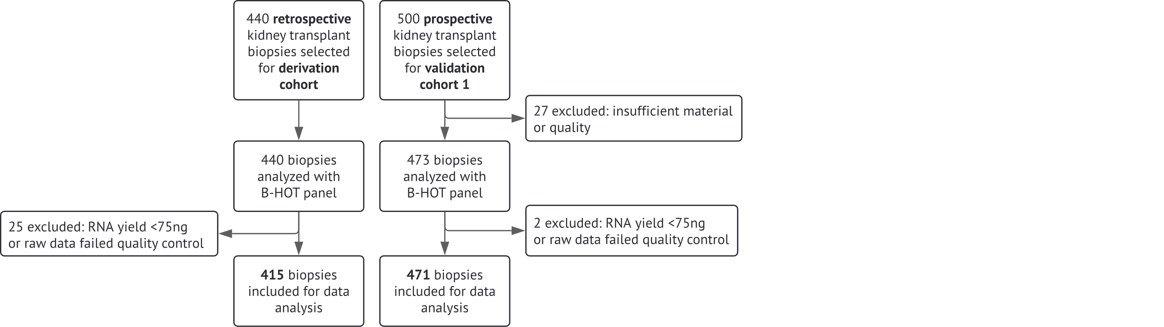
Supplementary Figure S1 | Study cohort. Flowchart of biopsy inclusion from University Hospitals Leuven (derivation and European validation cohort), starting with 530 retrospectively selected and 560 prospectively collected kidney transplant biopsies.

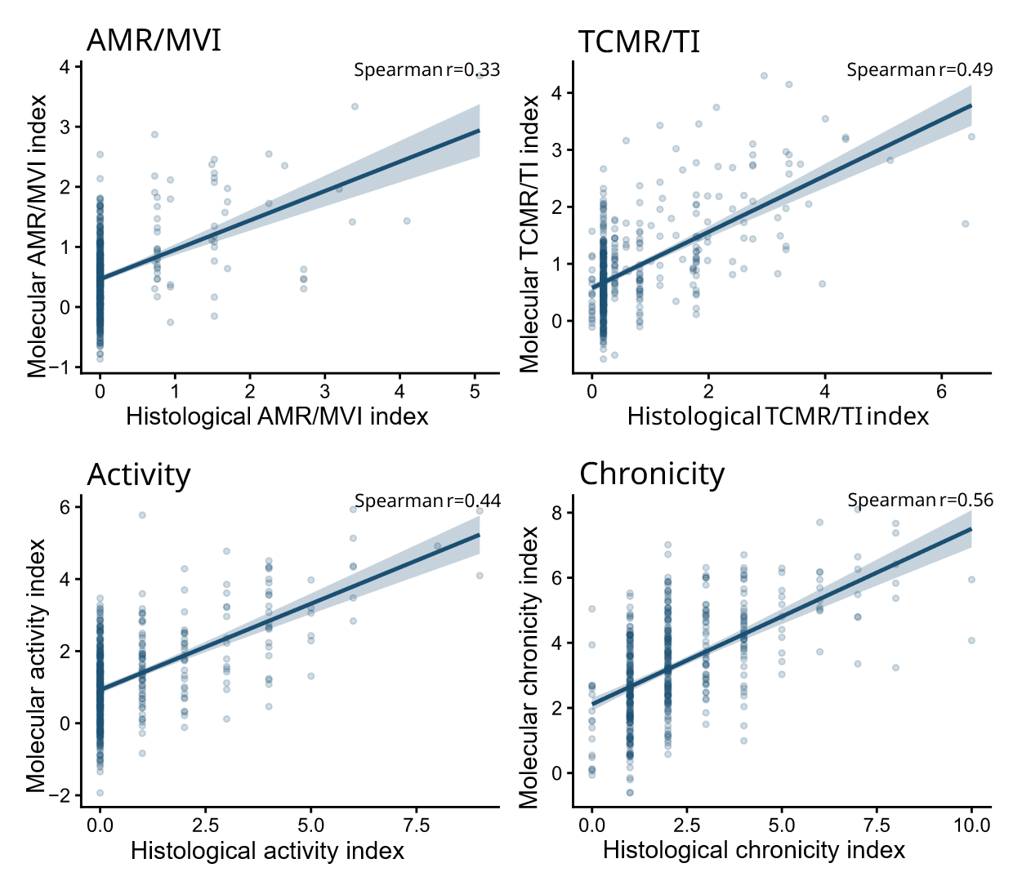
Supplementary Figure S2 | Correlation between molecular and histological indices in the European validation cohort (N=471). Scatter plots show the relationship between each molecular index and its corresponding continuous histological index for AMR/MVI, TCMR/TI, inflammatory activity and chronicity in the European validation cohort (N=471). Points represent individual biopsies. Lines indicate linear fits with shaded 95% confidence intervals. Spearman correlation coefficients are shown in each panel.
Abbreviations: AMR, antibody-mediated rejection; MVI, microvascular inflammation; TCMR, T cell–mediated rejection; TI, tubulointerstitial inflammation.

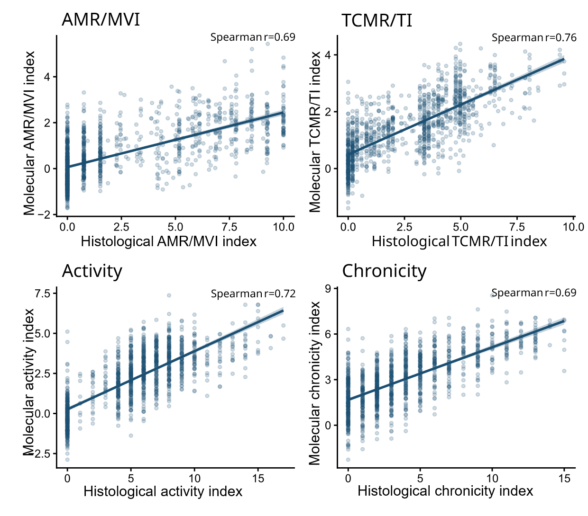

Supplementary Figure S3 | Correlation between molecular and histological indices in the US validation cohort (N=1190). Scatter plots show the relationship between each molecular index and its corresponding continuous histological index for AMR/MVI, TCMR/TI, inflammatory activity and chronicity in the US validation cohort (N=1190). Points represent individual biopsies. Lines indicate linear fits with shaded 95% confidence intervals. Spearman correlation coefficients are shown in each panel.
Abbreviations: AMR, antibody-mediated rejection; MVI, microvascular inflammation; TCMR, T cell–mediated rejection; TI, tubulointerstitial inflammation.

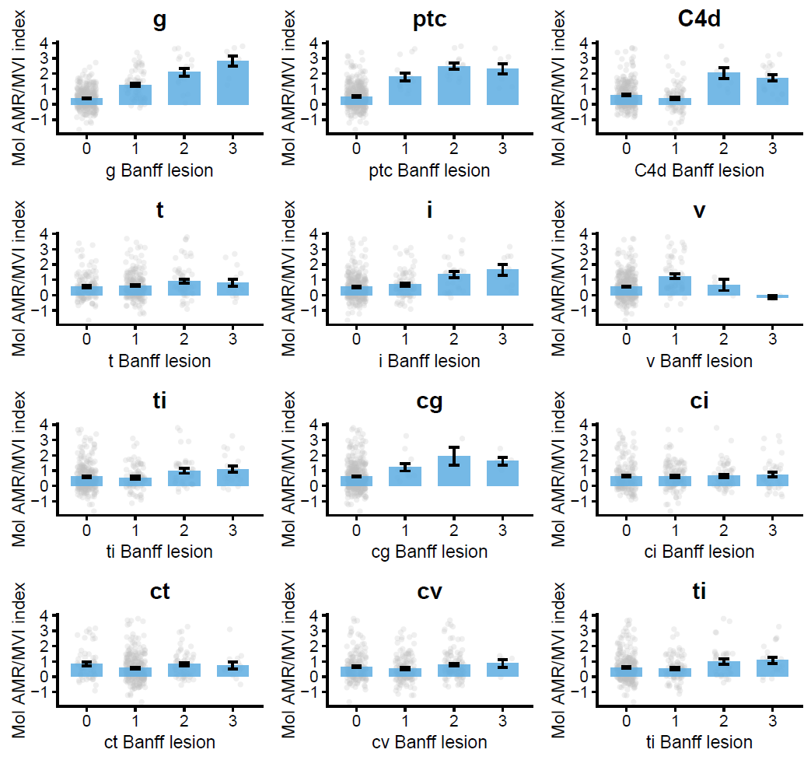Supplementary Figure S4 | Association of the molecular AMR/MVI index with Banff lesion scores in the derivation cohort (N=415). Panels show the distribution of the molecular AMR/MVI index across increasing Banff lesion scores. Grey points represent individual biopsies. Blue bars indicate the mean molecular index value at each lesion score, with error bars showing the standard error of the mean.

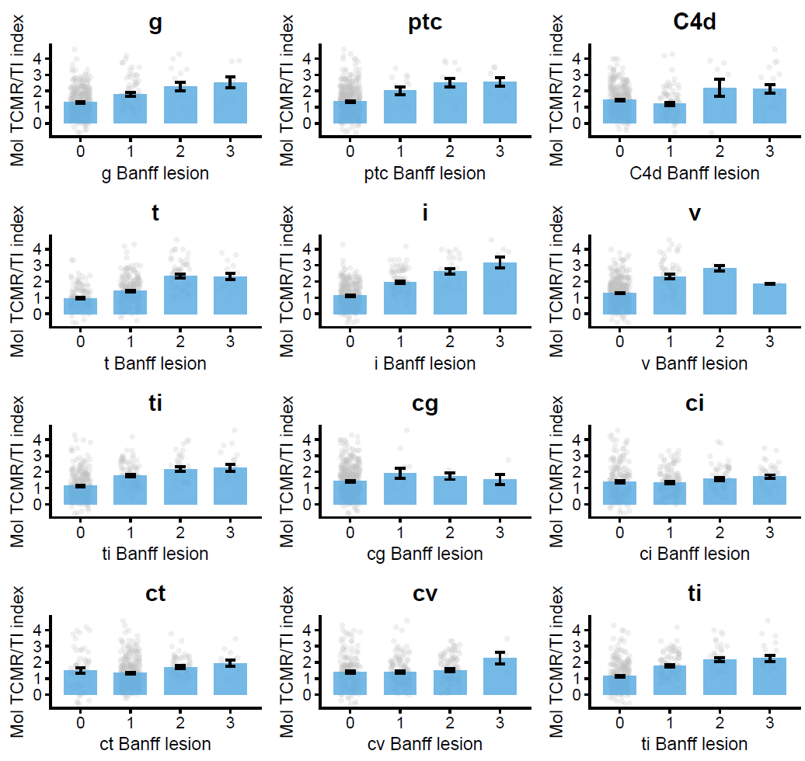
Supplementary Figure S5 | Association of the molecular TCMR/TI index with Banff lesion scores in the derivation cohort (N=415). Panels show the distribution of the molecular TCMR/TI index across increasing Banff lesion. Grey points represent individual biopsies. Blue bars indicate the mean molecular index value at each lesion score, with error bars showing the standard error of the mean.

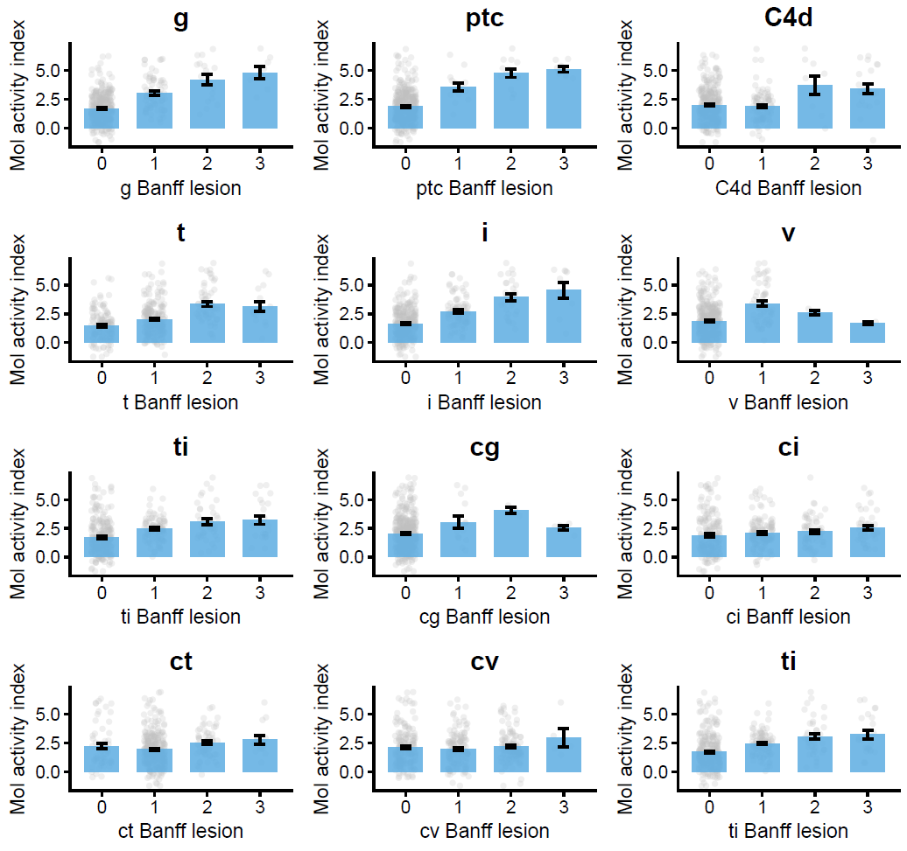
Supplementary Figure S6 | Association of the molecular activity index with Banff lesion scores in the derivation cohort (N=415). Panels show the distribution of the molecular activity index across increasing Banff lesion. Grey points represent individual biopsies. Blue bars indicate the mean molecular index value at each lesion score, with error bars showing the standard error of the mean.

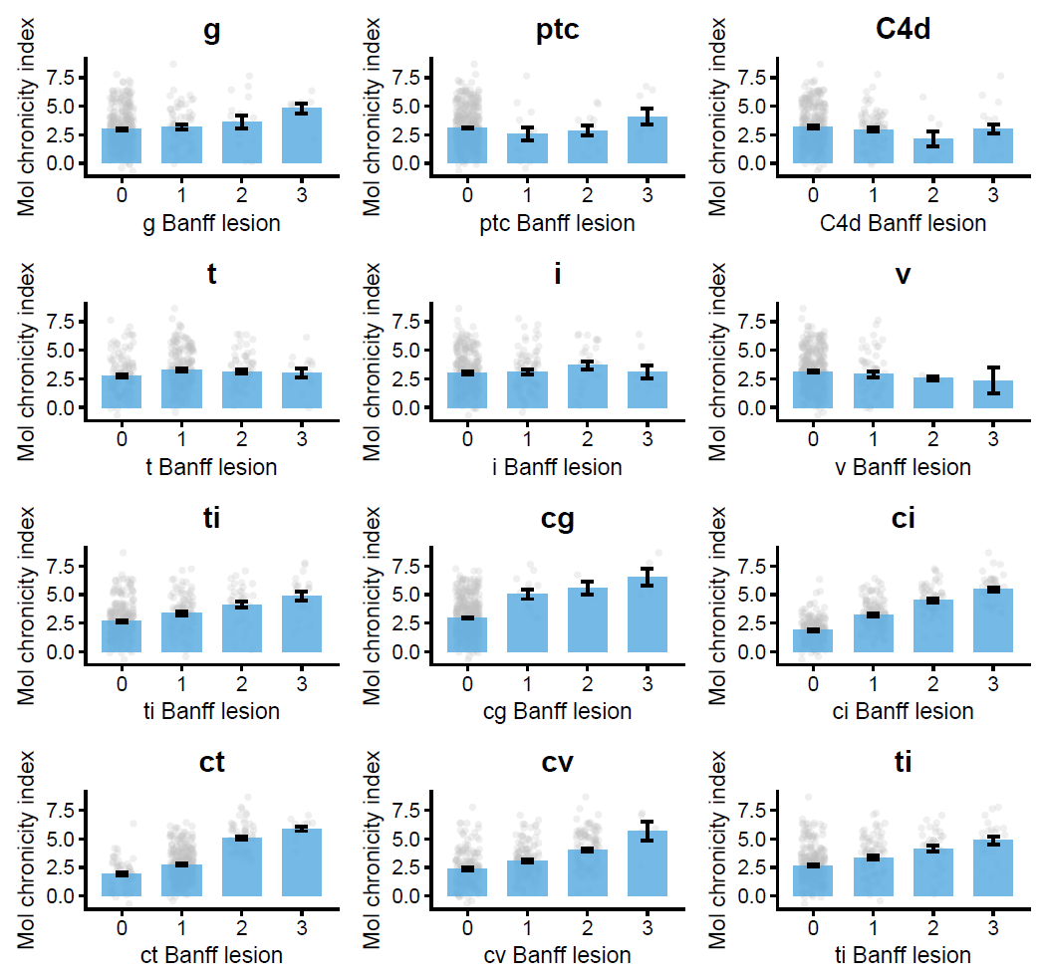
Supplementary Figure S7 | Association of the molecular chronicity index with Banff lesion scores in the derivation cohort (N=415). Panels show the distribution of the molecular chronicity index across increasing Banff lesion. Grey points represent individual biopsies. Blue bars indicate the mean molecular index value at each lesion score, with error bars showing the standard error of the mean.

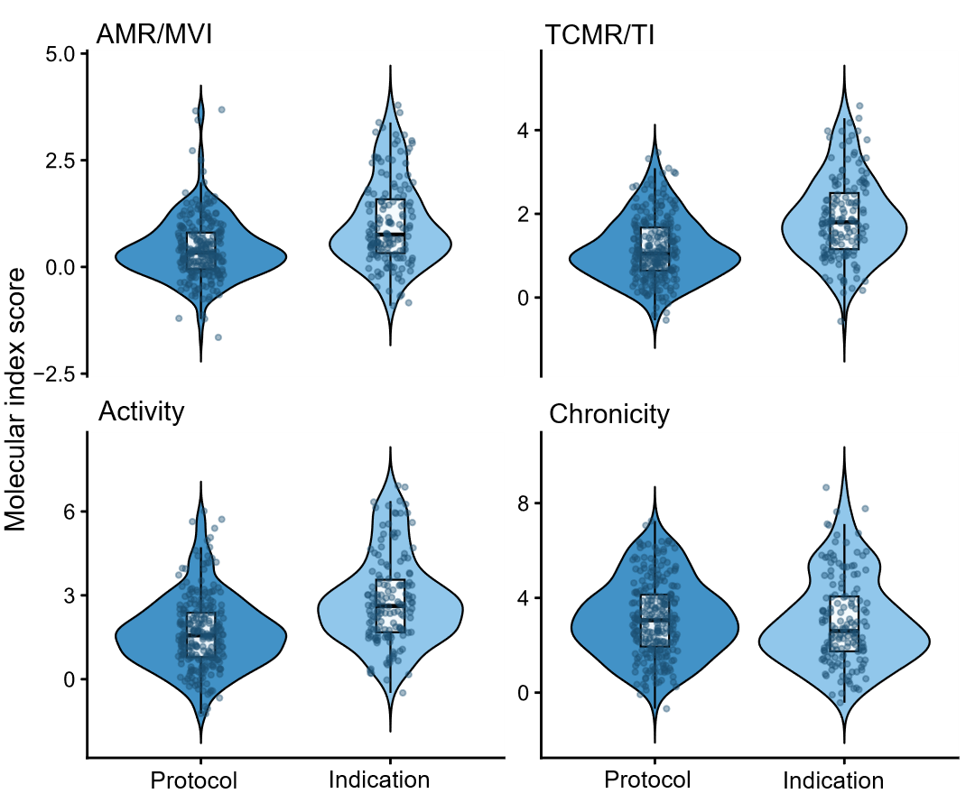
Supplementary Figure S8 | Distribution of molecular indices by biopsy type in the derivation cohort (N=415). Violin plots depict the distributions of continuous molecular indices in protocol and indication biopsies. Boxplots show median and interquartile range; points represent individual biopsies.

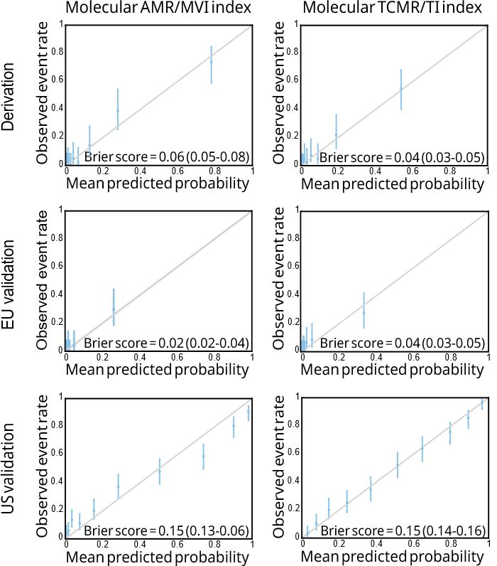

Supplementary Figure S9 | Calibration of molecular AMR/MVI and TCMR/TI indices across cohorts. Calibration plots show the agreement between predicted and observed probabilities for AMR/MVI and TCMR/TI phenotypes in the derivation cohort (N=415), European validation cohort (N=471) and US validation cohort (N=1,190).
Abbreviations: AMR, antibody-mediated rejection; MVI, microvascular inflammation; TCMR, T-cell mediated rejection; TI, tubulo-interstitial inflammation.

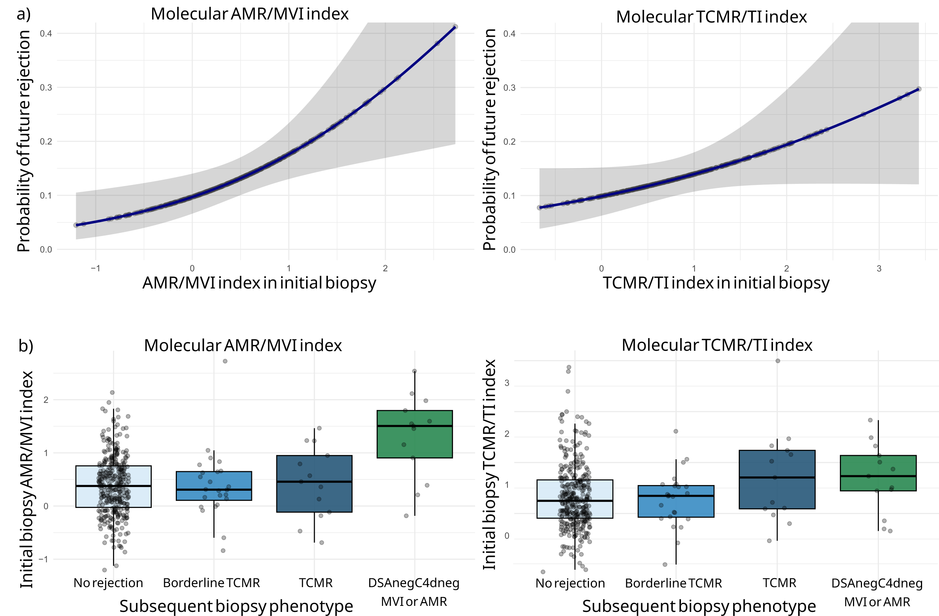Supplementary Figure S10 | Association between initial AMR/MVI and TCMR/TI molecular scores in no-rejection biopsies and subsequent biopsy phenotype
a, Initial molecular index and future rejection.
Predicted probability of future rejection (any rejection phenotype) derived from univariable logistic regression models with the initial molecular AMR/MVI index (left) or the molecular TCMR/TI index (right) as predictors in the combined derivation and European validation cohorts (N=886). Solid lines denote model-estimated probabilities and shaded areas represent 95% confidence intervals.
b, Initial molecular index by subsequent biopsy phenotype.
Boxplots show molecular AMR/MVI and TCMR/TI index values in initial biopsies classified as no rejection (N=377), stratified according to the phenotype observed in the subsequent biopsy: no rejection (N=327), borderline TCMR (N=24), TCMR (N=13), or DSAnegC4dneg MVI/AMR (N=13). Boxes indicate the median and interquartile range (IQR), with individual biopsies shown as points. Mean ± s.d. initial AMR/MVI and TCMR/TI index scores were: no rejection (0.39 ± 0.56; 0.76 ± 0.64), borderline TCMR (0.40 ± 0.66; 0.71 ± 0.55), TCMR (0.44 ± 0.68; 1.17 ± 0.94), and DSAnegC4dneg MVI/AMR (1.31 ± 0.79; 1.13 ± 0.68). Differences across groups were significant for the AMR/MVI index (Kruskal–Wallis (p=0.002), driven by higher values in DSAnegC4dneg MVI/AMR compared with no rejection (p=0.001), borderline TCMR (p=0.004) and TCMR (p=0.02), whereas no differences were observed between no rejection, borderline TCMR and TCMR (all p≥0.88). The TCMR/TI index did not differ significantly across groups (Kruskal–Wallis p=0.10; all pairwise p≥0.25).

Abbreviations: AMR, antibody-mediated rejection; C4d, complement split product C4d; DSA, donor-specific antibodies; IQR, interquartile range; MVI, microvascular inflammation; NR, no rejection; TCMR, T cell–mediated rejection; TI, tubulointerstitial inflammation.

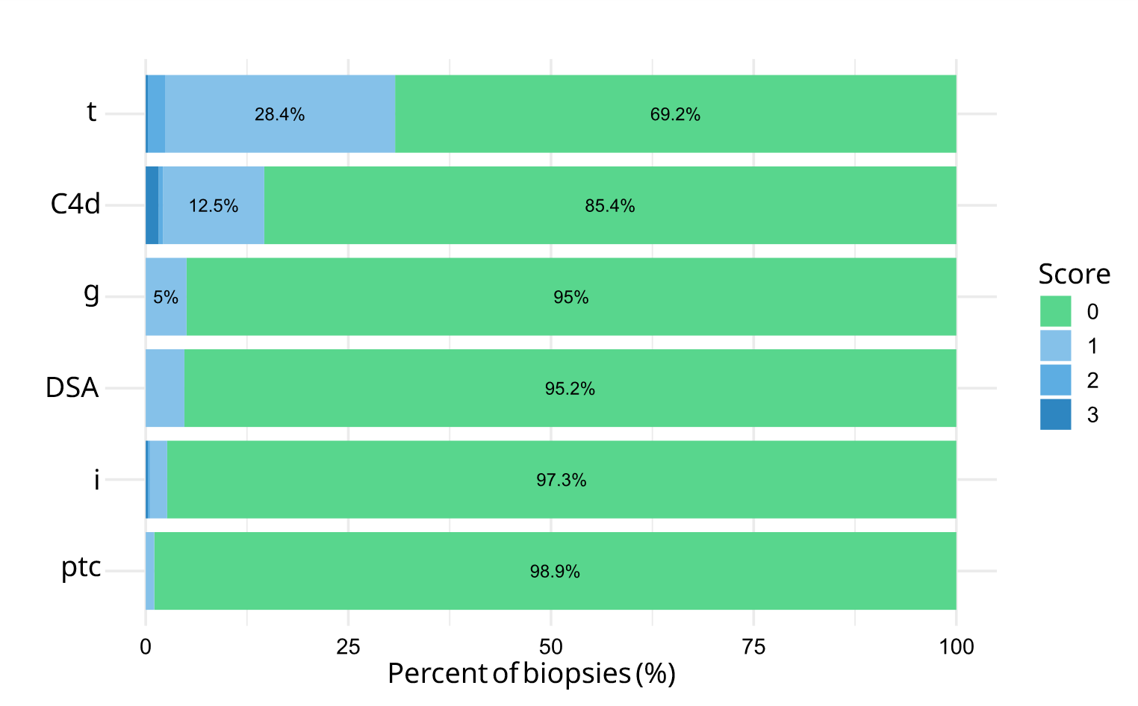
Supplementary Figure S11 | Subthreshold histologic lesions in biopsies classified as no rejection. Stacked bar plots show the distribution of Banff lesion scores (0–3) across biopsies assigned to the no-rejection category (N=377).
Abbreviations: C4d, complement split product 4d; DSA, donor-specific antibodies; g, glomerulitis; i, interstitial inflammation; ptc, peritubular capillaritis; t, tubulitis.

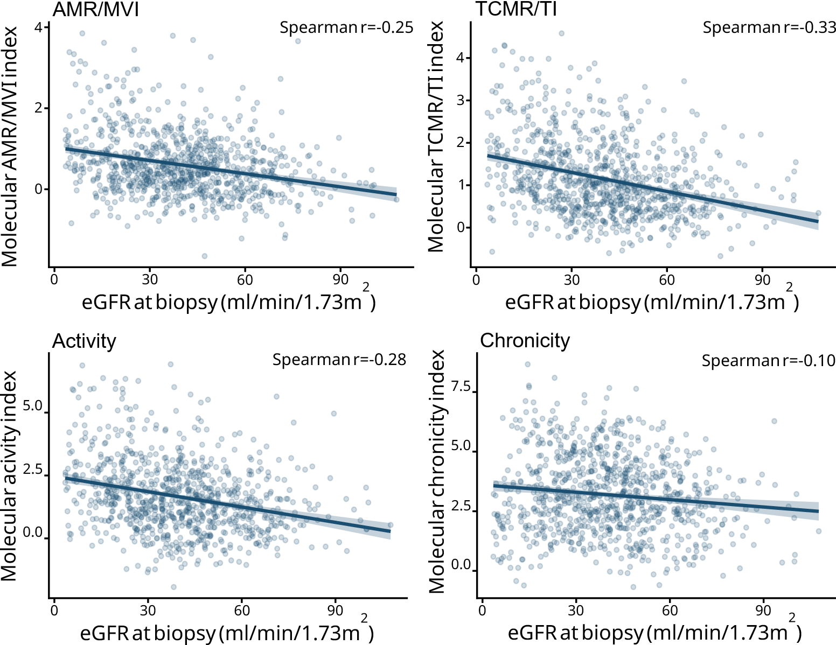
Supplementary Figure S12 | Correlation between molecular indices and eGFR at the time of biopsy in combined derivation and EU validation cohort (N=886). Scatterplots show the relationship between estimated glomerular filtration rate (eGFR) at the time of biopsy and each continuous molecular index. Points represent individual biopsies. Lines indicate linear fits with shaded 95% confidence intervals. Spearman correlation coefficients are shown in each panel.

Abbreviations: AMR, antibody-mediated rejection; eGFR, estimated glomerular filtration rate; MVI, microvascular inflammation; TCMR, T cell–mediated rejection; TI, tubulointerstitial inflammation.

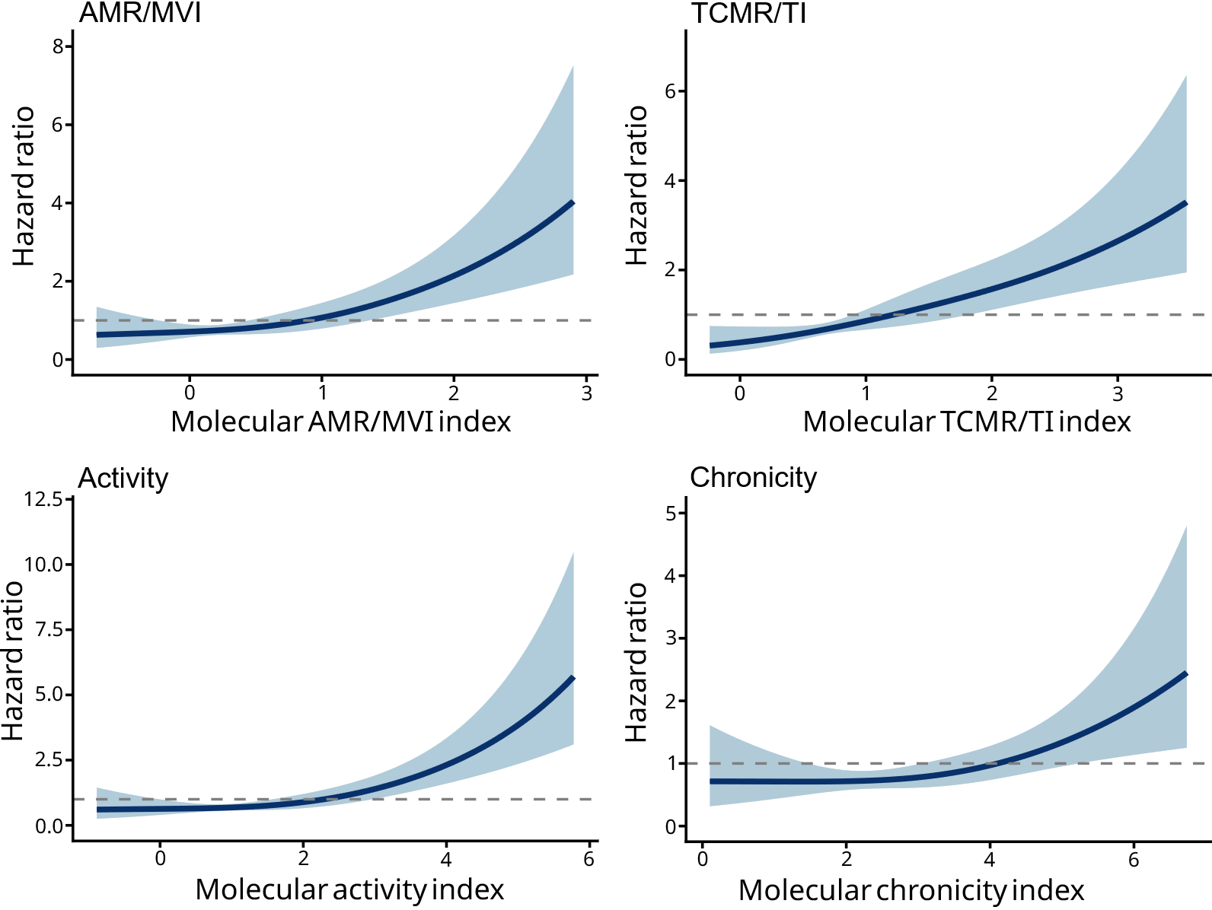
Supplementary Figure S13 | Continuous relationship between molecular indices and graft failure in combined derivation and EU validation cohort (N=886). Restricted cubic spline Cox models were used to assess the functional form of the association between each continuous molecular index and graft failure. Hazard ratios are shown with 95% confidence intervals. No significant evidence of non-linearity was observed (nonlinear Wald test p-values: AMR/MVI p=0.31; TCMR/TI p=0.57; activity p=0.14; chronicity p=0.21).

Abbreviations: AMR, antibody-mediated rejection; MVI, microvascular inflammation; TCMR, T cell–mediated rejection; TI, tubulointerstitial inflammation.

