Supplementary methods

Analysis of single-cell RNA-sequencing data in human AAA and normal tissues
In this study, the necessary single-cell transcriptomic data and bulk transcriptomic data for the research were retrieved from the Gene Expression Omnibus (GEO), a public database. The single-cell transcriptomic data were obtained from the GSE226492 dataset, which includes 3 AA samples and 3 control samples. cGAS-STING signaling pathway genes were obtained and downloaded from the Kyoto Encyclopedia of Genes and Genomes (KEGG) Database (hsa04623). Since all data were acquired from open-access databases, ethical approval was not required for the utilization of these data in the present study.
Single-cell RNA sequencing data were processed using the Seurat R package (v4.3.0) and scDblFinder (v1.10.0). Quality control filtering excluded cells meeting any of the following criteria: fewer than 300 detected genes (nFeature_RNA > 300), total UMI counts exceeding 40,000 (nCount_RNA < 40,000), hemoglobin gene expression ≥10% (percent.HB < 10), mitochondrial gene content ≥10% (percent.mt < 10), or library complexity below the established threshold (log10GenesPerUMI > 0.85). Doublets were identified and removed using scDblFinder. Normalization was performed with Seurat’s standard log-normalization method (scaling counts to 10,000 transcripts per cell followed by natural log transformation). Highly variable genes were selected to capture transcriptional heterogeneity using Seurat’s variance-stabilizing approach.Principal component analysis (PCA) was computed using the top 10 significant PCs, followed by graph-based clustering at a resolution of 0.3. Cell populations were annotated by cross-referencing expression signatures against the CellMarker 2.0 database. Vascular smooth muscle cells (VSMCs) were subclassified into contractile and synthetic phenotypes based on established marker gene expression profiles. Contractile VSMCs were defined by elevated expression of markers associated with the differentiated contractile state, including MYH11, ACTA2, CNN1, TAGLN, MYL9, RGS5, NOTCH3, CALD1, TPM2, and CSRP1. Conversely, synthetic VSMCs were identified by heightened expression of genes characteristic of the synthetic/proliferative phenotype: COL1A1, COL1A2, FN1, POSTN, MMP2, PDGFRA, DCN, LUM, FBLN1, and SERPINE1.Genes with biological significance and significantly high expression (|log₂FC| > 0.25, adj. p-value < 0.05) were used as subgroup markers.
Single-sample gene set enrichment analysis (ssGSEA) was used to quantify the enrichment scores of target pathways (e.g., STING pathway) and functional signatures (e.g., ECM-related, Protein Digestion-related) in individual cells, utilizing the R package GSVA (version 1.50.0) with default parameters. The gsva() function was implemented with method = "ssgsea", kcdf = "Gaussian" to fit the expression distribution of normalized scRNA-seq data, and abs.ranking = TRUE to prioritize absolute expression differences. Target gene sets were curated from literature and biological databases KEGG.
Spearman's rank correlation analysis was employed to quantify the associations between target indicators. This nonparametric test was selected to accommodate the non-normal distribution of single-cell data, with the core parameter method = "spearman" to calculate the correlation coefficient (ρ) and statistical significance (P-value). Analyses were stratified by experimental groups (All cells, AA group, Control group) and cell types (e.g., M1/M2 Macrophages, VSMC_Synthetic/VSMC_Contractile), and scatter plots with linear regression lines were used to visualize association trends. The purpose was to clarify the association strength and differential characteristics of target indicators under different biological conditions

Immunofluorescence staining in AAA tissues and mouse tissues
The human tissue collection protocol in this study was approved by the Ethics Committee of Chongqing Medical University (approval number: ). Human abdominal aortic tissues were obtained from patients undergoing AAA graft replacement surgery, with samples from the central dilated segment selected for the AAA group and proximal non-dilated segments for the control group. Mice were perfused systemically with pre-cooled PBS at 4 °C, and abdominal aortas were dissected under a microscope. Human or mouse ex vivo abdominal aortic tissues were fixed in 4% paraformaldehyde, embedded in paraffin, and sectioned (cross-sectional slices preserving the lumen structure). Sections were deparaffinized, rehydrated, and subjected to antigen retrieval, followed by blocking with 5% goat serum. Primary antibodies were incubated overnight, washed, and secondary antibodies incubated at room temperature for 50 min. Multiplex immunofluorescence staining was performed after TSA labeling (AIFang biological, AFIHC023) and repeating the above steps for each marker. Cell apoptosis was detected by TUNEL (Servicebio, G1501) and nuclei counterstained with DAPI. After staining, images were acquired using a laser confocal microscope (Olympus SpinSR, Japan), and fluorescence intensity was quantified to evaluate protein expression and cell apoptosis. Detailed information on antibodies and dilutions is listed in Table S1.

Animals
C57BL/6 and ApoE⁻/⁻ mice were purchased from Huasino Inc. (Jiangsu, China). All animal experiments were approved by the Animal Care and Use Committee of the Second Affiliated Hospital of Chongqing Medical University (Approval No. IACUC-SAHCQMU-2024-00128). Mice were housed and all experimental procedures were conducted under specific pathogen-free conditions. Animals were maintained in standard cages with controlled temperature, humidity, and a regular light–dark cycle, and were provided ad libitum access to food and water. All mice in this study were anesthetized by intraperitoneal injection of tribromoethanol or inhalation of isoflurane.

Simulation analysis of ultrasound propagation
Ultrasound propagation was simulated using finite element analysis software COMSOL (COMSOL Inc.) with the pressure acoustics physics interface. Based on the actual propagation path of focused ultrasound in the mouse abdomen, the abdominal tissues were simplified into a three-layer medium model: a skin/muscle layer (2–3 mm), an intestine/gas-containing layer (4–5 mm), and an abdominal aorta layer (~1 mm). According to reported acoustic parameters of human soft tissues, the sound speed of the skin/muscle and abdominal aorta layers was set to 1540 m/s, with a density of 1.0 g/cm³, an acoustic impedance of 1.5 × 10⁵ Rayl, and an attenuation coefficient of 1 dB/cm/MHz. Considering that the gastrointestinal layer consists of the intestinal wall, contents, and gas. Gas strongly affects ultrasound propagation, so the gas volume fraction was assumed to be 40%. Using a volume-fraction–weighted averaging method, the effective acoustic parameters of the intestine/gas layer were defined as a sound speed of 533 m/s, a density of 0.4 g/cm³, an acoustic impedance of 0.2 × 10⁵ Rayl, and an attenuation coefficient of 20 dB/cm/MHz. These acoustic parameters were sequentially assigned to the corresponding layers in the model. Absorbing boundary conditions were applied around the model to minimize reflections, and a focal peak negative pressure of 0.3 MPa was applied at the transducer location. A frequency-domain study was then implemented with a frequency of 650 kHz to simulate the propagation characteristics of low-intensity focused ultrasound through multilayer abdominal tissues in mice

Preparation of MBs, MM@MBs, and MMTp@MBs
The synthesis of MBs, MM@MBs, and MMTp@MBs was optimized based on previously reported microbubble preparation methods. Briefly, 7 mg of 1,2-dipalmitoyl-sn-glycero-3-phosphocholine (DPPC) and 3 mg of DSPE-PEG2000 were fully dissolved in chloroform and subjected to rotary evaporation at 60 °C and 120 rpm to form a uniform lipid film. The resulting film was hydrated with 1 mL of 10% glycerol/PBS and ultrasonicated in a 40 °C water bath to obtain a lipid suspension.
Subsequently, 500 μL of the lipid suspension was transferred into a 1.5 mL vial, and saturated C₃F₈ gas was introduced using a three-way gas exchange device to generate a microbubble precursor. The vial was then agitated using a silver-mercury amalgamator (Zhongrun Med., Hangzhou, China) at 4200 rpm for 60 s. After agitation, the lower phase containing unformed lipid suspension was removed to obtain blank microbubbles (MBs). The preparation of MM@MBs followed a similar procedure to that of MBs, except that oleic acid–modified Fe₃O₄ nanoparticles (~40 nm; XFNANO, Nanjing, China) were added to the chloroform during lipid dissolution to form a magnetic lipid film after rotary evaporation. The magnetic lipid film was then rehydrated as described above, followed by the addition of an appropriate amount of macrophage membrane at 4 °C and gentle mixing at 30 rpm to obtain a macrophage membrane–coated magnetic lipid suspension. The subsequent steps were identical to those used for MB preparation, yielding MM@MBs. MMTp@MBs were prepared based on MM@MBs, with TBK1-PROTAC (MCE, USA)introduced simultaneously during the addition of the macrophage membrane. All other preparation steps were identical to those for MM@MBs, resulting in TBK1-PROTAC-loaded macrophage membrane-coated magnetic targeting microbubbles (MMTp@MBs). The characteristic absorption peak of TBK1-PROTAC was determined using a UV–visible spectrophotometer. To quantify the encapsulation efficiency, the washed MMTp@MBs were completely dissolved in methanol, and the concentration of TBK1-PROTAC was calculated based on the corresponding standard calibration curve.
The size and surface charge (zeta potential) of the microbubbles were measured using a Malvern ZS-90 Nanosizer (Malvern Instruments, UK). Microbubble concentration was determined using a hematology analyzer following standard cell counting procedures. The morphology and surface structure of the microbubbles were characterized by cryogenic scanning electron microscopy (Cryo-SEM, Hitachi Regulus 8100, Japan).

Validation of magnetic targeting capability
A permanent magnet with a magnetic flux density of 12,000 Gauss and dimensions of 5 cm × 2 cm × 2 cm was used. DiI-labeled microbubbles were prepared by adding DiI dye (final concentration, 5 μM; Beyotime, China) to chloroform, followed by thorough mixing with the phospholipid components prior to subsequent microbubble fabrication. For evaluation of magnetic targeting capability, DiI-labeled magnetic microbubbles were diluted 1:100 and delivered through a Y-shaped three-way connector using a peristaltic pump at a constant flow rate of 10 mL/min, allowing distribution into different collection tubes. The distribution of DiI-labeled magnetic microbubbles in each tube was visualized by CLSM, and fluorescence intensity was quantitatively analyzed to determine the optimal loading amount of Fe₃O₄ nanoparticles. After determining the final formulation, DiI-labeled magnetic microbubbles were dropped onto glass slides, and the magnet was placed at different positions to induce magnetic attraction for 2 min. The aggregation behavior of the magnetic microbubbles was then imaged and evaluated using CLSM.
The chip mold was fabricated via computer numerical control (CNC) machining, using hydrophobic polycarbonate (PC) as the mold substrate. After CNC machining, the mold was subjected to polishing to ensure surface smoothness. The chip was fabricated by polydimethylsiloxane (PDMS) replica molding. Specifically, PDMS prepolymer and curing agent were mixed uniformly at a typical weight ratio of 10:1. The mixture was first degassed under vacuum to eliminate air bubbles, then slowly poured onto the PC mold surface. A second vacuum degassing step was performed to ensure complete filling of all microstructures in the mold. Subsequently, the mold-PDMS assembly was thermally cured at 60 °C for 4–6 hours. After curing, demolding was performed to obtain the PDMS chip layer. After hole punching on the PDMS chip, plasma treatment was applied to both the bonding surface of the chip and the surface of a clean glass slide. Immediately after treatment, the PDMS chip was aligned and bonded to the glass slide, ensuring a bubble- and gap-free bonding interface. Finally, catheters of appropriate specifications were inserted into the fluid inlets and outlets created by the prior punching process to complete chip assembly. The assembled chip was directly usable for subsequent experiments.

Extraction of macrophage membranes and validation of inflammation-targeting capability
RAW264.7 cells were cultured in complete medium (Procell, China) in 15-cm culture dishes until reaching 80–90% confluence. After three washes with prechilled PBS (600 g, 5 min), cells were resuspended at a density of 2–5 × 10⁷ cells/mL in lysis buffer containing 100 mM sucrose, 15 mM Tris-HCl (pH 7.5), 2 mM MgCl₂, 10 mM KCl, and 20 mM phenylmethylsulfonyl fluoride (PMSF), and incubated on ice for 15 min. The suspension was then subjected to three freeze–thaw cycles, and complete cell disruption was confirmed by light microscopy. The lysate was centrifuged at 700 g for 10 min at 4 °C to remove cell debris, and the supernatant was further centrifuged at 15,000 g for 30 min at 4 °C to collect the cell membrane pellet. The membrane fraction was resuspended in PBS, and membrane protein concentration was determined using a BCA assay (all membrane amounts reported in the main text refer to membrane protein mass).
To verify successful membrane preparation, a phospholipid suspension containing DSPE-PEG-FITC was prepared, and the membranes were labeled with DiI. Fluorescent signals were examined using confocal laser scanning microscopy (CLSM). For further validation, MM@MBs were lysed with 1% Triton X-100 and centrifuged at 15,000 g for 15 min at 4 °C to remove phospholipid precipitates, and the protein-containing supernatant was collected. This supernatant was analyzed together with macrophage membrane proteins extracted using a commercial membrane protein extraction kit (Beyotime, China) by SDS-PAGE, followed by Coomassie Brilliant Blue staining (Beyotime, China), to confirm that the shell proteins of MM@MBs originated from macrophage membranes. In addition, mouse aortic endothelial cells (MAECs) were cultured in complete medium (EallBio, China) to moderate confluence and treated with PBS or TNF-α (10 ng/mL) for 12 h, followed by incubation with DiI-labeled MM@MBs for 30 min. After gentle PBS washing, fixation, and DAPI nuclear staining, the interactions between microbubbles and endothelial cells were observed by CLSM

Animal model
Eight-week-old male APOE⁻/⁻ mice underwent baseline abdominal aortic diameter measurement by ultrasonography. Measurements were independently performed by two experienced operators, and the average value was used for analysis. Diameters were measured from adventitia to adventitia at three randomly selected sites within the suprarenal abdominal aorta. AAA was induced by subcutaneous implantation of osmotic minipumps (RWD, China) delivering angiotensin II (Ang II, 1000 ng/min/kg) for 28 days.

In vitro and in vivo ultrasound imaging
In this study, B-mode ultrasound and contrast-enhanced ultrasound (CEUS) imaging were performed using a Vevo LAZR small-animal ultrasound imaging system (FUJIFILM VisualSonics, Inc., Toronto, Canada). For in vitro imaging, 200 μL of MM@MBs were added into a custom-made agarose gel phantom. B-mode and CEUS images were continuously acquired over a period of 0-60 min. The signal intensity within the region of interest (ROI) was quantitatively analyzed to evaluate the echogenicity and imaging stability of the microbubbles.
For in vivo imaging, mice were anesthetized with isoflurane and placed on a temperature-controlled platform to maintain body temperature. The abdominal area was prepared, and a 30-MHz ultrasound transducer was used to image the abdominal aorta from the lateral abdominal direction. Subsequently, 100 μL of MBs or MM@MBs were intravenously administered via the tail vein. B-mode and CEUS images were acquired at 0 and 2 min post-injection, and the signal intensity within the abdominal aorta ROI was quantitatively analyzed.

In vitro and in vivo biocompatibility evaluation
In vitro cytotoxicity was evaluated using the Cell Counting Kit-8 (CCK-8) assay (MCE, USA) according to the manufacturer’s instructions. For hemocompatibility assessment, 500 μL of mouse whole blood was collected into EDTA-containing anticoagulant tubes and gently mixed. The samples were centrifuged at 500 × g for 15 min to obtain blood cells. The collected blood cells were washed and diluted with PBS, then incubated with different treatment formulations at 37 °C for 1 h. After incubation, the samples were centrifuged, and the absorbance (OD) of the supernatant was measured at 542 nm using a microplate reader.
For complete blood count (CBC) analysis, mouse whole blood samples were collected into EDTA-containing anticoagulant tubes and gently mixed. Hematological parameters were measured using an automated hematology analyzer for small animals (Tecom, China) according to the manufacturer’s instructions. For serum biochemical analysis, mouse blood samples were collected and allowed to clot naturally at room temperature, followed by centrifugation at 500 g for 10 min to obtain serum. Serum levels of alanine aminotransferase (ALT), aspartate aminotransferase (AST), lactate dehydrogenase (LDH), creatinine (CREA), and urea (UREA) were measured using an automated biochemical analyzer (Mindray, China) according to the manufacturer’s instructions. Mouse heart, liver, spleen, lung, kidney, and small intestine tissues were fixed, embedded in paraffin, and sectioned at 4–5 μm thickness. Paraffin sections were deparaffinized, rehydrated, and stained with hematoxylin and eosin (H&E). Following dehydration, clearing, and mounting, tissue morphology and histological changes were observed under an optical microscope.

Transmission electron microscopy (TEM) of the mouse aorta
Eight-week-old C57BL/6 mice were anesthetized and intravenously injected with 200 μL of MM@MBs, followed immediately by low-intensity focused ultrasound (LIFU) irradiation at different peak negative pressures (PNPs) in pulsed mode (650 kHz, pulsed/stop = 1:9) for 120 s. Two hours after treatment, mice were euthanized and perfused via cardiac perfusion. Abdominal aortas were harvested, fixed, and subjected to transmission electron microscopy (H-7500, Hitachi, Brisbane, CA).

In vitro and in vivo transendothelial delivery of TBK1-PROTAC
In vitro experiments, mouse aortic endothelial cells (MAECs) were cultured to full confluence (100%). During ultrasound treatment, a gel pad (1 cm thick) was placed between the transducer and the culture plate as an acoustic coupling medium. Prior to LIFU exposure, the culture medium was completely removed and replaced with a small volume of PBS or PBS containing MM@MBs to cover the cell surface. Cells were then subjected to LIFU under different acoustic parameters and exposure durations. After treatment, cells were incubated at 37 °C with 5% CO₂ for 30 min, washed with PBS, and fixed with ice-cold methanol for 15 min. Following blocking with 5% donkey serum at room temperature for 1 h, cells were incubated sequentially with primary antibodies and fluorescent secondary antibodies (antibody details are listed in Table S1). Nuclei were counterstained with DAPI, and images were acquired using a fluorescence microscope (Leica, Germany). For delivery experiments, MAECs were seeded onto Transwell inserts (0.4 μm pore size; Corning, USA) and cultured until the transendothelial electrical resistance (TEER) reached 200 Ω·cm², indicating formation of an intact endothelial barrier. PBS or PBS containing MM@MBs was then added to the apical chamber, followed by LIFU treatment. After ultrasound exposure, an equal amount of FITC-labeled TBK1-PROTAC was added to the apical chamber. At designated time points, aliquots were collected from the basolateral chamber and immediately replenished with an equal volume of HBSS. The fluorescence intensity of collected samples was measured using a multimode microplate reader (SpectraMax iD, USA). To correct for dilution effects caused by repeated sampling, fluorescence intensity at each time point was adjusted according to the following equation: Xtadj​=Xtmea​+Vtotal/​V​×Xt-1​. Xtadj represents the dilution-corrected fluorescence intensity at time point t, Xtmea​ is the measured fluorescence intensity, V is the replenishment volume at each sampling, Vtotal is the total volume of the basolateral chamber, and
𝑋𝑡-1 is the fluorescence intensity measured at the previous time point.
For in vivo transendothelial delivery studies, TBK1-PROTAC was fluorescently labeled with Cy5. Endothelial cells and vascular smooth muscle cells (VSMCs) were identified by immunostaining with CD31 and α-smooth muscle actin (αSMA), respectively. AAA mice were anesthetized and randomly assigned to receive Tp@MBs, MMTp@MBs, or MMTp@MBs combined with low-intensity focused ultrasound (LIFU) treatment. Two hours after administration, mice were humanely euthanized, and abdominal aortas were harvested for immunofluorescence analysis.

Bioassays in vitro
Primary VSMCs were isolated from the aortas of 8-week-old C57 mice. Briefly, after removing the endothelium, the medial layer was cut into 1 mm³ pieces and digested with trypsin. Cells were collected and cultured in smooth muscle cell-specific medium (Procell, China) until 90-100% confluence, then passaged for experiments. Prior to treatment, VSMCs were seeded to 80-90% confluence and preconditioned with different concentrations of H₂O₂ for 24 h to determine optimal oxidative stress conditions. For experimental treatments, VSMCs were incubated with PBS, MBs, MM@MBs, MMTp@MBs, or MMTp@MBs+LIFU for 12 h, followed by 400 μM H₂O₂ stimulation for 24 h. Protein extraction was performed using RIPA buffer supplemented with protease and phosphatase inhibitors (Yazyme, China), followed by 3 cycles of 100 W sonication and centrifugation at 8,000 g for 20 min at 4 °C. Protein samples were denatured at 100 °C for 10 min with SDS loading buffer(Yazyme, China). SDS-PAGE was performed (Yazyme, China), and proteins were transferred onto PVDF membranes (Milipore, USA), blocked with 5% nonfat milk (Beyotime, China), incubated with primary antibodies at 4 °C overnight, followed by secondary antibodies at room temperature for 2 h (Table S1), and visualized using a ChemiDoc imaging system. To avoid interference between target proteins and internal controls, bands were separated when distinguishable, or sequential detection was performed with antibody stripping (Beyotime, China) for indistinguishable bands. All target proteins and internal controls originated from the same membrane. For gene expression analysis, total RNA was extracted (Novozymes China), reverse transcribed into cDNA, and quantified by SYBR Green-based qRT-PCR (Novozymes China). Primer sequences were seen in Table S2. WB and qRT-PCR results were normalized to the corresponding control group. Cell apoptosis was assessed using an Annexin V-FITC/PI assay (Yazyme, China) and analyzed by flow cytometry (Beckman Coulter, USA). Macrophage polarization was evaluated by labeling treated cells with CD86 (M1) and CD206 (M2) antibodies (Table S1), followed by fixation, permeabilization, and flow cytometry analysis.

The therapeutic efficacy of MMTp@MBs + LIFU in vivo
Baseline abdominal aortic (AA) diameter was obtained by ultrasound imaging prior to osmotic pump implantation. During the 28-day AAA induction period, mice received the designated treatments every 3 days. For LIFU treatment, a transducer (650 kHz, 0.3 MPa, pulsed/stop 1:9) was positioned on one lateral side of the abdomen, targeting the suprarenal abdominal aorta, while a magnet was simultaneously applied to the contralateral side to provide continuous magnetic attraction. LIFU irradiation was applied for 120 s per treatment. In the Sham group, Ang II in the osmotic pump was replaced with normal saline. After 28 days, abdominal aortic ultrasound imaging was performed to measure AA diameter, following the same protocol as the baseline assessment (detailed measurement procedures are described in the Animal model section).
Mouse aortic tissues were fixed in 4% paraformaldehyde, paraffin-embedded, and sectioned at a thickness of 4-5 μm. HE staining (Beoytime, China) was performed to evaluate general histopathological changes. Elastic Van Gieson (EVG) staining was used to assess elastic fiber integrity and architecture (Solarbio, China). Masson’s (Solarbio, China) trichrome staining was conducted to evaluate collagen deposition and smooth muscle structure, while Sirius Red staining was applied to visualize collagen content and distribution, particularly collagen subtypes under polarized light (Solarbio, China). All stained sections were dehydrated, cleared, and mounted, and images were captured using a slide scanner (KF-FL-020, China) for further analysis. All staining were performed using commercially available staining kits according to the manufacturers’ standard protocols.

Transcriptomic and Proteomic Sequencing and Integrated Analysis
For transcriptomic and proteomic analyses, mouse abdominal aortic tissues were longitudinally divided into two equal portions, which were separately used for transcriptome and proteome library construction. Transcriptomic sequencing was performed on an Illumina NovaSeq 6000 platform, while proteomic profiling was conducted using liquid chromatography–tandem mass spectrometry (LC–MS/MS), with technical support provided by OE Biotech Co., Ltd. (China).
Total RNA was extracted using the QIAGEN RNeasy Lipid Tissue Mini Kit according to the manufacturer’s instructions. RNA purity was assessed using a NanoDrop spectrophotometer (Thermo Scientific), and RNA integrity was evaluated using an Agilent Bioanalyzer. Samples with a RNA integrity number (RIN) > 6 and a 28S/18S ratio ≥ 0.7 were considered qualified for subsequent library construction. Protein samples were quantified using the bicinchoninic acid (BCA) assay. Sample integrity and consistency were verified by SDS–PAGE followed by Coomassie Brilliant Blue staining prior to LC–MS/MS analysis.
Integrated multi-omics analysis was performed according to previously published methods. Statistical analysis and functional enrichment of transcriptomic and proteomic data were conducted using R software (version 4.2.1; R Foundation for Statistical Computing). Cell-type enrichment analysis was performed using reference single-cell RNA sequencing data of mouse abdominal aorta obtained from the Gene Expression Omnibus (GEO) database (accession number: GSE52583). Differentially expressed genes (DEGs) were defined as those with a false discovery rate–adjusted q value < 0.05 and a fold change > 2 or < 0.5. Differentially expressed proteins (DEPs) were identified using a threshold of p < 0.05 and a fold change > 2 or < 0.5.

Supplementary Tables

Table S1: Antibodies used in this study.
Antibody | Brand | Dilution ratio
IF in human (primary antibody)
Anti-STING | Biodragon (BD-PT5488) | 1:100
Anti-TBK1 | Abcam (ab40676) | 1:100
Anti-IRF3 | Proteintech (11312-1-AP) | 1:200
Anti-CD68 | Servicebio (GB14043) | 1:200
Anti-α-SMA | Servicebio (GB13044) | 1:300
IF in human (Secondary antibody)
Cy™3 Goat Anti-Mouse IgG (H+L) | Jackson (111-165-003) | 1:100
Cy5.5 Goat Anti-Rabbit IgG H&L | Bioss (bs-0295G) | 1:100
IF in mouse (primary antibody)
Anti-Claudin5 | Abcam (ab131259) | 1:200
Anti-ZO1 | Proteintech (21773-1-AP) | 1:100
Anti-CD31 | Abcam (ab281583) | 1:1000
Anti-CD68 | Servicebio (GB11067) | 1:200
Anti-CD86 | AiFang (AFRM0167) | 1:600
Anti-CD206 | AiFang (AFRM0009) | 1:600
Anti-αSMA | Servicebio (GB13044) | 1:300
Anti-MMP3 | Proteintech (66338-1-Ig) | 1:200
Anti-MMP9 | Affbiotech (AF5228) | 1:200
IF in mouse (Secondary antibody)
Donkey-anti-Rabbit IgG,AF594 | Oasisbio (D-RT594) | 1:500
Donkey-anti-Rabbit IgG,AF488 | Oasisbio (D-RT488) | 1:500
Goat Anti-Mouse IgG (H+L) 488 | Jackson (115-545-003) | 1:400
Goat Anti-Rabbit IgG H&L (Cy5.5) | Bioss (bs-0295G-Cy5.5) | 1:100
WB in mouse (primary antibody)
Anti-STING | Biodragon (BD-PT5488) | 1:1000
Anti-TBK1 | Abcam (ab40676) | 1:3000
Anti-IRF3 | Proteintech (66670-1-lg) | 1:5000
Anti-pSTING | CST (72971S) | 1:1000
Anti-pTBK1 | CST (5483S) | 1:1000
Anti-pIRF3 | CST (29047S) | 1:1000
Anti-OPN | Abclonal (A1261) | 1:1000
Anti-αSMA | Abclonal (A2235) | 1:3000
Anti-MLKL | Abclonal (A5579) | 1:500
Anti-RIP3 | CST (95702) | 1:1000
Anti-pMLKL | CST (37333) | 1:100
Anti-pRIP3 | Abclonal (AP1260) | 1:100
WB in mouse (Secondary antibody)
ERP Goat-anti-Rabbit | Boster (BA1054) | 1:1000
Flow cytometry in mouse
PE anti-mouse CD86 | Biolegend (105105) | - μg/10⁶cells
APC anti-mouse CD206 | Biolegend (141707) | 0.5 μg/10⁶cells

Table S1: Primers in qRT-PCR
Primer | Forward Primer (5’ to 3’) | Reverse Primer (5’ to 3’)
GAPDH | GGGTGTGAACCACGAGAAATA | GTCATGAGCCCTTCCACAAT
Cnn1 | TTGAGAGAAGGCAGGAACATC | GTACCCAGTTTGGGATCATAGAG
Myh11 | GATGAAGAGATCGCCCAGAAA | CTCTGAGTCTAGGTCCTCTTGT
Smtn | GAGAACTGGCTACACTCTCAAC | GTCAACTCCTCGACATCATTCA
Myh10 | GGAATCCTTTGGAAATGCGAAGA | GCCCCAACAATATAGCCAGTTAC
Ccl2 | GCATCCACGTGTTGGCTCA | CTCCAGCCTACTCATTGGGATCA
MMP2 | CAAGGATGGACTCCTGGCACAT | TACTCGCCATCAGCGTTCCCAT
MMP3 | GGCCTGGAACAGTCTTGGC | TGTCCATCGTTCATCATCGTCA
MMP9 | GGACCCGAAGCGGACATTG | CGTCGTCGAAATGGGCATCT
iNOs | TGCTTTGTGCGAAGTGTCAG | CCCTTTGTGCTGGGAGTCAT
TNFα | CCCTCACACTCAGATCATCTTCT | GCTACGACGTGGGCTACAG
IL-6 | TAGTCCTTCCTACCCCAATTTCC | TTGGTCCTTAGCCACTCCTTC
Arg1 | CTCCAAGCCAAAGTCCTTAGAG | AGGAGCTGTCATTAGGGACATC
Mrc1 | CTCTGTTCAGCTATTGGACGC | AGGAGCTGTCATTAGGGACATC
IL-10 | GCTCTTACTGACTGGCATGAG | CGCAGCTCTAGGAGCATGTG

Supplementary Figures

Figure S1. Immunofluorescence co-localization analysis of STING pathway and TUNEL staining in vascular smooth muscle cells within the medial layer of human abdominal aortic tissues.

Figure S2. CLSM images of magnetic MBs with varying masses of oleic acid-modified Fe₃O₄ nanoparticles. Scale bars are 10 μm.

Figure S3. CLSM images of the magnetic guidance capability of magnetic MBs with 200 µg oleic acid-modified Fe₃O₄ nanoparticles under various magnet orientations. (A) Center; (B) Side; (C) Non-magnet. Scale bars are 25 μm.

Figure S4. Evaluation of the magnetic guidance capability of magnetic-targeted MBs with 200 µg oleic acid-modified Fe₃O₄ nanoparticles under different distances. Scale bars are 25 μm

Figure S5. Size, zeta potential, and concentration of MM@MBs with different mass of macrophage membrane. (A) Size; (B) Zeta-potential; (C) Concentration. (n=3) ***P<0.001.

Figure S6. B-mode and CEUS images and signal intensity analysis of MM@MBs prepared with different macrophage membrane mass at various time points in vitro (n=3).

Figure S7. Ultrasound measurement of peak systolic velocity and end-diastolic velocity in the mouse abdominal aorta.

Figure S8. Coomassie Brilliant Blue staining of Macrophage membrane and MM@MBs

Figure S9. The inflammation-targeting capability of DiI-labeled MBs and MM@MBs was evaluated in MAECs following stimulation with PBS or TNF-α. Scale bars are 20 μm.

Figure S10. Ultrasound (US) and contrast-enhanced ultrasound (CEUS) imaging and quantitative signal intensity analysis of MBs and MM@MBs in the abdominal aorta of AAA mice. (n=3) **P<0.01.

Figure S11. CCK-8 of the in vitro cytotoxicity of TBK1-PROTAC in HUVECs, VSMCs, and RAW264.7 cells (n=3). ****P<0.0001
Figure S12. UV absorption spectrum of TBK1-PROTAC at different concentrations (A), calibration curve based on the characteristic peak (B), and encapsulation efficiency (C). (n=3)
Figure S13. The appearance of MBs, MM@MBs, and MMTp@MBs

Figure S14. The concentration of MBs, MM@MBs, MMTp@MBs measured by a hemocytometer.

Figure S15. Size changes of MBs, MM@MBs, MMTp@MBs during a period of 10 days at 4℃ (n=3).
Figure S16. Immunofluorescence and quantitative analysis of tight junction proteins Claudin-5 and ZO-1 in MAECs under different in vitro treatment conditions. (A) Quantitative analysis of Claudin-5 immunofluorescence (n = 3); (B) Immunofluorescence images of ZO-1; (C) Quantitative analysis of ZO-1 immunofluorescence (n = 3).

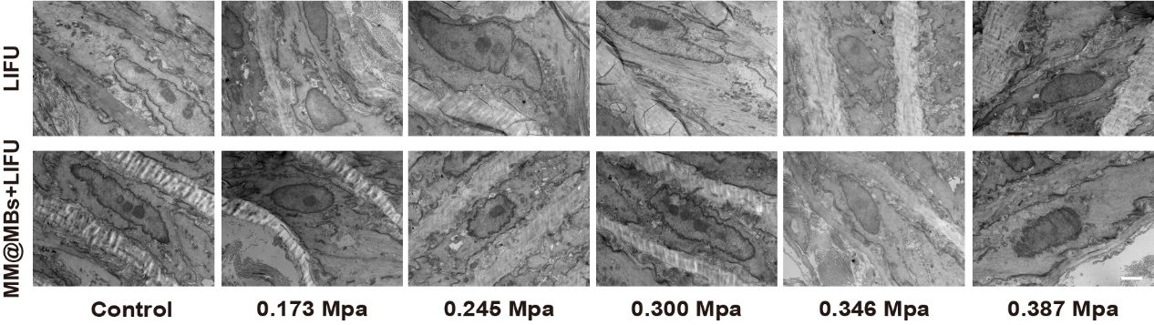
Figure S17. TEM images of the murine aortic endotheliumunder LIFU or MM@MBs+LIFU with different PNP. Scale bars are 1 μm.

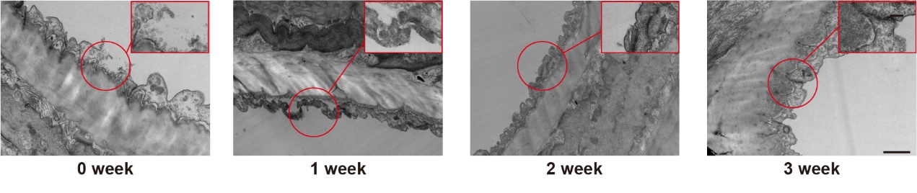
Figure S18. TEM images of the murine aortic endothelium after different weeks following MM@MBs + LIFU (0.300 Mpa). Scale bars are 1 μm.

Figure S19. Quantitative analysis of Cy5-TBK1-Protac delivery in AAA mice treated with Tp@MBs, MMTp@MBs, or MMTp@MBs + LIFU (n=3). **P<0.01; ***P<0.001; ****P<0.0001.

Figure S20. WB and quantitative analysis of STING–TBK1–IRF3 pathway activation in VSMCs stimulated with different concentrations of H₂O₂ (n=3). *P<0.05;**P<0.01.
Figure S21. Quantitative analysis of WB of STING–TBK1–IRF pathway expression in H₂O₂-stimulated VSMCs cells across treatment groups, with and without LIFU exposure (n=3). *P<0.05;**P<0.01. ***P<0.001; ****P<0.0001.
Figure S22. Flow cytometric analysis of apoptosis in H₂O₂-stimulated VSMCs treated with LIFU or oleic-acid Fe₃O₄ nanoparticles (n=3).
Figure S23. Quantitative analysis of necroptosis-related proteins MLKL and RIP3 and their phosphorylation in H₂O₂-induced VSMCs under different treatment conditions by shengwu WB (n=3). *P<0.05;**P<0.01. ***P<0.001.

Figure S24. Quantitative analysis of asthma-positive areas in the aortic media of mice from differrent treatment groups (n=3). ****P<0.0001.
Figure S25. Volcano plots of differentially expressed genes (DEGs) between the AAA, Sham, and Treatment groups (n=6). q-value < 0.05 and |log₂FC| > 1.

Figure S26. Volcano plots of differentially expressed proteins (DEPs) between the AAA, Sham, and Treatment groups (n=6). p-value < 0.05 and |log₂FC| > 1.

Figure S27. Venn diagrams were constructed to compare differentially expressed genes (q-value < 0.05, |log₂FC| > 1)and proteins (p-value < 0.05, |log₂FC| > 1) among the Sham, AAA, and Treatment groups, illustrating both the overlapping and non-overlapping entities (n=6).
Figure S28. Correlation analysis between overlapping differentially expressed genes and proteins (n=6).

Figure S29. Top 30 significantly enriched GO terms for DEGs across group comparisons. A: AAA vs. Sham; B: Treatment vs. AAA; C: Treatment vs. Sham. BP: Biological Process; CC: Cellular Component; MF: Molecular Function (n=6).

Figure S30. Top 30 significantly enriched GO terms for DEPs across group comparisons. A: AAA vs. Sham; B: Treatment vs. AAA; C: Treatment vs. Sham. BP: Biological Process; CC: Cellular Component; MF: Molecular Function. GO0006958: complement activation,clasicalpathway; GO0016064: immunoglobulin mediated immune response; GO0004867: serine-type endopeptidase inhibitor activity; GO0006122: mitochondrial electron transport, ubiquinol to cytochrome c; GO0033539 fatty acid beta-oxidation using acyl-CoA dehydrogenase; GO0010880: regulation of release of sequestered calcium ion into cytosol by sarcoplasmic reticulum; GO0003988: acetyl-CoA C-acyltransferase activity; GO0045242: isocitrate dehydrogenase complex (NAD+); GO0008137: NADH dehydrogenase (ubiquinone) activity; GO:0016712 oxidoreductase activity, acting on paired donors, with incorporation or reduction of molecular oxygen, reduced flavin or flavoprotein as one donor, and incorporation of one atom of oxygen; GO:0006086: acetyl-CoA biosynthetic process from pyruvate; GO0010890: positive regulation of sequestering of triglyceride; GO0006120 mitochondrial electron transport, NADH to ubiquinone; GO0019254: carnitine metabolic process, CoA-linked;GO0004368: glycerol-3-phosphate dehydrogenase (quinone) activity; GO0008137: NADH dehydrogenase (ubiquinone) activity; GO0004865: protein serine/threonine phosphatase inhibitor activity; GO0004775: chondroitin 4-sulfotransferase activity; GO0004739: alkylglycerophosphoethanolamine phosphodiesterase activity; GO0004466: long-chain fatty acyl-CoA dehydrogenase activity; GO0042590: antigen processing and presentation of exogenous peptide antigen via MHC class I; GO0086080: protein binding involved in heterotypic cell-cell adhesion; GO0051354: negative regulation of oxidoreductase activity; GO0017017: MAP kinase tyrosine/serine/threonine phosphatase activity (n=6).

Figure S31. Top 20 significantly enriched KEGG terms for DEGs across group comparisons. A: AAA vs. Sham; B: Treatment vs. AAA; C: Treatment vs. Sham. Cellp.:Cellular Proceses; Envlp.: Environmental information Processing; HumaD.: Human Diseases; OrgaS.: Organismal Systems (n=6).

Figure S32. Top 20 significantly enriched KEGG terms for DEPs across group comparisons. A: AAA vs. Sham; B: Treatment vs. AAA; C: Treatment vs. Sham (n=6).

Figure S33. GSEA of inflammatory and immune response-related in DEGs (n=6).

Figure S34. GSEA of inflammatory and immune response-related in DEPs (n=6).

Figure S35. CCK-8 of the in vitro cytotoxicity of different treatment groups in HUVECs, VSMCs, and RAW264.7 cells (n=3).

Figure S36. In vitro hemolysis assays to evaluate the blood compatibility of Tp@MBs and MMTp@MBs loaded with different concentrations of TBK1-PROTAC.

Figure S37. Body weight changes of mice from different treatment groups over a 28-day period (n=5).
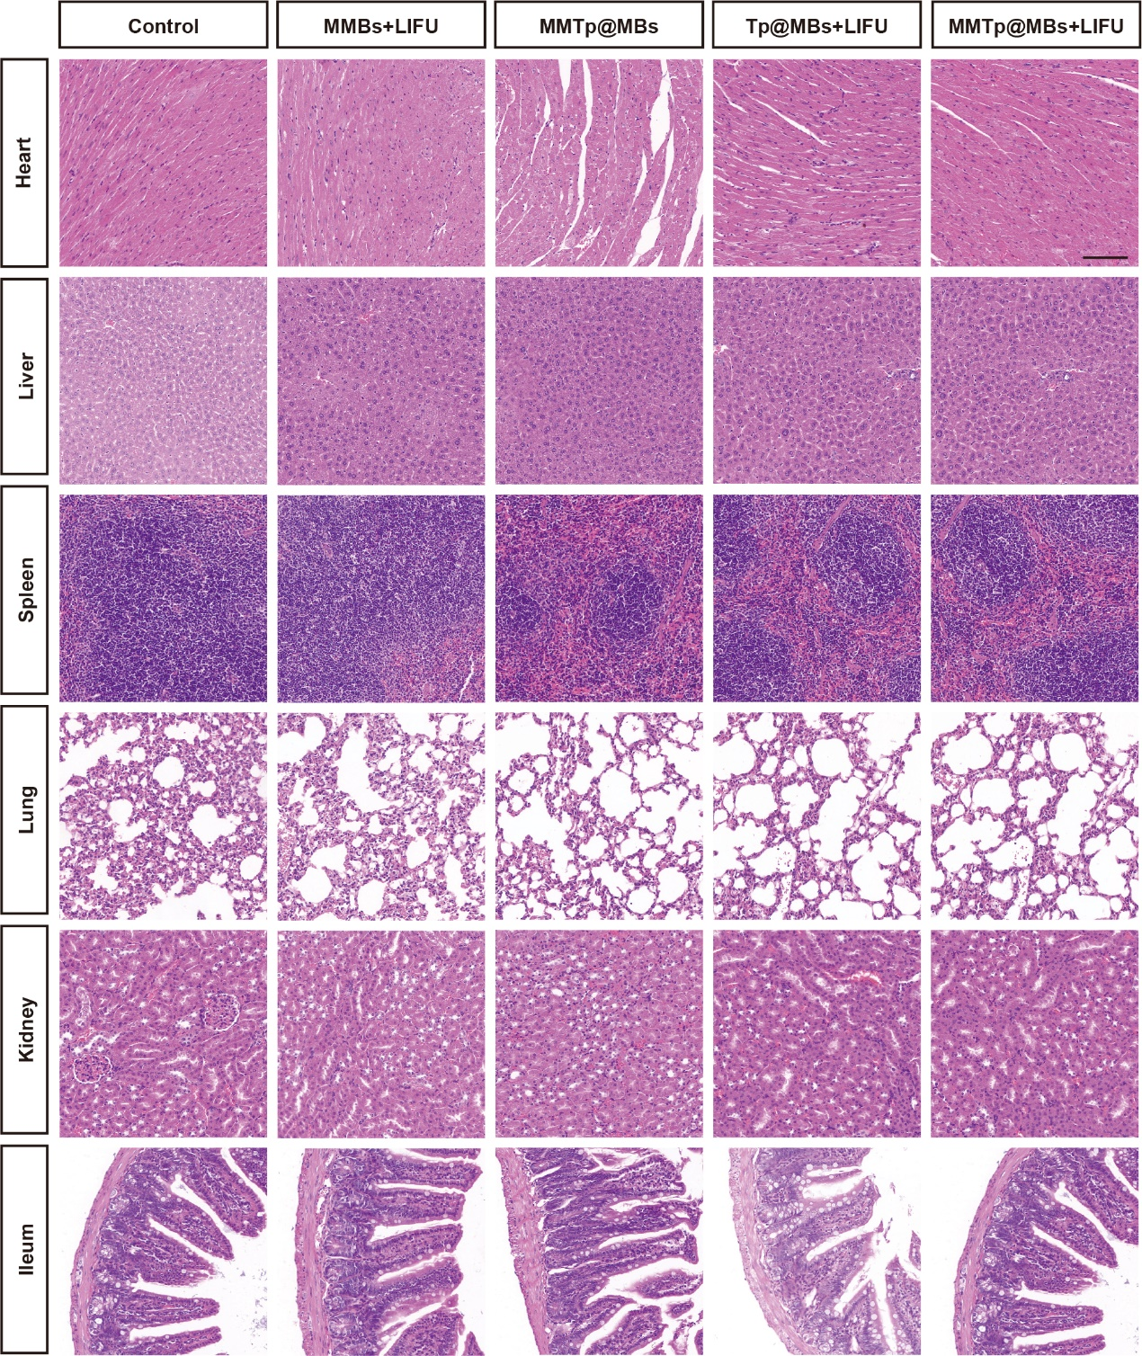
Figure S38. Hematoxylin and eosin (H&E) staining of the heart, liver, spleen, lung, kidney, and small intestine from mice in different treatment groups after 28 days. Scale bars are 100 μm.

Figure S39. The routine blood analysis of mice in different treatment groups after 28 days of treatment (n=5).

Figure S40. The blood biochemical analysis of mice in different treatment groups after 28 days of treatment (n=5).

