Additional file
Additional file 1. Online questionnaire used to assess the effect of different types of warning labels on emerging adult’s perceived healthfulness and purchasing intentions of energy drinks.
-------------------------------------------Welcome screen--------------------------------------------------
The study starts with a welcome screen followed by an information sheet. Participants are requested to provide their informed consent to participate through an online form before entering the questionnaire.
---------------------------------------------First section------------------------------------------------------
Below you will find a series of images of energy drinks.
We will ask you to look at each one and answer a few simple questions.

The four energy drink cans corresponding to the experimental group to which the participant was randomly assigned by the software are monadically presented in a balanced order following a Williams’ Latin square design.

Would you buy this drink?
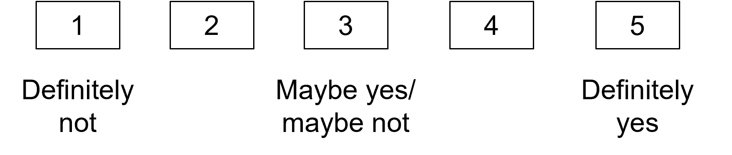
--------------------------------------------Second section---------------------------------------------------
Next, we will show you the images of energy drinks again.
We will ask you to observe each of them and to answer a series of questions about the effects they might have.

What effects could consuming this beverage have on you? Mark all the options that you consider applicable

The four energy drink cans corresponding to the experimental group to which the participant was randomly assigned by the software are monadically presented in a balanced order following a Williams’ Latin square design.

Increased concentration
Fatigue reduction
Increased energy
Improvement in athletic performance
Improvement in academic performance
Tachycardia
Insomnia
Anxiety
No effect

How would you rate the health effects of this drink?
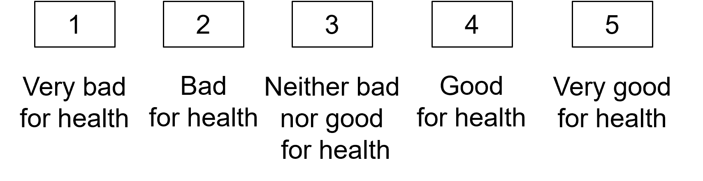
--------------------------------------------Third section---------------------------------------------------
Do you remember having seen this message on the cans you evaluated?

This section does not apply to participants assigned to the control experimental group. The remaining participants are presented with the warning corresponding to the intervention group to which they were randomly assigned by the software.

Yes
No

Did you take it into account when answering the questions? (only for those answering “”yes in the previous question)
Yes
No

What do you think about the message?

-------------------------------------------------Forth section-------------------------------------------------
Which of the following messages do you think would be most effective in discouraging the consumption of energy drinks?
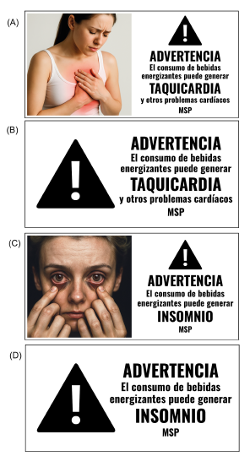

A
B
C
D

Why?

-------------------------------------------------Fifth section-------------------------------------------------
Before finishing, we will ask you to answer a series of simple questions to characterize the people participating in the study.

What is your gender?
Woman
Trans woman
Male

Trans man
Other
I prefer not to answer

How old are you?

What is your highest level of education completed?
Incomplete secondary school or less
Complete secondary school
Technical studies
Incomplete University
Complete University
Postgraduate studies

Are you currently studying a university degree or a non-university tertiary qualification?
Yes
No

Are you currently employed?
Yes
No

Which department do you live in?
(Select from a list including the 19 departments of Uruguay)

Do you consume energy drinks (e.g. Monster, Red Bull, Speed, Burn, Rock Star, Dark Dog)?
Yes
No

How old were you when you first consumed energy drinks (even if it was just a few sips)?

How often do you consume energy drinks?
1 or more times a day
1 to 6 times a week
1 to 3 times a month
Less than once a month

What brand of energy drinks do you usually consume?
Monster
Red Bull
Speed
Baly
Rock Star
Dark Dog

Another one

Do you usually consume energy drinks with or without sugar?
I usually consume sugary energy drinks
I usually consume sugar-free energy drinks

How risky do you think it is to consume energy drinks?
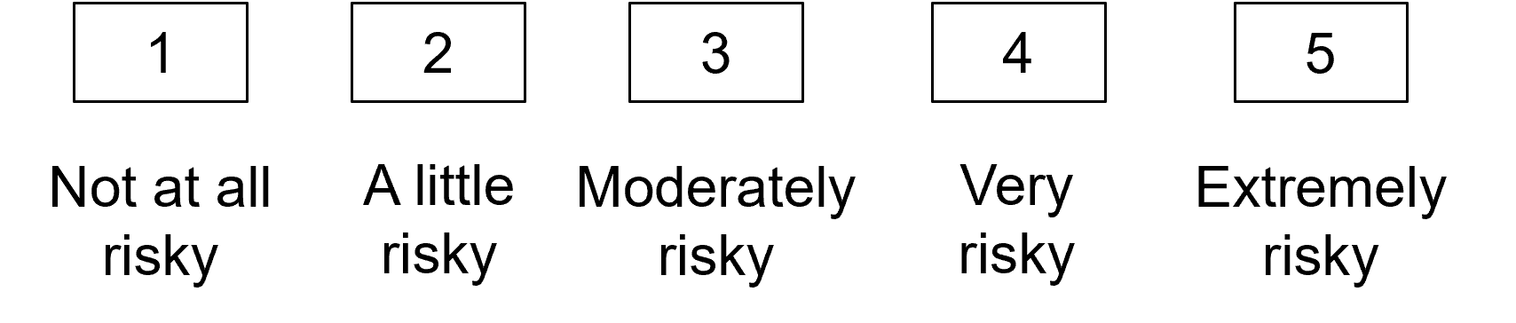
-------------------------------------------------Final screen-------------------------------------------------
Participants are thanked for their time

