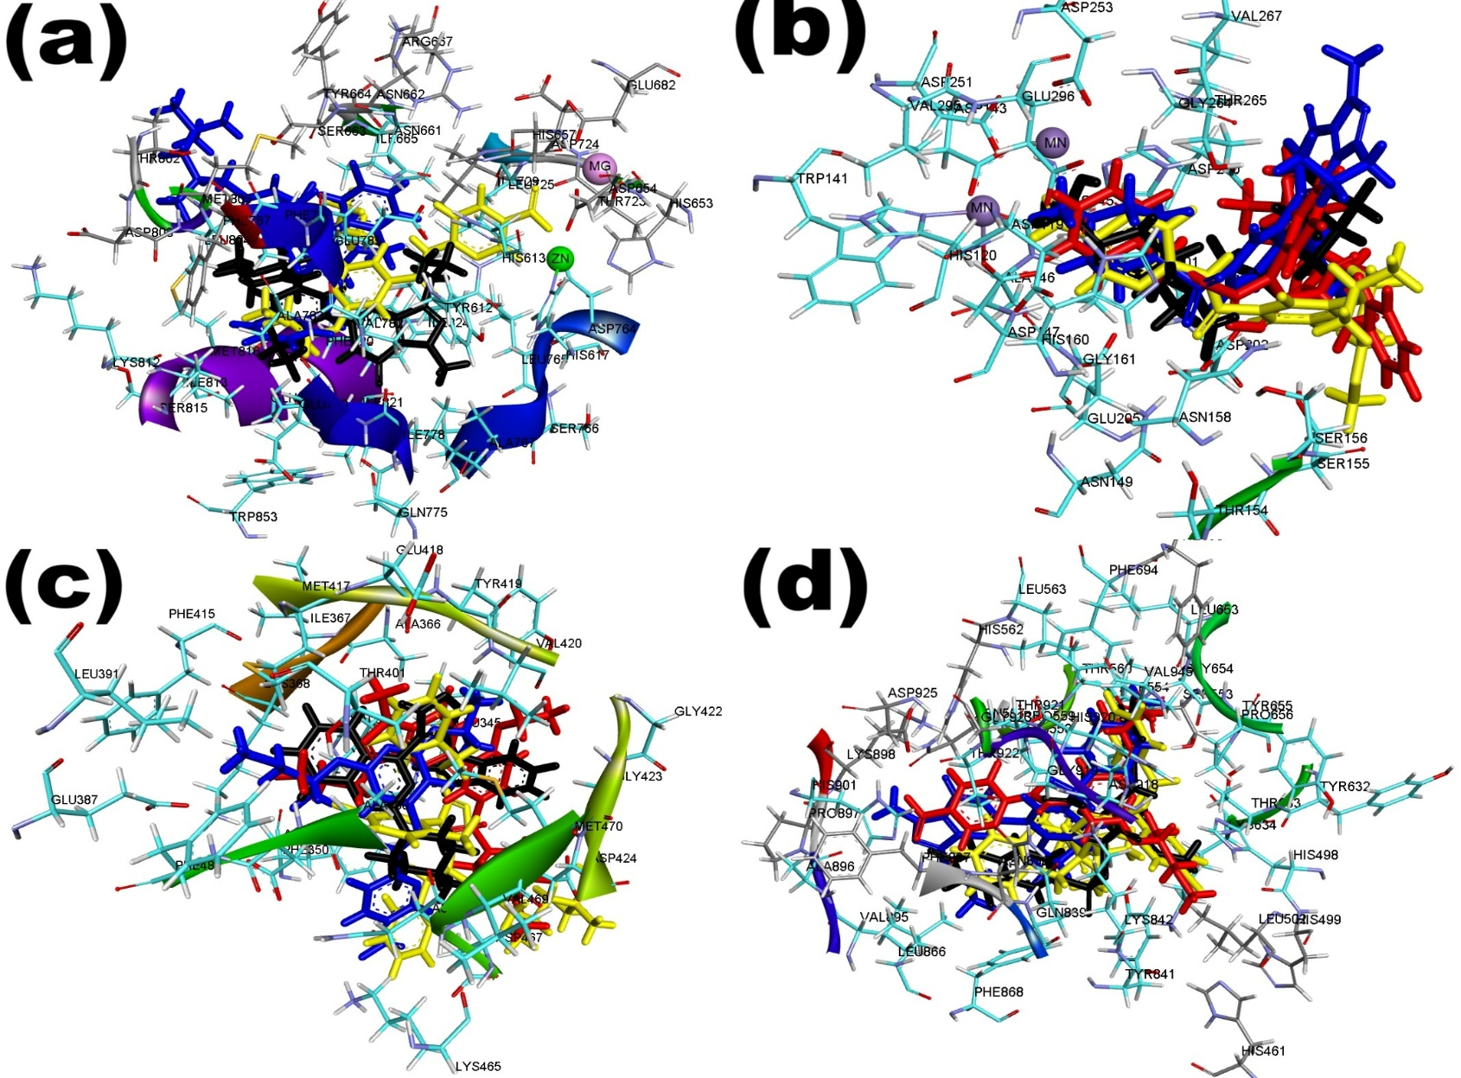
Figure S1: Superimposed structure of docked top-ranked compounds from ZINCPharmer pharmacophore search and sildenafil (standard drug) within the catalytic amino acid residues of (a) PDE-5 (b) arginase (c) PKC (d) O-GlcNAc on their native inhibitor (black). All had the same RMSD value of 0.5 Å
Table S1: Color codes of the compounds used in the docking validation
Compounds | PDE-5 |  | arginase |  | PKC | O-GlcNAc
6-[[2-(1-methoxypropan-2-yloxy)-6-propan-2-yloxypyridine-4-carbonyl]amino]pyridine-3-carboxylic acid (Compound 1) | Yellow | Yellow |  | Blue |  | Red
N-[1-[5-benzylsulfanyl-4-(5-chloro-2-methylphenyl)-1,2,4-triazol-3-yl]-2-phenylethyl]-3,5,5-trimethylhexanamide (Compound 4) | Blue | Red |  | Yellow |  | Yellow
Sildenafil (Standard drug) | Black | Blue |  | Red |  | Blue
Native ligand | - | Black |  | Black |  | Black

Table S2: Docking scores of the top-ranked compounds from ZINCPharmer pharmacophore search erectile dysfunction targets
Target | Compound | Docking score (kcal/mol) | MM-GBSA (kcal/mol)
PDE-5 (2H42) | 6-[[2-(1-methoxypropan-2-yloxy)-6-propan-2-yloxypyridine-4-carbonyl]amino]pyridine-3-carboxylic acid (Compound 1) | -9.06 | 17.79
PDE-5 (2H42) | 2-dihydroxyphosphanyloxyethyl dihydrogen phosphite (Compound 2) | -3.64 | 22.75
PDE-5 (2H42) | (2E,4E)-5-[4-(dibutylamino)phenyl]penta-2,4-dienoic acid (Compound 3) | -8.15 | 11.90
PDE-5 (2H42) | N-[1-[5-benzylsulfanyl-4-(5-chloro-2-methylphenyl)-1,2,4-triazol-3-yl]-2-phenylethyl]-3,5,5-trimethylhexanamide (Compound 4) | -9.11 | -55.98
Arginase (4I06) | 6-[[2-(1-methoxypropan-2-yloxy)-6-propan-2-yloxypyridine-4-carbonyl]amino]pyridine-3-carboxylic acid (Compound 1) | -4.10 | -3.63
Arginase (4I06) | 2-dihydroxyphosphanyloxyethyl dihydrogen phosphite (Compound 2) | -5.39 | -2.31
Arginase (4I06) | (2E,4E)-5-[4-(dibutylamino)phenyl]penta-2,4-dienoic acid (Compound 3) | -2.92 | 0.25
Arginase (4I06) | N-[1-[5-benzylsulfanyl-4-(5-chloro-2-methylphenyl)-1,2,4-triazol-3-yl]-2-phenylethyl]-3,5,5-trimethylhexanamide (Compound 4) | -3.78 | 15.75
PKC (3IW4) | 6-[[2-(1-methoxypropan-2-yloxy)-6-propan-2-yloxypyridine-4-carbonyl]amino]pyridine-3-carboxylic acid (Compound 1) | -5.73 | -34.58
PKC (3IW4) | 2-dihydroxyphosphanyloxyethyl dihydrogen phosphite (Compound 2) | -2.91 | -18.88
PKC (3IW4) | (2E,4E)-5-[4-(dibutylamino)phenyl]penta-2,4-dienoic acid (Compound 3) | -5.53 | -21.49
PKC (3IW4) | N-[1-[5-benzylsulfanyl-4-(5-chloro-2-methylphenyl)-1,2,4-triazol-3-yl]-2-phenylethyl]-3,5,5-trimethylhexanamide (Compound 4) | -5.74 | -52.13
O-GlcNAc (6MA5) | 6-[[2-(1-methoxypropan-2-yloxy)-6-propan-2-yloxypyridine-4-carbonyl]amino]pyridine-3-carboxylic acid (Compound 1) | -4.87 | -14.82
O-GlcNAc (6MA5) | 2-dihydroxyphosphanyloxyethyl dihydrogen phosphite (Compound 2) | -2.80 | -23.49
O-GlcNAc (6MA5) | (2E,4E)-5-[4-(dibutylamino)phenyl]penta-2,4-dienoic acid (Compound 3) | -3.36 | -35.22
O-GlcNAc (6MA5) | N-[1-[5-benzylsulfanyl-4-(5-chloro-2-methylphenyl)-1,2,4-triazol-3-yl]-2-phenylethyl]-3,5,5-trimethylhexanamide (Compound 4) | -5.01 | -45.41

