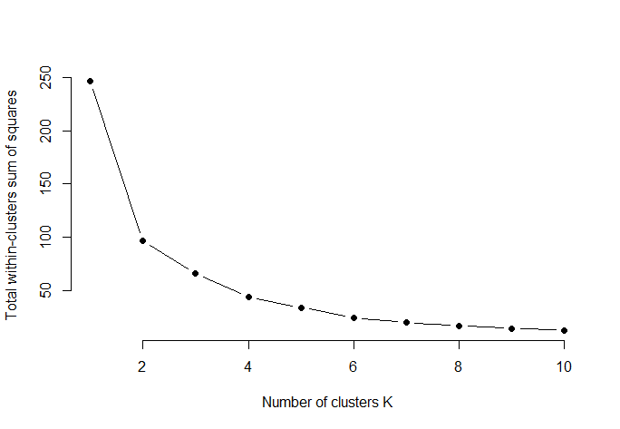
Supplemental Figures
Fig. S1 Optimal number of clusters for k-means clustering using the Elbow method.
The plot shows the total within-cluster sum of squares (WSS) as a function of the number of clusters (k).

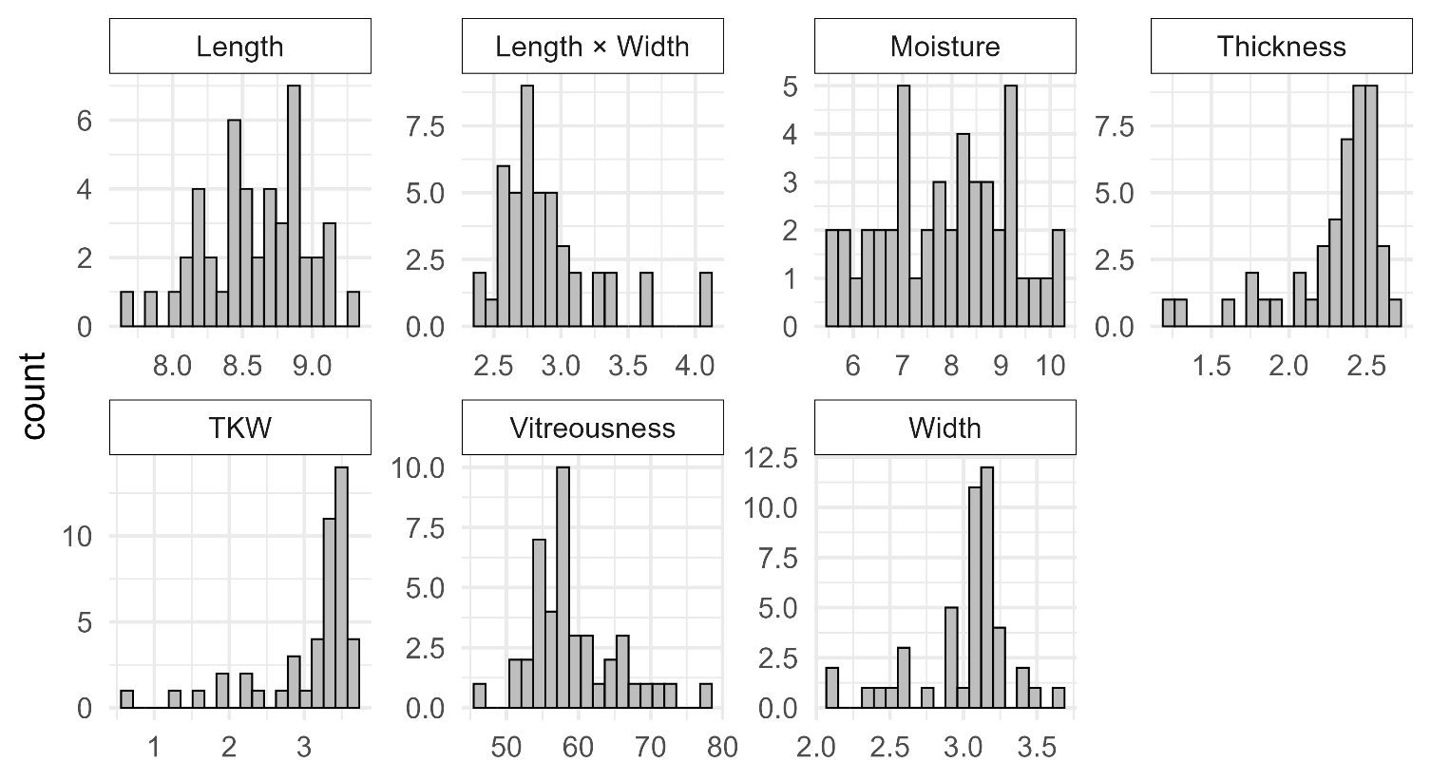
Fig. S2 Frequency distributions of barley quality traits.
The x-axis represents the measured value of each trait, and the y-axis indicates the sample count (frequency).

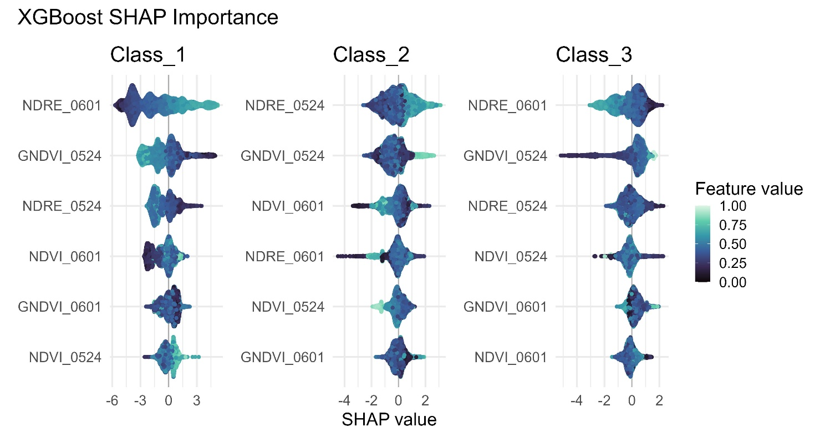
Fig. S3 SHAP summary plots illustrating feature importance for the XGBoost model across growth levels.
The panels correspond to growth levels of 0, 1, and 2. The features are ranked by their importance on the y-axis. The x-axis represents the SHAP value, which indicates the effect of each feature on the prediction probability of the model. The color gradient denotes the magnitude of the feature value, where lighter colors (green/yellow) represent higher values, and darker colors (purple/blue) represent lower values.

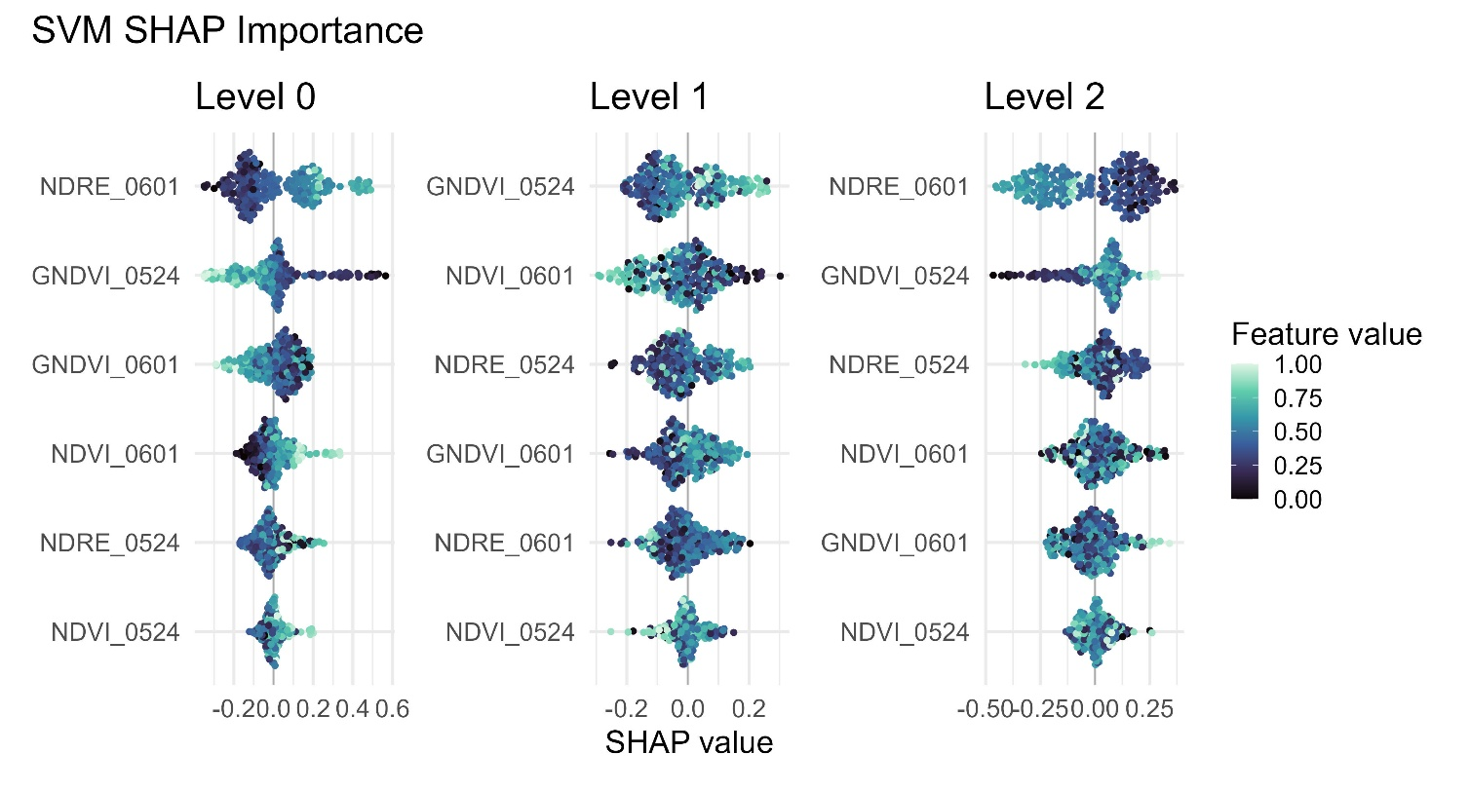
Fig. S4 SHAP summary plots illustrating feature importance for the SVM model across growth levels.
The panels correspond to growth levels of 0, 1, and 2. The features are ranked by their importance on the y-axis. The x-axis represents the SHAP value, which indicates the effect of each feature on the prediction probability of the model. The color gradient denotes the magnitude of the feature value, where lighter colors (green/yellow) represent higher values, and darker colors (purple/blue) represent lower values.

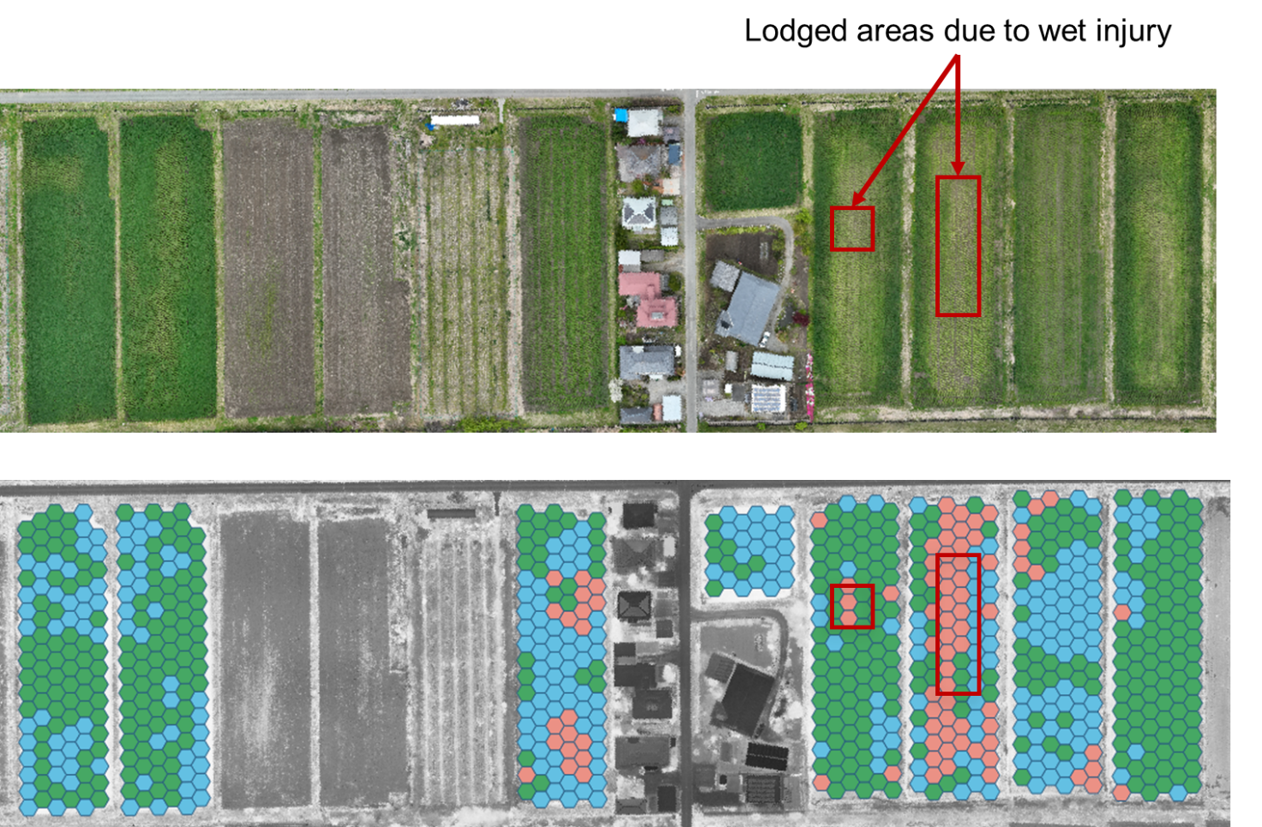
Fig. S5 Visual verification of model predictions against actual lodging areas.
The upper panel shows a true-colored aerial image of the experimental field acquired on April 23. The red frames indicate the areas where lodging caused by wet injury was visually confirmed. The lower panel shows the corresponding spatial distribution of the growth levels estimated by the RF model.

