Supplementary Table 1 Values of cloth insulation (I_{CL})
Ensemble/Garment | Insulation((I_{CL})(Clo)  1.0 Clo= 0.16 ºC.m²/Watt
T-shirt (Short sleeves) | 0.09
Socks | 0.02
Sandals | 0.02
Shoes | 0.04
Scarf | 0.02
Long sleeved shirt | 0.25
Dress | 0.33
Skirt | 0.19
Pants (thin) | 0.15
Pants (thick) Jeans | 0.24
Shorts | 0.08
Vest | 0.13
Boots | 0.10
Coveralls | 0.49
Cap/Hat | 0.01
Arabian gulf ensembles (Male) + Turban  (Massar) | 1.7
Arabian gulf ensembles (Male) + Cap | 1.50
Arabian gulf ensembles (Female) | 1.90
Indian ensembles (Male) | 1.40
Indian ensembles (Female) | 1.20
Pakistani ensembles (Male) | 1.30
Pakistani ensembles (Female) | 1.20
Underwear foreign (Male) | 0.03
Underwear foreign (Female) | 0.04

Supplementary Table 2 The comfort PET ranges in different climate zones in summer season.
City, Country | Climatic zone | Comfort range PET (°C) | Reference
Muscat, Oman | BWh  (Hot arid climate) | 23.6 -30.8 | This study
Cairo, Egypt | BWh  (Hot arid climate) | 23.0 – 32.0 | Elnabawi et al. (2016)
Ahvaz, Iran | BWh  (Hot arid climate) | 19.6 – 30.9 | Nasrollahi et al. (2021)
Isfahan, Iran | BWk  (Arid, desert, with cold winter climate) | 23 – 29.7 | Nasrollahi et al. (2017)
Dhaka, Bangladesh | Aw  (Tropical savanna climate) | 29.5 – 32.5 | Sharmin et al. (2019)
Safidon, India | BSh  (Hot semi-arid climate) | 26.0 – 36.4 | Kumar and Sharma (2022)
Tehran, Iran | BWk  (Arid, desert, with cold winter climate) | 22.1-28.0 | Hadianpour et al. (2018)
Turkey, Konya | BSk  (Cold semi-arid climate) | 21.6 – 32.0 | Canan et al. (2019)
Rome, Italy | Csa  (Hot -summer Mediterranean climate climate) | 21.1 – 29.2 | Salata et al. (2016)

Supplementary Figure 1. Anthropometric information of respondents in the survey

Supplementary Figure 2. Distribution of thermal sensation votes in vegetated and non-vegetated area

Supplementary Figure 3. Hourly mean variation in the physiological equivalent temperature (PET)°C in vegetated and non-vegetated area

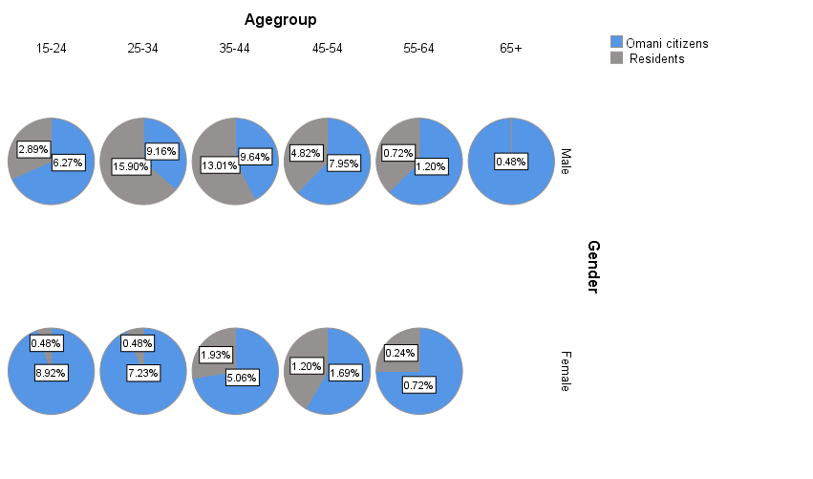
Supplementary Figure 1.

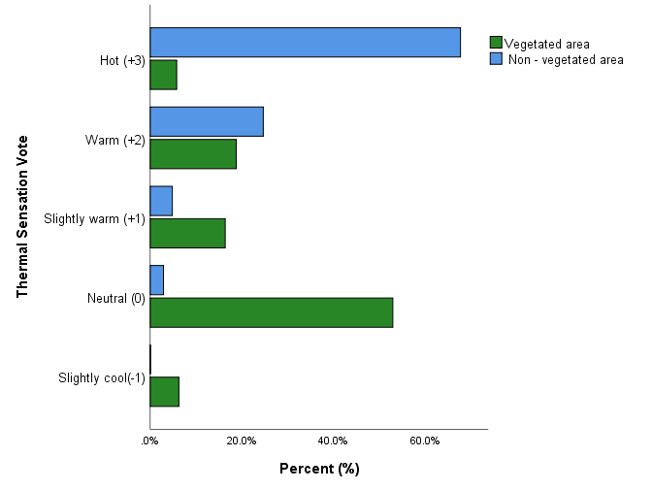
Supplementary Figure 2.

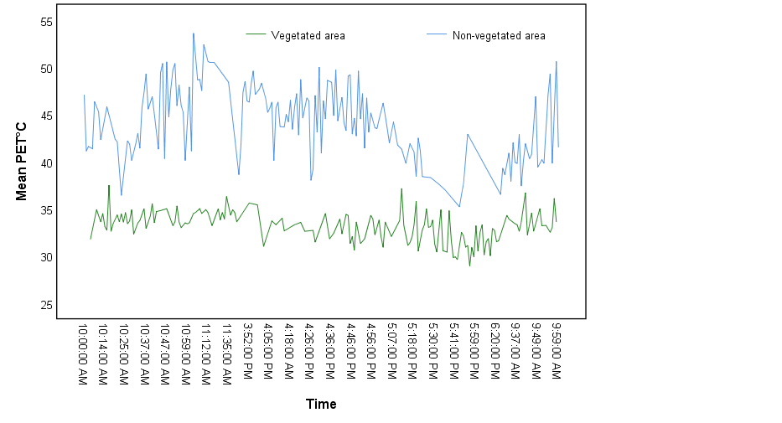
Supplementary Figure 3.

Supplementary file. Survey questionnaire used for data collection.
Outdoor Thermal Comfort Questionnaire
Dear Participants,
This survey aims to assess the outdoor thermal comfort of subjects and the preference to the microclimate conditions in urban spaces. The results from this study will be important for the country and also decision makers and urban planners.
May I request kind assistance to answer this questionnaire for the much-needed data. Your time and efforts are highly appreciated. (Notice: To complete filling this questionnaire it takes less than 10 minutes)
Date: _________________ Time: ______________ Location: _____________
First part
Demographic and personal information
Age: __________________ Weight: _______________Height: _______________
- What is your gender?
a. Male b. Female
- How long have you lived in Oman (Muscat governorate)?
a. More than six months b. Less than six months
3. What is your citizenship?
a. Omani b. non-Omani
4. How old are you?
a. 15-24 b. 25-34 c. 35-44 d. 45-54 e. 55-64 f. 65-74 g. 75+
5. What was your activity level in the past 30 minutes prior to the survey?
a. Reclining b. Sleeping c. Seating (chatting-playing mobile phone, reading, writing, etc.)
d. Standing (chatting-playing mobile phone, enjoy scenery, etc.)
e. Light activity (look after children, brisk walking, etc.)
f. Medium activity (house cleaning, Jogging, etc.)
g. High activity (running, doing exercise, cycling, etc.)
6. What is your activity level at this moment?
a. Sitting
b. Standing
- (For Men) Please check each item of clothing that you are wearing now
a. Dishdasha or thowb b. Sandals c. Shoes
d. Mussar (type of turban) e. Cap or Kuma or hat f. T-shirt
g. Socks h. Jeans i. Jacket
j. Sweater k. Shalwar (Pants) l. Shalwar kameez (shirt)
m. Bananian (vest) n. Coveralls o. Boots
p. Trouser q. Short r. Long-sleeved shirt s. Safety helmet
Other specify……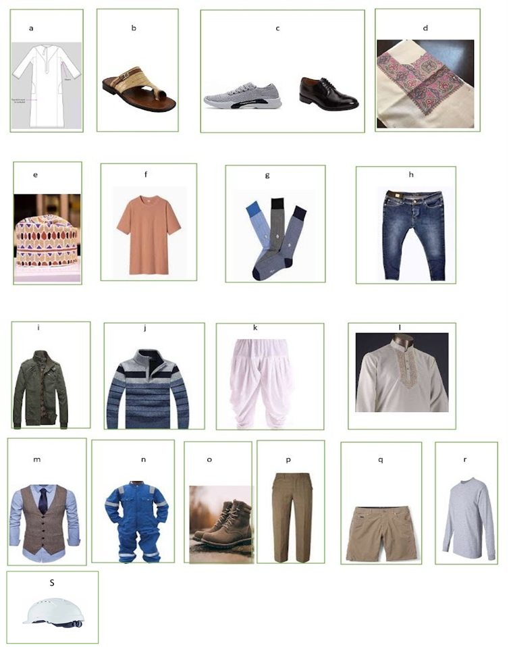

8- (For Women) Please check each item of clothing that you are wearing now
a. Darra (Dishdasha) b. Abaya c. Scarf (Shiala) d. Trousers
e. Jeans f. jacket g. Sandals h. Shoes
i. Boots j. Socks k. T-shirt l. Sweater
m. Skirt n. Dress o. Shalwar (Pants) p. Shalwar kameez (shirt)
q. Churidhar pants r. Churidhar dress s. Saree t. Long-sleeved shirt
Other specify…

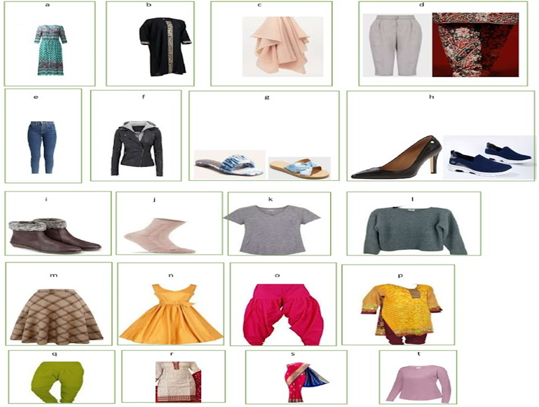
Second part
Thermal sensation and preference towards meteorological elements

9. What is your general thermal sensation at this moment?
a. Cold (-3) b. Cool (-2) c. Slightly cool ( -1) d. Neutral (0)
e. Slightly warm (+1) f. Warm (+2) g. Hot (+3)
10. What is your preference in regard to the air temperature?
a. Cooler (-1) b. Unchanged (0) c. Warmer (+1)
11. What is your preference in regard to the Relative humidity?
a. Drier (-1) b. Unchanged (0) c. Damper (+1)
12. What is your preference in regard to the wind speed?
a. Weaker (-1) b. Unchanged (0) c. Stronger (+1)
13. What is your preference in regard to the solar radiation?
a. Weaker (-1) b. Unchanged (0) c. Stronger (+1)
14. Please describe your overall comfort level
a. Uncomfortable (-1) b. Acceptable (0) c. Comfortable (+1)

**Thanks for your time and effort **

