Supplemental Figures
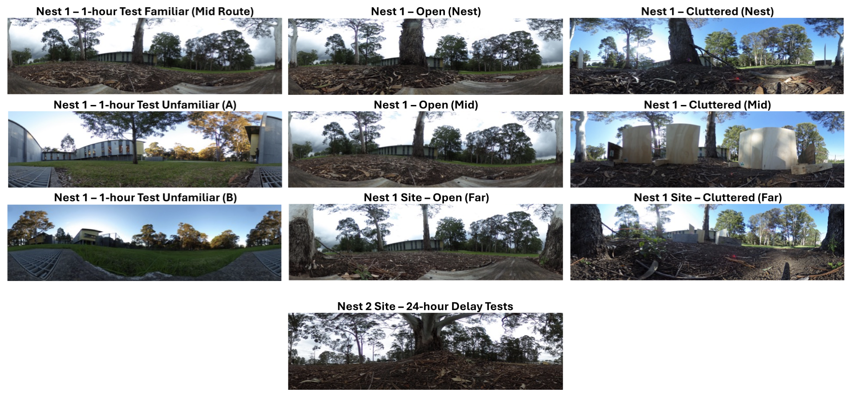

Supplemental Figure S1. 360º Panoramic images of all testing sites used across the three experiments. All panoramas at familiar sites are oriented to have the nest (and nest tree) centred. At the two unfamiliar sites, the panorama orientation is centred on the compass direction of the inbound route to the nest. All nest 1 and 2 panoramas are in the same compass direction (foraging tree to nest).

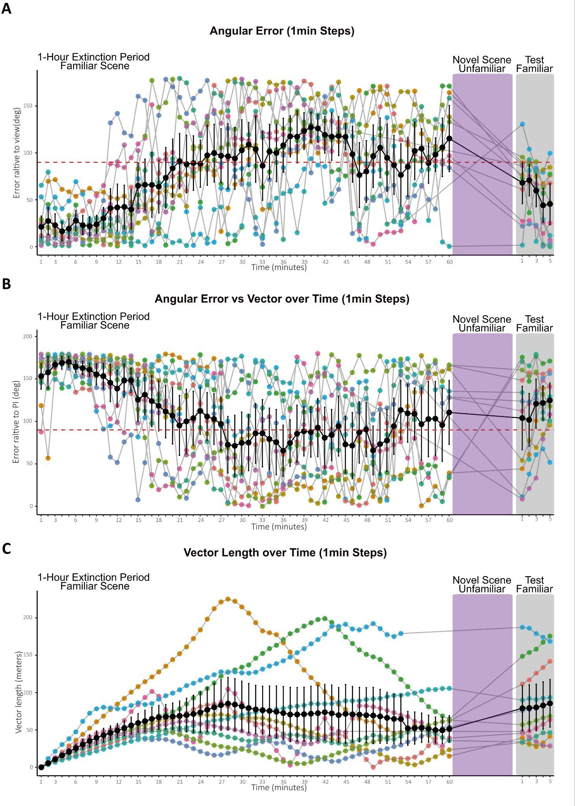
Supplemental Figure S2. Fine-scale 1min steps in heading error relative to nest-aligned views and the path integrator (PI) over 1h extinction at the familiar site. (A) Angular Error vs the nest. Foragers were initially well-oriented toward the nest-aligned direction, but orientation accuracy deteriorated over the 1-hour extinction period at the familiar site. Following a 5-minute exposure to an unfamiliar scene (purple), foragers were returned to the familiar scene for a 5-minute test (grey), resulting in a partial recovery of nest alignment. (B) Angular Error vs the PI direction (accumulated on trackball). Despite accumulating long PI vectors (>50m, see panel C) during the 1-hour exposure (C), foragers showed no significant group-level orientation toward the PI vector during the extinction period, the novel scene exposure (purple), or the final test (grey). (C) Vector Length. PI vector distance did not decrease during the unfamiliar scene exposure (see grey lines in purple box). This indicates that the observed recovery of nest-aligned orientation was view-memory based reevaluation rather than caused by foragers "running down" their PI memory during the 5-minute interval at the unfamiliar site. Black line, mean. Bars, SE. The red-dotted line denotes the orientation threshold.

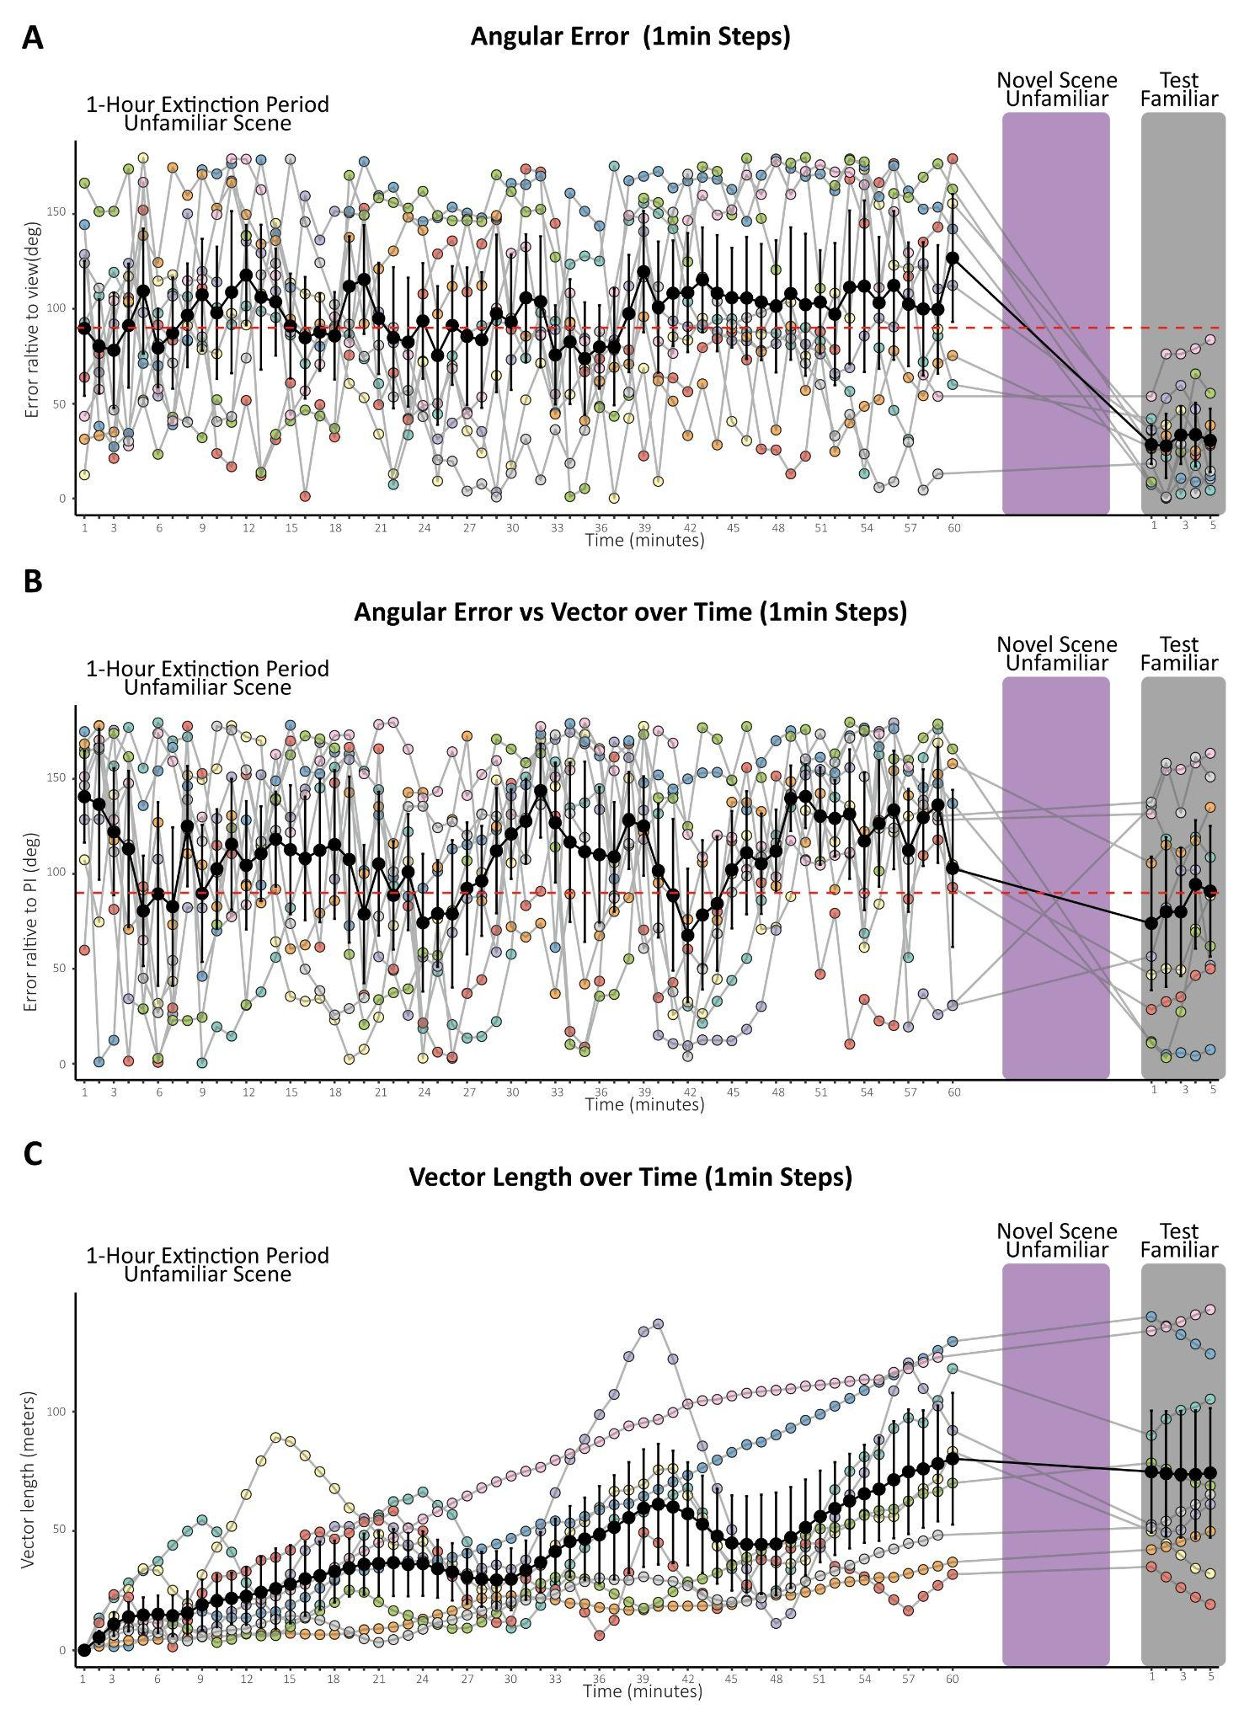
Supplemental Figure S3. Heading error relative to nest-aligned views and the Path Integrator (PI) in 1-minute increments during a 1-hour exposure to an unfamiliar site. (A) Angular Error vs Nest Compass Direction. Foragers showed no orientation to the nest compass at the unfamiliar sites (A and B), but immediately oriented to the nest-aligned view upon transfer to the familiar route (grey). This confirms sustained motivation. (B) PI Orientation. Foragers exhibited no consistent orientation toward their accumulated PI vector across any phase of the experiment. (C) Vector Length over time. PI vector length increased steadily throughout the 1-hour trackball session. This confirms that the lack of orientation was not due to foragers "running down" their vector, but rather a lack of reliance on the PI in an unfamiliar context.
Black line, mean. Bars, SE. The red-dotted line denotes the orientation threshold.

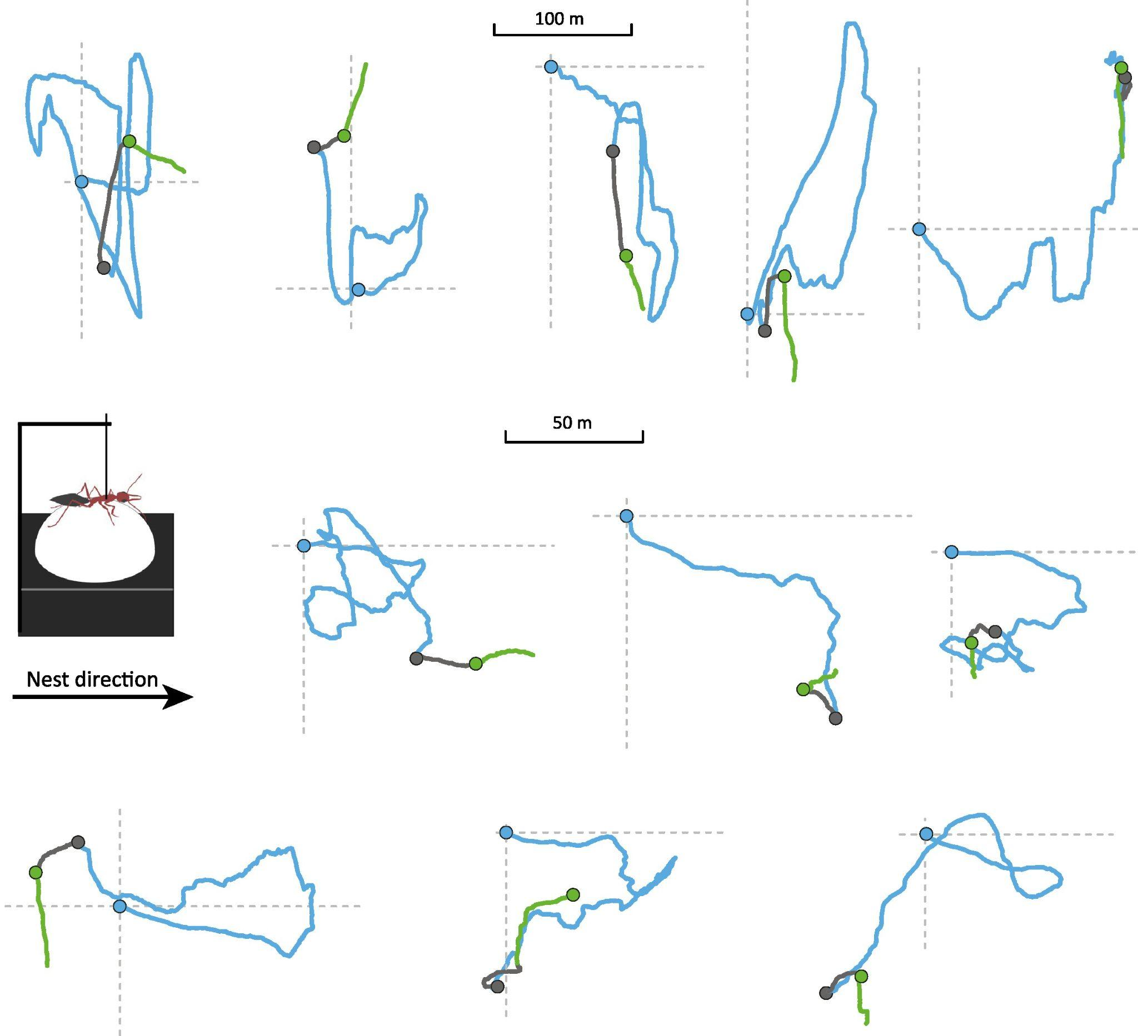
Supplemental Figure S4. Representative homing paths of tethered individuals in the 1-hour extinction condition at the familiar site. Blue paths indicate initial nest-alignment during the first ~20 minutes of homing following tethering (blue circle represents tethered start on trackball) and the progressive decline of nest-alignment. After one hour, foragers were transported to a distant unfamiliar site (grey dot); grey paths show movement during this 5-minute novel scene exposure period. Finally, individuals were returned to the original extinction site (green dot); green paths show the subsequent 5-minute re-exposure period to the original scene.

