APPENDIX I
Supplementary information to:
Assessment of Metabolites in Sera and Cerebrospinal Fluids of rabies-infected Dogs (Nigeria).

3. Results and discussion
3.2. GCxGC-TOFMS results
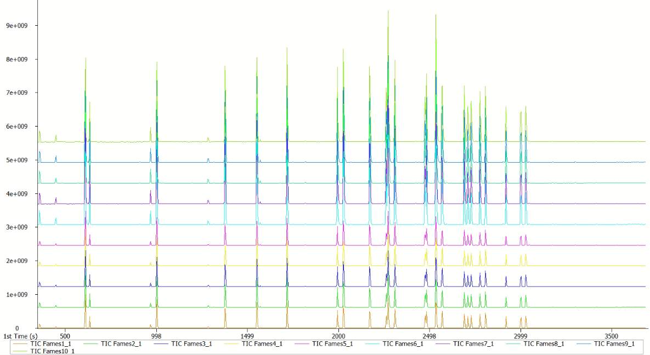
Figure S1: Chromatographic results of the FAMES standard within the analytical serum batches.
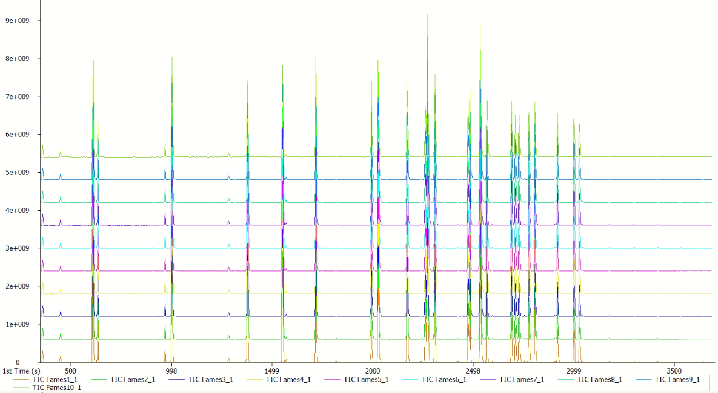
Figure S2: Chromatographic results of the FAMES standard within the analytical CSF batches.

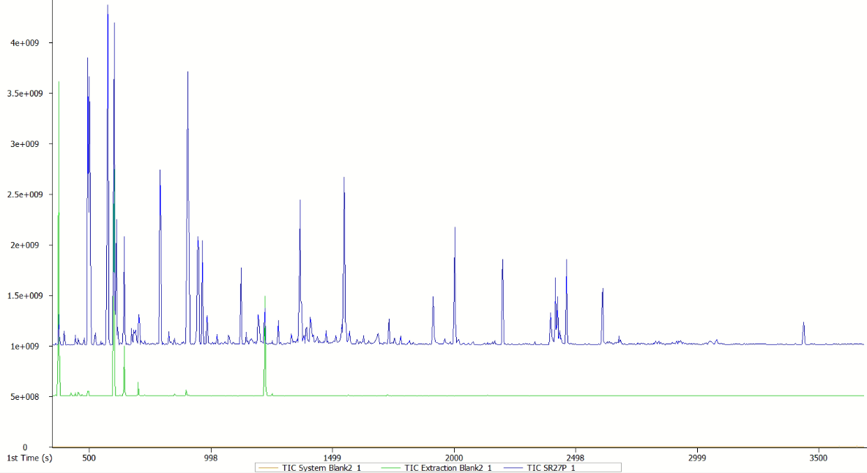
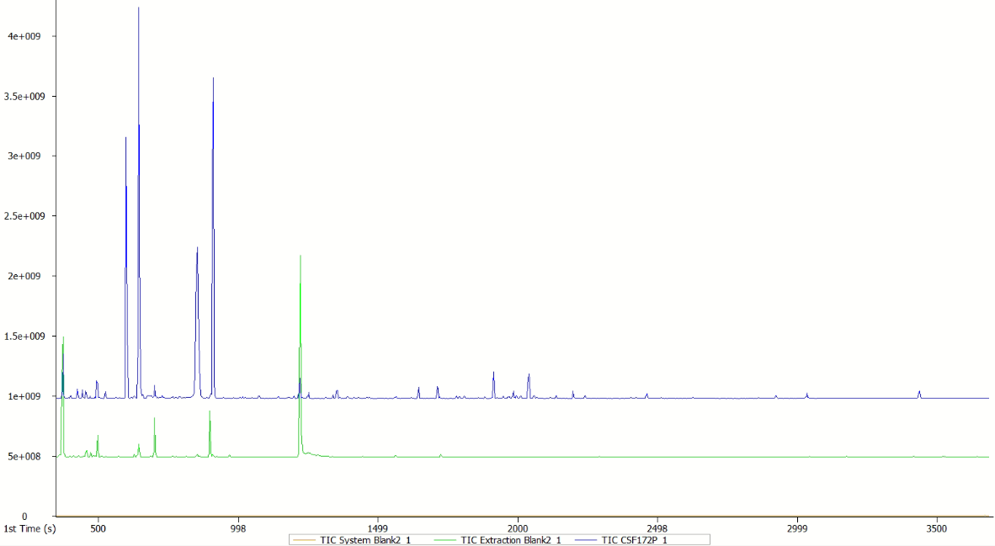
Figure S3: Overlay of the system blank (orange), extraction blank (green) and analytical sample chromatograms for serum (blue, top) and CSF (blue, bottom) batches.

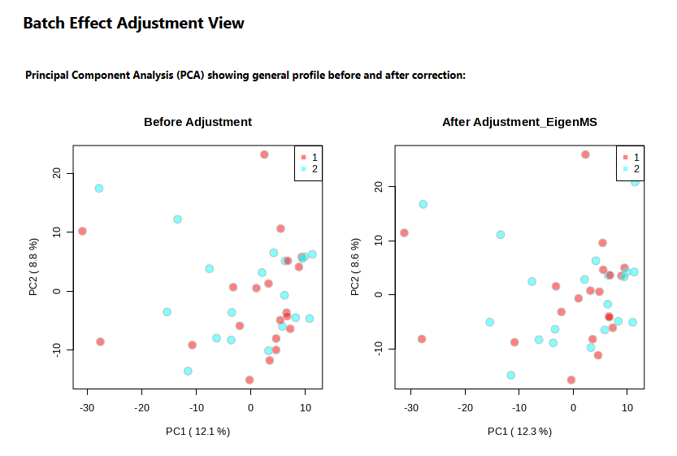
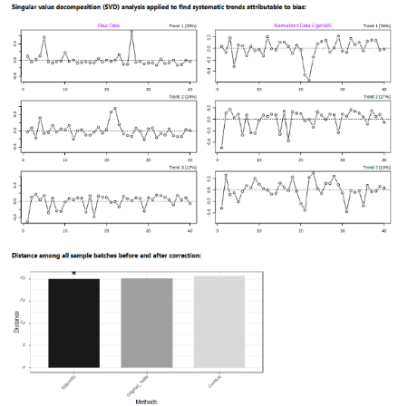
3.3 Data overview
Figure S4: Batch correction plots for the serum metabolite dataset showing variance reduction following EigenMS adjustment.

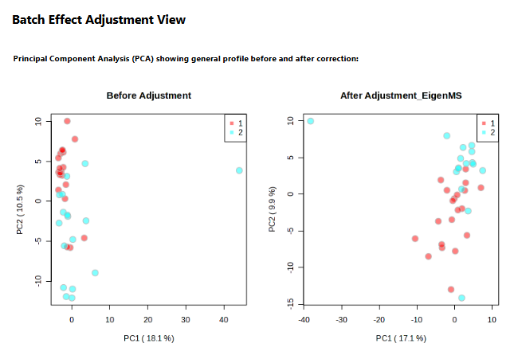
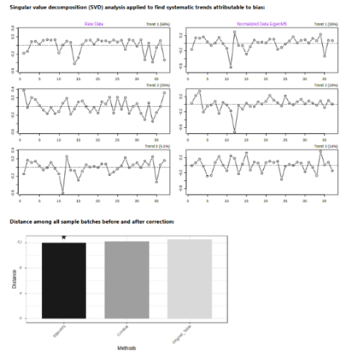
Figure S5: Batch correction plots for the CSF metabolite dataset showing variance reduction following EigenMS adjustment.

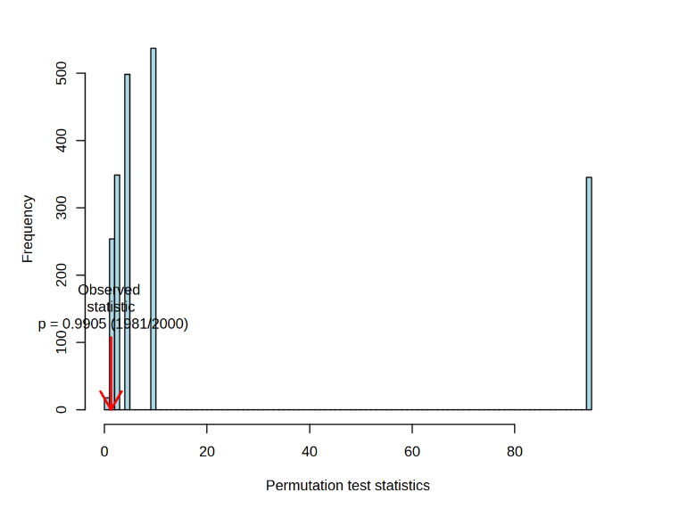
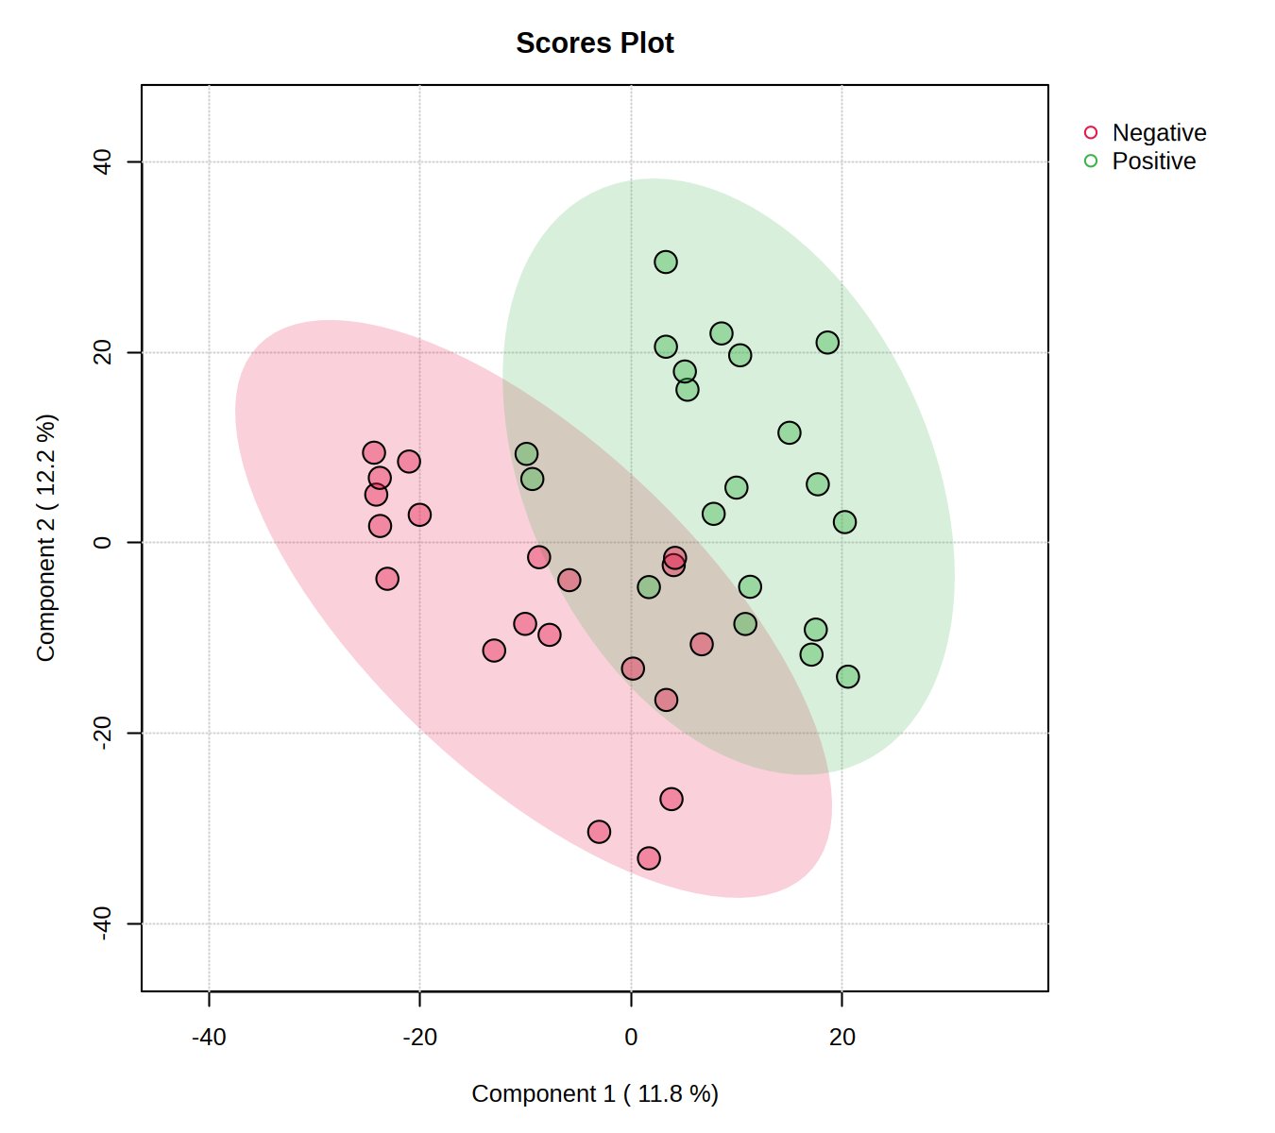
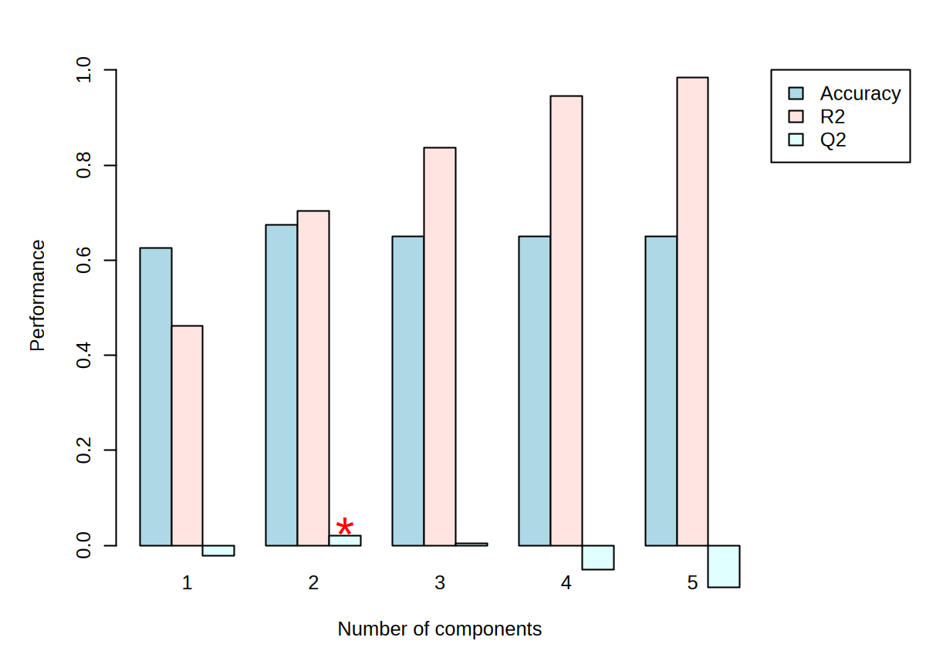
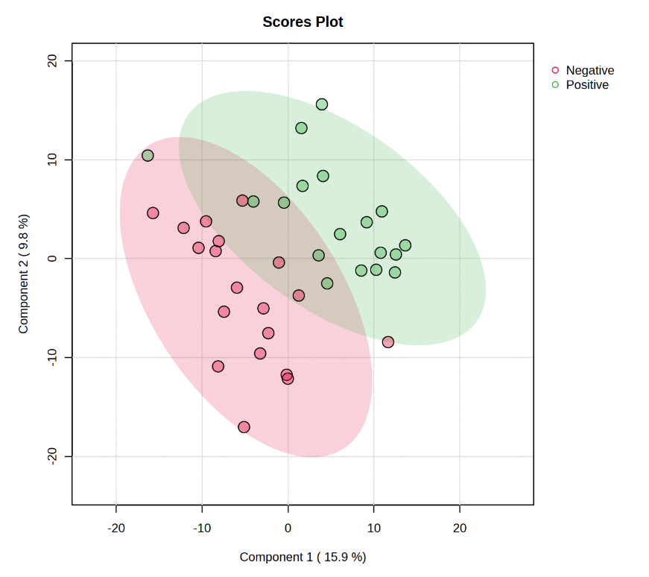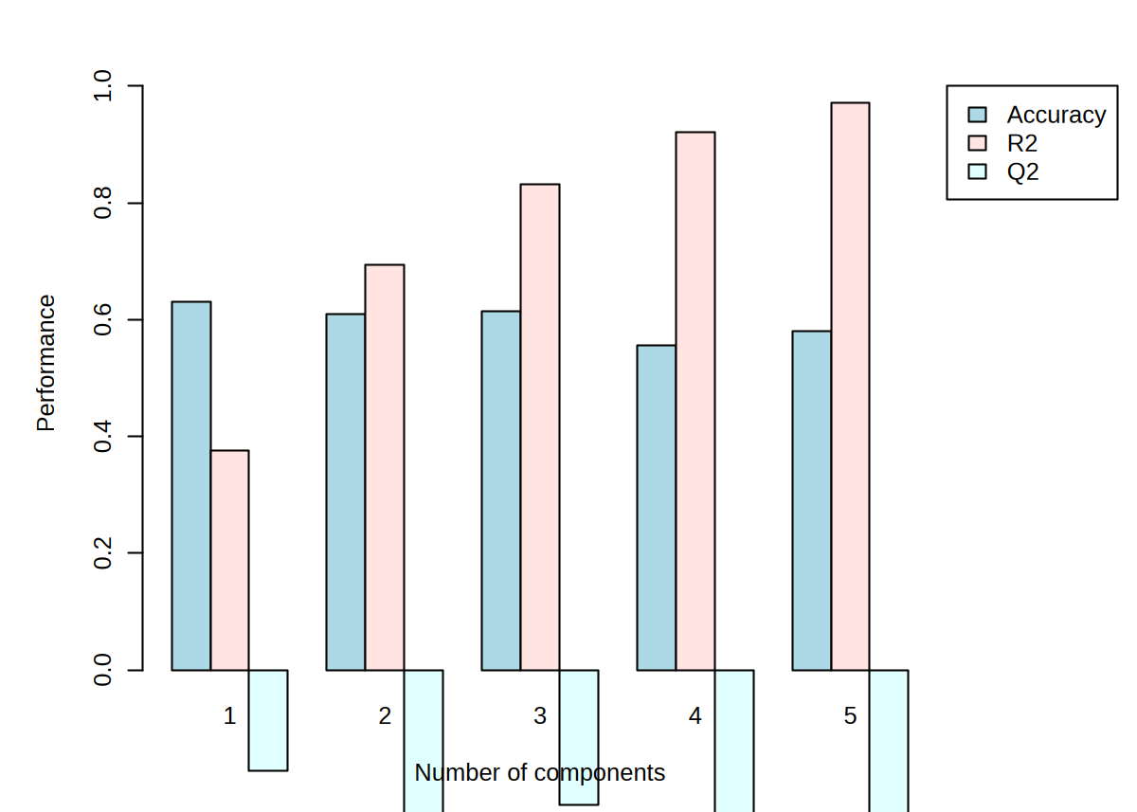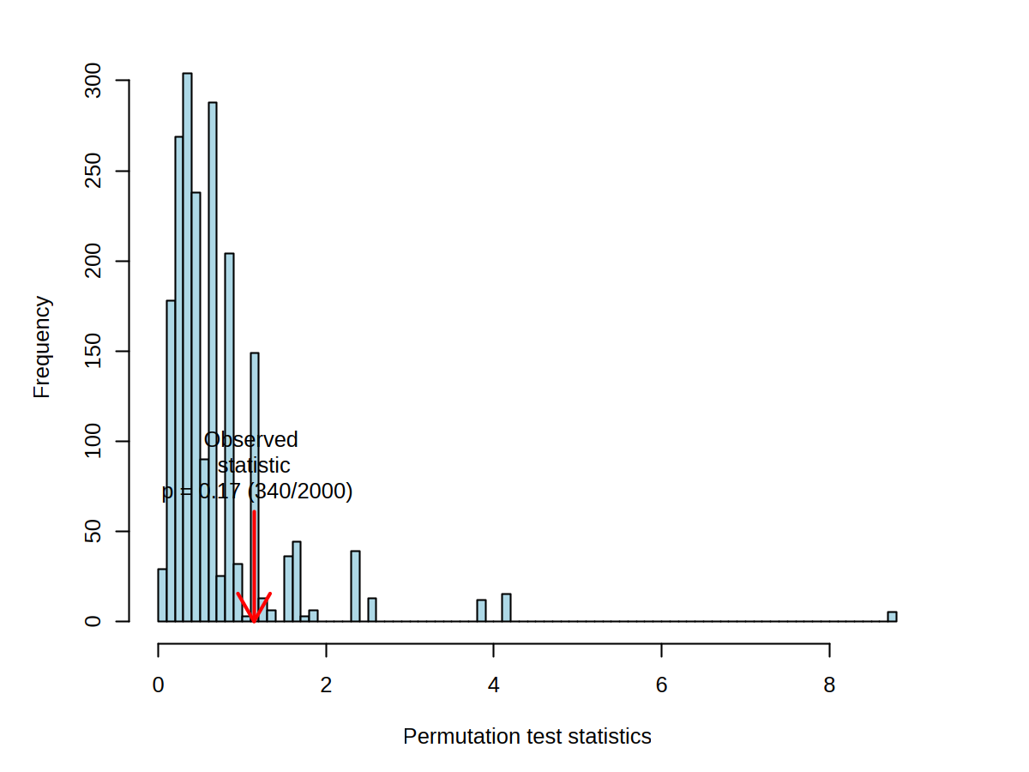
Table S1: Results of univariate analysis for serum metabolites showing differential metabolites based on volcano plot analysis.
Figure S7: Partial least squares discriminant analysis (PLS-DA) of the CSF metabolite dataset with permutation test validation.
Figure S6: Partial least squares discriminant analysis (PLS-DA) of the serum metabolite dataset with permutation test validation.
Peak name | FC | log2(FC) | Raw p value | -log10(p) | FDR
Analyte 634 | 6.5663 | 2.7151 | 7.9103E-07 | 6.1018 | 0.000343
Analyte 706 | 6.4349 | 2.6859 | 0.00017243 | 3.7634 | 0.037418
Glyceric acid | 2.6403 | 1.4007 | 6.1785E-07 | 6.2091 | 0.000343
Benzoic Acid | 0.30796 | -1.6992 | 0.00010426 | 3.9819 | 0.030167
Mandelic acid | 0.174 | -2.5228 | 0.0024086 | 2.6182 | 0.20906
4-Cyanophenol | 0.21303 | -2.2309 | 0.0041049 | 2.3867 | 0.2469
3-Hydroxymandelic acid | 0.34067 | -1.5536 | 0.0079954 | 2.0972 | 0.36413
Uracil | 0.33706 | -1.5689 | 0.011207 | 1.9505 | 0.36413
4-Hydroxybenzoic acid | 0.24474 | -2.0307 | 0.011858 | 1.926 | 0.36413
2-Amino-4-methylpyrimidine | 2.6729 | 1.4184 | 0.012166 | 1.9149 | 0.36413
7-Hydroxyheptanoic acid | 0.411 | -1.2828 | 0.016742 | 1.7762 | 0.4152
3-Butyl-3-methylcyclohex-1-en-1-ol | 0.25617 | -1.9648 | 0.017298 | 1.762 | 0.4152
Pipecolic acid | 0.13966 | -2.84 | 0.017698 | 1.7521 | 0.4152
4-Aminobutanoic acid | 0.11242 | -3.153 | 0.019179 | 1.7172 | 0.42281
3,4-Dimethylbenzoic acid | 0.43836 | -1.1898 | 0.021429 | 1.669 | 0.44246
Pyrrole-2-carboxylic acid | 0.34793 | -1.5231 | 0.022264 | 1.6524 | 0.44246
2-Methylpropane-1,2-diol | 3.222 | 1.688 | 0.023837 | 1.6227 | 0.44246
Indoleacetic acid | 0.25971 | -1.945 | 0.023877 | 1.622 | 0.44246
L-Asparagine | 2.2462 | 1.1675 | 0.023897 | 1.6217 | 0.44246
Indolelactic acid | 0.4696 | -1.0905 | 0.026876 | 1.5706 | 0.44676
Methylsuccinic acid | 0.42023 | -1.2507 | 0.027454 | 1.5614 | 0.44676
2-hydroxy-3-(4-hydroxy-3-methoxyphenyl)propanoic acid | 0.24367 | -2.037 | 0.028308 | 1.5481 | 0.44676
5-Methylpyrimidine-2,4-diol | 0.36208 | -1.4656 | 0.028308 | 1.5481 | 0.44676
Quinaldic acid | 0.18784 | -2.4124 | 0.035874 | 1.4452 | 0.50103
L-Threonine | 3.7202 | 1.8954 | 0.03705 | 1.4312 | 0.50103
D-Xylose* | 0.34366 | -1.541 | 0.037519 | 1.4257 | 0.50103
3-Hydroxyisovaleric acid | 0.15484 | -2.6912 | 0.046586 | 1.3317 | 0.53591
Benzeneacetic acid | 0.25899 | -1.9491 | 0.049649 | 1.3041 | 0.53591
* The identity of sugar-related metabolites is considered tentative, as GC-based analysis can present challenges in resolving and differentiating structurally similar sugars.

Table S2: Pathway analysis results for serum metabolites. The table summarises significantly enriched metabolic pathways identified from differential metabolites identified via volcano plot analysis.
Pathway name  (significant pathways in bold) | Hits/Total Compounds | Hits  (indicated in blue font) | Raw p | -log10(p) | Holm adjust | FDR | Impact
Glycerolipid metabolism | 1/14 | (Triacylglycerol; Acyl-CoA; 1,2-Diacyl-sn-glycerol; Phosphatidate; 1-Acylglycerol; 1-Acyl-sn-glycerol 3-phosphate; sn-Glycerol 3-phosphate; Glycerone; Glycerol; D-Glyceraldehyde; D-Glycerate; Fatty acid; Glycerone phosphate; 2-Phospho-D-glycerate) | 3.06E-06 | 5.5142 | 4.59E-05 | 1.53E-05 | 0.09346
Glyoxylate and dicarboxylate metabolism | 1/31 | (Hydroxypyruvate; cis-Aconitate; 4-Hydroxy-2-oxoglutarate; N-Formylderivatives; Oxygen; Glycolate; Acetyl-CoA; Oxaloacetate; (S)-Malate; (S)-Methylmalonyl-CoA; Propanoyl-CoA; (R)-Methylmalonyl-CoA; L-Serine; Glyoxylate; Glycine; Hydrogen peroxide; L-Glutamate; (2S)-Ethylmalonyl-CoA; D-Glycerate; Acetate; 2-Hydroxy-3-oxopropanoate; Isocitrate; Pyruvate; Formate; Citrate; Acetoacetyl-CoA; Succinyl-CoA; Ammonia; L-Glutamine; (2R)-Ethylmalonyl-CoA; 2-Phospho-D-glycerate) | 3.06E-06 | 5.5142 | 4.59E-05 | 1.53E-05 | 0.06433
Pentose phosphate pathway | 1/23 | (alpha-D-Glucose 6-phosphate; Deoxyribose; 2-Deoxy-D-ribose 1-phosphate; 2-Deoxy-D-ribose 5-phosphate; D-Ribose 5-phosphate; alpha-D-Ribose 1-phosphate; D-Ribose; D-Glyceraldehyde 3-phosphate; Sedoheptulose 7-phosphate; D-Ribulose 5-phosphate; D-Fructose 6-phosphate; D-Fructose 1,6-bisphosphate; 6-Phospho-D-gluconate; D-Glucono-1,5-lactone 6-phosphate; D-Gluconic acid; D-Glucono-1,5-lactone; D-Glycerate; Sedoheptulose; beta-D-Glucose 6-phosphate; 5-Phospho-alpha-D-ribose 1-diphosphate; D-Xylulose 5-phosphate; D-Erythrose 4-phosphate; 2-Phospho-D-glycerate) | 3.06E-06 | 5.5142 | 4.59E-05 | 1.53E-05 | 0
Glycine, serine and threonine metabolism | 2/34 | (L-Serine; Choline; Betaine aldehyde; Betaine; Guanidinoacetate; 3-Phospho-D-glycerate; N,N-Dimethylglycine; L-Cystathionine; Glycine; O-Phospho-L-serine; Sarcosine; 5,10-Methylenetetrahydrofolate; L-Threonine; Lipoylprotein; Aminoacetone; D-Glycerate; [Protein]-S8-aminomethyldihydrolipoyllysine; Tetrahydrofolate; Dihydrolipoylprotein; 2-Phospho-D-glycerate; D-Serine; Hydroxypyruvate; Creatine; 3-Phosphonooxypyruvate; L-Cysteine; L-Allothreonine; 2-Oxobutanoate; Glyoxylate; L-2-Amino-3-oxobutanoic acid; Pyruvate; CO2; 5-Aminolevulinate; Methylglyoxal; Ammonia) | 0.000597 | 3.224 | 0.007164 | 0.002239 | 0.05061
Alanine, aspartate and glutamate metabolism | 2/27 | (N-Acetyl-L-aspartate; 2-Oxosuccinamate; L-Aspartate; L-Asparagine; N-(L-Arginino)succinate; N6-(1,2-Dicarboxyethyl)-AMP; L-Alanine; Succinate semialdehyde; L-Glutamate; 4-Aminobutanoate; L-Glutamine; Ammonia; 2-Oxoglutaramate; (S)-1-Pyrroline-5-carboxylate; N-Acetylaspartylglutamate; N-Acetylaspartylglutamylglutamate; Citrate; Oxaloacetate; Fumarate; Pyruvate; N-Carbamoyl-L-aspartate; Succinate; 2-Oxoglutarate; Carbamoyl phosphate; D-Glucosamine 6-phosphate; 5-Phosphoribosylamine; beta-Citryl-L-glutamate) | 0.00371 | 2.4307 | 0.040804 | 0.011128 | 0.09677
Valine, leucine and isoleucine biosynthesis | 1/8 | (L-Threonine; (S)-3-Methyl-2-oxopentanoic acid; L-Leucine; 3-Methyl-2-oxobutanoic acid; 2-Oxobutanoate; L-Isoleucine; 4-Methyl-2-oxopentanoate; L-Valine) | 0.004615 | 2.3359 | 0.046146 | 0.011537 | 0
Pyrimidine metabolism | 1/38 | (UDP; L-Glutamine; Carbamoyl phosphate; (S)-Dihydroorotate; Orotidine 5'-phosphate; UMP; UTP; Uridine; 5,6-Dihydrouracil; 3-Ureidopropionate; CTP; CDP; CMP; Cytidine; dCDP; dCMP; dCTP; Deoxycytidine; dUTP; dUDP; dUMP; Deoxyuridine; dTDP; dTTP; dTMP; Thymidine; Thymine; (R)-5,6-Dihydrothymine; (R)-3-Ureidoisobutyrate; P1,P4-Bis(5'-uridyl) tetraphosphate; 2'-Deoxy-5-hydroxymethylcytidine-5'-diphosphate; N-Carbamoyl-L-aspartate; Orotate; 5-Phospho-alpha-D-ribose 1-diphosphate; Uracil; beta-Alanine; (R)-3-Amino-2-methylpropanoate; 2'-Deoxy-5-hydroxymethylcytidine-5'-triphosphate) | 0.009479 | 2.0232 | 0.08531 | 0.015798 | 0.0685
beta-Alanine metabolism | 1/21 | (Propanoyl-CoA; 3-Hydroxypropionyl-CoA; 3-Hydroxypropanoate; Malonyl-CoA; 3-Oxopropanoate; beta-Alanine; L-Aspartate; 1,3-Diaminopropane; 3-Aminopropanal; 3-Ureidopropionate; 5,6-Dihydrouracil; Carnosine; beta-Alanyl-N(pi)-methyl-L-histidine; Spermine; Propenoyl-CoA; Acetyl-CoA; beta-Alanyl-L-arginine; Uracil; beta-Alanyl-L-lysine; L-Histidine; Spermidin) | 0.009479 | 2.0232 | 0.08531 | 0.015798 | 0
Pantothenate and CoA biosynthesis | 1/20 | (Dephospho-CoA; Pantetheine 4'-phosphate; Pantetheine; (R)-4'-Phosphopantothenoyl-L-cysteine; N-((R)-Pantothenoyl)-L-cysteine; Pantothenate; 3-Ureidopropionate; 5,6-Dihydrouracil; L-Valine; L-Aspartate; CoA; Apo-[acyl-carrier protein]; D-4'-Phosphopantothenate; L-Cysteine; 3-Aminopropanal; beta-Alanine; Uracil; 3-Methyl-2-oxobutanoic acid; Acyl-carrier protein; Adenosine 3',5'-bisphosphate) | 0.009479 | 2.0232 | 0.08531 | 0.015798 | 0
Ubiquinone and other terpenoid-quinone biosynthesis | 1/19 | (all-trans-Polyprenyl diphosphate; 4-Hydroxybenzoate; 3-Demethylubiquinol; 3,4-Dihydroxy-5-polyprenylbenzoate; 3-(4-Hydroxyphenyl)pyruvate; L-Tyrosine; 2-Methoxy-6-all-trans-polyprenyl-1,4-benzoquinol; 5-Methoxy-2-methyl-3-(all-trans-polyprenyl)benzene-1,4-diol; Menaquinone; 2,3-Epoxymenaquinone; Phylloquinol; Phylloquinone; Menaquinol; Vitamin K1 epoxide; 4-Hydroxy-3-polyprenylbenzoate; 3-Methoxy-4-hydroxy-5-polyprenylbenzoate; Ubiquinol; Homogentisate; 2-Polyprenyl-6-methoxyphenol) | 0.032486 | 1.4883 | 0.19492 | 0.04873 | 0
Tryptophan metabolism | 1/39 | (L-Tryptophan; Melatonin; N-Acetylserotonin; Serotonin; 5-Hydroxyindoleacetate; 5-Hydroxykynurenamine; 5-Hydroxykynurenine; 5-Hydroxy-L-tryptophan; L-Formylkynurenine; Acetoacetyl-CoA; (S)-3-Hydroxybutanoyl-CoA; Crotonoyl-CoA; Glutaryl-CoA; 2-Oxoadipate; 2-Aminomuconate semialdehyde; 2-Amino-3-carboxymuconate semialdehyde; 3-Hydroxyanthranilate; L-Kynurenine; Formylanthranilate; 3-Hydroxy-L-kynurenine; 3-Hydroxykynurenamine; Indole-3-acetaldehyde; 5-Hydroxy-N-formylkynurenine; 5-Hydroxyindoleacetaldehyde; Tryptamine; Indolepyruvate; Formyl-N-acetyl-5-methoxykynurenamine; 6-Hydroxymelatonin; Formyl-5-hydroxykynurenamine; 5-Methoxyindoleacetate; 4,6-Dihydroxyquinoline; Acetyl-CoA; 2-Aminomuconate; Anthranilate; Cinnavalininate; 4-(2-Amino-3-hydroxyphenyl)-2,4-dioxobutanoate; 4-(2-Aminophenyl)-2,4-dioxobutanoate; 4,8-Dihydroxyquinoline; Indole-3-acetate) | 0.03701 | 1.4317 | 0.19492 | 0.050468 | 0
Arginine and proline metabolism | 1/36 | Guanidinoacetate; Creatine; L-Arginine; L-Ornithine; S-Adenosylmethioninamine; Putrescine; Spermidine; S-Adenosyl-L-methionine; Spermine; 4-Aminobutyraldehyde; 4-Aminobutanoate; N-Acetylputrescine; N4-Acetylaminobutanal; 4-Guanidinobutanoate; N(omega)-Hydroxyarginine; L-1-Pyrroline-3-hydroxy-5-carboxylate; Hydroxyproline; L-Proline; L-4-Hydroxyglutamate semialdehyde; L-Glutamate 5-semialdehyde; L-Glutamate; L-Glutamyl 5-phosphate; Peptide; L-erythro-4-Hydroxyglutamate; (4R)-4-Hydroxy-2-oxoglutarate; D-Proline; trans-3-Hydroxy-L-proline; Phosphocreatine; Agmatine; Homocarnosine; 4-Acetamidobutanoate; Nitric oxide; (S)-1-Pyrroline-5-carboxylate; Glyoxylate; Pyruvate; 1-Pyrroline-2-carboxylate) | 0.048856 | 1.3111 | 0.19542 | 0.056372 | 0.05645
Butanoate metabolism | 1/15 | ((R)-3-Hydroxybutanoate; Acetoacetate; (S)-3-Hydroxy-3-methylglutaryl-CoA; Acetoacetyl-CoA; Acetyl-CoA; (S)-3-Hydroxybutanoyl-CoA; Crotonoyl-CoA; 4-Aminobutanoate; L-Glutamate; Butanoyl-CoA; Succinate semialdehyde; Butanoic acid; 2-Oxoglutarate; Succinate; 2-Hydroxyglutarate) | 0.048856 | 1.3111 | 0.19542 | 0.056372 | 0.03175
Lysine degradation | 1/30 | (L-Lysine; N6-(L-1,3-Dicarboxypropyl)-L-lysine; L-2-Aminoadipate 6-semialdehyde; L-2-Aminoadipate; Thiamin diphosphate; 2-Oxoadipate; 4-Carboxy-1-hydroxybutyryl-ThPP; Enzyme N6-(lipoyl)lysine; [Dihydrolipoyllysine-residue succinyltransferase] S-glutaryldihydrolipoyllysine; Enzyme N6-(dihydrolipoyl)lysine; Glutaryl-CoA; Crotonoyl-CoA; (S)-3-Hydroxybutanoyl-CoA; Acetoacetyl-CoA; L-Hydroxylysine; 5-Phosphooxy-L-lysine; L-Pipecolate; Protein lysine; Protein N6-methyl-L-lysine; Protein N6,N6-dimethyl-L-lysine; N6,N6,N6-Trimethyl-L-lysine; 4-Trimethylammoniobutanal; 4-Trimethylammoniobutanoate; Procollagen 5-hydroxy-L-lysine; Acetyl-CoA; (S)-2,3,4,5-Tetrahydropyridine-2-carboxylate; Protein N6,N6,N6-trimethyl-L-lysine; (3S)-3-Hydroxy-N6,N6,N6-trimethyl-L-lysine; Carnitine; 5-(D-Galactosyloxy)-L-lysine-procollagen) | 0.065153 | 1.1861 | 0.19542 | 0.069807 | 0
Phenylalanine metabolism | 1/10 | Phenylacetaldehyde; L-Phenylalanine; Phenethylamine; Phenylpyruvate; Phenylacetyl-CoA; Phenylacetic acid; 2-Hydroxyphenylacetate; 2-Hydroxy-3-phenylpropenoate; L-Tyrosine; Phenylacetylglycine | 0.19556 | 0.70872 | 0.19556 | 0.19556 | 0

Table S3: Peak descriptors and AUC analysis results for statistically differential serum metabolites.
Peak name | Unique Mass |  | 1st and 2nd dimension retention times (s) | AUC analysis results
Peak name |  |  | 1st and 2nd dimension retention times (s) | AUC | P value | FC | Custers
Analyte 634 |  | 235 | 1487; 2.18 | 0.9575 | 5.61E-08 | 2.7151 | 4
Glyceric acid |  | 189 | 1016; 1.64 | 0.9250 | 3.06E-06 | 1.4007 | 1
Analyte 706 |  | 146 | 1565; 1.68 | 0.8475 | 2.44E-05 | 2.6859 | 4
Benzoic Acid |  | 179 | 848, 2.36 | 0.8425 | 0.000155 | -1.6992 | 5

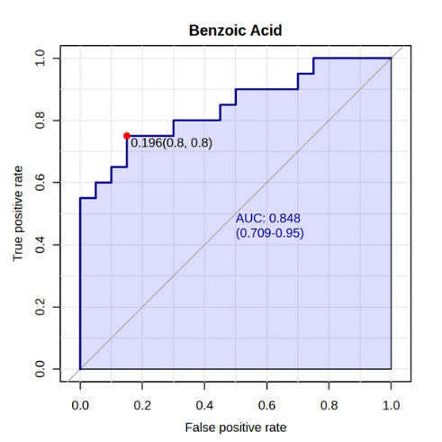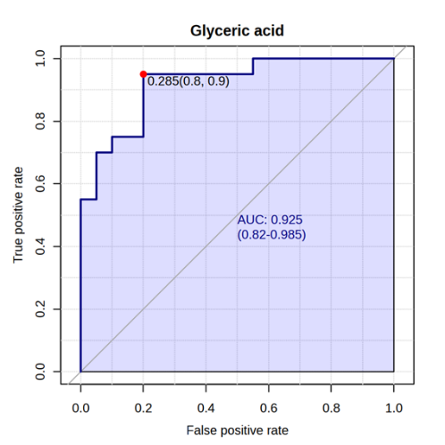
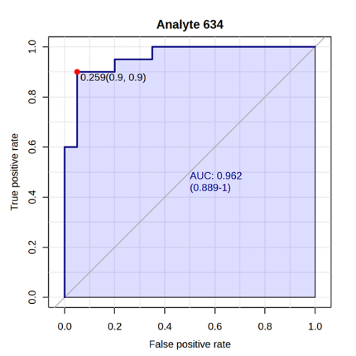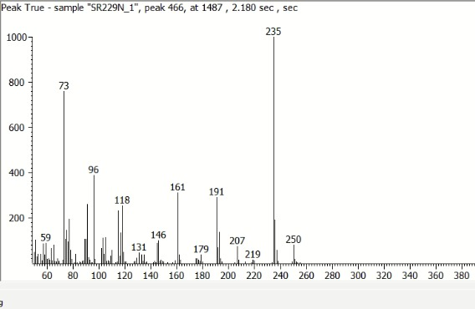
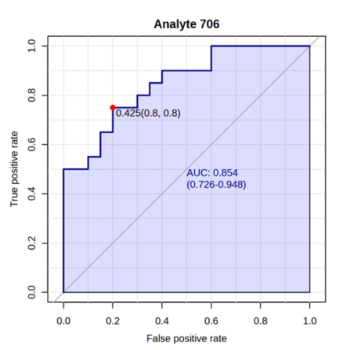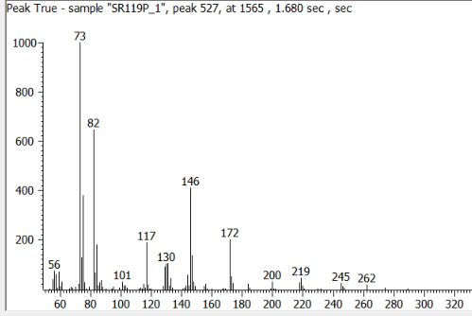
Figure S8: Receiver operating characteristic (ROC) curve analysis for differential metabolites identified in serum and representative mass spectrum for serum unannotated compounds :analyte 634 and analyte 706. The ROC curve displays the diagnostic performance of analyte 706 in distinguishing between the positive and negative groups, with the area under the curve (AUC) indicating overall discriminative ability.

Table S4: Results of univariate analysis for CSF metabolites showing differential metabolites based on volcano plot analysis.
Peak name | FC | log2(FC) | Raw p-value | -log10(p) | FDR
Analyte 369 | 7.1461 | 2.8371 | 0.000011021 | 4.9578 | 0.003306
Sorbose* | 4.3301 | 2.1144 | 0.0020991 | 2.678 | 0.31487
Gluconolactone | 6.197 | 2.6316 | 0.030917 | 1.5098 | 0.61851
Niacin | 0.36791 | -1.4426 | 0.033309 | 1.4774 | 0.61851
Pyroglutamic acid | 2.1642 | 1.1139 | 0.037343 | 1.4278 | 0.61851
Indolelactic acid | 0.13797 | -2.8576 | 0.041825 | 1.3786 | 0.61851
4-Hydroxymandelic acid | 0.40058 | -1.3198 | 0.042822 | 1.3683 | 0.61851
D-Gluconic acid | 5.6287 | 2.4928 | 0.04418 | 1.3548 | 0.61851
2-Methylglycerol | 0.29481 | -1.7621 | 0.047031 | 1.3276 | 0.61851
Methylmalonic acid | 0.17209 | -2.5388 | 0.04777 | 1.3208 | 0.61851
* The identity of sugar-related metabolites is considered tentative, as GC-based analysis can present challenges in resolving and differentiating structurally similar sugars.

Table S5: Pathway analysis results for CSF metabolites. The table summarises significantly enriched metabolic pathways identified from differential metabolites identified via volcano plot analysis.
Pathway name  (significant pathways in bold) | Hits/  Total Compounds | Hits  (indicated in blue font) | Raw p | -log10(p) | Holm adjust | FDR | Impact
Pentose phosphate pathway | 2/23 | alpha-D-Glucose 6-phosphate; Deoxyribose; 2-Deoxy-D-ribose 1-phosphate; 2-Deoxy-D-ribose 5-phosphate; D-Ribose 5-phosphate; alpha-D-Ribose 1-phosphate; D-Ribose; D-Glyceraldehyde 3-phosphate; Sedoheptulose 7-phosphate; D-Ribulose 5-phosphate; D-Fructose 6-phosphate; D-Fructose 1,6-bisphosphate; 6-Phospho-D-gluconate; D-Glucono-1,5-lactone 6-phosphate; D-Gluconic acid; D-Glucono-1,5-lactone; D-Glycerate; Sedoheptulose; beta-D-Glucose 6-phosphate; 5-Phospho-alpha-D-ribose 1-diphosphate; D-Xylulose 5-phosphate; D-Erythrose 4-phosphate; 2-Phospho-D-glycerate | 0.021355 | 1.6705 | 0.2349 | 0.11263 | 0.04185
Glutathione metabolism | 1/28 | R-S-Cysteinylglycine; R-S-Glutathione; Glutathione; NADP+; NADPH; Glutathione disulfide; Glycine; gamma-L-Glutamyl-L-cysteine; L-Cysteine; L-Glutamate; Cys-Gly; 5-Oxoproline; L-Amino acid; (5-L-Glutamyl)-L-amino acid; Acetyl-CoA; S-Substituted L-cysteine; RX; L-Ornithine; Putrescine; Spermidine; Cadaverine; Tryparedoxin; Trypanothione; S-Substituted N-acetyl-L-cysteine; Spermine; Aminopropylcadaverine; Tryparedoxin disulfide; Trypanothione disulfide | 0.049601 | 1.3045 | 0.49601 | 0.11263 | 0.00709
Nicotinate and nicotinamide metabolism | 1/15 | L-Aspartate; Deamino-NAD+; Quinolinate; Nicotinate D-ribonucleoside; Nicotinate D-ribonucleotide; NAD+; Nicotinamide D-ribonucleotide; Nicotinamide-beta-riboside; Nicotinamide; 1-Methylnicotinamide; NADP+; Iminoaspartate; Nicotinate; N1-Methyl-4-pyridone-5-carboxamide; N1-Methyl-2-pyridone-5-carboxamide | 0.069942 | 1.1553 | 0.62948 | 0.11263 | 0.1943
Fatty acid biosynthesis | 1/44 | Tetradecanoyl-[acp]; Hexadecanoyl-[acp]; Malonyl-[acyl-carrier protein]; Dodecanoyl-[acyl-carrier protein]; Decanoyl-[acp]; Octanoyl-[acp]; Hexanoyl-[acp]; Butyryl-[acp]; trans-Hexadec-2-enoyl-[acp]; (3R)-3-Hydroxypalmitoyl-[acyl-carrier protein]; 3-Oxohexadecanoyl-[acp]; trans-Tetradec-2-enoyl-[acp]; (3R)-3-Hydroxytetradecanoyl-[acyl-carrier protein]; 3-Oxotetradecanoyl-[acp]; trans-Dodec-2-enoyl-[acp]; (3R)-3-Hydroxydodecanoyl-[acyl-carrier protein]; 3-Oxododecanoyl-[acp]; trans-Dec-2-enoyl-[acp]; (3R)-3-Hydroxydecanoyl-[acyl-carrier protein]; 3-Oxodecanoyl-[acp]; trans-Oct-2-enoyl-[acp]; (3R)-3-Hydroxyoctanoyl-[acyl-carrier protein]; 3-Oxooctanoyl-[acp]; trans-Hex-2-enoyl-[acp]; (3R)-3-Hydroxyhexanoyl-[acyl-carrier protein]; 3-Oxohexanoyl-[acp]; But-2-enoyl-[acyl-carrier protein]; (3R)-3-Hydroxybutanoyl-[acyl-carrier protein]; Acetyl-[acyl-carrier protein]; Acyl-carrier protein; Malonyl-CoA; Acetyl-CoA; Hexadecanoic acid; Malonate; Acyl-[acyl-carrier protein]; Long-chain fatty acid; (3R)-3-Hydroxyacyl-[acyl-carrier protein]; trans-2,3-Dehydroacyl-[acyl-carrier protein]; 3-Oxoacyl-[acyl-carrier protein]; Tetradecanoic acid; 3-Oxostearoyl-[acp]; Acetoacetyl-[acp]; Palmitoyl-CoA; Long-chain acyl-CoA | 0.088041 | 1.0553 | 0.70433 | 0.11263 | 0
Phenylalanine, tyrosine and tryptophan biosynthesis | ¼ | Phenylpyruvate; L-Phenylalanine; L-Tyrosine; 3-(4-Hydroxyphenyl)pyruvate | 0.090026 | 1.0456 | 0.70433 | 0.11263 | 0.5
Tyrosine metabolism | 1/42 | L-Dopachrome; L-Normetanephrine; 3-Methoxy-4-hydroxyphenylglycolaldehyde; L-Noradrenaline; L-Adrenaline; 3,4-Dihydroxymandelate; 3,4-Dihydroxymandelaldehyde; 3,4-Dihydroxyphenylethyleneglycol; L-Metanephrine; Dopamine; 3,4-Dihydroxyphenylacetaldehyde; 3,4-Dihydroxyphenylacetate; 3-Methoxy-4-hydroxyphenylacetaldehyde; 3-Methoxytyramine; 3,4-Dihydroxy-L-phenylalanine; 3,5-Diiodo-L-tyrosine; 3-Iodo-L-tyrosine; L-Tyrosine; 3-Fumarylpyruvate; 4-Fumarylacetoacetate; 4-Maleylacetoacetate; Homogentisate; 3-(4-Hydroxyphenyl)pyruvate; 4-Hydroxyphenylacetaldehyde; Tyramine; 5,6-Dihydroxyindole; Gentisate aldehyde; 5,6-Dihydroxyindole-2-carboxylate; 3-Methoxy-4-hydroxymandelate; 3-Methoxy-4-hydroxyphenylethyleneglycol; Homovanillate; Triiodothyronine; Pyruvate; Fumarate; Acetoacetate; 2-Hydroxy-3-(4-hydroxyphenyl)propenoate; 4-Hydroxyphenylacetate; Indole-5,6-quinone; Dopaquinone; Thyroxine; 2,5-Dihydroxybenzoate; 5,6-Indolequinone-2-carboxylic acid | 0.090026 | 1.0456 | 0.70433 | 0.11263 | 0.13972
Ubiquinone and other terpenoid-quinone biosynthesis | 1/19 | all-trans-Polyprenyl diphosphate; 4-Hydroxybenzoate; 3-Demethylubiquinol; 3,4-Dihydroxy-5-polyprenylbenzoate; 3-(4-Hydroxyphenyl)pyruvate; L-Tyrosine; 2-Methoxy-6-all-trans-polyprenyl-1,4-benzoquinol; 5-Methoxy-2-methyl-3-(all-trans-polyprenyl)benzene-1,4-diol; Menaquinone; 2,3-Epoxymenaquinone; Phylloquinol; Phylloquinone; Menaquinol; Vitamin K1 epoxide; 4-Hydroxy-3-polyprenylbenzoate; 3-Methoxy-4-hydroxy-5-polyprenylbenzoate; Ubiquinol; Homogentisate; 2-Polyprenyl-6-methoxyphenol | 0.090026 | 1.0456 | 0.70433 | 0.11263 | 0
Phenylalanine metabolism | 1/10 | Phenylacetaldehyde; L-Phenylalanine; Phenethylamine; Phenylpyruvate; Phenylacetyl-CoA; Phenylacetic acid; 2-Hydroxyphenylacetate; 2-Hydroxy-3-phenylpropenoate; L-Tyrosine; Phenylacetylglycine | 0.090026 | 1.0456 | 0.70433 | 0.11263 | 0
Valine, leucine and isoleucine degradation | 1/40 | Enzyme N6-(lipoyl)lysine; 2-Methyl-1-hydroxybutyl-ThPP; Enzyme N6-(dihydrolipoyl)lysine; 2-Methyl-1-hydroxypropyl-ThPP; 3-Methyl-1-hydroxybutyl-ThPP; Acetyl-CoA; Acetoacetyl-CoA; Acetoacetate; (S)-3-Hydroxy-3-methylglutaryl-CoA; 3-Methylcrotonyl-CoA; 3-Methylbutanoyl-CoA; (S)-3-Methyl-2-oxopentanoic acid; Thiamin diphosphate; L-Valine; 2-Methylacetoacetyl-CoA; 2-Methylbut-2-enoyl-CoA; 2-Methylpropanoyl-CoA; [Dihydrolipoyllysine-residue (2-methylpropanoyl)transferase] S-(2-methylbutanoyl)dihydrolipoyllysine; 3-Methyl-2-oxobutanoic acid; L-Isoleucine; (R)-Methylmalonyl-CoA; (S)-Methylmalonyl-CoA; Propanoyl-CoA; (S)-Methylmalonate semialdehyde; 2-Methyl-3-oxopropanoate; L-3-Aminoisobutanoate; (2S,3S)-3-Hydroxy-2-methylbutanoyl-CoA; (S)-3-Hydroxyisobutyrate; (S)-3-Hydroxyisobutyryl-CoA; 2-Methylprop-2-enoyl-CoA; (S)-2-Methylbutanoyl-CoA; [Dihydrolipoyllysine-residue (2-methylpropanoyl)transferase] S-(2-methylpropanoyl)dihydrolipoyllysine; 4-Methyl-2-oxopentanoate; [Dihydrolipoyllysine-residue (2-methylpropanoyl)transferase] S-(3-methylbutanoyl)dihydrolipoyllysine; L-Leucine; Methylmalonate; (R)-3-Amino-2-methylpropanoate; 3-Methylglutaconyl-CoA; 3-Hydroxyisovaleryl-CoA; Succinyl-CoA | 0.095476 | 1.0201 | 0.70433 | 0.11263 | 0.02264
Tryptophan metabolism | 1/39 | L-Tryptophan; Melatonin; N-Acetylserotonin; Serotonin; 5-Hydroxyindoleacetate; 5-Hydroxykynurenamine; 5-Hydroxykynurenine; 5-Hydroxy-L-tryptophan; L-Formylkynurenine; Acetoacetyl-CoA; (S)-3-Hydroxybutanoyl-CoA; Crotonoyl-CoA; Glutaryl-CoA; 2-Oxoadipate; 2-Aminomuconate semialdehyde; 2-Amino-3-carboxymuconate semialdehyde; 3-Hydroxyanthranilate; L-Kynurenine; Formylanthranilate; 3-Hydroxy-L-kynurenine; 3-Hydroxykynurenamine; Indole-3-acetaldehyde; 5-Hydroxy-N-formylkynurenine; 5-Hydroxyindoleacetaldehyde; Tryptamine; Indolepyruvate; Formyl-N-acetyl-5-methoxykynurenamine; 6-Hydroxymelatonin; Formyl-5-hydroxykynurenamine; 5-Methoxyindoleacetate; 4,6-Dihydroxyquinoline; Acetyl-CoA; 2-Aminomuconate; Anthranilate; Cinnavalininate; 4-(2-Amino-3-hydroxyphenyl)-2,4-dioxobutanoate; 4-(2-Aminophenyl)-2,4-dioxobutanoate; 4,8-Dihydroxyquinoline; Indole-3-acetate | 0.11134 | 0.95335 | 0.70433 | 0.11263 | 0
Lysine degradation | 1/30 | L-Lysine; N6-(L-1,3-Dicarboxypropyl)-L-lysine; L-2-Aminoadipate 6-semialdehyde; L-2-Aminoadipate; Thiamin diphosphate; 2-Oxoadipate; 4-Carboxy-1-hydroxybutyryl-ThPP; Enzyme N6-(lipoyl)lysine; [Dihydrolipoyllysine-residue succinyltransferase] S-glutaryldihydrolipoyllysine; Enzyme N6-(dihydrolipoyl)lysine; Glutaryl-CoA; Crotonoyl-CoA; (S)-3-Hydroxybutanoyl-CoA; Acetoacetyl-CoA; L-Hydroxylysine; 5-Phosphooxy-L-lysine; L-Pipecolate; Protein lysine; Protein N6-methyl-L-lysine; Protein N6,N6-dimethyl-L-lysine; N6,N6,N6-Trimethyl-L-lysine; 4-Trimethylammoniobutanal; 4-Trimethylammoniobutanoate; Procollagen 5-hydroxy-L-lysine; Acetyl-CoA; (S)-2,3,4,5-Tetrahydropyridine-2-carboxylate; Protein N6,N6,N6-trimethyl-L-lysine; (3S)-3-Hydroxy-N6,N6,N6-trimethyl-L-lysine; Carnitine; 5-(D-Galactosyloxy)-L-lysine-procollagen | 0.11263 | 0.94835 | 0.70433 | 0.11263 | 0

Table S6: Peak descriptors and AUC analysis results for statistically differential CSF metabolites.
Peak name | Unique Mass |  | 1st and 2nd dimension retention times (s) |  | AUC analysis results
Peak name |  |  |  |  | AUC | P value | FC | Custers
Analyte 369 |  | 235 |  | 1487; 2.18 | 0.923977 | 5.85E-07 | 2.8371 | 1

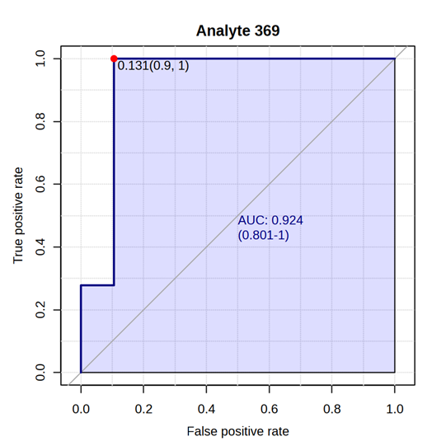. 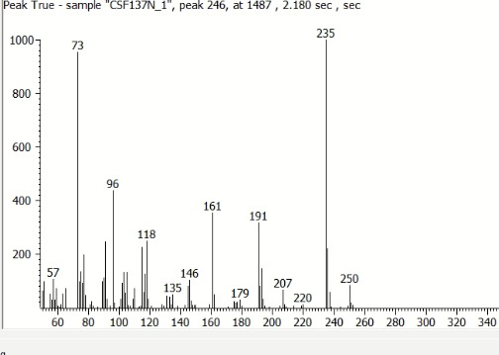
Figure S9: Receiver operating characteristic (ROC) curve analysis and representative mass spectrum for CSF Analyte 369.

APPENDIX II
INFORMED CONSENT FORM
For Collection of Blood, CSF, and Brain Tissue from Trade Dogs for Detection of Rabies Virus in Nigerian Dog Markets
Purpose of the Study:
We are carrying out a study to test for rabies virus in trade dogs sold in Nigerian dog markets. This research will help improve public health safety and protect people and animals from rabies.
What We Will Do:
- Before Slaughter:
- We will collect a small amount of blood (about 4 mL).
- We will collect a small sample of cerebrospinal fluid (CSF).
- After Slaughter:
- We will collect a small portion of the brain for rabies testing.
Risks:
- The dog may feel slight pain or stress during blood and CSF collection.
- All procedures will be carried out carefully using clean and safe veterinary methods.
Benefits:
- There may be no direct benefit to you.
- The results will help protect public health and improve rabies control in Nigeria.
Confidentiality:
- Your name and information will be kept private.
- Your identity will not appear in any report or publication.
Voluntary Participation:
- Participation is voluntary.
- You may refuse without any penalty.
- Your decision will not affect your right to sell dogs in the market.
Consent Statement:
I have read (or it has been explained to me), and I understand the purpose of this study. I voluntarily agree to allow my dogs to participate, including blood and CSF collection before slaughter and brain tissue collection after slaughter.
Name of Owner/Trader: ____________________________
Signature/Thumbprint: ____________________________
Date: ____________________________
Researcher’s Name: ____________________________
Signature: ____________________________
Date: ____________________________

