Kinetic Models for Thermally Activated Delayed Fluorescence Photocatalysts: From Time-Resolved Spectroscopy to Continuous Photoreactions
Caterina Bellatreccia,^{a,b} Federica Fina, ^{a,b} Paola Ceroni^{a,b}
ªAlma Mater Studiorum-Dipartimento di Chimica “G. Ciamician”, Università di Bologna, Via Gobetti 83, Bologna 40129, Italy
^{b}Center for Chemical Catalysis - C3, Alma Mater Studiorum, Università di Bologna, Via Gobetti 83, Bologna 40129, Italy
Corresponding author: Paola Ceroni (paola. ceroni@unibo.it)
Contents
1. Methods: description of the simulation and fitting algorithms 2
1.1. Simulation of experiments under pulsed irradiation: 2
2. Mathematical derivations of equations in the main text 4
2.1. Derivation of equations 18-21 4
2.2. When SV formulas are valid for TADF chromofores (derivation of conditions 22 and 23) 6
2.3. Derivation of [S₁], [T₁] at the steady state without a quencher (equations 25-26) 7
2.4. Derivation of Q evolution in time (equation 36) 8
2.5. Derivation of Φ_{B} in mechanism a (equation 41) and its stationary points 11
3. Additional data 13
3.1. Comparison of simulated data under continuous irradiation and prediction by eq. 36 13
3.2. Proof that most of the time Φ_{B} can be considered constant during reaction in mechanism a 16
3.3. Mechanism b: dependence of Φ_{B} on the substrate concentration 17
3.4 Collection of simulated quenching experiments (pulsed irradiation) and relative fitting parameters 19
4. Description of Jupiter notebooks 26
5. References 30

Methods: description of the simulation and fitting algorithms

Simulation of experiments under pulsed irradiation:
Our kinetic simulation consists in a C-language code, which numerically calculates the evolution of [S₀], [S₁], [T₁], [Q], [Q⁺] according to the following differential equations:
$\frac{d[S_{1}]}{dt}=k_{risc}\left[T_{1}\right]-\left(k^{S,0}+k_{isc}+k_{qS}[Q]\right)\left[S_{1}\right]$ (S1)
$\frac{d[T_{1}]}{dt}=k_{isc}\left[S_{1}\right]-\left(k^{T,0}+k_{risc}+k_{qT}[Q]\right)\left[T_{1}\right]$ (S2)
$\frac{d[Q]}{dt}={-(k}_{qS}\left[S_{1}\right]+k_{qT}\left[T_{1}\right])[Q]$ (S3)
Where all the kinetic constants are defined in the main text (equations 4-5, Figure 1). The simulation for pulsed-irradiation experiment did not include cage escape, as it does not affect the outcome of a lifetime measurement, but only the evaluation of the accumulated Q⁺ and PS⁻, which was not the purpose of this treatment.
The timestep of the simulation is set at 1 ps in order to obtain precise datasets.
A “simulated decay” is defined as a kinetic trace generated with the aforementioned simulation of either [S₀], [S₁], [T₁], given a certain set of kinetic constants and a certain initial concentration of the quencher ([Q]) (input parameters).
A “simulated quenching experiment” is defined as a set of simulated decays that have the same set of kinetic constants but differ for the initial [Q].
  - Fitting of the simulated quenching experiment
All [S₁] simulated decays were fitted with a biexponential decaying function with the following general formula:
$\left[S_{1}\right]=A_{1}e^{-t/τ_{1}}+A_{2}e^{-t/τ_{2}}$ (S8)
All [T₁] simulated decays were fitted with a biexponential function with the following general formula:
$\left[T_{1}\right]=-Be^{-t/τ_{1}}+Be^{-t/τ_{2}}$ (S9)
Therefore, A₁, A₂, B, τ₁, τ₂ are output values that can be compared to the pre-exponential factors and τ_{p} and τ_{d} lifetimes predicted by the exact solutions based on the input parameters used for the simulated decay under analysis (eq 11-13). All the analysed decays show excellent agreement between the output values and the values calulcated by equations 11-13.
τ₁ and τ₂ were subsequently analysed as commonly done for quenching experiments with Stern Volmer analysis. Analysis of τ₁ yielded the evaluation of k_{qp}:
$$\frac{τ_{1}^{0}}{τ_{1}}=K_{SV,p}\left[Q\right]+1$$ | (S10)
$$k_{qp}=\frac{K_{Sv,p}}{τ_{1}^{0}}$$ | (S11)
Where $τ_{1}^{0}$ indicates the prompt lifetime obtained by the fitting of the simulated S₁ decay with [Q] = 0M, $τ_{1}$ indicates the prompt lifetime obtained by the fitting of the simulated S₁ decay with different quencher concentrations, $K_{SV,p}$ is the slope of the resulting line and $k_{qp}$ represents the quenching constant that is commonly evalutated in Stern-Volmer experiments on the prompt lifetime of TADF photocatalysts.
Analysis of τ₂ yields the evaluation of k_{qd}:
$$\frac{τ_{2}^{0}}{τ_{2}}=K_{SV,d}\left[Q\right]+1$$ | (S12)
$$k_{qd}=\frac{K_{Sv,d}}{τ_{2}^{0}}$$ | (S13)
Where $τ_{2}^{0}$ indicates the delayed lifetime obtained by the fitting of the simulated S₁ decay with [Q] = 0M, $τ_{2}$ indicates the delayed lifetime obtained by the fitting of the simulated S₁ decay with different quencher concentrations, $K_{SV,d}$ is the slope of the resulting line and $k_{qd}$ represents the quenching constant that is commonly evalutated in Stern-Volmer experiments on the delayed lifetime of TADF photocatalysts.
The values of k_{qp} and k_{qd} obtained for a selected manifold of simulated quenching experiments are collected in Table S1 and commented in section 11.
In addition to that, τ₁ and τ₂ were used to perform a quenching analysis based on the new treatment presented in this article, by substituting k_{p} and k_{d} in equations 18-21 with the following values:
$${k_{p}=k}_{1}=\frac{1}{τ_{1}}$$ | (S14)
$${k_{d}=k}_{2}=\frac{1}{τ_{2}}$$ | (S15)
$$\frac{k_{p}+k_{d}}{k_{p}^{0}+k_{d}^{0}}=1+\frac{k_{qS}+k_{qT}}{k_{p}^{0}+k_{d}^{0}}\left[Q\right]$$ | (S16)
$${\left(\frac{k_{p}-k_{d}}{k_{p}^{0}-k_{d}^{0}}\right)}^{2}=1+\frac{2\left(k^{S,0}+k_{isc}-k^{T,0}-k_{risc}\right)\left(k_{qS}-k_{qT}\right)}{({k_{p}^{0}-k_{d}^{0})}^{2}}\left[Q\right]+{{\left(\frac{k_{qS}-k_{qT}}{k_{p}^{0}-k_{d}^{0}}\right)}^{2} \left[Q\right]}^{2}$$ | (S17)
With $k_{p}^{0}$ and $k_{d}^{0}$ in equations 18-20 indicating $k_{p}$ and $k_{d}$ obtained for [Q] = 0 M. Equation 18 and equation 19 express, respectively, a linear and quadratic relationship between the left term and the quencher concentration, such that the two expressions can be rewritten as follows:
$$\frac{k_{p}+k_{d}}{k_{p}^{0}+k_{d}^{0}}=1+m_{sum}\left[Q\right]$$ | (S18)
$${\left(\frac{k_{p}-k_{d}}{k_{p}^{0}-k_{d}^{0}}\right)}^{2}=1+a_{diff}\left[Q\right]+{b_{diff} \left[Q\right]}^{2}$$ | (S19)
Therefore, the left terms of equations S18 and S19 can be calculated for each decay of a quenching experiment, and the set of values obtained can be later fitted according to equations S18-S19 to obtain m_{sum}, a_{diff}, b_{diff}.
If b_{diff}>0, k_{qS}>k_{qT}, and the following formulas can be applied to derive k_{qS} and k_{qT}:
$$k_{qS}=\frac{1}{2}m_{sum}\left(k_{p}^{0}+k_{d}^{0}\right)+\frac{1}{2}\sqrt{a_{diff}}(k_{p}^{0}-k_{d}^{0})$$ | (20)
$$k_{qT}=\frac{1}{2}m_{sum}\left(k_{p}^{0}+k_{d}^{0}\right)-\frac{1}{2}\sqrt{a_{diff}}(k_{p}^{0}-k_{d}^{0})$$ | (21)
On the other hand, If b_{diff}<0, k_{qS}<k_{qT}, and the following formulas can be applied to derive k_{qS} and k_{qT}:
$$k_{qS}=\frac{1}{2}m_{sum}\left(k_{p}^{0}+k_{d}^{0}\right)-\frac{1}{2}\sqrt{a_{diff}}(k_{p}^{0}-k_{d}^{0})$$ | (S20)
$$k_{qT}=\frac{1}{2}m_{sum}\left(k_{p}^{0}+k_{d}^{0}\right)+\frac{1}{2}\sqrt{a_{diff}}(k_{p}^{0}-k_{d}^{0})$$ | (S21)
The values of k_{qp} and k_{qd} obtained for a selected manifold of simulated quenching experiments are collected in Table S1 and commented in section 11.
The full mathematical derivation of equations 18-21 is reported in section 3 of this document.
  - Simulation of experiments under continuous irradiation:
To account for continuous irradiation, we added the excitation term (eq. 24) in the differential equation of S₁, as T₁ cannot be directly populated by light irradiation. Therefore, the kinetic simulator for continuous irradiation is based on the following differential equations:
$$\frac{d[S_{1}]}{dt}=I_{0}\left(1-{10}^{-ϵd\left[S_{0}\right]}\right)-\left(k^{S,0}+k_{isc}+k_{qS}\left[Q\right]\right)\left[S_{1}\right]+k_{risc}\left[T_{1}\right]$$ | (28)
$$\frac{d{[T}_{1}]}{dt}=-\left(k^{T,0}+k_{risc}+k_{qT}\left[Q\right]\right)\left[T_{1}\right]+k_{isc}\left[S_{1}\right]$$ | (29)
$$\frac{d[Q]}{dt}=-\frac{d\left[Q^{+}\right]}{dt}=-{(k}_{qS}η_{ceS}\left[S_{1}\right]+k_{qT}η_{ceT}\left[T_{1}\right])[Q]$$ | (30)
Where all the kinetic constants and other parameters are defined in the main text (equations 4-5, 24, Figure 1). The timestep of the simulation is set at 1 ns in order to obtain precise datasets. A “simulated photoreaction trace” is defined as a kinetic trace generated with the aforementioned simulation of either one of the components of the system (S₀, S₁, T₁, Q, Q⁺, A, B), given a certain set of kinetic constants and a certain initial concentration of the quencher (input parameters). The “end of the photoreaction is always intended as the instant at which the substrate is 99% consumed ([A]_{t} = 0.01[A]₀)

Mathematical derivations of equations in the main text

Derivation of equations 18-21
As explained in the main text, for chromophores showing TADF the Stern-Volmer treatment is not strictly valid. This statement can be fully understood by applying Stern-Volmer treatment to the prompt and delayed lifetimes as expressed in equation 13:
$$\frac{τ_{p}^{0}}{τ_{p}}=\frac{k_{p}}{k_{p}^{0}}=\frac{k^{S,0}+{k_{isc}+k}^{T,0}+k_{risc}+k_{qS}[Q]+k_{qT}\left[Q\right]+\sqrt{{{[k}^{S,0}+k_{isc}-k^{T,0}-k_{risc}+{(k}_{qS}-k_{qT})[Q]]}^{2}+4k_{risc}k_{isc}}}{k^{S,0}+k_{isc}+k^{T,0}+k_{risc}+\sqrt{{{(k}^{S,0}-k^{T,0})}^{2}+4k_{risc}k_{isc}}}$$ | (S22)
$$\frac{τ_{d}^{0}}{τ_{d}}=\frac{k_{d}}{k_{d}^{0}}=\frac{k^{S,0}+{k_{isc}+k}^{T,0}+k_{risc}+k_{qS}\left[Q\right]+k_{qT}\left[Q\right]-\sqrt{{{[k}^{S,0}+k_{isc}-k^{T,0}-k_{risc}+{(k}_{qS}-k_{qT})[Q]]}^{2}+4k_{risc}k_{isc}}}{k^{S,0}+k_{isc}+k^{T,0}+k_{risc}-\sqrt{{{(k}^{S,0}-k^{T,0})}^{2}+4k_{risc}k_{isc}}}$$ | (S23)
Equations S22 and S23 show that the left term in both cases is not linearly related to [Q], as the Stern-Volmer treatment requires. This aspect reflects the kinetic coupling between S₁ and T₁: τ_{p} and τ_{d} depend on all the kinetic constants of the system, and therefore they cannot be linked to either one of the excited states independently. This aspect forbids the independent treatment of τ_{p} and τ_{d}, and requires instead a coupled approach. We derived therefore equations 18-19 as follows:
$$k_{p}+k_{d}=k^{S,0}+k_{isc}+k^{T,0}+k_{risc}+k_{qS}\left[Q\right]+k_{qT}[Q]$$ | (S24)
$$\frac{k_{p}+k_{d}}{k_{p}^{0}+k_{d}^{0}}=\frac{k^{S,0}+k_{isc}+k^{T,0}+k_{risc}+k_{qS}\left[Q\right]+k_{qT}[Q]}{k^{S,0}+k_{isc}+k^{T,0}+k_{risc}}$$ | (S25)
$$\frac{k_{p}+k_{d}}{k_{p}^{0}+k_{d}^{0}}=\frac{k^{S,0}+k_{isc}+k^{T,0}+k_{risc}+k_{qS}\left[Q\right]+k_{qT}[Q]}{k^{S,0}+k_{isc}+k^{T,0}+k_{risc}}=1+\frac{k_{qS}+k_{qT}}{k_{p}^{0}+k_{d}^{0}}[Q]$$ | (18)
$$k_{p}-k_{d}=\sqrt{{(k^{S,0}+k_{isc}-k^{T,0}-k_{risc}+{(k}_{qS}-k_{qT})[Q])}^{2}+4k_{risc}k_{isc}}$$ | (S26)
$${{(k}_{p}-k_{d})}^{2}=({k^{S,0}+k_{isc}-k^{T,0}-k_{risc}+{(k}_{qS}-k_{qT})[Q])}^{2}+4k_{risc}k_{isc}$$ | (S27)
$${\left(\frac{k_{p}-k_{d}}{k_{p}^{0}-k_{d}^{0}}\right)}^{2}=\frac{({k^{S,0}+k_{isc}-k^{T,0}-k_{risc}+{(k}_{qS}-k_{qT})[Q])}^{2}+4k_{risc}k_{isc}}{({k^{S,0}+k_{isc}-k^{T,0}-k_{risc})}^{2}+4k_{risc}k_{isc}}$$  $$=\frac{{{\left(k^{S,0}+k_{isc}-k^{T,0}-k_{risc}\right)}^{2}+{{(k}_{qS}-k_{qT})}^{2}\left[Q\right]}^{2}+2\left[Q\right]\left(k^{S,0}+k_{isc}-k^{T,0}-k_{risc}\right)\left(k_{qS}-k_{qT}\right)+4k_{risc}k_{isc}}{({k^{S,0}+k_{isc}-k^{T,0}-k_{risc})}^{2}+4k_{risc}k_{isc}}$$  $$=1+\frac{2(k^{S,0}+k_{isc}-k^{T,0}-k_{risc})(k_{qS}-k_{qT})}{{{(k}_{p}^{0}-k_{d}^{0})}^{2}}\left[Q\right]+{{\left(\frac{k_{qS}-k_{qT}}{k_{p}^{0}-k_{d}^{0}}\right)}^{2} \left[Q\right]}^{2}$$ | (19)
Where the green marks highlight the equivalent terms that can be simplified. Equation 18 and 19 express a linear and quadratic relationship between the left term and the concentration of the quencher [Q]. Therefore, we can rewrite them as follows:
$$\frac{k_{p}+k_{d}}{k_{p}^{0}+k_{d}^{0}}=1+m_{sum}[Q]$$ | (18bis)
$${\left(\frac{k_{p}-k_{d}}{k_{p}^{0}-k_{d}^{0}}\right)}^{2}=1+b_{diff} [Q]+{a_{diff} [Q]}^{2}$$ | (19bis)
Where m_{sum}, a_{diff} and b_{diff} are defined as follows:
$$m_{sum}=\frac{k_{qS}+k_{qT}}{k_{p}^{0}+k_{d}^{0}}$$ | (S28)
$$a_{diff}={\left(\frac{k_{qS}-k_{qT}}{k_{p}^{0}-k_{d}^{0}}\right)}^{2}$$ | (S29)
$$b_{diff}=\frac{2(k^{S,0}+k_{isc}-k^{T,0}-k_{risc})(k_{qS}-k_{qT})}{{{(k}_{p}^{0}-k_{d}^{0})}^{2}}$$ | (S30)
According to their definition, m_{sum} and a_{diff} are always positive, while b_{diff} can be either positive (if k_{qS}>k_{qT}) or negative (if k_{qS}<k_{qT}). Therefore, its sign already gives an indication about the values of the microscopic quenching constants.
The values of m_{sum}, a_{diff} and b_{diff} can be obtained experimentally as described in SI section 1.2. At the same time, they are related to the microscopic kinetic constants of the system, and therefore they offer a way to obtain k_{qS} and k_{qT}, according to the following system of equations:
$$\left\{\begin{aligned}m_{sum}=\frac{k_{qS}+k_{qT}}{k_{p}^{0}+k_{d}^{0}} \\ a_{diff}={\left(\frac{k_{qS}-k_{qT}}{k_{p}^{0}-k_{d}^{0}}\right)}^{2}\end{aligned}\right.$$ | (S31)
Which has the following solutions if b_{diff}>0:
$$k_{qS}=\frac{1}{2}m_{sum}\left(k_{p}^{0}+k_{d}^{0}\right)+\frac{1}{2}\sqrt{a_{diff}}(k_{p}^{0}-k_{d}^{0})$$ | (20)
$$k_{qT}=\frac{1}{2}m_{sum}\left(k_{p}^{0}+k_{d}^{0}\right)-\frac{1}{2}\sqrt{a_{diff}}(k_{p}^{0}-k_{d}^{0})$$ | (21)
And the following analogous solutions if b_{diff}<0:
$$k_{qS}=\frac{1}{2}m_{sum}\left(k_{p}^{0}+k_{d}^{0}\right)-\frac{1}{2}\sqrt{a_{diff}}(k_{p}^{0}-k_{d}^{0})$$ | (S32)
$$k_{qT}=\frac{1}{2}m_{sum}\left(k_{p}^{0}+k_{d}^{0}\right)+\frac{1}{2}\sqrt{a_{diff}}(k_{p}^{0}-k_{d}^{0})$$ | (S33)
In system S31 a_{diff} is employed rather than b_{diff} because the same treatment with b_{diff} requires the knowledge of k^{S,0}, k_{isc}, k^{T,0} and k_{risc}, which are not always known. on the other hand, equations 20-21 and S20-S21 show that k_{qS} and k_{qT} can be derived from observables that can be directly measured (k_{p}, k_{d}), analogously to Stern-Volmer treatment.

When SV formulas are valid for TADF chromofores (derivation of conditions 22 and 23)
Substituting the prompt lifetime as expressed in equation 17 in the Stern-Volmer equation, we obtain equations S22-S23:
$$\frac{τ_{p}^{0}}{τ_{p}}=\frac{k_{p}}{k_{p}^{0}}=\frac{k^{S,0}+{k_{isc}+k}^{T,0}+k_{risc}+k_{qS}[Q]+k_{qT}\left[Q\right]+\sqrt{{{[k}^{S,0}+k_{isc}-k^{T,0}-k_{risc}+{(k}_{qS}-k_{qT})[Q]]}^{2}+4k_{risc}k_{isc}}}{k^{S,0}+k_{isc}+k^{T,0}+k_{risc}+\sqrt{{{(k}^{S,0}-k^{T,0})}^{2}+4k_{risc}k_{isc}}}$$ | (S22)
$$\frac{τ_{d}^{0}}{τ_{d}}=\frac{k_{d}}{k_{d}^{0}}=\frac{k^{S,0}+{k_{isc}+k}^{T,0}+k_{risc}+k_{qS}\left[Q\right]+k_{qT}\left[Q\right]-\sqrt{{{[k}^{S,0}+k_{isc}-k^{T,0}-k_{risc}+{(k}_{qS}-k_{qT})[Q]]}^{2}+4k_{risc}k_{isc}}}{k^{S,0}+k_{isc}+k^{T,0}+k_{risc}-\sqrt{{{(k}^{S,0}-k^{T,0})}^{2}+4k_{risc}k_{isc}}}$$ | (S23)
Equations S22 and S23 can be approximated to a linear relationship in two cases:
 | $$k_{qS}\sim k_{qT}, such that {(k}_{qS}-k_{qT})≈0$$ | (22)
 | Under this condition, equation S22 can be easily simplified:
 | $$\frac{τ_{p}^{0}}{τ_{p}}=\frac{k_{p}}{k_{p}^{0}}≈\frac{k^{S,0}+k_{isc}+k^{T,0}+k_{risc}+k_{qS,T}\left[Q\right]+k_{qS,T}\left[Q\right]+\sqrt{[{k^{S,0}+k_{isc}-k^{T,0}-k_{risc}]}^{2}+4k_{risc}k_{isc}}}{k^{S,0}+k_{isc}+k^{T,0}+k_{risc}+\sqrt{{{(k}^{S,0}+k_{isc}-k^{T,0}-k_{risc})}^{2}+4k_{risc}k_{isc}}}$$  $$=1+k_{qS,T}τ_{p}[Q]$$ | (S34)
 | Equation S34 is analogous to the Stern-Volmer treatment for non-TADF systems, and a similar expression can be derived for the delayed lifetime as well.
 | $$\left(k^{S,0}+k_{isc}+{k_{qS}{[Q]}_{0}^{max}-k}^{T,0}-k_{risc}-k_{qT}{[Q]}_{0}^{max}\right)≫{4k}_{isc}k_{risc}$$ |  | (23)
 | Under this condition, the k_{isc}k_{risc} term under the radical is negligible, and equations S22-S23 can be simplified to equations S35-S36:
 | $$\frac{τ_{p}^{0}}{τ_{p}}=\frac{k_{p}}{k_{p}^{0}}≈\frac{k^{S,0}+k_{isc}+k^{T,0}+k_{risc}+\left(k_{qS}+k_{qT}\right)\left[Q\right]+k^{S,0}+k_{isc}-k^{T,0}-k_{risc}+{(k}_{qS}-k_{qT})[Q]}{k^{S,0}+k_{isc}+k^{T,0}+k_{risc}+\sqrt{({k^{S,0}+k_{isc}-k^{T,0}-k_{risc})}^{2}-4k_{risc}k_{isc}}}$$  $$=\frac{2{(k}^{S,0}+k_{isc})+2k_{qS}[Q]}{2k_{p}^{0}}=(k^{S,0}+k_{isc})τ_{p}^{0}+k_{qS}τ_{p}^{0}[Q]$$ |  | (S35)
 | $$\frac{τ_{p}^{0}}{τ_{p}}=\frac{k_{p}}{k_{p}^{0}}≈\frac{k^{S,0}+k_{isc}+k^{T,0}+k_{risc}+\left(k_{qS}+k_{qT}\right)\left[Q\right]-k^{S,0}-k_{isc}+k^{T,0}+k_{risc}-(k_{qS}-k_{qT})[Q]}{k^{S,0}+k_{isc}+k^{T,0}+k_{risc}+\sqrt{({k^{S,0}+k_{isc}-k^{T,0}-k_{risc})}^{2}-4k_{risc}k_{isc}}}$$  $$=\frac{2{(k}^{T,0}+k_{risc})+2k_{qT}[Q]}{2k_{d}^{0}}=(k^{T,0}+k_{risc})τ_{d}^{0}+k_{qT}τ_{d}^{0}[Q]$$ |  | (S36)
 | Also in this case, a linear relationship analogous to Stern-Volmer equation is derived. It should be noted, nevertheless, that in this case the intercept of a simil-Stern-Volmer plot would not be 1, but instead k^{S,0}+k_{isc} (analysis on τ_{p}, eq. S35) or k^{T,0}+k_{risc} (analysis on τ_{d}, eq. S36)

Derivation of [S₁], [T₁] at the steady state without a quencher (equations 25-26)
The differential equations describing a chromophore with the state diagram depicted in Figure 1 under continuous irradiation and without a quencher in solution are the following:
 | $$\frac{d[S_{1}]}{dt}=I_{0}\left(1-{10}^{-ϵd\left[S_{0}\right]}\right)-\left(k^{S,0}+k_{isc}\right)\left[S_{1}\right]+k_{risc}\left[T_{1}\right]$$ | (S37)
 | $$\frac{d{[T}_{1}]}{dt}=-\left(k^{T,0}+k_{risc}\right)\left[T_{1}\right]+k_{isc}\left[S_{1}\right]$$ | (S38)
Due to the high rate of the decaying pathways, the system rapidly reaches a steady state, in which the concentration of S₁ and T₁ do not change over time because the rate of ground state excitation equals the rate of excited state decay. The equations that describe this condition can be derived from the solution of the following system:
 | $$\left\{\begin{aligned}\frac{d[S_{1}]}{dt}=I_{abs}-\left(k^{S,0}+k_{isc}\right)\left[S_{1}\right]+k_{risc}\left[T_{1}\right]=0 \\ \frac{d{[T}_{1}]}{dt}=-\left(k^{T,0}+k_{risc}\right)\left[T_{1}\right]+k_{isc}\left[S_{1}\right]=0\end{aligned}\right.$$ | (S39)
Where I_{abs} (defined in eq. 24) can be considered constant, under the approximation [S₀]_{t}=[S₀]₀, which remains valid for values of photon fluxes commonly used in photochemical reactions (10⁻⁶-10⁻⁷ photons per second¹).
System S35 can be solved analytically:
 | $$\left\{\begin{aligned}I_{abs}-\left(k^{S,0}+k_{isc}\right)\left[S_{1}\right]+k_{risc}\left[T_{1}\right]=0 \\ \left[T_{1}\right]=\frac{k_{isc}\left[S_{1}\right]}{\left(k^{T,0}+k_{risc}\right)}\end{aligned}\right.$$ | (S40)
 | $$\left\{\begin{aligned}I_{abs}-\left(k^{S,0}+k_{isc}\right)\left[S_{1}\right]+\frac{k_{risc}k_{isc}\left[S_{1}\right]}{\left(k^{T,0}+k_{risc}\right)}=0 \\ \left[T_{1}\right]=\frac{k_{isc}\left[S_{1}\right]}{\left(k^{T,0}+k_{risc}\right)}\end{aligned}\right.$$ | (S41)
 | $$\left\{\begin{aligned}\left(k^{S,0}+k_{isc}\right)\left[S_{1}\right]-\frac{{k_{risc}k}_{isc}\left[S_{1}\right]}{\left(k^{T,0}+k_{risc}\right)}=I_{abs} \\ \left[T_{1}\right]=\frac{k_{isc}\left[S_{1}\right]}{\left(k^{T,0}+k_{risc}\right)}\end{aligned}\right.$$ | (S42)
 | $$\left\{\begin{aligned}\frac{\left(k^{S,0}+k_{isc}\right)\left(k^{T,0}+k_{risc}\right)\left[S_{1}\right]-{k_{risc}k}_{isc}\left[S_{1}\right]}{\left(k^{T,0}+k_{risc}\right)}=I_{abs} \\ \left[T_{1}\right]=\frac{k_{isc}\left[S_{1}\right]}{\left(k^{T,0}+k_{risc}\right)}\end{aligned}\right.$$ | (S43)
 | $$\left\{\begin{aligned}\frac{(k^{S,0}k^{T,0}+k_{risc}k^{S,0}+k_{isc}k^{T,0})}{\left(k^{T,0}+k_{risc}\right)}\left[S_{1}\right]=I_{abs} \\ \left[T_{1}\right]=\frac{k_{isc}\left[S_{1}\right]}{\left(k^{T,0}+k_{risc}\right)}\end{aligned}\right.$$ | (S44)
 | $$\left\{\begin{aligned}\left[S_{1}\right]=I_{abs}\frac{\left(k^{T,0}+k_{risc}\right)}{k_{isc}k^{T,0}+(k^{T,0}+k_{risc}{)k}^{S,0}} \\ \left[T_{1}\right]=\frac{k_{isc}\left[S_{1}\right]}{\left(k^{T,0}+k_{risc}\right)}=I_{abs}\frac{k_{isc}}{k_{isc}k^{T,0}+\left(k^{T,0}+k_{risc}\right)k^{S,0}}\end{aligned}\right.$$ | (25)  (26)

Derivation of Q evolution in time (equation 36)
Equations S37-S38 can be easily adapted to include a quencher in the system, obtaining equations 28-30:
 | $$\frac{d[S_{1}]}{dt}=I_{0}\left(1-{10}^{-ϵd\left[S_{0}\right]}\right)-\left(k^{S,0}+k_{isc}+k_{qS}\left[Q\right]\right)\left[S_{1}\right]+k_{risc}\left[T_{1}\right]$$ | (28)
 | $$\frac{d{[T}_{1}]}{dt}=-\left(k^{T,0}+k_{risc}+k_{qT}\left[Q\right]\right)\left[T_{1}\right]+k_{isc}\left[S_{1}\right]$$ | (29)
 | $$\frac{d[Q]}{dt}=-\frac{d\left[Q^{+}\right]}{dt}=-{(k}_{qS}η_{ceS}\left[S_{1}\right]+k_{qT}η_{ceT}\left[T_{1}\right])[Q]$$ | (30)
As mentioned in the main text, in the steady state treatment we included cage escape efficiencies, which are generally different for S₁ (η_{ceS}) and T₁ (η_{ceT}).
As exemplified by Figure 7, the system under analysis is characterized by a strong time-scale separation, and therefore we can consider the quencher concentration to be constant in the time scale of the decaying pathways of both S₁ and T₁. Under this conditions, equations 24-25 derived in SI section 2.3 can be easily adapted to include the concentration of the quencher, considering k_{qS}[Q] and k_{qT}[Q] additive terms to k^{S,0} and k^{T,0}, respectively:
$${\left[S_{1}\right]}_{QSS}=I_{abs}×\frac{k^{T}+k_{risc}}{k^{T}k_{isc}+{(k}^{T}+k_{risc})k^{S}}=I_{abs}×\frac{k^{T,0}{+k}_{risc}+k_{qT}[Q]}{{(k}^{T,0}+k_{qT}[Q])k_{isc}+\left(k^{T,0}+k_{risc}+k_{qT}[Q]\right)\left(k^{S,0}+k_{qS}[Q]\right)}$$ | (34)
$${\left[T_{1}\right]}_{QSS}=I_{abs}×\frac{k_{isc}}{k^{T}k_{isc}+{(k}^{T}+k_{risc})k^{S}}=I_{abs}×\frac{k_{isc}}{{(k}^{T,0}+k_{qT}[Q])k_{isc}+\left(k^{T,0}+k_{risc}+k_{qT}[Q]\right)\left(k^{S,0}+k_{qS}[Q]\right)}$$ | (35)
Equations 34-35 are validated in all the simulated reactions considered in this work: by substituting the numerically calculated [Q] in expressions 34 and 35, the evolution of [S₁] and [T₁] can be correctly predicted, as exemplified in Figure S1.
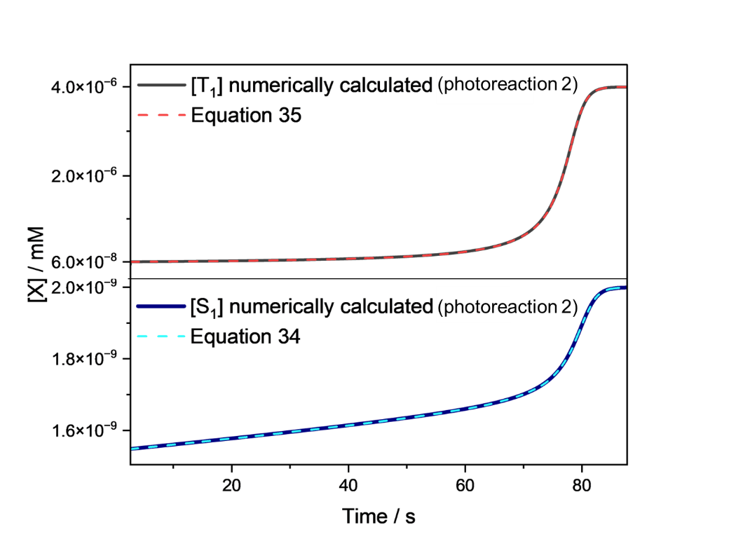
Figure S1: Comparison of the evolution of T₁ (top) and S₁ (bottom) calculated numerically with the simulator under continuous irradiation (solid line) and with the analytical expressions 34-35. The data are generated with the following input parameters: I₀=1.10⁻⁶ s⁻¹; [Q]₀ = 10 mM; [A]₀ = 1 mM; [PS]₀ = 1 mM; k^{S,0}=4.00.10⁸ s⁻¹; k^{T,0}= 5.00.10⁴ s⁻¹; k_{isc}= 2.00.10⁸ s⁻¹; k_{risc}= 5.00.10⁴ s⁻¹; k_{qS} = 5.00.10⁹ s⁻¹M⁻¹; k_{qT}= 5.00.10⁸ s⁻¹M⁻¹; η_{ceS} = 0.15; η_{ceT} = 0.4 (photoreaction 2).
Once obtained the relations linking [S₁] and [T₁] to [Q], the evolution of [Q] in time can be calculated by substituting eq. 34-35 in the differential equation dictating the evolution of [Q] (eq.30):
$$\frac{d\left[Q\right]}{dt}=-\frac{d\left[Q^{+}\right]}{dt}=-\left(k_{qS}η_{ceS}\left[S_{1}\right]+k_{qT}η_{ceT}\left[T_{1}\right]\right)\left[Q\right]$$  $$=k_{qS}η_{ceS}I_{abs}\left[Q\right]\frac{k^{T,0}{+k}_{risc}+k_{qT}\left[Q\right]}{{(k}^{T,0}+k_{qT}[Q])k_{isc}+\left(k^{T,0}+k_{risc}+k_{qT}\left[Q\right]\right)\left(k^{S,0}+k_{qS}\left[Q\right]\right)}+k_{qT}η_{ceT}I_{abs}\left[Q\right]\frac{k_{isc}}{{(k}^{T,0}+k_{qT}[Q])k_{isc}+\left(k^{T,0}+k_{risc}+k_{qT}\left[Q\right]\right)\left(k^{S,0}+k_{qS}\left[Q\right]\right)}$$  $$=-I_{abs}\frac{(k_{qS}η_{ceS}\left(k^{T,0}{+k}_{risc}\right)+k_{qT}η_{ceT}k_{isc})[Q]+k_{qS}η_{ceS}k_{qT}{\left[Q\right]}^{2}}{k^{T,0}k_{isc}+k^{S,0}\left(k^{T,0}+k_{risc}\right)+\{k_{qT}(k_{isc}+k^{S,0})+k_{qS}{(k}^{T,0}+k_{risc})\}\left[Q\right]+k_{qS}k_{qT}{\left[Q\right]}^{2}}$$ | (S45)
Equation S45 can be rewritten as follows:
$$\frac{d\left[Q\right]}{dt}=-I_{abs}\frac{[Q]\left\{(k_{qS}η_{ceS}\left(k^{T,0}{+k}_{risc}\right)+k_{qT}η_{ceT}k_{isc})+k_{qS}η_{ceS}k_{qT}[Q]\right\}}{D_{\left[Q\right]}}$$ | (S46)
Where D([Q]) is the denominator:
$$D_{\left[Q\right]}=k^{T,0}k_{isc}+k^{S,0}\left(k^{T,0}+k_{risc}\right)+\{k_{qT}(k_{isc}+k^{S,0})+k_{qS}{(k}^{T,0}+k_{risc})\}\left[Q\right]+k_{qS}k_{qT}{\left[Q\right]}^{2}$$ | (S47)
Then we can rearrange eq. S46 as follows:
$$-I_{abs}dt=\frac{D_{\left[Q\right]}}{\left[Q\right]\left\{\left(k_{qS}η_{ceS}\left(k^{T,0}{+k}_{risc}\right)+k_{qT}η_{ceT}k_{isc}\right)+k_{qS}η_{ceS}k_{qT}\left[Q\right]\right\}}d[Q]$$ | (S48)
To be able to integrate the right part of equation S48, it has to be decomposed in adding terms:
$$\frac{D_{\left[Q\right]}}{\left[Q\right]\left\{\left(k_{qS}η_{ceS}\left(k^{T,0}{+k}_{risc}\right)+k_{qT}η_{ceT}k_{isc}\right)+k_{qS}η_{ceS}k_{qT}\left[Q\right]\right\}}=X+\frac{Y}{[Q]}+\frac{Z}{\left(k_{qS}η_{ceS}\left(k^{T,0}{+k}_{risc}\right)+k_{qT}η_{ceT}k_{isc}\right)+k_{qS}η_{ceS}k_{qT}\left[Q\right]}$$ | (S49)
We can then take the least common multiple of the denominators:
$$D_{\left[Q\right]}=X\left[Q\right]\left\{\left(k_{qS}η_{ceS}\left(k^{T,0}{+k}_{risc}\right)+k_{qT}η_{ceT}k_{isc}\right)+k_{qS}η_{ceS}k_{qT}\left[Q\right]\right\}+Y\left\{\left(k_{qS}η_{ceS}\left(k^{T,0}{+k}_{risc}\right)+k_{qT}η_{ceT}k_{isc}\right)+k_{qS}η_{ceS}k_{qT}\left[Q\right]\right\}+Z[Q]$$ | (S50)
And substitute the extended form of D_{[Q]:}
$$k^{T,0}k_{isc}+k^{S,0}\left(k^{T,0}+k_{risc}\right)+\{k_{qT}(k_{isc}+k^{S,0})+k_{qS}{(k}^{T,0}+k_{risc})\}\left[Q\right]+k_{qS}k_{qT}{\left[Q\right]}^{2}=X\left[Q\right]\left\{\left(k_{qS}η_{ceS}\left(k^{T,0}{+k}_{risc}\right)+k_{qT}η_{ceT}k_{isc}\right)+k_{qS}η_{ceS}k_{qT}\left[Q\right]\right\}+Y\left\{\left(k_{qS}η_{ceS}\left(k^{T,0}{+k}_{risc}\right)+k_{qT}η_{ceT}k_{isc}\right)+k_{qS}η_{ceS}k_{qT}\left[Q\right]\right\}+Z[Q]$$ | (S51)
We can group the 0th, 1st and 2nd order terms in [Q] in the right term of the equation:
$$Xk_{qS}η_{ceS}k_{qT}{\left[Q\right]}^{2}+$$  $$+\left\{X\left\{k_{qS}η_{ceS}\left(k^{T,0}+k_{risc}\right)+k_{qT}η_{ceT}k_{isc}\right\}+Yk_{qS}η_{ceS}k_{qT}+Z\right\}\left[Q\right]+$$  $$+Y(k_{qS}η_{ceS}\left(k^{T,0}+k_{risc}\right)+k_{qT}η_{ceT}k_{isc})$$ | (S51) right term
Then we can equate the coefficient of the left and right term in eq. S51:
$$Xk_{qS}η_{ceS}k_{qT}=k_{qS}k_{qT} ⇒X=\frac{1}{η_{ceS}}$$ | (S52)
$$Y(k_{qS}η_{ceS}\left(k^{T,0}+k_{risc}\right)+k_{qT}η_{ceT}k_{isc})=k^{T,0}k_{isc}+k^{S,0}\left(k^{T,0}+k_{risc}\right)$$  $$⇒Y=\frac{k^{T,0}k_{isc}+\left(k^{T,0}+k_{risc}\right)k^{S,0}}{k_{qS}η_{ceS}{(k}^{T,0}+k_{risc})+k_{qT}{η_{ceT}k}_{isc}}$$ | (S53)
$$X\left\{k_{qS}η_{ceS}\left(k^{T,0}+k_{risc}\right)+k_{qT}η_{ceT}k_{isc}\right\}+Yk_{qS}η_{ceS}k_{qT}+Z=k_{qT}(k_{isc}+k^{S,0})+k_{qS}{(k}^{T,0}+k_{risc})$$  $$⇒C=k_{qT}(k_{isc}+k^{S,0})+k_{qS}{(k}^{T,0}+k_{risc})-\frac{k_{qS}η_{ceS}\left(k^{T,0}+k_{risc}\right)+k_{qT}η_{ceT}k_{isc}}{η_{ceS}}-\frac{k_{qS}η_{ceS}k_{qT}\{k^{T,0}k_{isc}+\left(k^{T,0}+k_{risc}\right)k^{S,0}\}}{k_{qS}η_{ceS}{(k}^{T,0}+k_{risc})+k_{qT}{η_{ceT}k}_{isc}}$$ | (S54)
Therefore, the final decomposed expression equivalent to equation S51 is:
$$\frac{D_{\left[Q\right]}}{\left[Q\right]\left\{\left(k_{qS}η_{ceS}\left(k^{T,0}{+k}_{risc}\right)+k_{qT}η_{ceT}k_{isc}\right)+k_{qS}η_{ceS}k_{qT}\left[Q\right]\right\}}=\frac{1}{η_{ceS}}+Y×\frac{1}{[Q]}+\frac{Z}{\left(k_{qS}η_{ceS}\left(k^{T,0}{+k}_{risc}\right)+k_{qT}η_{ceT}k_{isc}\right)+k_{qS}η_{ceS}k_{qT}\left[Q\right]}$$ | (S55)
Therefore, the final expression to be integrated is the following:
$$-I_{abs}dt=\left\{\frac{1}{η_{ceS}}+Y×\frac{1}{\left[Q\right]}+\frac{Z}{\left(k_{qS}η_{ceS}\left(k^{T,0}{+k}_{risc}\right)+k_{qT}η_{ceT}k_{isc}\right)+k_{qS}η_{ceS}k_{qT}\left[Q\right]}\right\}d[Q]$$ | (S56)
Which results in the following transcendental solution:
$$-I_{abs}×t=C_{{\left[Q\right]}_{0}}+\frac{\left[Q\right]}{η_{ceS}}+Y×\ln\left[Q\right]+\frac{1}{k_{qS}η_{ceS}k_{qT}}×Z×\ln{\{\left(k_{qS}η_{ceS}\left(k^{T,0}{+k}_{risc}\right)+k_{qT}η_{ceT}k_{isc}\right)+k_{qS}η_{ceS}k_{qT}\left[Q\right]\}}$$ | (S57)
Which is equivalent to eq. 36 in the main text, by substituting the coefficients with the parameters α, β, γ as defined by eq. 37-40:
$$-I_{abs}×t=C_{{\left[Q\right]}_{0}}+\frac{\left[Q\right]}{η_{ceS}}+α×\ln\left[Q\right]+β×\ln\left(k_{qS}η_{ceS}k_{qT}\left[Q\right]+γ\right)$$ | (36)
$$C_{{\left[Q\right]}_{0}}=\frac{{\left[Q\right]}_{0}}{η_{ceS}}+α×\ln{{\left[Q\right]}_{0}}+β×ln⁡(k_{qS}η_{ceS}k_{qT}{\left[Q\right]}_{0}+γ)$$ | (37)
$$α=Y=\frac{k^{T,0}k_{isc}+{(k}^{T,0}+k_{risc})k^{S,0}}{k_{qS}η_{ceS}{(k}^{T,0}+k_{risc})+k_{qT}{η_{ceT}k}_{isc}}$$ | (38)
$$β=\frac{1}{k_{qS}η_{ceS}k_{qT}}×Z=$$  $$=\frac{1}{k_{qS}η_{ceS}k_{qT}}\left[k_{qT}k_{isc}+k_{qT}k^{S,0}+k_{qS}\left(k^{T,0}+k_{risc}\right)-\frac{k_{qS}η_{ceS}{(k}^{T,0}+k_{risc})+k_{qT}η_{ceT}k_{isc}}{η_{ceS}}-\frac{k_{qS}η_{ceS}k_{qT}×\left[k^{T,0}k_{isc}+{(k}^{T,0}+k_{risc}\right)k^{S,0}]}{k_{qS}η_{ceS}k^{T,0}+k_{qT}η_{ceT}k_{isc}}\right]=$$  $$=\frac{k^{S,0}+k_{isc}}{k_{qS}η_{ceS}}-\frac{k_{isc}}{k_{qS}}\frac{η_{ceT}}{η_{ceS}^{2}}-\frac{k^{T,0}k_{isc}+k^{T,0}k^{S,0}+k_{risc}k^{S,0}}{k_{qS}η_{ceS}{(k}^{T,0}+k_{risc})+k_{qT}{η_{ceT}k}_{isc}}$$ | (39)
$${γ=k}_{qS}η_{ceS}{(k}^{T,0}+k_{risc})+k_{qT}{η_{ceT}k}_{isc}$$ | (40)

Derivation of Φ_{B} in mechanism a (equation 41) and its stationary points
To calculate Φ_{B}, we can apply equation 36 to compute the necessary time to end the reaction. To do so, we need to define a condition to consider the reaction finished. We choose to consider the reaction finished when 99% of the substrate (A) is converted into product (B). Since we consider a 1:1 stoichiometric ratio in reactions 31-32, meaning that 1 molecule of formed product requires 1 molecule of consumed Q, we can consider the following condition as the end of the photoreaction:
$${\left[Q\right]}_{end}={\left[Q\right]}_{0}-0.99×{\left[A\right]}_{0}$$ | (S58)
According to equation S58, we can calculate the necessary time to end the reaction as follows:
$$Δt_{\left[B\right]=0.99{\left[B\right]}_{0}}=Δt_{{\left[Q\right]}_{0}-0.99×{\left[A\right]}_{0}}=$$  $$\frac{1}{I_{abs}}×\left\{C_{{\left[Q\right]}_{0}}+\frac{{\left[Q\right]}_{0}}{η_{ceS}}+α×\ln{{\left[Q\right]}_{0}}+β×\ln\left(k_{qS}η_{ceS}k_{qT}{\left[Q\right]}_{0}+γ\right)-C_{{\left[Q\right]}_{0}}-\frac{{\left[Q\right]}_{0}-0.99{\left[A\right]}_{0}}{η_{ceS}}-α×\ln{{\{\left[Q\right]}_{0}-0.99{\left[A\right]}_{0}\}}-β×\ln\left(k_{qS}η_{ceS}k_{qT}\left({\left[Q\right]}_{0}-0.99{\left[A\right]}_{0}\right)+γ\right)\right\}$$  $$=\frac{1}{I_{abs}}×\left\{\frac{0.99{\left[A\right]}_{0}}{η_{ceS}}-α×ln\left(1-0.99\frac{{\left[A\right]}_{0}}{{\left[Q\right]}_{0}}\right)-β×\ln\left(1-\frac{0.99k_{qS}η_{ceS}k_{qT}{\left[A\right]}_{0}}{k_{qS}η_{ceS}k_{qT}{\left[Q\right]}_{0}+γ}\right)\right\}$$ | (S59)
Therefore, by applying the definition of photoreaction quantum yield, we obtain equation 41:
$$Φ_{B}=\frac{[ΔB]}{I_{abs}×Δt}=\frac{0.99{×[A]}_{0}}{I_{abs}×Δt_{[B]=0.99{[A]}_{0}}}=\frac{0.99{×η_{ceS}×[A]}_{0}}{0.99×{[A]}_{0}-η_{ceS}×α×\ln\left(1-0.99\frac{{\left[A\right]}_{0}}{{\left[Q\right]}_{0}}\right)-η_{ceS}×β×\ln\left(1-\frac{{0.99k}_{qS}η_{ceS}k_{qT}{[A]}_{0}}{k_{qS}η_{ceS}k_{qT}[{Q]}_{0}+γ}\right)}$$ | (41)
To identify the quencher concentration that maximise equation 41, we need to evaluate its derivative in [Q]₀. To do so, we can simplify equation 41 as follows:
$$Φ_{B}=\frac{Constant}{Den_{{\left[Q\right]}_{0}}}$$ | (S60)
With:
$$Den_{{\left[Q\right]}_{0}}=0.99×{[A]}_{0}-η_{ceS}×α×\ln\left(1-0.99\frac{{\left[A\right]}_{0}}{{\left[Q\right]}_{0}}\right)-η_{ceS}×β×\ln\left(1-\frac{{0.99k}_{qS}η_{ceS}k_{qT}{[A]}_{0}}{k_{qS}η_{ceS}k_{qT}[{Q]}_{0}+γ}\right)$$ | (S61)
Then the derivative can be calculated as follows:
$$\frac{{dΦ}_{B}}{d{\left[Q\right]}_{0}}=-\frac{0.99×η_{ceS}×{\left[A\right]}_{0}}{Den_{{\left[Q\right]}_{0}}^{2}}×\frac{d}{d{\left[Q\right]}_{0}}Den_{{\left[Q\right]}_{0}}$$ | (S62)
Therefore, to have a stationary point, equation S63 must be verified:
$$\frac{d}{d{\left[Q\right]}_{0}}Den_{{\left[Q\right]}_{0}}=0$$ | (S63)
$${-η}_{ceS}\left(α\frac{0.99×{\left[A\right]}_{0}}{{\left[Q\right]}_{0}({\left[Q\right]}_{0}-0.99{\left[A\right]}_{0})}+β\frac{{0.99k}_{qS}η_{ceS}k_{qT}{\left[A\right]}_{0}}{{(k}_{qS}η_{ceS}k_{qT}[{Q]}_{0}+γ){(k}_{qS}η_{ceS}k_{qT}[{Q]}_{0}+γ-0.99k_{qS}η_{ceS}k_{qT}[{A]}_{0})}\right)=0$$ | (S63)
$$α\frac{0.99×{\left[A\right]}_{0}}{{\left[Q\right]}_{0}({\left[Q\right]}_{0}-0.99{\left[A\right]}_{0})}+β\frac{{0.99k}_{qS}η_{ceS}k_{qT}{\left[A\right]}_{0}}{{(k}_{qS}η_{ceS}k_{qT}[{Q]}_{0}+γ){(k}_{qS}η_{ceS}k_{qT}[{Q]}_{0}+γ-0.99k_{qS}η_{ceS}k_{qT}[{A]}_{0})}=0$$ | (S63)
Although equation S63 can, in principle, be solved analytically using the quadratic formula, the resulting expression is very complicated and difficult to work with, so we preferred to determine the maximum numerically for simplicity and practical usability. To this purpose, we developed a numerical calculator in python for calculating Φ_{B} for different values of [Q]₀ employed in a certain range (Jupiter notebook 2_Finding-the-optimal-Q0-for-a-photoreaction.ipynb). The python script needs as input the kinetic constants, the cage escape efficiencies and the range of [Q]₀ that should be analysed. It will then yield a Φ_{B} curve as a function of [Q]₀, indicating what are the optimal conditions to obtain a high photoreaction quantum yield.
Although a closed-form solution is not found, a useful information can be extracted by equation S63. According to their definitions (eq. 38-39), α is always positive while β can be both positive and negative. The terms that α and β multiply to in equation S63 are always positive. Therefore, S63 can only have a solution if β<0:
$$\frac{k^{S,0}+k_{isc}}{k_{qS}η_{ceS}}-\frac{k_{isc}}{k_{qS}}\frac{η_{ceT}}{η_{ceS}^{2}}-\frac{k^{T,0}k_{isc}+k^{T,0}k^{S,0}+k_{risc}k^{S,0}}{k_{qS}η_{ceS}{(k}^{T,0}+k_{risc})+k_{qT}{η_{ceT}k}_{isc}}<0$$ | (S64)
$$\frac{1}{k_{qS}η_{ceS}}\left[k^{S,0}+k_{isc}\left(1-\frac{η_{ceT}}{η_{ceS}}\right)\right]<\frac{k^{T,0}k_{isc}+k^{T,0}k^{S,0}+k_{risc}k^{S,0}}{k_{qS}η_{ceS}{(k}^{T,0}+k_{risc})+k_{qT}{η_{ceT}k}_{isc}}$$ | (S64)
Under the assumption k^{S,0}+k_{isc}>k^{T,0}+k_{risc}, which is always true for commonly employed TADF chromophores, condition S64 is equivalent to condition 42:
$$\frac{1}{k_{qS}η_{ceS}}\left[k^{S,0}+k_{isc}\left(1-\frac{η_{ceT}}{η_{ceS}}\right)\right]<\frac{k^{T,0}k_{isc}+k^{T,0}k^{S,0}+k_{risc}k^{S,0}}{k_{qS}η_{ceS}{(k}^{T,0}+k_{risc})+k_{qT}{η_{ceT}k}_{isc}}$$  $$\underset{⇔}{k^{S,0}+k_{isc}>k^{T,0}+k_{risc}}k^{S,0}+k_{isc}\left(1-\frac{η_{ceT}}{η_{ceS}}\right)<0$$ | (S65)
$$⇒η_{isc}^{0}>\frac{η_{ceS}}{η_{ceT}}$$ | (42)
A detailed explanation of condition 42 and its physical interpretation is given in the main text.

Additional data

Comparison of simulated data under continuous irradiation and prediction by eq. 36
Equation 36 can predict the evolution of the quencher concentration during a photoreaction, which determines the concentration of all other species in the system. At the same time, the kinetic simulation under continuous irradiation can compute the same quantities numerically. In this section we compare the results obtained for [Q], [S₁] and [T₁] with the two methods (method 1: analytical calculation with equations 36, 34, 35; method 2: numerical calculation with the kinetic simulation described in SI section 1.3) for 5 different sets of input parameters (kinetic constants, cage escape efficiencies, initial concentrations) to validate the analytical solutions proposed in this article.
Table S1: Collection of the input parameters used for the selected photoreactions. In all experiments, I₀ = 10⁻⁶ photons.s⁻¹.
 | k^{S,0 a} | k_{isc} ª | k^{T,0 a} | k_{risc} ª | k_{qS}^{b} | k_{qT}^{b} | η_{ceS} | η_{ceT} | [Q]₀^{c} | [A]₀ ^{c} | [S₀]₀ ^{c}
1 | 4.10⁸ | 2.10⁸ | 5.10⁴ | 5.10⁴ | 5.10⁹ | 5.10⁸ | 0.05 | 0.40 | 10 | 1 | 1
2 | 4.10⁸ | 2.10⁸ | 5.10⁴ | 5.10⁴ | 5.10⁹ | 5.10⁸ | 0.15 | 0.40 | 10 | 1 | 1
3 | 4.10⁹ | 2.10⁹ | 5.10⁴ | 5.10⁴ | 5.10⁹ | 5.10⁸ | 0.05 | 0.40 | 10 | 1 | 1
4 | 4.10⁸ | 2.10⁸ | 5.10⁶ | 5.10⁶ | 5.10⁹ | 5.10⁸ | 0.05 | 0.40 | 10 | 1 | 1
5 | 4.10⁸ | 2.10⁸ | 5.10⁴ | 5.10⁴ | 5.10⁸ | 5.10⁹ | 0.05 | 0.40 | 10 | 1 | 1
ªexpressed in s⁻¹
^{b}expressed in M⁻¹s⁻¹
^{c}expressed in M
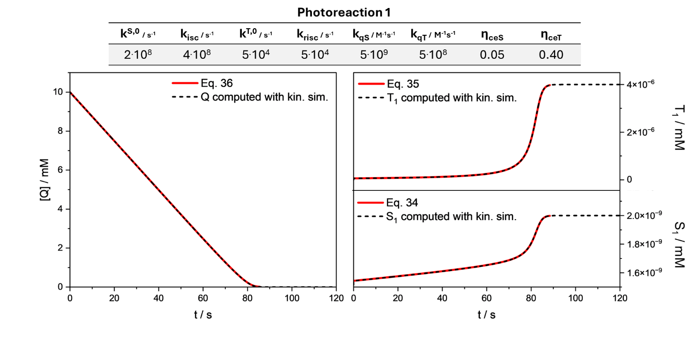
Figure S2: Comparison of the evolution of Q (left), T₁ (right top) and S₁ (right bottom) calculated numerically with the simulator under continuous irradiation (dotted black lines) and with the analytical expressions 34-36 (red solid lines) for photoreaction 1. The input parameters can be found in Table S1.
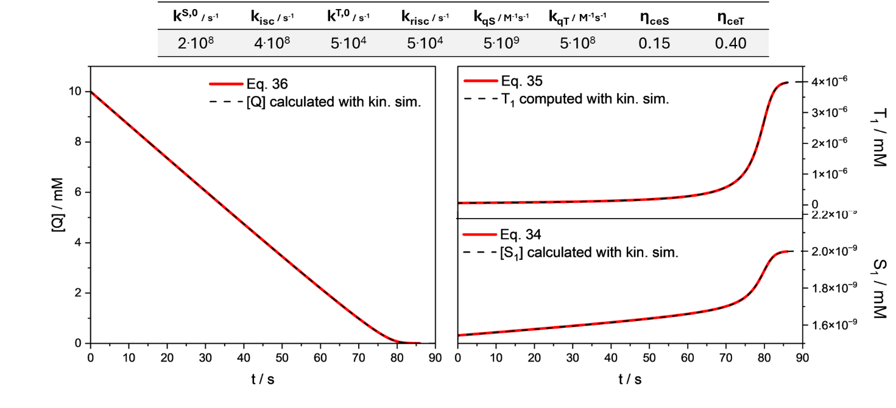
Figure S3: Comparison of the evolution of Q (left), T₁ (right top) and S₁ (right bottom) calculated numerically with the simulator under continuous irradiation (dotted black lines) and with the analytical expressions 34-36 (red solid lines) for photoreaction 2. The input parameters can be found in Table S1.
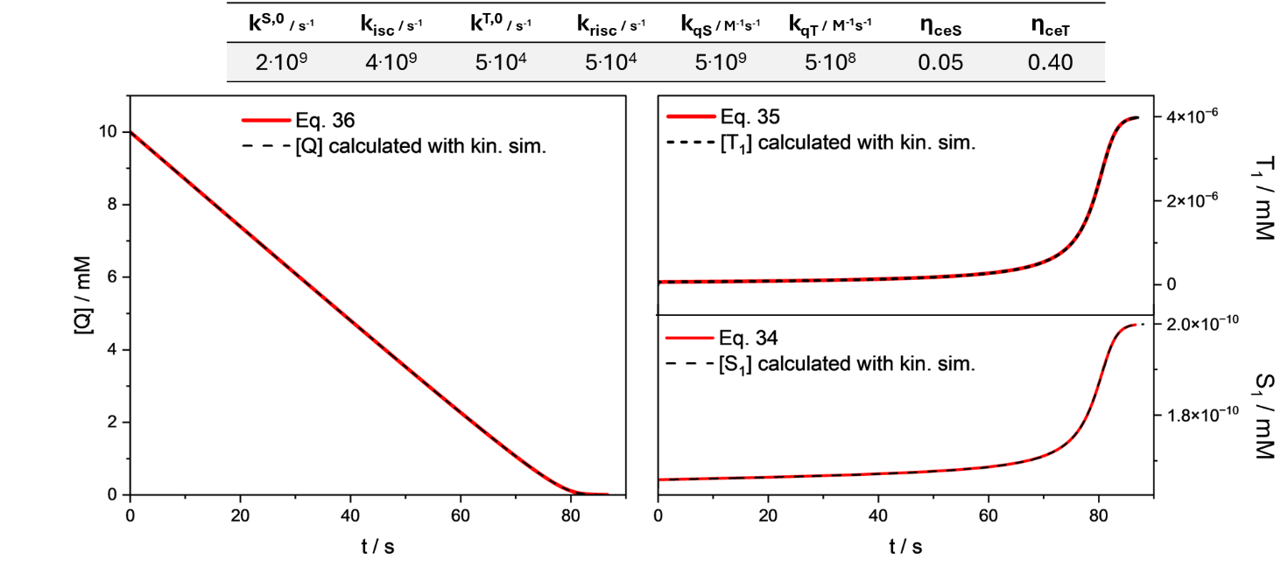
Figure S4: Comparison of the evolution of Q (left), T₁ (right top) and S₁ (right bottom) calculated numerically with the simulator under continuous irradiation (dotted black lines) and with the analytical expressions 34-36 (red solid lines) for photoreaction 3. The input parameters can be found in Table S1.
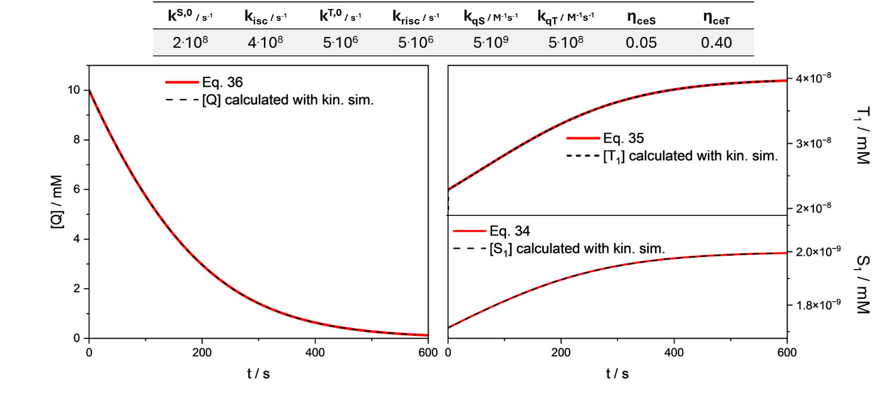
Figure S5: Comparison of the evolution of Q (left), T₁ (right top) and S₁ (right bottom) calculated numerically with the simulator under continuous irradiation (dotted black lines) and with the analytical expressions 34-36 (red solid lines) for photoreaction 4. The input parameters can be found in Table S1.
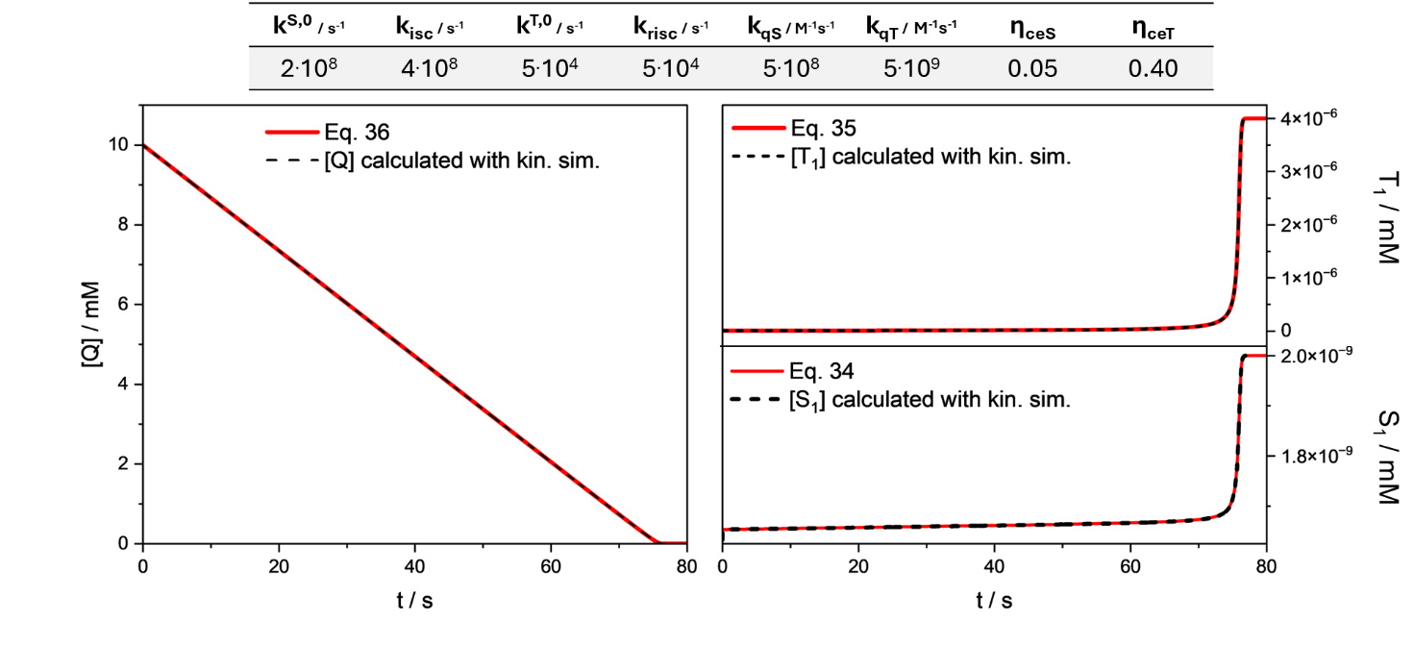
Figure S6: Comparison of the evolution of Q (left), T₁ (right top) and S₁ (right bottom) calculated numerically with the simulator under continuous irradiation (dotted black lines) and with the analytical expressions 34-36 (red solid lines) for photoreaction 5. The input parameters can be found in Table S1.

Proof that most of the time Φ_{B} can be considered constant during reaction in mechanism a
In mechanism a, the quencher of the excited state is the sacrificial donor and not the substrate. Therefore, in this case the consumption of the quencher depends on the ratio [A]₀/[Q]₀: if an excess of [Q]₀ is employed, the concentration of the quencher will not sensitively change during reaction, therefore the quenching efficiency and consequently the photoreaction quantum yield can be considered fairly constant (all lines but the yellow one in Figure S7). On the other hand, when similar concentrations of substrate and quencher are employed, the evolution of the reaction determines a substantial decrease in the quencher concentration, therefore affecting the photoreaction quantum yield (yellow lines in Figure S7). The evolution of the photoreaction quantum yield in mechanism a can be predicted by equation 36, and the Jupiter notebook 3_Modelling-the-evolution-of-a-photoreaction.ipynb provided in the supporting information is able to predict it for specific experimental set ups once the input parameters are given.
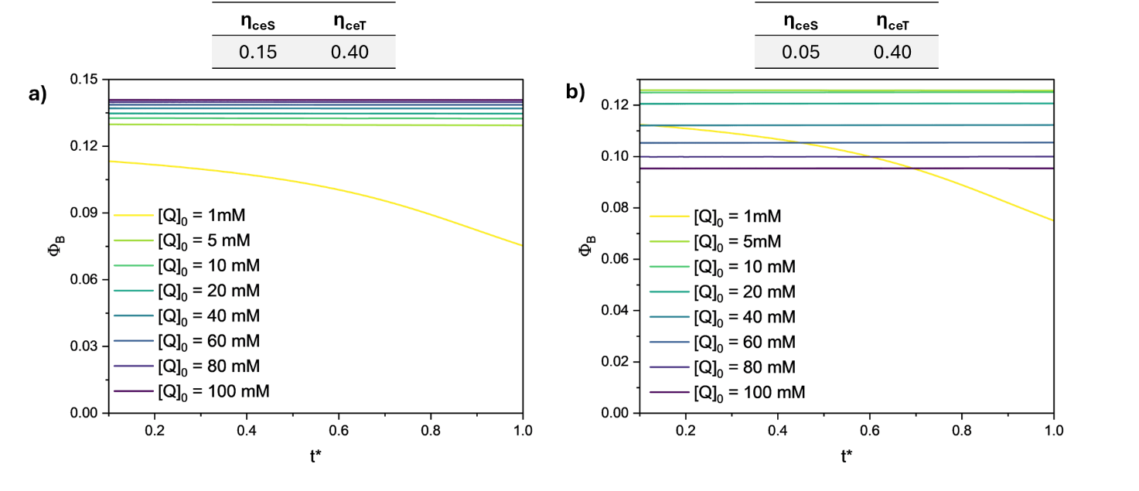
Figure S7: Evolution of Φ_{B} along normalised time (t*=Δt/Δt_{fin}, with Δt_{fin} is defined as the time corresponding to [A]_{t} = 0.01[A]₀) during a photoreaction employing different starting concentration of the quencher. Input parameters of photoreaction 1-2 were employed: I₀=1.10⁻⁶ s⁻¹; [A]₀ =1 mM; k^{S,0}=4.00.10⁸ s⁻¹; k^{T,0}= 5.00.10⁴ s⁻¹; k_{isc}= 2.00.10⁸ s⁻¹; k_{risc}= 5.00.10⁴ s⁻¹; k_{qS} = 5.00.10⁹ s⁻¹M⁻¹; k_{qT}= 5.00.10⁸ s⁻¹M⁻¹. The left plots refer to η_{ceS} = 0.15; η_{ceT} = 0.4 (photoreaction 2), which does not verify condition 42, while right plots refer to η_{ceS} = 0.05; η_{ceT}= 0.4 (photoreaction 1), which verify condition 42.

Mechanism b: dependence of Φ_{B} on the substrate concentration
The same procedure to calculate Φ_{B} employed in SI section 2.5 can be extended to mechanism a. The only difference in the latter case is that the quencher is now the substrate, which actually simplifies the treatment. Under these conditions, the end of the photoreaction is reached when [Q]_{t}=[A]_{t}=0.01[A]₀. Therefore, the formula for Φ_{B} prediction is slightly different:
$$ϕ_{B}=\frac{[ΔB]}{I_{abs}×Δt}=\frac{0.99{×[A]}_{0}}{I_{abs}×Δt_{0.99A_{0}}}=\frac{0.99{×η_{ceS}×[A]}_{0}}{0.99×{[A]}_{0}+η_{ceS}×β×\ln\left(\frac{k_{qS}η_{ceS}k_{qT}{[A]}_{0}+γ}{{0.01×k}_{qS}η_{ceS}k_{qT}{[A]}_{0}+γ}\right)+η_{ceS}×α×ln⁡(100)}$$ | (S66)
Analogously to mechanism a, a [A]₀ value that maximises Φ_{B} can only be found if condition 42 is satisfied. Figure S4 shows the relationship between Φ_{B} and [A]₀ in the same conditions employed for Figure 8 in the main text, but switching from mechanism a to mechanism b. The trend of Φ_{B} is very similar, although the optimal [A]₀ value changes due to the different condition corresponding to the end of photoreaction.
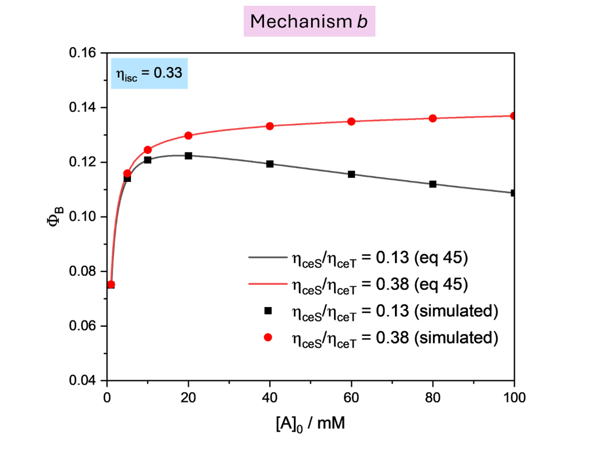
Figure S8: Dependence of photoreaction quantum yield on initial concentration of the quencher in photoreaction 1-2, mechanism b (I₀=1.10⁻⁶ s⁻¹; [A]₀ =1 mM; k^{S,0}=4.00.10⁸ s⁻¹; k^{T,0}= 5.00.10⁴ s⁻¹; k_{isc}= 2.00.10⁸ s⁻¹; k_{risc}= 5.00.10⁴ s⁻¹; k_{qS} = 5.00.10⁹ s⁻¹M⁻¹; k_{qT}= 5.00.10⁸ s⁻¹M⁻¹). The solid lines are obtained with equation S66. The scatter points are obtained by numerical integration of the evolution of [B] in time through the kinetic simulator and calculation of the photoreaction quantum yield at the time corresponding to [B] = 0.99[A]₀. The red plots refer to η_{ceS} = 0.15; η_{ceT} = 0.4, which does not verify condition 42, while black plots refer to η_{ceS} = 0.05; η_{ceT}= 0.4, which verify condition 42.

Collection of simulated quenching experiments (pulsed irradiation) and relative fitting parameters
Table S2: Summary of the simulated quenching experiments performed in this work. The color of the lateral border identifies the type of the system according to the classification given in Figure 4 (green: uncoupled system; yellow: weakly coupled system; orange: coupled system)
 | Input parameters |  |  |  |  |  |  | Output parameters
 |  |  |  |  |  |  |  | Fitting parameters  obtained from T₁ and S₁ decay |  |  |  | Obtained with Stern-Volmer |  | Obtained with eq. 18-21
 | k^{S,0 a} | k_{isc} ª | k^{T,0 a} | k_{risc} ª | k_{qS} ^{b} | k_{qT}^{b} | [Q] / M | A₁ / M | τ ₁ / s | A₂ / M | τ ₂ / s | k_{qp}^{b} | k_{qd}^{b} | k_{qS}^{b} | k_{qT}^{b}
 |  |  |  |  |  |  | 0 | 1.00E-05 | 9.09E-09 | 4.17E-10 | 1.83E-06
 |  |  |  |  |  |  | 2.00E-02 | 1.00E-05 | 8.33E-09 | 4.17E-10 | 9.48E-08
1 | 1.00E+08 | 1.00E+07 | 5.00E+04 | 5.00E+05 | 5.00E+08 | 5.00E+08 | 4.00E-02 | 1.00E-05 | 7.69E-09 | 4.17E-10 | 4.87E-08 | 5.00E+08 | 5.00E+08
 |  |  |  |  |  |  | 6.00E-02 | 1.00E-05 | 7.14E-09 | 4.17E-10 | 3.27E-08
 |  |  |  |  |  |  | 8.00E-02 | 1.00E-05 | 6.67E-09 | 4.17E-10 | 2.47E-08
 |  |  |  |  |  |  | 0 | 1.00E-05 | 9.09E-09 | 4.17E-10 | 1.83E-06
 |  |  |  |  |  |  | 2.00E-02 | 1.00E-05 | 9.08E-09 | 5.04E-10 | 9.48E-08
2 | 1.00E+08 | 1.00E+07 | 5.00E+04 | 5.00E+05 | 5.00E+06 | 5.00E+08 | 4.00E-02 | 1.00E-05 | 9.07E-09 | 6.22E-10 | 4.87E-08 | 5.03E+06 | 5.00E+08 | 5.07e+06 | 5.00e+08
 |  |  |  |  |  |  | 6.00E-02 | 1.00E-05 | 9.07E-09 | 7.86E-10 | 3.27E-08
 |  |  |  |  |  |  | 8.00E-02 | 1.00E-05 | 9.06E-09 | 1.02E-09 | 2.47E-08
 |  |  |  |  |  |  | 0 | 1.00E-05 | 9.09E-09 | 4.17E-10 | 1.83E-06
 |  |  |  |  |  |  | 2.00E-02 | 1.00E-05 | 9.07E-09 | 5.03E-10 | 9.48E-08
3 | 1.00E+08 | 1.00E+07 | 5.00E+04 | 5.00E+05 | 1.00E+07 | 5.00E+08 | 4.00E-02 | 1.00E-05 | 9.06E-09 | 6.19E-10 | 4.87E-08 | 1.00E+07 | 5.00E+08 | 1.01e+07 | 5.00e+08
 |  |  |  |  |  |  | 6.00E-02 | 1.00E-05 | 9.04E-09 | 7.80E-10 | 3.27E-08
 |  |  |  |  |  |  | 8.00E-02 | 1.00E-05 | 9.02E-09 | 1.01E-09 | 2.47E-08
 |  |  |  |  |  |  | 0 | 1.00E-05 | 9.09E-09 | 4.17E-10 | 1.83E-06
 |  |  |  |  |  |  | 2.00E-02 | 1.00E-05 | 9.01E-09 | 4.95E-10 | 9.48E-08
4 | 1.00E+08 | 1.00E+07 | 5.00E+04 | 5.00E+05 | 5.00E+07 | 5.00E+08 | 4.00E-02 | 1.00E-05 | 8.93E-09 | 5.98E-10 | 4.87E-08 | 5.00E+07 | 5.00E+08 | 5.01e+07 | 5.00e+08
 |  |  |  |  |  |  | 6.00E-02 | 1.00E-05 | 8.85E-09 | 7.35E-10 | 3.27E-08
 |  |  |  |  |  |  | 8.00E-02 | 1.00E-05 | 8.77E-09 | 9.27E-10 | 2.47E-08
 |  |  |  |  |  |  | 0 | 1.00E-05 | 9.09E-09 | 4.17E-10 | 1.83E-06
 |  |  |  |  |  |  | 2.00E-02 | 1.00E-05 | 8.93E-09 | 4.86E-10 | 9.48E-08
5 | 1.00E+08 | 1.00E+07 | 5.00E+04 | 5.00E+05 | 1.00E+08 | 5.00E+08 | 4.00E-02 | 1.00E-05 | 8.77E-09 | 5.72E-10 | 4.87E-08 | 1.00E+08 | 5.00E+08 | 1.00e+08 | 5.00e+08
 |  |  |  |  |  |  | 6.00E-02 | 1.00E-05 | 8.62E-09 | 6.85E-10 | 3.27E-08
 |  |  |  |  |  |  | 8.00E-02 | 1.00E-05 | 8.47E-09 | 8.33E-10 | 2.47E-08
 |  |  |  |  |  |  | 0 | 1.00E-05 | 9.09E-09 | 4.17E-10 | 1.83E-06
 |  |  |  |  |  |  | 2.00E-02 | 1.00E-05 | 8.33E-09 | 3.51E-10 | 1.55E-06
6 | 1.00E+08 | 1.00E+07 | 5.00E+04 | 5.00E+05 | 5.00E+08 | 5.00E+06 | 4.00E-02 | 1.00E-05 | 7.69E-09 | 2.99E-10 | 1.34E-06 | 5.00E+08 | 5.02E+06 | 5.00e+08 | 4.98e+06
 |  |  |  |  |  |  | 6.00E-02 | 1.00E-05 | 7.14E-09 | 2.58E-10 | 1.18E-06
 |  |  |  |  |  |  | 8.00E-02 | 1.00E-05 | 6.67E-09 | 2.25E-10 | 1.06E-06
 |  |  |  |  |  |  | 0 | 1.00E-05 | 9.09E-09 | 4.17E-10 | 1.83E-06
 |  |  |  |  |  |  | 2.00E-02 | 1.00E-05 | 8.33E-09 | 3.52E-10 | 1.34E-06
7 | 1.00E+08 | 1.00E+07 | 5.00E+04 | 5.00E+05 | 5.00E+08 | 1.00E+07 | 4.00E-02 | 1.00E-05 | 7.69E-09 | 3.00E-10 | 1.06E-06 | 5.00E+08 | 1.00E+07 | 5.00e+08 | 9.99e+06
 |  |  |  |  |  |  | 6.00E-02 | 1.00E-05 | 7.14E-09 | 2.59E-10 | 8.72E-07
 |  |  |  |  |  |  | 8.00E-02 | 1.00E-05 | 6.67E-09 | 2.26E-10 | 7.43E-07
Table S2 continued
 | Input parameters |  |  |  |  |  |  | Output parameters
 |  |  |  |  |  |  |  | Fitting parameters  obtained from T₁ and S₁ decay |  |  |  | Obtained with Stern-Volmer |  | Obtained with eq. 18-21
 | k^{S,0 a} | k_{isc} ª | k^{T,0 a} | k_{risc} ª | k_{qS} ^{b} | k_{qT}^{b} | [Q] / M | A₁ / M | τ ₁ / s | A₂ / M | τ ₂ / s | k_{qp}^{b} | k_{qd}^{b} | k_{qS}^{b} | k_{qT}^{b}
 |  |  |  |  |  |  | 0 | 1.00E-05 | 9.09E-09 | 4.17E-10 | 1.83E-06
 |  |  |  |  |  |  | 2.00E-02 | 1.00E-05 | 8.33E-09 | 3.56E-10 | 6.47E-07
8 | 1.00E+08 | 1.00E+07 | 5.00E+04 | 5.00E+05 | 5.00E+08 | 5.00E+07 | 4.00E-02 | 1.00E-05 | 7.69E-09 | 3.08E-10 | 3.93E-07 | 5.00E+08 | 5.00E+07 | 5.00e+08 | 5.00e+07
 |  |  |  |  |  |  | 6.00E-02 | 1.00E-05 | 7.14E-09 | 2.69E-10 | 2.82E-07
 |  |  |  |  |  |  | 8.00E-02 | 1.00E-05 | 6.67E-09 | 2.36E-10 | 2.20E-07
 |  |  |  |  |  |  | 0 | 1.00E-05 | 9.09E-09 | 4.17E-10 | 1.83E-06
 |  |  |  |  |  |  | 2.00E-02 | 1.00E-05 | 8.33E-09 | 3.62E-10 | 3.93E-07
9 | 1.00E+08 | 1.00E+07 | 5.00E+04 | 5.00E+05 | 5.00E+08 | 1.00E+08 | 4.00E-02 | 1.00E-05 | 7.69E-09 | 3.18E-10 | 2.20E-07 | 5.00E+08 | 1.00E+08 | 5.00e+08 | 1.00e+08
 |  |  |  |  |  |  | 6.00E-02 | 1.00E-05 | 7.14E-09 | 2.81E-10 | 1.53E-07
 |  |  |  |  |  |  | 8.00E-02 | 1.00E-05 | 6.67E-09 | 2.50E-10 | 1.17E-07
 |  |  |  |  |  |  | 0 | 1.00E-05 | 9.09E-09 | 4.17E-10 | 1.83E-06
 |  |  |  |  |  |  | 1.00E-02 | 1.00E-05 | 8.33E-09 | 5.05E-10 | 4.87E-08
10 | 1.00E+08 | 1.00E+07 | 5.00E+04 | 5.00E+05 | 5.00E+08 | 1.00E+09 | 2.00E-02 | 1.00E-05 | 7.69E-09 | 6.25E-10 | 2.47E-08 | 5.00E+08 | 1.00E+09 | 5.00e+08 | 1.00e+09
 |  |  |  |  |  |  | 3.00E-02 | 1.00E-05 | 7.14E-09 | 7.92E-10 | 1.65E-08
 |  |  |  |  |  |  | 4.00E-02 | 1.00E-05 | 6.67E-09 | 1.04E-09 | 1.24E-08
 |  |  |  |  |  |  | 0 | 1.00E-05 | 3.33E-09 | 1.11E-09 | 1.94E-06
 |  |  |  |  |  |  | 2.00E-02 | 1.00E-05 | 3.23E-09 | 1.11E-09 | 9.51E-08
11 | 1.00E+08 | 2.00E+08 | 5.00E+04 | 5.00E+05 | 5.00E+08 | 5.00E+08 | 4.00E-02 | 1.00E-05 | 3.12E-09 | 1.11E-09 | 4.87E-08 | 5.00E+08 | 5.00E+08 | - | -
 |  |  |  |  |  |  | 6.00E-02 | 1.00E-05 | 3.03E-09 | 1.11E-09 | 3.28E-08
 |  |  |  |  |  |  | 8.00E-02 | 1.00E-05 | 2.94E-09 | 1.11E-09 | 2.47E-08
 |  |  |  |  |  |  | 0 | 1.00E-05 | 3.33E-09 | 1.11E-09 | 1.94E-06
 |  |  |  |  |  |  | 2.00E-02 | 1.00E-05 | 3.23E-09 | 1.19E-09 | 4.87E-08
12 | 1.00E+08 | 2.00E+08 | 5.00E+04 | 5.00E+05 | 5.00E+08 | 1.00E+09 | 4.00E-02 | 1.00E-05 | 3.12E-09 | 1.28E-09 | 2.47E-08 | 5.00E+08 | 1.00E+09 | 5.04e+08 | 9.96e+08
 |  |  |  |  |  |  | 6.00E-02 | 1.00E-05 | 3.03E-09 | 1.38E-09 | 1.65E-08
 |  |  |  |  |  |  | 8.00E-02 | 1.00E-05 | 2.94E-09 | 1.48E-09 | 1.24E-08
 |  |  |  |  |  |  | 0 | 1.00E-05 | 3.33E-09 | 1.11E-09 | 1.94E-06
 |  |  |  |  |  |  | 1.00E-02 | 1.00E-05 | 3.23E-09 | 2.28E-09 | 9.95E-09
13 | 1.00E+08 | 2.00E+08 | 5.00E+04 | 5.00E+05 | 5.00E+08 | 5.00E+09 | 2.00E-02 | 9.99E-06 | 3.12E-09 | 6.99E-09 | 4.99E-09 | 5.07e+08 | 4.99e+09 | 5.02e+08 | 5.00e+09
 |  |  |  |  |  |  | 4.00E-02 | 9.89E-06 | 3.03E-09 | 1.11E-07 | 3.33E-09
 |  |  |  |  |  |  | 6.00E-02 | 2.71E-08 | 2.50E-09 | 9.97E-06 | 2.94E-09
 |  |  |  |  |  |  | 0 | 1.00E-05 | 3.33E-09 | 1.11E-09 | 1.94E-06
 |  |  |  |  |  |  | 2.00E-02 | 1.00E-05 | 3.12E-09 | 1.04E-09 | 9.51E-08
14 | 1.00E+08 | 2.00E+08 | 5.00E+04 | 5.00E+05 | 1.00E+09 | 5.00E+08 | 4.00E-02 | 1.00E-05 | 2.94E-09 | 9.80E-10 | 4.87E-08 | 1.00E+09 | 5.00E+08 | 9.97e+08 | 5.03e+08
 |  |  |  |  |  |  | 6.00E-02 | 1.00E-05 | 2.78E-09 | 9.21E-10 | 3.28E-08
 |  |  |  |  |  |  | 8.00E-02 | 1.00E-05 | 2.63E-09 | 8.68E-10 | 2.47E-08
 |  |  |  |  |  |  | 0 | 1.00E-05 | 3.33E-09 | 1.11E-09 | 1.94E-06
 |  |  |  |  |  |  | 2.00E-02 | 1.00E-05 | 2.50E-09 | 6.59E-10 | 9.50E-08
15 | 1.00E+08 | 2.00E+08 | 5.00E+04 | 5.00E+05 | 5.00E+09 | 5.00E+08 | 4.00E-02 | 1.00E-05 | 2.00E-09 | 4.35E-10 | 4.87E-08 | 5.00E+09 | 5.00E+08 | 5.00e+09 | 5.00e+08
 |  |  |  |  |  |  | 6.00E-02 | 1.00E-05 | 1.67E-09 | 3.08E-10 | 3.28E-08
 |  |  |  |  |  |  | 8.00E-02 | 1.00E-05 | 1.43E-09 | 2.30E-10 | 2.47E-08
Table S2 continued
 | Input parameters |  |  |  |  |  |  | Output parameters
 |  |  |  |  |  |  |  | Fitting parameters  obtained from T₁ and S₁ decay |  |  |  | Obtained with Stern-Volmer |  | Obtained with eq. 18-21
 | k^{S,0 a} | k_{isc} ª | k^{T,0 a} | k_{risc} ª | k_{qS} ^{b} | k_{qT}^{b} | [Q] / M | A₁ / M | τ ₁ / s | A₂ / M | τ ₂ / s | k_{qp}^{b} | k_{qd}^{b} | k_{qS}^{b} | k_{qT}^{b}
 |  |  |  |  |  |  | 0 | 9.99E-06 | 3.33E-09 | 1.15E-08 | 1.94E-07
 |  |  |  |  |  |  | 2.00E-02 | 9.99E-06 | 3.22E-09 | 1.15E-08 | 6.60E-08
16 | 1.00E+08 | 2.00E+08 | 5.00E+05 | 5.00E+06 | 5.00E+08 | 5.00E+08 | 4.00E-02 | 9.99E-06 | 3.12E-09 | 1.15E-08 | 3.97E-08 | 5.00E+08 | 5.00E+08 | - | -
 |  |  |  |  |  |  | 6.00E-02 | 9.99E-06 | 3.03E-09 | 1.15E-08 | 2.84E-08
 |  |  |  |  |  |  | 8.00E-02 | 9.99E-06 | 2.94E-09 | 1.15E-08 | 2.21E-08
 |  |  |  |  |  |  | 0 | 9.99E-06 | 3.33E-09 | 1.15E-08 | 1.94E-07
 |  |  |  |  |  |  | 2.00E-02 | 9.99E-06 | 3.22E-09 | 1.23E-08 | 3.98E-08
17 | 1.00E+08 | 2.00E+08 | 5.00E+05 | 5.00E+06 | 5.00E+08 | 1.00E+09 | 4.00E-02 | 9.99E-06 | 3.12E-09 | 1.32E-08 | 2.22E-08 | 5.01E+08 | 9.99E+08 | 5.03e+08 | 9.97e+08
 |  |  |  |  |  |  | 6.00E-02 | 9.99E-06 | 3.03E-09 | 1.42E-08 | 1.54E-08
 |  |  |  |  |  |  | 8.00E-02 | 9.98E-06 | 2.94E-09 | 1.54E-08 | 1.17E-08
 |  |  |  |  |  |  | 0 | 9.99E-06 | 3.33E-09 | 1.15E-08 | 1.94E-07
 |  |  |  |  |  |  | 2.00E-02 | 9.98E-06 | 3.22E-09 | 2.37E-08 | 9.52E-09
18 | 1.00E+08 | 2.00E+08 | 5.00E+05 | 5.00E+06 | 5.00E+08 | 5.00E+09 | 4.00E-02 | 9.93E-06 | 3.12E-09 | 7.46E-08 | 4.89E-09 | 1.18E+09 | 4.32E+09 | 5.01e+08 | 5.00e+09
 |  |  |  |  |  |  | 6.00E-02 | 8.87E-06 | 3.00E-09 | 1.13E-06 | 3.31E-09
 |  |  |  |  |  |  | 8.00E-02 | 2.18E-07 | 2.46E-09 | 9.78E-06 | 2.95E-09
 |  |  |  |  |  |  | 0 | 9.99E-06 | 3.33E-09 | 1.15E-08 | 1.94E-07
 |  |  |  |  |  |  | 2.00E-02 | 9.99E-06 | 3.12E-09 | 1.08E-08 | 6.59E-08
19 | 1.00E+08 | 2.00E+08 | 5.00E+05 | 5.00E+06 | 1.00E+09 | 5.00E+08 | 4.00E-02 | 9.99E-06 | 2.94E-09 | 1.01E-08 | 3.97E-08 | 1.00+08 | 5.00E+08 | 9.99e+08 | 5.02e+08
 |  |  |  |  |  |  | 6.00E-02 | 9.99E-06 | 2.78E-09 | 9.47E-09 | 2.84E-08
 |  |  |  |  |  |  | 8.00E-02 | 9.99E-06 | 2.63E-09 | 8.91E-09 | 2.21E-08
 |  |  |  |  |  |  | 0 | 9.99E-06 | 3.33E-09 | 1.15E-08 | 1.94E-07
 |  |  |  |  |  |  | 2.00E-02 | 9.99E-06 | 2.50E-09 | 6.75E-09 | 6.56E-08
20 | 1.00E+08 | 2.00E+08 | 5.00E+05 | 5.00E+06 | 5.00E+09 | 5.00E+08 | 4.00E-02 | 1.00E-05 | 2.00E-09 | 4.44E-09 | 3.95E-08 | 5.00E+09 | 5.02E+08 | 5.00e+09 | 4.99e+08
 |  |  |  |  |  |  | 6.00E-02 | 1.00E-05 | 1.67E-09 | 3.14E-09 | 2.83E-08
 |  |  |  |  |  |  | 8.00E-02 | 1.00E-05 | 1.43E-09 | 2.33E-09 | 2.21E-08
 |  |  |  |  |  |  | 0 | 1.00E-05 | 9.09E-09 | 1.66E-09 | 3.55E-06
 |  |  |  |  |  |  | 2.00E-02 | 1.00E-05 | 8.33E-09 | 1.66E-09 | 9.73E-08
21 | 1.00E+08 | 1.00E+07 | 2.00E+05 | 1.00E+05 | 5.00E+08 | 5.00E+08 | 4.00E-02 | 1.00E-05 | 7.69E-09 | 1.66E-09 | 4.93E-08 | 5.00E+08 | 5.00E+08 | - | -
 |  |  |  |  |  |  | 6.00E-02 | 1.00E-05 | 7.14E-09 | 1.66E-09 | 3.30E-08
 |  |  |  |  |  |  | 8.00E-02 | 1.00E-05 | 6.67E-09 | 1.66E-09 | 2.48E-08
 |  |  |  |  |  |  | 0 | 1.00E-05 | 9.09E-09 | 1.66E-09 | 3.55E-06
 |  |  |  |  |  |  | 2.00E-02 | 1.00E-05 | 8.33E-09 | 2.01E-09 | 4.93E-08
22 | 1.00E+08 | 1.00E+07 | 2.00E+05 | 1.00E+05 | 5.00E+08 | 1.00E+09 | 4.00E-02 | 1.00E-05 | 7.69E-09 | 2.48E-09 | 2.48E-08 | 5.00E+08 | 1.00E+09 | 5.00e+08 | 1.00e+09
 |  |  |  |  |  |  | 6.00E-02 | 1.00E-05 | 7.14E-09 | 3.15E-09 | 1.66E-08
 |  |  |  |  |  |  | 8.00E-02 | 1.00E-05 | 6.67E-09 | 4.11E-09 | 1.25E-08
 |  |  |  |  |  |  | 0 | 1.00E-05 | 9.09E-09 | 1.66E-09 | 3.55E-06
 |  |  |  |  |  |  | 2.00E-02 | 9.95E-06 | 8.33E-09 | 5.08E-08 | 9.98E-09
23 | 1.00E+08 | 1.00E+07 | 2.00E+05 | 1.00E+05 | 5.00E+08 | 5.00E+09 | 4.00E-02 | 4.04E-09 | 4.99E-09 | 1.00E-05 | 7.69E-09 | 3.80E+09 | 1.70E+09 | 5.00e+08 | 5.00e+09
 |  |  |  |  |  |  | 6.00E-02 | 7.78E-10 | 3.33E-09 | 1.00E-05 | 7.14E-09
 |  |  |  |  |  |  | 8.00E-02 | 3.19E-10 | 2.50E-09 | 1.00E-05 | 6.67E-09
Table S2 continued
 | Input parameters |  |  |  |  |  |  | Output parameters
 |  |  |  |  |  |  |  | Fitting parameters  obtained from T₁ and S₁ decay |  |  |  | Obtained with Stern-Volmer |  | Obtained with eq. 18-21
 | k^{S,0 a} | k_{isc} ª | k^{T,0 a} | k_{risc} ª | k_{qS} ^{b} | k_{qT}^{b} | [Q] / M | A₁ / M | τ ₁ / s | A₂ / M | τ ₂ / s | k_{qp}^{b} | k_{qd}^{b} | k_{qS}^{b} | k_{qT}^{b}
 |  |  |  |  |  |  | 0 | 1.00E-05 | 9.09E-09 | 1.66E-09 | 3.55E-06
 |  |  |  |  |  |  | 2.00E-02 | 1.00E-05 | 7.69E-09 | 1.40E-09 | 9.72E-08
24 | 1.00E+08 | 1.00E+07 | 2.00E+05 | 1.00E+05 | 1.00E+09 | 5.00E+08 | 4.00E-02 | 1.00E-05 | 6.67E-09 | 1.19E-09 | 4.93E-08 | 1.00E+09 | 5.00E+08 | 1.00e+09 | 5.00e+08
 |  |  |  |  |  |  | 6.00E-02 | 1.00E-05 | 5.88E-09 | 1.02E-09 | 3.30E-08
 |  |  |  |  |  |  | 8.00E-02 | 1.00E-05 | 5.26E-09 | 8.92E-10 | 2.48E-08
 |  |  |  |  |  |  | 0 | 1.00E-05 | 9.09E-09 | 1.66E-09 | 3.55E-06
 |  |  |  |  |  |  | 2.00E-02 | 1.00E-05 | 4.76E-09 | 5.01E-10 | 9.72E-08
25 | 1.00E+08 | 1.00E+07 | 2.00E+05 | 1.00E+05 | 5.00E+09 | 5.00E+08 | 4.00E-02 | 1.00E-05 | 3.23E-09 | 2.38E-10 | 4.93E-08 | 5.00E+09 | 5.00E+08 | 5.00e+09 | 4.99e+08
 |  |  |  |  |  |  | 6.00E-02 | 1.00E-05 | 2.44E-09 | 1.39E-10 | 3.30E-08
 |  |  |  |  |  |  | 8.00E-02 | 1.00E-05 | 1.96E-09 | 9.07E-11 | 2.48E-08
 |  |  |  |  |  |  | 0 | 9.98E-06 | 9.08E-09 | 1.74E-08 | 3.55E-07
 |  |  |  |  |  |  | 2.00E-02 | 9.98E-06 | 8.32E-09 | 1.74E-08 | 7.80E-08
26 | 1.00E+08 | 1.00E+07 | 2.00E+06 | 1.00E+06 | 5.00E+08 | 5.00E+08 | 4.00E-02 | 9.98E-06 | 7.68E-09 | 1.74E-08 | 4.38E-08 | 5.00E+08 | 5.00E+08 | - | -
 |  |  |  |  |  |  | 6.00E-02 | 9.98E-06 | 7.13E-09 | 1.74E-08 | 3.05E-08
 |  |  |  |  |  |  | 8.00E-02 | 9.98E-06 | 6.66E-09 | 1.74E-08 | 2.34E-08
 |  |  |  |  |  |  | 0 | 9.98E-06 | 9.08E-09 | 1.74E-08 | 3.55E-07
 |  |  |  |  |  |  | 2.00E-02 | 9.98E-06 | 8.32E-09 | 2.11E-08 | 4.39E-08
27 | 1.00E+08 | 1.00E+07 | 2.00E+06 | 1.00E+06 | 5.00E+08 | 1.00E+09 | 4.00E-02 | 9.97E-06 | 7.68E-09 | 2.62E-08 | 2.34E-08 | 5.01E+08 | 9.99E+08 | 5.00e+08 | 1.00e+09
 |  |  |  |  |  |  | 6.00E-02 | 9.97E-06 | 7.13E-09 | 3.34E-08 | 1.59E-08
 |  |  |  |  |  |  | 8.00E-02 | 9.96E-06 | 6.65E-09 | 4.40E-08 | 1.21E-08
 |  |  |  |  |  |  | 0 | 9.98E-06 | 9.08E-09 | 1.74E-08 | 3.55E-07
 |  |  |  |  |  |  | 2.00E-02 | 9.42E-06 | 8.26E-09 | 5.75E-07 | 9.81E-09
28 | 1.00E+08 | 1.00E+07 | 2.00E+06 | 1.00E+06 | 5.00E+08 | 5.00E+09 | 4.00E-02 | 3.71E-08 | 4.92E-09 | 9.96E-06 | 7.71E-09 | 3.84E+09 | 1.66E+09 | 5.00e+08 | 5.00e+09
 |  |  |  |  |  |  | 6.00E-02 | 7.51E-09 | 3.30E-09 | 9.99E-06 | 7.15E-09
 |  |  |  |  |  |  | 8.00E-02 | 3.12E-09 | 2.48E-09 | 1.00E-05 | 6.67E-09
 |  |  |  |  |  |  | 0 | 9.98E-06 | 9.08E-09 | 1.74E-08 | 3.55E-07
 |  |  |  |  |  |  | 2.00E-02 | 9.99E-06 | 7.68E-09 | 1.45E-08 | 7.79E-08
29 | 1.00E+08 | 1.00E+07 | 2.00E+06 | 1.00E+06 | 1.00E+09 | 5.00E+08 | 4.00E-02 | 9.99E-06 | 6.66E-09 | 1.24E-08 | 4.38E-08 | 9.99E+08 | 5.01E+08 | 1.00e+09 | 5.00e+08
 |  |  |  |  |  |  | 6.00E-02 | 9.99E-06 | 5.88E-09 | 1.06E-08 | 3.04E-08
 |  |  |  |  |  |  | 8.00E-02 | 9.99E-06 | 5.26E-09 | 9.23E-09 | 2.33E-08
 |  |  |  |  |  |  | 0 | 9.98E-06 | 9.08E-09 | 1.74E-08 | 3.55E-07
 |  |  |  |  |  |  | 1.00E-02 | 9.99E-06 | 6.24E-09 | 8.63E-09 | 1.27E-07
30 | 1.00E+08 | 1.00E+07 | 2.00E+06 | 1.00E+06 | 5.00E+09 | 5.00E+08 | 2.00E-02 | 9.99E-06 | 4.76E-09 | 5.15E-09 | 7.75E-08 | 5.00E+09 | 5.02E+08 | 5.00e+09 | 4.99e+08
 |  |  |  |  |  |  | 3.00E-02 | 1.00E-05 | 3.84E-09 | 3.41E-09 | 5.58E-08
 |  |  |  |  |  |  | 4.00E-02 | 1.00E-05 | 3.23E-09 | 2.43E-09 | 4.36E-08
 |  |  |  |  |  |  | 0 | 1.00E-05 | 3.33E-09 | 4.45E-09 | 6.00E-06
 |  |  |  |  |  |  | 2.00E-02 | 1.00E-05 | 3.22E-09 | 4.45E-09 | 9.84E-08
31 | 1.00E+08 | 2.00E+08 | 2.00E+05 | 1.00E+05 | 5.00E+08 | 5.00E+08 | 4.00E-02 | 1.00E-05 | 3.12E-09 | 4.45E-09 | 4.96E-08 | 5.00E+08 | 5.00E+08 | - | -
 |  |  |  |  |  |  | 6.00E-02 | 1.00E-05 | 3.03E-09 | 4.45E-09 | 3.31E-08
 |  |  |  |  |  |  | 8.00E-02 | 1.00E-05 | 2.94E-09 | 4.45E-09 | 2.49E-08
Table S2 continued
 | Input parameters |  |  |  |  |  |  | Output parameters
 |  |  |  |  |  |  |  | Fitting parameters  obtained from T₁ and S₁ decay |  |  |  | Obtained with Stern-Volmer |  | Obtained with eq. 18-21
 | k^{S,0 a} | k_{isc} ª | k^{T,0 a} | k_{risc} ª | k_{qS} ^{b} | k_{qT}^{b} | [Q] / M | A₁ / M | τ ₁ / s | A₂ / M | τ ₂ / s | k_{qp}^{b} | k_{qd}^{b} | k_{qS}^{b} | k_{qT}^{b}
 |  |  |  |  |  |  | 0 | 1.00E-05 | 3.33E-09 | 4.45E-09 | 6.00E-06
 |  |  |  |  |  |  | 2.00E-02 | 1.00E-05 | 3.22E-09 | 4.76E-09 | 4.96E-08
32 | 1.00E+08 | 2.00E+08 | 2.00E+05 | 1.00E+05 | 5.00E+08 | 1.00E+09 | 4.00E-02 | 9.99E-06 | 3.12E-09 | 5.11E-09 | 2.49E-08 | 5.00E+08 | 1.00E+09 | 5.04e+08 | 9.96e+08
 |  |  |  |  |  |  | 6.00E-02 | 9.99E-06 | 3.03E-09 | 5.49E-09 | 1.66E-08
 |  |  |  |  |  |  | 8.00E-02 | 9.99E-06 | 2.94E-09 | 5.92E-09 | 1.25E-08
 |  |  |  |  |  |  | 0 | 1.00E-05 | 3.33E-09 | 4.45E-09 | 6.00E-06
 |  |  |  |  |  |  | 1.00E-02 | 9.99E-06 | 3.28E-09 | 6.15E-09 | 1.99E-08
33 | 1.00E+08 | 2.00E+08 | 2.00E+05 | 1.00E+05 | 5.00E+08 | 5.00E+09 | 2.00E-02 | 9.99E-06 | 3.22E-09 | 9.07E-09 | 9.99E-09 | 5.06e+08 | 4.99e+09 | 5.04e+08 | 5.00e+09
 |  |  |  |  |  |  | 3.00E-02 | 9.99E-06 | 3.17E-09 | 1.47E-08 | 6.66E-09
 |  |  |  |  |  |  | 4.00E-02 | 9.97E-06 | 3.12E-09 | 2.77E-08 | 5.00E-09
 |  |  |  |  |  |  | 0 | 1.00E-05 | 3.33E-09 | 4.45E-09 | 6.00E-06
 |  |  |  |  |  |  | 2.00E-02 | 1.00E-05 | 3.12E-09 | 4.17E-09 | 9.83E-08
34 | 1.00E+08 | 2.00E+08 | 2.00E+05 | 1.00E+05 | 1.00E+09 | 5.00E+08 | 4.00E-02 | 1.00E-05 | 2.94E-09 | 3.91E-09 | 4.96E-08 | 1.00E+09 | 5.00E+08 | 9.97e+08 | 5.03e+08
 |  |  |  |  |  |  | 6.00E-02 | 1.00E-05 | 2.78E-09 | 3.68E-09 | 3.31E-08
 |  |  |  |  |  |  | 8.00E-02 | 1.00E-05 | 2.63E-09 | 3.46E-09 | 2.49E-08
 |  |  |  |  |  |  | 0 | 1.00E-05 | 3.33E-09 | 4.45E-09 | 6.00E-06
 |  |  |  |  |  |  | 2.00E-02 | 1.00E-05 | 2.50E-09 | 2.63E-09 | 9.81E-08
35 | 1.00E+08 | 2.00E+08 | 2.00E+05 | 1.00E+05 | 5.00E+09 | 5.00E+08 | 4.00E-02 | 1.00E-05 | 2.00E-09 | 1.74E-09 | 4.95E-08 | 5.00E+09 | 5.01E+08 | 5.00e+09 | 5.00e+08
 |  |  |  |  |  |  | 6.00E-02 | 1.00E-05 | 1.67E-09 | 1.23E-09 | 3.31E-08
 |  |  |  |  |  |  | 8.00E-02 | 1.00E-05 | 1.43E-09 | 9.19E-10 | 2.49E-08
 |  |  |  |  |  |  | 0 | 9.53E-06 | 3.18E-09 | 4.72E-07 | 6.28E-08
 |  |  |  |  |  |  | 2.00E-02 | 9.53E-06 | 3.09E-09 | 4.72E-07 | 3.86E-08
36 | 1.00E+08 | 2.00E+08 | 2.00E+07 | 1.00E+07 | 5.00E+08 | 5.00E+08 | 4.00E-02 | 9.53E-06 | 2.99E-09 | 4.72E-07 | 2.78E-08 | 5.00E+08 | 5.00E+08 | - | -
 |  |  |  |  |  |  | 6.00E-02 | 9.53E-06 | 2.91E-09 | 4.72E-07 | 2.18E-08
 |  |  |  |  |  |  | 8.00E-02 | 9.53E-06 | 2.82E-09 | 4.72E-07 | 1.79E-08
 |  |  |  |  |  |  | 0 | 9.53E-06 | 3.18E-09 | 4.72E-07 | 6.28E-08
 |  |  |  |  |  |  | 2.00E-02 | 9.50E-06 | 3.08E-09 | 5.04E-07 | 2.82E-08
37 | 1.00E+08 | 2.00E+08 | 2.00E+07 | 1.00E+07 | 5.00E+08 | 1.00E+09 | 4.00E-02 | 9.46E-06 | 2.98E-09 | 5.39E-07 | 1.82E-08 | 5.27E+08 | 9.73E+08 | 5.02e+08 | 9.98e+08
 |  |  |  |  |  |  | 6.00E-02 | 9.42E-06 | 2.89E-09 | 5.77E-07 | 1.34E-08
 |  |  |  |  |  |  | 8.00E-02 | 9.38E-06 | 2.81E-09 | 6.19E-07 | 1.07E-08
 |  |  |  |  |  |  | 0 | 9.53E-06 | 3.18E-09 | 4.72E-07 | 6.28E-08
 |  |  |  |  |  |  | 2.00E-02 | 9.09E-06 | 3.03E-09 | 9.09E-07 | 9.09E-09
38 | 1.00E+08 | 2.00E+08 | 2.00E+07 | 1.00E+07 | 5.00E+08 | 5.00E+09 | 4.00E-02 | 7.90E-06 | 2.84E-09 | 2.10E-06 | 5.07E-09 | 1.80E+09 | 3.70E+09 | 5.01e+08 | 5.00e+09
 |  |  |  |  |  |  | 6.00E-02 | 5.00E-06 | 2.54E-09 | 5.00E-06 | 3.75E-09
 |  |  |  |  |  |  | 8.00E-02 | 2.10E-06 | 2.16E-09 | 7.90E-06 | 3.25E-09
 |  |  |  |  |  |  | 0 | 9.53E-06 | 3.18E-09 | 4.72E-07 | 6.28E-08
 |  |  |  |  |  |  | 2.00E-02 | 9.56E-06 | 3.00E-09 | 4.43E-07 | 3.79E-08
39 | 1.00E+08 | 2.00E+08 | 2.00E+07 | 1.00E+07 | 1.00E+09 | 5.00E+08 | 4.00E-02 | 9.58E-06 | 2.83E-09 | 4.17E-07 | 2.72E-08 | 9.79E+08 | 5.21E+08 | 1.00e+09 | 5.01e+08
 |  |  |  |  |  |  | 6.00E-02 | 9.61E-06 | 2.68E-09 | 3.93E-07 | 2.12E-08
 |  |  |  |  |  |  | 8.00E-02 | 9.63E-06 | 2.55E-09 | 3.71E-07 | 1.74E-08
Table S2 continued
 | Input parameters |  |  |  |  |  |  | Output parameters
 |  |  |  |  |  |  |  | Fitting parameters  obtained from T₁ and S₁ decay |  |  |  | Obtained with Stern-Volmer^{c} |  | Obtained with eq. 18-21^{c}
 | k^{S,0 a} | k_{isc} ª | k^{T,0 a} | k_{risc} ª | k_{qS} ^{b} | k_{qT}^{b} | [Q] / M | A₁ / M | τ ₁ / s | A₂ / M | τ ₂ / s | k_{qp}^{b} | k_{qd}^{b} | k_{qS}^{b} | k_{qT}^{b}
 |  |  |  |  |  |  | 0 | 9.53E-06 | 3.18E-09 | 4.72E-07 | 6.28E-08
 |  |  |  |  |  |  | 2.00E-02 | 9.72E-06 | 2.43E-09 | 2.83E-07 | 3.42E-08
40 | 1.00E+08 | 2.00E+08 | 2.00E+07 | 1.00E+07 | 5.00E+09 | 5.00E+08 | 4.00E-02 | 9.81E-06 | 1.97E-09 | 1.87E-07 | 2.42E-08 | 4.91e+09 | 5.95E+08 | 5.00e+09 | 4.99e+08
 |  |  |  |  |  |  | 6.00E-02 | 9.87E-06 | 1.65E-09 | 1.32E-07 | 1.90E-08
 |  |  |  |  |  |  | 8.00E-02 | 9.90E-06 | 1.42E-09 | 9.78E-08 | 1.57E-08
ªExpressed in s⁻¹
^{b}Expressed in M⁻¹s⁻¹
^{c}See SI section 1.2 for more details on the workflow for obtaining k_{qp}, k_{qd}, k_{qS}, k_{qT} values.
Table S2 collects the results of a selected manifold of simulated quenching experiment performed as described in SI section 1.1. Under the Input parameters, all the kinetic constants and quenching concentration provided to the simulating program as detailed in SI section 1.2 are listed. Output parameters collect the values obtained by fitting the simulated decays and later by fitting the obtained lifetimes by Stern-Volmer analysis or by equations 18-21, as described in the SI section 1.2.
We selected this manifold of simulated experiments to exemplify the general rules summarised in Figure 4 of the main text:
- Experiments 1-10 reflect an uncoupled system, with k^{S,0}≥10k_{isc} and k^{T,0}≥k_{risc}, and the reported results show that, under all the conditions explored, the Stern-Volmer treatment remains well reliable for the evaluation of kqS and kqT, and we can safely state that in this case
$$k_{qS}≈k_{qp}$$
$$k_{qT}≈k_{qd}$$
- Experiments 11-30 represent a weakly coupled system, with either k^{S,0}∽10k_{isc} (exp. 11-20) or k^{T,0}∽10k_{risc} (exp. 21-30). Under this conditions, Stern-Volmer treatment is generally reliable, but some entries show significant deviation of k_{qp}, k_{qd} from the input k_{qS}, k_{qT} (exp. 18, 23, 28, highlighted in red in Table S1). All these experiments are characterized by k_{qT}>k_{qS}, as predicted in Figure 4 of the main text.
- Experiments 31-40 represent a coupled system, with both k^{S,0}∽10k_{isc} and k^{T,0}∽10k_{risc}. Under this conditions, Stern-Volmer treatment is well reliable only if τ ₂⁰>> τ ₁⁰ (exp. 31-35) or k_{qS}=k_{qT} (exp.36). The other entries (37-40) show significant deviation of k_{qp}, k_{qd} from the input k_{qS}, k_{qT} , especially when k_{qT}>>k_{qS}.
On the other hand, the values obtained by using equations 18-21 are always in good agreement with the input k_{qS} and k_{qT}, validating the treatment presented in this paper. The minor differences observed in the input k_{qS}, k_{qT} and the output k_{qS}, k_{qT} (such as in exp. 2, 12, 32, 33) are a result of a higher error propagation due to equation 19, which is parabolic instead of linear. For this reason, and because in real-case experiments the experimental error is certainly higher than in simulated ones, Stern-Volmer treatment should be preferred in all the cases which show little or no deviation between k_{qp}, k_{qd} and k_{qS}, k_{qT}.

- Description of Jupiter notebooks
We provide the reader with 3 Jupiter notebooks, developed in python:
- Stern-Volmer validity: allows to evaluate the deviation of the quenching constants measured on TADF chromophores with Stern-Volmer treatment. It requires all kinetic constants of the system and the concentration of quencher that the user intends to use in the quenching experiment. It calculates the prompt and delayed lifetimes based on eq. 13, and then applies either Stern-Volmer treatment or equations 18-21 to compare the results obtained by the two methods.
- Finding the optimal Q0 for a photoreaction: Allows to evaluate the amount of quencher that maximizes the photoreaction quantum yield in a photoreaction following mechanism a, according to equation 41. The program requires all kinetic constants and cage escape efficiencies of the system, the initial concentrations of substrate and photosensitiser, the photon flux and the molar absorption coefficient of the sensitiser, a range of [Q]₀ to be scanned, and the fraction of substrate consumption that should be considered “the end of the photoreaction”. It returns a plot indicating the dependency of Φ_{B} on [Q]₀ employed, together with the found optimal [Q]₀ and the maximum photoreaction quantum yield. For these conditions, the program also predicts the evolution of the reaction in terms of evolution of concentration of the substrate and the product, and evolution of photoreaction quantum yield.
- Modelling a photoreaction: Allows to predict the evolution of a photoreaction following either mechanism in terms of evolution of concentration of the substrate and the product and evolution of photoreaction quantum yield. Requires knowing the mechanism type (as depicted in fig. 6), the full set of kinetic constants and cage escape efficiencies, the initial concentrations of substrate, sacrificial donor and photosensitiser, the photon flux and the molar absorption coefficient of the sensitiser, and the fraction of substrate consumption that should be considered “the end of the photoreaction”.
The following pages report screenshots of the Jupiter notebooks opened in Visual Studio Code, with the basic instructions to compile and use them. The same Jupiter notebooks can also be uploaded in other ready-to-use development environments such as Google Colab.

Stern-Volmer validity:
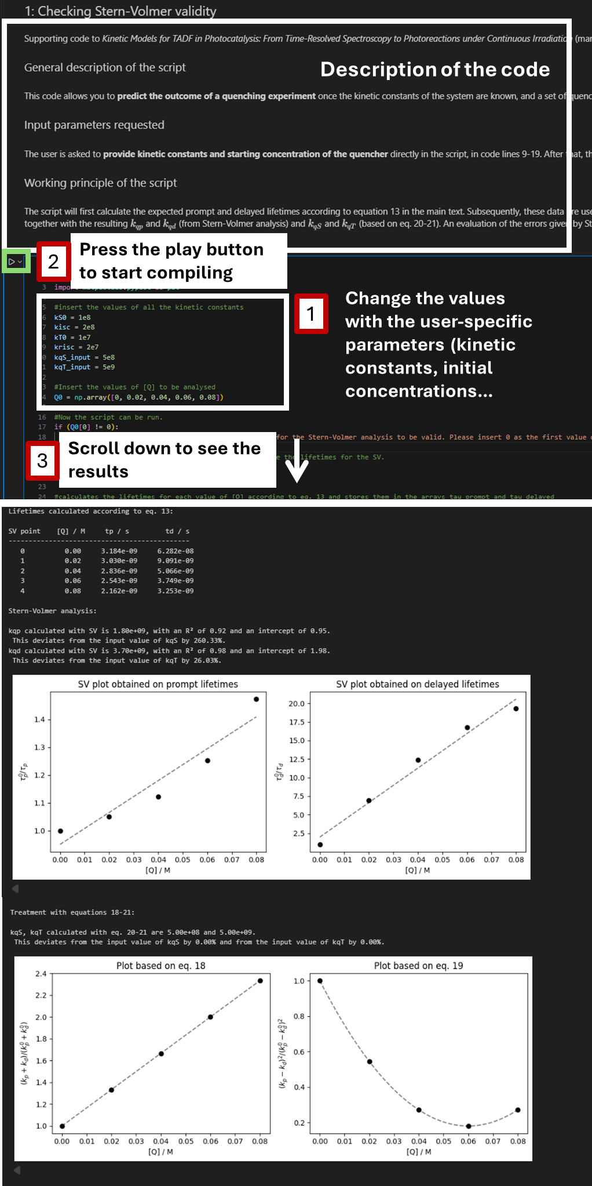
Finding the optimal Q0 for a photoreaction
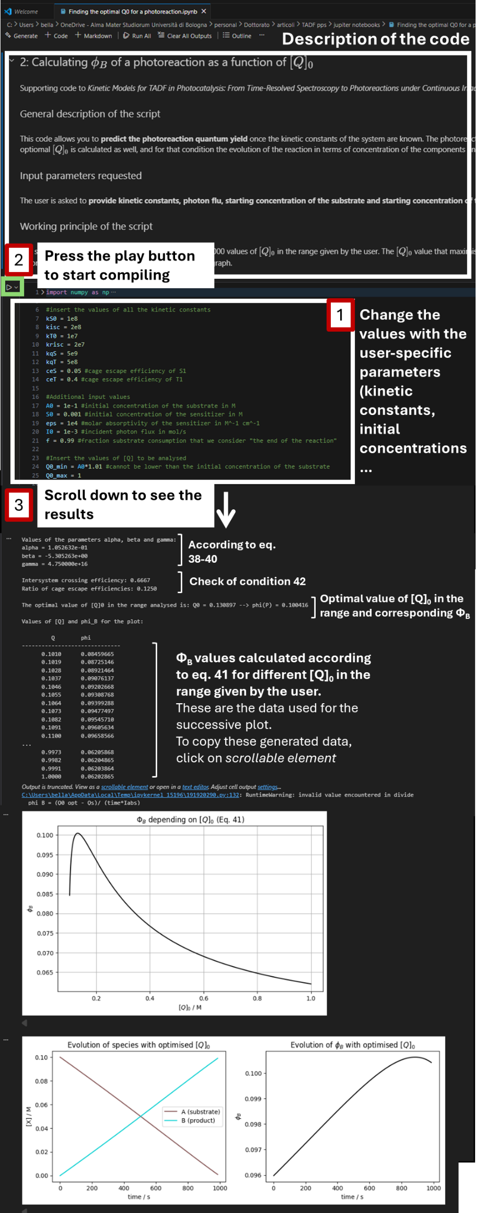
Modelling-a-photoreaction:
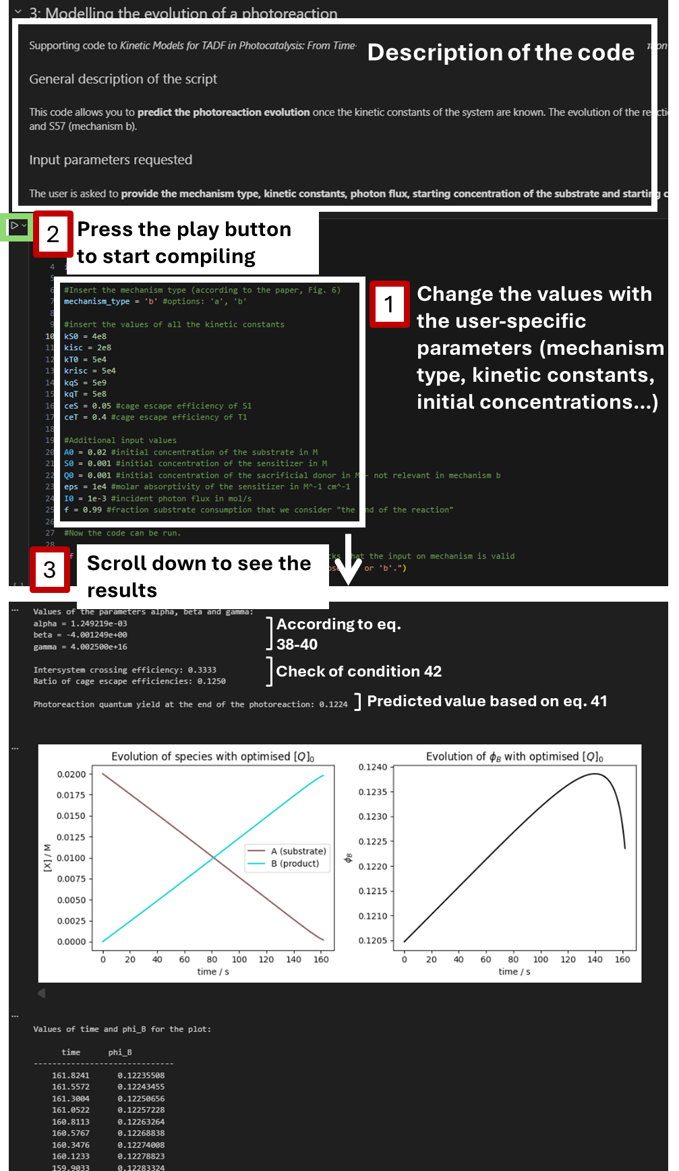

- References
1. PR160L | Kessil LED. Kessil https://www.Kessil.com/products/science_PR160L.php.

We assume that the relationship k^{S,0}+k_{isc} > k^{T,0}+k_{risc} always holds, meaning that in the unquenched system S₁ is always longer lived than T₁.
Assuming [Q]₀>0.99[A]₀, which is necessary to be able to reach the end of the photoreaction.

