Figure S1. MMRM LS-means trajectories with 95% CI by group (approximated from raw means)
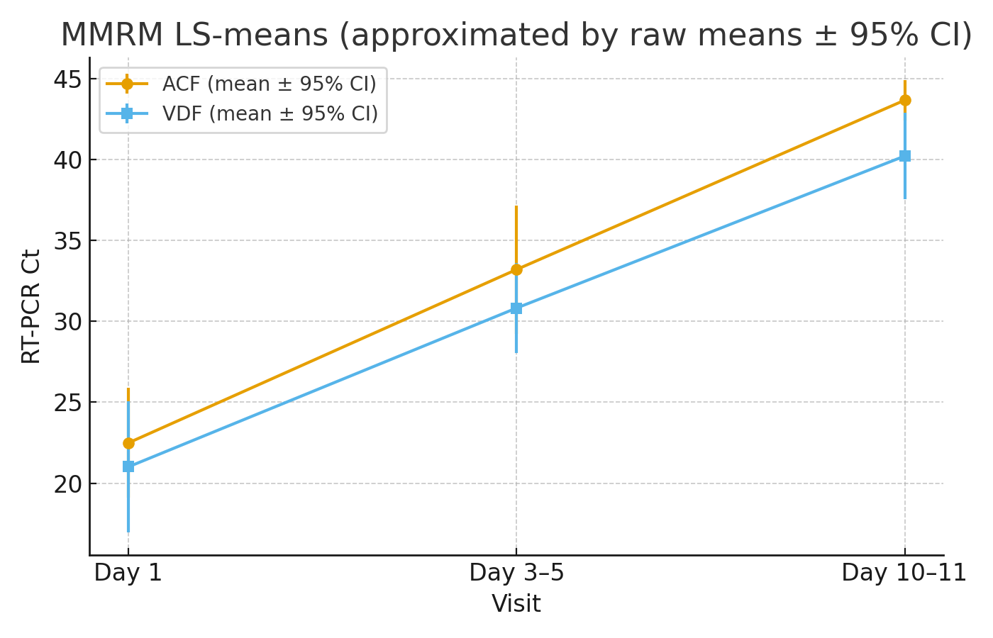
MMRM: mixed-effects model for repeated measures; CI: confidence interval; ACF: ammonium chloride formulation; VDF: vitamin D formulation; Ct: cycle threshold; RT-PCR: reverse transcriptase polymerase chain reaction
MMRM: Mixed-Effects Model for Repeated Measures, a statistical approach that accounts for within-subject correlations across multiple timepoints.
LS: Least Squares means (also called Estimated Marginal Means), representing model-adjusted group averages rather than raw arithmetic means.

Figure S2. Forest plot of adjusted effects (ACF−VDF) across sensitivity methods with 95% CIs (Dashed line at 0 Ct difference)
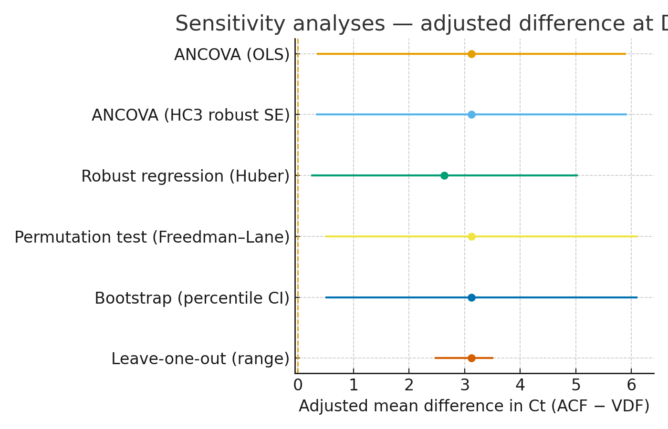
ACF: ammonium chloride formulation; VDF: vitamin D formulation; CI: confidence interval; Ct: cycle threshold; ANCOVA: analysis of covariance; OLS: Ordinary Least Squares ; SE: standard errors
OLS: Ordinary Least Squares, the standard estimation method used in linear regression and ANCOVA, which minimizes the sum of squared residuals to obtain parameter estimates.

Table S1. Sensitivity analyses for the adjusted between-arm difference at Day 10–11
Method | Estimate (Ct) | 95% CI lower | 95% CI upper | p-value
ANCOVA (OLS) | 3.122 | 0.344 | 5.901 | 0.036
ANCOVA (HC3 robust SE) | 3.122 | 0.324 | 5.921 | 0.029
Robustregression (Huber) | 2.637 | 0.238 | 5.037 | 0.031
Permutationtest (Freedmanâ€“Lane) | 3.122 | 0.5 | 6.108 | 0.033
Bootstrap (percentile CI) | 3.122 | 0.5 | 6.108
Leave-one-out (range of estimates) | 3.122 | 2.462 | 3.516
Ct: cycle threshold; CI: confidence interval; ANCOVA: analysis of covariance; OLS: Ordinary Least Squares ; SE: standard errors
OLS: Ordinary Least Squares, the standard estimation method used in linear regression and ANCOVA, which minimizes the sum of squared residuals to obtain parameter estimates.

Appendix: Glossary of Statistical Terms and Abbreviations
- ANCOVA (Analysis of Covariance): A general linear model that combines ANOVA and regression, used here to compare cycle threshold (Ct) values between groups while adjusting for baseline Ct.
- ARR (Absolute Risk Reduction): The difference in event rates between two groups; used to calculate the NNT.
- Bootstrap (Percentile CI): A resampling method that estimates confidence intervals by repeatedly drawing samples with replacement from the data.
- CI (Confidence Interval): A statistical interval estimate that provides a range of values within which the true parameter is expected to lie with a specified probability (commonly 95%).
- Cliff’s δ (delta): A non-parametric effect size measure representing the probability that a randomly selected value from one group exceeds a randomly selected value from another group.
- Cohen’s d / Hedges’ g: Standardized effect size measures representing the difference between two means expressed in units of standard deviation.
- Ct (Cycle Threshold): The number of PCR cycles required for the fluorescent signal to cross the detection threshold; inversely proportional to the viral load.
- FDR (False Discovery Rate): A multiple-comparison correction method (e.g., Benjamini–Hochberg) that controls the expected proportion of false positives among results declared significant.
- HC3 robust SE (Heteroskedasticity-Consistent Standard Errors, type 3): A variance estimator that adjusts for heteroskedasticity and small-sample bias in OLS regression.
- Hodges–Lehmann Estimator: A non-parametric estimator of the median difference between two groups, robust to non-normal distributions.
- ITT (Intention-to-Treat): An analysis principle in which all randomized participants are analyzed in their originally assigned groups, regardless of adherence or protocol deviations.
- Kaplan–Meier Curve: A survival analysis method used to estimate the probability of an event (here, viral clearance) over time.
- LS (Least Squares Means or Estimated Marginal Means): Model-adjusted group averages derived from ANCOVA or MMRM, representing expected values after accounting for covariates, not simple arithmetic means.
- MMRM (Mixed-Effects Model for Repeated Measures): A longitudinal statistical model that accounts for correlations within subjects across repeated timepoints, including both fixed and random effects.
- NNT (Number Needed to Treat): The reciprocal of the absolute risk reduction; indicates how many patients must be treated with ACF instead of VDF for one additional patient to achieve viral clearance by Day 10–11.
- OLS (Ordinary Least Squares): The standard estimation method for linear regression and ANCOVA, minimizing the sum of squared residuals to obtain parameter estimates.
- OR (Odds Ratio): A measure of association representing the odds of an event occurring in one group compared to another.
- Permutation Test (Freedman–Lane): A non-parametric resampling method for testing significance by permuting residuals, robust to distributional assumptions.
- p-value: The probability of observing results as extreme as (or more extreme than) those obtained, under the null hypothesis of no difference.
- q-value: The false discovery rate (FDR)-adjusted p-value, representing the minimum FDR at which a particular test result would be considered significant.
- RR (Relative Risk): The ratio of the probability of an event in the treatment group to that in the control group.

Supplementary Tables – Raw Data

Table S2. Participant-level raw Ct values across study timepoints
Participant ID | Timepoint 1 (Ct) | Timepoint 2 (Ct) | Timepoint 3 (Ct)
ACF group (n=16)
P01 | 22.40 | 34.40 | 45.00
P02 | 21.79 | 33.20 | 45.00
P03 | 25.31 | 34.56 | 45.00
P04 | 22.71 | 33.60 | 45.00
P05 | 16.13 | 40.15 | 45.00
P06 | 14.59 | 24.36 | 42.00
P07 | 22.67 | 35.00 | 45.00
P08 | 22.91 | 27.97 | 40.00
P09 | 25.97 | 35.28 | 45.00
P10 | 17.03 | 17.79 | 45.00
P11 | 28.73 | 45.00 | 45.00
P12 | 31.92 | 45.00 | 45.00
P13 | 19.39 | 29.84 | 45.00
P14 | 39.60 | 45.00 | 45.00
P15 | 12.38 | 22.00 | 39.50
P16 | 16.33 | 28.00 | 37.00
VDF group (n=16)
P17 | 12.66 | 32.07 | 38.91
P18 | 14.45 | 30.59 | 36.73
P19 | 12.66 | 32.07 | 38.91
P20 | 16.52 | 28.50 | 34.07
P21 | 14.62 | 28.65 | 45.00
P22 | 24.07 | 45.00 | 45.00
P23 | 14.17 | 34.81 | 45.00
P24 | 15.13 | 28.50 | 45.00
P25 | 25.88 | 37.41 | 45.00
P26 | 17.19 | 23.89 | 29.00
P27 | 37.05 | 30.01 | 45.00
P28 | 29.10 | 36.03 | 45.00
P29 | 38.09 | 30.98 | 45.00
P30 | 20.56 | 25.61 | 37.30
P31 | 17.46 | 21.18 | 32.60
P32 | 26.60 | 27.76 | 35.78
Ct: cycle threshold obtained from RT-PCR testing; higher Ct values correspond to lower viral RNA levels.
Timepoint 1 = baseline (Day 0); Timepoint 2 = follow-up measurement (3–5 days after baseline); Timepoint 3 = follow-up measurement (7–10 days after baseline).
Ct values of 45 represent the upper detection limit of the assay and indicate undetectable viral RNA.
Participants are grouped by treatment arm for clarity; participant identifiers are anonymized and do not reflect enrollment order.

Table S3. Participant-level changes in Ct values between study timepoints
Participant ID | ΔCt Timepoint 1–2 | ΔCt Timepoint 1–3 | ΔCt Timepoint 2–3
ACF group (n=16)
P01 | 12.00 | 22.60 | 10.60
P02 | 11.41 | 23.21 | 11.80
P03 | 9.25 | 19.69 | 10.44
P04 | 10.89 | 22.29 | 11.40
P05 | 24.02 | 28.87 | 4.85
P06 | 9.77 | 27.41 | 17.64
P07 | 12.33 | 22.33 | 10.00
P08 | 5.06 | 17.09 | 12.03
P09 | 9.31 | 19.03 | 9.72
P10 | 0.76 | 27.97 | 27.21
P11 | 16.27 | 16.27 | 0.00
P12 | 13.08 | 13.08 | 0.00
P13 | 10.45 | 25.61 | 15.16
P14 | 5.40 | 5.40 | 0.00
P15 | 9.62 | 27.12 | 17.50
P16 | 11.67 | 20.67 | 9.00
VDF group (n=16)
P17 | 19.41 | 26.25 | 6.84
P18 | 16.14 | 22.28 | 6.14
P19 | 19.41 | 26.25 | 6.84
P20 | 11.98 | 17.55 | 5.57
P21 | 14.03 | 30.38 | 16.35
P22 | 20.93 | 20.93 | 0.00
P23 | 20.64 | 30.83 | 10.19
P24 | 13.37 | 29.87 | 16.50
P25 | 11.53 | 19.12 | 7.59
P26 | 6.70 | 11.81 | 5.11
P27 | -7.04 | 7.95 | 14.99
P28 | 6.93 | 15.90 | 8.97
P29 | -7.11 | 6.91 | 14.02
P30 | 5.05 | 16.74 | 11.69
P31 | 3.72 | 15.14 | 11.42
P32 | 1.16 | 9.18 | 8.02
ΔCt values represent differences between Ct measurements at the indicated timepoints (ΔCt = Ct_later − Ct_earlier). Positive ΔCt values indicate an increase in Ct over time, corresponding to a reduction in viral RNA levels.
Negative ΔCt values indicate a decrease in Ct between timepoints.
Ct: cycle threshold obtained from RT-PCR testing.
Participants are grouped by treatment arm for clarity; participant identifiers are anonymized and do not reflect enrollment order.

