Fig.S1A The synthetic procedure of compound 3
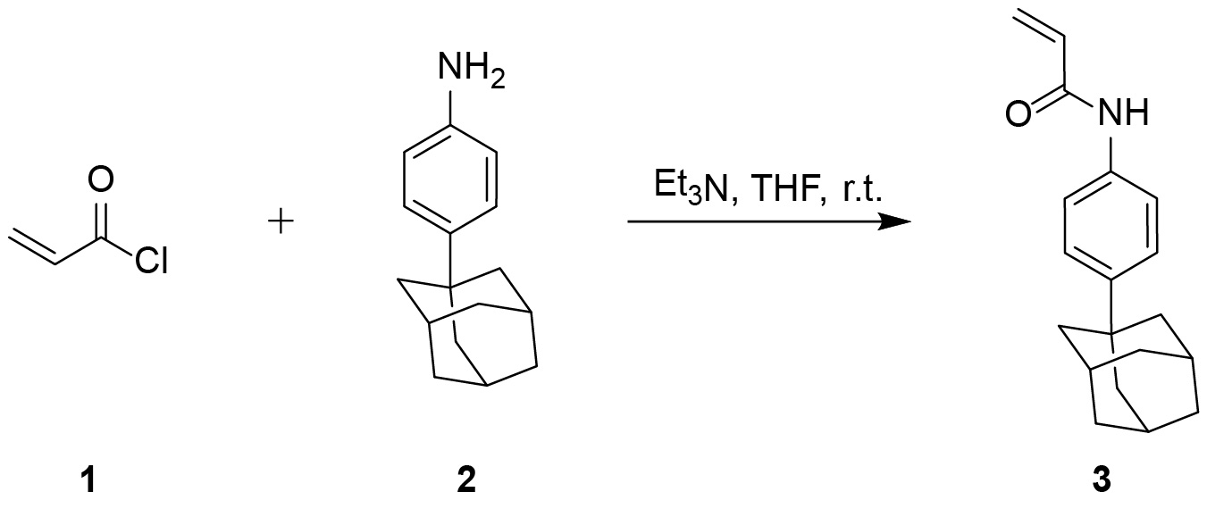
A dry THF (50 mL) solution containing acryloyl chloride (1, 4.6 mL, 57.2 mmol, 1.3 eq.) was added dropwise to a mixture of 4-(1-adamantyl)aniline (2, 10 g, 44.0 mmol, 1.0 eq.) and triethylamine (Et₃N, 8 mL, 57.2 mmol, 1.3 eq.) in dry THF (150 mL), while the reaction mixture was kept at ice bath. After added completely, the reaction mixture was allowed to stir at r.t. for 1.5 h, monitored by TLC (silica gel, CH₂Cl₂/CH₃OH, 98:2) until the reaction was fully finished. Subsequently, most of the organic solvent was removed by evaporation. The remaining reaction mixture (approximately 50 mL) was poured into ice-cold saturated aqueous sodium bicarbonate solution (500 mL), stirred for 1 h at 0 ℃, and the resulting precipitate was filtered and washed twice with ice water. The crude product was dissolved in EtOH with heating, and active charcoal was added. After hot filtration, the filtrate was cooled to 0 ℃ and ice water was slowly added until precipitation was complete. The solvent was removed by filtration, and the obtained solid was dried, affording compound 3 as a white solid (11.1 g, 89.5%). ¹H NMR (DMSO-d₆, 600 MHz) δ 10.05 (s, 1H, NH), 7.60-7.56 (m, 2H, aromatic H), 7.31-7.27 (m, 2H, aromatic H), 6.42 (dd, J = 17.0, 10.2 Hz, 1H, -CH=CH₂), 6.24 (dd, J = 17.0, 2.0 Hz, 1H, -CH=CH₂), 5.72 (dd, J = 10.1, 2.0 Hz, 1H, -CH=CH₂), 2.04 (p, J = 3.4 Hz, 3H, adamantane 3×CH), 1.83 (d, J = 3.1 Hz, 6H, adamantane 3×CH₂), 1.76-1.69 (m, 6H, adamantane 3×CH₂). ¹³C NMR (151 MHz, DMSO-d₆) δ 162.91, 146.11, 136.49, 131.97, 126.51, 124.91, 119.14, 42.65, 36.18, 35.37, 28.31. ESI-TOF m/z calcd for C₁₉H₂₃NO [M + Na]⁺ 304.1677, found 304.1676.

Fig.S1B The synthetic procedure of compound NY-1, NY-2, and NY-3
A suspension of 5-FU (500 mg, 3.8 mmol, 1 eq.), compound 3 (2.2 g, 7.7 mmol, 2 eq.), 1,8-diazabicyclo[5.4.0]undec-7-ene (DBU, 572 μL, 3.8 mmol, 1 eq.) and butylated hydroxytoluene (BHT, 42 mg, 0.2 mmol, 0.05 eq.) in DMF (50 mL) was refluxed at 100 ℃. The mixture was continuously reacted for 24 h under an Ar atmosphere and monitored by TLC (silica gel, CH₂Cl₂/CH₃OH, 95:5). And then, the reaction mixture was poured into H₂O (100 mL) and extracted with CH₂Cl₂ (3 × 200 mL). The combined organic layers were washed with saturated brine, dried over anhydrous Na₂SO₄ and concentrated by vacuum evaporation to remove the solvent. The remaining residue was absorbed on silica gel and applied to FC (silica gel, eluted with CH₂Cl₂/CH₃OH from 99:1 to 97:3).
From the fast migration zone, compound NY-1 (826 mg, 31.0%) was isolated as a white powder. ¹H NMR (DMSO-d₆, 600 MHz) δ 9.92 (s, 1H, NH), 9.89 (s, 1H, NH), 8.13 (d, J = 6.6 Hz, 1H, pyrimidine H-6), 7.48-7.44 (m, 4H, aromatic H), 7.28-7.22 (m, 4H, aromatic H), 4.10 (t, J = 7.4 Hz, 2H, CH₂), 3.97 (t, J = 6.7 Hz, 2H, CH₂), 2.70 (t, J = 6.8 Hz, 2H, CH₂), 2.55 (t, J = 7.4 Hz, 2H, CH₂), 2.02 (q, J = 3.1 Hz, 6H, adamantane 6×CH), 1.81 (t, J = 2.9 Hz, 12H, adamantane 6×CH₂), 1.74-1.67 (m, 12H, adamantane 6×CH₂). ¹³C NMR (DMSO-d₆, 151 MHz) δ 168.33, 156.76, 156.60, 149.33, 145.88, 145.78, 139.46, 137.97, 136.48, 136.37, 129.63, 129.41, 124.82, 124.75, 119.11, 119.04, 45.81, 42.65, 37.81, 36.18, 35.31, 35.30, 34.70, 33.98, 28.31. ESI-TOF m/z calcd for C₄₂H₄₉FN₄O₄ [M + Na]⁺ 715.3636, found 715.3636.
Compound NY-2 (238 mg, 15.1%) was furnished from the intermediate migration zone as a white powder. ¹H NMR (DMSO-d₆, 600 MHz) δ 11.78 (s, 1H, pyrimidine NH-3), 9.94 (s, 1H, NH), 8.02 (d, J = 7.0 Hz, 1H, pyrimidine H-6), 7.49-7.43 (m, 2H, aromatic H), 7.29-7.23 (m, 2H, aromatic H), 3.90 (t, J = 6.7 Hz, 2H, CH₂), 2.70 (t, J = 6.7 Hz, 2H, CH₂), 2.03 (p, J = 3.1 Hz, 3H, adamantane 3×CH), 1.82 (d, J = 3.3 Hz, 6H, adamantane 3×CH₂), 1.75-1.68 (m, 6H, adamantane 3×CH₂). ¹³C NMR (DMSO-d₆, 151 MHz) δ 168.37, 157.56, 157.39, 149.48, 145.95, 139.94, 138.42, 136.35, 130.89, 130.67, 124.86, 119.10, 44.83, 42.67, 36.19, 35.35, 34.83, 28.32. ESI-TOF m/z calcd for C₂₃H₂₆FN₃O₃ [M + Na]⁺ 434.1856, found 434.1850.
Evaporation of the slower migration zone gave compound NY-3 (724 mg, 45.8%) as a white powder. ¹H NMR (DMSO-d₆, 600 MHz) δ 11.09 (d, J = 4.0 Hz, 1H, pyrimidine NH-1), 9.90 (s, 1H, NH), 7.84 (t, J = 5.0 Hz, 1H, pyrimidine H-6), 7.49-7.43 (m, 2H, aromatic H), 7.28-7.23 (m, 2H, aromatic H), 4.06 (t, J = 7.5 Hz, 2H, CH₂), 2.56 (t, J = 7.5 Hz, 2H, CH₂), 2.04 (p, J = 3.4 Hz, 3H, adamantane 3×CH), 1.83 (d, J = 3.1 Hz, 6H, adamantane 3×CH₂), 1.75-1.69 (m, 6H, adamantane 3×CH₂). ¹³C NMR (DMSO-d₆, 151 MHz) δ 168.41, 157.32, 157.16, 149.75, 145.79, 140.18, 138.68, 136.51, 125.05, 124.84, 124.76, 119.15, 42.67, 37.11, 36.19, 35.33, 34.11, 28.32. ESI-TOF m/z calcd for C₂₃H₂₆FN₃O₃ [M + Na]⁺ 434.1856, found 434.1856.

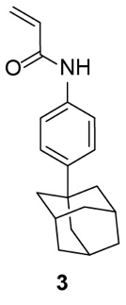
Fig.S1C ¹H NMR spectrum of compound 3 in DMSO-d₆.

Fig.S1D ¹³C NMR spectrum of compound 3 in DMSO-d₆.

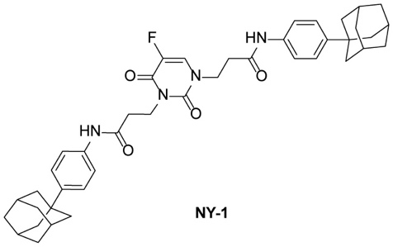
Fig.S1E ¹H NMR spectrum of compound NY-1 in DMSO-d₆.

Fig.S1F ¹³C NMR spectrum of compound NY-1 in DMSO-d₆.

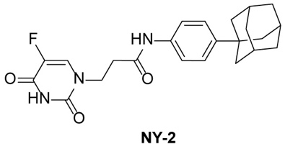
Fig.S1G ¹H NMR spectrum of compound NY-2 in DMSO-d₆.

Fig.S1H ¹³C NMR spectrum of compound NY-2 in DMSO-d₆.

Fig.S1I COSY spectrum of compound NY-2 in DMSO-d₆.

Fig.S1J HSQC spectrum of compound NY-2 in DMSO-d₆.

Fig.S1K HMBC spectrum of compound NY-2 in DMSO-d₆.

Fig.S1L NOESY spectrum of compound NY-2 in DMSO-d₆.

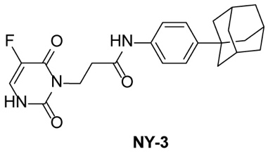
Fig.S1M ¹H NMR spectrum of compound NY-3 in DMSO-d₆.

Fig.S1N ¹³C NMR spectrum of compound NY-3 in DMSO-d₆.

Fig.S1O COSY spectrum of compound NY-3 in DMSO-d₆.

Fig.S1P HSQC spectrum of compound NY-3 in DMSO-d₆.

Fig.S1Q HMBC spectrum of compound NY-3 in DMSO-d₆.

Fig.S1R NOESY spectrum of compound NY-3 in DMSO-d₆.
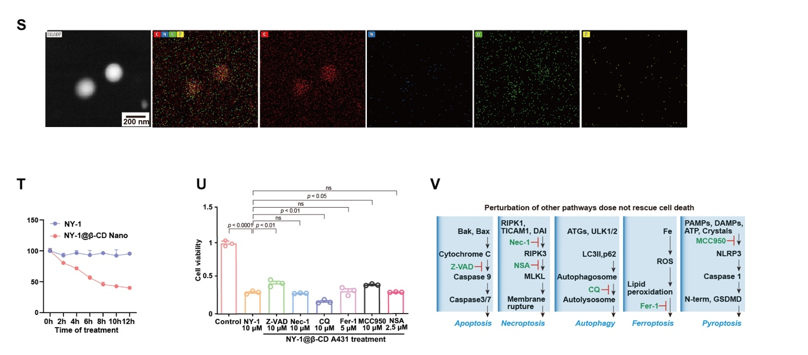 Fig.S1 (S) The EDS spectra of NY-1@β-CD nanoparticle. (T) Comparison of the cell viability NY-1 effect of NY-1 and NY-1@β-CD for Cal-27 under the same time. (U) CCK8 assays showing the effect of NY-1@β-CD (10 µM), Z-VAD-FMK (10 µM),Nec-1 (10 µM), CQ (10 µM), Fer-1 (5 µM), MCC950 (10 µM), and NSA (2.5 µM) on cell viability of Cal-27. (V) Schematic diagram of apoptosis, necroptosis, autophagy, ferroptosis, and pyroptosis. Inhibited pathways are marked in red.
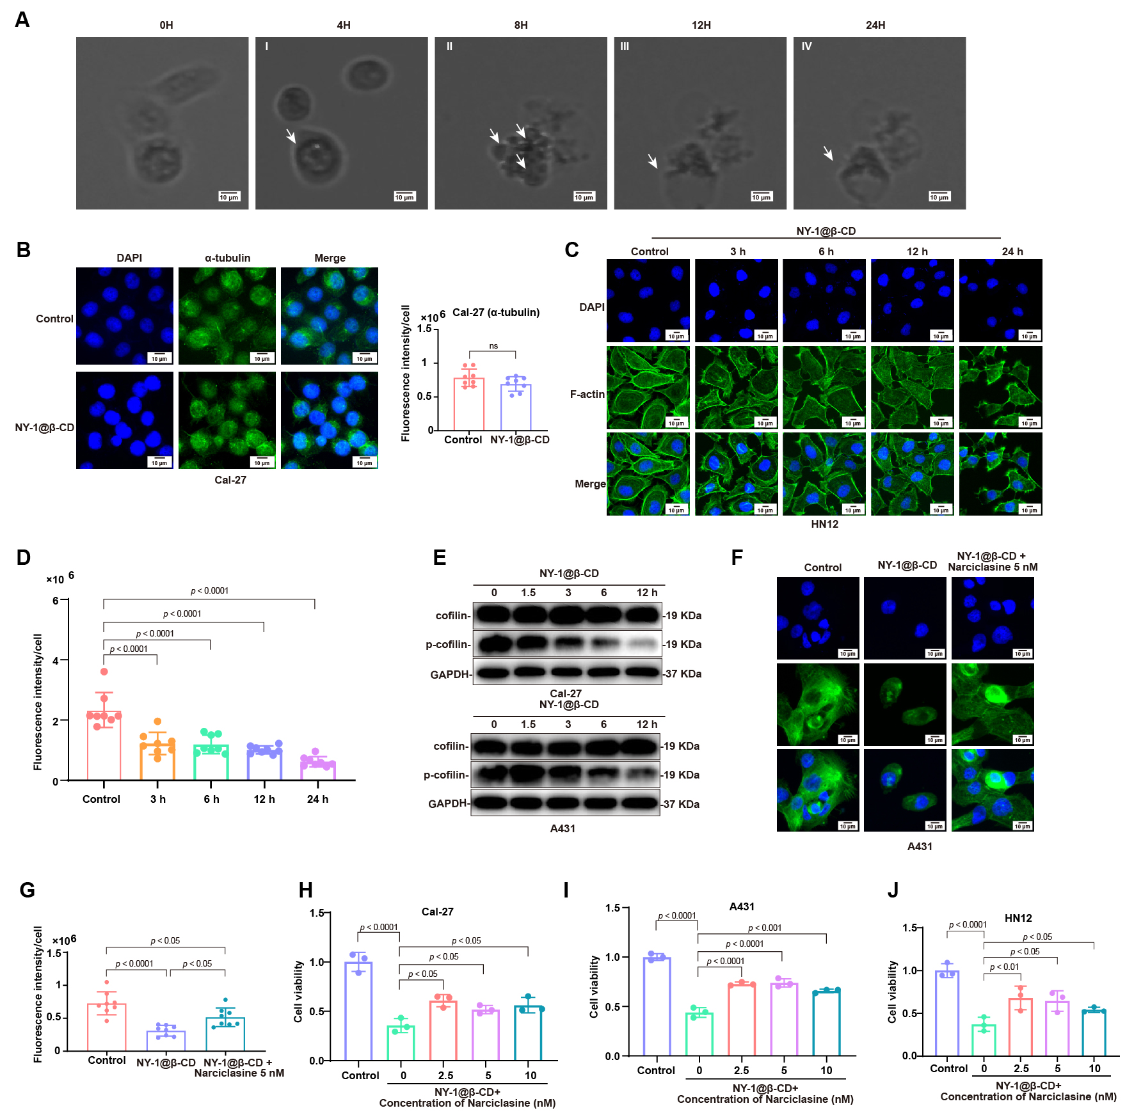 Fig.S2 (A) Images of living cells with bubbling caused by NY-1, white arrow: small membrane blebbing. (B) Immunofluorescence showing effect of NY-1@β-CD (10 µM) on α-tubulin in Cal-27 cells. Mean fluorescence intensity per Cal-27 cell were shown. Data presented as mean ± SD; n = 8 different areas; significance was determined by Mann-Whitney test. ns, no significance. (C and D) Immunofluorescence showing effect of NY-1@β-CD (10 µM) on F-actin at 24 h in NH12. Mean fluorescence intensity per NN12 cell were shown. Data presented as mean ± SD; n = 8 different areas; significance was determined by Mann-Whitney test. ns, no significance. (E) Immunoblotting showing effect of NY-1@β-CD (10 µM) on cofilin and p-cofilin protein level in Cal-27 and A431 cells at 0, 1.5, 3, 6, and 12 h. (F and G) Immunofluorescence showing effect of NY-1@β-CD (10 µM) and Narciclasine (5 nM) on F-actin at 24 h in NH12. Mean fluorescence intensity per NH12 cell were shown. Data presented as mean ± SD; n = 8 different areas; significance was determined by Mann-Whitney test. ns, no significance. (H-J) CCK8 assays showing the effect of NY-1@β-CD (10 µM) and Narciclasine (2.5, 5, 10 nM) on cell viability of Cal-27, A431 and HN12 cells at 24 h. Data presented as mean ± SD, n = 3 biologically independent samples, significance was determined by one-way ANOVA. ns, no significance.

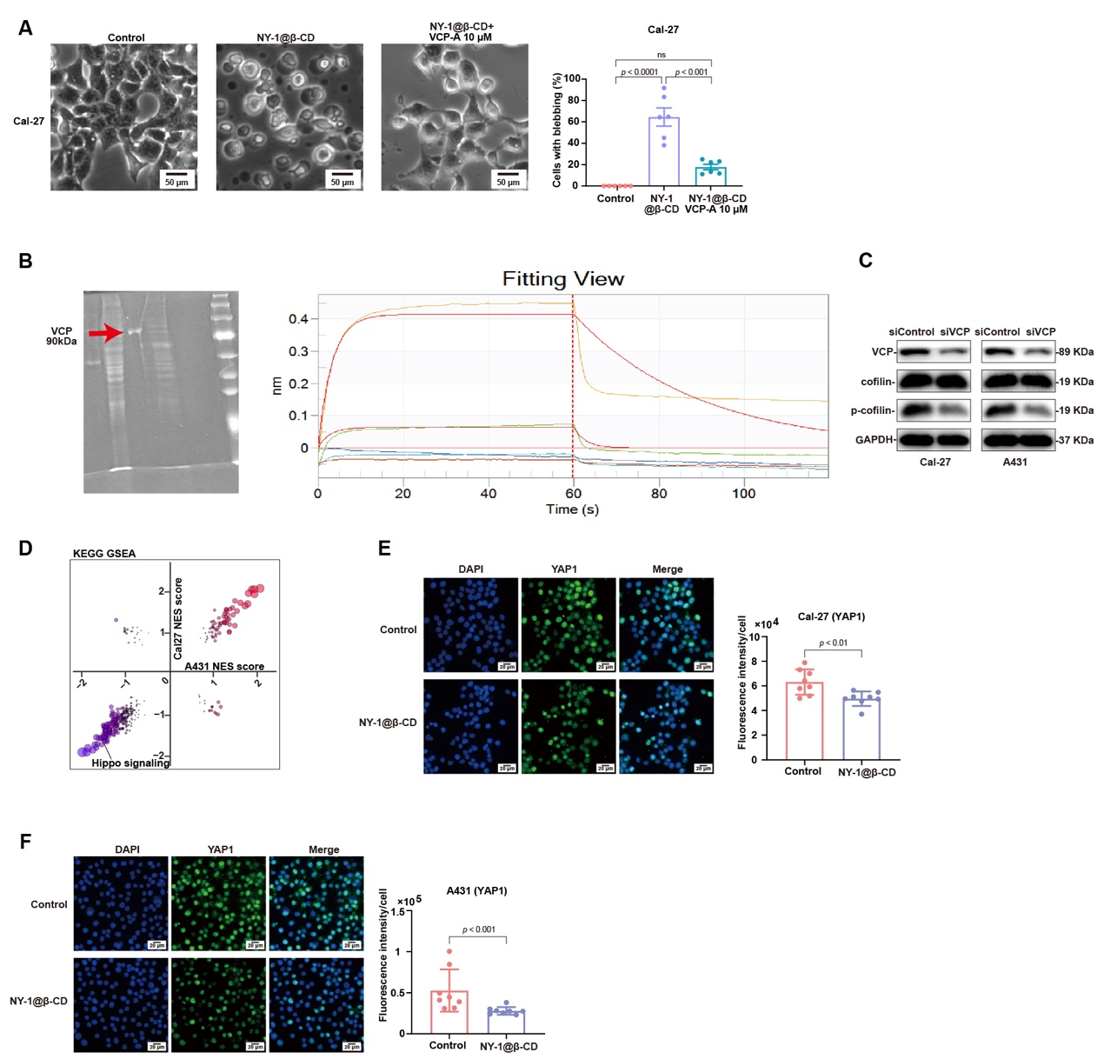
Fig.S3 (A) The effect of NY-1@β-CD (10 µM) and VCP-A (10 µM) on cell membrane blebbing of Cal-27 cells at 24 h. Data presented as mean ± SEM; n = 6 different areas; significance was determined by one-way ANOVA. ns, no significance. (B) Gel electrophoresis diagram of VCP protein and the BIL results of VCP and NY-1. (C) Immunoblotting showing effect of siVCP on VCP, FAK, p-FAK, YAP1, and p-YAP1 protein level in Cal-27 and A431 cells. (D) GSEA analysis of the KEGG pathway enrichment showing the involving pathways of up/down-regulated differentially expressed genes between Cal-27 and A431 cells treated with NY-1@β-CD (10 µM) for 24 h. (E and F) Immunofluorescence showing effect of NY-1@β-CD (10 µM) on nuclear YAP1 in Cal-27 and A431 cells. Mean fluorescence intensity per Cal-27 and A431 cell (H) were shown. Data presented as mean ± SD; n = 8 different areas; significance was determined by Mann-Whitney test. ns, no significance.

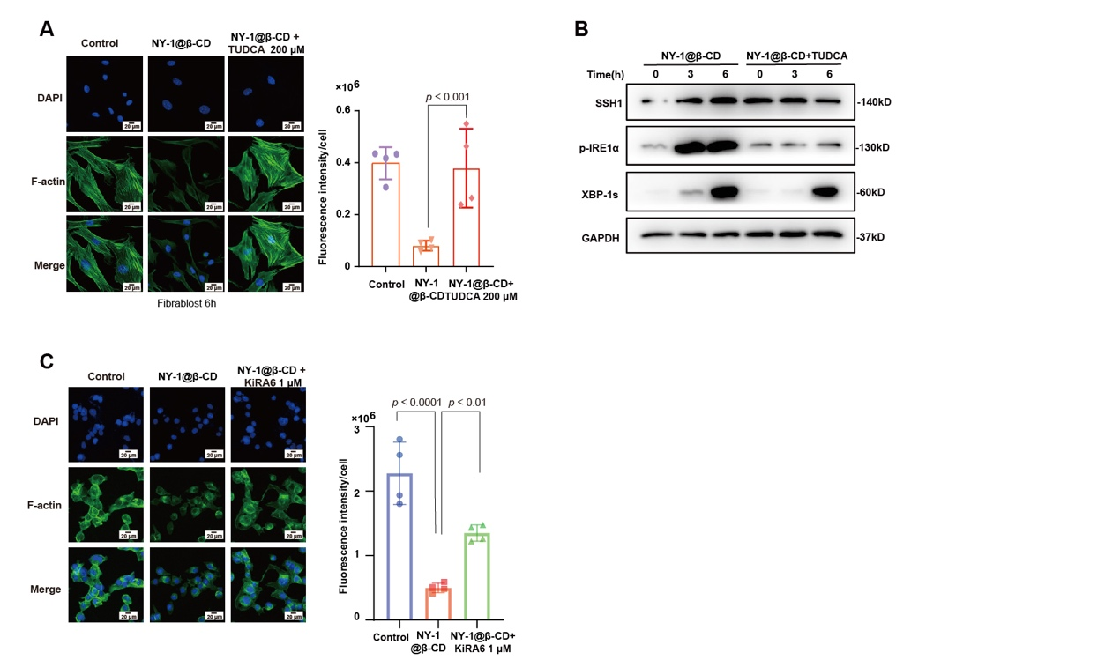
Fig.S4 (A) Immunofluorescence showing effect of NY-1@β-CD (10 µM) on F-actin at different time for fibroblast. Mean fluorescence intensity per fibroblast cell were shown. Data presented as mean ± SD; n = 4 different areas; significance was determined by Mann-Whitney test. ns, no significance. (B) The downregulation of SSH1 after TUDCA reversed the ER stress. (C) F-actin detection assay showing effect of KiRA6 on F-actin in Cal-27 cells. Data presented as mean ± SD; n = 4 different areas; significance was determined by Mann-Whitney test. ns, no significance.

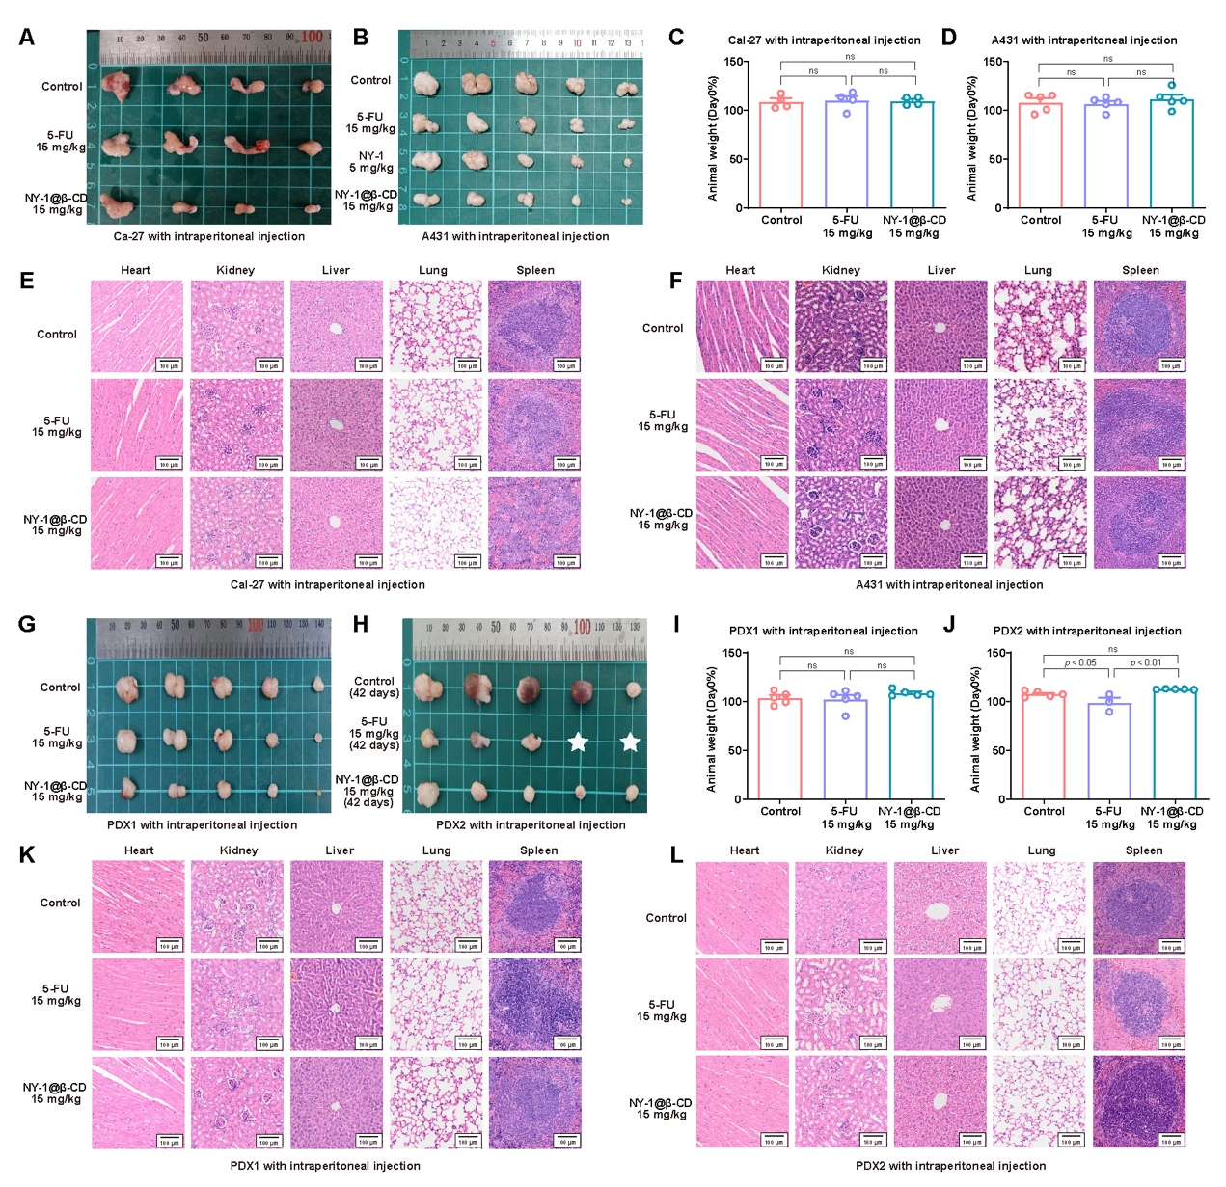
Fig.S5 (A,B,G,H) The image of Cal-27 CDX (A), A431 CDX (B), PDX1 (G), and PDX2 (H) xenografts at the end of experiment with 5/15 mg/kg NY-1@β-CD or 15 mg/kg 5-FU treatment by intraperitoneal injection. White star: the mice have dead. (C,D,I,J) Mouse body weight analysis of Cal-27 CDX (C), A431 CDX (D), PDX1 (I), and PDX2. (J) model mice receiving the indicated treatment at the end of the experiment. Data presented as mean ± SEM; n = 4 or 5 mice per group; significance was determined by one-way ANOVA. ns, no significance. (E,F,K,L) Representative graph of mouse organs with H&E staining of Cal-27 CDX (E), A431 CDX (F), PDX1 (K), and PDX2 (L) model mice receiving the indicated treatment.

Video 1: The video of the origin of bubbles. White: Cell membrane; Bule: DAIP.

