SUPPLEMENTARY INFORMATION

“Induction of robust cellular and humoral immunity against SARS-CoV-2 after a third dose of BNT162b2 vaccine in previously unresponsive elderly”

Addi J. Romero-Olmedo, Ph.D.¹*, Axel Ronald Schulz, Ph.D.²*, Svenja Hochstätter³, Dennis DasGupta M.D.¹ Iiris Virta, M.Sc.², Heike Hirseland², Daniel Staudenraus M.S.¹, Bärbel Camara¹, Carina Münch³, Véronique Hefter ³, Siddhesh Sapre M.S.³, Henrik E. Mei, Ph.D.^{2#}, Christian Keller, M.D.^{3#}, Michael Lohoff, M.D.^{1#}

¹ Institute of Medical Microbiology and Hospital Hygiene, Philipps-University Marburg, Marburg, Germany
² Deutsches Rheumaforschungszentrum Berlin, a Leibniz Institute, Berlin, Germany
³ Institute of Virology, Philipps-University, Marburg, Germany

* Addi J. Romero-Olmedo and Axel Ronald Schulz contributed equally to this work.

# Henrik E. Mei, Christian Keller and Michael Lohoff contributed equally as senior authors.

Supplementary Table 1. Study participants

Donor ID | Age (years) | Sex | Exclusion (reason) | Non-responder
1 | 81 | m
2 | 86 | m
3 | 81 | f
4 | 84 | m
5 | 81 | m
6 | 83 | f
7 | 83 | m
8 | 87 | f
9 | 83 | f
10 | 81 | m
11 | 86 | f
12 | 82 | f
13 | 82 | m
14 | 82 | f
15 | 84 | f
16 | 82 | m | own decision
17 | 95 | m |  | X
18 | 85 | f
19 | 85 | f
20 | 81 | f
21 | 86 | f
22 | 82 | m
23 | 82 | f
24 | 87 | m | death due to accident
25 | 81 | f | own decision
26 | 80 | m
27 | 86 | m
28 | 89 | f
29 | 85 | f |  | X
30 | 81 | f
31 | 82 | m |  | X
32 | 88 | f
33 | 86 | f
34 | 86 | m | previous COVID-19
35 | 83 | f
36 | 80 | f
37 | 91 | f
38 | 81 | f
39 | 80 | m
40 | 84 | f
41 | 97 | f
42 | 88 | f
43 | 80 | m
44 | 86 | m
45 | 87 | f | own decision
46 | 83 | f
47 | 83 | f
48 | 81 | m |  | X
49 | 84 | f
50 | 91 | m
51 | 80 | m
52 | 89 | w
53 | 81 | f
54 | 83 | m |  | X
55 | 81 | m
56 | 82 | f
61 | 31 | f
62 | 31 | m
100 | 35 | m
101 | 33 | m
102 | 22 | m
103 | 44 | f
104 | 28 | f
105 | 25 | f
106 | 25 | f
107 | 30 | f
108 | 23 | f
109 | 28 | m
110 | 22 | f
111 | 26 | f
112 | 35 | f
113 | 33 | m
114 | 36 | f
115 | 31 | m
116 | 29 | f
117 | 39 | f
118 | 28 | f
119 | 27 | m
120 | 53 | f
121 | 34 | f
122 | 42 | m
123 | 36 | m
124 | 33 | m
125 | 40 | m
126 | 26 | f
127 | 39 | f
128 | 40 | m
129 | 26 | f
130 | 22 | f
131 | 21 | m
132 | 33 | f
133 | 29 | m
134 | 29 | f
135 | 30 | f
136 | 37 | m
137 | 33 | w
138 | 32 | f
139 | 20 | f
140 | 22 | f
141 | 31 | f
142 | 30 | m
143 | 26 | f

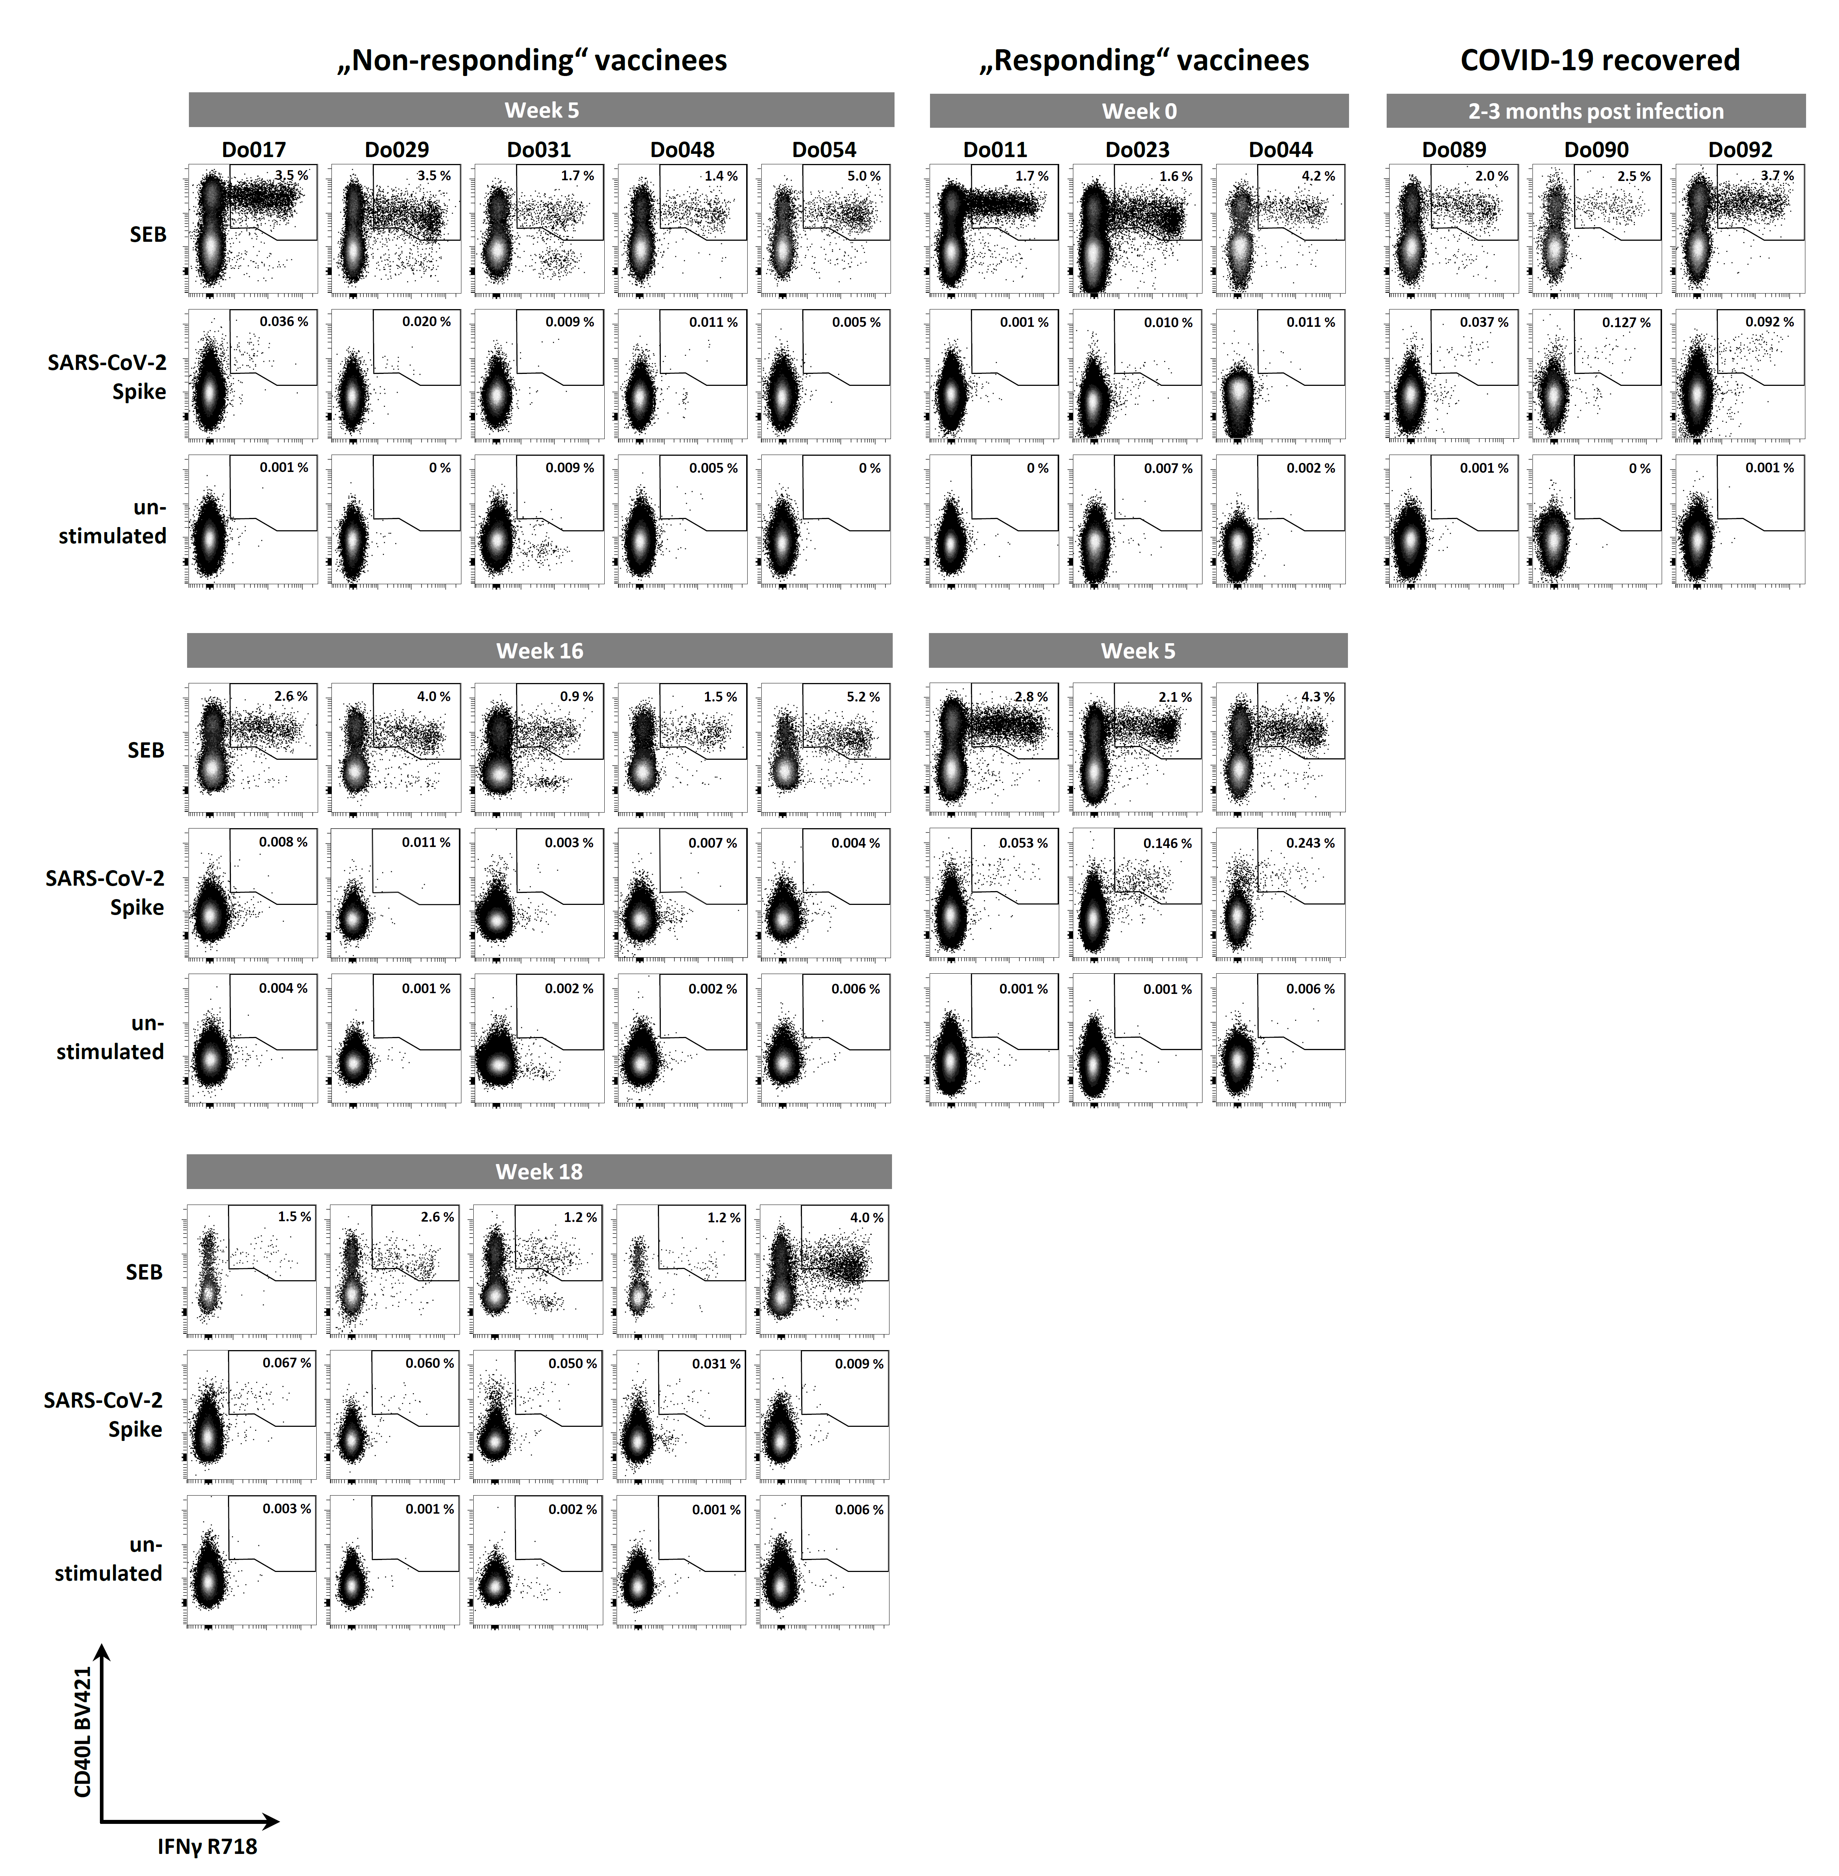

Supplementary Figure 1. Multi-parametric flow cytometry of T cells from individuals who received the BNT162b12 vaccine or overcame COVID-19. Peripheral blood CD4 T cell responses to SARS-CoV2 spike peptide pool, SEB, and control conditions (unstimulated) of representative responders and the five non-responders to two-dose BNT162b2 vaccination, and of reconvalescent COVID-19 patients were analyzed by flow cytometry at the indicated time points. All plots show data of gated CD4 T cells also stained for CD40L and IFNγ as markers of activated T cells. The frequency of CD40L/IFNγ co-expressing cells among total CD4 T cells is indicated in each plot.

Supplementary Methods

Detailed description of assessment of antigen-specific T cells
Antigen-reactive T cell responses were analyzed using a protocol based on previous work ¹. 500 µL media containing 5 x 10⁶ PBMC were transferred into 12 mL round-bottom tubes (Greiner Bio-One GmbH, Frickenhausen, Germany) and stimulated with either SARS-CoV-2 spike protein peptide mix (wildtype, Miltenyi Biotec), SEB (0.7 µg / mL, kindly provided by Prof. Bernhard Fleischer, Bernhard Nocht Institute of Tropical Medicine, Hamburg, Germany), or with an equal volume of water as a control, in the presence of anti-CD28 (5 µg / mL) and monensin (1 µg / mL) for 12 hours under humid conditions in a 5 % CO₂ atmosphere. Brefeldin A (1 µg / mL) was added 2 hours after the start of the stimulation. The stimulation was stopped by adding 2 nM EDTA. PBMC were harvested, transferred to a new 15 mL centrifuge tube, washed with 10 mL PBS / 0.2 % BSA, and pelleted for 10 min at 490 x g, at 4 °C. Dead cell labeling was performed by resuspending the cell pellet in 500 µL PBS supplemented with 1:1000 amine reactive Zombie Aqua™ Fixable Viability dye (Biolegend), incubated for 20 min in the dark at room temperature. PBS / 0.2 % BSA was added to quench the remaining reactive dye. After washing with 2 mL PBS / 0.2 % BSA, and pelleting for 10 min, at 490 x g, at 4 °C, PBMC were fixed for 20 minutes using 2% formaldehyde solution (Thermo Scientific, Germany) in the dark, washed with 2 mL PBS / 0.2 % BSA, and pelleted for 10 min at 490 x g, at 4 °C, and resuspended in 2 mL PBS / 0.2 % BSA. PBMC were spun down (700 x g, 10 min, 4 °C), supernatants were aspirated, cell pellets resuspended in 200 µL PBS / 0.2 % BSA and transferred into a V-bottom-96 well plate (Sarstedt), and centrifuged (700 x g, 5 min, 4 °C). After discarding the supernatants, pellets were resuspended in 50µL Brilliant Violet Staining Buffer (Biolegend) supplemented with antibodies including anti-CD4-PECy7 for the detection of CD4 T cells, anti-CD8-BV570, and anti-CD19/123/33-BV510 (all from Biolegend) for the exclusion of CD8 T cells, monocytes and other myeloid cells, B cells, basophils, and plasmacytoid dendritic cells; anti-CD27-StarBright Blue 700 (Bio-Rad, Hercules, CA), and anti-CD45RA-PerCp (Miltenyi), and incubated 30 minutes in the dark, at room temperature. Afterwards, cells were washed once with 200 µL PBS / 0.2% BSA, and centrifuged (700 x g, 5 min, 4 °C). Cell pellets were then washed twice in 200µL permeabilization buffer (diluted using Millipore water from 10 x concentrated stock buffer, ThermoFisher, Waltham, MA), and finally resuspended in 50 µL permeabilization buffer supplemented with antibodies targeting CD40L (conjugated to BV421, Biolegend), and intracellular molecules including anti-IFNγ-R718 (BD Biosciences, San Jose, CA), and incubated for 30 minutes at room temperature in the dark. Then, cells were washed once in 200µL permeabilization buffer, once in PBS / 0.2 % BSA, and stored at 4 °C in PBS / 0.2 % BSA until acquisition on a MACSQuant 16 flow cytometer (Miltenyi Biotec, Bergisch Gladbach, Germany).
FlowJo version 10 (BD, Ashland, OR) and OMIQ.ai (Santa Clara, CA) were used for analyzing flow cytometry data. Flow cytometry standard (FCS) files underwent quality control and, where applicable, anomaly removal by FlowAI², and data of live CD4+ T lymphocytes were gated according to FSC and SSC parameters and their CD4⁺CD8⁻CD19⁻CD123⁻CD33⁻LD-Aqua^{low/-} phenotype. Cell aggregates were removed by gating according to FSC-H/FSC-A and SSC-H/SSC-A parameters. Antigen-reactive CD4 T cells (ART) were defined as CD40L+ IFNγ+ expressing cells after spike peptide stimulation, and their frequencies were determined among total CD4 T cells.
For background correction, frequencies of CD40L+IFNγ+ T cells among CD4 T cells from unstimulated control samples were subtracted from ART frequencies for each individual donor. Whenever this difference was equal to or below 0%, frequencies were set to 0.0001%, a value exceeded by all measurements in which ART were detectable, in order to allow the display of data on a logarithmic scale in Figure 1. We tested but found no evidence that the very low number of ART detected in non-responders was due to the number of sampled CD4 T cells: The median limit of detection (LOD) in day35 responder data was 1 cell in 142,720 CD4 T cells, the median LOD in day 35 non-responder data was 1 cell in 84,252 CD4 T cells (p=0.19, Mann Whitney test, two-tailed), and 1 cell in 138,205 CD4 T cells in non-responder data at week 15, prior to the third vaccination (p=0.86, Mann Whitney test, two-tailed).

Supplementary References

1. Schulz, A. R. et al. Low Thymic Activity and Dendritic Cell Numbers Are Associated with the Immune Response to Primary Viral Infection in Elderly Humans. J Immunol 195, 4699–4711 (2015).
2. Monaco, G. et al. flowAI: automatic and interactive anomaly discerning tools for flow cytometry data. Bioinformatics 32, 2473–2480 (2016).

