Figure S1. The expression level of HIF1A and HIF3A and their related survival time in cervical cancer patients and normal specimens.

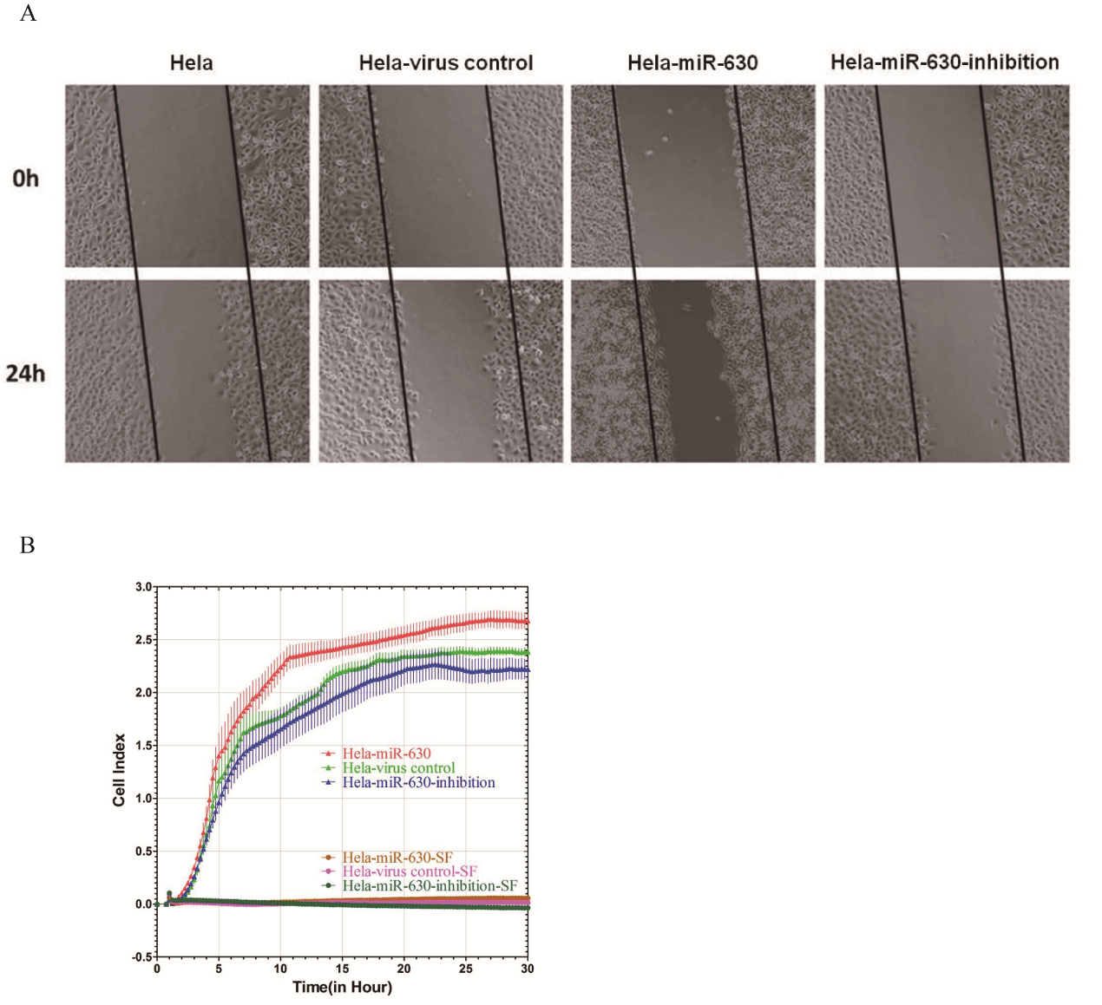

Figure S2. MiR-630 enhances HeLa cell migration and invasion in vitro.

