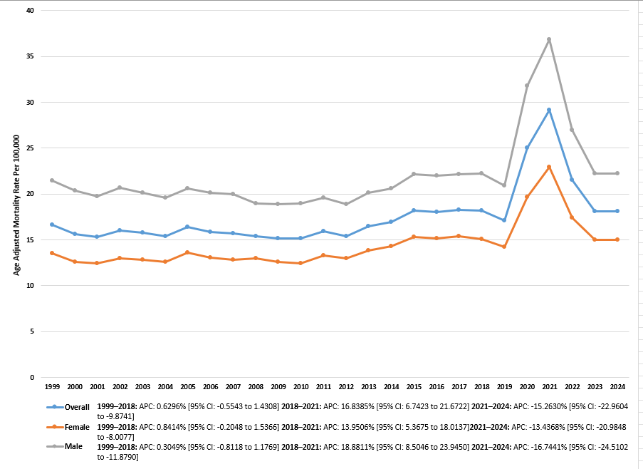
Supplementary Figure 1: Trends in Pneumonia and Sepsis-related AAMR per 100,000, stratified by sex, in the United States from 1999-2024.

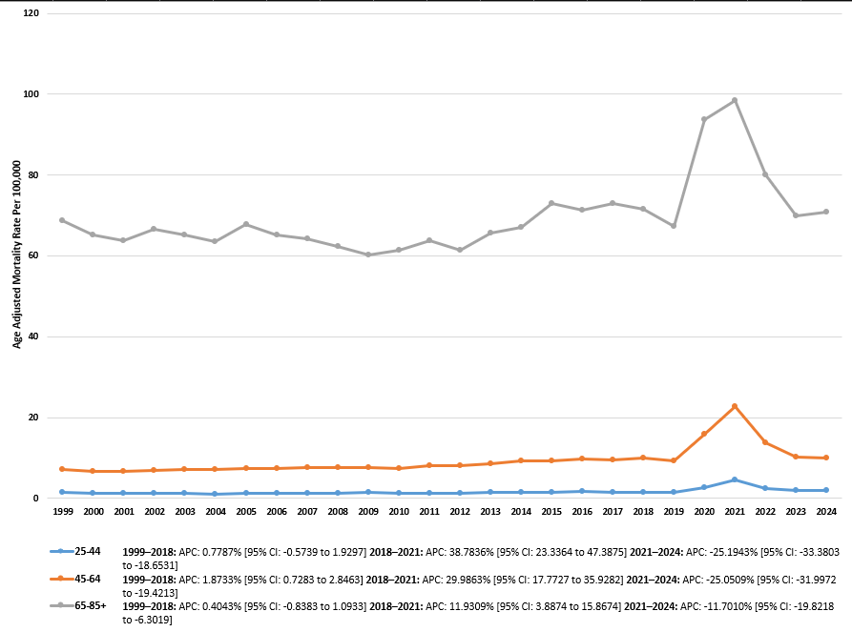
Supplementary Figure 2: Trends in Pneumonia and Sepsis-related AAMR per 100,000, stratified by age groups, in the United States from 1999-2024.

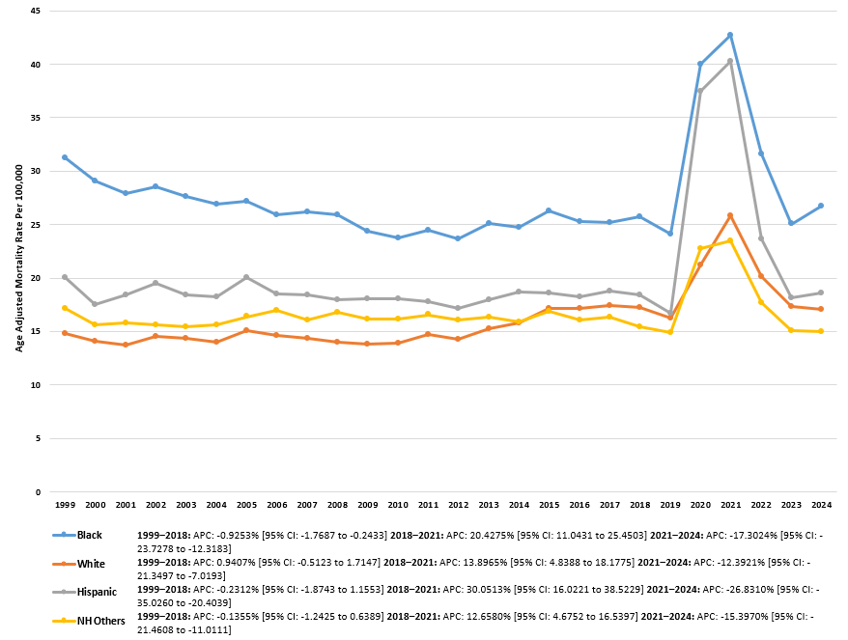
Supplementary Figure 3: Trends in Pneumonia and Sepsis-related AAMR per 100,000, stratified by race, in the United States from 1999-2024.

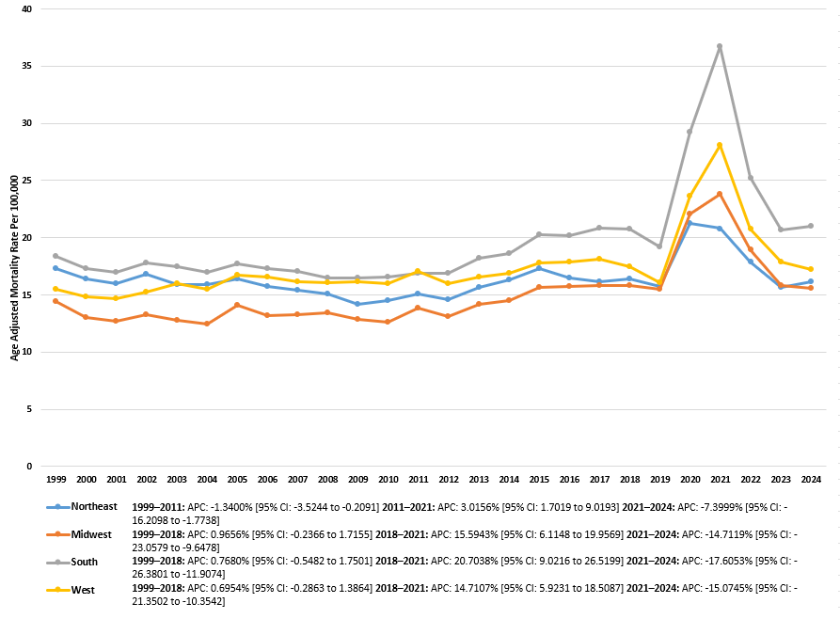
Supplementary Figure 4: Trends in Pneumonia and Sepsis-related AAMR per 100,000, stratified by census region, in the United States from 1999-2024.

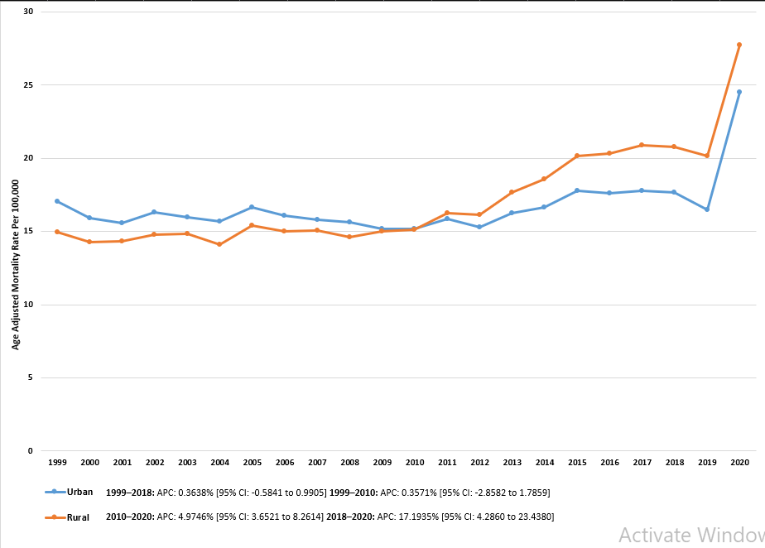
Supplementary Figure 5: Trends in Pneumonia and Sepsis-related AAMR per 100,000, stratified by urbanisation, in the United States from 1999-2024.

