Supplementary Table S1. Univariable associations with hospital-associated disability
Variable | β coefficient | Odds ratio (95% CI) | p value
Age (per year) | 0.098 | 1.10 (1.08–1.12) | <0.001
Barthel Index at admission (per point) | −0.017 | 0.98 (0.98–0.99) | <0.001
Clinical Frailty Scale (per point) | 0.487 | 1.63 (1.49–1.78) | <0.001
MMSE (per point) | −0.098 | 0.91 (0.89–0.93) | <0.001
Instrumental ADL (per point) | −0.252 | 0.78 (0.74–0.81) | <0.001
Body mass index (per kg/m²) | −0.078 | 0.93 (0.90–0.96) | <0.001
Emergency admission | 2.023 | 7.56 (5.62–10.17) | <0.001
Abbreviations: HAD, hospital-associated disability; CI, confidence interval; MMSE, Mini-Mental State Examination; ADL, activities of daily living.
Results are from univariable logistic regression analyses with HAD as the dependent variable.
Continuous variables were analyzed per unit increase as indicated. Emergency admission was analyzed as a binary variable (emergency vs elective admission).
β coefficients represent log-odds. Odds ratios indicate the change in odds of HAD per 1-unit increase in each variable.
Variables were examined as candidate predictors based on clinical relevance and prior literature and were considered for multivariable modeling.
All tests were two-sided, and p < 0.05 was considered statistically significant.

Supplementary Table S2. HAD risk score
Variable | Criteria | Points
Age | ≥80 years | +1
Frailty | Clinical Frailty Scale ≥5 | +2
Cognitive function | MMSE ≤23 | +2
Admission type | Emergency admission | +3
Total score |  | 0–8 points
Abbreviations: HAD, hospital-associated disability; MMSE, Mini-Mental State Examination.
The HAD-RES score was derived from the multivariable logistic regression model predicting HAD.

Supplementary figure S1 Study Flow

Supplementary figure S2. ROC curve
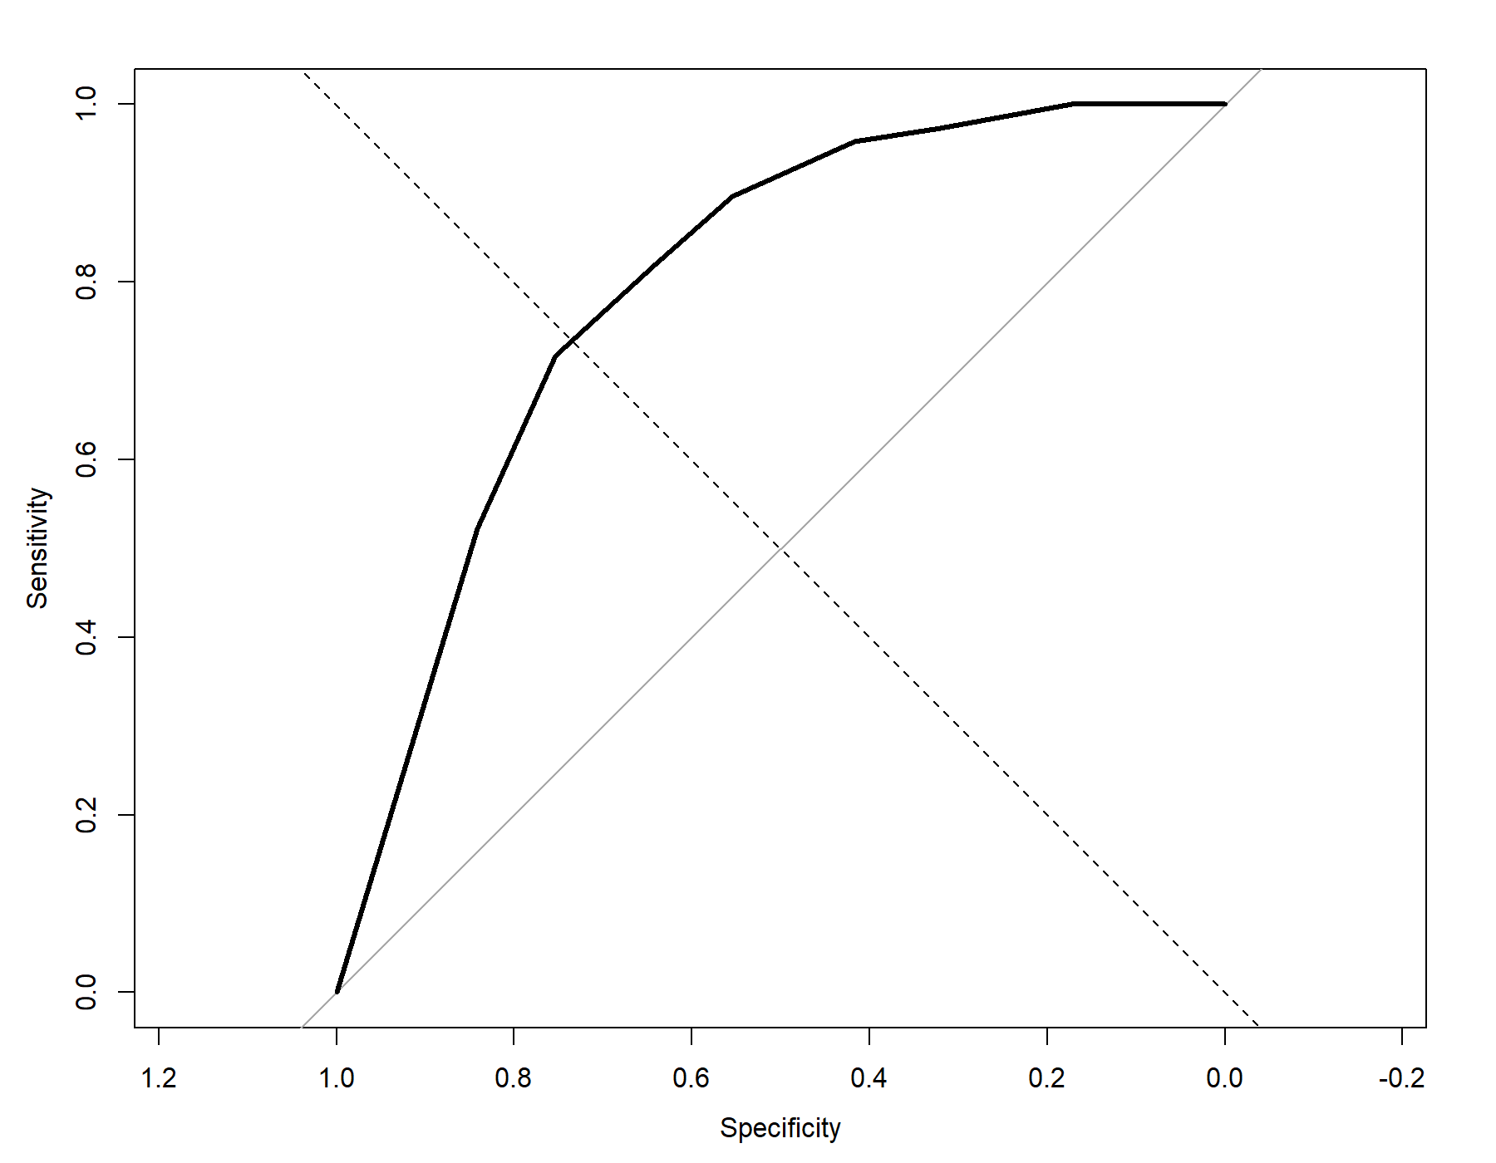
Supplementary figure S3 Decision curve analysis

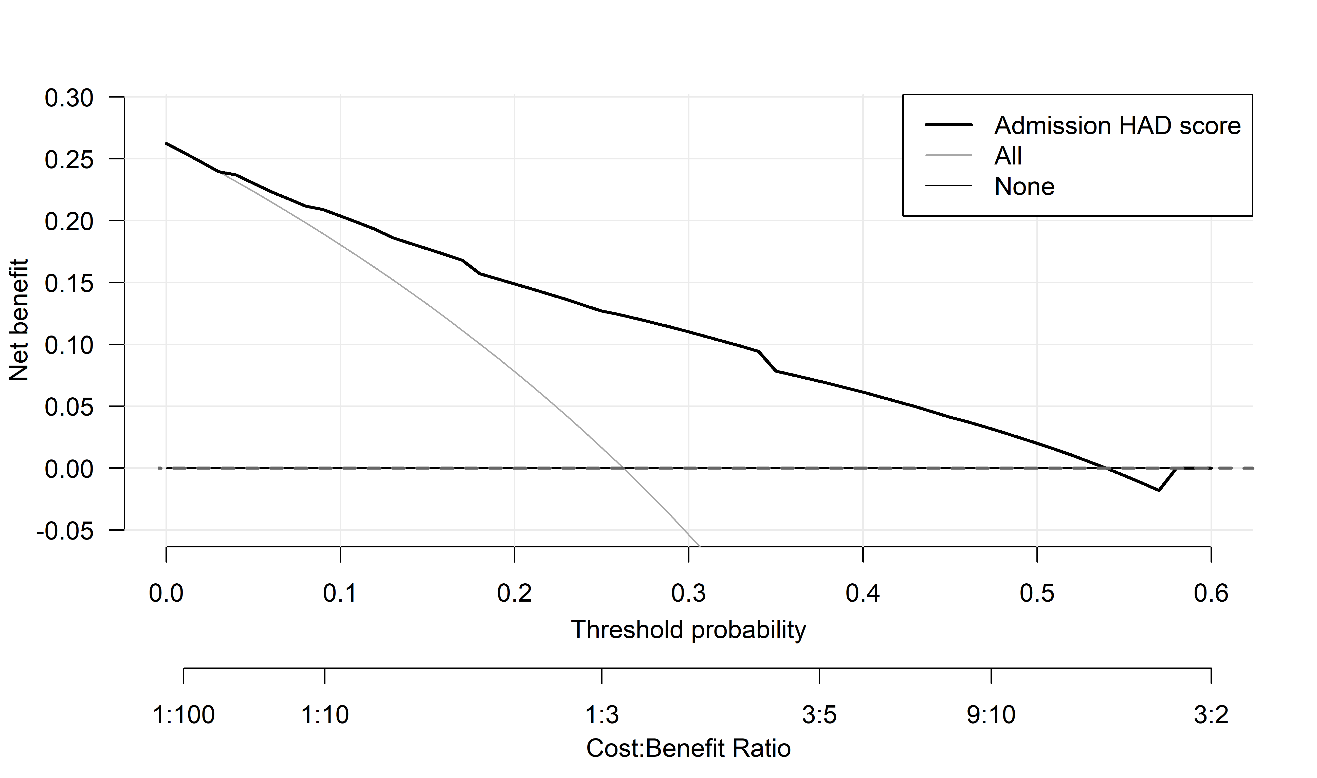
Supplementary figure S4 Clinical use algorithm
