Supplementary Information

Pilot-scale pretreatment of sugarcane straw using a combined sulfuric acid- and bisulfite-catalyzed steam explosion process
Marcelo B. W. Saad^{ab*}, Rodrigo H. S. Garcia^{c}, Vanessa O. A. Pellegrini^{bc}, Francisco E. G. Guimaraes^{c}, Eduardo R. DeAzevedo^{c}, Igor Polikarpov^{c} and Adilson R. Gonçalvesª

ªBioenergy Research Institute, São Paulo State University, Rua 10 No. 2527, 13500-230, Rio Claro, São Paulo, Brazil
^{b}Raízen Energia S/A, Rodovia SP-308 km 175, 13411-900, Piracicaba, São Paulo, Brazil
^{c}São Carlos Institute of Physics, University of São Paulo, Av. Trabalhador São-carlense No. 400, 13566-590, São Carlos, São Paulo, Brazil

*Corresponding author: marcelo.saad@unesp.br

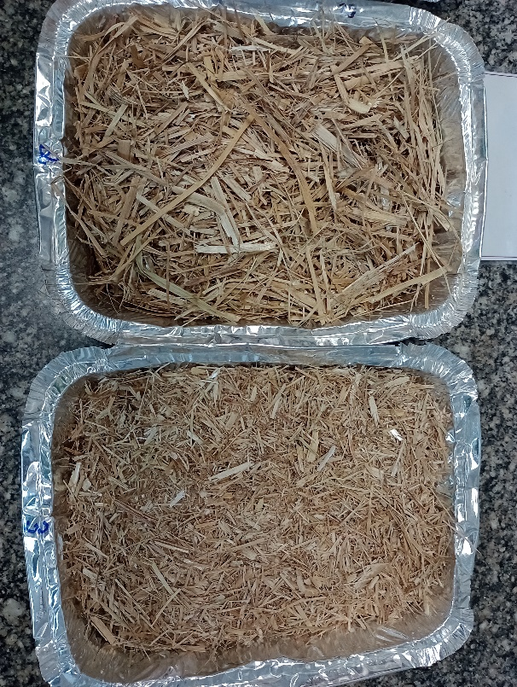  (7.3±0.6 mm) | (3.9±0.4 mm)

Fig. S1 Particle-size distribution of the raw straw used during S1-S6 pretreatment experiments.

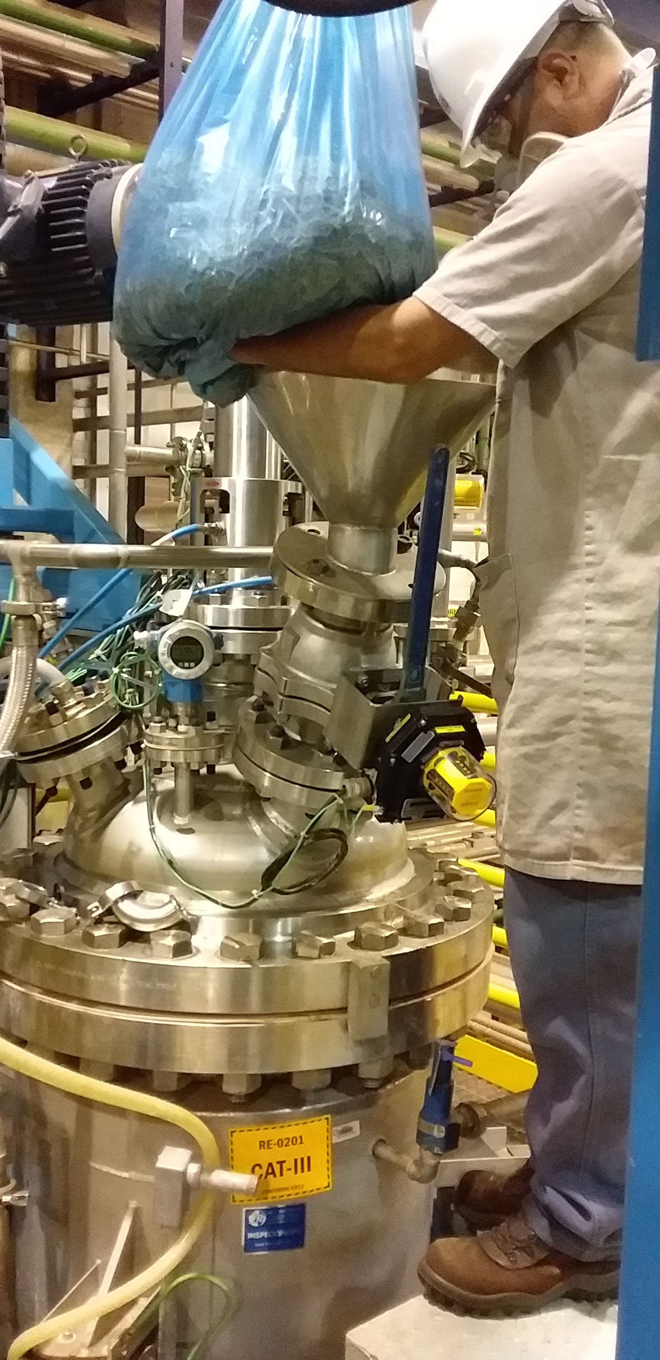  (A) | 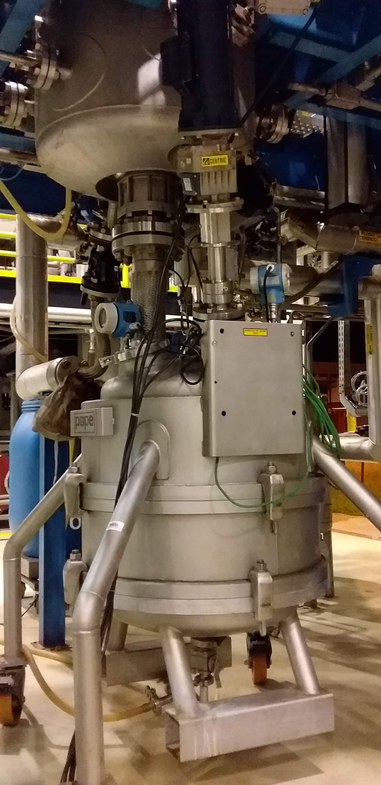  (B) | 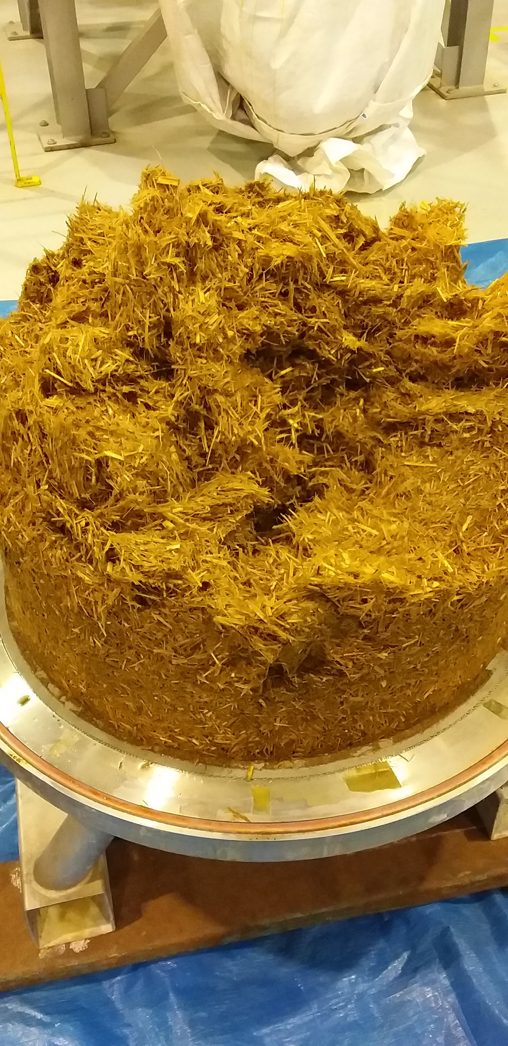  (C)
Fig. S2 Acid soaking system used to impregnate and prepare straw for steam explosion experiments. (A) acid soak tank, (B) Nutsche filter, and (C) soaked straw.

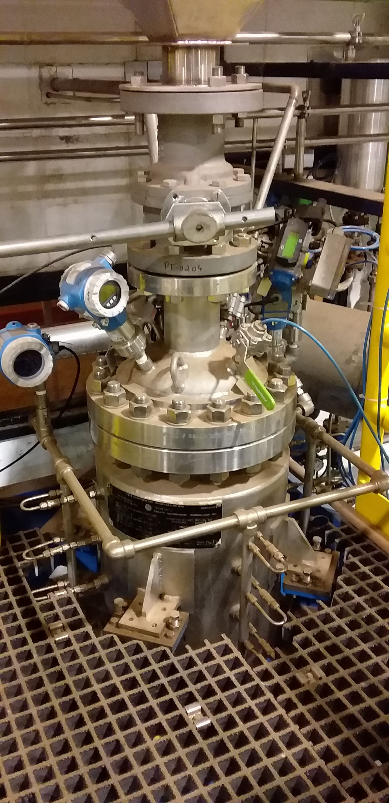  (A) | 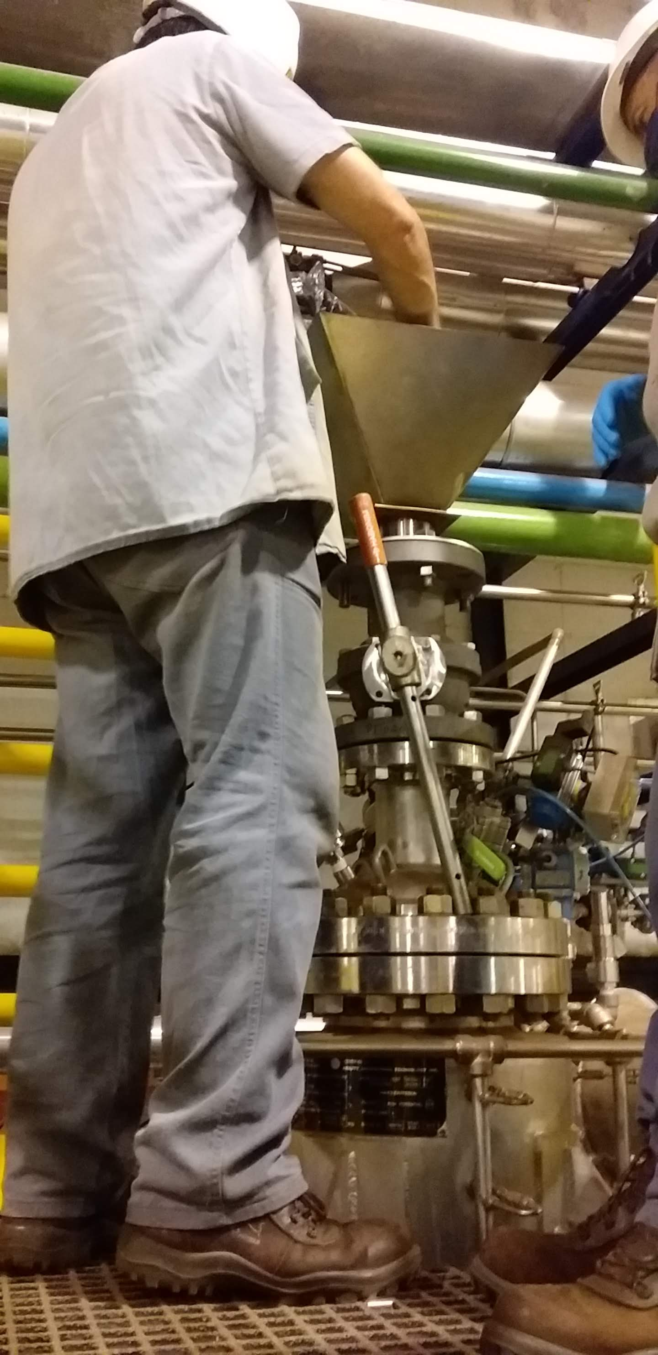  (B) | 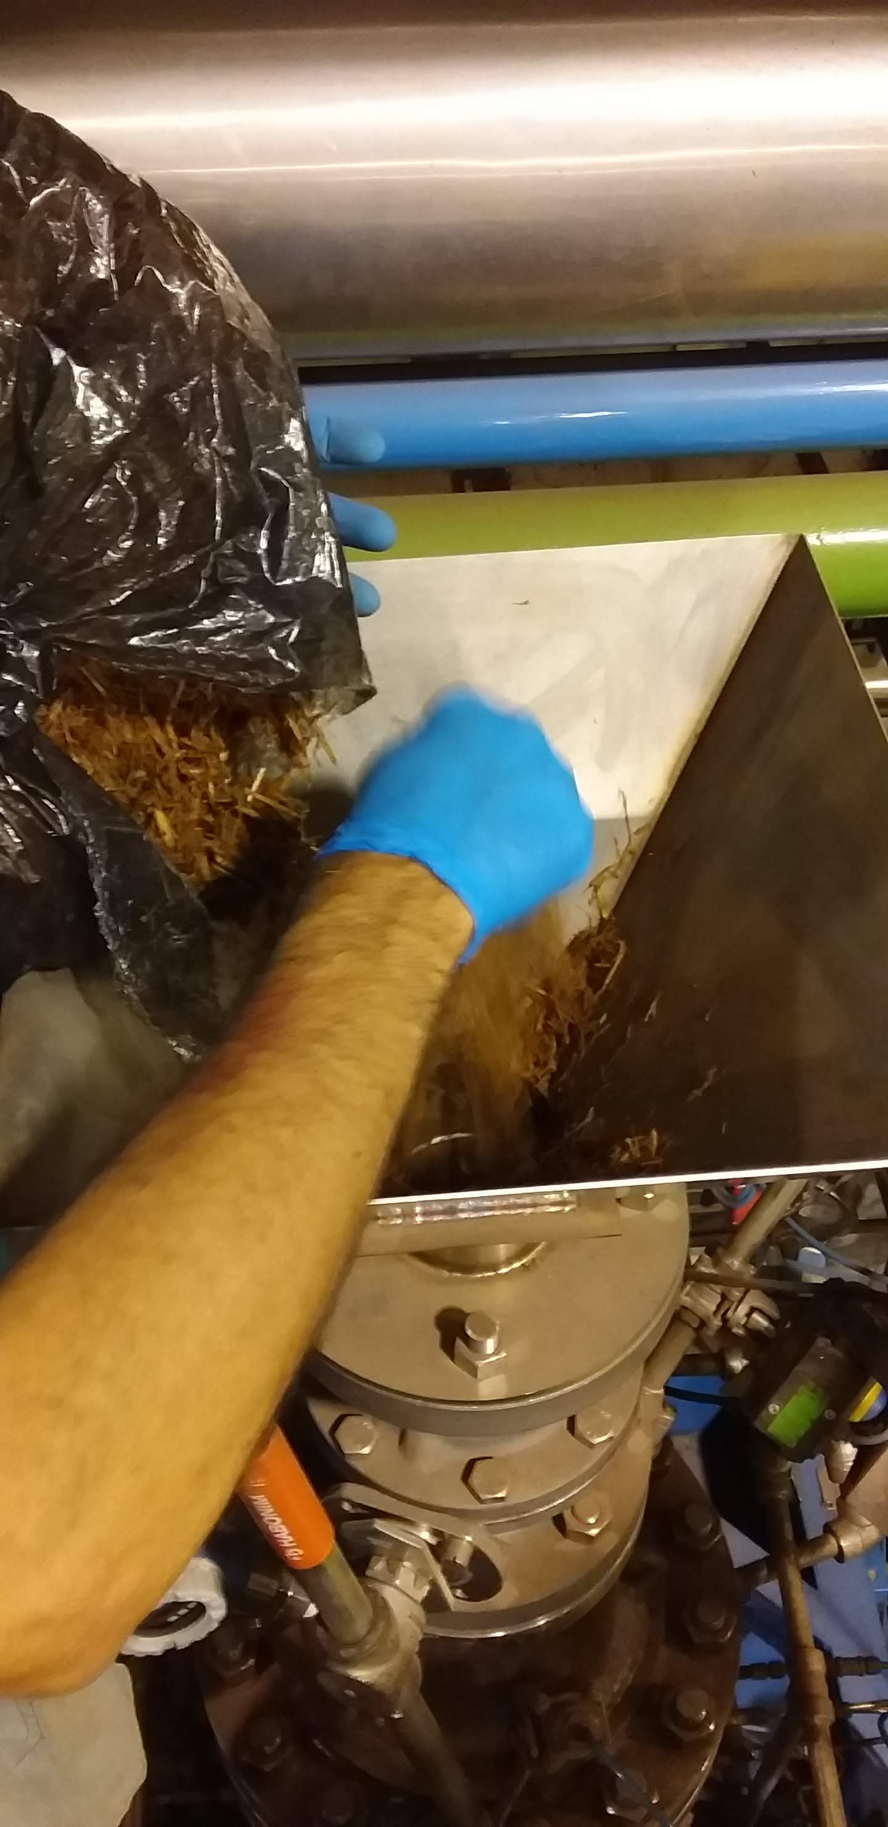  (C)
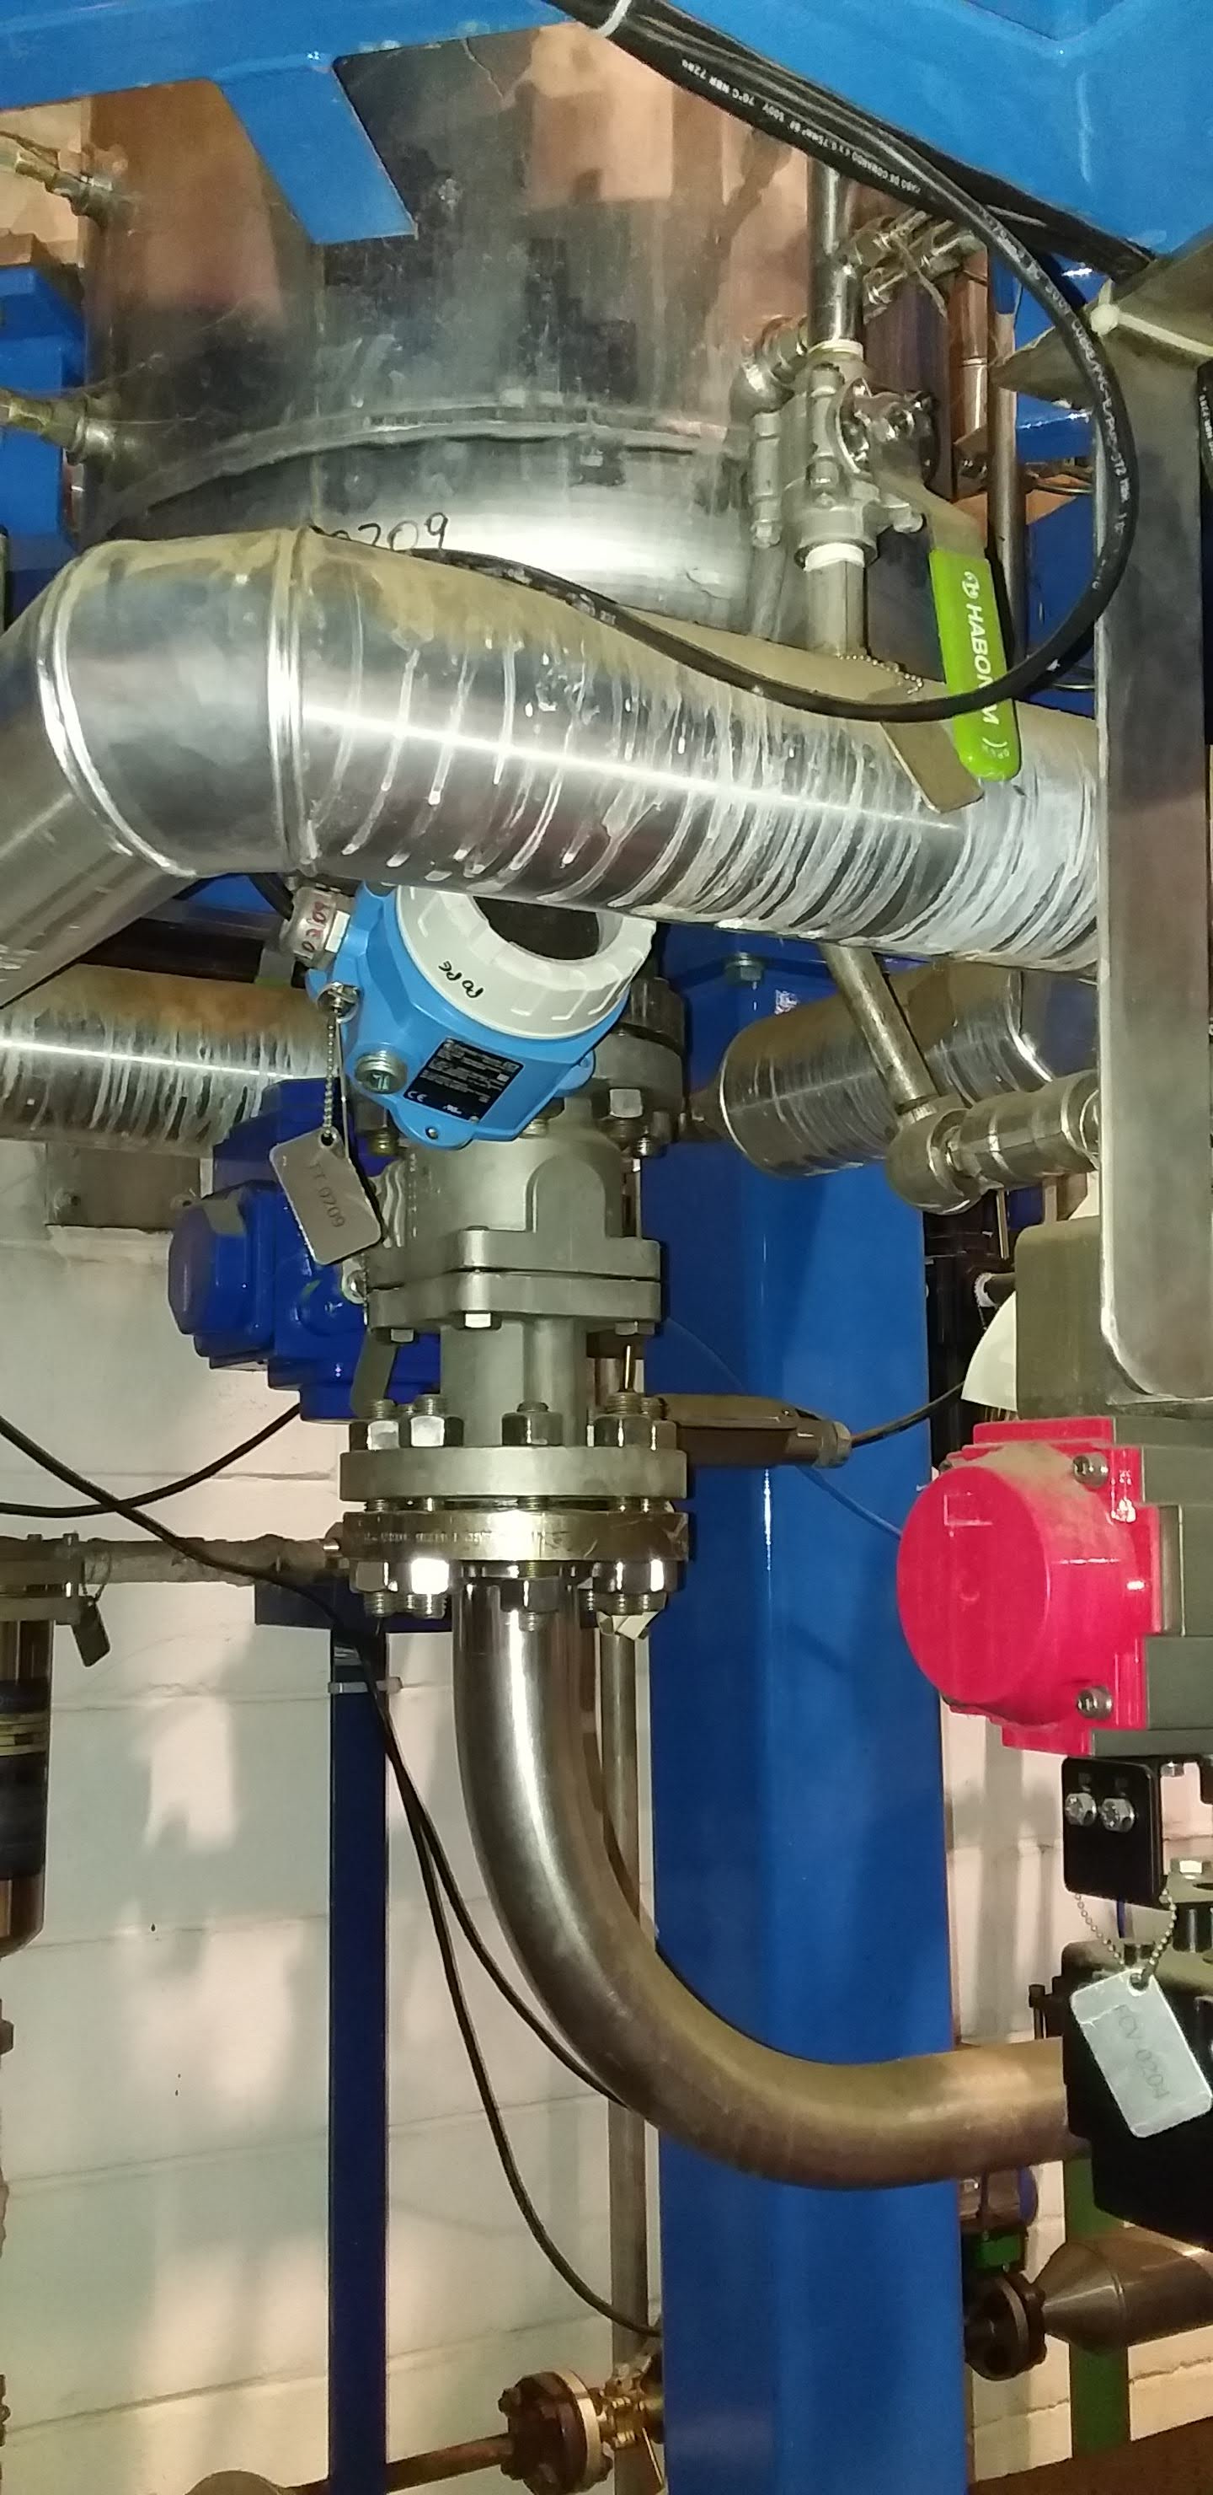  (D) | 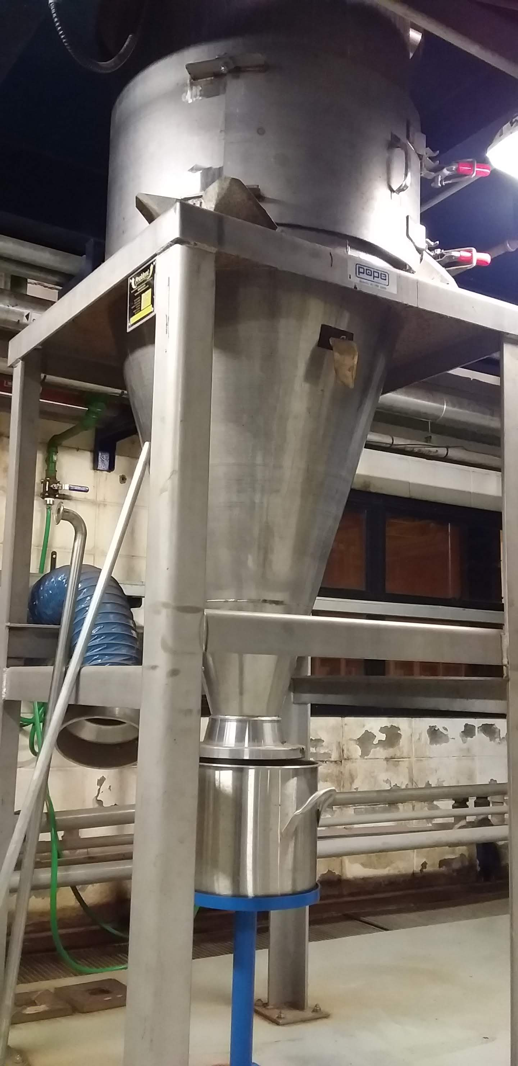  (E) | 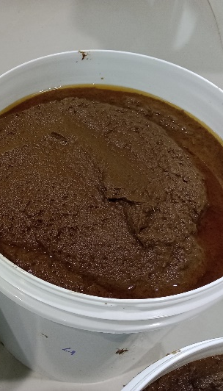  (F)
Fig. S3 Pretreatment system used during the steam explosion experiments. (A) steam explosion reactor, (B) and (C) reactor’s feeding, (D) reactor’s discharging device (blow valve), (E) flash tank (atmospheric cyclone), and (F) pretreated slurry.

Fig. S4 Crystallinity index and lignin conversion results of the acid-catalyzed initial experiments as a function of pretreatment severity.

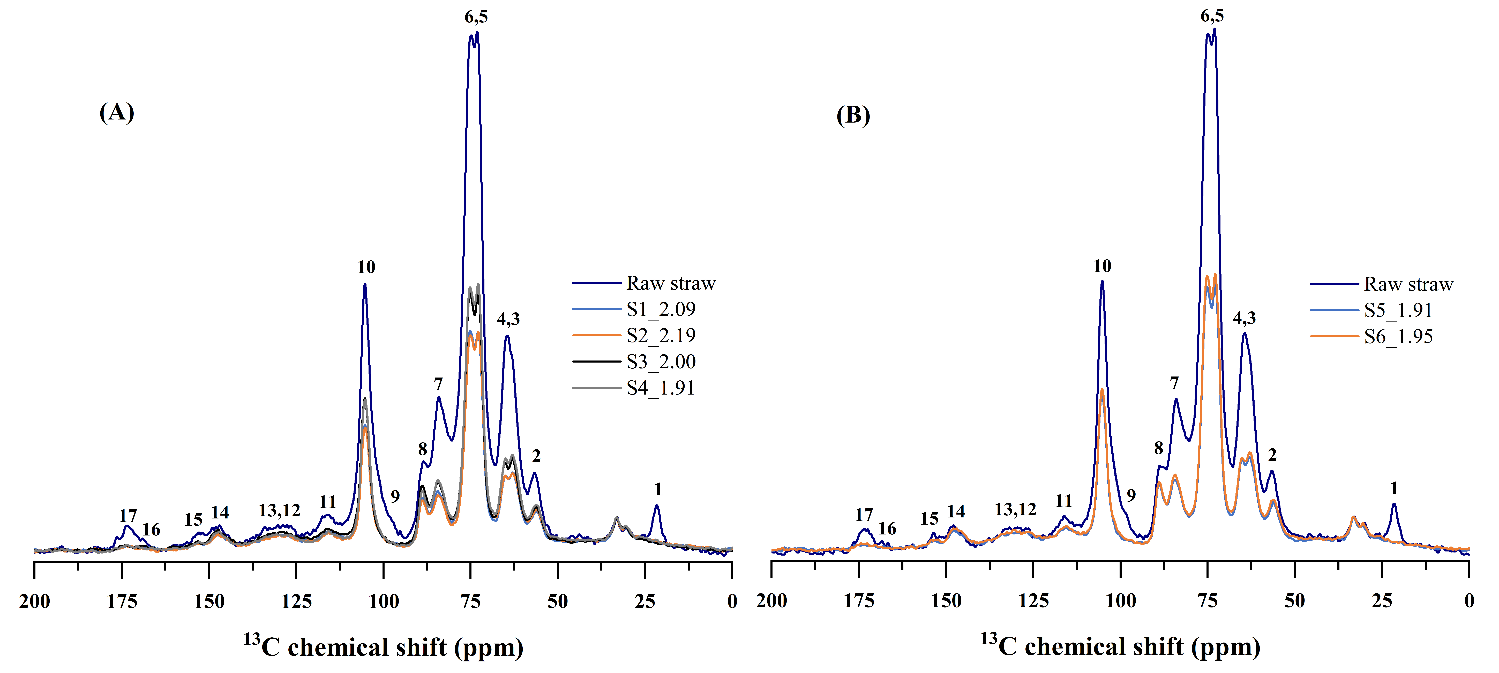
Fig. S5 ¹³C ssNMR (CPMAS-DEC) spectra of the raw and pretreated straws obtained under the S1-S4 (A) and S5-S6 (B) soaking and pretreatment conditions, normalized based on the 31-36 ppm peaks.

Fig. S6 Decay of the CPMG signals (¹H NMR relaxometry measurements) of the raw and pretreated straws obtained under the S2 and S4 pretreatment conditions.

Table S1 Straw composition and acid soaking conditions of the initial experiments and the S1-S6 trials.
 | Initial Exp. | S1 | S2 | S3 | S4 | S5 | S6
Straw size (mm) | 5.0±0.4 | 7.3±0.6 | 3.9±0.4 | 3.9±0.4 | 3.9±0.4 | 3.9±0.4 | 3.9±0.4
Raw straw glucan (mg/g) | 336.1±5.7 | 342.9±8.2 | 365.1±11.1 | 365.1±11.1 | 365.1±11.1 | 365.1±11.1 | 365.1±11.1
Raw straw xylan (mg/g) | 220.5±9.6 | 210.0±5.4 | 222.8±6.3 | 222.8±6.3 | 222.8±6.3 | 222.8±6.3 | 222.8±6.3
Raw straw lignin (mg/g) | 221.8±1.9 | n/d | n/d | n/d | n/d | n/d | n/d
Raw straw extractives (mg/g) | 61.1±3.7 | n/d | n/d | n/d | n/d | n/d | n/d
Raw straw ash (mg/g) | 50.7±0.3 | 50.4±0.7 | 33.7±0.2 | 33.7±0.2 | 33.7±0.2 | 33.7±0.2 | 33.7±0.2
Raw straw acetyl (mg/g) | 34.0±0.1 | n/d | n/d | n/d | n/d | n/d | n/d
Soaking pH | 1.24 | 1.27 | 1.17 | 1.36 | 1.45 | 1.23 | 1.19
Sulfuric acid (%wt solution) | 0.67 | 0.63 | 0.63 | 0.63 | 0.63 | 0.67 | 0.82
Sulfuric acid (%wt biomass) | 2.92 | 3.15 | 3.15 | 3.38 | 3.29 | 3.46 | 3.71
Metabisulfite (%wt solution) | 0.00 | 0.00 | 0.00 | 0.16 | 0.31 | 0.00 | 0.26
Metabisulfite (%wt biomass) | 0.00 | 0.00 | 0.00 | 0.85 | 1.65 | 0.00 | 1.19
Raw straw (kg dry basis) | 23.8 | 8.0 | 8.0 | 8.0 | 8.0 | 8.4 | 8.4
Soaked straw (kg dry basis) | 21.0 | 7.2 | 7.2 | 7.4 | 7.5 | 7.4 | 7.7
Soaked straw ins. solids (%) | 19.9±0.2 | 19.6±0.1 | 18.6±0.2 | 22.9±0.3 | 21.0±0.1 | 22.9±0.2 | 21.6±0.3
Soaking solids yield (%wt) | 11.7 | 9.9 | 9.6 | 7.2 | 6.1 | 11.9 | 8.0
Dewatering relation (%wt) | 82.0 | 78.8 | 78.9 | 77.3 | 77.9 | 77.5 | 80.1
Soaked straw glucan (mg/g) | 354.6±8.8 | 376.8±10.2 | 379.1±12.0 | 355.6±3.2 | 347.3±4.9 | 371.1±2.0 | 362.8±2.1
Soaked straw xylan (mg/g) | 228.1±10.0 | 232.7±7.9 | 234.3±6.8 | 214.5±2.5 | 211.5±1.9 | 229.2±1.5 | 225.0±3.9
Soaked straw lignin (mg/g) | 248.3±4.9 | 275.2±0.7 | 273.3±0.9 | 274.5±1.1 | 267.1±1.0 | n/d | n/d
Soaked straw ash (mg/g) | 44.6±0.2 | 28.0±0.5 | 30.9±1.0 | 37.2±0.8 | 43.1±0.6 | n/d | n/d
Soaked straw acetyl (mg/g) | 16.1±0.1 | n/d | n/d | n/d | n/d | n/d | n/d

Table S2 Pretreatment and hydrolysis data of the acid-catalyzed initial experiments.
 | Unit | 1 | 2 | 3 | 4 | 5 | 6 | 7 | 8 | 9 | 10 | 11 | 12
PRETREATMENT
Pretreatment Severity | - | 1.04 | 1.15 | 1.26 | 1.49 | 1.74 | 1.74 | 1.74 | 1.88 | 1.96 | 1.96 | 2.33 | 2.33
Pretreatment Pressure | barG | 7.1 | 6 | 10.2 | 7.1 | 10.2 | 10.2 | 10.2 | 14.3 | 10.2 | 10.2 | 14.3 | 16.2
Pretreatment Temperature | °C | 171 | 165 | 185 | 171 | 185 | 185 | 185 | 199 | 185 | 185 | 199 | 205
Pretreatment time | sec | 95 | 180 | 60 | 265 | 180 | 180 | 180 | 95 | 300 | 300 | 265 | 180
Soaked Straw (dry basis) | kg | 1.0 | 1.0 | 1.0 | 1.0 | 1.0 | 1.0 | 1.0 | 1.0 | 1.0 | 1.0 | 1.0 | 1.0
Pretreated Slurry | kg | 10.6 | 11.5 | 11.2 | 11.2 | 11.8 | 11.1 | 11.6 | 12.1 | 11.9 | 11.1 | 12.1 | 11.7
Pretreated Slurry Insoluble Solids | % | 6.3±0.0 | 5.7±0.1 | 5.7±0.2 | 5.8±0.1 | 5.0±0.0 | 5.5±0.1 | 5.4±0.0 | 5.0±0.0 | 5.3±0.0 | 5.4±0.0 | 4.9±0.1 | 4.9±0.0
Pretreatment Solids Yield | % | 68.0 | 66.2 | 65.1 | 65.8 | 59.9 | 61.8 | 63.3 | 61.2 | 63.6 | 60.1 | 59.7 | 57.7
Pulp Glucan | mg/g | 483.9±4.5 | 489±9.7 | 495.9±1.9 | 498±1.3 | 523±2.0 | 523.3±1.9 | 504.9±6.6 | 513.1±1.0 | 504.2±5.4 | 520.1±8.6 | 505.8±3.5 | 509.1±7.4
Pulp Xylan | mg/g | 103.1±6 | 103±2.1 | 85.1±7.3 | 77.8±2 | 48±4.1 | 57.9±1.6 | 72.3±2.6 | 74.4±0.8 | 66.1±1.6 | 52.6±4.1 | 48.2±0.9 | 37.3±2.9
Pulp Lignin | mg/g | 302.1±10.6 | 288.9±6.8 | 291.7±5.0 | 317.4±1.1 | 322.9±4.6 | 315.4±0.2 | 315±3.2 | 313.2±3.8 | 318.1±2.8 | 327.1±0.8 | 337.1±2.2 | 350.7±0.9
Crystallinity Index | % | n/d | 42.1±1.7 | 42.2±2.2 | 43.2±3.1 | n/d | n/d | 44.0±2.1 | 45.2±0.8 | 45.1±0.7 | 44.2±2.9 | 39.9±2.0 | 40.4±2.5
Pretreated Slurry Xylose | g/L | 15.4±0.7 | 14.4±0.6 | 16.3±0.0 | 17.6±1.9 | 17.7±0.0 | 16.9±0.0 | 15.3±0.0 | 15.0±0.0 | 15.6±0.4 | 17.7±0.5 | 13.7±1.0 | 14.2±1.1
Pretreated Slurry Glucose | g/L | 1.8±0.2 | 1.7±0.1 | 2.3±0.0 | 2.2±0.1 | 3.0±0.0 | 2.7±0.0 | 2.5±0.0 | 2.9±0.2 | 2.7±0.0 | 3.1±0.1 | 3.8±0.3 | 4.4±0.4
Pretreated Slurry Xylo-Oligo. | g/L | 2.3 | 3.2 | 1.0 | 0.4 | 1.1 | n/d | 1.5 | 1.1 | n/d | 2.6 | 1.0 | 1.7
Pretreated Slurry Furfural | mg/L | 90±10 | 100±8 | 237±5 | 207±27 | 487±20 | 377±31 | 320±25 | 672±86 | 620±55 | 567±40 | 949±80 | 942±75
Pretreated Slurry HMF | mg/L | 24±1 | 27±1 | 58±1 | 41±1 | 106±8 | 73±4 | 66±2 | 139±3 | 103±6 | 105±5 | 252±10 | 298±8
Pretreatment Xylose Yield | % | 59.9±2.6 | 60.9±2.5 | 67.4±2.9 | 72.1±4.8 | 77.1±2.1 | 68.8±3.0 | 65.7±3.5 | 67±1.4 | 68.5±1.6 | 72.5±2.2 | 61.1±4.7 | 61.3±4.9
Pretreatment Glucose Yield | % | 4.5±0.4 | 4.7±0.2 | 6.3±0.2 | 6.0±0.4 | 8.7±0.4 | 7.3±0.4 | 7.0±0.5 | 8.5±0.5 | 7.8±0.1 | 8.4±0.2 | 11.3±1.0 | 12.5±1.1
Pretreatment Xylo-Oligo. Yield | % | 8.7 | 13.5 | 4.0 | 1.7 | 4.9 | n/d | 6.4 | 5.1 | n/d | 10.5 | 4.4 | 7.3
Pretreatment Xylan Conversion | % | 69.2±4.0 | 70.1±1.4 | 75.7±6.5 | 77.6±2.0 | 87.4±7.5 | 84.3±2.3 | 79.9±2.9 | 80.1±0.8 | 81.6±2.0 | 86.1±6.8 | 87.4±1.7 | 90.6±7.0
Pretreatment Glucan Conversion | % | 7.1±0.1 | 8.8±0.2 | 8.9±0.0 | 7.6±0.0 | 11.7±0.0 | 8.8±0.0 | 9.8±0.1 | 11.5±0.0 | 9.5±0.1 | 11.8±0.2 | 14.8±0.1 | 17.1±0.2
Pretreatment Lignin Conversion | % | n/d | 23.0±0.8 | 23.5±1.0 | n/d | 22.1±0.9 | 21.5±0.1 | n/d | 22.8±1.1 | n/d | 20.8±0.2 | 18.9±0.6 | 18.5±0.3
HYDROLYSIS
Accessibility | % | 76.1±0.7 | 78.5±4.5 | 81.2±3.5 | 82.6±4.4 | 85.0±1.8 | 87.2±2.1 | 88.9±2.9 | 83.3±2.2 | 84.9±2.8 | 84.0±1.8 | 84.9±0.8 | 85.6±4.6
Maximum Theoretical Glucose | g/L | 61.3 | 60.2 | 61.8 | 62.4 | 64.6 | 64.2 | 62.2 | 63.9 | 61.5 | 64.3 | 62.3 | 62.9
Maximum Theoretical Xylose | g/L | 13.0 | 12.7 | 10.6 | 9.7 | 5.9 | 7.1 | 8.9 | 9.3 | 8.1 | 6.5 | 5.9 | 4.6
6.3 mg/gCel enzyme dosage
Hydrolysis Initial Glucose | g/L | 0.9 | 0.3 | 0.3 | 0.3 | 1.9 | 0.5 | 0.5 | 1.0 | 0.5 | 0.4 | 0.5 | 0.9
Hydrolysis Initial Xylose | g/L | 3.1 | 2.2 | 2.6 | 3.8 | 3.2 | 2.3 | 2.7 | 2.2 | 1.8 | 1.9 | 1.7 | 2.4
Hydrolysis Final Glucose | g/L | 36.3±0.3 | 36.2±0.2 | 39.0±2.5 | 39.2±0.4 | 45.6±1.7 | 44.4±0.1 | 42.3±0.2 | 45.4±0.7 | 43.2±0.9 | 44.7±1.0 | 43.7±1.4 | 46.6±0.7
Hydrolysis Final Xylose | g/L | 3.6±0.1 | 3.7±0.1 | 2.8±0.2 | 4.2±0.1 | 3.0±0.1 | 3.0±0.1 | 3.0±0.1 | 3.5±0.3 | 2.7±0.2 | 2.7±0.1 | 3.3±0.4 | 4.0±0.1
Hydrolysis Glucose Yield | % | 57.7±0.6 | 59.6±0.3 | 62.7±4.0 | 62.3±0.7 | 67.5±2.6 | 68.5±0.1 | 67.2±0.4 | 69.5±1.1 | 69.3±1.4 | 69±1.6 | 69.2±2.3 | 72.6±1.0
Hydrolysis Xylose Yield | % | 0.0±0.0 | 12.0±0.3 | 0.0±0.0 | 4.6±0.1 | 0.0±0.0 | 9.4±0.3 | 0.0±0.0 | 14.1±1.4 | 11.5±0.6 | 11.4±0.3 | 26.8±3.0 | 34.3±1.2
Global Glucose Yield | g/kg | 228.8 | 232.5 | 249.8 | 250.7 | 269.3 | 274.9 | 266.5 | 275.9 | 278.0 | 272.7 | 276.9 | 286.2
Global Xylose Yield | g/kg | 155.3 | 167.2 | 174.6 | 189.6 | 199.7 | 182.1 | 170.4 | 181.0 | 183.1 | 192.0 | 167.3 | 167.2
Global Monomers Yield | % | 58.8 | 61.2 | 65.0 | 67.4 | 71.8 | 70.0 | 66.9 | 70.0 | 70.6 | 71.1 | 68.0 | 69.4
12.6 mg/gCel enzyme dosage
Hydrolysis Initial Glucose | g/L | 1.0 | 0.5 | 0.4 | 0.4 | 2.1 | 0.6 | 0.6 | 1.1 | 0.6 | 0.5 | 0.7 | 1.1
Hydrolysis Initial Xylose | g/L | 3.2 | 2.3 | 2.7 | 3.9 | 3.3 | 2.4 | 2.8 | 2.3 | 1.9 | 2.0 | 1.8 | 2.5
Hydrolysis Final Glucose | g/L | 38.1±1.1 | 38.2±2.1 | 44.6±2.2 | 45.8±2.0 | 52.3±2.7 | 51.7±3.5 | 51.6±2.3 | 53±2.2 | 48.7±1.9 | 51.9±3.3 | 51.5±1.5 | 52.9±4.2
Hydrolysis Final Xylose | g/L | 7.0±0.1 | 6.5±0.3 | 6.0±0.2 | 8.3±0.4 | 6.1±0.3 | 6.1±0.5 | 6.8±0.5 | 5.6±0.2 | 4.8±0.1 | 5.0±0.2 | 4.8±0.4 | 5.1±0.3
Hydrolysis Glucose Yield | % | 60.5±1.7 | 62.6±3.5 | 71.5±3.5 | 72.7±3.1 | 77.7±4.1 | 79.6±5.4 | 81.9±3.4 | 81.2±3.9 | 78.0±2.7 | 79.9±5.1 | 81.5±2.4 | 82.3±6.6
Hydrolysis Xylose Yield | % | 29.6±0.5 | 33.3±1.3 | 31.4±1.1 | 45.4±2.3 | 46.1±2.6 | 51.6±4.1 | 44.6±3.5 | 36.3±1.4 | 36.5±1.1 | 46.1±2.1 | 50.3±4.1 | 56.2±3.4
Global Glucose Yield | g/kg | 239.1 | 243.5 | 281.7 | 288.4 | 304.6 | 314.7 | 318.5 | 316.8 | 309.1 | 310.9 | 318.1 | 318.0
Global Xylose Yield | g/kg | 178.9 | 183.7 | 194.4 | 213.3 | 214.8 | 199.3 | 193.6 | 192.5 | 195.0 | 204.4 | 174.9 | 172.5
Global Monomers Yield | % | 64.0 | 65.4 | 72.9 | 76.8 | 79.5 | 78.7 | 78.4 | 78.0 | 77.2 | 78.9 | 75.5 | 75.1

Table S3 ANOVA of the global monomers yield model of the acid-catalyzed initial experiments (R² = 99.40%).
Source of variation | Sum of squares | Degrees of freedom | Mean squares | F calc | p-value
Regression | 289.0 | 5 | 57.8 | 166.5 | 0.0000
Residual error | 1.7 | 5 | 0.3
Lack of fit | 1.1 | 3 | 0.4 | 1.1 | 0.5163
Pure error | 0.7 | 2 | 0.3
Total | 290.8 | 10

Table S4 Pretreatment and hydrolysis data of the combined acid- and bisulfite-catalyzed experiments (S1-S4 trials).
 | Unit | 1 | 2 | 3 | 4 | 5 | 6 | 7 | 8 | 9 | 10 | 11 | 12
PRETREATMENT
Soaking Trial |  | S1 | S1 | S1 | S2 | S2 | S2 | S3 | S3 | S3 | S4 | S4 | S4
Pretreatment Severity | - | 1.87 | 1.99 | 2.09 | 1.97 | 2.09 | 2.19 | 1.78 | 1.90 | 2.00 | 1.69 | 1.81 | 1.91
Pretreatment time | sec | 150 | 200 | 250 | 150 | 200 | 250 | 150 | 200 | 250 | 150 | 200 | 250
Pretreatment pH | - | 1.27 | 1.27 | 1.27 | 1.17 | 1.17 | 1.17 | 1.36 | 1.36 | 1.36 | 1.45 | 1.45 | 1.45
Soaked Straw (dry basis) | kg | 2.0 | 2.0 | 2.0 | 2.1 | 2.1 | 2.1 | 2.2 | 2.2 | 2.2 | 1.9 | 1.9 | 1.9
Pretreated Slurry | kg | 18.3 | 19.2 | 18.5 | 19.2 | 19.4 | 19.3 | 18.4 | 18.2 | 18.7 | 18.9 | 18.1 | 18.1
Pretreated Slurry Insoluble Solids | % | 7.1±0.1 | 6.7±0.2 | 6.7±0.1 | 6.8±0.1 | 6.5±0.0 | 6.5±0.0 | 6.9±0.0 | 6.9±0.0 | 6.8±0.1 | 6.3±0.0 | 6.7±0.0 | 6.7±0.0
Pretreatment Solids Yield | % | 63.8 | 62.6 | 61.1 | 61.7 | 59.4 | 58.7 | 58.8 | 57.9 | 58.7 | 63.1 | 64.3 | 64.4
Pulp Glucan | mg/g | 544±12.3 | 552.6±18.8 | 563.9±11.6 | 551.2±18.9 | 558.2±17.9 | 562.8±2.2 | 555.9±5.5 | 555.7±1.3 | 550.4±0.5 | 509.9±0.9 | 503.7±9.0 | 504.5±1.9
Pulp Xylan | mg/g | 22.8±2.1 | 18.7±0.7 | 18.1±0.7 | 18.2±0.3 | 17±0.3 | 15.3±0.1 | 25.3±1.0 | 25.2±0.3 | 22.1±0.3 | 36±3.5 | 34.3±1.1 | 32.9±2.6
Pulp Lignin | mg/g | 342.5±7.7 | 341.7±0.5 | 347.7±2.3 | 362.9±2.1 | 362.3±0.3 | 376.5±7.0 | 331.9±5.1 | 337.6±3.7 | 337.7±5.4 | 323.6±7.0 | 314.4±6.9 | 328.4±0.8
Pretreated Slurry Xylose | g/L | 24.8±0.9 | 22.8±0.8 | 22.8±0.8 | 24.9±0.8 | 23.2±0.9 | 22.2±0.6 | 21.5±0.7 | 20.8±0.7 | 18.3±0.7 | 17.4±0.7 | 17.4±0.8 | 16±0.6
Pretreated Slurry Glucose | g/L | 3.4±0.4 | 3.6±0.4 | 3.7±0.3 | 4.8±0.4 | 5.4±0.2 | 5.6±0.1 | 3.7±0.2 | 4.2±0.2 | 4.0±0.1 | 2.3±0.1 | 2.2±0.1 | 2.1±0.2
Pretreated Slurry Furfural | mg/L | 589±5 | 799±34 | 938±78 | 990±18 | 1168±101 | 1343±39 | 851±37 | 1070±50 | 998±11 | 663±21 | 749±90 | 788±50
Pretreated Slurry HMF | mg/L | 164±58 | 196±9 | 241±5 | 250±4 | 305±4 | 325±32 | 193±28 | 289±5 | 275±4 | 150±10 | 135±16 | 138±21
Pretreatment Xylose Yield | % | 78.2±2.8 | 75.8±2.7 | 72.9±2.6 | 78.8±2.4 | 74.3±2.9 | 70.5±2.0 | 69.9±2.2 | 66.9±2.2 | 60.4±2.3 | 67.4±2.6 | 64.5±2.9 | 59.5±2.1
Pretreatment Glucose Yield | % | 6.7±0.9 | 7.6±0.8 | 7.5±0.7 | 9.6±0.7 | 11.0±0.3 | 11.2±0.2 | 7.4±0.4 | 8.4±0.4 | 8.2±0.3 | 5.5±0.3 | 5.0±0.3 | 4.9±0.5
Pretreatment Xylan Conversion | % | 93.7±8.6 | 95.0±3.7 | 95.2±3.8 | 95.2±1.7 | 95.7±1.9 | 96.2±0.9 | 93.1±3.6 | 93.2±0.9 | 94.0±1.5 | 89.2±8.6 | 89.6±2.8 | 90.0±7.1
Pretreatment Glucan Conversion | % | 7.9±0.2 | 8.2±0.3 | 8.6±0.2 | 10.3±0.7 | 12.6±0.6 | 12.8±0.0 | 8.1±0.1 | 9.4±0.0 | 9.1±0.0 | 7.3±0.0 | 6.8±0.1 | 6.4±0.0
Pretreatment Lignin Conversion | % | 20.6±0.6 | 22.3±0.0 | 22.8±0.2 | 18.1±0.1 | 21.3±0.0 | 19.1±0.4 | 28.9±0.4 | 28.7±0.3 | 27.7±0.4 | 23.5±0.5 | 24.3±0.7 | 20.8±0.1
HYDROLYSIS
Accessibility | % | 92.9±0.8 | 95.1±3.0 | 92.8±2.2 | 91.6±0.7 | 92.4±1.2 | 92.5±1.0 | 94.0±1.2 | 96.1±1.5 | 96.3±1.5 | 98.0±1.1 | 100.9±1.1 | 99.6±0.8
Maximum Theoretical Glucose | g/L | 64.7 | 65.7 | 67.0 | 65.6 | 66.4 | 66.9 | 66.1 | 66.1 | 65.5 | 60.8 | 60.1 | 60.2
Maximum Theoretical Xylose | g/L | 2.7 | 2.2 | 2.2 | 2.2 | 2.0 | 1.8 | 3.0 | 3.0 | 2.6 | 4.3 | 4.1 | 3.9
6.3 mg/gCel enzyme dosage
Hydrolysis Initial Glucose | g/L | 0.8 | 1.0 | 1.1 | 1.3 | 1.2 | 1.5 | 0.8 | 0.9 | 1.1 | 0.6 | 0.5 | 0.7
Hydrolysis Initial Xylose | g/L | 4.5 | 4.5 | 4.5 | 4.8 | 4.1 | 4.9 | 3.5 | 3.3 | 2.9 | 3.5 | 3.1 | 3.3
Hydrolysis Final Glucose | g/L | 52.0±1.6 | 50.6±1.1 | 51.1±1.1 | 52.1±1.1 | 50.6±1.1 | 49.7±1.0 | 50.2±0.3 | 50.9±0.3 | 52.2±0.1 | 47.1±1.0 | 48.5±0.6 | 50.4±1.0
Hydrolysis Final Xylose | g/L | 5.6±0.3 | 5.4±0.2 | 5.0±0.2 | 5.3±0.3 | 4.5±0.1 | 5.2±0.1 | 4.5±0.1 | 3.7±0.2 | 3.6±0.2 | 4.9±0.4 | 4.7±0.3 | 4.9±0.5
Hydrolysis Glucose Yield | % | 78.9±2.8 | 75.3±2.0 | 74.5±1.9 | 77.2±1.9 | 74.4±2.0 | 71.9±1.8 | 74.6±0.5 | 75.4±0.4 | 77.8±0.2 | 76.4±1.7 | 79.7±0.9 | 82.5±1.6
Hydrolysis Xylose Yield | % | 42.4±2.1 | 37.8±1.5 | 24.7±1.1 | 22.9±1.8 | 21.7±0.7 | 16.8±0.4 | 33.4±0.5 | 16.0±0.8 | 26.8±1.1 | 32.1±2.6 | 38.9±2.8 | 39.5±3.6
Global Glucose Yield | g/kg | 332.6 | 321.2 | 316.5 | 332.1 | 320.1 | 311.3 | 300.4 | 302.9 | 312.2 | 294.2 | 305.9 | 316.8
Global Xylose Yield | g/kg | 213.8 | 205.6 | 195.9 | 212.8 | 200.3 | 189.5 | 176.1 | 165.6 | 151.2 | 170.2 | 164.8 | 152.5
Global Monomers Yield | % | 80.0 | 77.1 | 75.0 | 79.3 | 75.7 | 72.9 | 74.6 | 73.3 | 72.5 | 74.2 | 75.2 | 74.9
12.6 mg/gCel enzyme dosage
Hydrolysis Initial Glucose | g/L | 0.9 | 1.1 | 1.2 | 1.5 | 1.3 | 1.6 | 0.9 | 1.1 | 1.2 | 0.7 | 0.7 | 0.8
Hydrolysis Initial Xylose | g/L | 4.6 | 4.6 | 4.6 | 4.9 | 4.2 | 5.0 | 3.6 | 3.4 | 3.0 | 3.6 | 3.2 | 3.4
Hydrolysis Final Glucose | g/L | 59.4±1.3 | 61.7±2.1 | 62.7±1.7 | 59.7±0.8 | 60.3±0.2 | 61.7±0.7 | 60.1±2.0 | 60.7±2.1 | 63.8±0.4 | 57.8±0.4 | 57.5±0.2 | 56.6±0.7
Hydrolysis Final Xylose | g/L | 5.8±0.1 | 6.0±0.3 | 5.5±0.2 | 5.7±0.2 | 4.9±0.0 | 5.5±0.1 | 5.0±0.3 | 4.4±0.5 | 4.4±0.1 | 5.8±0.2 | 5.7±0.2 | 6.0±0.1
Hydrolysis Glucose Yield | % | 90.3±2.0 | 92.1±3.0 | 91.8±2.1 | 88.8±1.0 | 88.9±0.5 | 89.8±1.0 | 89.6±2.9 | 90.1±2.9 | 95.5±0.6 | 93.9±0.7 | 94.7±0.5 | 92.7±1.1
Hydrolysis Xylose Yield | % | 42.3±0.5 | 61.5±2.7 | 42.7±1.7 | 36.3±1.3 | 33.6±0.3 | 30.9±0.8 | 46.1±2.7 | 34.2±3.6 | 50.9±1.2 | 50.2±1.6 | 60.9±1.7 | 64.8±0.7
Global Glucose Yield | g/kg | 376.5 | 385.8 | 382.8 | 375.8 | 373.7 | 377.0 | 354.6 | 355.6 | 375.6 | 356.8 | 359.9 | 353.6
Global Xylose Yield | g/kg | 213.8 | 208.7 | 198.2 | 214.5 | 201.7 | 190.9 | 178.3 | 168.7 | 154.8 | 174.9 | 170.4 | 158.6
Global Monomers Yield | % | 86.4 | 87.0 | 85.1 | 85.9 | 83.7 | 82.6 | 83.4 | 82.1 | 83.0 | 84.9 | 84.7 | 81.8

Table S5 Pretreatment and hydrolysis data of the combined acid- and bisulfite-catalyzed experiments (S5-S6 trials).
 | Unit | 1 | 2
PRETREATMENT
Soaking Trial | - | S5 | S6
Pretreatment Severity | - | 1.91 | 1.95
Pretreatment pH | - | 1.23 | 1.19
Soaked Straw (dry basis) | kg | 3.3 | 2.9
Pretreated Slurry | kg | 26.7 | 22.3
Pretreated Slurry Insoluble Solids | % | 7.3±0.1 | 7.9±0.1
Pretreatment Solids Yield | % | 58.9 | 60.7
Pulp Glucan | mg/g | 549.5±4.1 | 537.9±3.5
Pulp Xylan | mg/g | 18.5±0.6 | 14.8±0.3
Pretreated Slurry Xylose | g/L | 25.2±0.4 | 26.9±0.5
Pretreated Slurry Glucose | g/L | 4.1±0.1 | 4.5±0.1
Pretreated Slurry Furfural | mg/L | 1083±30 | 1186±22
Pretreated Slurry HMF | mg/L | 179±4 | 219±5
Pretreatment Xylose Yield | % | 72.6±1.3 | 71.6±1.4
Pretreatment Glucose Yield | % | 7.5±0.1 | 7.7±0.1
Pretreatment Xylan Conversion | % | 95.3±3.1 | 96.0±2.1
Pretreatment Glucan Conversion | % | 12.8±0.5 | 10.0±0.5
HYDROLYSIS
Maximum Theoretical Glucose | g/L | 86.8 | 85.0
Hydrolysis Glucose Yield (5.5 mg/gCel) | % | 65.6±1.2 | 64.6±1.4
Hydrolysis Glucose Yield (8.4 mg/gCel) | % | 73.3±1.7 | 73.0±0.6
Hydrolysis Glucose Yield (11.1 mg/gCel) | % | 83.2±1.5 | 80.4±0.4
Hydrolysis Glucose Yield (12.6 mg/gCel) | % | 84.6±0.8 | 84.2±0.2
Hydrolysis Glucose Yield (14.0 mg/gCel) | % | 84.9±1.9 | 84.3±1.7
Hydrolysis Glucose Yield (16.7 mg/gCel) | % | 85.6±1.2 | 84.7±1.0

