Supplementary Information:

Metabolic plasticity can amplify ecosystem responses to global warming

Rebecca L. Kordas¹, Samraat Pawar¹, Guy Woodward¹, and Eoin J. O’Gorman^{2,*}
¹ Department of Life Sciences, Imperial College London, Silwood Park Campus, Buckhurst Road, Ascot, Berkshire, SL5 7PY, UK.
² School of Life Sciences, University of Essex, Wivenhoe Park, Colchester, CO4 3SQ, UK.
Running head: Body size and thermal adaptation
Type of paper: Letter
* Corresponding author: Eoin O'Gorman
E-mail: e.ogorman@essex.ac.uk
Supplementary Methods
R code for statistical model fitting
We followed the methods detailed by Zuur et al.¹ for determining the optimal random and fixed effects structures describing the effects of body mass, acute temperature exposure, and chronic temperature exposure on metabolic rate. Specifically, we started with the full model detailed in Equation 3 of the main text and determined the optimal random effects structure using the following R code:
lmec = lmeControl(opt = "optim", msMaxIter = 200, msMaxEval = 500))
r1 = gls(lnI ~ lnM + TA + TC + lnM:TA + lnM:TC + TA:TC + lnM:TA:TC,
method="REML", control=lmec)
r2 = lme(lnI ~ lnM + TA + TC + lnM:TA + lnM:TC + TA:TC + lnM:TA:TC,
random = ~1 | species,
method="REML", control=lmec)
r3 = lme(lnI ~ lnM + TA + TC + lnM:TA + lnM:TC + TA:TC + lnM:TA:TC,
random = ~1 + lnM | species,
method="REML", control=lmec)
r4 = lme(lnI ~ lnM + TA + TC + lnM:TA + lnM:TC + TA:TC + lnM:TA:TC,
random = ~1 + TA | species,
method="REML", control=lmec)
r5 = lme(lnI ~ lnM + TA + TC + lnM:TA + lnM:TC + TA:TC + lnM:TA:TC,
random = ~1 + TC | species,
method="REML", control=lmec)
r6 = lme(lnI ~ lnM + TA + TC + lnM:TA + lnM:TC + TA:TC + lnM:TA:TC,
random = ~1 + lnM + TA | species,
method="REML", control=lmec)
r7 = lme(lnI ~ lnM + TA + TC + lnM:TA + lnM:TC + TA:TC + lnM:TA:TC,
random = ~1 + lnM + TC | species,
method="REML", control=lmec)
r8 = lme(lnI ~ lnM + TA + TC + lnM:TA + lnM:TC + TA:TC + lnM:TA:TC,
random = ~1 + TA + TC | species,
method="REML", control=lmec)
r9 = lme(lnI ~ lnM + TA + TC + lnM:TA + lnM:TC + TA:TC + lnM:TA:TC,
random = ~1 + lnM + TA + TC | species,
method="REML", control=lmec)
AIC(r1,r2,r3,r4,r5,r6,r7,r8,r9)
Here, lnI, lnM, T_{A}, and T_{C} were continuous variables defined in Equations 1–3 in the main text, while ‘species’ was a categorical variable corresponding to the species name for each data point in the analysis. The values we used for ‘lmeControl’ were simply to deal with convergence issues and were implemented consistently throughout our analyses. The model r9 was determined to contain the optimal random effects structure using Akaike Information Criterion (ΔAIC > 29.9; see Table S4). The subsequent R code for determining the optimal fixed effects structure was as follows:
m1 = lme(lnI ~ lnM + TA + TC + lnM:TA + lnM:TC + TA:TC + lnM:TA:TC,
random = ~1 + lnM + TA + TC | species,
method="ML", control=lmec)
m2 = lme(lnI ~ lnM + TA + TC + lnM:TA + lnM:TC + TA:TC,
random = ~1 + lnM + TA + TC | species,
method="ML", control=lmec)
m3 = lme(lnI ~ lnM + TA + TC + lnM:TA + lnM:TC,
random = ~1 + lnM + TA + TC | species,
method="ML", control=lmec)
m4 = lme(lnI ~ lnM + TA + TC + lnM:TA + TA:TC,
random = ~1 + lnM + TA + TC | species,
method="ML", control=lmec)
m5 = lme(lnI ~ lnM + TA + TC + lnM:TC + TA:TC,
random = ~1 + lnM + TA + TC | species,
method="ML", control=lmec)
m6 = lme(lnI ~ lnM + TA + TC + lnM:TA,
random = ~1 + lnM + TA + TC | species,
method="ML", control=lmec)
m7 = lme(lnI ~ lnM + TA + lnM:TA,
random = ~1 + lnM + TA + TC | species,
method="ML", control=lmec)
m8 = lme(lnI ~ lnM + TA + TC + lnM:TC,
random = ~1 + lnM + TA + TC | species,
method="ML", control=lmec)
m9 = lme(lnI ~ lnM + TC + lnM:TC,
random = ~1 + lnM + TA + TC | species,
method="ML", control=lmec)
m10 = lme(lnI ~ lnM + TA + TC + TA:TC,
random = ~1 + lnM + TA + TC | species,
method="ML", control=lmec)
m11 = lme(lnI ~ TA + TC + TA:TC,
random = ~1 + lnM + TA + TC | species,
method="ML", control=lmec)
m12 = lme(lnI ~ lnM + TA + TC,
random = ~1 + lnM + TA + TC | species,
method="ML", control=lmec)
m13 = lme(lnI ~ lnM + TA,
random = ~1 + lnM + TA + TC | species,
method="ML", control=lmec)
m14 = lme(lnI ~ lnM + TC,
random = ~1 + lnM + TA + TC | species,
method="ML", control=lmec)
m15 = lme(lnI ~ TA + TC,
random = ~1 + lnM + TA + TC | species,
method="ML", control=lmec)
m16 = lme(lnI ~ lnM,
random = ~1 + lnM + TA + TC | species,
method="ML", control=lmec)
m17 = lme(lnI ~ TA,
random = ~1 + lnM + TA + TC | species,
method="ML", control=lmec)
m18 = lme(lnI ~ TC,
random = ~1 + lnM + TA + TC | species,
method="ML", control=lmec)
m19 = lme(lnI ~ 1,
random = ~1 + lnM + TA + TC | species,
method="ML", control=lmec)
AIC(m1,m2,m3,m4,m5,m6,m7,m8,m9,m10,m11,m12,m13,m14,m15,m16,m17,m18,m19)
The model m5 was determined to contain the optimal fixed effects structure (ΔAIC > 0.5; see Table S5). Note that model m2 performed similarly (ΔAIC = 0.5), but contained a non-significant interaction between lnM and T_{A} (t₁₂₈₆ = -1.43, p = 0.1534). Thus, we also arrived at m5 by dropping each non-significant higher order term until all terms in the model were significant¹. The R code for exploring the best-fitting model was thus:
summary(mod = lme(lnI ~ lnM + TA + TC + lnM:TC + TA:TC,
random = ~1 + lnM + TA + TC | species,
method="REML", control=lmec))
R code for plotting the partial residuals
To visualise the effect of chronic temperature exposure on the size-dependence of metabolic rate (Fig. 1a), we first had to temperature-correct the metabolic rate data according to the acute temperature exposure parameters in our best fitting model. We then refitted the model to the temperature-corrected data, removing any terms in the model containing acute temperature exposure. Finally, we extracted the partial residuals for plotting as follows:
tcor_I = I / exp(TA*(summary(mod)$tTable["TA","Value"] +
summary(mod)$tTable["TA:TC","Value"]*TC))
tcor_mod = lme(ln(tcor_I) ~ lnM + TC + lnM:TC,
random = ~1 + lnM + TC | species,
method="REML", control=lmec))
tcor_resids <- resid(tcor_mod)
tcor_partials = tcor_resids +
summary(tcor_mod)$tTable["(Intercept)","Value"] +
summary(tcor_mod)$tTable["lnM","Value"]*lnM +
summary(tcor_mod)$tTable["TC","Value"]*TC +
summary(tcor_mod)$tTable["lnM:TC","Value"]*lnM*TC
Similarly, to visualise the effect of chronic temperature exposure on the acute temperature-dependence of metabolic rate (Fig. 1c), we first had to mass-correct the metabolic rate data according to the body mass parameters in our best fitting model. We then refitted the model to the mass-corrected data, removing any terms in the model containing body mass. Finally, we extracted the partial residuals for plotting:
mcor_I = I / M^(summary(mod)$tTable["lnM","Value"] +
summary(mod)$tTable["lnM:TC","Value"]*TC)
mcor_mod = lme(ln(mcor_I) ~ TA + TC + TA:TC,
random = ~1 + TA + TC | species,
method="REML", control=lmec))
mcor_resids <- resid(mcor_mod)
mcor_partials = mcor_resids +
summary(mcor_mod)$tTable["(Intercept)","Value"] +
summary(mcor_mod)$tTable["TA","Value"]*TA +
summary(mcor_mod)$tTable["TC","Value"]*TC +
summary(mcor_mod)$tTable["TA:TC",”Value"]*TA*TC
To visualise the effect of chronic temperature exposure on the allometric exponent, b (Fig. 1b), we performed a generalised least squares regression on the residuals of our temperature-corrected model (i.e., ‘tcor_resids’) to estimate how a data point deviates in dependence of stream identity (‘streamID’), nested within the deviance in the size-dependence (lnM). Similarly, to visualise the effect of chronic temperature exposure on the activation energy, E (Fig. 1d), we performed a generalised least squares regression on the residuals of our mass-corrected model (i.e., ‘mcor_resids’) to estimate how a data point deviates in dependence of stream identity, nested within the deviance in the acute temperature-dependence (T_{A}). In both cases, we set the intercept to zero by including ‘-1’ in the model description, following standard protocols for analysis of residuals^{2,3}. Note that this was not a formal statistical analysis and was used solely for visualisation purposes. The R code for this procedure was as follows:
b_mod = gls(tcor_resids ~ streamID/lnM - 1, method="ML", data=final)
b_partials = summary(tcor_mod)$tTable["lnM",”Value"] +
summary(tcor_mod)$tTable["lnM:TC",”Value"]*TC +
summary(b_mod)$tTable[10:18]
E_mod = gls(mcor_resids ~ streamID/TA - 1, method="ML", data=final)
E_partials = summary(mcor_mod)$tTable["TA",”Value"] +
summary(mcor_mod)$tTable["TA:TC",”Value"]*TC +
summary(E_mod)$tTable[10:18]
Quantitative differences between energy fluxes and empirical ecosystem respiration
There is a strong positive relationship between our model-predicted sum of energy fluxes through all trophic links and empirical measurements of ecosystem respiration (Fig. S3; r² > 0.70). However, there are two quantitative differences between the observed and predicted values: the observed ecosystem respiration is approximately two orders of magnitude higher than the predicted total flux, and the slope of the relationship is 0.64, rather than 1 (i.e., the magnitude of the difference decreases at higher predicted energy flux values). These differences are expected because total ecosystem respiration does not equate to total energy flux through trophic links. Specifically: (i) the observed ecosystem respiration reflects the approximately 90% of energy lost due to inefficient transfer through food web links⁴; (ii) The observed ecosystem respiration also includes microbial and algal respiration, which are not included in our model (only losses by consumer species need to be balanced – see main text Methods⁵); (iii) The deviation from a 1:1 prediction (the sublinear slope of the observed and predicted relationship) likely stems from the invertebrate consumers accounting for a greater proportional biomass in the warmest streams³ (i.e., invertebrate biomass increases, and diatom biomass decreases with increasing stream temperature). As a result, a greater proportion of ecosystem respiration is accounted for by our modelled energy flux (which is most strongly influenced by invertebrate metabolic rates) at higher temperatures, and the slope of the line deviates from 1 (i.e., gets closer to the empirical estimate) in the warmer streams.
Fig. S1. Map of the Hengill geothermal valley. Mean stream temperatures from May 2015 to July 2017 are shown, along with stream codes corresponding to previous publications from the study system^{3,6,7}. Streams from which metabolic rates (and energy fluxes) were measured are coloured by their mean temperatures, with additional streams used in the exploration of energy flux coloured in light grey. A detailed temperature profile for each stream is shown in Fig. S2.
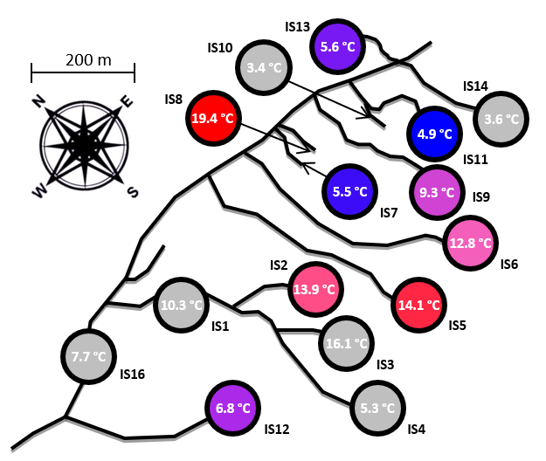
Fig. S2. Stream temperature profiles for the duration of the study. Temperatures were logged every four hours from 30th April 2015 to 5th July 2017, using Maxim Integrated DS1921G Thermochron iButton temperature loggers. Note that the loggers in IS7 and IS4 were not recovered during summer sampling in 2016 and 2017, respectively, so there are no data for the preceding 12 months. Colours and stream codes are explained in Fig. S1.
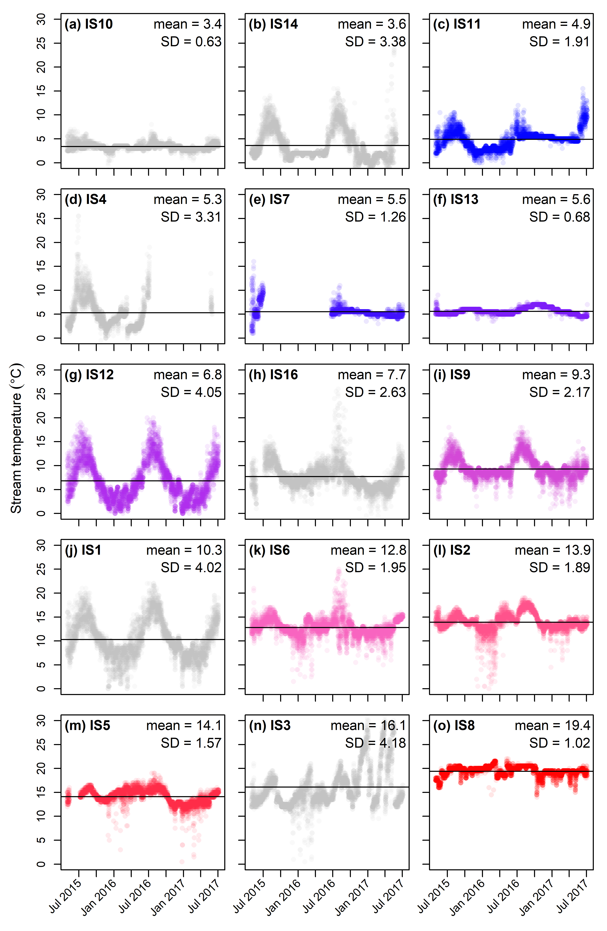
Fig. S3. Model-estimated total energy flux can qualitatively predict empirical measurements of ecosystem respiration in the study streams. The lines of best fit show the relationships for models with (Linear regression: F_{1,9} = 25.04, y = 1.400 + 0.608 x, r² = 0.71) and without (Linear regression: F_{1,9} = 24.61, y = 1.440 + 0.639 x, r² = 0.70) metabolic plasticity. The shaded areas are the 95% prediction bounds. There is little difference in the explanatory power of the two models here because there is no warming scenario involved (just chronic exposure to different stream temperatures), and thus little scope for metabolic plasticity to alter energy flux. See section above on “Quantitative differences between predicted energy flux and empirical ecosystem respiration” for an explanation of the quantitative difference between the two variables.
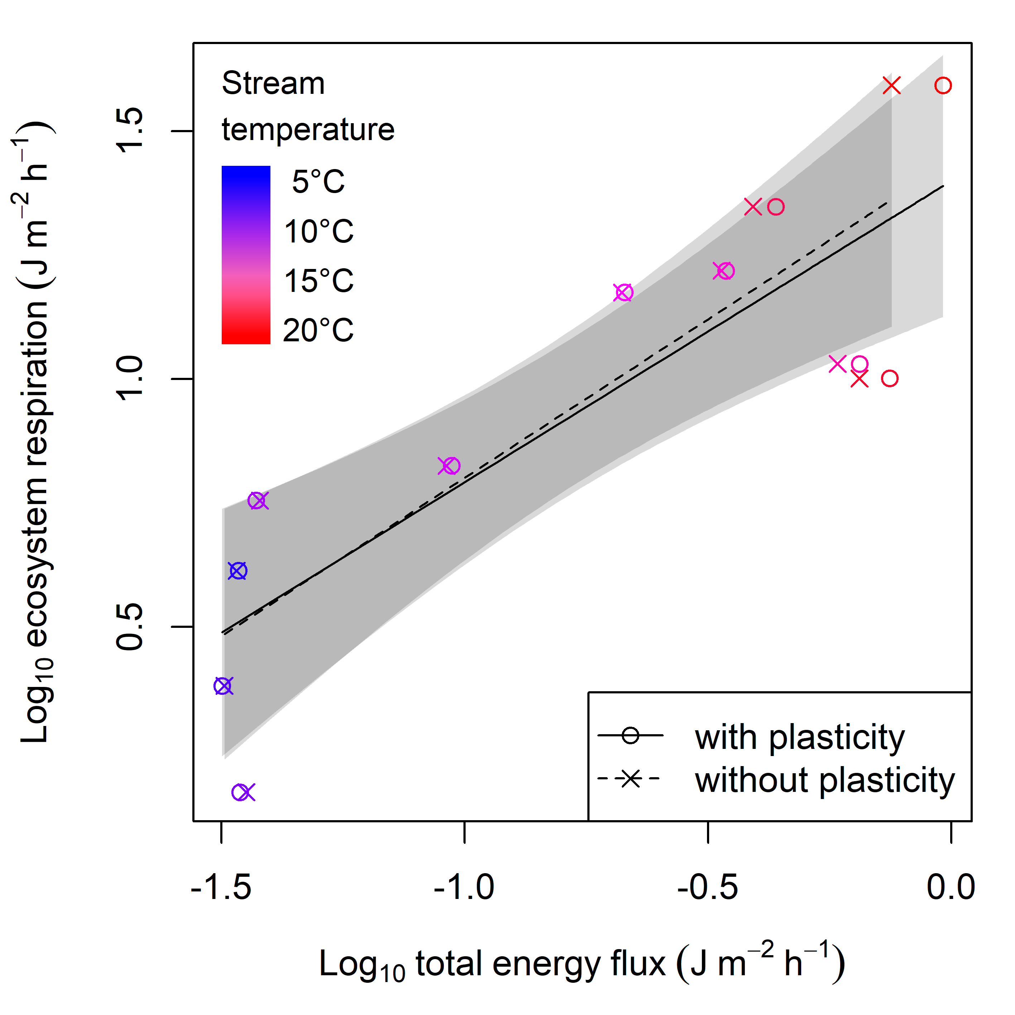
Fig. S4. Size-dependence of metabolic rate for individual species. The relationship between log body mass and log metabolic rate is visualised for each species × stream combination (n = 44 populations), after temperature-correcting metabolic rates using the activation energies from the Metabolic Theory of Ecology models specified in Table S2. Relationships for the same species from different streams are included in the same plot for visual comparison, but analysed separately. The colour of the data points and regression lines corresponds to the long-term mean temperature of each stream (see Fig. S2).
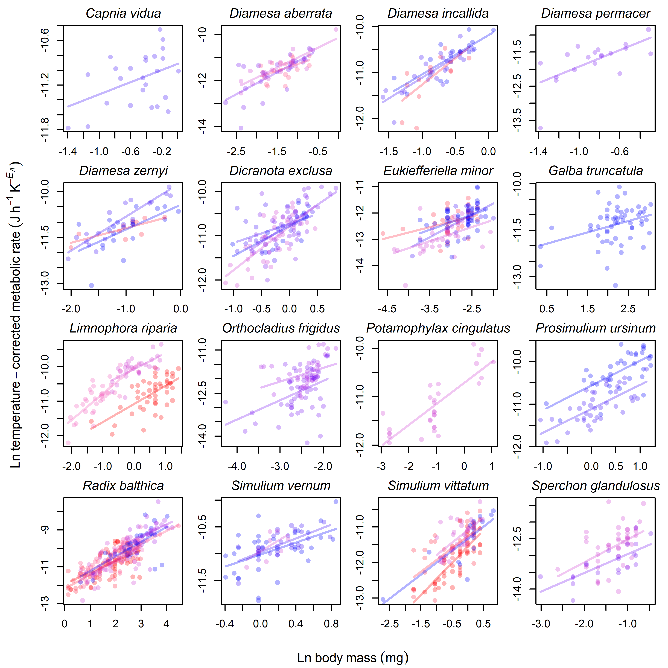
Fig. S5. Temperature-dependence of metabolic rate for individual species. The relationship between temperature and log metabolic rate is visualised for each species × stream combination (n = 44 populations), after mass-correcting metabolic rates using the allometric exponents from the Metabolic Theory of Ecology models specified in Table S2. Relationships for the same species from different streams are included in the same plot for visual comparison, but analysed separately. The colour of the data points and regression lines corresponds to the long-term mean temperature of each stream (see Fig. S2).
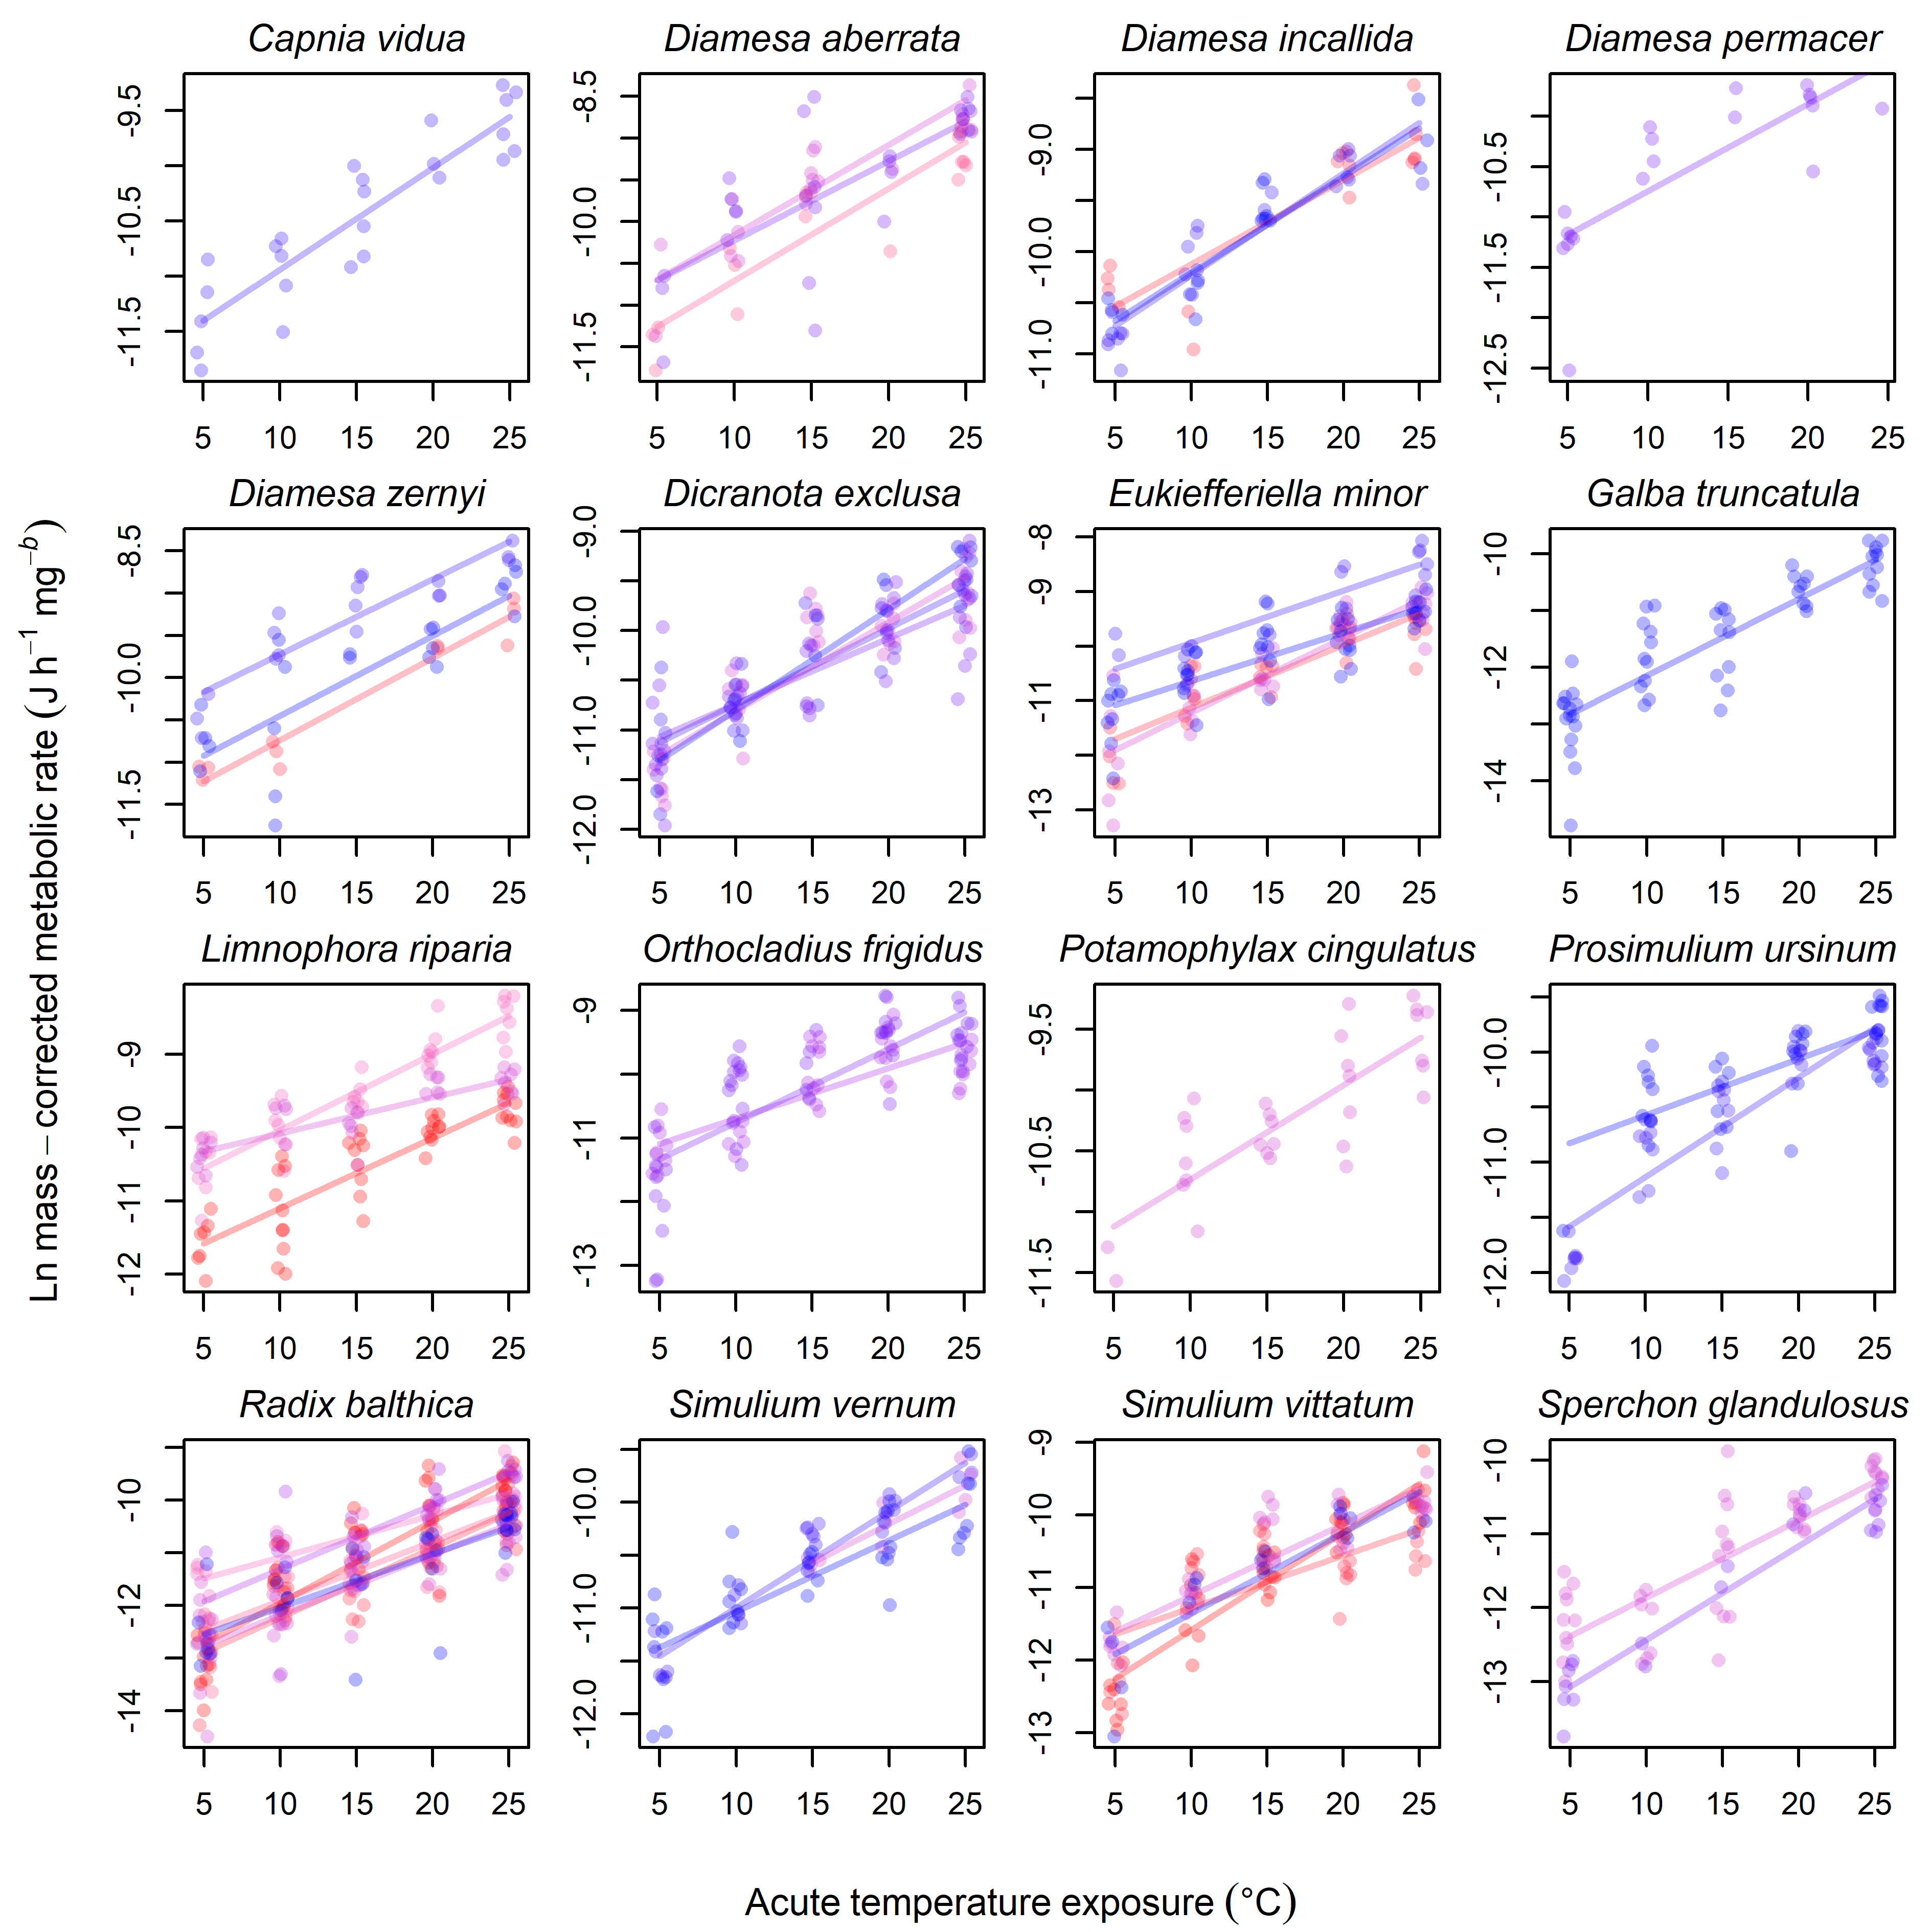
Fig. S6. Chronic exposure to warmer conditions alters the size- and temperature-dependence of metabolic rate for the full dataset (n = 1,819 individuals). (a) Temperature-corrected metabolic rates are elevated for smaller organisms and inhibited for larger organisms after chronic exposure to warmer conditions, seen as (b) a decline in their allometric scaling exponent. (c) Mass-corrected metabolic rates are inhibited at lower acute temperatures and elevated at higher acute temperatures after chronic exposure to warmer conditions, seen as (d) an increase in their activation energy. The bars represent 95% confidence intervals around the mean. The colour of points in all panels relates to the extent of chronic temperature exposure they have experienced (see graphical legends). Statistical outputs for the models fitted to the full dataset are shown in Table S3.
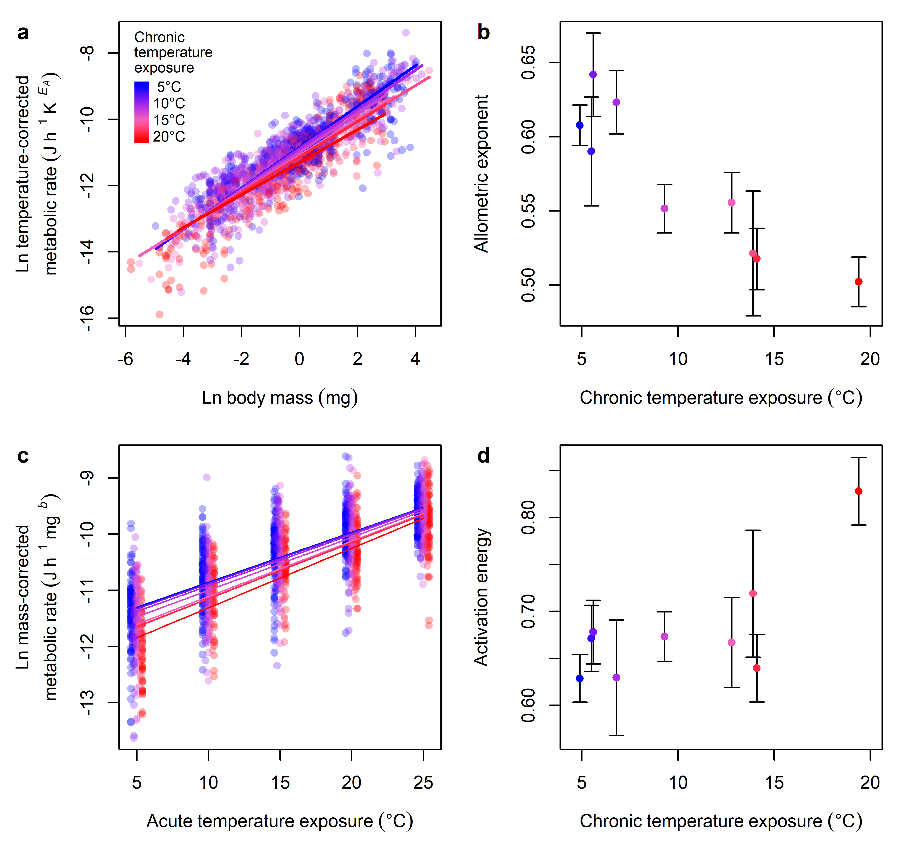
Table S1. Length-mass relationships used for estimating body mass of invertebrates. Linear dimensions (HW = head capsule width; BL = body length; SL = shell length; BW = body width), reference to published papers containing length-dry mass relationships, the taxonomic groups measured in the referenced study, and regression equations that correspond to each species (x = linear dimension in mm; y = dry mass in mg) are also provided.
Species | Dimension | Reference | Group | Formula
Capnia vidua | HW | ⁸ | Allocapnia spp. | y = 0.5438x^{3.255}
Diamesa aberrata | HW | ⁹ | Chironomidae | y = 4.86x^{3.15}
Diamesa incallida | HW | ⁹ | Chironomidae | y = 4.86x^{3.15}
Diamesa permacer | HW | ⁹ | Chironomidae | y = 4.86x^{3.15}
Diamesa zernyi | HW | ⁹ | Chironomidae | y = 4.86x^{3.15}
Dicranota exclusa | BL | ⁸ | Dicranota sp. | y = 0.0027x^{2.637}
Eukiefferiella claripennis | HW | ¹⁰ | Orthocladiinae | y = 0.8694x^{1.72}
Eukiefferiella minor | HW | ¹⁰ | Orthocladiinae | y = 0.8694x^{1.72}
Galba truncatula | SL | ¹¹ | Radix balthica | y = 0.1002x^{2.6575}
Limnophora riparia | BL | ¹² | Limnophora riparia | y = 0.00056x^{3.4032}
Macropelopia sp. | HW | ⁸ | Tanypodinae | y = 2.1694x^{2.623}
Orthocladius frigidus | HW | ¹⁰ | Orthocladiinae | y = 0.8694x^{1.72}
Orthocladius oblidens | HW | ¹⁰ | Orthocladiinae | y = 0.8694x^{1.72}
Potamophylax cingulatus | HW | ¹³ | Potamophylax spp. | y = 1.872x^{3.6358}
Prosimulium ursinum | BL | ¹¹ | Simuliidae | y = 0.0025x^{3.0676}
Radix balthica | SL | ¹¹ | R. balthica | y = 0.1002x^{2.6575}
Simulium vernum | BL | ¹¹ | Simuliidae | y = 0.0025x^{3.0676}
Simulium vittatum | BL | ¹¹ | Simuliidae | y = 0.0025x^{3.0676}
Sperchon glandulosus | BW | ¹⁴ | Sperchon glandulosus | y = 0.185x^{2.599}
Thienemanniella sp. | HW | ¹⁰ | Orthocladiinae | y = 0.8694x^{1.72}

Table S2. Statistical output of Metabolic Theory of Ecology (MTE) models for each population (i.e., species × stream combination) in the study system. Species names are provided, along with the stream they were collected from and its average temperature (Temp) over the study period. The model-estimated value, with associated standard error (SE) and p values, are provided for the intercept (I₀), allometric exponent (b), and activation energy (E) of the MTE model (see Equation 1 in the main text). The r² value and number (n) of individual organisms quantified for each model is also provided. The final column indicates whether a population was excluded, which happened if p > 0.05 for any term in the model or r² < 0.5. Note that we only included data where n ≥ 10 for any given population. Only data that were not excluded following these procedures were analysed for impacts of chronic warming in this study. Relationships are visualised in Fig. S4 and Fig. S5.
 |  |  | I₀ |  |  | b |  |  | E
Species | Stream | Temp | Value | SE | p value | Value | SE | p value | Value | SE | p value | r² | n | Exclude
Capnia vidua | 7 | 5.5 | -10.91 | 0.135 | <0.001 | 0.41 | 0.194 | 0.046 | 0.66 | 0.069 | <0.001 | 0.82 | 25 | no
Diamesa aberrata | 2 | 13.9 | -10.68 | 0.410 | <0.001 | 0.60 | 0.262 | 0.035 | 0.79 | 0.084 | <0.001 | 0.87 | 21 | no
Diamesa aberrata | 9 | 9.3 | -10.13 | 0.211 | <0.001 | 0.87 | 0.147 | <0.001 | 0.77 | 0.109 | <0.001 | 0.78 | 17 | no
Diamesa aberrata | 13 | 5.6 | -10.20 | 0.383 | <0.001 | 0.95 | 0.204 | <0.001 | 0.68 | 0.128 | <0.001 | 0.72 | 27 | no
Diamesa incallida | 5 | 14.1 | -10.10 | 0.296 | <0.001 | 1.16 | 0.319 | 0.003 | 0.59 | 0.084 | <0.001 | 0.81 | 16 | no
Diamesa incallida | 7 | 5.5 | -10.20 | 0.140 | <0.001 | 0.91 | 0.154 | <0.001 | 0.71 | 0.063 | <0.001 | 0.87 | 22 | no
Diamesa incallida | 11 | 4.9 | -10.18 | 0.113 | <0.001 | 0.86 | 0.167 | <0.001 | 0.67 | 0.066 | <0.001 | 0.87 | 18 | no
Diamesa permacer | 13 | 5.6 | -10.72 | 0.345 | <0.001 | 1.20 | 0.367 | 0.005 | 0.62 | 0.121 | <0.001 | 0.73 | 19 | no
Diamesa zernyi | 5 | 14.1 | -10.72 | 0.162 | <0.001 | 0.48 | 0.149 | 0.012 | 0.70 | 0.063 | <0.001 | 0.92 | 11 | no
Diamesa zernyi | 7 | 5.5 | -9.70 | 0.170 | <0.001 | 1.11 | 0.124 | <0.001 | 0.64 | 0.079 | <0.001 | 0.90 | 18 | no
Diamesa zernyi | 11 | 4.9 | -10.42 | 0.299 | <0.001 | 0.81 | 0.256 | 0.005 | 0.68 | 0.111 | <0.001 | 0.71 | 21 | no
Dicranota exclusa | 7 | 5.5 | -10.72 | 0.102 | <0.001 | 0.43 | 0.198 | 0.039 | 0.55 | 0.076 | <0.001 | 0.73 | 24 | no
Dicranota exclusa | 9 | 9.3 | -10.78 | 0.090 | <0.001 | 0.99 | 0.153 | <0.001 | 0.64 | 0.055 | <0.001 | 0.85 | 38 | no
Dicranota exclusa | 11 | 4.9 | -10.77 | 0.103 | <0.001 | 0.68 | 0.199 | 0.006 | 0.72 | 0.072 | <0.001 | 0.90 | 14 | no
Dicranota exclusa | 13 | 5.6 | -10.72 | 0.078 | <0.001 | 0.85 | 0.181 | <0.001 | 0.47 | 0.065 | <0.001 | 0.57 | 43 | no
Eukiefferiella claripennis | 8 | 19.4 | -11.94 | 2.197 | 0.001 | 0.35 | 0.487 | 0.491 | 0.93 | 0.207 | 0.002 | 0.72 | 11 | yes
Eukiefferiella minor | 5 | 14.1 | -11.10 | 0.553 | <0.001 | 0.41 | 0.175 | 0.026 | 0.82 | 0.084 | <0.001 | 0.80 | 32 | no
Eukiefferiella minor | 7 | 5.5 | -9.92 | 0.789 | <0.001 | 0.86 | 0.282 | 0.010 | 0.68 | 0.111 | <0.001 | 0.79 | 15 | no
Eukiefferiella minor | 8 | 19.4 | -12.11 | 0.876 | <0.001 | 0.25 | 0.199 | 0.223 | 0.75 | 0.209 | 0.002 | 0.46 | 26 | yes
Eukiefferiella minor | 9 | 9.3 | -11.18 | 0.569 | <0.001 | 0.54 | 0.175 | 0.004 | 0.98 | 0.089 | <0.001 | 0.79 | 34 | no
Eukiefferiella minor | 11 | 4.9 | -10.62 | 0.589 | <0.001 | 0.58 | 0.204 | 0.007 | 0.63 | 0.079 | <0.001 | 0.72 | 47 | no
Galba truncatula | 9 | 9.3 | -11.82 | 0.425 | <0.001 | 0.11 | 0.253 | 0.682 | 0.94 | 0.106 | <0.001 | 0.84 | 19 | yes
Galba truncatula | 11 | 4.9 | -12.11 | 0.316 | <0.001 | 0.36 | 0.141 | 0.013 | 0.97 | 0.077 | <0.001 | 0.76 | 56 | no
Limnophora riparia | 5 | 14.1 | -10.23 | 0.145 | <0.001 | 0.24 | 0.134 | 0.084 | 0.28 | 0.051 | <0.001 | 0.42 | 41 | yes
Limnophora riparia | 6 | 12.8 | -10.01 | 0.133 | <0.001 | 0.77 | 0.112 | <0.001 | 0.74 | 0.057 | <0.001 | 0.84 | 35 | no
Limnophora riparia | 7 | 5.5 | -10.17 | 0.060 | <0.001 | 0.18 | 0.096 | 0.086 | 0.51 | 0.042 | <0.001 | 0.89 | 19 | yes
Limnophora riparia | 8 | 19.4 | -11.08 | 0.089 | <0.001 | 0.53 | 0.099 | <0.001 | 0.69 | 0.059 | <0.001 | 0.80 | 46 | no
Limnophora riparia | 9 | 9.3 | -10.06 | 0.054 | <0.001 | 0.46 | 0.101 | <0.001 | 0.35 | 0.044 | <0.001 | 0.79 | 31 | no
Limnophora riparia | 11 | 4.9 | -10.78 | 0.104 | <0.001 | 0.20 | 0.176 | 0.264 | 0.49 | 0.071 | <0.001 | 0.61 | 44 | yes
Macropelopia sp | 13 | 5.6 | -10.31 | 0.353 | <0.001 | 1.12 | 0.562 | 0.078 | 0.47 | 0.258 | 0.101 | 0.43 | 12 | yes
Orthocladius frigidus | 12 | 6.8 | -10.67 | 0.458 | <0.001 | 0.47 | 0.188 | 0.016 | 0.57 | 0.069 | <0.001 | 0.62 | 44 | no
Orthocladius frigidus | 13 | 5.6 | -10.73 | 0.535 | <0.001 | 0.67 | 0.207 | 0.002 | 0.82 | 0.097 | <0.001 | 0.61 | 51 | no
Orthocladius oblidens | 8 | 19.4 | -11.29 | 0.762 | <0.001 | 0.43 | 0.281 | 0.158 | 0.96 | 0.126 | <0.001 | 0.83 | 13 | yes
Potamophylax cingulatus | 9 | 9.3 | -10.71 | 0.114 | <0.001 | 0.43 | 0.059 | <0.001 | 0.56 | 0.075 | <0.001 | 0.79 | 30 | no
Potamophylax cingulatus | 11 | 4.9 | -7.65 | 0.751 | <0.001 | -0.09 | 0.245 | 0.704 | 0.56 | 0.122 | <0.001 | 0.34 | 41 | yes
Prosimulium ursinum | 7 | 5.5 | -11.11 | 0.060 | <0.001 | 0.56 | 0.091 | <0.001 | 0.65 | 0.046 | <0.001 | 0.87 | 40 | no
Prosimulium ursinum | 11 | 4.9 | -10.56 | 0.116 | <0.001 | 0.58 | 0.110 | <0.001 | 0.36 | 0.067 | <0.001 | 0.57 | 36 | no
Radix balthica | 2 | 13.9 | -11.88 | 0.182 | <0.001 | 0.71 | 0.092 | <0.001 | 0.80 | 0.089 | <0.001 | 0.83 | 31 | no
Radix balthica | 5 | 14.1 | -12.19 | 0.171 | <0.001 | 0.78 | 0.100 | <0.001 | 0.94 | 0.080 | <0.001 | 0.86 | 41 | no
Radix balthica | 6 | 12.8 | -11.06 | 0.548 | <0.001 | 0.48 | 0.211 | 0.031 | 0.57 | 0.072 | <0.001 | 0.68 | 31 | no
Radix balthica | 8 | 19.4 | -11.91 | 0.392 | <0.001 | 0.61 | 0.176 | 0.001 | 1.11 | 0.102 | <0.001 | 0.75 | 40 | no
Radix balthica | 9 | 9.3 | -12.15 | 0.212 | <0.001 | 0.74 | 0.101 | <0.001 | 0.82 | 0.069 | <0.001 | 0.76 | 59 | no
Radix balthica | 11 | 4.9 | -12.01 | 0.405 | <0.001 | 0.79 | 0.141 | <0.001 | 0.73 | 0.101 | <0.001 | 0.71 | 34 | no
Radix balthica | 12 | 6.8 | -11.27 | 1.004 | <0.001 | 0.65 | 0.293 | 0.038 | 0.87 | 0.135 | <0.001 | 0.64 | 26 | no
Simulium vernum | 7 | 5.5 | -10.97 | 0.067 | <0.001 | 0.65 | 0.162 | 0.001 | 0.65 | 0.041 | <0.001 | 0.91 | 27 | no
Simulium vernum | 9 | 9.3 | -10.96 | 0.149 | <0.001 | 1.01 | 0.424 | 0.044 | 0.54 | 0.096 | <0.001 | 0.77 | 11 | no
Simulium vernum | 11 | 4.9 | -11.01 | 0.071 | <0.001 | 0.56 | 0.174 | 0.003 | 0.48 | 0.060 | <0.001 | 0.72 | 36 | no
Simulium vittatum | 5 | 14.1 | -11.26 | 0.146 | <0.001 | 0.66 | 0.137 | <0.001 | 0.51 | 0.098 | <0.001 | 0.60 | 32 | no
Simulium vittatum | 6 | 12.8 | -11.60 | 0.160 | <0.001 | 0.29 | 0.124 | 0.032 | 0.48 | 0.129 | 0.002 | 0.39 | 22 | yes
Simulium vittatum | 8 | 19.4 | -11.55 | 0.080 | <0.001 | 0.91 | 0.108 | <0.001 | 0.96 | 0.059 | <0.001 | 0.89 | 41 | no
Simulium vittatum | 9 | 9.3 | -11.09 | 0.079 | <0.001 | 0.70 | 0.152 | <0.001 | 0.70 | 0.058 | <0.001 | 0.81 | 35 | no
Simulium vittatum | 11 | 4.9 | -11.33 | 0.135 | <0.001 | 0.67 | 0.143 | <0.001 | 0.80 | 0.122 | <0.001 | 0.84 | 16 | no
Sperchon glandulosus | 9 | 9.3 | -11.83 | 0.271 | <0.001 | 0.68 | 0.190 | 0.001 | 0.75 | 0.079 | <0.001 | 0.71 | 47 | no
Sperchon glandulosus | 13 | 5.6 | -12.40 | 0.223 | <0.001 | 0.56 | 0.127 | <0.001 | 0.91 | 0.071 | <0.001 | 0.93 | 21 | no
Thienemanniella sp | 13 | 5.6 | -13.42 | 1.208 | <0.001 | -0.49 | 0.329 | 0.157 | -0.03 | 0.261 | 0.920 | 0.04 | 18 | yes

Table S3. Statistical output of models exploring the key drivers of metabolic rate for the full dataset (n = 1,819 individuals). The estimated coefficients (value) for size- and temperature-dependence parameters are shown with standard errors (SE), t values, and p values, obtained from linear mixed effects models fitted to metabolic rate data on invertebrate populations from 9 streams of different temperature (Fig. S6). In both models, log metabolic rate [ln(I) in J h⁻¹] was the dependent variable and the random effects structure included a random intercept for species identity and random slopes for each of the main effects. (a) The most parsimonious model included an intercept [ln(I₀)], main effects of log body mass [ln(M) in mg], acute temperature exposure [T_{A} in K], and chronic temperature exposure [T_{C} in K], and interactive effects of T_{C} on ln(M) and T_{A}. (b) An alternative model without metabolic plasticity contains only an intercept and main effects for ln(M) and T_{A}, in line with the general MTE prediction of a universal size-scaling and activation energy (but with ΔAIC > 9, indicating significantly weaker explanatory power than the model with metabolic plasticity).
 | Value | SE | t value | p value
(a) With metabolic plasticity (AIC = 2878.4)
I₀ | -11.012 | 0.1188 | -92.709 | <0.001
ln(M) | 0.5700 | 0.0451 | 12.646 | <0.001
T_{S} | 0.6827 | 0.0278 | 24.573 | <0.001
T_{L} | -0.1612 | 0.0581 | -2.773 | 0.006
ln(M):T_{L} | -0.0608 | 0.0221 | -2.748 | 0.006
T_{S}:T_{L} | 0.0534 | 0.0204 | 2.624 | 0.009
(b) Without metabolic plasticity (AIC = 2887.6)
I₀ | -11.040 | 0.1200 | -92.022 | <0.001
ln(M) | 0.5673 | 0.0467 | 12.154 | <0.001
T_{S} | 0.6823 | 0.0286 | 23.877 | <0.001
Table S4. Comparison of random effects structures for the full model (Equation 3 in the main text) used for determining effects of body mass, acute temperature exposure, and chronic temperature exposure on metabolic rate. Model identity (ID) and corresponding random effects structures are defined in the “R code for statistical model fitting” section above. The degrees of freedom (df), Akaike Information Criterion (AIC), and difference in Akaike Information Criterion relative to the most parsimonious model (ΔAIC) are also displayed.
Model ID | Random effects | df | AIC | ΔAIC
r1 | none | 9 | 2798.9 | 791.1
r2 | ~ 1 | species | 10 | 2138.4 | 130.5
r3 | ~ 1 + ln(M) | species | 12 | 2082.5 | 74.6
r4 | ~ 1 + TS | species | 12 | 2093.7 | 85.8
r5 | ~ 1 + TL | species | 12 | 2090.6 | 82.7
r6 | ~ 1 + ln(M) + TS | species | 15 | 2039.0 | 31.2
r7 | ~ 1 + ln(M) + TL | species | 15 | 2053.4 | 45.5
r8 | ~ 1 + TS + TL | species | 15 | 2042.9 | 35.0
r9 | ~ 1 + ln(M) + TS + TL | species | 19 | 2007.9 | 0

Table S5. Comparison of fixed effects structures for determining effects of body mass, acute temperature exposure, and chronic temperature exposure on metabolic rate. Model identity (ID) and corresponding fixed effects structures are defined in the “R code for statistical model fitting” section above. The degrees of freedom (df), Akaike Information Criterion (AIC), and difference in Akaike Information Criterion relative to the most parsimonious model (ΔAIC) are also displayed. Note that there was similar support for models m2 and m5 (ΔAIC < 2), but the additional term in m2 [ln(M):T_{S}] was not significant, so we present the results of m5.
Model ID | Fixed effects | df | AIC | ΔAIC
m1 | ln(M) + TS + TL + ln(M):TS + ln(M):TL + TS:TL + ln(M):TS:TL | 19 | 1965.6 | 2.1
m2 | ln(M) + TS + TL + ln(M):TS + ln(M):TL + TS:TL | 18 | 1963.8 | 0.2
m3 | ln(M) + TS + TL + ln(M):TS + ln(M):TL | 17 | 1984.1 | 20.6
m4 | ln(M) + TS + TL + ln(M):TS + TS:TL | 17 | 1971.4 | 7.9
m5 | ln(M) + TS + TL + ln(M):TL + TS:TL | 17 | 1963.6 | 0
m6 | ln(M) + TS + TL + ln(M):TS | 16 | 1993.7 | 30.1
m7 | ln(M) + TS + ln(M):TS | 15 | 1991.9 | 28.4
m8 | ln(M) + TS + TL + ln(M):TL | 16 | 1983.9 | 20.3
m9 | ln(M) + TL + ln(M):TL | 15 | 2039.7 | 76.2
m10 | ln(M) + TS + TL + TS:TL | 16 | 1969.6 | 6.0
m11 | TS + TL + TS:TL | 15 | 2009.1 | 45.6
m12 | ln(M) + TS + TL | 15 | 1992.6 | 29.0
m13 | ln(M) + TS | 14 | 1991.2 | 27.7
m14 | ln(M) + TL | 14 | 2047.8 | 84.2
m15 | TS + TL | 14 | 2031.6 | 68.0
m16 | ln(M) | 13 | 2048.0 | 84.4
m17 | TS | 13 | 2030.1 | 66.5
m18 | TL | 13 | 2051.4 | 87.8
m19 | none | 12 | 2052.8 | 89.3

Supplementary References
1 Zuur, A. F., Ieno, E. N., Walker, N. J., Saveliev, A. A. & Smith, G. M. in Mixed effects models and extensions in ecology with R 101-142 (Springer, 2009).
2 Bell, T. et al. A linear model method for biodiversity–ecosystem functioning experiments. The American Naturalist 174, 836-849 (2009).
3 O'Gorman, E. J. et al. Unexpected changes in community size structure in a natural warming experiment. Nature Climate Change 7, 659-666 (2017).
4 O'Gorman, E. J. et al. Temperature effects on fish production across a natural thermal gradient. Global Change Biology 22, 3206-3220 (2016).
5 Gauzens, B. et al. fluxweb: An R package to easily estimate energy fluxes in food webs. Methods in Ecology and Evolution 10, 270-279 (2019).
6 O’Gorman, E. J. et al. A simple model predicts how warming simplifies wild food webs. Nature Climate Change 9, 611-616 (2019).
7 Woodward, G. et al. Sentinel systems on the razor's edge: effects of warming on Arctic geothermal stream ecosystems. Global Change Biology 16, 1979-1991 (2010).
8 Benke, A. C., Huryn, A. D., Smock, L. A. & Wallace, J. B. Length-Mass Relationships for Freshwater Macroinvertebrates in North America with Particular Reference to the Southeastern United States. Journal of the North American Benthological Society 18, 308-343 (1999).
9 Johnston, T. A. & Cunjak, R. A. Dry mass–length relationships for benthic insects: a review with new data from Catamaran Brook, New Brunswick, Canada. Freshwater Biology 41, 653-674 (1999).
10 Baumgärtner, D. & Rothhaupt, K.-O. Predictive Length–Dry Mass Regressions for Freshwater Invertebrates in a Pre-Alpine Lake Littoral. International Review of Hydrobiology 88, 453-463 (2003).
11 Hannesdóttir, E. R., Gíslason, G. M., Ólafsson, J. S., Ólafsson, Ó. P. & O’Gorman, E. J. Increased stream productivity with warming supports higher trophic levels. Advances in Ecological Research 48, 283-340 (2013).
12 Archer, L. C. et al. Consistent temperature dependence of functional response parameters and their use in predicting population abundance. Journal of Animal Ecology 88, 1670-1683 (2019).
13 Meyer, E. The relationship between body length parameters and dry mass in running water invertebrates. Archiv für Hydrobiologie 117, 191-203 (1989).
14 Lindegaard, C. Zoobenthos ecology of Thingvallavatn: vertical distribution, abundance, population dynamics and production. Oikos, 257-304 (1992).

