Supplementary Information for

Restoration of the GTPase activity of Gαo mutants by Zn²⁺ in GNAO1 encephalopathy models

Yonika A. Larasati^{1,#}, Mikhail Savitsky^{1,#}, Alexey Koval^{1,#}, Gonzalo P. Solis¹, Vladimir L. Katanaev^{1,2,}*

¹Translational Research Center in Oncohaematology, Department of Cell Physiology and Metabolism, Faculty of Medicine, University of Geneva, CH-1211 Geneva, Switzerland.
²School of Biomedicine, Far Eastern Federal University, 690090 Vladivostok, Russia.

#Equal contribution authors.

*Author for correspondence: vladimir.katanaev@unige.ch

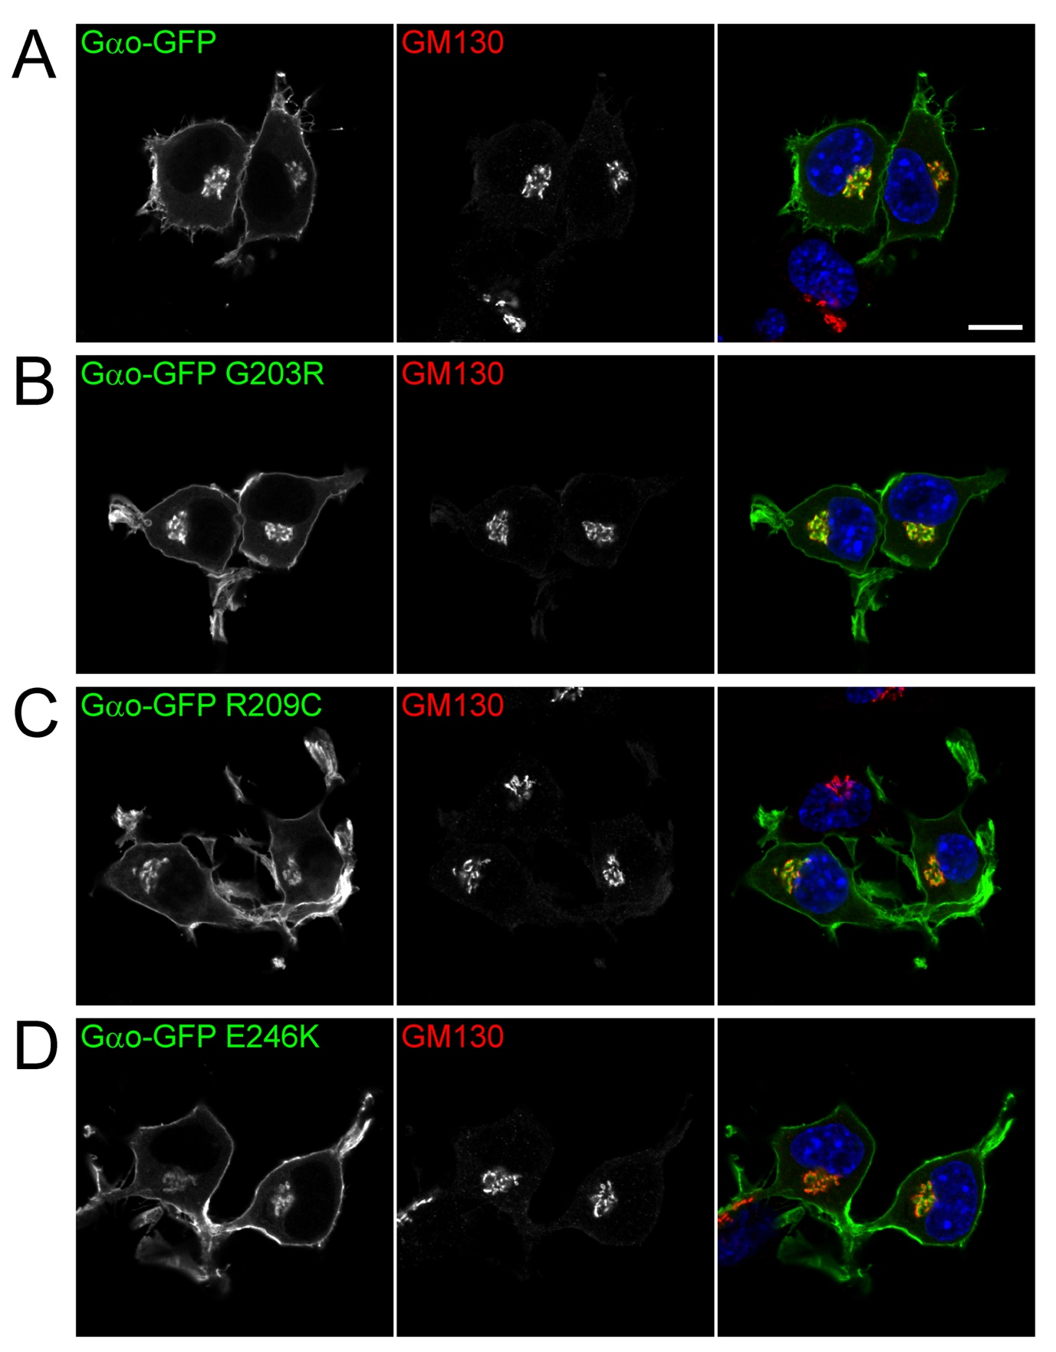

Supplementary Figure S1. Normal intracellular localization of the [G203R], [R209C], and [E246K], mutants.
(A-D) Representative images of N2a cells expressing Gαo-GFP (C-terminally tagged) wild type (A) or the mutants G203R (B), R209C (C), and E246K (D). Gαo shows its dual localization at the plasma membrane and Golgi apparatus, and no obvious defects were observed for the Gαo encephalopathy mutants. Immunostaining against GM130 was used to label the Golgi. Scale bar, 10µm.
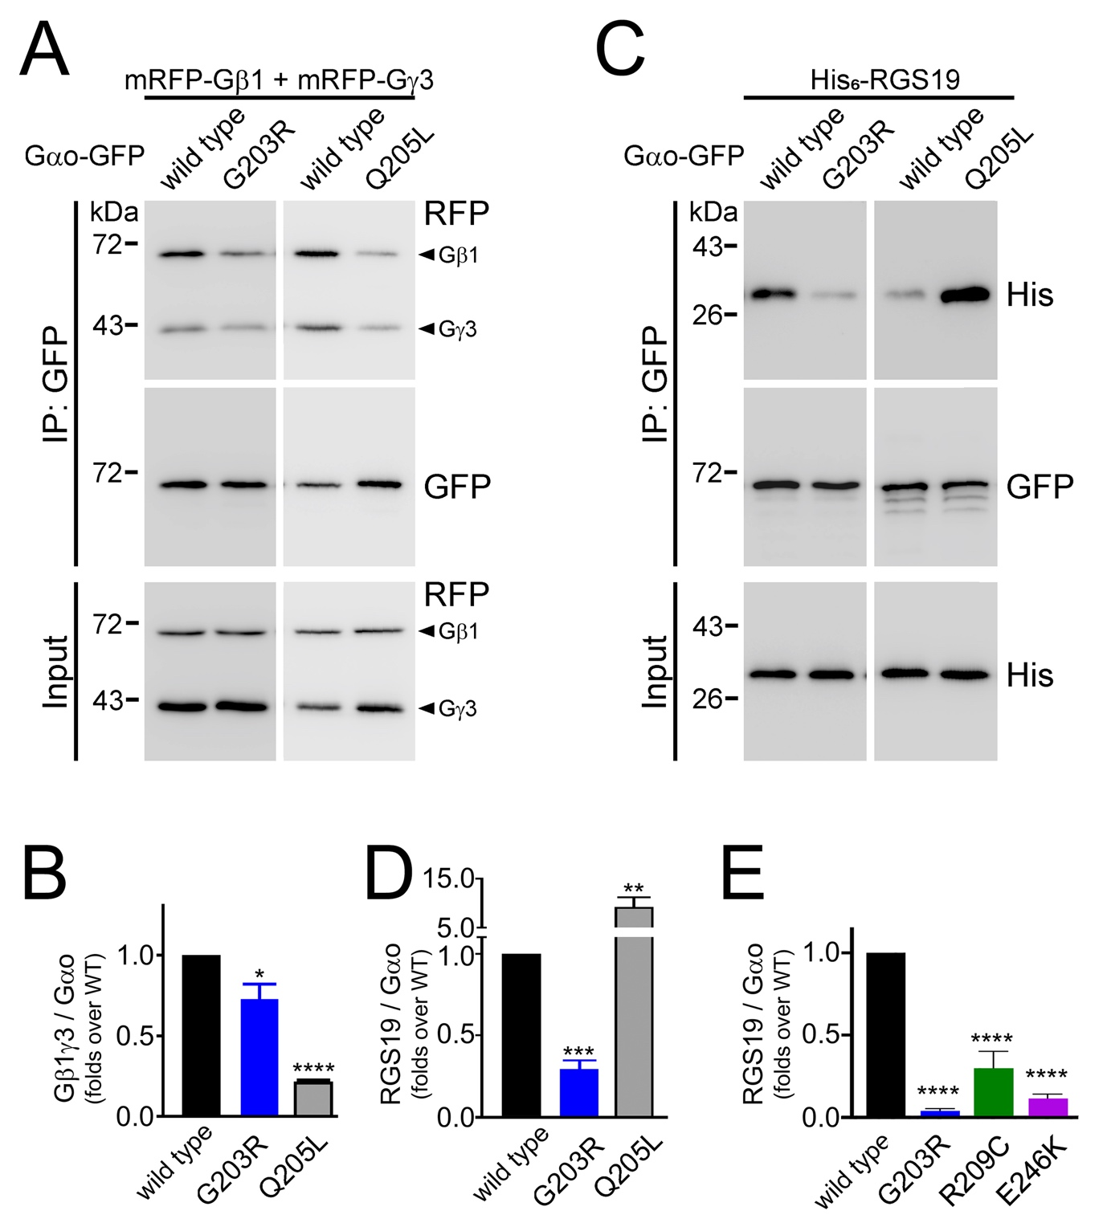
Supplementary Figure S2. Defective cellular interactions of the [G203R], [R209C], and [E246K] Gαo mutants. (A, B) N2a cells were co-transfected with mRFP-Gβ1, mRFP-Gγ3, and Gαo-GFP (internally tagged) wild type, G203R, or the activated Q205L mutant as control. Immunoprecipitation (IP) of Gαo was done using a nanobody against GFP, and the co-precipitation of Gβ1γ3 was analyzed by SDS-PAGE and Western Blot (A). Ab against GFP was used for detection of Gαo and against mRFP (RFP) – for Gβ1γ3 (arrowheads). Quantification of the co-IP of Gβ1γ3 by the different Gαo constructs (B). (C, D) Co-IP of His₆-tagged RGS19 (His₆-RGS19) by Gαo-GFP wild type, G203R, and Q205L was performed as in (A). Abs against GFP and His₆-tag were used for the detection of Gαo and RGS19, respectively (C). Quantification of the co-IP of RGS19 by the Gαo constructs (D). (E) Quantification of the co-IP of His₆-RGS19 by Gαo-GFP (C-terminally tagged) wild type, G203R, R209C, and E246K. See Supplementary Fig. S7B and Fig. 2F for representative Western blots.
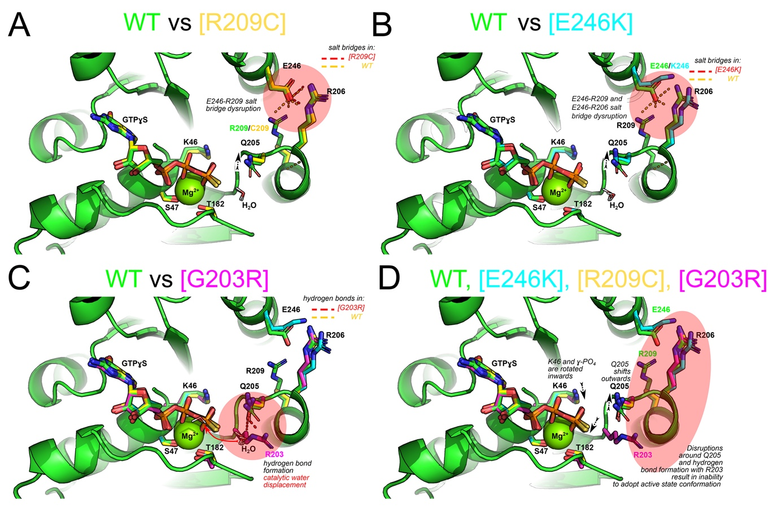
Supplementary Figure S3. Mutations [G203R], [R209C], and [E246K] in Gαo affect the immediate surroundings of Q205, the key residue for GTP hydrolysis.
The panels show the active site of wild type or mutant Gαo energy-minimized models. All the panels show the cartoon of the backbone of wild type Gαo (WT, green) overlaid with color-coded side chains (C-atoms colored only) of mutant proteins. Indicated residues are the ones which have the major role in the complex formation with Mg²⁺ (S47, T182), orientation of γ-phosphate (K46) and orientation of Q205 (R206, R209, E246). (A, B) Mutations R209C and E246K disrupt either one (A) or both (B) salt bridges formed in the GTP-bound Gαo between the α2 and α3 helices and required to adopt the active conformation. (C) Mutation G203R results in formation of a new hydrogen bond between side chains of R203 and Q205. Additionally, it results in displacement of the water molecule required for the hydrolysis due to the resulting steric hindrance (red arrow). (D) Similarity of the changes in the 3 mutants: in all of them, the Q205 side chain is significantly moved outwards of the plane of view, whereas the γ-phosphate and the K46 side chain are displaced inwards thus increasing the distance between Q205 and the γ-phosphate.

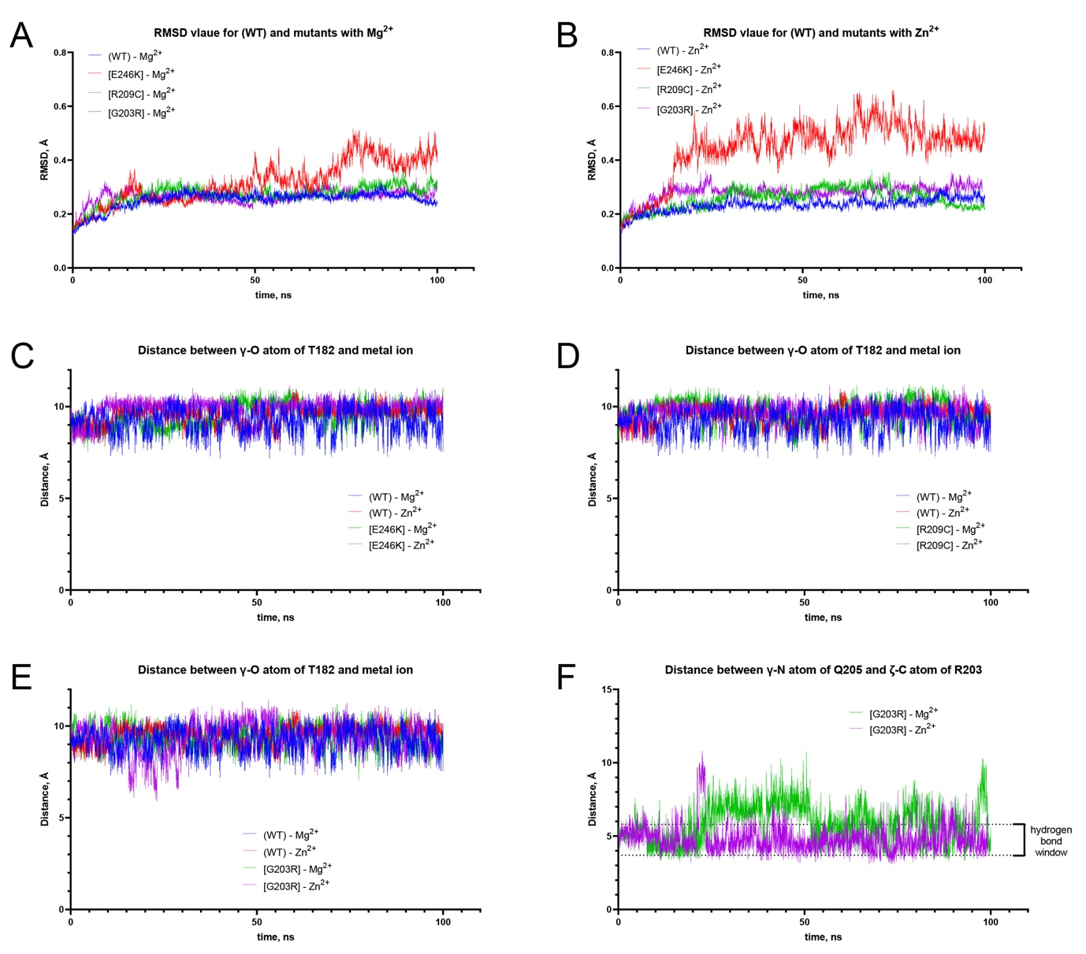
Supplementary Figure S4. Analysis of global stability, T182 residue, and R203-Q205 residues in Gαo wild type and mutants in the Mg²⁺- and Zn²⁺-bound GTP states by molecular dynamics.
(A, B) RMSD plots reflect overall changes of the wild type (WT) Gαo or the three mutants with Mg²⁺ (A) or Zn²⁺ (B) in the active site. Only the [E246K] mutant demonstrates significant global rearrangements as compared to the wild type (see also Supplementary Movie S1). These rearrangements are somewhat increased when Mg²⁺ is replaced by Zn²⁺ (see also Supplementary Movie S2). (C, D, E) Analysis of the distance between the γ-O atom of T182 and the metal ion center in the wild type or mutant Gαo proteins reveals no significant influence of Zn²⁺ / Mg²⁺ substitution on the position of this residue in any Gαo form. (F) Comparison of the distance between the γ-N atom of Q205 residue and ζ-C atom (center of guanidino group) of R203 in Gαo[G203R] with Mg²⁺ or Zn²⁺ in the active site over 100ns of molecular dynamics simulation. The limits of the “hydrogen bond window” are marked on the graph. Note that these atoms are not directly involved in the hydrogen bond formation, however this distance provides the best measure of the R203-Q205 H-bonding because Q205’ carbonyl oxygen forms H-bonds with hydrogen of different nitrogens of R203’ guanidino group throughout simulation. The results indicate that Zn²⁺ stabilizes this bond, rather than disrupts it.

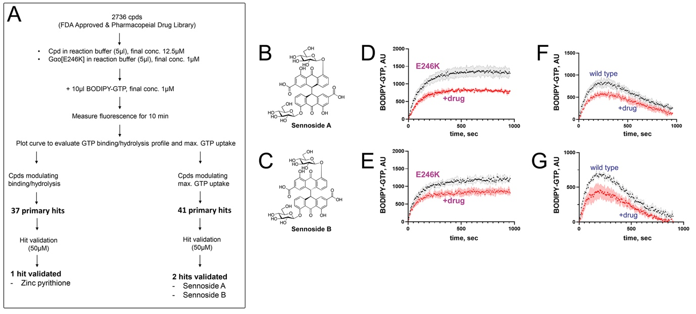
Supplementary Figure S5. High-throughput screening to recover the GTPase activity of Gαo[E246K].
(A) The scheme of high-throughput screening (HTS) performed by measuring GTP binding and hydrolysis by Gαo[E246K]. (B, C) In addition to ZPT, HTS and hit validation resulted in two other compounds: sennoside A and sennoside B. (D, E) Representative curves of BODIPY-labeled GTP binding and hydrolysis by Gαo[E246K] in the presence of 50μM sennoside A (D) or sennoside B (E). (F, G) Representative curves of BODIPY-labeled GTP binding and hydrolysis by wild type Gαo in the presence of 50μM sennoside A (F) or sennoside B (G). It is apparent that the sennosides affect wild type Gαo. Data in (D-G) are mean of two experiments ± SD.

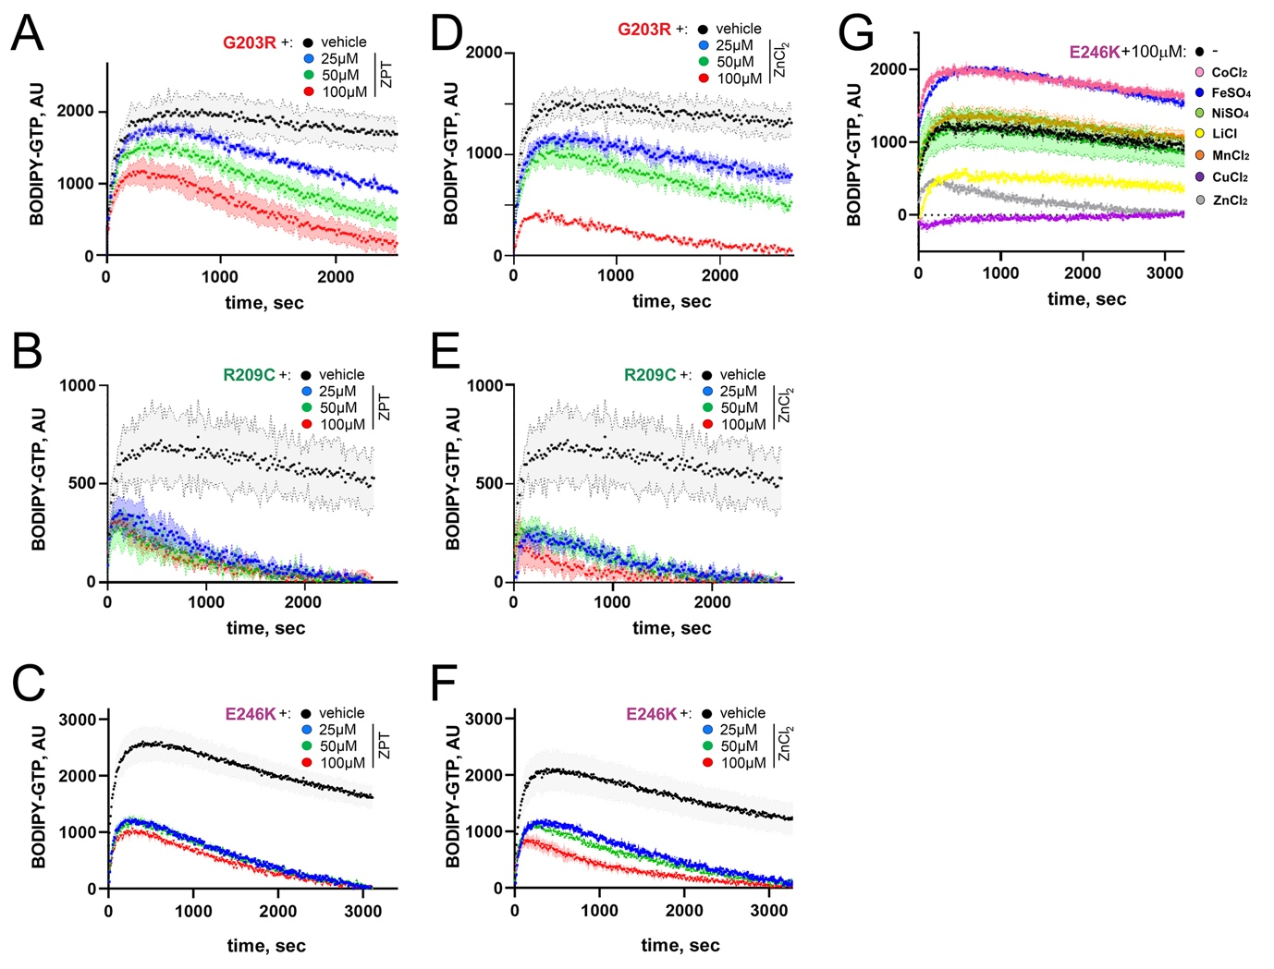
Supplementary Figure S6. ZPT and Zn²⁺ restore the GTPase activity of the three encephalopathy Gαo mutants.
(A-C) Representative curves of BODIPY-labeled GTP binding and hydrolysis by Gαo[E203R] (A), Gαo[R209C] (B), and Gαo[E246K] (C) in the presence of 25-100μM ZPT. (D-F) Representative curves of BODIPY-labeled GTP binding and hydrolysis by Gαo[E203R] (D), Gαo[R209C] (E), and Gαo[E246K] (F) in the presence of 25-100μM ZnCl₂. (G) Representative curves of BODIPY-labeled GTP binding and hydrolysis by Gαo[E246K] in the presence of 100μM of various salts. Data are mean of three (two in (G)) experiments ± SD.

Supplementary Figure S7. ZPT restores cellular RGS19 interactions of Gαo[E246K].
(A) Acute toxicity of ZPT, ZnCl₂, and pyrithione were determined on N2a cells. N2a cells were treated with 0.1-100μM of compounds for 3h before being subjected to the MTT assay. (B, C) N2a cells were co-transfected with His₆-RGS19 and Gαo-GFP (C-terminally tagged), wild type or [E246K]. The next day, cells were treated with DMSO, 1µM ZPT, or 100µM ZnCl₂ for 3h before being subjected for immunoprecipitation (IP). IP of Gαo was done using a nanobody against GFP, and the co-precipitation of co-precipitation of RGS19 was analyzed by SDS-PAGE and Western Blot. Abs against GFP and His₆-tag were used for the detection of Gαo and RGS19, respectively (B). Quantification of the co-IP of His₆-RGS19 by Gαo-GFP wild type and E246K (C). Data are mean of at least three experiments ± SD. *p<0.05, **p<0.01, ****p<0.0001 by the T-test.

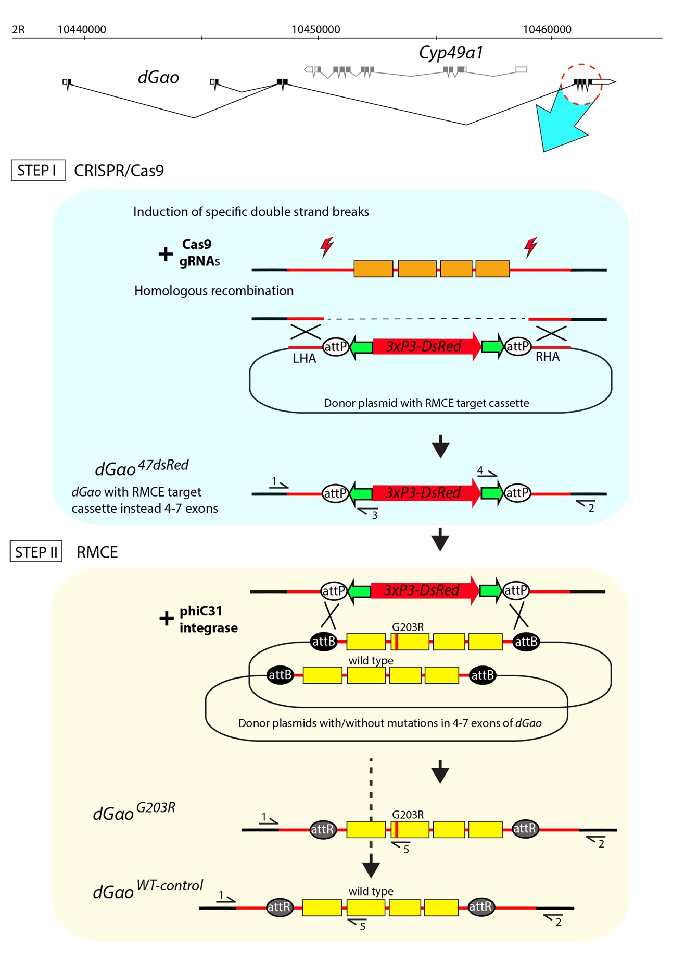
Supplementary Figure S8. Scheme of creation of dGαo mutants.
A two-step strategy for bringing point mutations in the dGαo gene (gene map shown schematically on top of the figure, including the gene Cyp49a1 inserted in the intronic region of dGαo) was applied. The first step (blue background) is creation of flies with the target cassette instead of exons 4-7 of dGαo. The primers for validation of the correct donor sequence integration in the genome are designated with black horizontal arrows and marked with numbers (see Methods for the respective primer sequences). Left (LHA) and right homologous arms (RHA) in the donor plasmids were required for the homologous recombination with the genomic sequences during the CRISPR/Cas9 gene editing. The second step (orange background) is creation of mutant alleles via the recombinase-mediated cassette exchange (RMCE) using phiC31-integrase. The ovals marked as attP, attB and attR are designated recognition sequences for phiC31-integrase (attP, attB) and the result of recombination between them (attR). The vertical red line in the 5th exon designates the sequence with mismatches that lead to the G203R mutation.

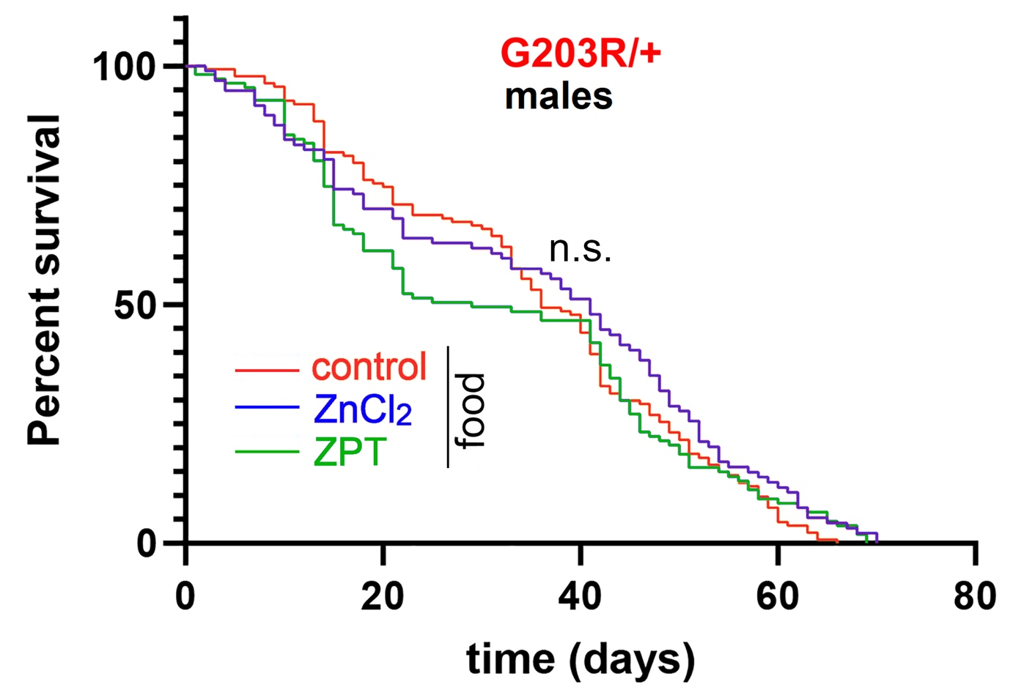
Supplementary Figure S9. Dietary Zn²⁺ does not rescue the reduced lifespan of male G203R/+ Drosophila.
The lifespan of male G203R/+ flies is not influenced by dietary supplementation of ZnCl₂ or ZPT. Data presentation and analysis as in Fig. 4C, F. Median survivals are calculated as 29days (ZPT-supplemented food), 36 days (control food), and 41 days (ZnCl₂-supplemented food); Mantel-Cox and Gehan-Breslow-Wilcoxon tests both show no statistical significance among the three conditions (‘n.s.’).

Supplementary Movie S1. Overlay of the overall protein structure over 100ns of molecular dynamics simulations in the three mutants and wild type Gαo protein. Note a significant displacement of the all-helical domain in the [E246K] mutant and lack of such rearrangements in the other Gαo forms.

Supplementary Movie S2. Overlay of the overall protein structure over 100ns of molecular dynamics simulation of wild type or the three Gαo mutant proteins loaded with Mg²⁺ or Zn²⁺. Note aggravation of the all-helical domain displacement in the [E246K] mutant and lack of thereof in the other Gαo forms.

Supplementary Table S1. Primers used in the molecular analysis and cloning.
Ep203fw GACGTCAGAGGCCAGCGATCTGA
Ep203rev TCAGATCGCTGGCCTCTGACGTC
Ep209fw AGCGATCTGAATGCAAGAAGTGGATCCA
Ep209rev TGGATCCACTTCTTGCATTCAGATCGCT
Ep246fw ACCGCATGCACAAGTCTCTCAT
Ep246rev ATGAGAGACTTGTGCATGCGGT
attPfwRI TAGTGTCTTCGGGGCCGAATTCAGAAGCGGTTTTCGGGAGTAGT
attPrevHpaI TATCTTTCTAGGGTTAACATGTCGGCGACCCTAC
attPfwKpnI TGGTCTTCTTTTCCCGGTACCAGAAGCGGTTTTCGGGAGTAGT
dGao47Lrev CGACATGAATTCTGCCAAGACTTGAGCAAACAAT
dGao47Lfw ACCGCAGAATTCGAGCATGACTTAGCCAATTTCC
dGao47Rfw ACACAAGGTACCGGTATTAAAGAGCAGCGCGGG
dGao47Rrev ACAACTGTATGCAATGTTGGCGCTTGTG
attBcircle CCATGGGTGAGGTGGAGTAC
attBNco_Gao47L TACTCCACCTCACCCATGGGCGGAAAATTGAGAATGGACGGGT
attBNco_Gao47R TACTCCACCTCACCCATGGTTACGGTGTTCCCTGCTAACGCCC
G203Rfw TTTGACGTGCGCGGTCAGCGCT
G203Rrev (5) AGCGCTGACCGCGCACGTCAAA
dGao47Rnew1RevLong (2) GACCACACGCTGACACTCAATCAAATGAATA
dGao47Test3 (1) CGAATATCGGGCATTAGCTTTGA
pBacWTlong (3) CCGATAAAACACATGCGTCAATTT
pBac_rev (4) GAGAGAGCAATATTTCAAGAATGC

Numbers in brackets after the primers’ names represent how they are designated in Supplementary Fig. S8.

