Screening of Characteristic Peptide Biomarkers for Edible Locust Allergens by LC-MS/MS

Yijun Pan ^{1,2}, Wenhan Kang ¹, Yang Wan ¹, Jiukai Zhang ¹, Xuguang Qiao², Ning Yu ^{1*}, Ying Chen ^{1*}

¹ Chinese Academy of Quality and Inspection & Testing, Beijing 100176, China.
² College of Food Science and Engineering, Shandong Agricultural University, Taian Shandong 271018, China.

Corresponding author 1: Ying Chen, Chinese Academy of Inspection and Quarantine, No. 11 Ronghua Nanlu, Beijing Economic-Technological Development Area, 100176, Beijing, China.
Tel.: +86-10-53897910, E-mail: chenyingcaiq@163.com
Corresponding author 2: Ning Yu, Chinese Academy of Inspection and Quarantine, No. 11 Ronghua Nanlu, Beijing Economic-Technological Development Area, 100176, Beijing, China.
Tel.: +86-18600562988, E-mail: yu962925@126.com
Appendix
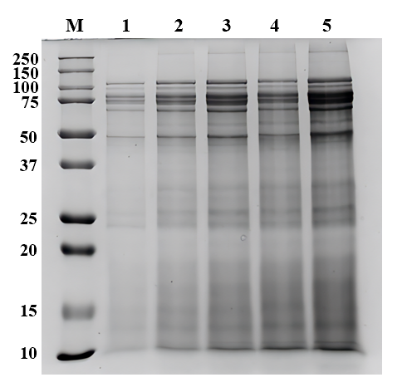
Figure S1 SDS-PAGE analysis of locust protein extraction solution
Note: M: Marker; Lanes 1-5 represent protein concentrations of 1~5 mg/mL, respectively.

