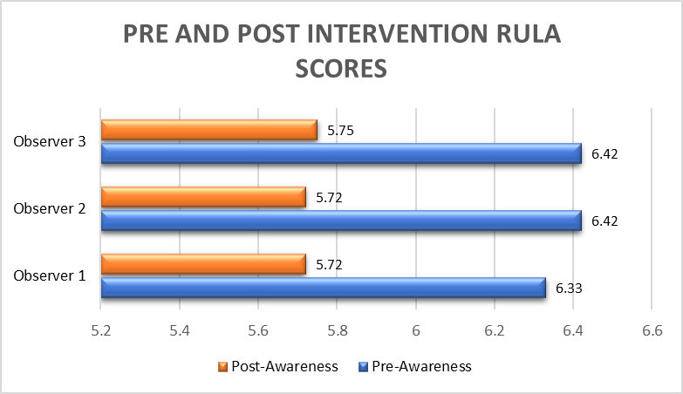

Graph 1: comparison of Pre and post intervention RULA scores by three observers

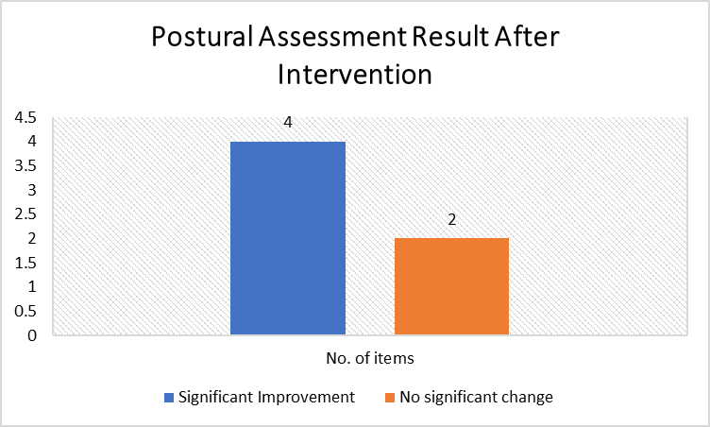

Graph 2: significant improvement in postural assessment results after intervention

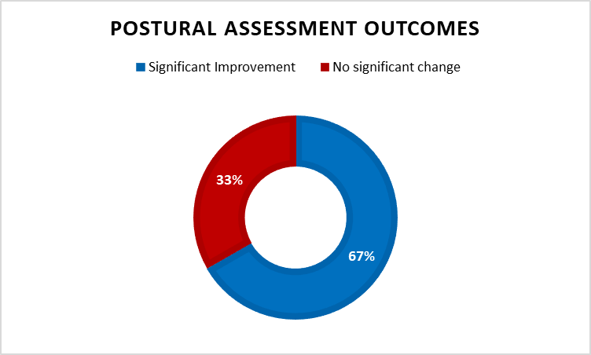Graph 3: Postural assessment significant outcome.

