Questionnaire Response Sheet-

- Name of student:

.

- Are you aware of term Ergonomics and its implications in dental offices?

O Yes

O Partially yes O No

- Should dentists follow ergonomic principles in routine dental practice?

O Yes

O Partially yes O No

- If yes, then do you think ergonomics should be a part of dental curriculum?

O Yes

O Partially yes O No

- Are you following ergonomic principles?

O Yes

O Partially yes O No
- Do you think instruments play any role in following the principles of ergonomics in dental practice?
O Yes

O Partially yes O No

8. YOU think various dental institutions should conduct ’Continuing Dental Education’ (CDE) regarding ergonomics regularly?
O Yes

O Partially yes O No

- Do you think dentist should alternate between sitting and standing posture in between two Patient’s appointment?
O Yes O No

- Are you aware of some stretching exercises which can avoid muscular pain?

O Yes O No

- Do you think every dentist should carry out stretching exercises in between two appointments?
O Yes O No

- If yes then are you doing so? And since how long?

O Yes, since 1month O Yes, since 6 months
O Yes, since more than 6 months O Never

- Are you aware of correct chair positions?

O Yes

O Partially yes O No

- While working on maxillary posterior teeth operator should seat at 7o'cIock position.

O Agree

O Disagree

- Elbow of operator should be at patient's eye level.

O Agree

O Disagree

Study Tool –
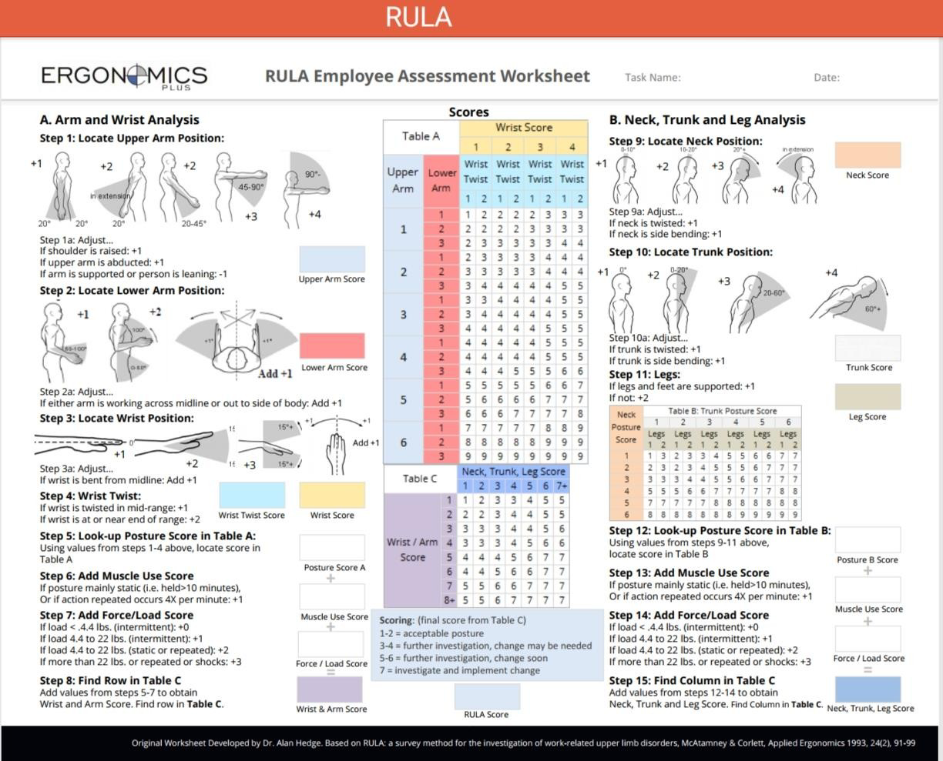
RULA Postural Assessment Sheet
Informed Consent Form-

" Impact of early ergonomics exposure on awareness and postural assessment in second year pre-clinical undergraduate dental students" aim to aware second year undergraduate students about ergonomics in relation to dental operatory position and actual postural assessment before and after early exposure to ergonomics in dentistry.
In this study, we will compare before and after awareness knowledge by questionnaire form at and will also compare postural habits using before and after awareness visual record comparison using rapid upper limb assessment [RULA] method.
For assessment will give a same exercise of maxillary central incisor tooth preparation for all participants.
I am participating in this study voluntarily. I am free to discontinue from the study at any moment without giving any reason.
I also give my consent to take my video recordings for purpose of study and to publish my data for academic purpose provided my identity is kept confidential.
I am also aware that I am supposed to retain one copy of written consent with me. I have also been assuring that my participation is completely voluntary.
I Age- residing .

Hereby give written consent to participate in research study. Participants Signature:
Address:

Contact no.:

Date:

Ethical Committee Chair Person Principal (Signature) (Signature)

