SUPPLEMENTARY FILE
Figure S1. Correlation heatmap between poultry condemnation causes and climatic variables with lag of 1 month. Each cell shows the Spearman rank correlation coefficient with the corresponding p-value. P-values < 0.05 indicate statistically significant correlation.
Figure S2. Correlation heatmap between poultry condemnation causes and climatic variables with lag of 2 months. Each cell shows the Spearman rank correlation coefficient with the corresponding p-value. P-values < 0.05 indicate statistically significant correlation.
Figure S3. Correlation heatmap between poultry condemnation causes and climatic variables with lag of 3 months. Each cell shows the Spearman rank correlation coefficient with the corresponding p-value. P-values < 0.05 indicate statistically significant correlation.

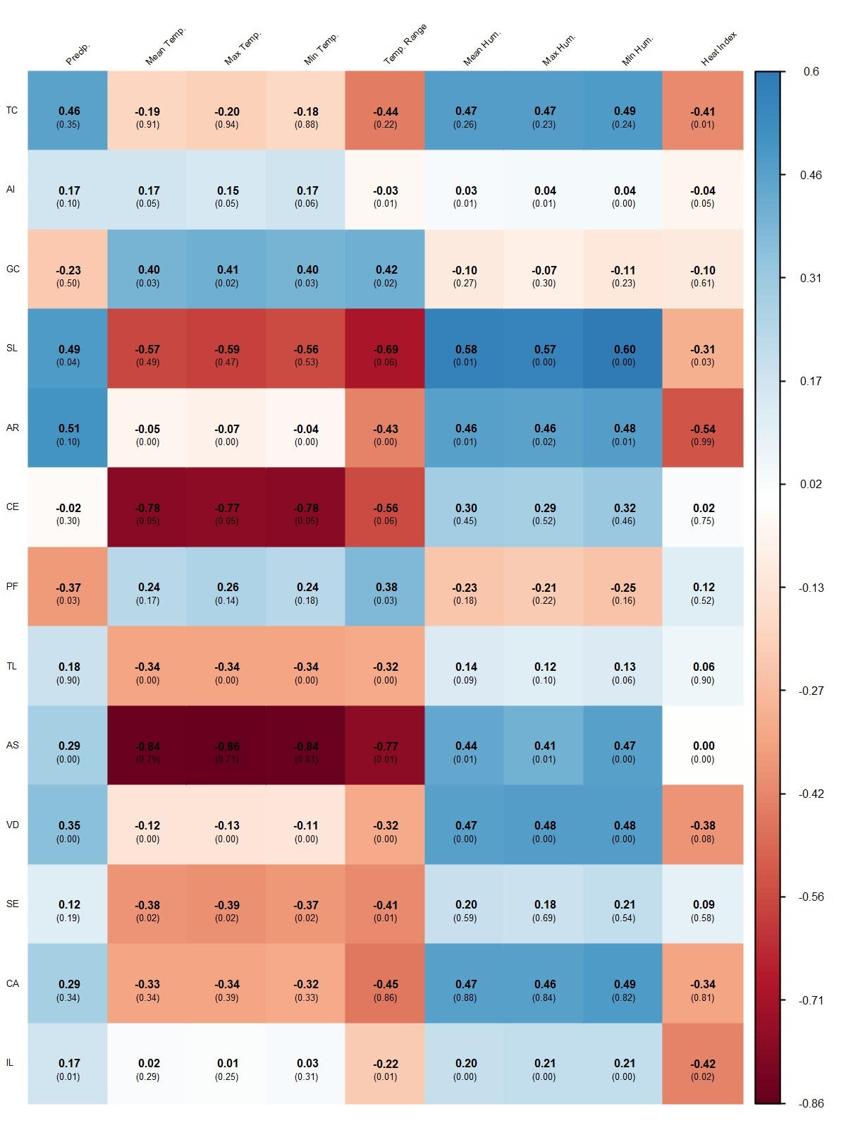
Figure S1

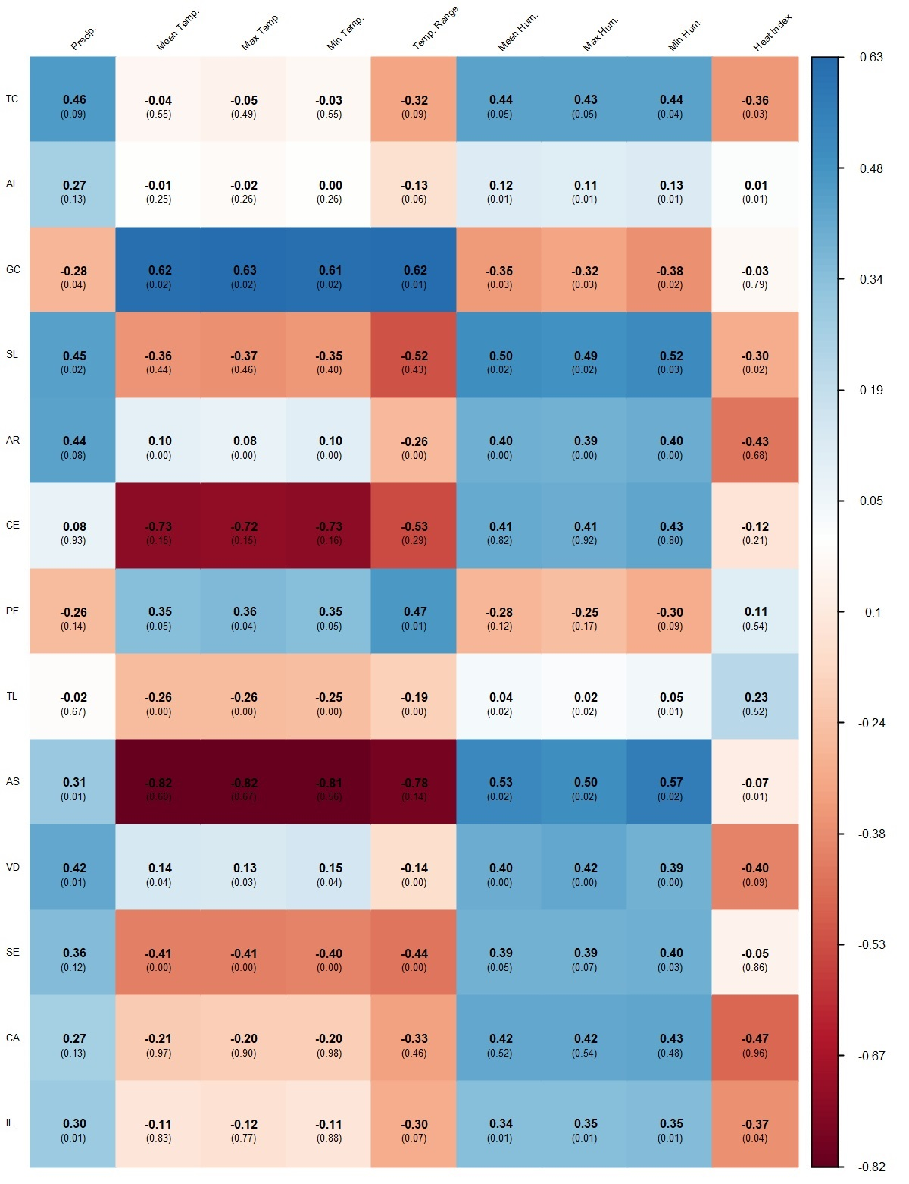
Figure S2

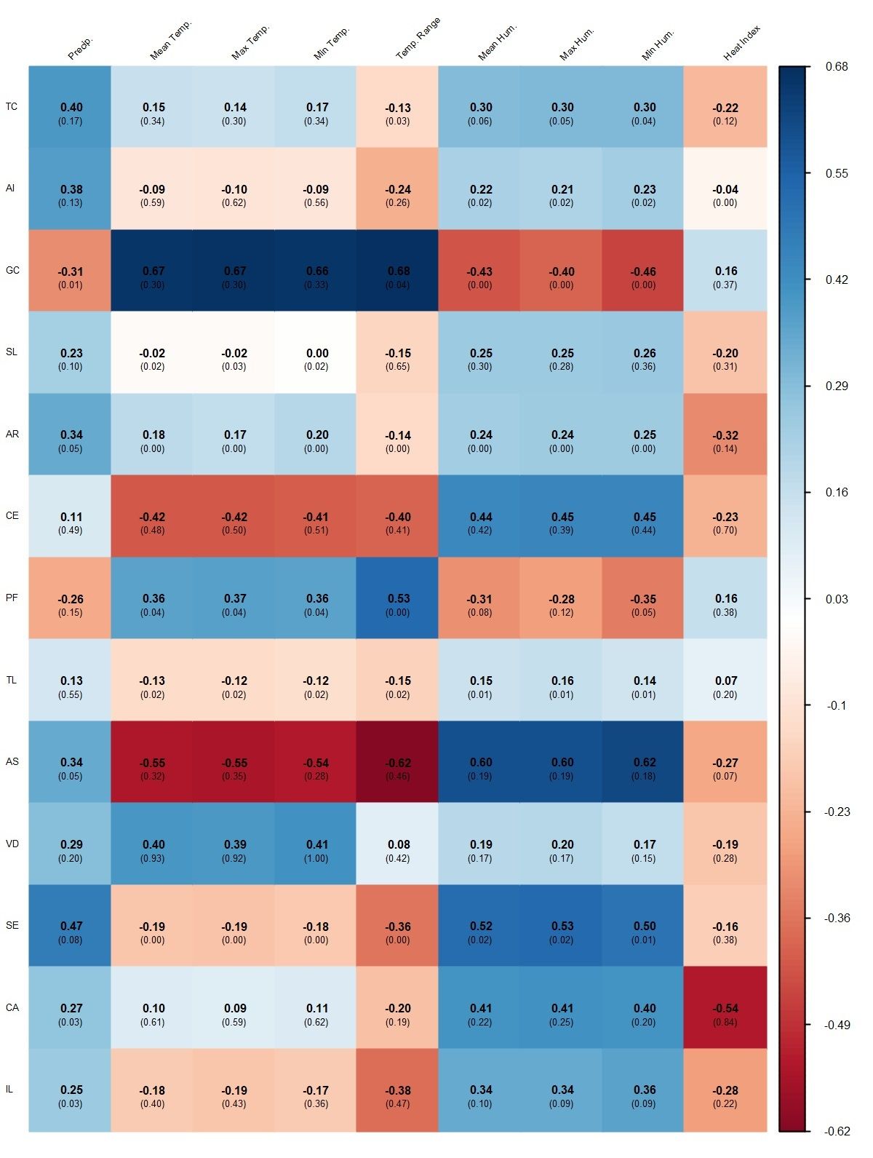
Figure S3

Table S1. Descriptive statistics for each condemnation cause of broiler carcases in Santa Catarina from 2021 to 2023.

Variable | Year | Mean | Standard Deviation | Minimum | Maximum
Airsacculitis Proportion | 2021 | 0.0022 | 0.0007 | 0.0016 | 0.0033
Airsacculitis Proportion | 2022 | 0.0098 | 0.0088 | 0.0025 | 0.0295
Airsacculitis Proportion | 2023 | 0.0143 | 0.0087 | 0.0060 | 0.0295
Cellulitis Proportion | 2021 | 0.0074 | 0.0015 | 0.0056 | 0.0107
Cellulitis Proportion | 2022 | 0.0080 | 0.0028 | 0.0050 | 0.0137
Cellulitis Proportion | 2023 | 0.0067 | 0.0015 | 0.0044 | 0.0094
Processing Failures Proportion | 2021 | 0.0085 | 0.0021 | 0.0051 | 0.0111
Processing Failures Proportion | 2022 | 0.0081 | 0.0017 | 0.0062 | 0.0111
Processing Failures Proportion | 2023 | 0.0069 | 0.0013 | 0.0051 | 0.0089
Traumatic Lesions Proportion | 2021 | 0.0034 | 0.0005 | 0.0027 | 0.0041
Traumatic Lesions Proportion | 2022 | 0.0037 | 0.0006 | 0.0029 | 0.0040
Traumatic Lesions Proportion | 2023 | 0.0029 | 0.0004 | 0.0024 | 0.0036
Ascites Proportion | 2021 | 0.0026 | 0.0011 | 0.0018 | 0.0046
Ascites Proportion | 2022 | 0.0038 | 0.0016 | 0.0022 | 0.0060
Ascites Proportion | 2023 | 0.0034 | 0.0011 | 0.0022 | 0.0047
Visual Defects Proportion | 2021 | 0.0022 | 0.0002 | 0.0019 | 0.0025
Visual Defects Proportion | 2022 | 0.0024 | 0.0004 | 0.0020 | 0.0029
Visual Defects Proportion | 2023 | 0.0026 | 0.0006 | 0.0020 | 0.0037
Septicaemia Proportion | 2021 | 0.0016 | 0.0002 | 0.0012 | 0.0018
Septicaemia Proportion | 2022 | 0.0023 | 0.0008 | 0.0014 | 0.0033
Septicaemia Proportion | 2023 | 0.0016 | 0.0003 | 0.0012 | 0.0020
Cachexia Proportion | 2021 | 0.0004 | 0.0001 | 0.0003 | 0.0006
Cachexia Proportion | 2022 | 0.0004 | 0.0001 | 0.0003 | 0.0007
Cachexia Proportion | 2023 | 0.0005 | 0.0002 | 0.0003 | 0.0008
Inflammatory Lesions Proportion | 2021 | 0.0004 | 0.0002 | 0.0003 | 0.0007
Inflammatory Lesions Proportion | 2022 | 0.0006 | 0.0003 | 0.0002 | 0.0010
Inflammatory Lesions Proportion | 2023 | 0.0007 | 0.0003 | 0.0005 | 0.0014

Table S2. Descriptive statistics of the meteorological variables in Santa Catarina from 2021 to 2023.

Variable | Year | Mean | Standard Deviation | Minimum | Maximum
Precipitation (mm) | 2021 | 99.30 | 94.33 | 7.40 | 323.60
Precipitation (mm) | 2022 | 178.76 | 92.66 | 40.78 | 370.00
Precipitation (mm) | 2023 | 215.49 | 142.13 | 88.40 | 545.80
Mean Temperature (°C) | 2021 | 19.93 | 3.72 | 13.43 | 24.60
Mean Temperature (°C) | 2022 | 18.12 | 3.86 | 13.70 | 24.17
Mean Temperature (°C) | 2023 | 20.00 | 3.10 | 15.55 | 23.83
Maximum Temperature (°C) | 2021 | 20.58 | 3.86 | 14.07 | 25.44
Maximum Temperature (°C) | 2022 | 18.68 | 3.98 | 14.18 | 24.93
Maximum Temperature (°C) | 2023 | 20.62 | 3.21 | 16.01 | 24.54
Minimum Temperature (°C) | 2021 | 19.28 | 3.59 | 12.79 | 23.81
Minimum Temperature (°C) | 2022 | 17.58 | 3.75 | 13.21 | 23.44
Minimum Temperature (°C) | 2023 | 19.39 | 3.00 | 15.07 | 23.12
Mean Temperature Range (°C) | 2021 | 1.30 | 0.30 | 0.88 | 1.63
Mean Temperature Range (°C) | 2022 | 1.10 | 0.25 | 0.67 | 1.49
Mean Temperature Range (°C) | 2023 | 1.23 | 0.36 | 0.87 | 1.52
Mean Relative Humidity (%) | 2021 | 66.94 | 5.95 | 55.66 | 73.06
Mean Relative Humidity (%) | 2022 | 71.85 | 7.91 | 58.43 | 82.81
Mean Relative Humidity (%) | 2023 | 73.66 | 3.49 | 69.50 | 79.05
Maximum Relative Humidity (%) | 2021 | 70.14 | 5.90 | 58.99 | 76.27
Maximum Relative Humidity (%) | 2022 | 74.95 | 7.77 | 61.62 | 85.13
Maximum Relative Humidity (%) | 2023 | 76.69 | 3.49 | 72.42 | 81.45
Minimum Relative Humidity (%) | 2021 | 63.77 | 6.03 | 52.27 | 69.89
Minimum Relative Humidity (%) | 2022 | 68.78 | 8.04 | 55.47 | 80.46
Minimum Relative Humidity (%) | 2023 | 70.73 | 3.48 | 66.63 | 76.68
Heat Index | 2021 | 76.76 | 4.36 | 73.06 | 86.14
Heat Index | 2022 | 74.73 | 2.74 | 71.17 | 78.59
Heat Index | 2023 | 74.27 | 2.00 | 70.39 | 76.80

Table S3. Detailed regression results for total condemnations rate (TC), airsacculitis rate (AI), gastrointestinal contamination rate (GC), and skin lesions rate (SL)

 | TC |  | AI |  | GC |  | SL
 | Base Model | Stepwise Model | Base Model | Stepwise Model | Base Model | Stepwise Model | Base Model | Stepwise Model
β₀ | 50.628 (23.481) | 50.522 (17.771) | 27.015 (12.590)* | 27.015 (12.590)* | -13.435 (11.206) | -7.497 (6.916) | 4.404 (16.485) | 5.504 (0.338)***
β₁ | -0.004 (0.003) | -0.004 (0.003) | -0.002 (0.002) | -0.002 (0.002) | -0.0002 (0.001) |  | -0.001 (0.002)
β₂ | -0.141 (0.155) | -0.141 (0.146) | -0.250 (0.083)** | -0.250 (0.083)** | 0.119 (0.074) | 0.078 (0.043)* | 0.023 (0.109)
β₃ | -0.100 (0.070) | -0.100 (0.063) | -0.071 (0.038)* | -0.071 (0.038)* | 0.020 (0.033) |  | 0.009 (0.049)
β₄ | -0.094 (0.099) | -0.094 (0.094) | -0.050 (0.053) | -0.050 (0.053) | 0.031 (0.047) |  | -0.026 (0.070)
β₅ | 0.00003 (0.004) |  | -0.002 (0.002) | -0.002 (0.002) | -0.002 (0.002) | -0.002 (0.001) | 0.001 (0.003)
β₆ | -0.259 (0.176) | -0.258 (0.148) | -0.192 (0.094)* | -0.192 (0.094)* | 0.141 (0.084) | 0.132 (0.072)* | -0.038 (0.123) | -0.121 (0.017)***
β₇ | -0.076 (0.089) | -0.075 (0.049) | -0.055 (0.048) | -0.055 (0.048) | 0.052 (0.042) | 0.042 (0.034) | 0.001 (0.062)
β₈ | -0.124 (0.111) | -0.123 (0.093) | -0.066 (0.059) | -0.066 (0.059) | 0.086 (0.053) | 0.078 (0.046) | 0.002 (0.078)
Jan. | -1.564 (1.277) | -1.561 (1.189) | 0.706 (0.685) | 0.706 (0.685) | -0.825 (0.609) | -0.631 (0.401) | -0.197 (0.896)
Feb. | -1.546 (1.035) | -1.544 (0.976) | 0.569 (0.555) | 0.569 (0.555) | -1.184 (0.494)** | -1.054 (0.356)*** | -0.226 (0.727)
Mar. | -0.092 (0.853) | -0.092 (0.819) | 0.909 (0.458)* | 0.909 (0.458)* | -0.788 (0.407)* | -0.613 (0.278)** | -0.284 (0.599)
Apr.
May | -0.680 (1.028) | -0.676 (0.858) | -1.300 (0.551)** | -1.300 (0.551)** | 0.775 (0.491) | 0.693 (0.418) | 0.069 (0.722)
Jun. | -0.152 (1.205) | -0.148 (1.047) | -1.472 (0.646)** | -1.472 (0.646)** | 0.967 (0.575) | 0.928 (0.514)* | 0.452 (0.846)
Jul. | -1.526 (1.223) | -1.522 (1.083) | -1.975 (0.656)** | -1.975 (0.656)** | 0.362 (0.584) | 0.315 (0.477) | 0.806 (0.859)
Aug. | -2.184 (1.287) | -2.179 (1.059)* | -2.097 (0.690)** | -2.097 (0.690)** | -0.166 (0.614) | -0.263 (0.484) | 0.839 (0.904)
Sep. | -2.642 (1.240)* | -2.637 (1.008)** | -1.429 (0.665)* | -1.429 (0.665)* | -0.282 (0.592) | -0.327 (0.489) | 0.329 (0.870)
Oct. | -0.749 (1.155) | -0.747 (1.059) | 0.006 (0.619) | 0.006 (0.619) | -0.297 (0.551) | -0.369 (0.382) | 0.320 (0.811)
Nov. | -1.270 (1.715) | -1.260 (0.950) | 0.699 (0.920) | 0.699 (0.920) | 0.291 (0.819) | 0.111 (0.598) | -0.082 (1.204)
Dec. | -1.161 (1.399) | -1.154 (1.020) | 0.710 (0.750) | 0.710 (0.750) | -0.434 (0.668) | -0.390 (0.481) | -0.043 (0.982)
2022 | 2.422 (0.399)*** | 2.423 (0.378)*** | 1.114 (0.214)*** | 1.114 (0.214)*** | 0.011 (0.190) | -0.021 (0.152) | 0.453 (0.280) | 0.462 (0.142)***
2023 | 4.325 (0.454)*** | 4.325 (0.435)*** | 1.956 (0.243)*** | 1.956 (0.243)*** | -0.192 (0.217) | -0.202 (0.169) | 0.862 (0.318)** | 1.018 (0.143)***
Adj. R² | 0.829 | 0.843 | 0.739 | 0.739 | 0.521 | 0.599 | 0.490 | 0.721
RSE (df) | 0.636 (12) | 0.611 (13) | 0.341 (12) | 0.341 (12) | 0.304 (12) | 0.278 (15) | 0.447 (12) | 0.330 (30)
SW (p) | 0.8491 |  | 0.6314 |  | 0.2043 |  | 0.9843
BP (p) | 0.3547 |  | 0.1881 |  | 0.2394 |  | 0.1772
 | GVIF (Stepwise) | GVIF^{1/(2df)} (Stepwise) | GVIF (Stepwise) | GVIF^{1/(2df)} (Stepwise) | GVIF (Stepwise) | GVIF^{1/(2df)} (Stepwise) | GVIF (Stepwise) |  | GVIF^{1/(2df)} (Stepwise)
X₁ | 10.30 | 3.21 | 10.50 | 3.24
X₂ | 22.92 | 4.79 | 23.84 | 4.88 | 9.53 | 3.09
X₃ | 16.16 | 4.02 | 18.61 | 4.31
X₄ | 6.45 | 2.54 | 6.61 | 2.57
X₅ |  |  | 18.13 | 4.26 | 10.68 | 3.27
X₆ | 22.67 | 4.76 | 29.52 | 5.43 | 25.91 | 5.09 | 1.03 |  | 1.01
X₇ | 9.97 | 3.16 | 29.89 | 5.47 | 22.73 | 4.77
X₈ | 6.26 | 2.50 | 8.23 | 2.87 | 7.52 | 2.74
Month | 5798.29 | 1.48 | 30520.37 | 1.60 | 908.70 | 1.36
Year | 4.15 | 1.43 | 4.28 | 1.44 | 2.84 | 1.30 | 1.03 |  | 1.01
RSE: Residual standard error; SW: Shapiro Wilk; BP: Breusch-Pagan; df: degrees of freedom; *p < 0.1; **p < 0.05; ***p < 0.01; GVIF: Generalised variance inflation factor. Regression coefficients are expressed as mean (standard error). X₁: precipitation (mm), X₂: mean temperature (°C), X₃: mean humidity (%), X₄: heat index, X₅: precipitation lag-1 (mm), X₆: temperature lag-1 (°C), X₇: humidity lag-1 (%), X₈: heat index lag-1.

Table S4. Detailed regression results for total arthritis rate (AR), cellulitis rate (CE), processing failure rate (PF), and traumatic lesions rate (TL)

 | AR |  | CE |  | PF |  | TL
 | Base Model | Stepwise Model | Base Model | Stepwise Model | Base Model | Stepwise Model | Base Model | Stepwise Model
β₀ | 13.353 (10.106) | 17.228 (7.022)** | 7.447 (4.392) | 8.116 (2.804)** | 7.163 (4.660) | 6.229 (1.429)*** | -0.374 (0.921) | -0.059 (0.096)
β₁ | -0.001 (0.001) |  | -0.0003 (0.001) | -0.0005 (0.0004) | 0.0001 (0.001) |  | 0.00004 (0.0001)
β₂ | 0.029 (0.067) |  | 0.021 (0.029) |  | -0.006 (0.031) |  | 0.008 (0.006) | 0.011 (0.003)***
β₃ | -0.021 (0.030) | -0.038 (0.015)** | -0.001 (0.013) |  | -0.011 (0.014) | -0.010 (0.006) | -0.001 (0.003)
β₄ | 0.021 (0.043) |  | 0.009 (0.019) |  | -0.041 (0.020)* | -0.038 (0.012)*** | -0.002 (0.004)
β₅ | 0.002 (0.002) | 0.002 (0.001)** | 0.002 (0.001)** | 0.002 (0.001)** | 0.0004 (0.001) | 0.0004 (0.0003) | 0.0002 (0.0002) | 0.0002 (0.0001)***
β₆ | -0.098 (0.076) | -0.107 (0.067) | -0.059 (0.033)* | -0.053 (0.029)* | -0.008 (0.035) |  | 0.011 (0.007) | 0.006 (0.003)*
β₇ | -0.055 (0.038) | -0.057 (0.034) | -0.029 (0.017) | -0.027 (0.014)** | -0.002 (0.018) |  | 0.002 (0.003)
β₈ | -0.089 (0.048)* | -0.093 (0.043)** | -0.024 (0.021) | -0.023 (0.019) | -0.025 (0.022) | -0.022 (0.011)* | 0.004 (0.004)
Jan. | -1.656 (0.550)** | -1.479 (0.370)*** | -0.400 (0.239) | -0.244 (0.150) | 0.248 (0.253) | 0.214 (0.134) | -0.015 (0.050) | -0.039 (0.027)
Feb. | -0.877 (0.446)* | -0.724 (0.323)** | -0.351 (0.194)* | -0.240 (0.138) | 0.166 (0.205) | 0.128 (0.126) | -0.058 (0.041) | -0.065 (0.025)**
Mar. | -0.283 (0.367) | -0.122 (0.226) | -0.301 (0.160)* | -0.233 (0.103)** | 0.227 (0.169) | 0.202 (0.094)** | -0.033 (0.033) | -0.049 (0.021)**
Apr.
May | 0.104 (0.443) | 0.044 (0.365) | -0.294 (0.192) | -0.318 (0.160)* | -0.038 (0.204) | 0.001 (0.096) | 0.086 (0.040)* | 0.062 (0.023)**
Jun. | 0.170 (0.519) | 0.145 (0.434) | -0.332 (0.225) | -0.375 (0.193)* | -0.052 (0.239) | -0.002 (0.111) | 0.129 (0.047)** | 0.100 (0.030)***
Jul. | -0.553 (0.526) | -0.593 (0.439) | -0.388 (0.229) | -0.371 (0.187)* | -0.053 (0.243) | 0.00000 (0.114) | 0.131 (0.048)** | 0.107 (0.032)***
Aug. | -0.692 (0.554) | -0.751 (0.465) | -0.486 (0.241)* | -0.464 (0.192)** | -0.057 (0.256) | -0.009 (0.115) | 0.117 (0.050)** | 0.093 (0.028)***
Sep. | -0.981 (0.534)* | -1.008 (0.472)** | -0.521 (0.232)** | -0.467 (0.197)** | -0.148 (0.246) | -0.110 (0.100) | 0.093 (0.049)* | 0.063 (0.025)**
Oct. | -0.327 (0.497) | -0.529 (0.348) | -0.349 (0.216) | -0.307 (0.172)* | -0.294 (0.229) | -0.256 (0.093)** | 0.045 (0.045) | 0.033 (0.021)
Nov. | -1.271 (0.738) | -1.336 (0.665)* | -0.992 (0.321)*** | -0.866 (0.246)*** | -0.461 (0.340) | -0.431 (0.148)** | -0.024 (0.067) | -0.064 (0.029)**
Dec. | -1.145 (0.602)* | -1.036 (0.503)* | -0.856 (0.262)*** | -0.696 (0.192)*** | -0.146 (0.278) | -0.153 (0.116) | -0.035 (0.055) | -0.073 (0.026)**
2022 | 1.007 (0.172)*** | 0.957 (0.141)*** | -0.241 (0.075)*** | -0.263 (0.063)*** | -0.232 (0.079)** | -0.222 (0.062)*** | 0.049 (0.016)*** | 0.048 (0.011)***
2023 | 2.151 (0.195)*** | 2.106 (0.158)*** | -0.327 (0.085)*** | -0.333 (0.072)*** | -0.476 (0.090)*** | -0.475 (0.077)*** | -0.045 (0.018)** | -0.044 (0.013)***
Adj. R² | 0.901 | 0.917 | 0.580 | 0.633 | 0.610 | 0.705 | 0.646 | 0.718
RSE (df) | 0.274 (12) | 0.250 (15) | 0.119 (12) | 0.111 (15) | 0.126 (12) | 0.110 (16) | 0.025 (12) | 0.022 (17)
SW (p) | 0.5887 |  | 0.7631 |  | 0.8389 |  | 0.9295
BP (p) | 0.1797 |  | 0.4639 |  | 0.2937 |  | 0.0120
 | GVIF (Stepwise) | GVIF^{1/(2df)} (Stepwise) | GVIF (Stepwise) | GVIF^{1/(2df)} (Stepwise) | GVIF (Stepwise) | GVIF^{1/(2df)} (Stepwise) | GVIF (Stepwise) |  | GVIF^{1/(2df)} (Stepwise)
X₁ |  |  | 5.65 | 2.38
X₂ |  |  |  |  |  |  | 9.52 |  | 3.09
X₃ | 5.70 | 2.39 |  |  | 5.17 | 2.27
X₄ |  |  |  |  | 3.30 | 1.82
X₅ | 16.64 | 4.08 | 15.63 | 3.95 | 4.90 | 2.21 | 3.82 |  | 1.95
X₆ | 27.93 | 5.29 | 25.85 | 5.08 |  |  | 8.35 |  | 2.89
X₇ | 28.33 | 5.32 | 25.52 | 5.05
X₈ | 8.05 | 2.84 | 7.65 | 2.77 | 2.72 | 1.65
Month | 1188.62 | 1.38 | 1137.69 | 1.38 | 42.21 | 1.19 | 105.35 |  | 1.24
Year | 2.75 | 1.29 | 2.84 | 1.30 | 2.78 | 1.29 | 2.38 |  | 1.24
RSE: Residual standard error; SW: Shapiro Wilk; BP: Breusch-Pagan; df: degrees of freedom; *p < 0.1; **p < 0.05; ***p < 0.01; GVIF: Generalised variance inflation factor. Regression coefficients are expressed as mean (standard error). X₁: precipitation (mm), X₂: mean temperature (°C), X₃: mean humidity (%), X₄: heat index, X₅: precipitation lag-1 (mm), X₆: temperature lag-1 (°C), X₇: humidity lag-1 (%), X₈: heat index lag-1.

Table S5. Detailed regression results for total ascites rate (AS), visual defects rate (VD), septicaemia rate (SE), and cachexia rate (CA)

 | AS |  | VD |  | SE |  | CA
 | Base Model | Stepwise Model | Base Model | Stepwise Model | Base Model | Stepwise Model | Base Model | Stepwise Model
β₀ | 1.795 (0.584)*** | 1.962 (0.252)*** | 1.574 (0.602)** | 1.574 (0.602)** | 1.133 (1.172) | 0.634 (0.161)*** | 0.303 (0.243) | 0.186 (0.043)***
β₁ | -0.00004 (0.0001) |  | -0.0001 (0.0001) | -0.0001 (0.0001) | -0.00002 (0.0001) |  | 0.00004 (0.00003) | 0.00003 (0.00002)
β₂ | -0.020 (0.004)*** | -0.021 (0.003)*** | -0.005 (0.004) | -0.005 (0.004) | -0.021 (0.008)** | -0.018 (0.005)*** | -0.003 (0.002) | -0.003 (0.001)***
β₃ | -0.006 (0.002)*** | -0.006 (0.001)*** | -0.003 (0.002) | -0.003 (0.002) | -0.003 (0.004) | -0.002 (0.002) | -0.002 (0.001)* | -0.001 (0.0005)**
β₄ | -0.008 (0.002)*** | -0.008 (0.002)*** | -0.004 (0.003) | -0.004 (0.003) | -0.004 (0.005) |  | 0.00001 (0.001)
β₅ | 0.00005 (0.0001) |  | 0.0001 (0.0001) | 0.0001 (0.0001) | -0.0001 (0.0002) | -0.0001 (0.0001) | -0.00002 (0.00004) | -0.00003 (0.00002)
β₆ | -0.015 (0.004)*** | -0.017 (0.002)*** | -0.008 (0.005) | -0.008 (0.005) | -0.001 (0.009) |  | -0.001 (0.002)
β₇ | 0.0002 (0.002) |  | -0.004 (0.002) | -0.004 (0.002) | 0.0001 (0.004) |  | -0.0005 (0.001)
β₈ | 0.001 (0.003) |  | -0.004 (0.003) | -0.004 (0.003) | -0.002 (0.006) |  | -0.001 (0.001)
Jan. | 0.117 (0.032)*** | 0.118 (0.025)*** | -0.026 (0.033) | -0.026 (0.033) | 0.106 (0.064) | 0.065 (0.033)* | -0.008 (0.013) | -0.006 (0.007)
Feb. | 0.071 (0.026)** | 0.080 (0.020)*** | -0.038 (0.027) | -0.038 (0.027) | 0.060 (0.052) | 0.029 (0.031) | -0.013 (0.011) | -0.014 (0.007)**
Mar. | 0.059 (0.021)** | 0.061 (0.017)*** | -0.010 (0.022) | -0.010 (0.022) | 0.057 (0.043) | 0.040 (0.027) | 0.0004 (0.009) | 0.001 (0.006)
Apr.
May | -0.028 (0.026) | -0.036 (0.015)** | -0.032 (0.026) | -0.032 (0.026) | -0.048 (0.051) | -0.043 (0.026) | -0.004 (0.011) | 0.002 (0.006)
Jun. | -0.014 (0.030) | -0.022 (0.030) | -0.016 (0.031) | -0.016 (0.031) | -0.060 (0.060) | -0.054 (0.031)* | 0.007 (0.012) | 0.015 (0.007)**
Jul. | 0.018 (0.030) | 0.010 (0.022) | -0.042 (0.031) | -0.042 (0.031) | -0.038 (0.061) | -0.036 (0.029) | -0.004 (0.013) | 0.005 (0.006)
Aug. | 0.066 (0.032)* | 0.058 (0.019)*** | -0.091 (0.033)** | -0.091 (0.033)** | 0.007 (0.064) | 0.005 (0.027) | -0.019 (0.013) | -0.010 (0.006)
Sep. | 0.091 (0.031)** | 0.082 (0.017)*** | -0.095 (0.032)** | -0.095 (0.032)** | 0.045 (0.062) | 0.041 (0.023)* | -0.020 (0.013) | -0.012 (0.005)**
Oct. | 0.107 (0.029)*** | 0.091 (0.014)*** | -0.051 (0.030) | -0.051 (0.030) | 0.018 (0.058) | 0.016 (0.023) | -0.014 (0.012) | -0.007 (0.007)
Nov. | 0.056 (0.043) | 0.058 (0.017)*** | -0.077 (0.044) | -0.077 (0.044) | 0.071 (0.086) | 0.066 (0.038) | -0.009 (0.018) | 0.0003 (0.008)
Dec. | 0.086 (0.035)** | 0.089 (0.022)*** | -0.037 (0.036) | -0.037 (0.036) | 0.126 (0.070)* | 0.099 (0.032)*** | 0.00004 (0.014) | 0.006 (0.007)
2022 | 0.066 (0.010)*** | 0.065 (0.008)*** | 0.049 (0.010)*** | 0.049 (0.010)*** | 0.078 (0.020)*** | 0.085 (0.015)*** | 0.005 (0.004) | 0.005 (0.003)
2023 | 0.088 (0.011)*** | 0.088 (0.009)*** | 0.063 (0.012)*** | 0.063 (0.012)*** | 0.044 (0.023)* | 0.051 (0.018)** | 0.025 (0.005)*** | 0.025 (0.004)***
Adj. R² | 0.970 | 0.975 | 0.744 | 0.744 | 0.598 | 0.694 | 0.724 | 0.781
RSE (df) | 0.016 (12) | 0.014 (16) | 0.016 (12) | 0.016 (12) | 0.032 (12) | 0.028 (17) | 0.007 (12) | 0.006 (16)
SW (p) | 0.4234 |  | 0.5400 |  | 0.3881 |  | 0.8094
BP (p) | 0.3170 |  | 0.1067 |  | 0.1157 |  | 0.3817
 | GVIF (Stepwise) | GVIF^{1/(2df)} (Stepwise) | GVIF (Stepwise) | GVIF^{1/(2df)} (Stepwise) | GVIF (Stepwise) | GVIF^{1/(2df)} (Stepwise) | GVIF (Stepwise) |  | GVIF^{1/(2df)} (Stepwise)
X₁ |  |  | 10.50 | 3.24 |  |  | 8.86 |  | 2.98
X₂ | 20.31 | 4.51 | 23.84 | 4.88 | 10.63 | 3.26 | 11.39 |  | 3.38
X₃ | 6.90 | 2.63 | 18.61 | 4.31 | 5.00 | 2.24 | 10.11 |  | 3.18
X₄ | 5.83 | 2.42 | 6.61 | 2.57
X₅ |  |  | 18.13 | 4.26 | 4.40 | 2.10 | 4.66 |  | 2.16
X₆ | 8.30 | 2.88 | 29.52 | 5.43
X₇ |  |  | 29.89 | 5.47
X₈ |  |  | 8.23 | 2.87
Month | 199.98 | 1.27 | 30520.37 | 1.60 | 79.61 | 1.22 | 298.00 |  | 1.30
Year | 2.73 | 1.29 | 4.28 | 1.44 | 2.64 | 1.27 | 2.69 |  | 1.28
RSE: Residual standard error; SW: Shapiro Wilk; BP: Breusch-Pagan; df: degrees of freedom; *p < 0.1; **p < 0.05; ***p < 0.01; GVIF: Generalised variance inflation factor. Regression coefficients are expressed as mean (standard error). X₁: precipitation (mm), X₂: mean temperature (°C), X₃: mean humidity (%), X₄: heat index, X₅: precipitation lag-1 (mm), X₆: temperature lag-1 (°C), X₇: humidity lag-1 (%), X₈: heat index lag-1.

Table S6. Detailed regression results for inflammatory lesions rate (IL)

 | IL
 | Base Model | Stepwise Model | GLM Model | GLM Model
β₀ | 3.691 (2.505) | 1.035 (0.384)** |  | 7.601 (4.392)*
β₁ | 0.0001 (0.0003)
β₂ | -0.010 (0.017)
β₃ | -0.005 (0.007)
β₄ | -0.007 (0.011) | -0.005 (0.004) |  | -0.034 (0.044)
β₅ | 0.0002 (0.0004)
β₆ | -0.022 (0.019)
β₇ | -0.008 (0.009)
β₈ | -0.019 (0.012) | -0.007 (0.003)** |  | -0.096 (0.047)*
Jan. | 0.017 (0.136)
Feb. | 0.022 (0.110)
Mar. | 0.046 (0091)
Apr.
May | -0.134 (0.110)
Jun. | -0.172 (0.129)
Jul. | -0.165 (0.130)
Aug. | -0.139 (0.137)
Sep. | -0.137 (0.132)
Oct. | -0.133 (0.123)
Nov. | -0.202 (0.183)
Dec. | -0.077 (0.149)
2022 | -0.069 (0.043) |  |  | -0.789 (0.299)**
2023 | -0.011 (0.048) |  |  | -0.184 (0.273)
Adj. R² | -0.471 | 0.198
RSE (df) | 0.068 | 0.050 | Dispersion | 0.0284
SW (p) | 0.0769
BP (p) | 0.0010
 | GVIF (Stepwise) | GVIF^{1/(2df)} (Stepwise) | GVIF (GLM) | GVIF^{1/(2df)} (GLM)
X₁ | 1.78 | 1.33
X₂
X₃
X₄ | 1.61 | 1.27 | 1.22 | 1.11
X₅
X₆
X₇
X₈ | 1.21 | 1.10 | 1.14 | 1.07
Month
Year | 1.31 | 1.07 | 1.22 | 1.05
RSE: Residual standard error; SW: Shapiro Wilk; BP: Breusch-Pagan; df: degrees of freedom; *p < 0.1; **p < 0.05; ***p < 0.01; GVIF: Generalised variance inflation factor. Regression coefficients are expressed as mean (standard error). X₁: precipitation (mm), X₂: mean temperature (°C), X₃: mean humidity (%), X₄: heat index, X₅: precipitation lag-1 (mm), X₆: temperature lag-1 (°C), X₇: humidity lag-1 (%), X₈: heat index lag-1.

Table S7. Ridge regression coefficients for CT, AI, GC, SL, AR, CE, PF, TL, and AS, addressing multicollinearity in stepwise linear models. Coefficients are rounded to three decimal places.
Response | CT | AI | GC | SL | AR | CE | PF | TL | AS
Intercept | 30.667 | 9.883 | 5.409 | 4.187 | 8.102 | 0.971 | 1.682 | 0.382 | 0.615
X₁ | -0.003 | -0.002 | 0.000 | 0.000 | 0.000 | 0.000 | 0.000 | 0.000 | 0.000
X₂ | -0.045 | -0.109 | 0.003 | -0.010 | -0.002 | -0.001 | 0.002 | 0.002 | -0.007
X₃ | -0.030 | -0.030 | 0.000 | 0.006 | -0.004 | -0.002 | -0.001 | -0.001 | -0.002
X₄ | -0.107 | -0.107 | -0.005 | -0.016 | -0.023 | 0.001 | -0.009 | -0.002 | -0.001
X₅ | -0.001 | -0.001 | 0.000 | 0.000 | 0.000 | 0.000 | 0.000 | 0.000 | 0.000
X₆ | -0.079 | -0.079 | 0.023 | -0.034 | -0.020 | -0.011 | 0.007 | 0.001 | -0.013
X₇ | 0.019 | 0.019 | -0.001 | 0.010 | 0.001 | 0.002 | 0.002 | 0.000 | 0.001
X₈ | -0.074 | -0.074 | -0.003 | 0.002 | -0.057 | 0.001 | -0.004 | 0.001 | 0.002
January | -0.259 | 0.355 | 0.064 | -0.016 | -0.522 | -0.016 | 0.002 | 0.005 | 0.024
February | -0.701 | 0.119 | -0.108 | -0.050 | -0.134 | -0.038 | -0.003 | -0.021 | 0.000
March | -0.067 | 0.466 | -0.017 | -0.192 | 0.031 | 0.001 | 0.133 | -0.022 | -0.015
April
May | 0.261 | -0.501 | 0.201 | -0.152 | 0.414 | -0.023 | 0.044 | 0.023 | -0.020
June | 0.796 | -0.490 | 0.207 | 0.053 | 0.443 | 0.015 | 0.006 | 0.040 | -0.005
July | 0.016 | -0.953 | -0.042 | 0.300 | -0.014 | 0.097 | -0.011 | 0.049 | 0.026
August | -0.150 | -0.997 | -0.304 | 0.387 | 0.091 | 0.179 | -0.047 | 0.041 | 0.073
September | -0.898 | -0.639 | -0.281 | 0.121 | -0.188 | 0.056 | -0.076 | 0.032 | 0.072
October | -0.268 | 0.519 | -0.190 | -0.050 | -0.135 | 0.001 | -0.068 | -0.001 | 0.081
November | -0.033 | 1.066 | -0.042 | -0.121 | -0.291 | -0.050 | -0.090 | -0.035 | 0.023
December | 0.126 | 0.623 | -0.030 | 0.007 | -0.009 | -0.064 | -0.085 | -0.027 | 0.011
2022 | 1.459 | 1.041 | -0.061 | 0.071 | 0.581 | -0.063 | -0.028 | 0.040 | 0.058
2023 | 2.789 | 1.596 | -0.099 | 0.352 | 1.553 | -0.104 | -0.172 | -0.034 | 0.064

Table S8. Ridge regression coefficients for VD, SE, CA, and IL, addressing multicollinearity in stepwise linear models. Coefficients are rounded to three decimal places.
Response | VD | SE | CA | IL
Intercept | 0.559 | 0.170 | 0.111 | 0.082
X₁ | 0.000 | 0.000 | 0.000 | 0.000
X₂ | -0.001 | -0.001 | -0.001 | 0.000
X₃ | 0.000 | 0.000 | -0.001 | 0.000
X₄ | -0.003 | 0.001 | 0.000 | 0.000
X₅ | 0.000 | 0.000 | 0.000 | 0.000
X₆ | -0.001 | -0.001 | 0.000 | 0.000
X₇ | 0.000 | 0.000 | 0.000 | 0.000
X₈ | -0.001 | 0.000 | 0.000 | 0.000
January | 0.004 | 0.005 | -0.005 | 0.000
February | -0.018 | -0.008 | -0.012 | 0.000
March | -0.009 | -0.010 | -0.004 | 0.000
April
May | 0.009 | -0.006 | 0.003 | 0.000
June | 0.025 | -0.006 | 0.012 | 0.000
July | 0.009 | -0.002 | 0.005 | 0.000
August | -0.019 | 0.016 | -0.006 | 0.000
September | -0.031 | 0.014 | -0.011 | 0.000
October | -0.019 | -0.001 | -0.004 | 0.000
November | -0.009 | -0.002 | -0.001 | 0.000
December | 0.012 | 0.008 | 0.004 | 0.000
2022 | 0.031 | 0.028 | 0.002 | 0.000
2023 | 0.033 | -0.004 | 0.020 | 0.000

