Appendix 1: Study setting characteristics and supplementary results
Table A1 Demographic and health indicators in Kilifi County
Indicator
Total population (2019) | 1,453,787
Male | 704,089
Female | 749,673
Intersex | 25
Share of rural population | 77%
Poverty rate | 46.1%
Health insurance coverage | 12%
Estimated hypertension prevalence | 26.5%
Health Personnel (Public sector in 2023)
Nurses per 10,000 people | 4
Doctors per 10,000 people | 1
Health Facilities (2022)
Dispensaries | 132
Health Centres | 18
Public Hospitals | 9
Faith-based facilities | 25
Private for-profit health facilities | 186
Source: (1)
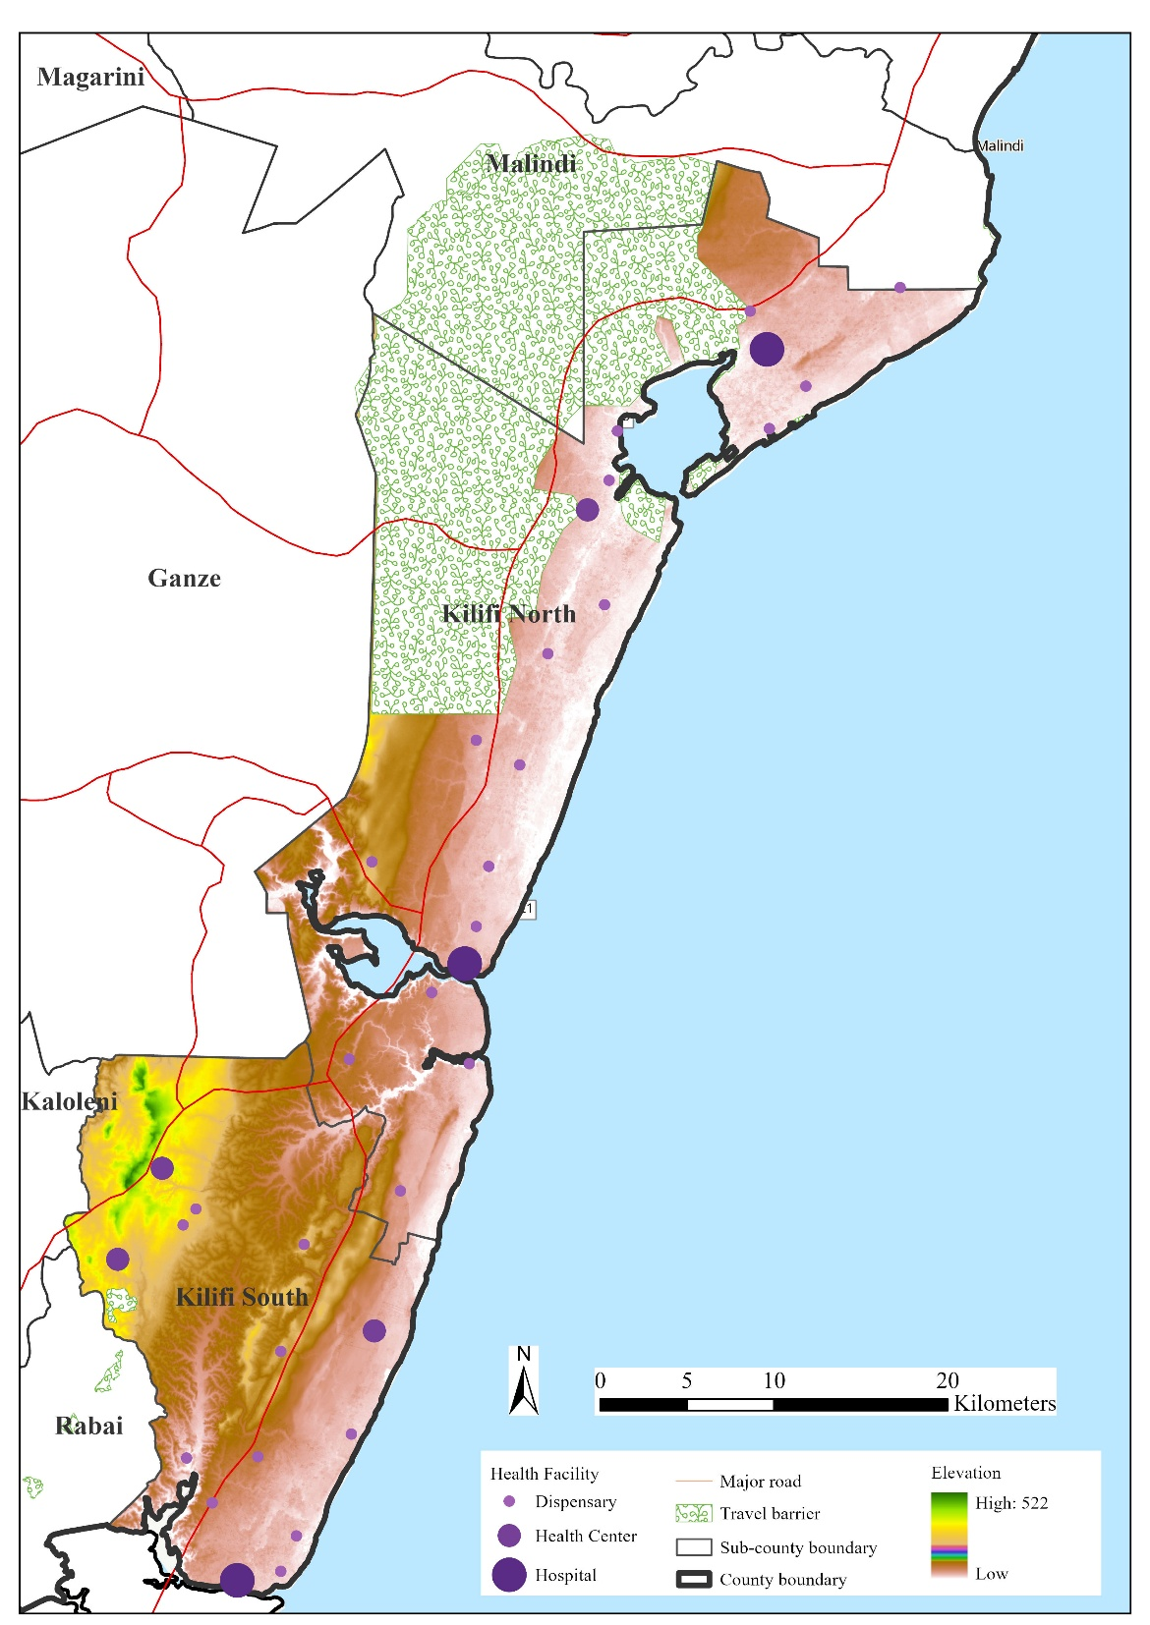
Figure A1 Map of Kilifi North and Kilifi South sub-counties, Kilifi County

Figure A2 Comparison of weighting approaches for facility readiness

Table A2: Knowledge Score Comparisons by Facility Type
Comparison | Mean Difference | 95% CI | p-value
ANOVA overall | - | - | 0.001
Hospital vs. Dispensary | 1.16 points | 0.42 to 1.89 | <0.001*
Hospital vs. Health Centre | 0.49 points | -0.54 to 1.51 | 0.49
Health Centre vs. Dispensary | 0.67 points | -0.22 to 1.55 | 0.16
*Tukey-adjusted
Table A3: Knowledge by Facility Readiness Status
Readiness Status | n | Mean Score (95% CI) | %Score  (95% CI) | p-value
Not ready (<70%) | 57 | 11.7 (11.4-12.0) | 89.7 (87.3-92.2) | 0.003
Ready (≥70%) | 16 | 12.6 (12.3-13.0) | 97.1 (94.6-99.7) | -

Table A4: Multivariable linear regression analysis of predictors of knowledge score
Knowledge score | Coefficient | Std. Error | p-value | 95% Conf. Interval
Facility type
Dispensary (Ref)
Health Centre | 0.005 | 2.993 | 0.999 | -5.969 - 5.980
Hospital | 3.099 | 3.148 | 0.328 | -3.184 - 9.382
Health worker cadre
Nursing Officer (Ref)
Clinical Officer | 8.970 | 2.508 | 0.001 | 3.965 - 13.975
Medical Officer | 9.339 | 4.546 | 0.044 | 0.266 - 18.412
Consultant Physician | 9.339 | 4.471 | 0.058 | -0.339 - 19.017
Constant | 87.562 | 4.849 | 0.000 | 85.276 - 89.849

Table A5: Mixed effects model accounting for facility clustering
Knowledge score | Coefficient | Std. Error | p-value | 95% Conf. Interval
Facility type
Dispensary (Ref)
Health Centre | 0.030 | 3.045 | 0.992 | -5.939 - 5.998
Hospital | 3.180 | 3.237 | 0.326 | -3.164 - 9.523
Health worker cadre
Nursing Officer (Ref)
Clinical Officer | 8.724 | 2.335 | 0.000 | 4.147 - 13.301
Medical Officer | 9.225 | 4.132 | 0.026 | 1.125 - 17.323
Consultant Physician | 9.390 | 4.471 | 0.036 | 0.626 - 18.153
Constant | 87.631 | 1.152 | 0.000 | 85.374 - 89.889

Reference
1. Oyando R, Kagwanja N, Diallo BA, Hassan S, Badjie J, Lucinde R, et al. Access to hypertension services and health-seeking experiences in rural Coastal Kenya: A qualitative study. PLOS Global Public Health. 2025;5(11):e0004324.

