Supplementary Information 1. Response and selected explanatory variables used in this study

Variables | Type | Units | Descriptions
GWL | Response | cm | Groundwater level (depth to water table), averaged to biweekly course
Precip_raw | Explanatory/ predictor; dynamic | mm | Current biweekly- summed precipitation
Precip_raw_lag1 | Explanatory/ predictor; dynamic | mm | Precipitation from the previous biweekly period
Precip_raw_lag2 | Explanatory/ predictor; dynamic | mm | Precipitation from two previous biweekly periods
Precip_cum_lag2 | Explanatory/ predictor; dynamic | mm | Cumulative precipitation of the current and two previous biweekly periods
S_raw | Explanatory/ predictor; dynamic | mm | Current biweekly partial storage (LO + S = P – ET)
S_raw_lag1 | Explanatory/ predictor; dynamic | mm | S from the previous biweekly period
S_raw_lag2 | Explanatory/ predictor; dynamic | mm | S from two previous biweekly periods
S_cum_lag1 | Explanatory/ predictor; dynamic | mm | Cumulative S of the current and previous biweekly period
S_cum_lag2 | Explanatory/ predictor; dynamic | mm | Cumulative S of the current and two previous biweekly periods
SM_raw | Explanatory/ predictor; dynamic | %v/v | Current biweekly-averaged soil moisture (SM)
SM_raw_lag1 | Explanatory/ predictor; dynamic | %v/v | SM from the previous biweekly period
SM_raw_lag2 | Explanatory/ predictor; dynamic | %v/v | SM from two previous biweekly periods
Peat_thick | Explanatory/ predictor; static | m | Peat thickness (or depth of peat layer)
Eucl_dist_ar | Explanatory/ predictor; static | m | Euclidean distance to the nearest natural streams
Filled_surf | Explanatory/ predictor; static | masl | Surface elevation after depression-filling
Filled_subsurf | Explanatory/ predictor; static | masl | Subsurface elevation (mineral soil below peat layer; surface elevation subtracted by peat thickness) after depression-filling (DEM preprocessing)
Slope_surf | Explanatory/ predictor; static | rad | Slope derived from filled surface DEM
Slope_subsurf | Explanatory/ predictor; static | rad | Slope derived from filled subsurface DEM
Coast | Explanatory/ predictor; static | m | Euclidean distance to the nearest coastline
Season_dummy | Explanatory/ predictor; Time-derived hot-encoded-dummy | - | Binary (0, 1); 1 for dry season, 0 for rainy season
Year_2019 | Explanatory/ predictor; Time-derived hot-encoded-dummy | - | Binary (0, 1); 1 for year 2019, 0 for else
Year_2020 | Explanatory/ predictor; Time-derived hot-encoded-dummy | - | Binary (0, 1); 1 for year 2020, 0 for else
Year_2021 | Explanatory/ predictor; Time-derived hot-encoded-dummy | - | Binary (0, 1); 1 for year 2021, 0 for else
Year_2022 | Explanatory/ predictor; Time-derived hot-encoded-dummy | - | Binary (0, 1); 1 for year 2022, 0 for else
Year_2023 | Explanatory/ predictor; Time-derived hot-encoded-dummy | - | Binary (0, 1); 1 for year 2023, 0 for else
Year_2024 | Explanatory/ predictor; Time-derived hot-encoded-dummy | - | Binary (0, 1); 1 for year 2024, 0 for else
Year_2025 | Explanatory/ predictor; Time-derived hot-encoded-dummy | - | Binary (0, 1); 1 for year 2025, 0 for else
Supplementary Information 2. Land use change in PHU Pulau Rupat during study period
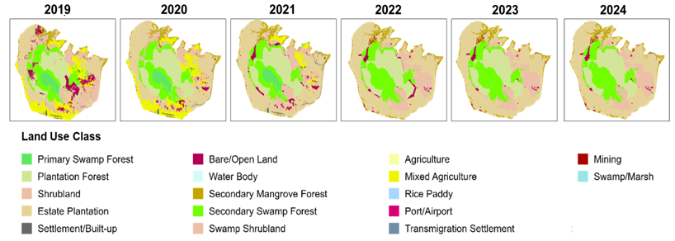

Landuse | Area (ha)
Landuse | 2019 | 2020 | 2021 | 2022 | 2023 | 2024
Secondary Swamp Forest | 16,582.25 | 17,614.50 | 16,177.25 | 20,993.50 | 20,921.50 | 20,899.50
Secondary Mangrove Forest | 560.00 | 603.25 | 726.75 | 806.50 | 806.50 | 806.00
Primary Swamp Forest | 4,151.50 | 4,149.25 | 4,144.25 | - | - | -
Plantation Forest | 16,338.75 | 20,809.50 | 20,247.50 | 19,307.25 | 20,506.25 | 20,506.25
Shrubland | - | 5.50 | 5.50 | - | - | -
Swamp Shrubland | 14,727.25 | 6,814.25 | 10,401.75 | 16,396.00 | 16,216.00 | 16,216.00
Estate Plantation | 15,077.50 | 22,043.50 | 27,088.25 | 26,124.00 | 26,124.00 | 26,124.50
Mixed Agriculture-Shrubland | 11,578.75 | 11,651.50 | 3,381.50 | - | - | -
Bare/Open Land | 6,718.00 | 1,934.75 | 3,436.00 | 2,280.50 | 1,333.50 | 1,355.50
Swamp/Marsh | 141.75 | 143.75 | 134.50 | - | - | -
Total | 85,875.75 | 85,769.75 | 85,743.25 | 85,907.75 | 85,907.75 | 85,907.75
Note: land use classes within study period of early 2025 (Jan-Apr) were assumed same as in 2024.

Supplementary Information 3. Rs-GWL response curve equations used in this study (derived from ^{14,15})

Factor | Equation | Valid Range (cm) | R²
General | Rs = $117.06-\frac{70.91}{1 +\exp{(-0.10 \left(GWL + 75.78\right))}}$ | −120 ≤ GWL ≤ +10 | 0.49
LU-Based
Primary Forest* | Rs =$exp⁡\left(\frac{3.61}{1 + \exp\left((30.7 \left(\frac{GWL}{100} - 1\right)\right)}+\frac{0.33}{1 + \exp\left(103\left(\frac{GWL}{100} + 0.06\right)\right)}\right)$ | −80 ≤ GWL ≤ +10 | 0.85
Secondary Forest | Rs = 46.1423 − 0.2393 $×$ GWL $×$0.00524 $×$ GWL² | −80 ≤ GWL ≤ −30 | -
Forest Plantation | Rs = 96.9625 − 1.1780 $×$GWL + 0.01425 $×$ GWL² | −110 ≤ GWL ≤ −50 | -
Estate Plantation | Rs = 0.0151$×$ GWL² − 0.7904$×$GWL + 52.263 | -80 ≤ GWL ≤ 0 | 0.49
Agriculture and other land uses | Rs = 25.9822 − 1.5543 $×$GWL − 0.00946$×$GWL² | -90 ≤ GWL ≤ 0 | -
Note: *CO₂-GWL response curve for primary forest is selected from ⁵²

Supplementary Information 4. Uncertainty (upper: SD and lower: SE) of GWL predictions
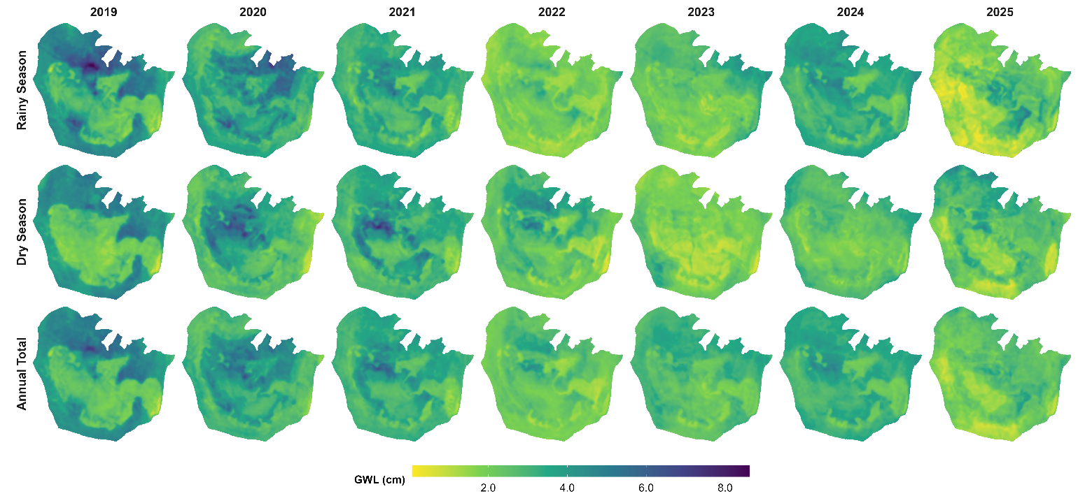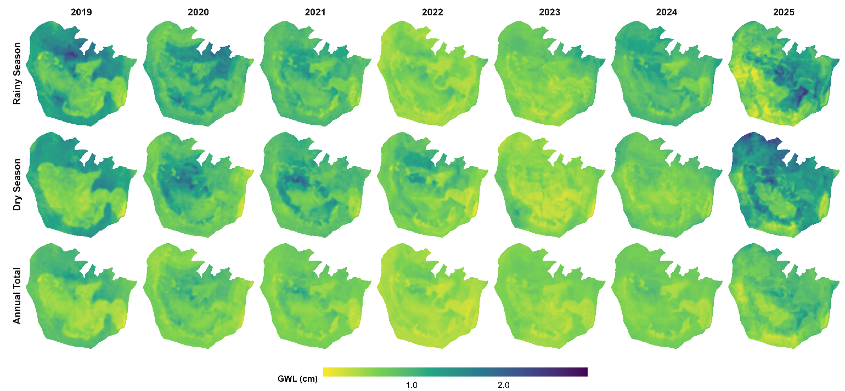

Supplementary Information 5. Uncertainty (upper: SD and lower: SE) of Rs predictions based on Rs-GWL general equation¹⁵
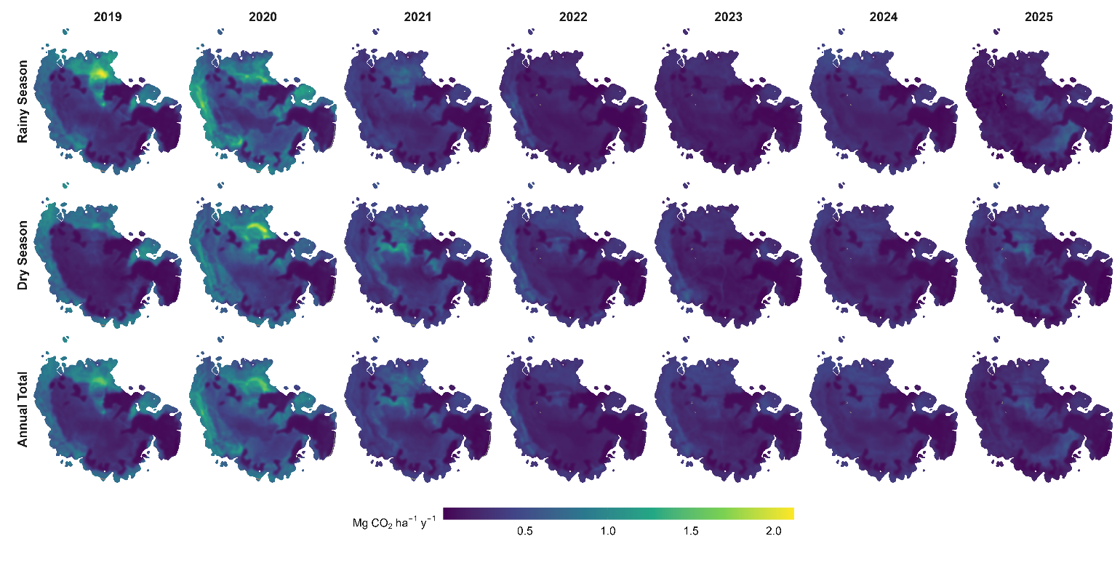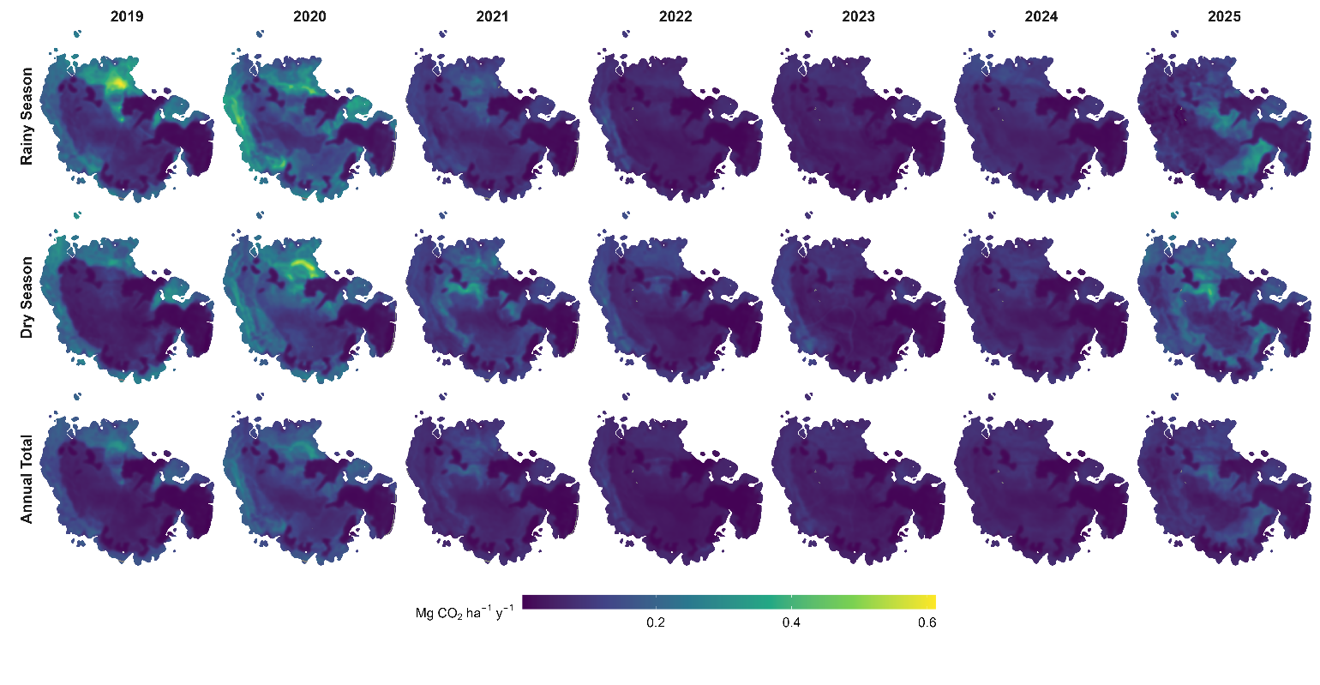

Supplementary Information 6. Uncertainty (upper: SD and lower: SE) of Rs predictions based on land use-based Rs-GWL¹⁴

