Repurposed smart tuna-fishing buoys provide real-time ocean intelligence for ecological and blue economy applications

Mario Lebrato^{1,2,*}, Kathryn Gavira-O’Neill³, Teresa Losada³, Alvaro Bravo⁴, Nelson Nhamussua^{1,2}, Maria da Graça^{1,2}, Mauro Jije^{1,2}, Ekaterina Kalashnikova^{1,2}, and Calum Murie⁵

¹ BCSS Ocean Observatory. Bazaruto Center for Scientific Studies (BCSS), Benguerra Island, Mozambique.
² Kisawa Sanctuary. Benguerra Island, Mozambique.
³ Satlink S.L. Alcobendas, Madrid, Spain
⁴ Universal Plastic (UP). Scientific Technology Park (Gijon), Asturias, Spain.
⁵ Underwater Africa, Inhambane, Mozambique.

Keyword: tuna-fishing, smart buoys, blue economy, ecosystem monitoring, biomass, biodiversity

*Corresponding Author:
Address: BCSS Ocean Observatory. Bazaruto Center for Scientific Studies (BCSS), Benguerra Island, Mozambique.
E-mail: mario.lebrato@bcssmz.org
Telephone: +34 610 67 77 42

Supplementary materials
Text S1. Blue economy design for smart-buoy systems. Supplementary details outlining the conceptual and operational integration of smart-buoys with complementary scientific technologies (e.g., hydrophones, benthic landers/cameras, and diver-based surveys) to support real-world applications in blue economy sectors. The framework enables ecosystem monitoring, verification of conservation interventions, and climate adaptation strategies. This text expands upon the system illustrated in Figure 6.

Modular smart-buoy ecosystem observatory framework for blue economy applications

1. Overview
This framework proposes an integrated, fixed-point/drifting observatory system designed to monitor, verify, and support marine ecosystem recovery and intervention assessments. It scales from local deployments (e.g., individual sites/reef, MPAs) to regional and global observatory networks, providing critical data for the blue economy, marine conservation, and climate policy.

2. Core System Components
Each observatory node includes the following interoperable technologies:
Component | Function
Smart-buoy | Real-time telemetry of biomass and ocean/weather data
Hydrophone | Passive acoustic monitoring of marine mammals, soundscapes, and anthropogenic noise
Benthic Lander + Camera | Time-lapse or event-triggered seafloor imagery for biomass dynamics, substrate changes, and species presence
Scuba Surveys | Ground-truthing of biomass structure, habitat complexity, biodiversity

3. Observational Outputs
The system delivers high-resolution (hourly to daily), multiscale time-series datasets per site/habitat/ecosystem/region:
- Total biomass and biodiversity metrics.
- Acoustic detection of marine mammal species (biodiversity) and soundscape profiling.
- Species identification (biodiversity) and habitat structure.
- Environmental (ocean/weather) metrics.
4. Functional Applications
The observatory supports both scientific research and operational policy in the following domains:
- Ecological Applications
- Ecosystem recovery monitoring
- Marine Protected Area (MPA) performance.
- Coral, mangrove, and seagrass restoration.
- Fisheries closure or regulation assessments.
- Climate change adaptation in marine systems.

- Blue Economy/Governance Applications
- Verification for blue bonds & conservation finance.
- Supply/Demand-side verification (accountability, investor trust).
- Marine spatial planning (MSP).
- ESG-aligned investment & biodiversity crediting.
- Industry and coastal infrastructure risk analysis.
- Open-data and SDG-aligned ocean accounting.

5. Scaling Logic
The same modular observatory unit can be deployed at:
- Local scale: individual sites, habitats/ecosystems.
- Regional scale: island chains, shelf systems, national parks/MPAs.
- Global scale: observatory networks across EEZs or ocean basins, open-ocean, fisheries arrays.

6. Ecosystem Targets
This system is especially suitable for:
- Coral reefs, seagrass, mangroves, open-ocean.
- Seamounts, pinnacles, submarine plateaus.
- Coastal MPAs, endangered species habitats.
- Areas under restoration or policy protection.

7. Key Benefits
- Scientific: Time-series biomass/biodiversity baselines, recovery tracking.
- Economic: Verified blue finance, ESG impacts, sustainable resource management.
- Policy: Supports SDG 14, Kunming-Montreal GBF, TNFD reporting frameworks, and climate adaptation strategies.
- Technology: Combines real-time sensing with scalable cloud-data architecture.

8. End-use sectors (science/economy/policy)
- Fisheries management.
- Tourism impact monitoring.
- Biodiversity offsets.
- Blue Bonds verification.
- Coastal development risk forecasting.

9. Summary
The modular smart-buoy observatory system is a scalable, multidisciplinary system that provides continuous ecological intelligence for marine conservation and blue economy innovation. By integrating sensor technologies and ecological assessment tools into a unified platform, it bridges the gap between marine science, policy, and sustainable finance.

Figure S1. Satlink software platform interface and smart-buoy deployments in the field. The Satlink control panel displays the real-time position of a smart-buoy during a fixed-point station deployment cycle over a coral reef, alongside live-streamed biomass time-series data derived from echo-sounder readings. Data are transmitted via satellite to Satlink headquarters and simultaneously integrated into the BCSS Ocean Observatory platform. Also shown are fieldwork photographs documenting buoy deployments and dive surveys conducted to assess megafauna biomass structure and species diversity across habitat types.

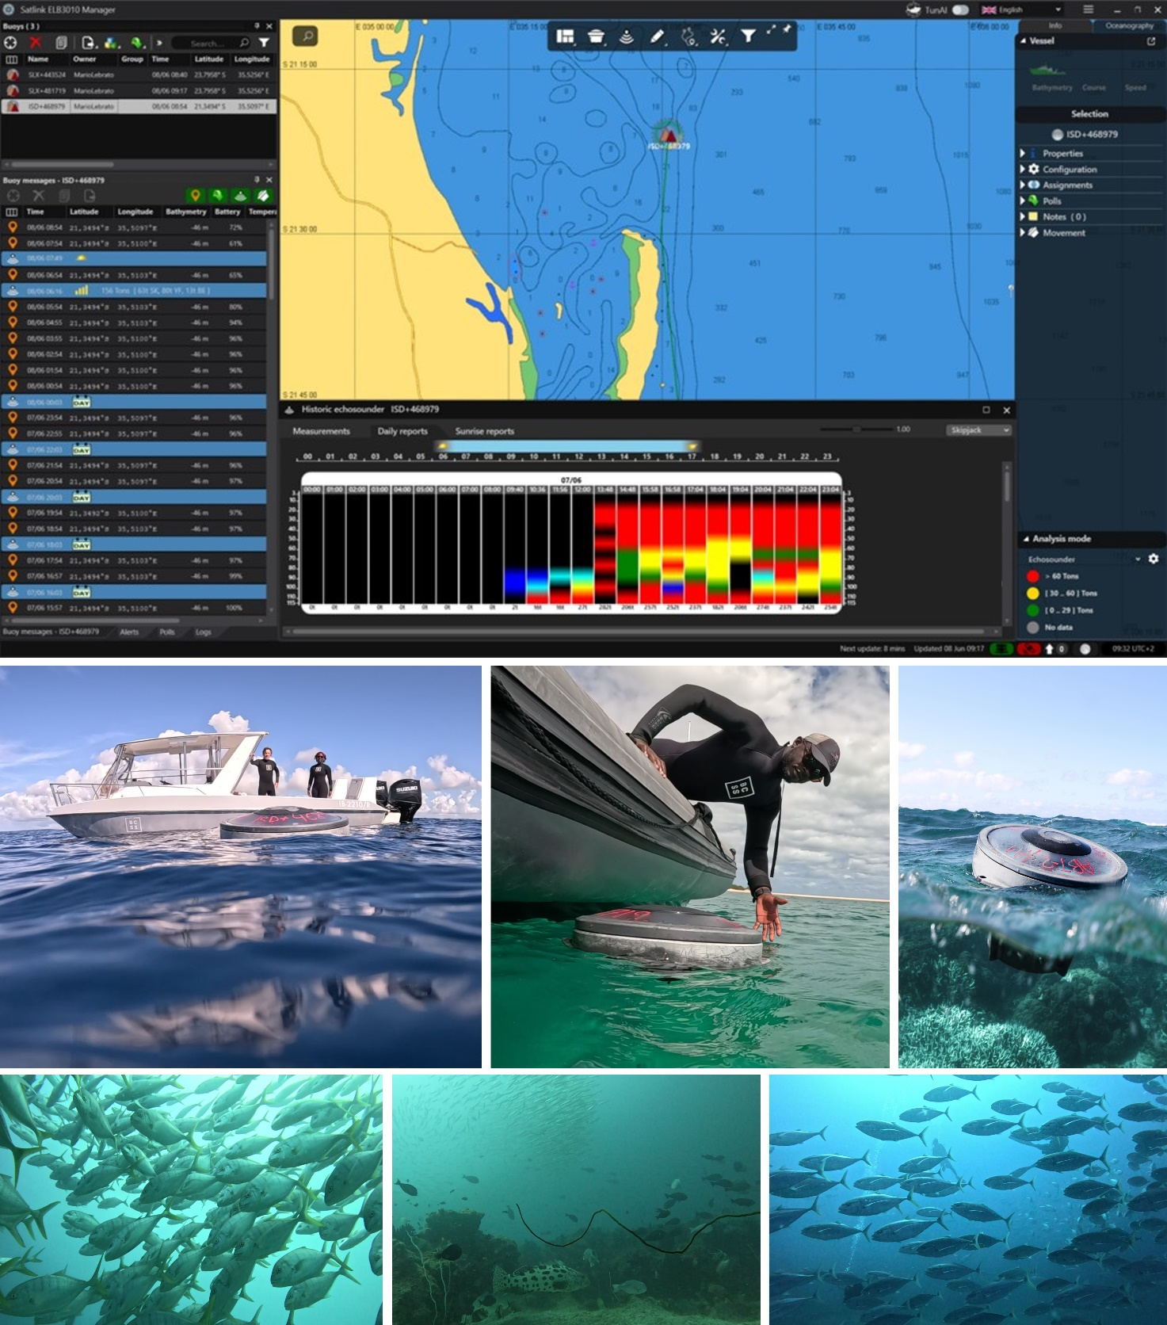

Figure S2. Ecological metrics across sites and status categories. (A) Violin plots of six ecological metrics across the four study sites. Points show medians with interquartile ranges. (B) Effect size estimates comparing “healthy” vs. “overfished” sites for each metric. (C) Heatmap of site-level medians per metric per site.
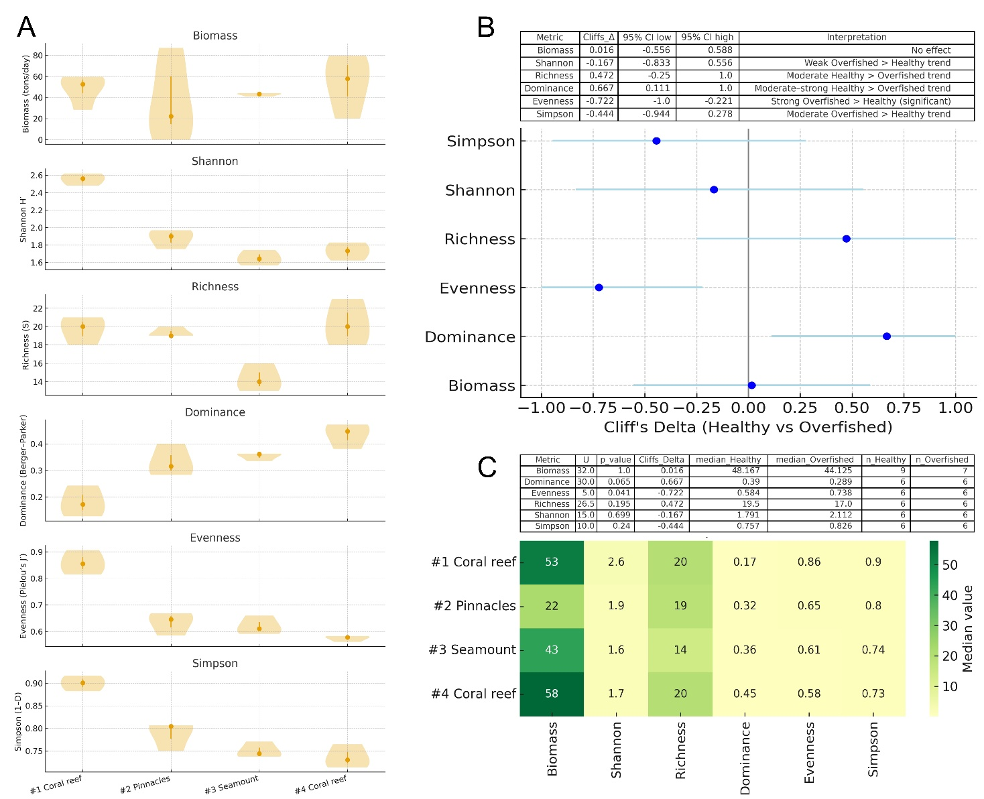

Tables S1. Smart-buoy operational details in the Bazaruto Archipelago. Details of environmental (ocean/weather) time-series data, fixed-point deployments (moorings), drifts (grid around the fixed-point), and scuba diving surveys. All datasets are available at the BCSS Ocean Observatory repository (https://bcssmz.org/) with DOI links https://doi.org/10.82174/bcssmz.ocean.observatory.data.access/ and https://doi.org/10.82174/bcssmz.ocean.observatory.data.repository/.
