Supplementary Information for

Electrically Controlled Spatial Light Modulator for Ultrawideband Hyperspectral Terahertz Single-Pixel Imaging
Xudong Liu¹, Wenjing Ma², Chenyu Wang³, Chuanfu Sun³, Yu Liao³, Emma Pickwell-MacPherson⁴, Xiaoyu Weng¹¶, Junle Qu¹#, Songlin Zhuang⁵ & Yiwen Sun¹*
¹Key Laboratory of Optoelectronic Devices and Systems of Ministry of Education and Guangdong Province, College of Physics and Optoelectronics Engineering, Shenzhen University, Shenzhen, 518060, China
²National Engineering Laboratory for Big Data System Computing Technology, Shenzhen University, Shenzhen 518060, China
³Department of Biomedical Engineering, School of Medicine, Shenzhen University, Shenzhen 518060, China
⁴Department of Physics, University of Warwick, Coventry CV4 7AL, United Kingdom
⁵School of Optical-Electrical and Computer Engineering, University of Shanghai for Science and Technology, Shanghai, China
¶xiaoyu@szu.edu.cn, #jlqu@szu.edu.cn, *ywsun@szu.edu.cn

- Structure details of the terahertz spatial light modulator (THz-SLM)
This device comprises a planar array of subwavelength microslit elements fabricated on epitaxial n-doped GaAs, grown on a semi-insulating GaAs substrate. Each pixel of the terahertz SLM consists of a 3$×$3 mm² area with 375 grating periods, as illustrated in Fig. S1. The microslit elements feature a 200-nm-thick gold layer, a 6 μm width, and a 2 μm gap spacing. These elements are connected via a contact pad, functioning as a metallic Schottky gate. An external voltage bias modulates the charge carrier density in the substrate near the microslit gaps, enabling tunable absorption of terahertz waves. The THz SLM is configured as a ​10×10 array, with each pixel independently controlled by an external voltage applied between the Schottky contact and the ohmic contact.
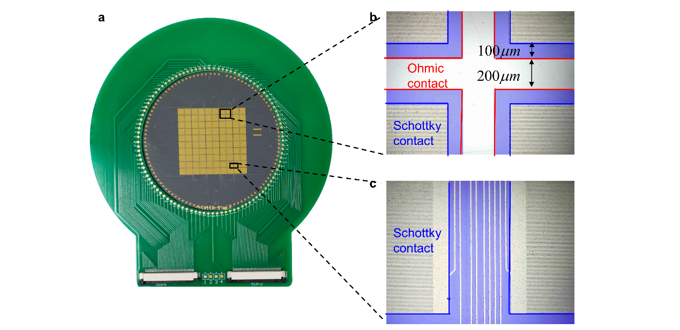
Fig. S1 Photograph and microscopy image of the fabricated THz-SLM. Each pixel contains gold microslits functioning as Schottky contacts. These microslits were individually connected to an external voltage source, enabling independent pixel control. Gold stripes, acting as ohmic contacts, are positioned between the pixels and share a common 5 V electrode.
2. Voltage control circuit board
The MCU delivers control signals to the shifter register (74LVX595) via GPIO ports. These signals drive the 100 MOSFETs and corresponding LEDs, with the LEDs providing real-time visual feedback on the pixel switching status for monitoring spatial encoding patterns of the THz-SLM. The MOSFET outputs are routed through two 50-pin FPC connectors, which interface with the THz-SLM adapter board via FPC cables to regulate individual pixel states.
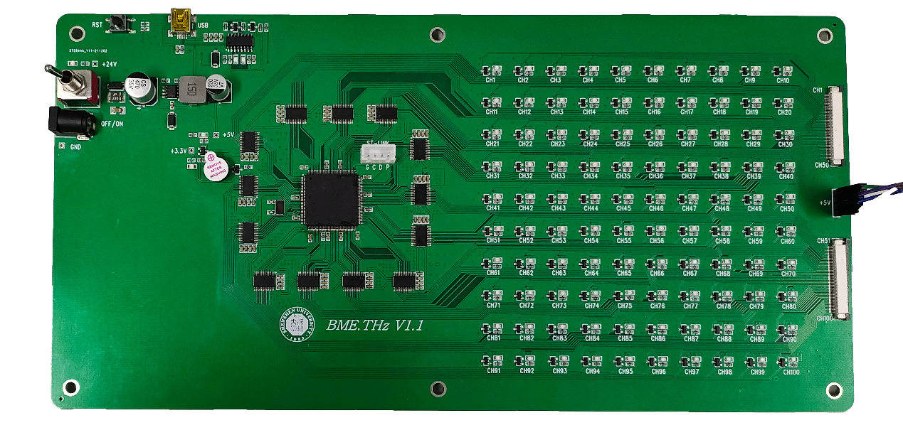
Fig. S2 Photograph of the voltage control circuit board.
3. Operational frequency of the THz-SLM
The modulation speed of the THz-SLM depends on the conductivity variation frequency in the n-GaAs layer. This parameter can be indirectly characterized by measuring terahertz wave transmittance changes under square-wave voltage excitation at different frequencies. Fig. S3a and S3b illustrate the experimental setup for speed measurement. In the experiment, the optical delay line was fixed at the time-domain signal peak position (corresponding to the maximum terahertz pulse electric field) to optimize detection signal-to-noise ratio. A control circuit generated square-wave driving signals (0-5 V amplitude, 50% duty cycle) with frequencies ranging from 1 Hz to 20 kHz, synchronously switching all THz-SLM pixels. The terahertz detector output was recorded using an oscilloscope (Tektronix TBS 1072B) configured in rising-edge trigger mode to ensure precise synchronization with the driving signal. At each driving frequency, the oscilloscope-captured output voltage waveforms were recorded. The raw experimental data corresponding to the fitted results in Figure 3d are presented in Fig. S3c-S3f.
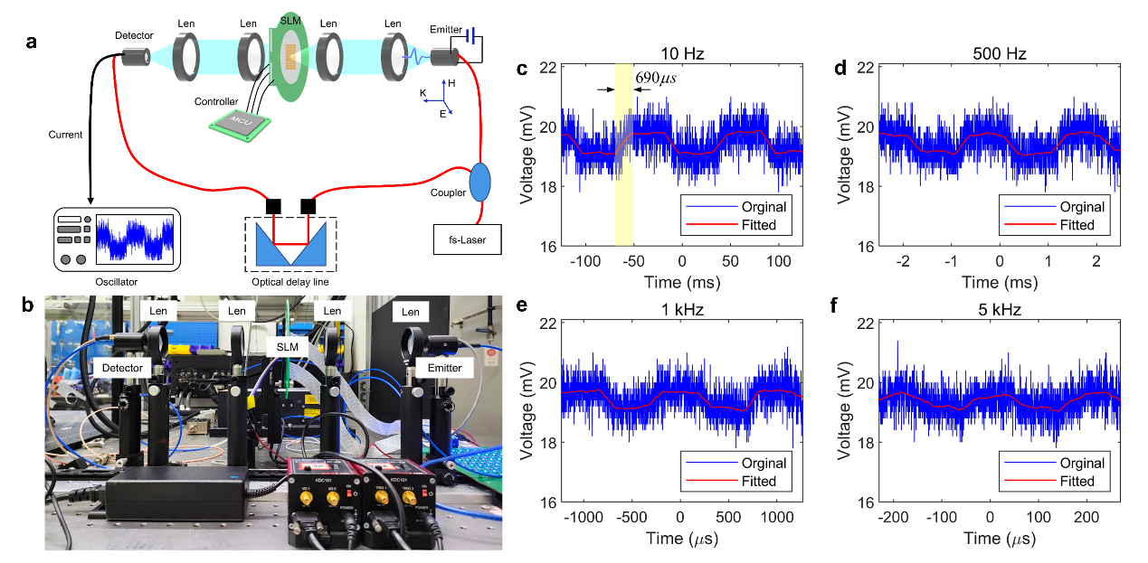
Fig. S3 Modulation speed measurement and fitting. a and b are schematic and experimental setup of the modulation speed measurement system. c-f are modulated terahertz beam signals under 0-5 V square-wave driving at 10 Hz, 500 Hz, 1 kHz and 5 kHz, with red curves showing the fitted results.
4. ​Ordering of Hadamard basis patterns: a diagonal path approach
The ordering of Hadamard patterns significantly impacts reconstruction quality, with the most significant patterns sampled first. This approach stems from the observation that patterns yielding higher measured intensities contribute more substantially to image reconstruction, warranting their prioritized acquisition ¹. Drawing from the sequence-ordered 2D Hadamard transform spectrum of natural images, we note that low-sequency regions consistently exhibit larger amplitudes than their high-sequency counterparts. As Fig. S5 demonstrates, Hadamard-transformed images show strong energy concentration in the upper-left quadrant, corresponding to low-sequency basis patterns. This energy distribution parallels the frequency-domain characteristics of Fourier transforms while maintaining the unique sequency ordering specific to Walsh-Hadamard systems. The Hadamard spectrum comprises a group of Hadamard coefficients that can be obtained by a single-pixel detector. The sequence of a Hadamard coefficient is defined as the number of sign changes in its basis pattern ². Downsampling can be achieved by first obtaining the Hadamard coefficients corresponding to the low-frequency area. The observed energy compaction (Fig. S5) enables efficient downsampling by initially acquiring coefficients from low-sequency regions. Notably, these coefficients align precisely with measurements obtained when using the Hadamard matrix as the measurement matrix in compressed sensing frameworks.
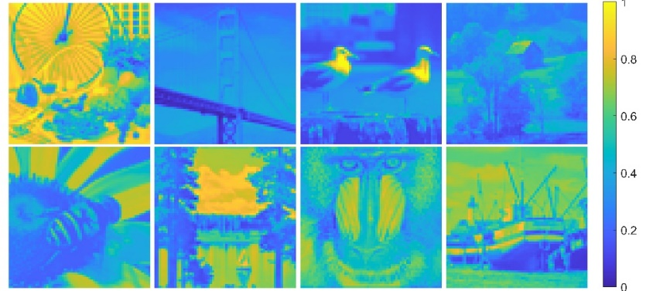
Fig. S4 Standard grayscale test images used for analysis the robustness of Diag order. All the images were resized to 64×64. The colormap is parula.
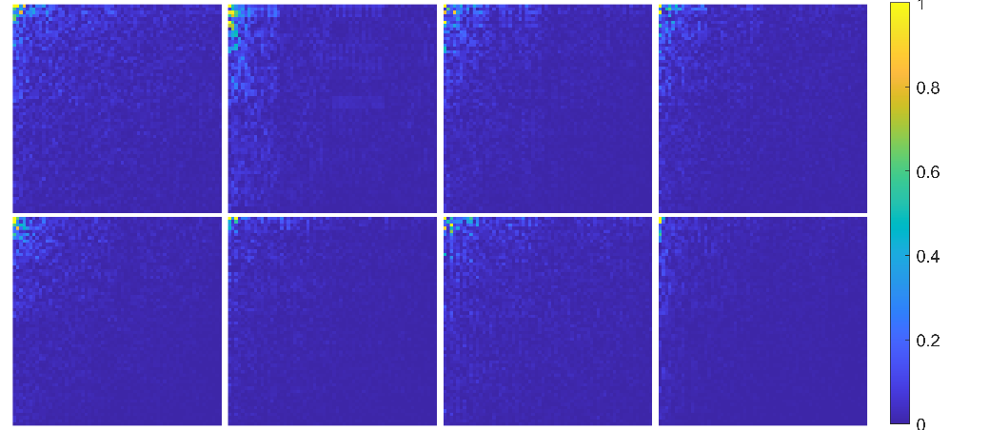
Fig. S5 Test images show strong energy compaction in the upper-left quadrant of their Hadamard-Walsh transforms, confirming preferential low-sequency energy distribution.

Table. S1 Pseudo-code for Hadamard matrix construction based on diagonal scanning.
Algorithm 1: Direct Hadamard generation based on diag scanning order
Input: Image resolution N (N is a power of 2)
Output: Hadamard basis pattern sequence {H_k(x,y)} generated in Diag order
1 | // Step 1: Generate coordinate sequence for Diag scanning path
2 | scan_order = generate_Diag_order(N)
3 | // Step 2: Directly generate basis patterns in Diag order
4 | base_patterns = [ ]
5 | for each (i, j) in scan_order do
6 | // Generate the unit impulse function δ_ij
7 | δ = zeros(N,N) // Initialize an N×N matrix
8 | δ[i, j] = 1 // Set impulse at position (i,j)
9 | // Perform inverse Walsh-Hadamard transform to generate basis pattern
10 | H_k = inverse_walsh_Hadamard(δ)
11 | base_patterns.append(H_k) // Store in Diag order
12 | end for
13 | return base_patterns

Table. S2 Pseudo-code for diagonal scanning path generation.
Algorithm 2: Function generate_Diag_order(N):
Input: Image resolution N (N is a power of 2)
Output: Scanning path coordinate sequence {scan_order} = [(i, j)]
1 | scan_order = [ ];
2 | for d = 1 to 2*N-1:
3 | if d <= N:
4 | start_i, start_j = 1, d
5 | else:
6 | start_i, start_j = d-N+1, N
7 | i, j = start_i, start_j
8 | while i <= N and j >= 1:
9 | scan_order.append((i, j))
10 | i += 1
11 | j -= 1
12 | return scan_order

To evaluate the advantage of our proposed method, we benchmark it against conventional Hadamard orders commonly used in terahertz and compressed sensing (CS) imaging: Natural order ⁵, Paley order ⁶, Walsh order ⁵, Cake-Cutting (CC) order ⁷. As demonstrated in Fig. S6 showing the averaged absolute measuement distributions across eight test images, the Natural sequence preserves the original Hadamard matrix construction, yielding randomly distributed measurement magnitudes that compromise compressed sampling efficiency. While both Paley and Walsh sequences show significant front-loading improvements over the Natural baseline, their energy distributions remain dispersed across full sequency bands. In contrast, the CC and proposed Diag sequences achieve optimal energy compaction without requiring prior target information, creating an ideal observational framework for efficient CS reconstruction.
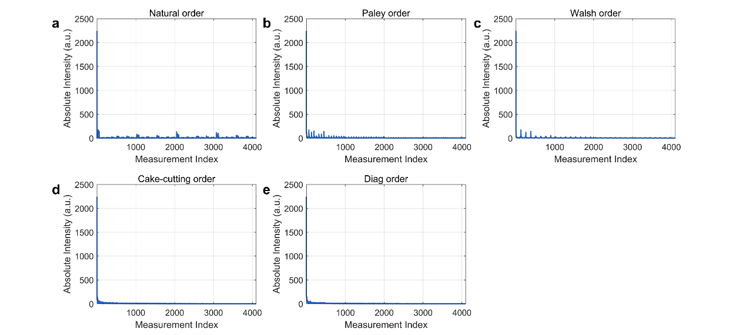
Fig. S6 Comparison of measurement sequences under different ordering schemes. a. Natural ordering; b. Paley ordering; c. Walsh ordering; d. Cake-cutting ordering; e. Diag ordering.
Since peak signal-to-noise ratio (PSNR) serves as a key metric for assessing reconstructed image quality in CS imaging, we calculated it using the following expression:
,
where m represents the bit-width of the pixel, the MSE (mean square error) represents the mean square error between reconstructed and actual imaging object data, which can be expressed as:
,
where n represents the number of pixels of the image, x_{j} denotes the pixel value of the original object image, and y_{j} represents the pixel value of the corresponding reconstructed image. The PSNR is a metric of similarity, the smaller the MSE, the larger the PSNR value, indicating higher image similarity.
Systematic validation across noise conditions (noiseless, 0 dB, and −10 dB) in Figs. S7-S9 demonstrates that the proposed Diag ordering consistently achieves the highest average PSNR at 20% sampling rates among all compared methods. In noiseless and 0 dB weak-noise scenarios (Figs. S7-S8), all ordering methods show monotonic PSNR improvement with increasing sampling rates (20-100%), confirming enhanced detail recovery through additional high-frequency measurements. However, under −10 dB strong noise (Fig. S9), a critical divergence emerges: while Natural/Paley/Walsh orders maintain gradual PSNR gains, both CC and Diag exhibit slight quality degradation beyond 40% sampling. This phenomenon stems from their intrinsic energy compaction-while optimally concentrating dominant signals in early measurements, exceeding 40% sampling introduces noise-dominated high-sequency components. When cumulative noise energy surpasses attenuated signal strength in these higher-index measurements, reconstruction fidelity deteriorates despite increased sampling. The Diag ordering's advantage in strong-noise/low-rate regimes (−10 dB, 20-40% sampling) directly results from its energy-frontloaded sequence that prioritizes high-SNR component acquisition before noise accumulation dominates subsequent measurements.
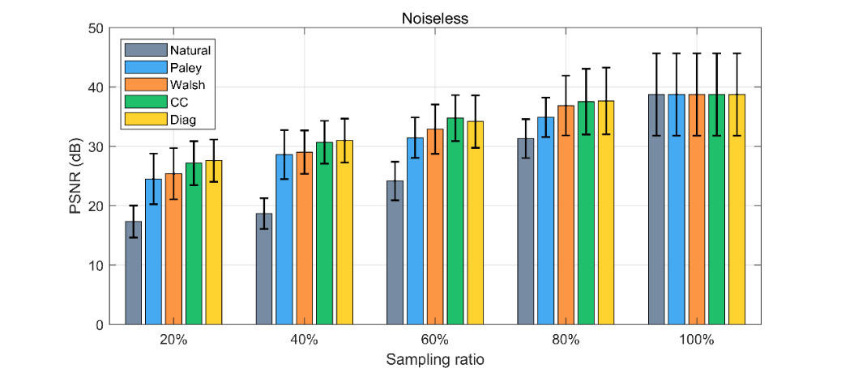
Fig. S7 The quantitative analysis results of image reconstruction using different sorting methods at various sampling rates under noiseless conditions.
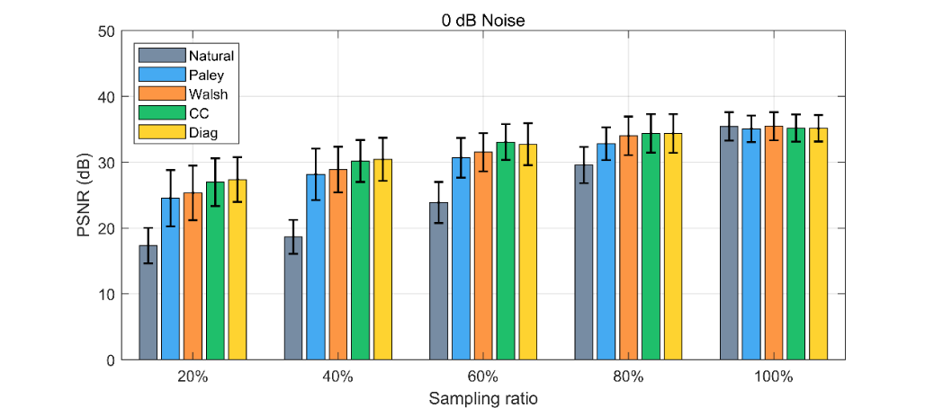
Fig. S8 The quantitative analysis results of image reconstruction using different sorting methods at various sampling rates under 0 dB noise conditions.
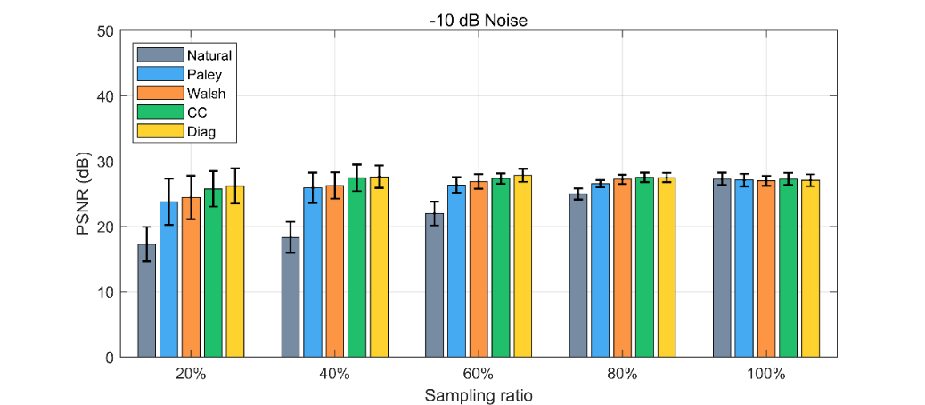
Fig. S9 The quantitative analysis results of image reconstruction using different sorting methods at various sampling rates under -10 dB noise conditions.
5. Image quality assessment (PSNR) from experimental data at varying sampling rates
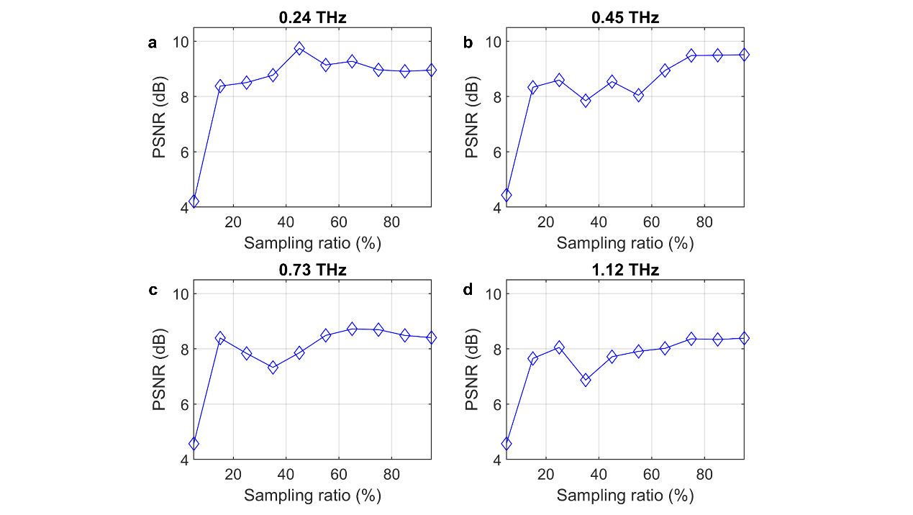
Fig. S10 a-d PSNR of the reconstructed images at 0.24 THz, 0.45 THz, 0.73 THz and 1.12 THz across different sampling ratios.
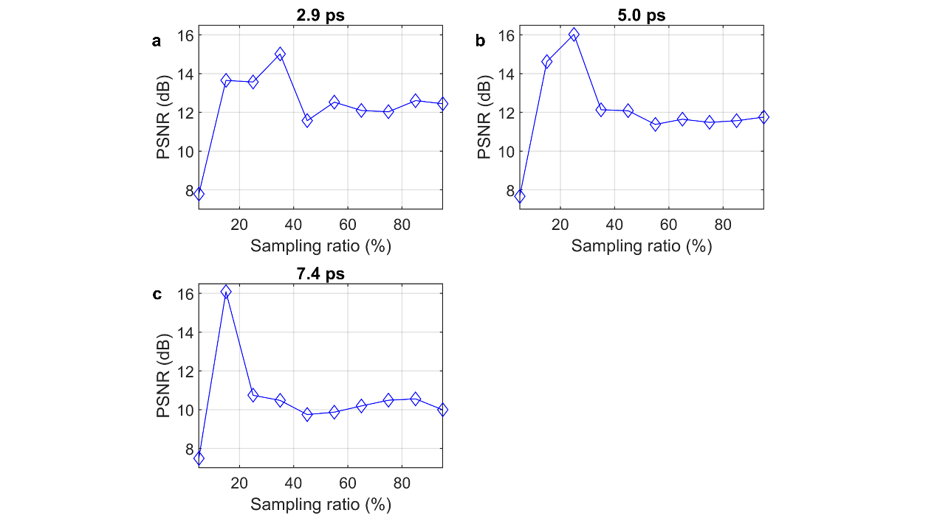
Fig. S11 a-c PSNR of the reconstructed images at 2.9 ps, 5.0 ps and 7.4 ps across different sampling ratios.
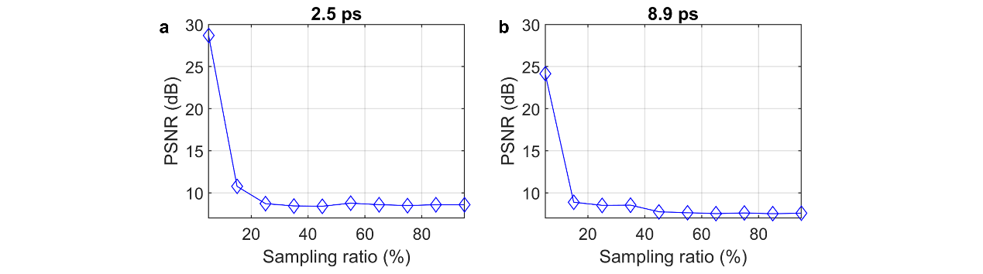
Fig. S12 a and b PSNR of the reconstructed images at 2.5 ps and 8.9 ps across different sampling ratios.

References
1 Radwell, N. et al. Single-pixel infrared and visible microscope. Optica 1, doi:10.1364/optica.1.000285 (2014).
2 Pratt, W. K., Kane, J. & Andrews, H. C. HADAMARD TRANSFORM IMAGE CODING. Proc. IEEE 57, 58-&, doi:10.1109/proc.1969.6869 (1969).
3 Li, C., Yin, W., Jiang, H. & Zhang, Y. An efficient augmented Lagrangian method with applications to total variation minimization. Comput. Optim. Appl. 56, 507-530, doi:10.1007/s10589-013-9576-1 (2013).
4 Geadah, Y. A. & Corinthios, M. J. G. NATURAL, DYADIC, AND SEQUENCY ORDER ALGORITHMS AND PROCESSORS FOR WALSH-HADAMARD TRANSFORM. IEEE Trans. Comput. 26, 435-442 (1977).
5 Vaz, P. G., Amaral, D., Requicha Ferreira, L. F., Morgado, M. & Cardoso, J. Image quality of compressive single-pixel imaging using different Hadamard orderings. Opt Express 28, 11666-11681, doi:10.1364/OE.387612 (2020).
6 Stantchev, R. I., Yu, X., Blu, T. & Pickwell-MacPherson, E. Real-time terahertz imaging with a single-pixel detector. Nat Commun 11, 2535, doi:10.1038/s41467-020-16370-x (2020).
7 Yu, W. K. Super Sub-Nyquist Single-Pixel Imaging by Means of Cake-Cutting Hadamard Basis Sort. Sensors (Basel) 19, doi:10.3390/s19194122 (2019).

