The supplementary information includes:
Figure S1. Characterization and functional validation of hESC-EVs..
Table S1. Real-time quantitative PCR primers.
Table S2. Oligonucleotide sequences and constructs for PTX3 modulation.
Table S3. Sequences of miRNA mimics and inhibitors used in this study.
Table S4. Sequences of PTX3 3′UTR constructs used in dual-luciferase reporter assays.
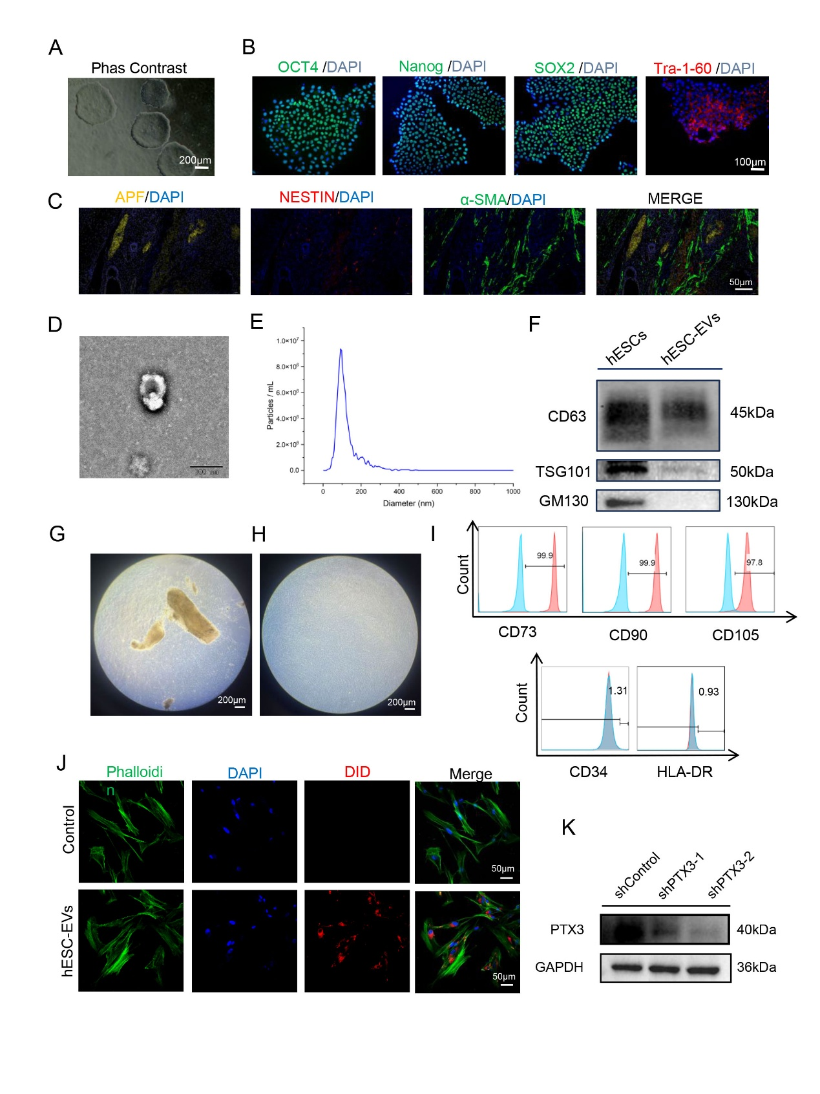
Figure S1. Characterization of hESC-derived extracellular vesicles (hESC-EVs) and recipient human gingival fibroblasts (hGFs). (A)Morphological observation of human embryonic stem cells (hESCs). (B)Immunofluorescence staining showing the expression of hESC markers OCT4, Nanog, Sox2, andTra-1-60 in hESC-EVs. Scale bar = 100 μm. (C)Immunohistochemical staining confirms the multilineage differentiation potential of hESCs.(D)Transmission electron microscopy (TEM) showing the morphology of hESC-EVs. (E)Nanoparticle tracking analysis showing the size distribution of hESC-EVs. (F)Western blot analysis showing the expression of EV markers CD63 and TSG101, and the negative marker GM130 in hESC-EVs. (G) Outgrowth of spindle-shaped cells from a tissue explant after 3 days. Scale bar = 200 μm.(H) Representative morphology of hGFs at day 14, showing a typical fibroblastic spindle shape. Scale bar = 200 μm. (I) Flow cytometric analysis of hGF surface markers. Cells were highly positive for CD105, CD73, and CD90 (≥90%) and negative for CD34 and HLA-DR (≤5%). (J)hGFs were co-cultured with hESC-EVs. DiD-labeled hESC-EVs were taken up by hGFs (green) after 4 h of co-incubation. Scale bar = 50μm. (K)Western blot analysis showing PTX3 protein expression in hGFs transfected with a non-targeting control shRNA (shControl) or one of two different PTX3-targeting shRNAs (shPTX3-1, shPTX3-2).

Supplementary Table S1. Real-time quantitative PCR primers.
Primer | PrimerForward primer(5-3') | Reverse primer (3-5')
a-SMA | TGGAAAAGATCTGGCACCAC | TCCGTTAGCAAGGTCGGATG
COL1 | GAGGGCCAAGACGAAGACATC | CAGATCACGTCATCGCACAAC
Vimentin | GACGCCATCAACACCGAGTT | CTTTGTCGTTGGTTAGCTGGT
GAPDH | ACAACTTTGGTATCGTGGAAGG | GCCATCACGCCACAGTTTC

Supplementary Table S2. Oligonucleotide sequences and constructs for PTX3 modulation.
Name | Target Gene | Sequence (5' to 3') | Vector
Scrambled | Non-targeting control | TTCTCCGAACGTGTCACGT | GV493
shRNA-1 | PTX3 | GCACAAAGAGGAATCCATATG | GV493
shRNA-2 | PTX3 | GGAGAACTCGCAGATGAGAGA | GV493
shRNA-3 | PTX3 | GCTCACATCCTTGTGGGTAAA | GV493
Name | Target Gene | Insert Information | Vector
Vector-Control | - | - | GV492
oeRNA | PTX3  Gene ID=5806 | >NM_002852.4:  ATGCATCTCCTTGCGATTCTGTTTTGTGCTCTCTGGTCTGCAGTGTTGGCCGAGAACTCGGATGATTATG  ATCTCATGTATGTGAATTTGGACAACGAAATAGACAATGGACTCCATCCCACTGAGGACCCCACGCCGTG  CGCCTGCGGTCAGGAGCACTCGGAATGGGACAAGCTCTTCATCATGCTGGAGAACTCGCAGATGAGAGAG  CGCATGCTGCTGCAAGCCACGGACGACGTCCTGCGGGGCGAGCTGCAGAGGCTGCGGGAGGAGCTGGGCC  GGCTCGCGGAAAGCCTGGCGAGGCCGTGCGCGCCGGGGGCTCCCGCAGAGGCCAGGCTGACCAGTGCTCT  GGACGAGCTGCTGCAGGCGACCCGCGACGCGGGCCGCAGGCTGGCGCGTATGGAGGGCGCGGAGGCGCAG  CGCCCAGAGGAGGCGGGGCGCGCCCTGGCCGCGGTGCTAGAGGAGCTGCGGCAGACGCGAGCCGACCTGC  ACGCGGTGCAGGGCTGGGCTGCCCGGAGCTGGCTGCCGGCAGGTTGTGAAACAGCTATTTTATTCCCAAT  GCGTTCCAAGAAGATTTTTGGAAGCGTGCATCCAGTGAGACCAATGAGGCTTGAGTCTTTTAGTGCCTGC  ATTTGGGTCAAAGCCACAGATGTATTAAACAAAACCATCCTGTTTTCCTATGGCACAAAGAGGAATCCAT  ATGAAATCCAGCTGTATCTCAGCTACCAATCCATAGTGTTTGTGGTGGGTGGAGAGGAGAACAAACTGGT  TGCTGAAGCCATGGTTTCCCTGGGAAGGTGGACCCACCTGTGCGGCACCTGGAATTCAGAGGAAGGGCTC  ACATCCTTGTGGGTAAATGGTGAACTGGCGGCTACCACTGTTGAGATGGCCACAGGTCACATTGTTCCTG  AGGGAGGAATCCTGCAGATTGGCCAAGAAAAGAATGGCTGCTGTGTGGGTGGTGGCTTTGATGAAACATT  AGCCTTCTCTGGGAGACTCACAGGCTTCAATATCTGGGATAGTGTTCTTAGCAATGAAGAGATAAGAGAG  ACCGGAGGAGCAGAGTCTTGTCACATCCGGGGGAATATTGTTGGGTGGGGAGTCACAGAGATCCAGCCAC  ATGGAGGAGCTCAGTATGTTTCATAA | GV492

Supplementary Table S3. Sequences of miRNA mimics and inhibitors used in this study.
miRNA Name | Type (Mimic/Inhibitor) | Sequence (5' to 3') | Supplier (Catalog #, if any)
hsa-miR-302a-5p | Mimic | UCGUACGAUCACGUACGAUGUA | Sangon Biotech
hsa-miR-302a -5p | Inhibitor | UACGUACGUGAUCGUACGAUA | Sangon Biotech

Supplementary Table S4. Sequences of PTX3 3′UTR constructs used in dual-luciferase reporter assays
Construct | Sequence (5′→3′) | Note
H_PTX3 3′UTR (hsa-miR-302a-5p) WT | AATTTAAGACTATTTTTGTAAAGCTCTACTGTAAATAAAATATTTTATAAAACTAGCTCACGTCATTTAATTATAAATTTAAGAGA | Predicted miR-302a-5p binding site underlined
H_PTX3 3′UTR (hsa-miR-302a-5p) MT1 | AAGGGCCTCCTATTTTTGTAAAGCTCTACTGTAAATAAAATATTTTATAAAACTAGCTCACGTCATTTAATTATAAATTTAAGAGA | Single mutant 1
H_PTX3 3′UTR (hsa-miR-302a-5p) MT2 | AATTTAAGACTATTTTTGTAAAGCTCTACTGTAAATAAAATATTTTATAAAACTAGCTCACGTCATTTAATTATAAAGGGCCTCGA | Single mutant 2
H_PTX3 3′UTR (hsa-miR-302a-5p) MT-full | AAGGGCCTCCTATTTTTGTAAAGCTCTACTGTAAATAAAATATTTTATAAAACTAGCTCACGTCATTTAATTATAAAGGGCCTCGA | Full-length mutant

