Supplementary material
Table S1 Structure, CAS and formula of 4-Alkyl branched-chain fatty acids
BCFAs | Structure | CAS | Formula
MOA(4-Me-8:0) | 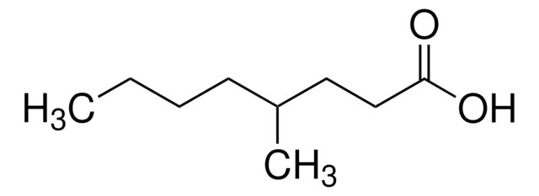 | 54947-74-9 | C₉H₁₈O₂
EOA(4-Et-8:0) | 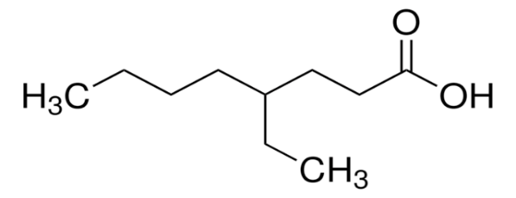 | 16493-80-4 | C₁₀H₂₀O₂
MNA(4-Me-9:0) | 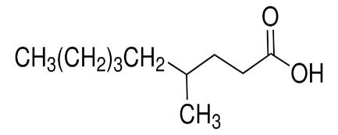 | 45019-28-1 | C₁₀H₂₀O₂
Table S2 Accuracy and precision assessment of individual branched-chain fatty acids (4-Me-8:0, 4-Et-8:0, and 4-Me-9:0) at a concentration of 40 μg/mL based on triplicate measurements recorded on GC-MS
BCFAs | Measured value（μg/mL） | Accuracy（%） | Precision  (% RSD)
4-Me-8:0 | 38.66 | 3.35 | 3.40
4-Et-8:0 | 37.82 | 5.45 | 2.55
4-Me-9:0 | 38.28 | 4.30 | 1.78
Table S3 Statistical analysis (ANOVA) of quantification values to assess repeatability at a concentration of 40 μg/mL for standard branched-chain fatty acids (4-Me-8:0, 4-Et-8:0, and 4-Me-9:0)
 | F | p-value | F crit
Comparative result for 4-Me-8:0, 4-Et-8:0, and 4-Me-9:0 | 2.327 | 0.151 | 4.07
F: the ratio of between-group variance to within-group variance, used to test whether multiple group means differ significantly;
F crit: the critical threshold of the F-distribution at a given significance level and degrees of freedom.
Table S4 Statistical analysis (One-Way ANOVA) for quantification of individual standard branched chain fatty acids at different concentrations 1μg/mL, 5μg/mL, 10μg/mL,20μg/mL, 30μg/mL, and 40μg/mL with triplicate measurements to assess the deviation
Concentration（μg/mL） | F | P-value | F crit
40 | 0.288 | 0.837 | 4.07
30 | 1.349 | 0.642 | 4.07
20 | 2.332 | 0.336 | 4.07
10 | 0.998 | 0.547 | 4.07
5 | 0.679 | 0.478 | 4.07
1 | 1.223 | 0.223 | 4.07
F: the ratio of between-group variance to within-group variance, used to test whether multiple group means differ significantly;
F crit: the critical threshold of the F-distribution at a given significance level and degrees of freedom.
Table S5 Quantification results, Accuracy and precision (%RSD) for mixed standard branched-chain fatty acids samples at various concentrations 1 μg/mL, 5 μg/mL, 10 μg/mL, 20 μg/mL, 30 μg/mL, and 40μg/mL performed by using GC-MS
Concentration（μg/mL） | 4-Me-8:0 |  |  | 4-Et-8:0 |  |  | 4-Me-9:0
Concentration（μg/mL） | Measured value（μg/mL） | Accuracy（%） | Precision  (% RSD) | Measured value（μg/mL） | Accuracy（%） | Precision  (% RSD) | Measured value（μg/mL） | Accuracy（%） | Precision  (% RSD)
40 | 41.31±1.72 | -3.28 | 4.24 | 38.52±1.56 | 3.70 | 4.08 | 44.01±2.58 | 10.03 | 5.88
30 | 31.94±2.14 | -4.85 | 6.86 | 31.43±2.24 | -3.80 | 7.22 | 28.97±0.88 | 2.58 | 3.06
20 | 21.87±1.36 | -4.68 | 6.44 | 20.81±0.89 | -2.03 | 4.38 | 20.45±0.57 | -1.13 | 2.83
10 | 11.33±1.04 | -3.33 | 9.79 | 10.54±0.52 | -1.35 | 5.12 | 11.88±0.86 | -4.70 | 7.30
5 | 4.90±0.08 | 0.25 | 1.90 | 4.86±0.13 | 0.35 | 2.87 | 5.16±0.15 | -0.40 | 2.97
1 | 1.06±0.02 | -0.15 | 7.62 | 1.06±0.08 | -0.15 | 13.20 | 1.16±0.12 | -0.40 | 11.08
Table S6 Statistical analysis (Two-Way ANOVA) of quantification values for the specificity analysis of 4-Me-8:0, 4-Et-8:0, and 4-Me-9:0 at various concentrations (1 μg/mL, 5 μg/mL, 10 μg/mL, 20 μg/mL, 30 μg/mL, and 40μg/mL) in individual and mixed solution
 | F | P-value | F crit
4-Me-8:0 | 3.298 | 0.335 | 6.554
4-Et-8:0 | 1.239 | 0.289 | 6.554
4-Me-9:0 | 1.098 | 1.442 | 6.554
F: the ratio of between-group variance to within-group variance, used to test whether multiple group means differ significantly;
F crit: the critical threshold of the F-distribution at a given significance level and degrees of freedom.
Table S7 Quantification results for repeatability assessment of standard branched-chain fatty acids (4-Me-8:0, 4-Et-8:0, and 4-Me-9:0) acquired by different operators at a concentration of 40 μg/mL
BCFAs | Measured value（μg/mL） | Accuracy（%） | Precision  (% RSD)
4-Me-8:0 | 39.84 | 0.40 | 1.51
4-Et-8:0 | 37.75 | 5.63 | 1.30
4-Me-9:0 | 38.76 | 3.10 | 1.92
Table S8 Statistical analysis (ANOVA) of quantification values to assess repeatability at a concentration of 40 μg/mL for standard branched-chain fatty acids (4-Me-8:0, 4-Et-8:0, and 4-Me-9:0)
 | F | P-value | F crit
Comparative result for 4-Me-8:0, 4-Et-8:0, and 4-Me-9:0 | 1.407 | 0.990 | 5.143
F: the ratio of between-group variance to within-group variance, used to test whether multiple group means differ significantly;
F crit: the critical threshold of the F-distribution at a given significance level and degrees of freedom.
Table S9 Quantification results for reproducibility assessment of standard branched-chain fatty acids (4-Me-8:0, 4-Et-8:0, and 4-Me-9:0) acquired at a concentration of 40 μg/mL
BCFAs | Measured value（μg/mL） | Accuracy（%） | Precision  (% RSD)
4-Me-8:0 | 41.90 | -4.75 | 3.23
4-Et-8:0 | 39.39 | 1.53 | 4.37
4-Me-9:0 | 38.76 | 3.1 | 3.45
Table S10 Statistical analysis (ANOVA) of quantification values to assess reproducibility at a concentration of 40 μg/mL for standard branched-chain fatty acids (4-Me-8:0, 4-Et-8:0, and 4-Me-9:0)
 | F | P-value | F crit
Comparative result for 4-Me-8:0, 4-Et-8:0, and 4-Me-9:0 | 4.097 | 0.113 | 7.71
F: the ratio of between-group variance to within-group variance, used to test whether multiple group means differ significantly;
F crit: the critical threshold of the F-distribution at a given significance level and degrees of freedom.

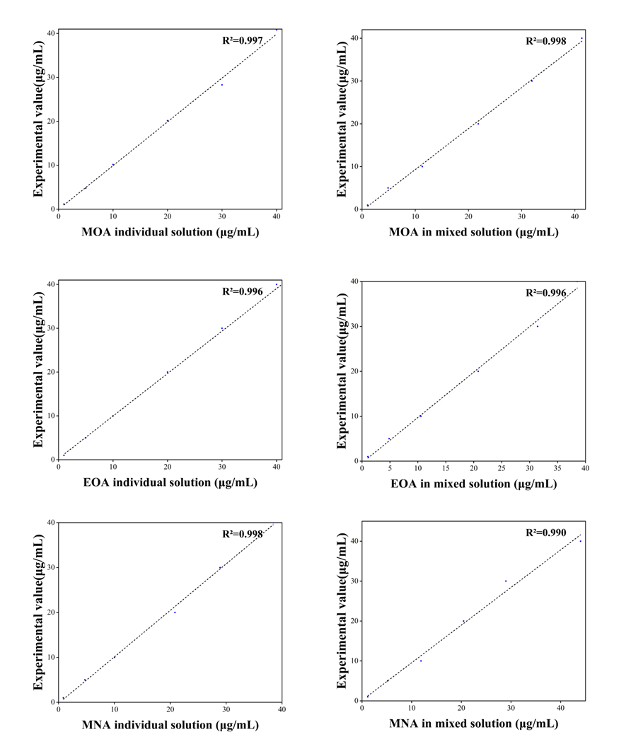
Figure S1 Linear plots of measured versus true values of MOA, EOA, and MNA at different concentrations of each individual standard branched-chain fatty acids, and of MOA, 4-ethyl octanoic acid, and MNA at different concentrations in mixed solutions.

