Supplementary Information
Metallic Nickel Activation of Non-Reconstructed Amorphous Nickel Selenide Interface for Ampere-level Natural Seawater Splitting

Supplementary Methods

Synthesis of Ni/C-a-NiSe₂ and C-a-NiSe₂
Ni/C-a-NiSe₂ was synthesized using a one-step γ-ray radiation reduction method. Initially, 1 mmol of (CH₃COO)₂Ni·4H₂O and 2 mmol of Na₃C₆H₅O₇·2H₂O were dissolved in ultrapure water. Subsequently, 8 mL of isopropanol and 8 mL of a 0.2 M Na₂SeSO₃ solution (prepared according to previously reported procedures) were added, and the total volume was adjusted to 30 mL.¹ The resulting precursor solution was purged with N₂ to remove dissolved oxygen, sealed, and irradiated using a ⁶⁰Co source (Department of Applied Chemistry, Peking University). Optimization of the sample was achieved by varying the amount of Na₃C₆H₅O₇·2H₂O and the dose rate, detailed preparation conditions provided in Table S1. The Ni/C-a-NiSe₂-III with an absorbed dose of 50 kGy and a dose rate of 50 Gy min⁻¹ is abbreviated as Ni/C-a-NiSe₂. For comparison, C-a-NiSe₂ was synthesized by reducing the isopropanol volume to 4 mL, while keeping all other preparation conditions consistent with those described above. To further demonstrate the advantages of the radiation approach, h-NiSe₂ was also prepared via a conventional hydrothermal method with the addition of 2 mmol of Na₃C₆H₅O₇·2H₂O.²

Materials Characterizations
The crystal structure was analyzed using X-ray diffraction (XRD, X-Pert3 Powder) with Cu-Kα radiation (λ = 1.54178 Å). Morphological and structural characteristics were examined by scanning electron microscopy (SEM, Hitachi S-4800) and high-resolution transmission electron microscopy (HRTEM, Tecnai 2100F), coupled with energy-dispersive X-ray spectroscopy (EDS) for elemental analysis. Fourier transform infrared spectroscopy (FTIR, Thermo Fisher Scientific Nicolet iS20) was employed to identify functional groups modified by organic compounds. Thermogravimetric analysis (TGA, Q600 SDT) was conducted under a nitrogen atmosphere from 25 °C to 800 °C at a heating rate of 10 °C min⁻¹. Raman spectroscopy with a 532 nm laser was utilized to further investigate the material composition. The elemental chemical environment was characterized by X-ray photoelectron spectroscopy (XPS, AXIS Supra) using an Al-Kα source, with charge correction based on the C 1s peak. Synchrotron radiation X-ray absorption spectroscopy (XAS) was employed to probe the fine electronic structure, providing insights into the coordination environment and coordination number. Surface charge properties were measured at various pH values using a zeta potential analyzer (Malvern Zetasizer Nano ZS90). Hydrophilicity and hydrophobicity were assessed via contact angle measurements (LAUDA Scientific LSA100S-T). Vacancy defects were confirmed by electron paramagnetic resonance spectroscopy (EPR, Bruker EMXplus-6/1). Elemental leaching was monitored using inductively coupled plasma optical emission spectroscopy (ICP-OES, Agilent 5110). Time-of-flight secondary ion mass spectrometry (ToF-SIMS, PHI nanoTOFII) was utilized to analysis the catalyst interface after HER, with Bi³⁺ as the ion beam and the collection mode set to high mass resolution.

Electrochemical Measurements
Electrochemical measurements were conducted using the AUTOLAB PGSTAT302 workstation (Metrohm Autolab, Switzerland). The three-electrode system consists of a carbon rod as the counter electrode, HgO/Hg as the reference electrode, and the catalyst as the working electrode, with 1 M KOH as the electrolyte. To prepare the catalyst ink, 4 mg of catalyst powder was dispersed in a mixture of 480 μL ethanol, 312 μL deionized water, and 50 μL of 20% Nafion solution. This suspension was ultrasonicated to ensure homogeneity and subsequently drop-cast onto a glassy carbon electrode (3 mm diameter) as the working electrode. The hydrogen evolution reaction (HER) activity was evaluated by linear sweep voltammetry (LSV) under an Ar-saturated atmosphere, sweeping from 0 V to 0.4 V vs.RHE at a scan rate of 5 mV s⁻¹. The Tafel slope, which provides insight into the reaction kinetics, was determined according to Equation 1:
(1)
where b is the Tafel slope, J is the current density, and η is the overpotential.
Cyclic voltammetry (CV) was performed within the non-Faradaic potential window (0.02 V to 0.12 V) to evaluate the intrinsic electrocatalytic activity. The electrochemically active surface area (ECSA) and double-layer capacitance (C_{dl}) were determined from the CV curves recorded at scan rates ranging from 10 mV s⁻¹ to 60 mV s⁻¹, as described by Equations 2.
(2)
Electrochemical impedance spectroscopy (EIS) was conducted at -1.024 V vs. RHE over a frequency range of 100 kHz to 10 mHz, using an amplitude of 5 mV. To probe the kinetics isotope effect, experiments were conducted in D₂O as the electrolyte. Additionally, 0.1 M KSCN was introduced to poison the metallic active sites, facilitating the identification of catalytic centers. The catalytic stability was evaluated through long-term chronoamperometry. The 100,000-cycles CV test with a scan rate of 10 mV s⁻¹ over the potential range of -0.15 to 0.05 V was also employed for accelerated degradation testing (ADT) to validate the catalyst's performance robustness. To further demonstrate the practical applicability, HER performance was evaluated using natural seawater as the electrolyte, collected from Qingdao, Shandong Province, China. For fabrication of self-supported electrodes, the catalyst slurry was drop-cast onto nickel foam (5×5 cm⁻²) with the loading of 5 mg cm⁻², which served as the cathode in an anion exchange membrane (AEM) electrolyzer, assembled with C-NiFe-LDH/NF (citrate-modified NiFe-LDH, prepared as reported in prior literature).³ For comparative analysis, commercial Pt/C catalysts were subjected to analogous electrode preparation and testing protocols. The Faraday efficiency measurement is achieved by collecting gas content through the displacement method.
All potentials were converted to reversible hydrogen electrode (RHE) potentials using Equation 3.
(3)
where iR represents the correction for ohmic resistance.
In-situ electrochemical measurements were conducted using a three-electrode system in conjunction with appropriate characterization instruments, including IR spectroscopy, Raman spectroscopy and EIS. The applied potential range was set from 0 to -0.5 V.
All electrochemical tests were strictly controlled at 25 °C.

Chemicals and Reagents
Nickel (II) acetate tetrahydrate ((CH₃COO)₂Ni·4H₂O), iron nitrate nonahydrate (Fe(NO₃)₃·9H₂O), nickel nitrate hexahydrate (Ni(NO₃)₂·6H₂O), trisodium citrate dihydrate (Na₃C₆H₅O₇·2H₂O), urea (CH₄N₂O), ammonium fluoride (NH₄F), selenium powder (Se, 400 mesh), sodium sulfite (Na₂SO₃), isopropyl alcohol (IPA, C₃H₈O, 99.8%), ethanol (C₂H₆O, ≥99%), deionized water with a resistivity of ≥18 MΩ (PSDK-20-E, Beijing Zihan Shiji Technology Co., Ltd), nickel foam (NF, thickness = 0.5 mm), Nafion solution (20wt% in water), 20 wt% Pt/C, RuO₂ (Suzhou Sinero Technology Co., Ltd). All chemicals and reagents were used without further purification.
Table S1. Preparation conditions of Ni/C-a-NiSe₂-I to VII.
Sample | n_{cit} / mmol | Absorbed dose/kGy | Dose rate/Gy min⁻¹
Ni/C-a-NiSe₂-I | 0.5 | 50 | 50
Ni/C-a-NiSe₂-II | 1.0
Ni/C-a-NiSe₂-III | 2.0
Ni/C-a-NiSe₂-IV | 4.0
Ni/C-a-NiSe₂-V | 2.0 | 50 | 30
Ni/C-a-NiSe₂-VI |  |  | 80
Ni/C-a-NiSe₂-VII |  |  | 100

Theoretical Calculations
All the calculations are performed in the framework of the density functional theory with the projector augmented plane-wave method, as implemented in the Vienna ab initio simulation package⁴. The generalized gradient approximation proposed by Perdew, Burke, and Ernzerhof is selected for the exchange-correlation potential⁵. The long range van der Waals interaction is described by the DFT-D3 approach⁶. The cut-off energy for plane wave is set to 400 eV. The energy criterion is set to 10⁻⁵ eV in iterative solution of the Kohn-Sham equation. A vacuum layer of 15 Å is added perpendicular to the sheet to avoid artificial interaction between periodic images. The Brillouin zone integration is performed using a 2x2x1 k-mesh. All the structures are relaxed until the residual forces on the atoms have declined to less than 0.05 eV/Å. The energy barriers were calculated by Climbing image-nudged elastic band (CI-NEB) method in VTST code⁷ embedded in VASP, and eight intermediates were taken into consideration. During the calculations, the amorphous NiSe₂ was constructed by AIMD simulation. The initial structure was built from a 2*2*2 supercell of NiSe₂ primate cell. Then the structure was heated from 100 K to 3000 K in 40 ps with a timestep of 2 fs. The final structure was fully optimized to get the ground state of the amorphous structure. Then the Ni13 cluster was put on the slab surface of the amorphous structure to simulate the amorphous NiSe₂ supported Ni clusters.

Calculation of Electrolyzer Production Efficiency and Hydrogen Cost
Hydrogen Production Rate Calculation (PR_{H})：
(4)
Hydrogen Equivalent Power Output (P_{H}):
(5)
LHV denotes the lower heating value, which for hydrogen corresponds to the energy released during complete combustion: 2.42 × 10⁵ J mol⁻¹ H₂. FE denotes the Faraday efficiency at the corresponding current density.
Electrolyzer Power Consumption (P_{E}):
(6)
Electrolyzer Energy Conversion Efficiency (η):
(7)
Hydrogen Production Costs (C_{E}):
(8)
E_{bill} represents the electricity bill, typically $0.02 per kWh.
Electrolyzer Production Energy consumption (kWh Nm⁻³):
(9)

Supplementary Figures
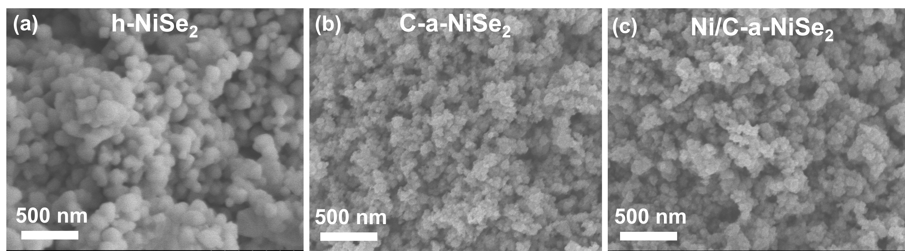
Fig. S1. SEM images of (a) h-NiSe₂, (b) C-a-NiSe₂ and (c) Ni/C-a-NiSe₂.

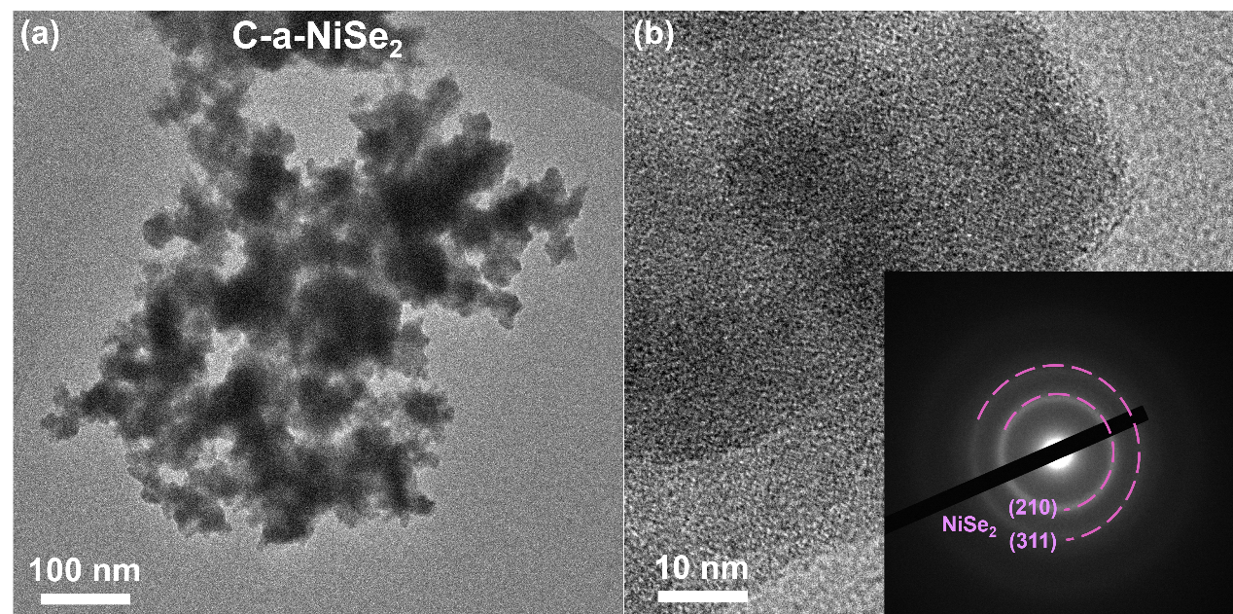
Fig. S2. (a, b) HRTEM images of C-a-NiSe₂ (the inset is corresponding SAED image).

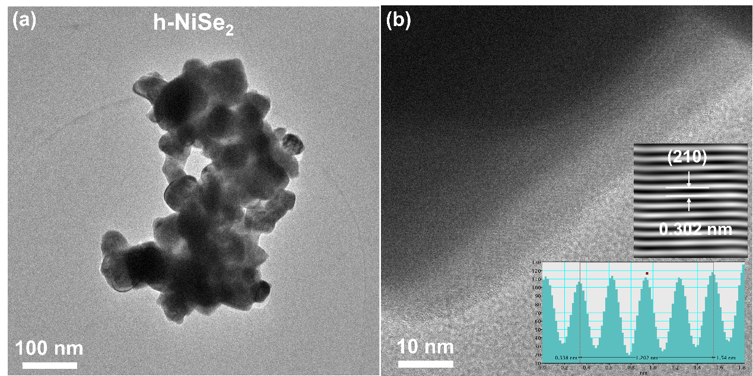
Fig. S3. (a, b) HRTEM images of h-NiSe₂ (the inset is the lattice fringe images of (210) plane).

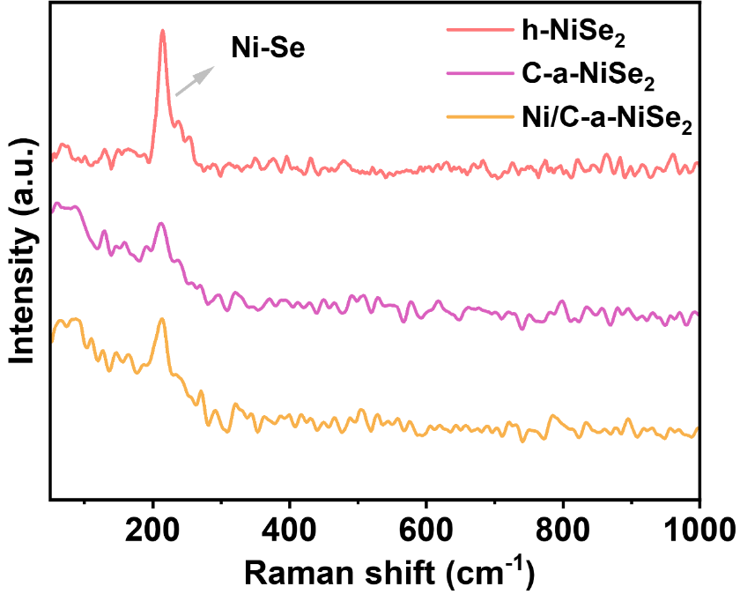
Fig. S4. Raman spectrum of h-NiSe₂, C-a-NiSe₂ and Ni/C-a-NiSe₂.

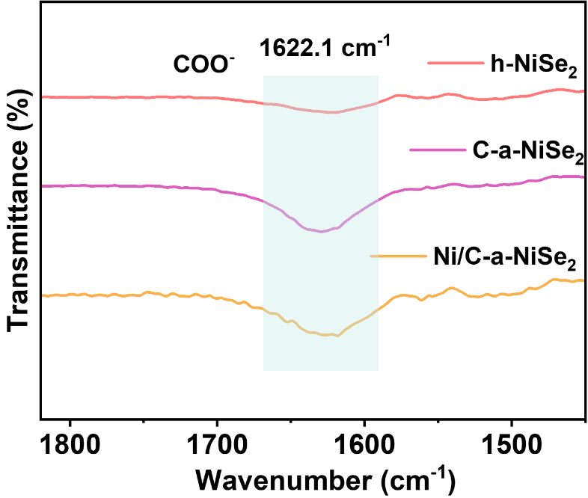
Fig. S5. IR spectrum of h-NiSe₂, C-a-NiSe₂ and Ni/C-a-NiSe₂.

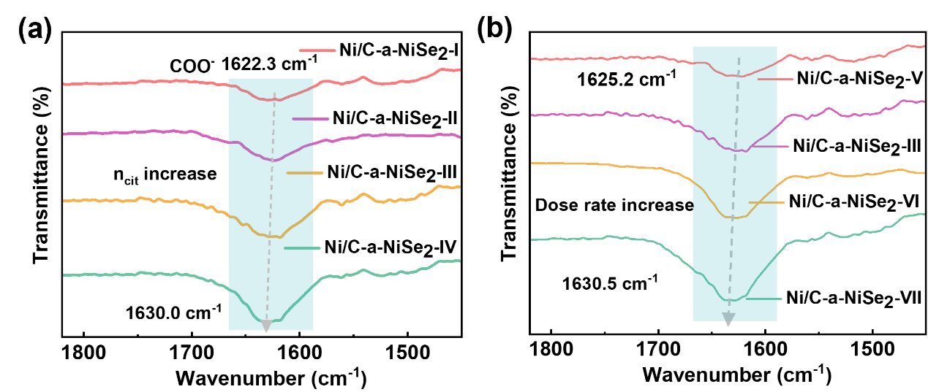
Fig. S6. IR spectrum of Ni/C-a-NiSe₂-I to VII.

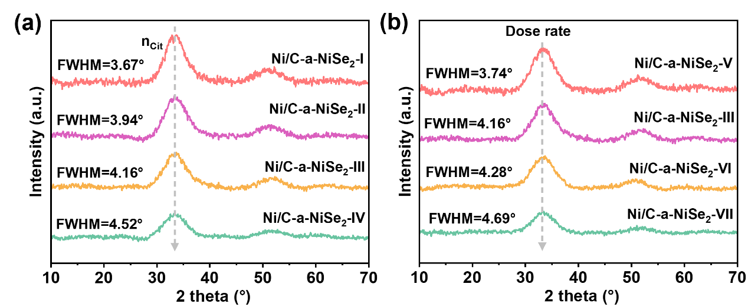
Fig. S7. XRD patterns of Ni/C-a-NiSe₂-I to VII.

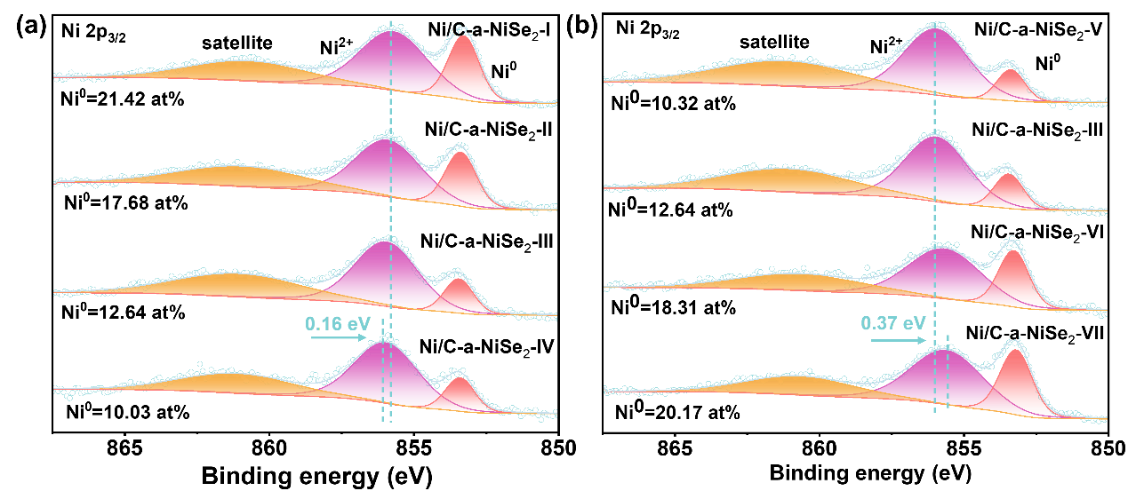
Fig. S8. Ni 2p spectra of XPS spectrum for Ni/C-a-NiSe₂-I to VII.

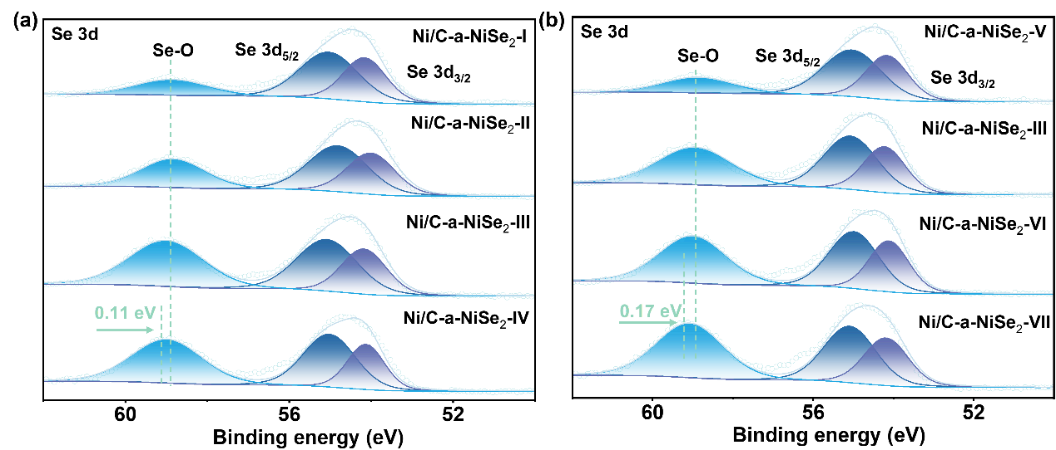
Fig. S9. Se 3d spectra of XPS spectrum for Ni/C-a-NiSe₂-I to VII.

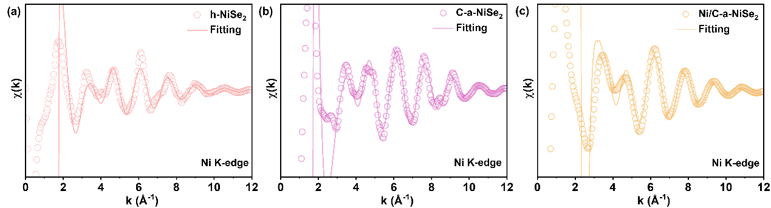
Fig. S10. Experimental and the fitting Ni K-edge EXAFS spectra in k-space for (a) h-NiSe₂, (b) C-a-NiSe₂ and (c) Ni/C-a-NiSe₂.

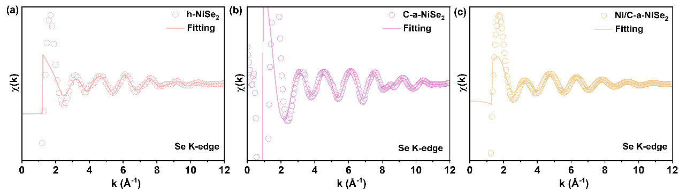
Fig. S11. Experimental and the fitting Se K-edge EXAFS spectra in k-space for (a) h-NiSe₂, (b) C-a-NiSe₂ and (c) Ni/C-a-NiSe₂.

Table S2. EXAFS fitting parameters.ª
Sample | Shell | N | R/ Å | σ² | R factor (%)
h-NiSe₂ | Ni-Se | 5.7±0.15 | 2.19±0.003 | 0.0073 | 0.97
h-NiSe₂ | Ni-O | 0.4±0.02 | 3.36±0.012 | 0.0092 | 0.97
h-NiSe₂ | Ni-O-Ni | 0.5±0.07 | 4.25±0.009 | 0.0063 | 0.97
C-a-NiSe₂ | Ni-Se | 5.4±0.16 | 1.99±0.011 | 0.0081 | 0.86
Ni/C-a-NiSe₂ | Ni-Se | 5.5±0.09 | 2.12±0.015 | 0.0043 | 1.05
Ni/C-a-NiSe₂ | Ni-Ni | 0.6±0.03 | 3.68±0.022 | 0.0037
Ni/C-a-NiSe₂ | Ni-Ni | 0.4±0.08 | 4.39±0.026 | 0.0015
h-NiSe₂ | Se-Ni/Se | 3.9±0.17 | 2.08±0.023 | 0.0022 | 1.14
C-a-NiSe₂ | Se-Ni/Se | 2.9±0.13 | 2.05±0.018 | 0.0041 | 0.82
C-a-NiSe₂ | Se-O | 0.8±0.11 | 3.09±0.033 | 0.0034
Ni/C-a-NiSe₂ | Se-Ni/Se | 3.1±0.19 | 2.11±0.019 | 0.0087 | 0.89
Ni/C-a-NiSe₂ | Se-O-C | 0.6±0.14 | 3.07±0.028 | 0.0056
ªFitting regions of samples.
3.000≤k (/Å)≤12.000 and 1.00≤R (Å)≤5.00.

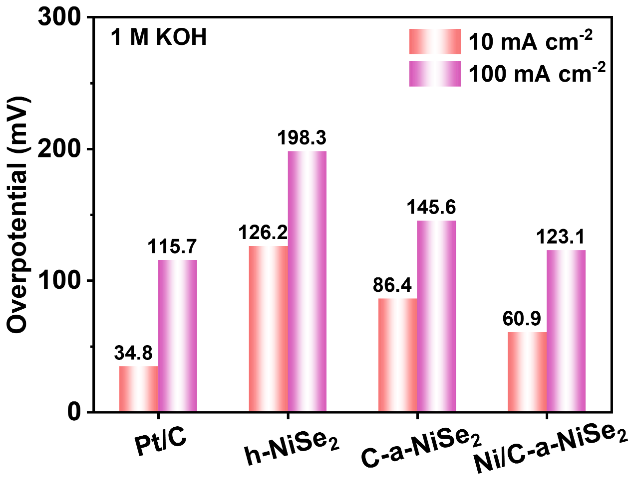
Fig. S12. Hydrogen evolution overpotential at 10 mA cm⁻² and 100 mA cm⁻² in 1 M KOH for Pt/C, h-NiSe₂, C-a-NiSe₂ and Ni/C-a-NiSe₂.

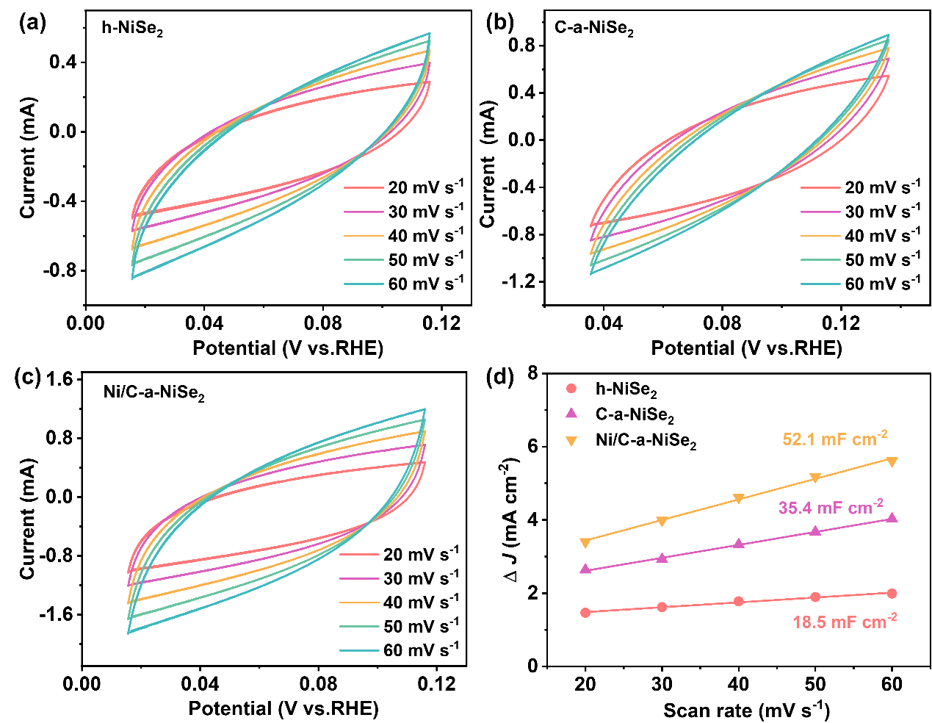
Fig. S13. (a-c) CV curves at scan rates of 20–60 mV s⁻¹ for h-NiSe₂, C-a-NiSe₂ and Ni/C-a-NiSe₂ and (d) the C_{dl} linear fitting.

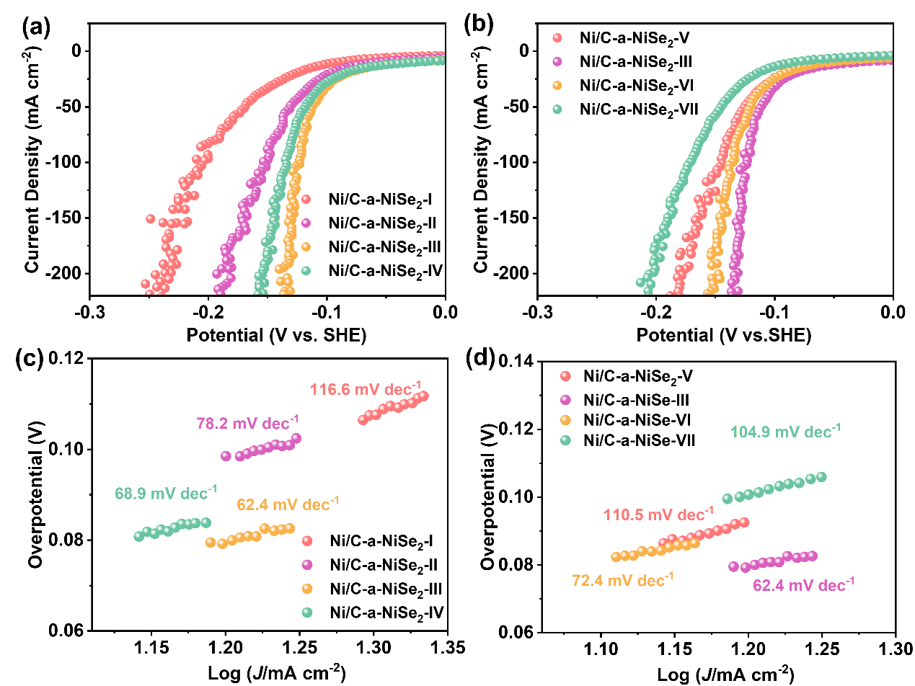
Fig. S14. LSV curves in 1 M KOH for (a, b) Ni/C-a-NiSe₂-I to VII and (c, d) corresponding Tafel slope.

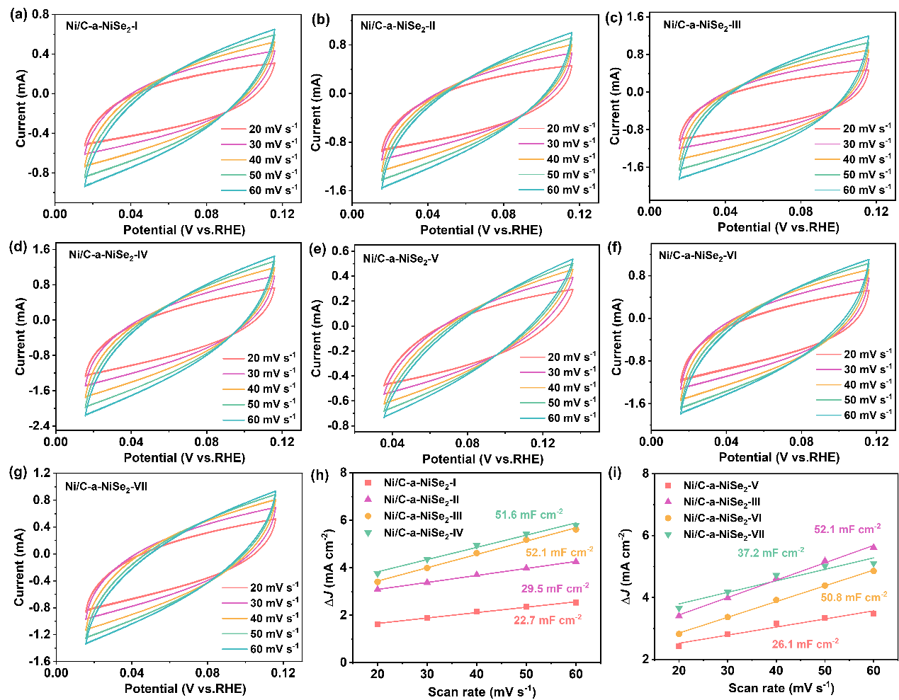
Fig. S15. (a-g) CV curves at scan rates of 20–60 mV s⁻¹ for Ni/C-a-NiSe₂-I to VII and (h, i) the C_{dl} linear fitting.

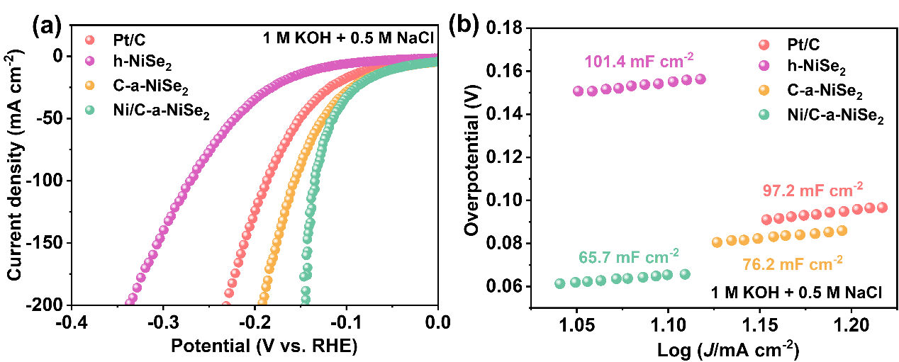
Fig. S16. (a) LSV curves in 1 M KOH+0.5 M NaCl for Pt/C, h-NiSe₂, C-a-NiSe₂, Ni/C-a-NiSe₂ and (b) corresponding Tafel slope.

Table S3. Comparison of seawater electrolytic performance between nickel-based and chalcogenide-based catalysts in a three-electrode system.
Samples | electrolyte | η (mV) | Tafel slope/ mV dec⁻¹ | Refs.
Se/NiSe₂ | 1 M KOH+seawater | η₁₀₀:280 | 109 | ⁸
P-NiSe₂ | seawater | η₁₀:296; | 180 | ⁹
Ru,W-NiSe₂ | seawater | η₁₀:353 | 152.5 | ¹⁰
1 T-MoSe₂/NiSe | 1 M KOH +seawater | η₁₀:104 | 124 | ¹¹
CrO_{x}@ Ni₂P-Ni₅P₄ | seawater | η₁₀:164 | 112 | ¹²
Mo₃Se₄-NiSe | seawater | η₁₀:166 | 90.12 | ¹³
CoSe/NiSe₂ | 1 M KOH+seawater | η₁₀:204.5 | 122 | ¹⁴
1T/2H-MoSe₂ | Simulated seawater | η₁₀:274 | 142 | ¹⁵
CoS₂@CoFe-LDH | 1 M KOH+seawater | η₁₀₀:311 | 95 | ¹⁶
NRAHM-NiO | 1 M KOH+0.5 M NaCl | η₁₀₀:247 | 116 | ¹⁷
Ni₂P–FeNi-LDH | 1 M KOH+seawater | η₁₀₀:230 | 55.63 | ¹⁸
MoS₂–ReS₂ | 1 M KOH+seawater | η₁₀:200 | 101.58 | ¹⁹
Ni/C-a-NiSe₂ | seawater | η₁₀:90.3  η1₀₀:159.8 | 68.5 | This work

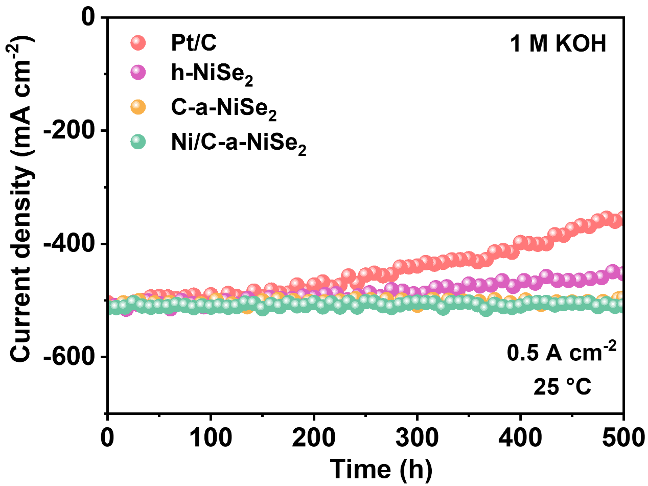
Fig. S17. Catalytic stability in 1 M KOH of Pt/C, h-NiSe₂, C-a-NiSe₂ and Ni/C-a-NiSe₂.

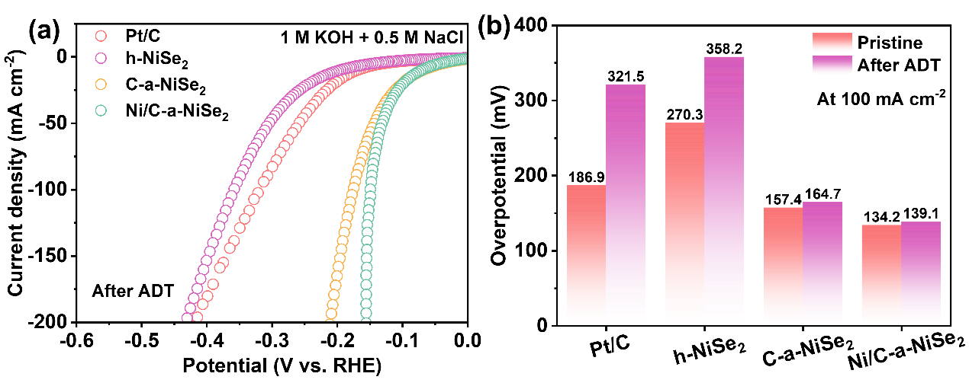
Fig. S18. (a) LSV curve in 1 M KOH+0.5 M NaCl for Pt/C, h-NiSe₂, C-a-NiSe₂ and Ni/C-a-NiSe₂ after ADT testing. (b) Performance comparison before and after ADT Testing at 100 mA cm⁻².

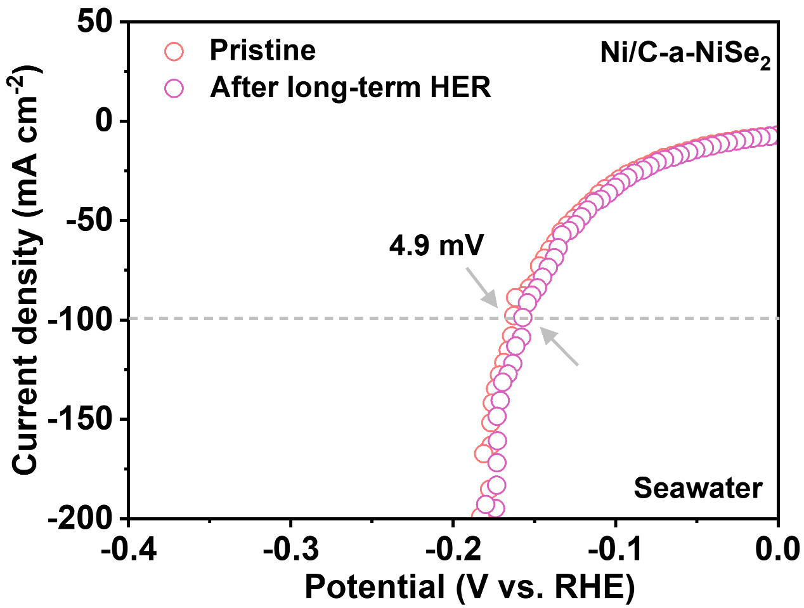
Fig. S19. Differences in LSV curves of Ni/C-a-NiSe₂ before and after long-term seawater electrolysis.

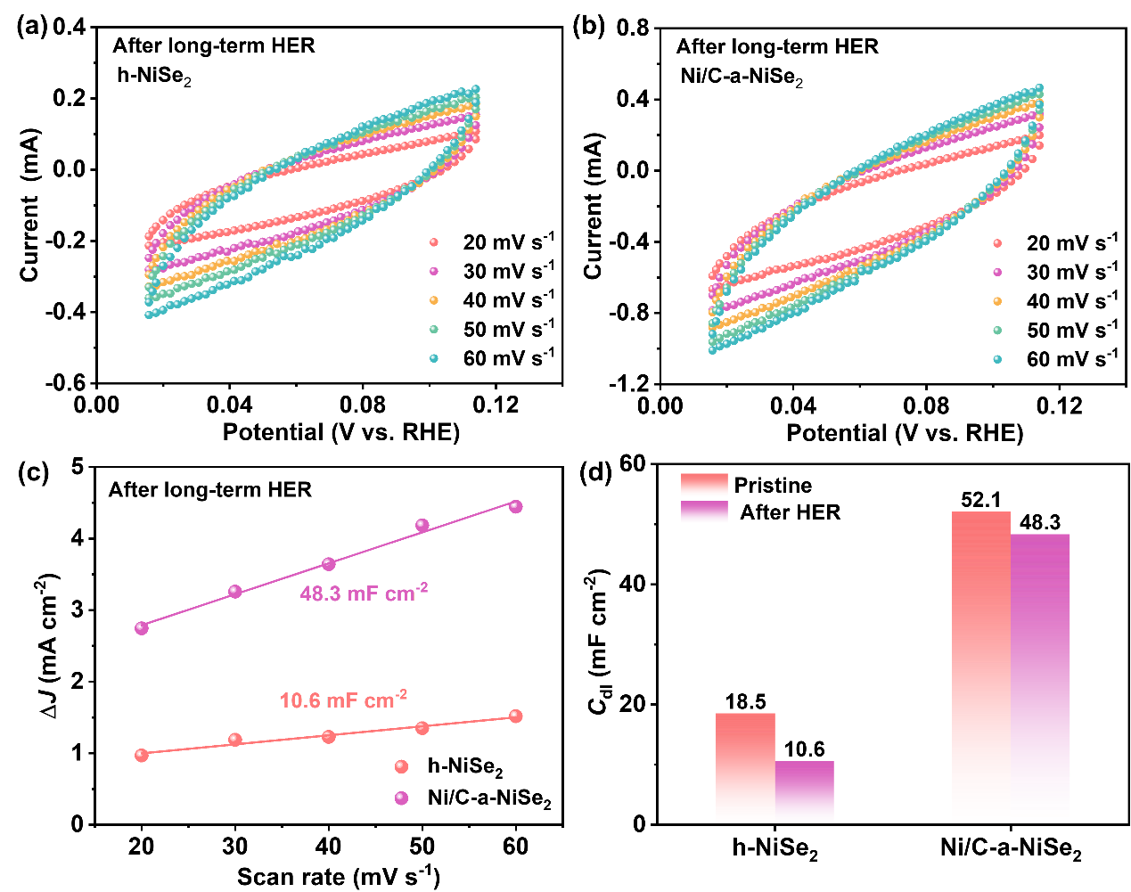
Fig. S20. CV curves at scan rates of 20–60 mV s⁻¹ for (a) h-NiSe₂, (b) Ni/C-a-NiSe₂ and (c) the C_{dl} linear fitting after long-term seawater HER. (d) Comparison of the decreased C_{dl} value for h-NiSe₂ and Ni/C-a-NiSe₂.

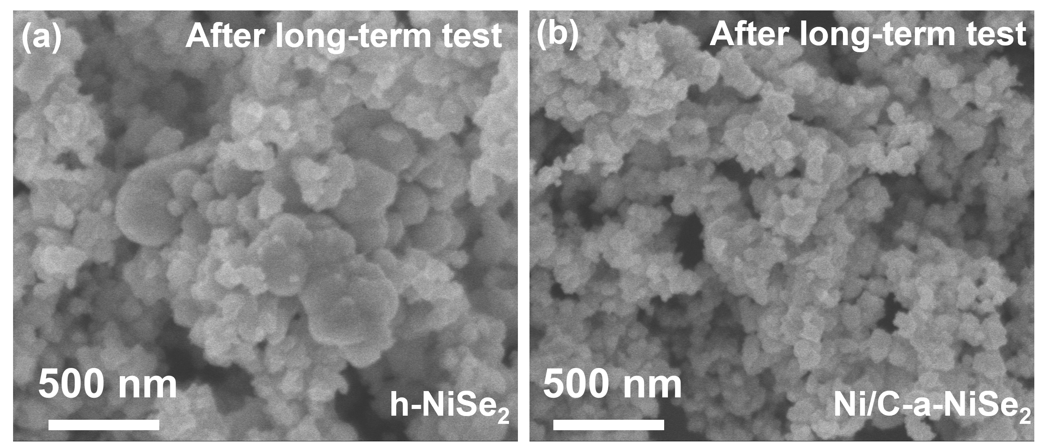
Fig. S21. SEM images of (a) h-NiSe₂ and (b) Ni/C-a-NiSe₂ after long-term seawater electrolysis.

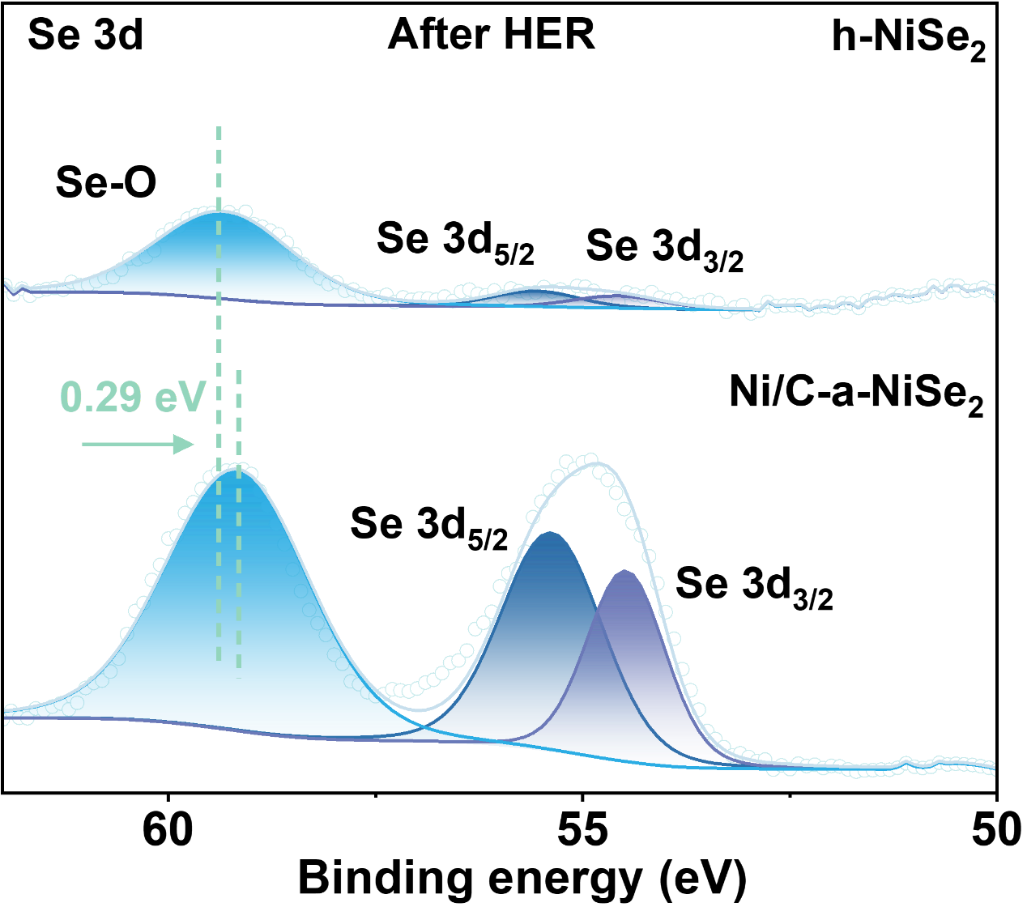
Fig. S22. Se 3d spectra of XPS spectrum for h-NiSe₂ and Ni/C-a-NiSe₂ after long-term seawater electrolysis.

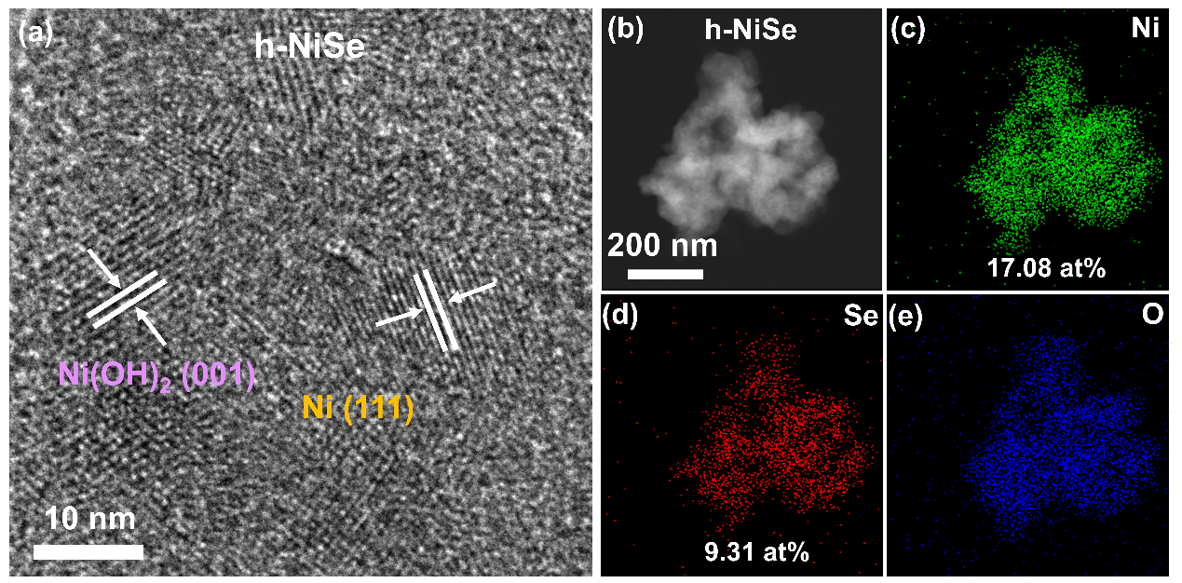
Fig. S23. (a) HRTEM image, (b) STEM images of h-NiSe₂ and (c-e) EDS mapping of Ni, Se and O element.

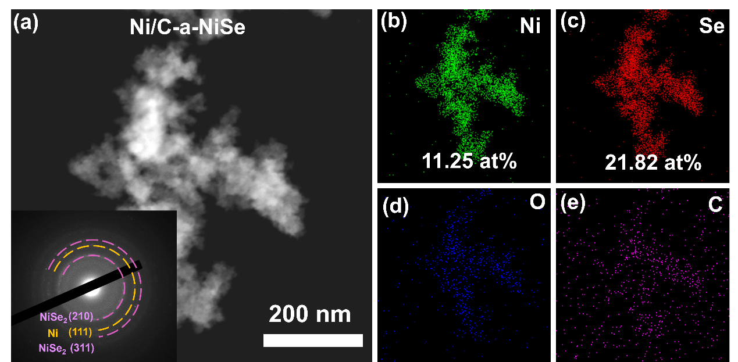
Fig. S24. (a) STEM images of h-NiSe₂ (the inset is corresponding SAED pattern) and (b-e) EDS mapping of Ni, Se and O element.

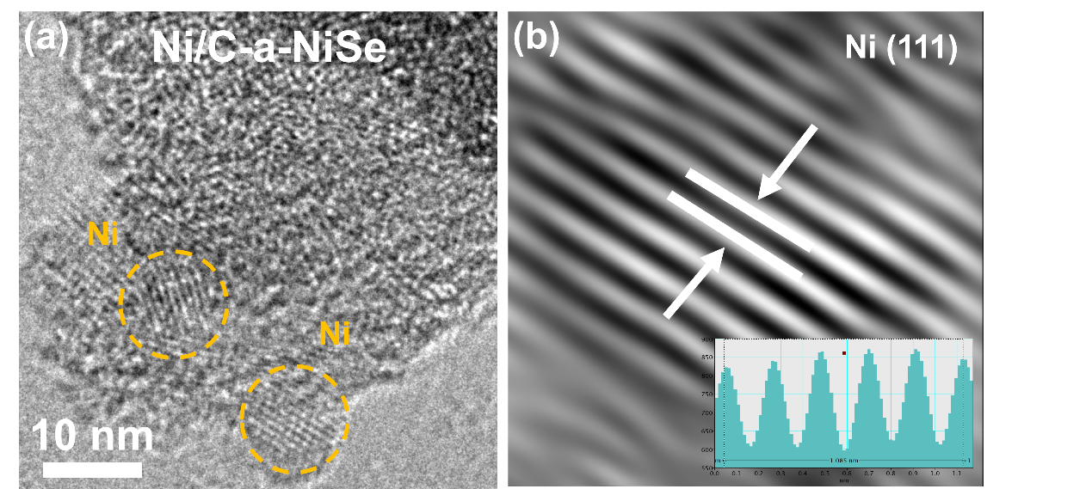
Fig. S25. (a) HRTEM images of Ni/C-a-NiSe₂ and (b) FFT image of lattice fringes on the Ni (111) crystal plane (inset is the integrated pixel intensities).

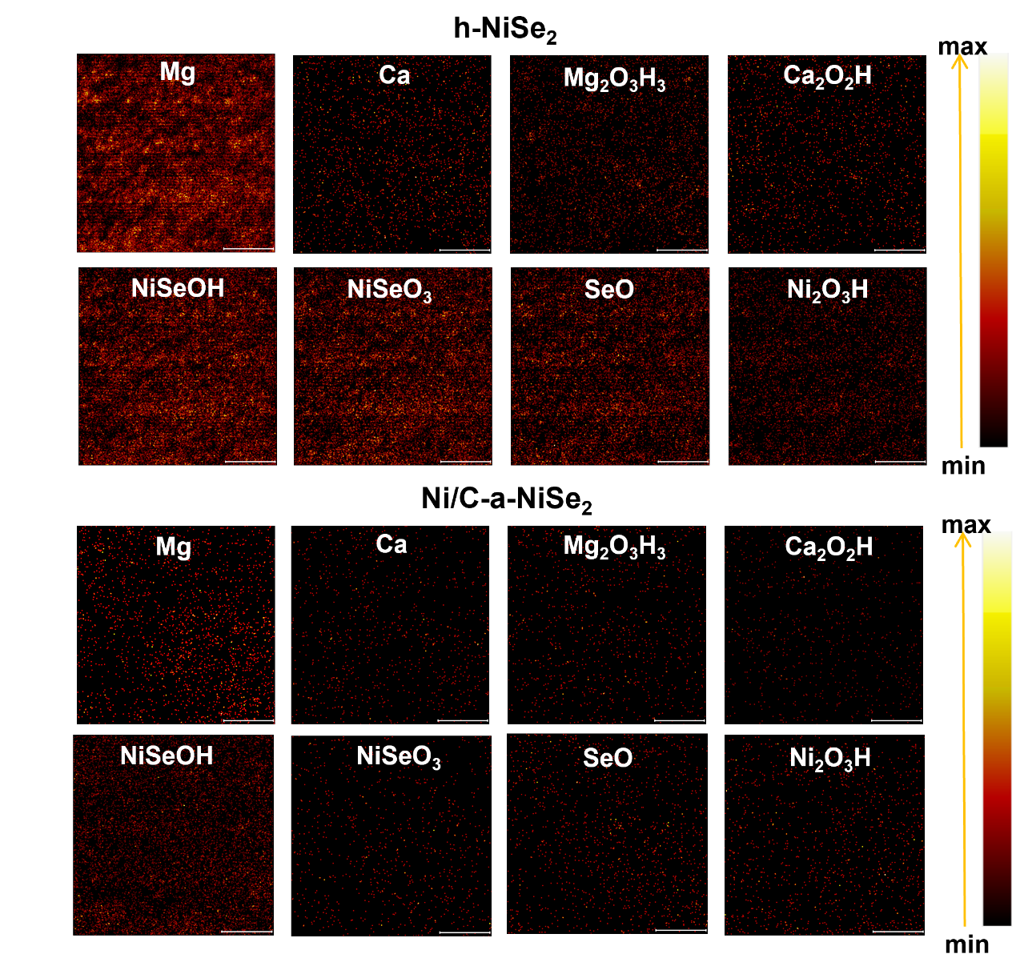
Fig. S26. Two-dimensional TOF-SIMS interface mapping of h-NiSe₂ and Ni/C-a-NiSe₂ (brightness represents ion sputtering intensity).

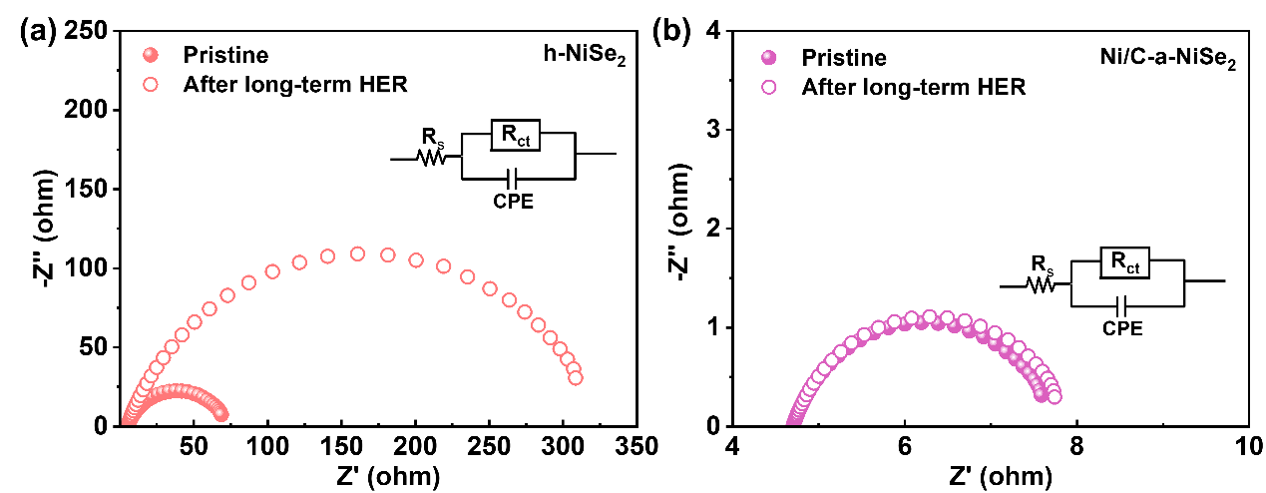
Fig. S27. EIS plots after long-term HER in seawater for (a) h-NiSe₂ and (b) Ni/C-a-NiSe₂.

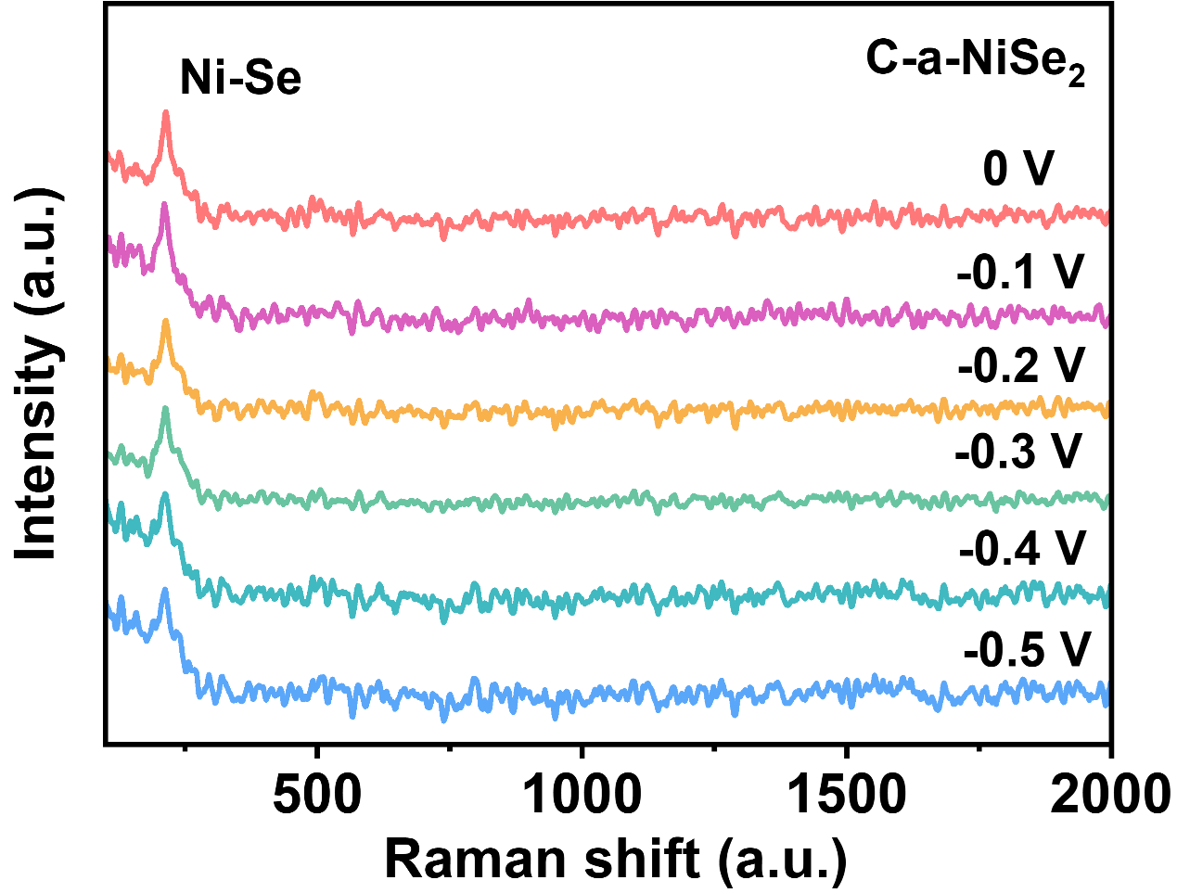
Fig. S28. In situ Raman spectrum of C-a-NiSe₂ within the potential range of 0 to -0.5 V.

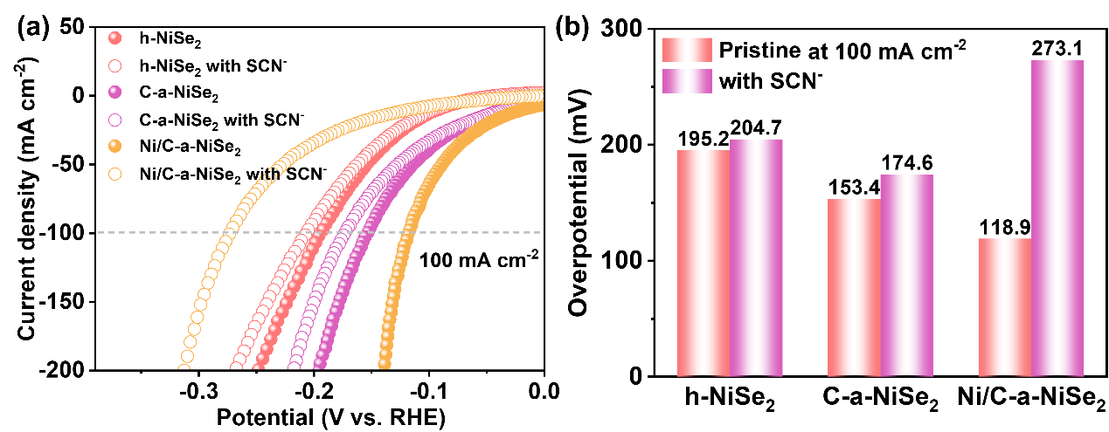
Fig. S29. (a) LSV Curves of h-NiSe₂, C-a-NiSe₂, Ni/C-a-NiSe₂ after KSCN poisoning and (b) the overpotential at 100 mA cm⁻².

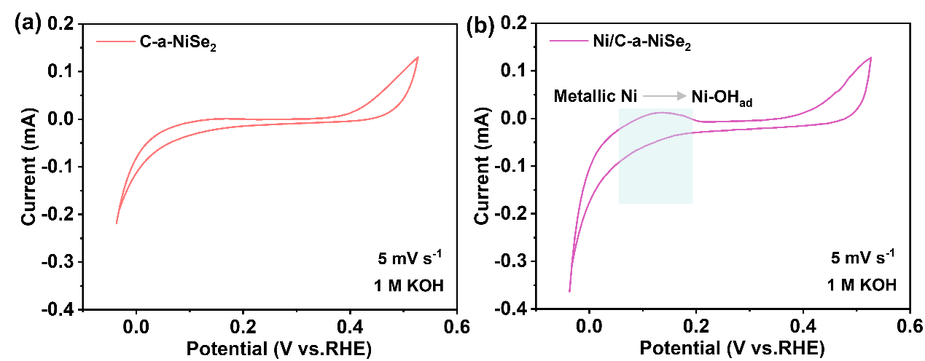
Fig. S30. CV curves within the potential range of -0.05 V to 0.5 V of (a) C-a-NiSe₂ and (b) Ni/C-a-NiSe₂.

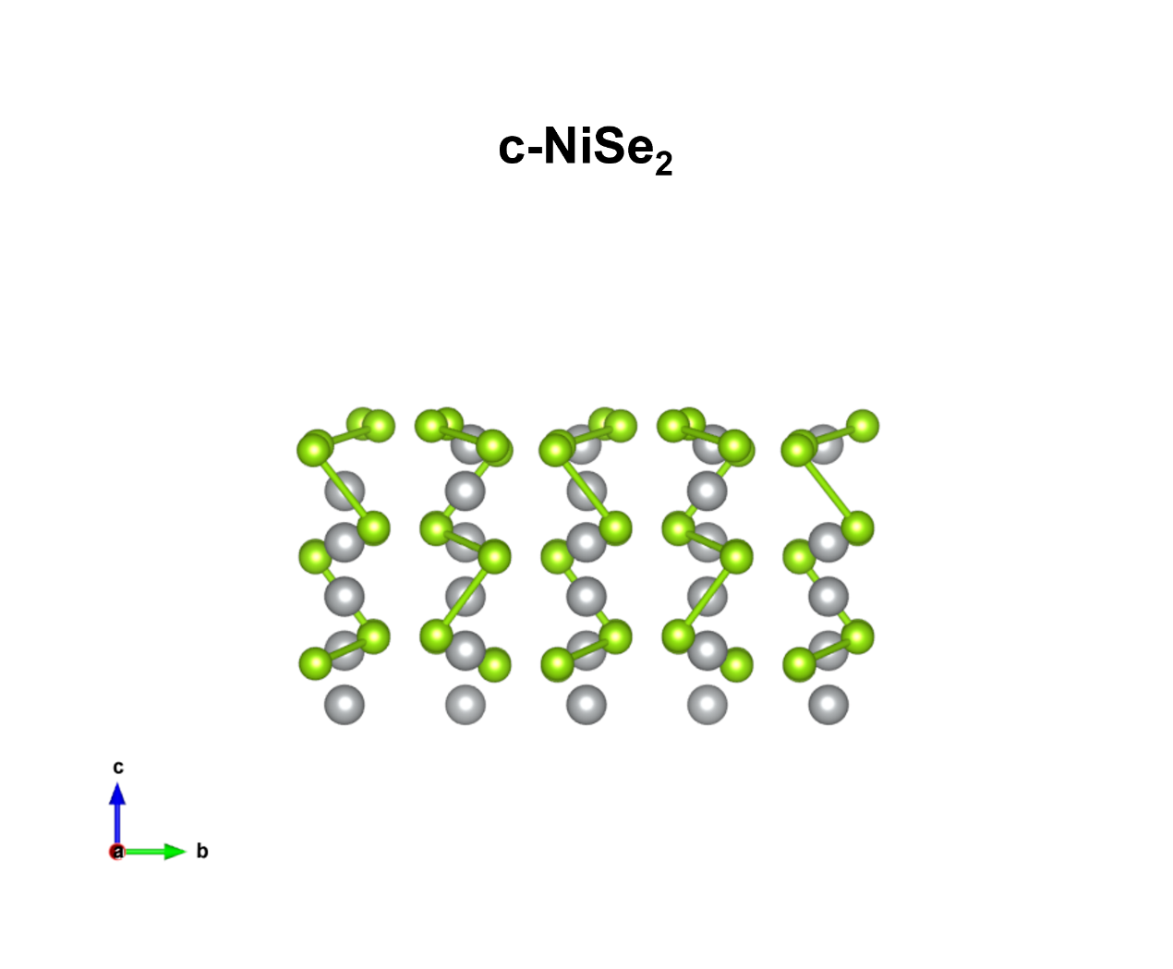
Fig. S31. Front view of the cubic crystalline nickel selenide structural model (c-NiSe₂).

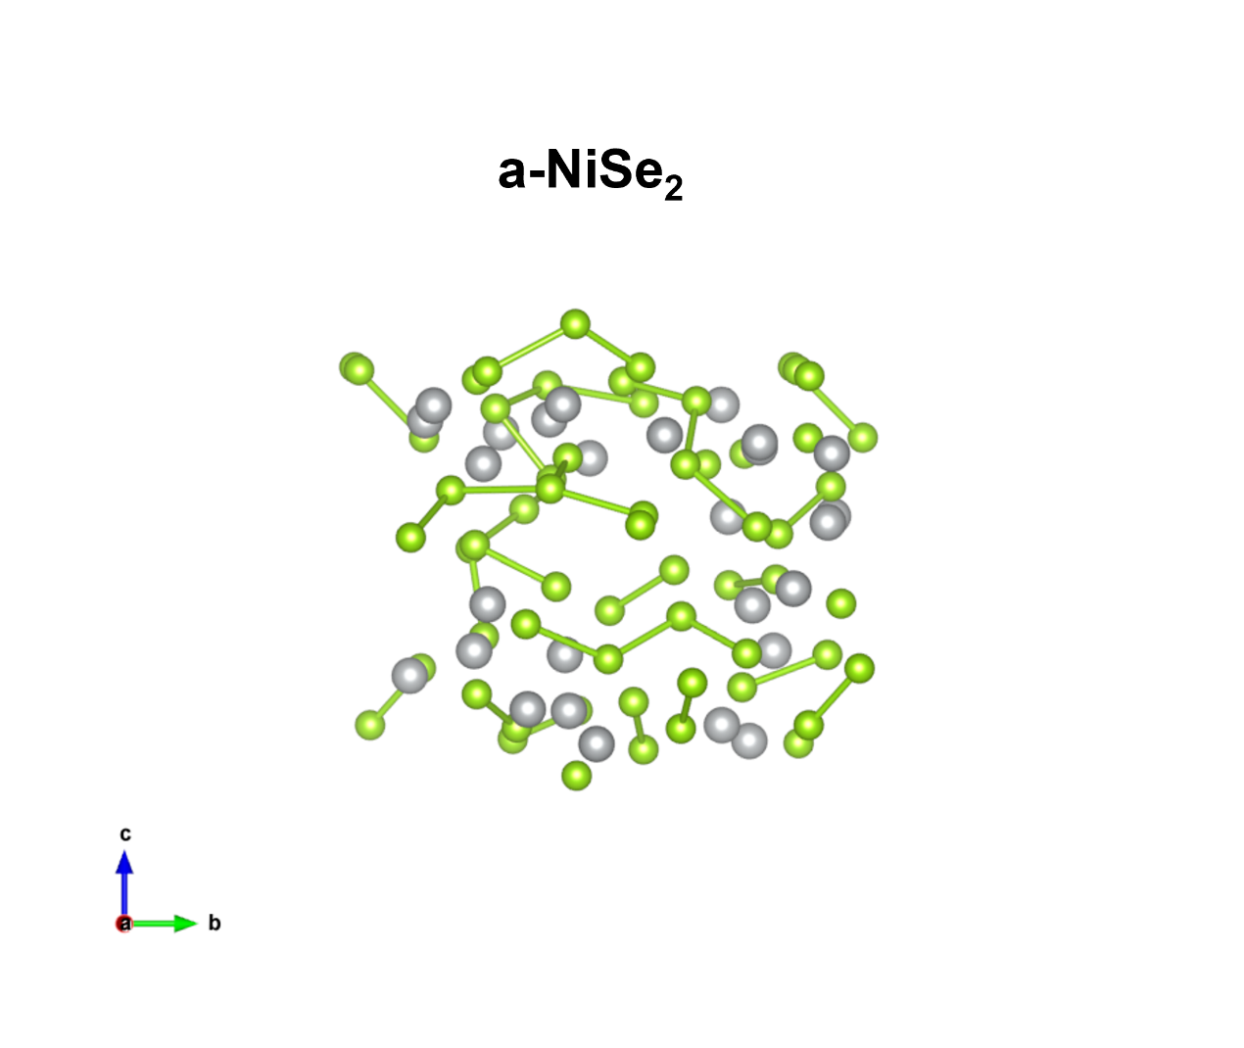
Fig. S32. Front view of the amorphous nickel selenide structural model (a-NiSe₂).

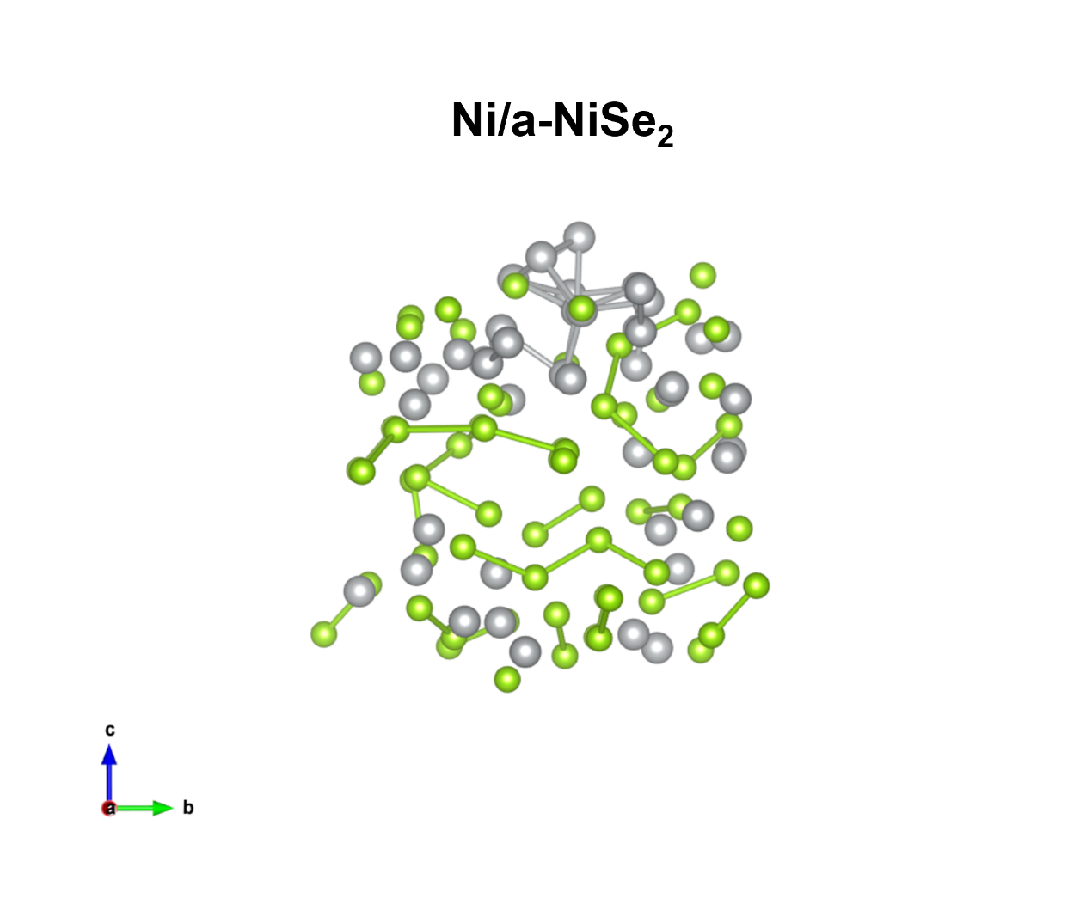
Fig. S33. Front view of the metallic Ni decorated amorphous nickel selenide structural model (Ni/a-NiSe₂).

Fig. S34. The free energy of *H migration from the metallic Ni site to the NiSe₂ metallic site in Ni/a-NiSe₂.

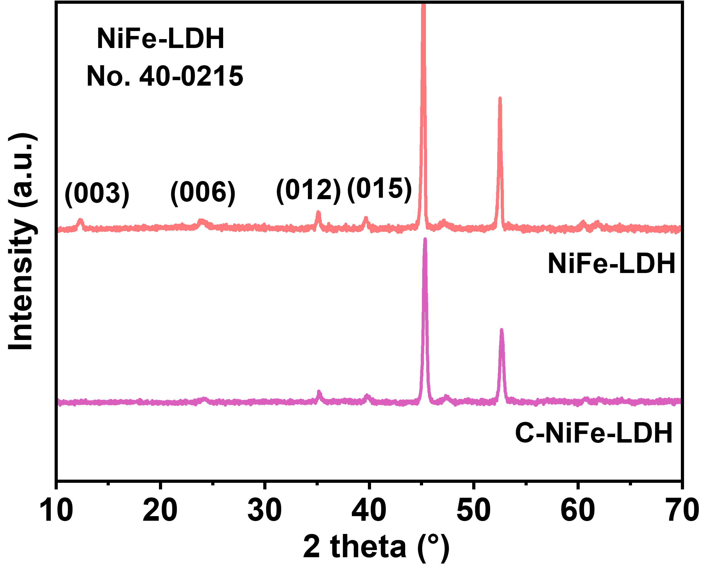
Fig. S35. XRD pattern of NiFe-LDH and C-NiFe-LDH.

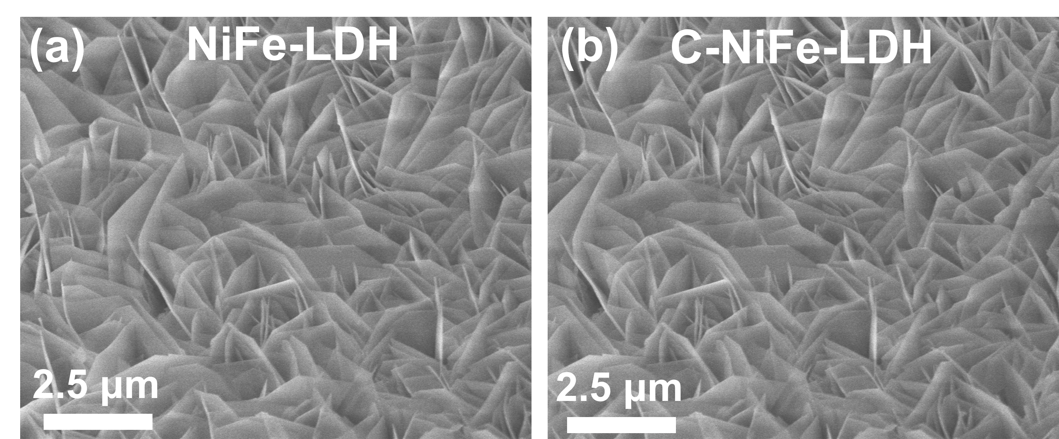
Fig. S36. SEM images of (a) NiFe-LDH and (b) C-NiFe-LDH.

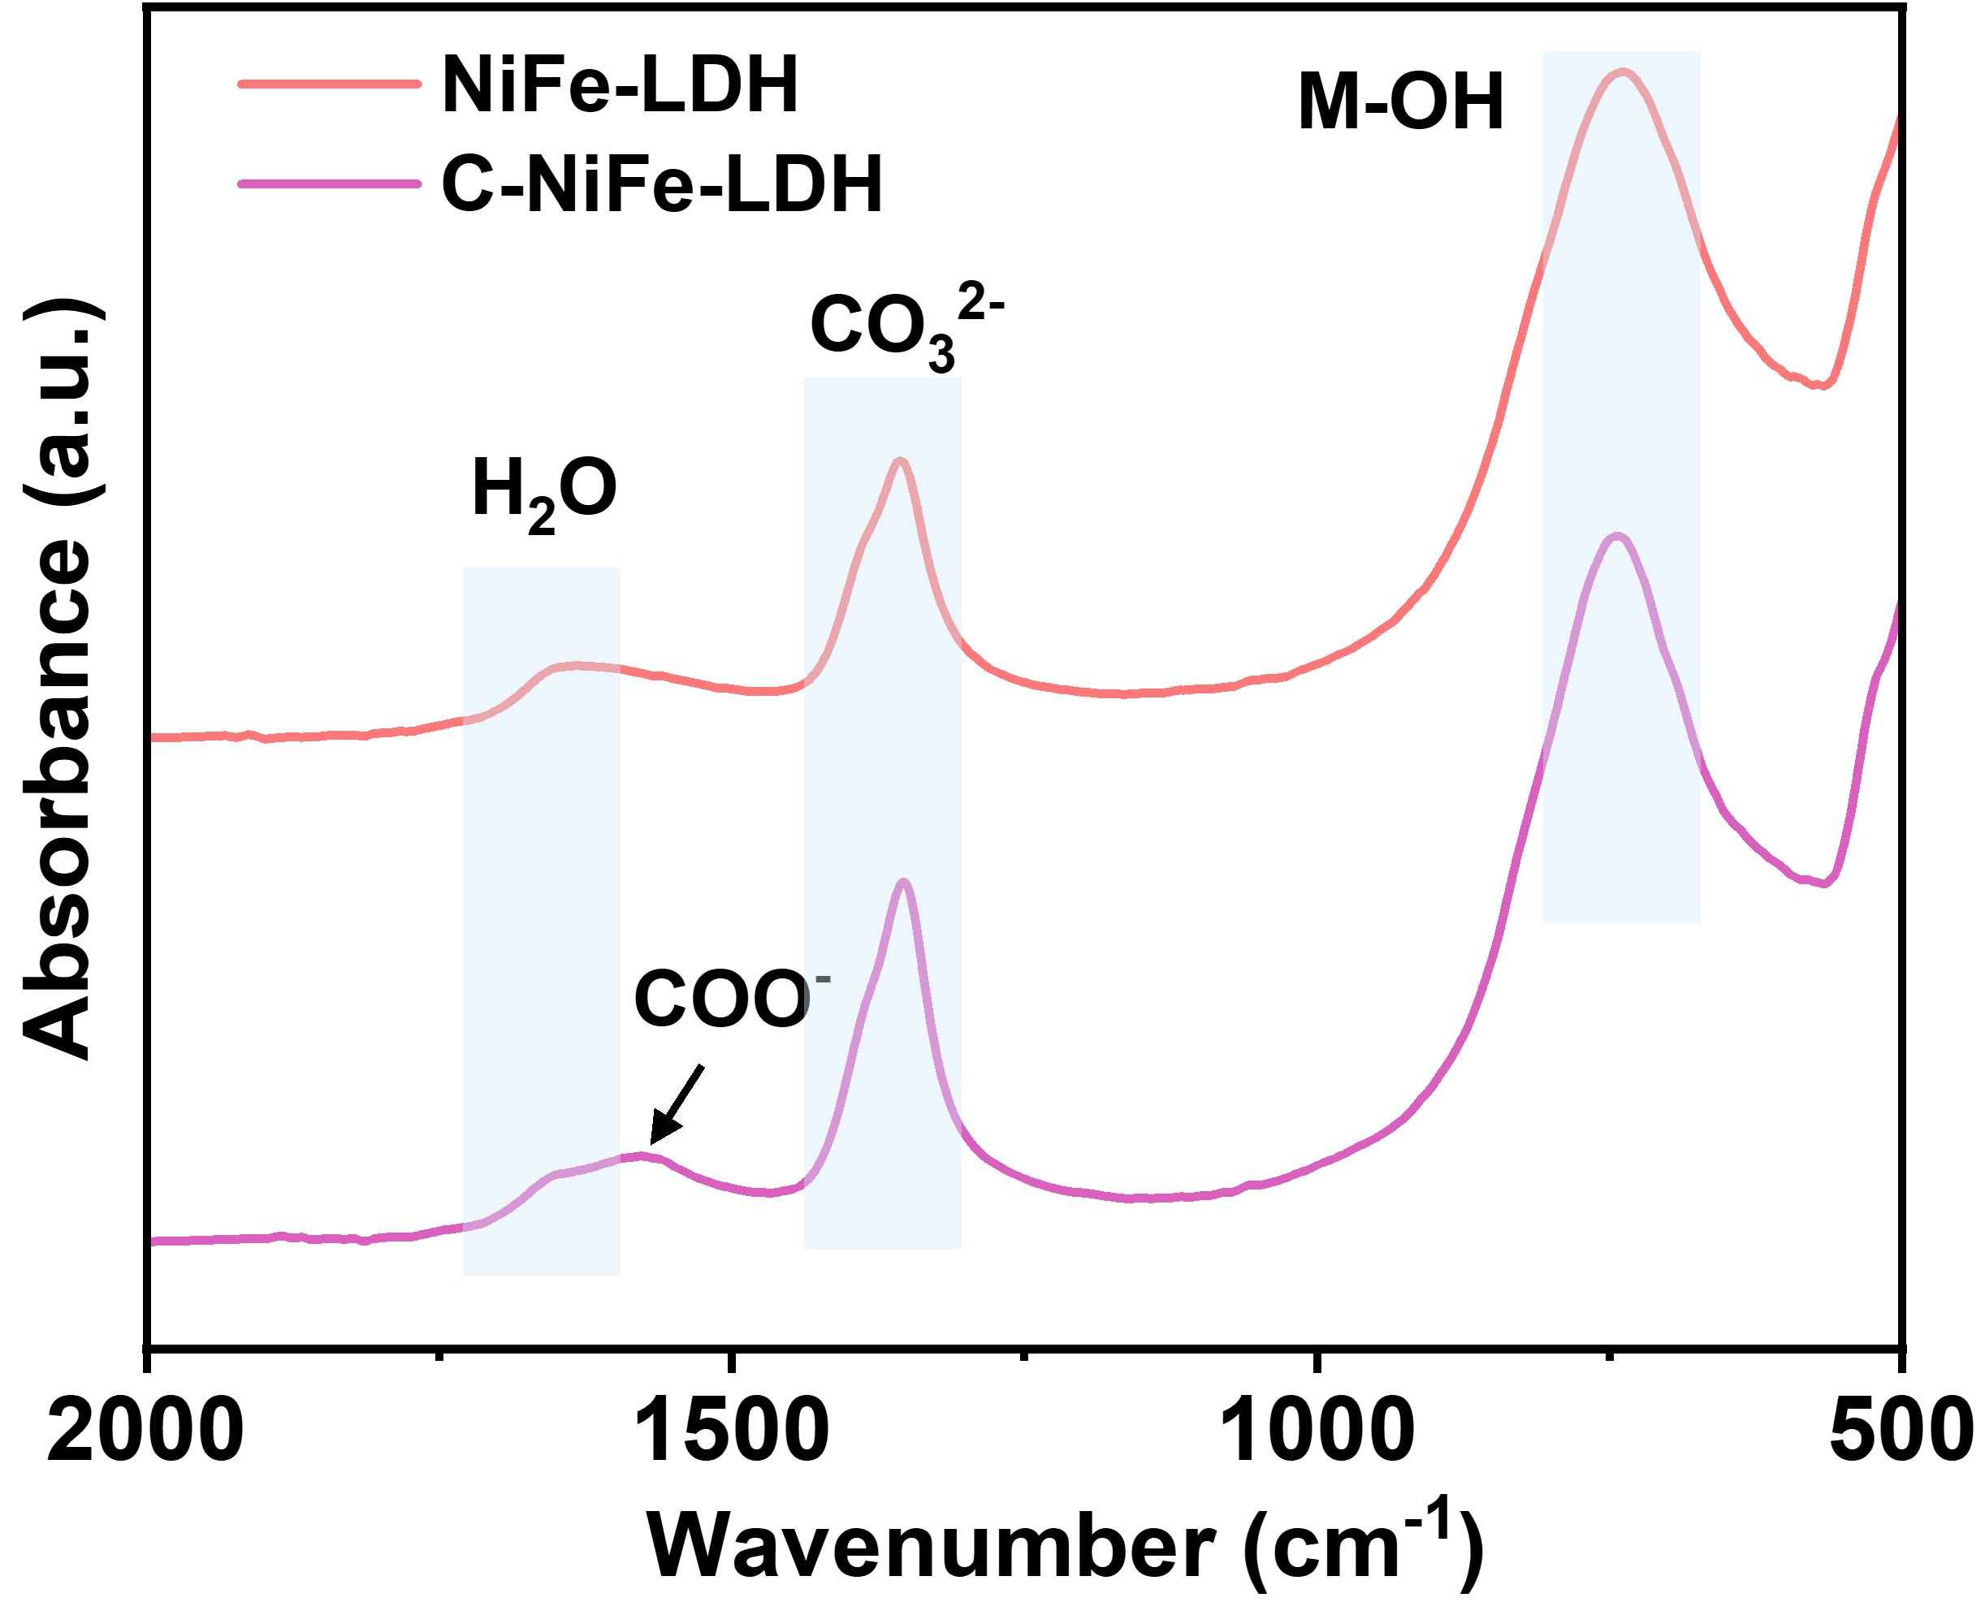
Fig. S37. IR spectrum of NiFe-LDH and C-NiFe-LDH.

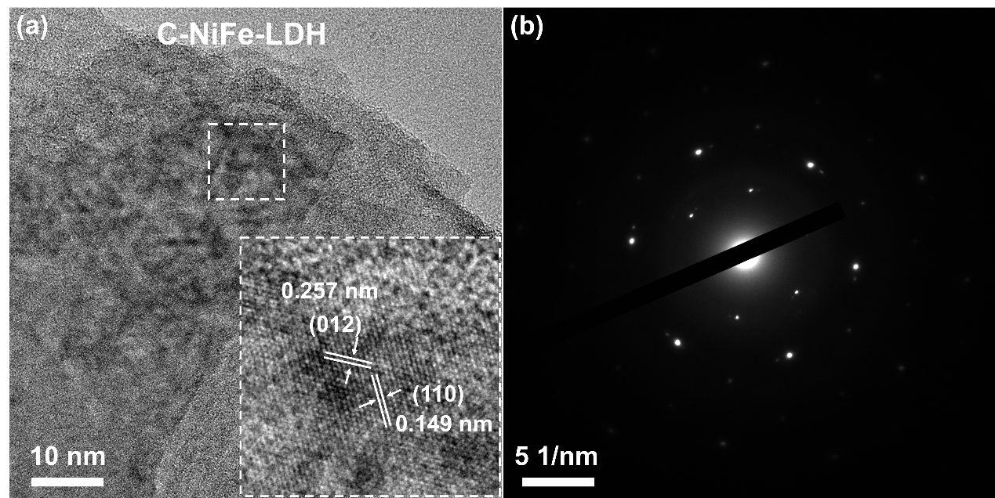
Fig. S38. (a) HRTEM image and (b) SAED pattern of C-NiFe-LDH.

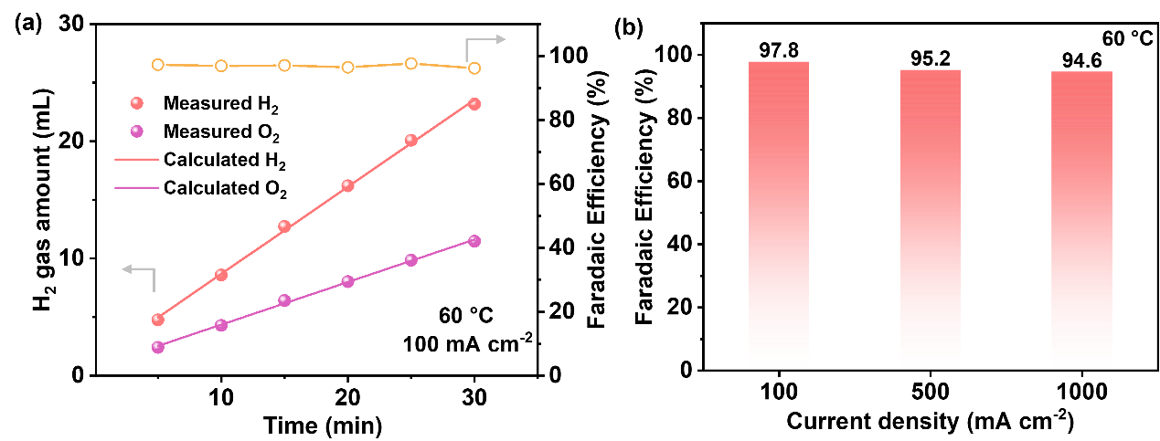
Fig. S39. (a) Gas production measurement for Ni/C-a-NiSe₂// C-NiFe-LDH electrolyzer at 100 mA cm⁻² and (b) the Faraday efficiency at various current density under 60 °C.

Table S4. Production efficiency and economic analysis of direct seawater electrolysis in AEM.
j /A cm⁻² | Voltage /V | theoretical H₂ production rate (mol H₂ cm⁻² s⁻¹) | Faradaic Efficiency (%) | Electrolyzer Power (W cm⁻²) | Efficiency of AEM (%) | H₂ Price ($/kg)
0.1 | 1.56 | 5.18 × 10⁻⁷ | 97.8 | 0.156 | 78.6 | 0.855
0.5 | 1.63 | 2.59 × 10⁻⁶ | 95.2 | 0.815 | 72.9 | 0.918
1.0 | 1.71 | 5.18 × 10⁻⁶ | 94.6 | 1.71 | 69.4 | 0.969

Table S5. Comparison of hydrogen evolution performance in seawater electrolyzers.
Electrolyzer | Electrolyte | Cell voltage at 1 A cm⁻²/V | Stability/h | Refs.
S-FeNiOOH||P-Fe₃O_{4-x} | 1 M KOH+seawater | 1.97@60℃ | 1 A cm⁻²@1000 | ²⁰
Ni_{x}-Fe₃N@NCPs | 1 M KOH + 0.5 M NaCl | 1.72 at 0.5A cm⁻²@25℃ | 0.5 A cm⁻²@1200 | ²¹
NiCoP_{v}@NF | 6 M KOH+seawater | 1.79@60℃ | 0.5 A cm⁻²@120 | ²²
RuO₂//Mo₃Se₄-NiSe | seawater | 1.71 at 0.01A cm⁻²@25℃ | 0.05 A cm⁻²@50 | ¹³
Ni₃FeN@PO₄³⁻/NF//PtNi@NiMoN/NF | 6 m KOH+seawater | 2.09@25℃ | 1 A cm⁻²@140 | ²³
Ru LC Ni(OH)₂//FeNi LDH | 1 M KOH+seawater | 1.77@25℃ | 0.5 A cm⁻²@500 | ²⁴
Ru@NMoC and Pt/C | 1 M KOH+seawater | 1.86@25℃ | 0.5 A cm⁻²@500 | ²⁵
Ru–BOx–OH-300 | 1 M KOH + seawater | 1.95@25℃ | 1 A cm⁻²@400 | ²⁶
Os-Ni₄Mo/MoO₂ | 1 M KOH + seawater | >2.00V@25℃ | 0.2 A cm⁻²@200 | ²⁷
Pt/WO₂ // NiFe LDH | seawater | 2.47 V at 0.5A cm⁻²@60℃ | 0.5 A cm⁻²@100 | ²⁸
NiCoS NAs/NFF | 1 M KOH + seawater | 2.00@30℃ | 0.6 A cm⁻²@500 | ²⁹
RuMoNi | 6 M KOH + seawater | 1.72@80℃ | 0.5 A cm⁻²@240 | ³⁰
Mo₂N //IrO₂ | 1 M KOH + seawater | 1.87@ 60 °C | 1 A cm⁻²@900 | ³¹
S-RuO₂ | 1 M KOH + seawater | 2.01@60℃ | 0.4 A cm⁻²@100 | ³²
Ni/C-a-NiSe₂// C-NiFe-LDH | seawater | 1.81@25℃;1.71@60℃ | 1 A cm⁻²@2000 | This work

References
1 Jiang, F. et al. Triggering Asymmetric Hybridization via Ni–Se–Co Electron Bridges on Rich Amorphous Heterostructured Nickel Selenide for Durable Alkaline Water Splitting. Appl. Catal. B Environ. 372, 125326 (2025).
2 Zhang, Y. H. et al. Hydrothermal Synthesis of NiSe₂ Octahedral Structure and Sodium Ion Storage Performance. J. Electroanal. Chem. 943, 117596 (2023).
3 Song, J. et al. Citrate Ions-Modified NiFe Layered Double Hydroxide for Durable Alkaline Seawater Oxidation. J. Colloid Interface Sci. 679, 1-8 (2025).
4 Kresse, G. & Joubert, D. From Ultrasoft Pseudopotentials to the Projector Augmented-Wave Method. Physical Review B 59, 1758-1775 (1999).
5 Perdew, J. P., Burke, K. & Ernzerhof, M. Generalized Gradient Approximation Made Simple. Phys. Rev. Lett. 77, 3865-3868 (1996).
6 Grimme, S., Antony, J., Ehrlich, S. & Krieg, H. A Consistent and Accurate Ab Initio Parametrization of Density Functional Dispersion Correction (DFT-D) for the 94 Elements H–Pu. J. Chem. Phys. 132, 154104 (2010).
7 Henkelman, G., Uberuaga, B. P. & Jónsson, H. A Climbing Image Nudged Elastic Band Method for Finding Saddle Points and Minimum Energy Paths. J. Chem. Phys. 113, 9901-9904 (2000).
8 Khatun, S. & Roy, P. Mott–Schottky Heterojunction of Se/NiSe₂ as Bifunctional Electrocatalyst for Energy-Efficient Hydrogen Production via Urea-Assisted Seawater Electrolysis. J. Colloid Interface Sci. 630, 844-854 (2023).
9 Maleki, M. et al. Binder-Free P-Doped Ni–Se Nanostructure Electrode toward Highly Active and Stable Hydrogen Production in Wide pH Range and Seawater. J. Electroanal. Chem. 916, 116379 (2022).
10 Dang, Y. et al. Enhanced Alkaline/Seawater Hydrogen Evolution Reaction Performance of NiSe₂ by Ruthenium and Tungsten Bimetal Doping. Int. J. Hydrogen Energy 48, 17035-17044 (2023).
11 Sun, J., Meng, X., Zhang, Z. & Li, Z. Interface-Induced Phase Engineering to Boost Intrinsic Catalytic Activity of Nickel Selenide for Improved Water/Seawater Hydrogen Evolution. J. Alloys Compd. 967, 171815 (2023).
12 Zhang, P. et al. CrO_{x} Modified Nickel Phosphides Electrocatalyst for Stable Hydrogen Evolution Reaction in Neutral Media. Adv. Funct. Mater. 34, 2409365 (2024).
13 Poudel, M. B. et al. Low-Cost Hydrogen Production from Alkaline/Seawater over a Single-Step Synthesis of Mo₃Se₄-NiSe Core–Shell Nanowire Arrays. Adv. Mater. 36, 2305813 (2024).
14 Zhou, H. et al. Interface Engineering Induced Homogeneous Isomeric Bimetallic of CoSe/NiSe₂ Electrocatalysts for High Performance Water/Seawater Splitting. Adv. Sustainable Syst. 9, 2400849 (2025).
15 Xu, Y. et al. Anderson-Type Polyoxometalate-Assisted Synthesis of Defect-Rich Doped 1T/2H-MoSe₂ Nanosheets for Efficient Seawater Splitting and Mg/Seawater Batteries. ACS Appl. Mater. Interfaces 14, 10246-10256 (2022).
16 Afshan, G. et al. Green H₂ Generation from Seawater Deploying a Bifunctional Hetero-Interfaced CoS₂-CoFe-Layered Double Hydroxide in an Electrolyzer. Small 21, 2406431 (2025).
17 Hemmati, K. et al. Nanorod Array-Based Hierarchical NiO Microspheres as a Bifunctional Electrocatalyst for a Selective and Corrosion-Resistance Seawater Photo/Electrolysis System. ACS Catal. 13, 5516-5528 (2023).
18 Ge, Z. Q. et al. p–d Orbitals Coupling Heterosites of Ni₂P/NiFe-LDH Interface Enable O─H Cleavage for Water Splitting. Adv. Funct. Mater. 34, 2411024 (2024).
19 Diao, L. et al. Interface-Engineered 3D Porous MoS₂–ReS₂ In-Plane Heterojunction as Efficient Hydrogen Evolution Reaction Electrocatalysts. J. Colloid Interface Sci. 661, 957-965 (2024).
20 Yu, Q. et al. Regulating Local Atomic Environment of Fe₃O₄ to Promote Anion-Exchange-Membrane-Based Alkaline Seawater Electrolysis. Appl. Catal. B Environ. 361, 124598 (2025).
21 Wang, G. et al. The Ni Heteroatom-Induced Electronic Structure Tailoring of Ultrastable Fe₃N@NCPs Nanosheets Electrocatalyst for Boosting Alkaline Seawater Electrolysis. Adv. Funct. Mater. 34, 2404470 (2024).
22 Guo, L. et al. Phosphorus Defect Mediated Electron Redistribution to Boost Anion Exchange Membrane-Based Alkaline Seawater Electrolysis. Adv. Energy Mater. 14, 2400975 (2024).
23 Hu, H. et al. Engineered Nickel–Iron Nitride Electrocatalyst for Industrial-Scale Seawater Hydrogen Production. Adv. Mater. 37, 2415421 (2025).
24 Wang, L. et al. Manipulating the Microenvironment of Single Atoms by Switching Support Crystallinity for Industrial Hydrogen Evolution. Angew. Chem. Int. Ed. 63, e202317220 (2024).
25 Zhao, J. et al. Delicate Control Over Electron Distribution and Water Dissociation Kinetics in Strongly Coupled Ru@NMoC Hybrid Catalyst Realizes Efficient Seawater Electrolysis. Angew. Chem. Int. Ed. 64, e202505031 (2025).
26 Shen, L. W. et al. Ruthenium Nanoparticles Decorated with Surface Hydroxyl and Borate Species Boost Overall Seawater Splitting via Increased Hydrophilicity. Energy Environ. Sci. 17, 3888-3897 (2024).
27 Liu, D. et al. Efficient and Ultrastable Seawater Electrolysis at Industrial Current Density with Strong Metal-Support Interaction and Dual Cl−-Repelling Layers. Adv. Mater. 36, 2408982 (2024).
28 Bao, D. et al. Dynamic Creation of a Local Acid-like Environment for Hydrogen Evolution Reaction in Natural Seawater. J.Am.Chem.Soc. 146, 34711-34719 (2024).
29 Na, J., Yu, H., Chi, J., Jia, S. & Shao, Z. Operando Electrochemical Reduction Reconstruction Boosted Long-Term Overall Seawater Splitting. ACS Energy Lett. 10, 788-797 (2025).
30 Kang, X. et al. A Corrosion-Resistant RuMoNi Catalyst for Efficient and Long-Lasting Seawater Oxidation and Anion-Exchange-Membrane Electrolyzer. Nature Commun. 14, 3607 (2023).
31 Zhang, X. L. et al. In Situ Ammonium Formation Mediates Efficient Hydrogen Production from Natural Seawater Splitting. Nature Commun. 15, 9462 (2024).
32 Liu, Y. et al. Surface S-Doped Nanostructured RuO₂ and Its Anion Passivating Effect for Efficient Overall Seawater Splitting. ACS Nano 19, 2715-2725 (2025).

