Supplementary Materials

Supplementary Discussion 1:
To assess the broader impact of these materials, nanoporous High Entropy Alloy (HEA) is compared to Steel DP600, a widely used component in automobile manufacturing [1]. The nanoporous Al_{0.1}CoCrFeNi system, with a relative density of 28.9% and a ligament size of 4.23 nm, has a calculated density of 2100.45 kg/m³. Its specific strength and specific modulus are 0.159 MPa/(kg/m³) and 0.00769 GPa/(kg/m³), respectively. In contrast, Steel DP600 has a significantly higher density of 7800 kg/m³, with specific strength and specific modulus values of 0.046 MPa/(kg/m³) and 0.0273 GPa/(kg/m³), respectively.
The nanoporous HEA not only demonstrates superior specific strength and modulus, enhancing safety performance, but also has a density that is just 26.9% of DP600’s density. This significant reduction in density can contribute to lower fuel consumption and decreased CO₂ emissions. Studies indicate that for every 100 kg reduction in vehicle weight, CO₂ emissions decrease by 11 g/km [2]. Since steel constitutes approximately 70% of a vehicle’s total weight, the average steel content in a car is estimated at 1319.59 kg, based on an average vehicle weight of 1885.13 kg [2,3]. Replacing steel with nanoporous HEA would result in a weight reduction of 964.24 kg, bringing the vehicle’s weight down to 49% of its original mass. This translates to a reduction in carbon emissions of 106.07 g/km and a fuel consumption savings of 3.86 L per 100 km, equating to a 40% decrease in fuel usage.
Moreover, the remarkably high density of nanopores significantly increases the surface-to-volume ratio, enhancing radiation tolerance. In nanoporous HEAs, surfaces function as unsaturable sinks for defects, enabling a self-healing mechanism that makes them highly promising for next-generation nuclear reactors. Notably, materials such as NbMoTaW, when used for additional shielding and as fusion first-wall components, demonstrate remarkable helium radiation resistance [4-7].

Supplementary Discussion 2:
The phase separation was achieved through demixing of the fcc Ni-Cu system, where atomic concentrations were determined based on the relative density. This process utilized a lattice parameter of 0.356 nm and an embedded atom method (EAM) interatomic potential for Ni-Cu [8,9]. Additionally, a fully repulsive Lennard-Jones potential was implemented to model atomic interactions between Ni and Cu, ensuring complete immiscibility within the system [10]. A Nose/Hoover thermostat ensemble was applied at a temperature exceeding the Ni-Cu system’s melting point for a predefined duration to induce phase separation. Extended demixing times led to increased ligament sizes, with a 100 ps demixing period used for larger ligaments and a 50 ps duration for smaller ligament structures. Upon completion of the process, the Cu phase was removed, leaving behind a Ni scaffold, which served as the framework for randomly placing atoms comprising the disordered fcc crystalline phase with an Al_{0.1}CoCrFeNi composition.
The structures shown in Figures S6 and S9 do not exhibit true bimodal porosity. The fine internal texture is due to atomic-scale roughness that arises from the non-equilibrium dealloying-like simulation process. These features reflect local curvature and surface faceting, not secondary pores. We estimate this surface roughness increases the specific surface area by ~15-25% compared to an ideal bicontinuous structure with smooth ligaments. Simulation cell dimensions and resolution details are provided in Supplementary Discussion 5.
A similar approach was employed using a W-Ta binary system with a lattice parameter of 0.316 nm to generate the nanoporous NbMoTaW system [11]. While this method may not directly correspond to a physically realistic means of experimentally producing nanoporous materials, it provides a suitable bicontinuous structure necessary for simulation analysis.

Supplementary Discussion 3:
The energy barrier calculations for the a/2<110>{111} edge dislocation in the Al_{0.1}CoCrFeNi, Ni, and Co systems were conducted using the nudged elastic band method. In this approach, a slab is oriented with x//$[1\underline{1}0]$, y//$[111]$, and z//$[11\underline{2}]$ directions for the bulk material, with dimensions 12.50nm x 12.37nm x 13.12nm.
Atomsk software is used to introduce an edge dislocation at the center of the simulation box by removing a half-plane below the glide plane while maintaining periodicity along the x-axis [20]. A second identical system is created, but with an edge dislocation shifted by one y lattice parameter unit. Both systems undergo minimization with periodic boundary conditions applied in the x and z directions and shrink-wrapped boundary conditions in the y direction. After minimization, the nudged elastic band method is applied to determine the potential energy landscape between the two reaction coordinates, expressed in eV per unit length along the x-direction.
The Potential Energy Landscape (PEL) of the edge dislocations are displayed in Figure S3 where the Al_{0.1}CoCrFeNi dislocation is shown to have the highest PEL compared to the single constituent materials.

Supplementary Discussion 4:
While the Dislocation Extraction Algorithm (DXA) is generally effective in identifying defects in fcc systems, it may be overly simplistic for bcc structures (as discussed in Supplementary Discussion 2), where it could potentially overlook defects such as planar faults and less common dislocations beyond screw and edge dislocations. To address these limitations, the bcc defect analysis (BDA) tool is utilized, leveraging the common neighbor analysis method integrated into OVITO [12,13].
Using the BDA tool, we identified minute twin boundaries within the nodes of the nanoporous system that were not detected in the initial DXA analysis. Additionally, the BDA revealed a greater number of dislocations at higher strain values compared to DXA, particularly in regions where ligament fracture was occurring as showcased in Figure S9.

Supplementary Discussion 5:
An analysis of the Burgers vectors in the Al_{0.1}CoCrFeNi system reveals that Shockley partial dislocations with a Burgers vector of a/6<112> dominate at low strain levels in both high- and low-temperature experiments. While these dislocations remain the most prevalent, other types, including a/3<1-00> stair-rod dislocations and a/3<110> Lomer dislocations, are also observed. These dislocation types are frequently reported in experimental studies of bulk Al_{0.1}CoCrFeNi [14,15].
With increasing strain, noticeable changes in dislocation behavior emerge. Ligament systems experiencing approximately 35% strain or higher begin to exhibit dislocations with Burgers vectors a/18<721> and a/18<552>, which appear to be associated with grain boundaries in the fcc lattice structure [16]. As strain continues to rise, these dislocation types progressively surpass the Shockley partials. This abrupt shift in dislocation characteristics is likely due to the formation of grain boundaries as ligaments come into contact under high compressive strain (Figure S10).
The strain threshold at which these dislocations appear is influenced by the relative density of the Al_{0.1}CoCrFeNi nanoporous system, with higher relative density samples exhibiting these dislocations at lower strain values. Moreover, smaller ligament systems appear to impact dislocation development by increasing the strain required for the formation of a/18<721> and a/18<552> dislocations at comparable relative densities. This behavior mirrors observations of grain boundary formation during thermal coarsening in nanoporous Au ¹⁷.
In the NbMoTaW system, the most prevalent dislocation types observed during both tension and compression are a/2<111> edge and screw dislocations. Comparisons with other molecular dynamics and density functional theory calculations indicate the edge dislocations play a critical role in governing the strength of refractory HEAs [18,19]. At higher strain levels, a/2<111> dislocations remain dominant; however, other less common dislocation types, such as a<100> and a<110>, increase in density as strain values rise. The presence of a<110> dislocations is another characteristic feature of NbMoTaW that contributes to its strength control [19].

Supplementary Discussion 6:
The energy barrier calculations for the a/2<111>{110} edge dislocation in both the NbMoTaW and W systems were conducted using the nudged elastic band method. In this approach, a slab is oriented with x//$[1\underline{1}0]$, y//$[111]$, and z//$[11\underline{2}]$ directions for the bulk material, with dimensions 13.79nm x 16.75nm x 12.74nm. A nanopillar with a 5 nm diameter is then generated along the y-axis with dimensions 22.91nm x 13.89nm x 15.87nm.
Atomsk software is used to introduce an edge dislocation at the center of the simulation box by removing a half-plane below the glide plane while maintaining periodicity along the y-axis [20]. A second identical system is created, but with an edge dislocation shifted by one y lattice parameter unit. Both systems undergo minimization with periodic boundary conditions applied in the y and x directions and shrink-wrapped boundary conditions in the z direction. After minimization, the nudged elastic band method is applied to determine the potential energy landscape between the two reaction coordinates, expressed in eV per unit length along the x-direction.

Supplementary Discussion 7:
The surface energy appears to vary depending on the type of mechanical test performed. As shown in Figure S11, the surface energy under both compressive and tensile tests for the 600 K and 1273 K systems follows distinct patterns. In tensile tests, surface energy initially increases before stabilizing for most of the strain range, with a slight decline at higher strain levels. However, higher temperatures tend to suppress these surface energy increases, and in some cases, surface energy even decreases at higher strain levels.
In compression tests, surface energy follows a similar trend: an initial increase, followed by a plateau, and then a growth phase at higher strains. These surface energy trends under compression are consistent with previous nanoporous W simulations, which exhibit similar surface energy versus strain behavior [21].
Temperature influences surface energy differently in compression and tensile tests. At higher strain levels, increasing temperature reduces surface energy in tensile tests but enhances it in compression. While previous studies suggest that decreasing surface energy may drive a transition from twinning to perfect dislocation plasticity, no such shift in the deformation mechanism was observed for the second-highest surface energy system, which has a relative density of 46.9% and ligament size of 3.04 nm. It is likely that even higher surface energy levels would be necessary to induce such a transformation in the deformation mechanism.
It is important to highlight that the behavior of the 46.9% relative density system with a 2.57 nm ligament size deviates from other systems at higher temperatures and strain levels (Figure S11). This difference is particularly noticeable in tensile tests, where the surface energy of the 46.9% density, 2.57 nm ligament system continues to rise, whereas the other systems either plateau or decline. A similar trend is observed in compression tests, where the 46.9% density system exhibits lower surface energy at higher strains compared to the 65.9% relative density system with a 3.04 nm ligament size. These variations may be attributed to the small ligament sizes breaking down in a manner similar to the 27.8% density, 2.20 nm ligament system, which became unstable at elevated temperatures. This instability may be further intensified by the high strain conditions.
Surface energy and surface stress, while related, are distinct physical quantities. Surface energy refers to the thermodynamic cost of creating new surface area (bond breaking), whereas surface stress relates to the mechanical strain imposed on surface atoms that are not in equilibrium positions. While increased surface stress can influence roughness and defect interactions, the two are not strictly proportional. Additionally, mechanical loading can modify surface atom configurations, potentially reducing surface stress. Environmental effects (e.g., oxidation) may also alter surface stress and surface chemistry [22,23].

Supplementary Discussion 8:
A crucial consideration when comparing MD results with experimental findings is the significantly high strain rate inherent in MD simulations, which generally leads to higher yield strengths. This discrepancy is particularly evident when contrasting stress-strain calculations for bulk gold between experiments and simulations. In MD simulations, the yield strength is approximately 8.21 GPa, whereas experimental measurements report yield strengths around 205 MPa [24,25].
This difference is especially pronounced in bulk and nanocrystalline/polycrystalline systems, where high strain rates induce unique defect mechanisms that contribute to increased strength, such as the formation of low dislocation densities. The primary factors responsible for the elevated strength observed in MD simulations appear to be the high strain rate and the relatively small system volume [26].
However, this concern becomes less significant when studying nanoporous materials with bicontinuous structures. MD simulations of nanoporous gold and platinum show remarkable agreement with experimental data, even when accounting for high strain rates, as illustrated in the Gibson-Ashby plot in Figure 1 of the main text [27-32]. This consistency can be attributed to the fact that the ligaments in nanoporous structures behave similarly to nanowires or nanopillars, typically measuring in the tens of nanometers. As a result, the mechanical response observed in simulations closely aligns with experimental findings. Theoretical yield strengths obtained from MD simulations match well with expected experimental values, which are primarily influenced by nanopillar orientation and size [33].
The primary difference between simulation and experimental results lies in the strain value at which the yield strength is reached, with experimental values generally being lower than those observed in MD simulations [33]. Given that the MD simulations in this study involve ligaments smaller than 10 nm and employ large-scale models with over 2,000,000 atoms, it is reasonable to anticipate that experimental data under similar conditions would yield comparable results.

Supplementary Discussion 9:
Many of the nanoporous systems examined in this study exhibit an fcc crystal structure. The exceptions are nanoporous NbMoTaW and W, both of which demonstrate significantly higher yield strengths compared to other fcc nanoporous materials. Unlike fcc systems that deform primarily along {111} close-packed planes, bcc metals lack true close-packed planes. Instead, plasticity occurs through complex slip involving {110}, {112}, or {123} planes, often dominated by screw dislocations with non-planar cores [34].
In fcc metals, slip is governed by dislocation glide along the close-packed {111} planes in the a/2<110> directions, which offer the lowest energy pathways for plastic deformation [34]. Low stacking fault energies facilitate the splitting of dislocations into partial dislocations, which then dissociate onto these closely packed planes, making slip relatively easy compared to bcc structures [34].
The primary dislocation type in bcc structures is the screw dislocation, which inherently lacks well-defined slip planes. This constraint reduces the mobility of screw dislocations relative to faster-moving edge dislocations, ultimately increasing strength while decreasing the ductility of bcc materials [35]. By integrating a nanoporous bicontinuous architecture with a bcc crystal structure, the intrinsic brittleness of bcc materials can be mitigated by lowering the Young’s modulus, following Gibson-Ashby scaling laws [36].
This concept of bcc materials exhibiting higher strengths extends to nanoporous HEA systems, which may demonstrate even greater strain hardening compared to single-element materials. In bcc HEAs, solid solution strengthening suggests that at low stress levels, common screw and edge dislocations remain immobile until a critical stress threshold is reached. This results in exceptionally high strength at low strain levels. Once this critical stress is exceeded, both dislocation types exhibit similar behavior with relatively low velocities. This contrasts with single-element bcc materials, where screw dislocations primarily govern ductility, while edge dislocations move more rapidly and contribute significantly to plastic deformation [34].
The reduced mobility of dislocations increases the likelihood of dislocation-dislocation interactions, potentially promoting dislocation multiplication and enhancing strain hardening [35]. The response to high strain varies depending on the specific bcc HEA being examined. For example, the bcc HEA Co_{16.67}Fe_{36.67}Ni_{16.67}Ti₃₀ exhibits a transition from jerky motion to smooth gliding dislocations at high strain levels, similar to other single-element bcc materials [35]. In contrast, the TiZrNbHfTa bcc system exhibits significant cross-slipping during fracture analysis, a behavior absent in the previously mentioned bcc HEA, thereby enhancing ductility [27]. This highlights the importance of selecting an appropriate bcc HEA to mitigate slip mechanisms that could accelerate ligament failure in a nanoporous system.

a)  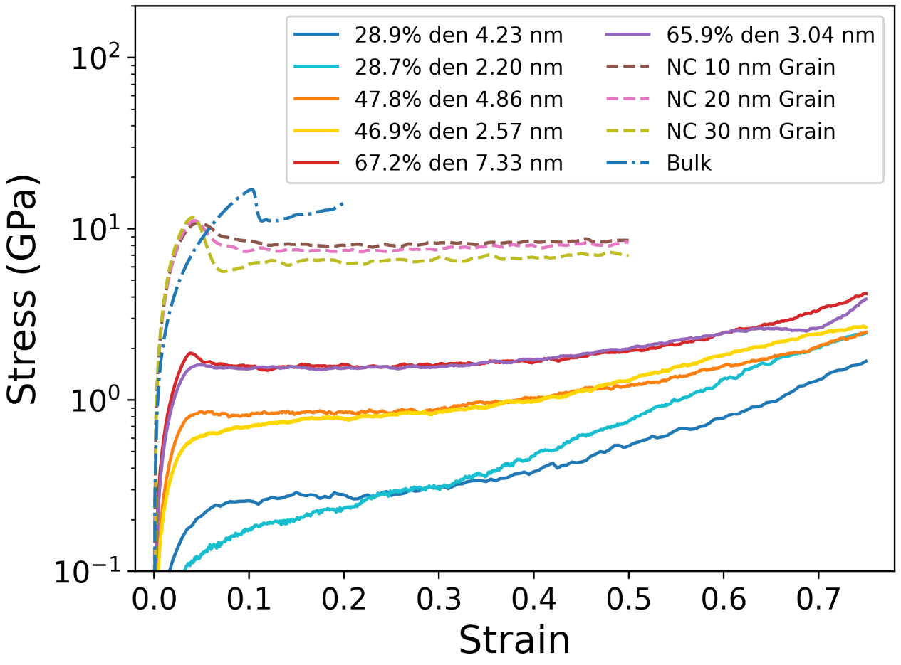 | d)  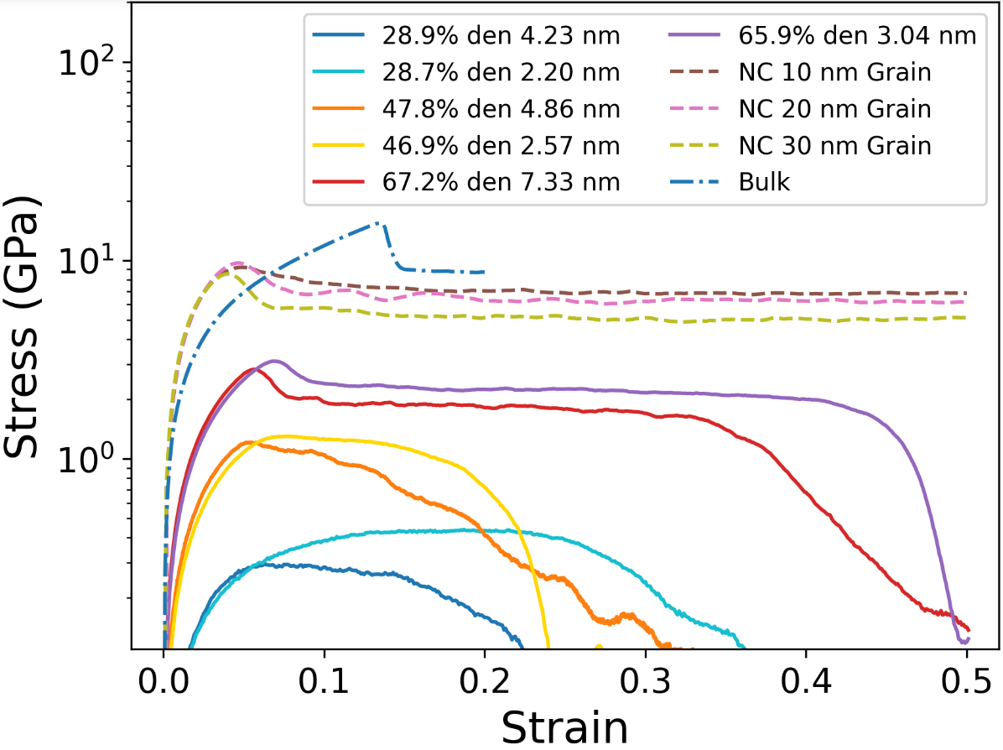
b)  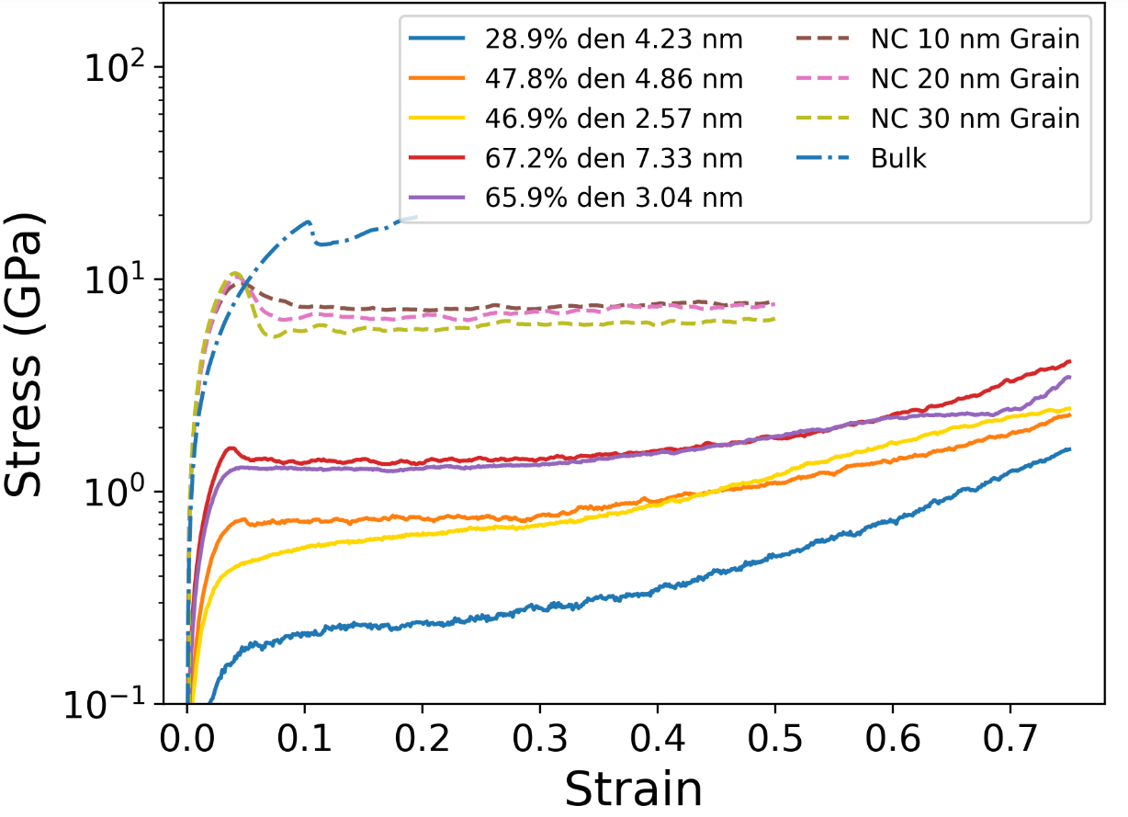 | e)  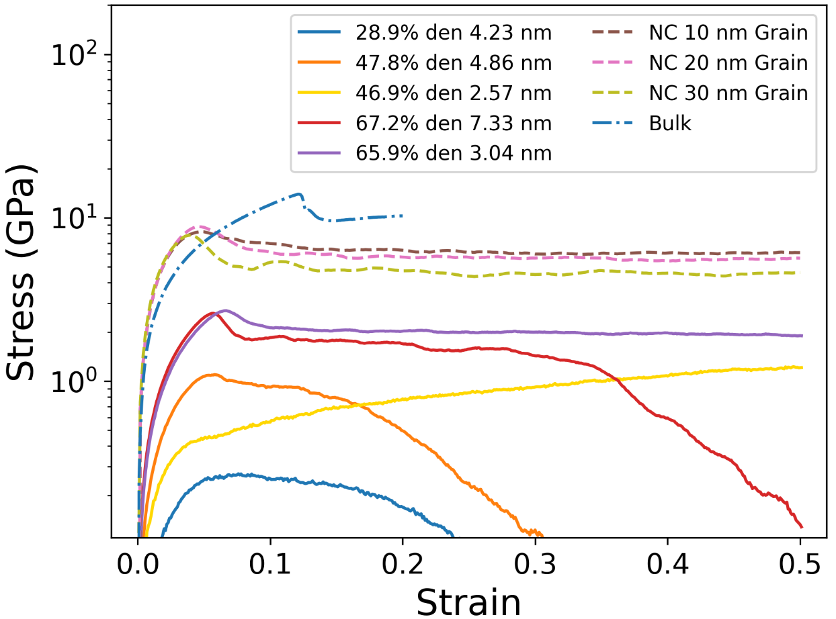
c)  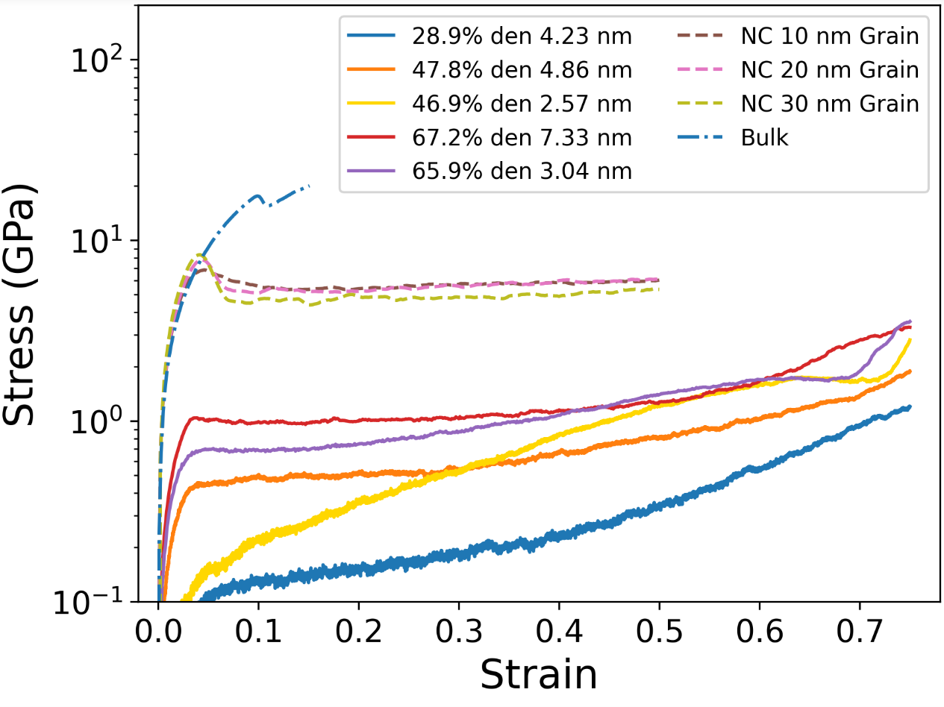 | f)  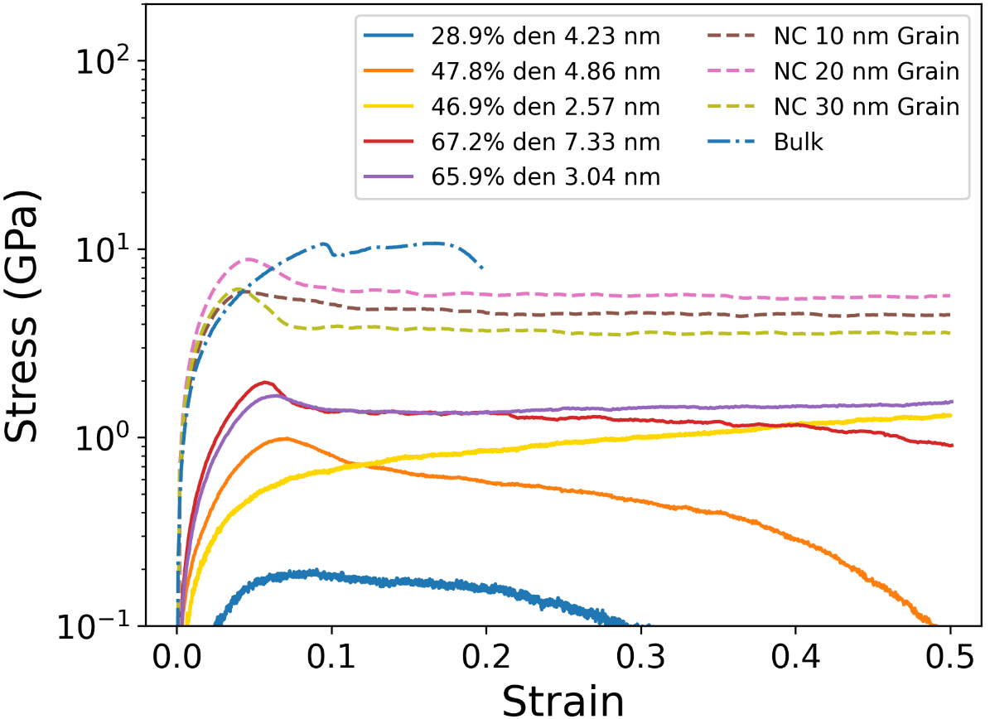
Figure S1. Stress strain curves of Al_{0.1}CoCrFeNi systems under compression at (a) 298 K, (b) 600 K, (c) 1273 K and tension at (d) 298 K, (e) 600 K, (f) 1273 K. NC represent nanocrystalline systems.

a)  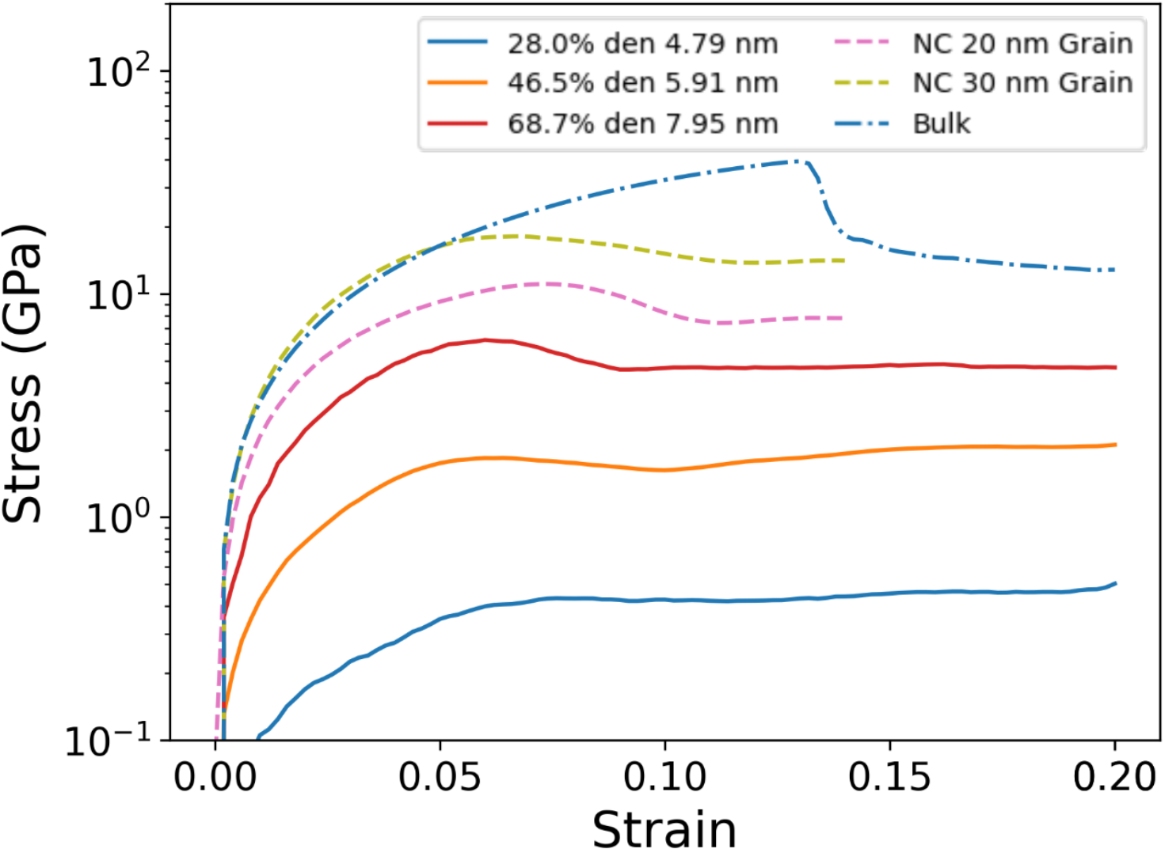 | d)  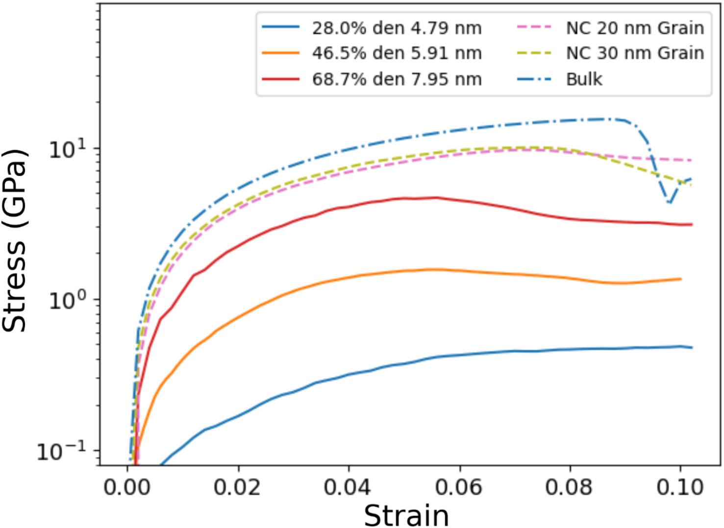
b)  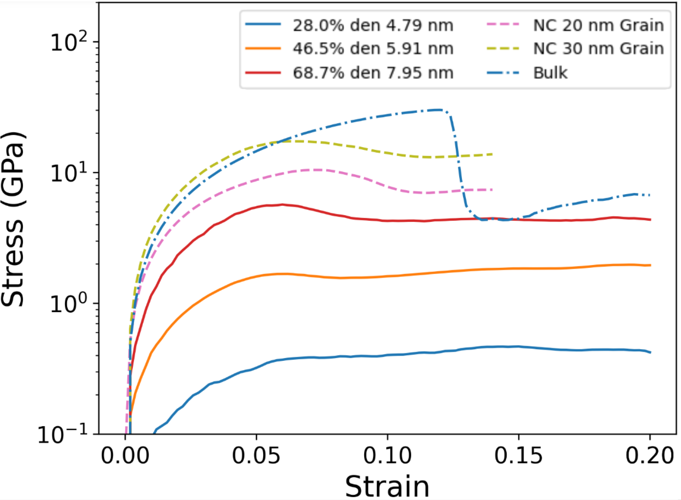 | e)  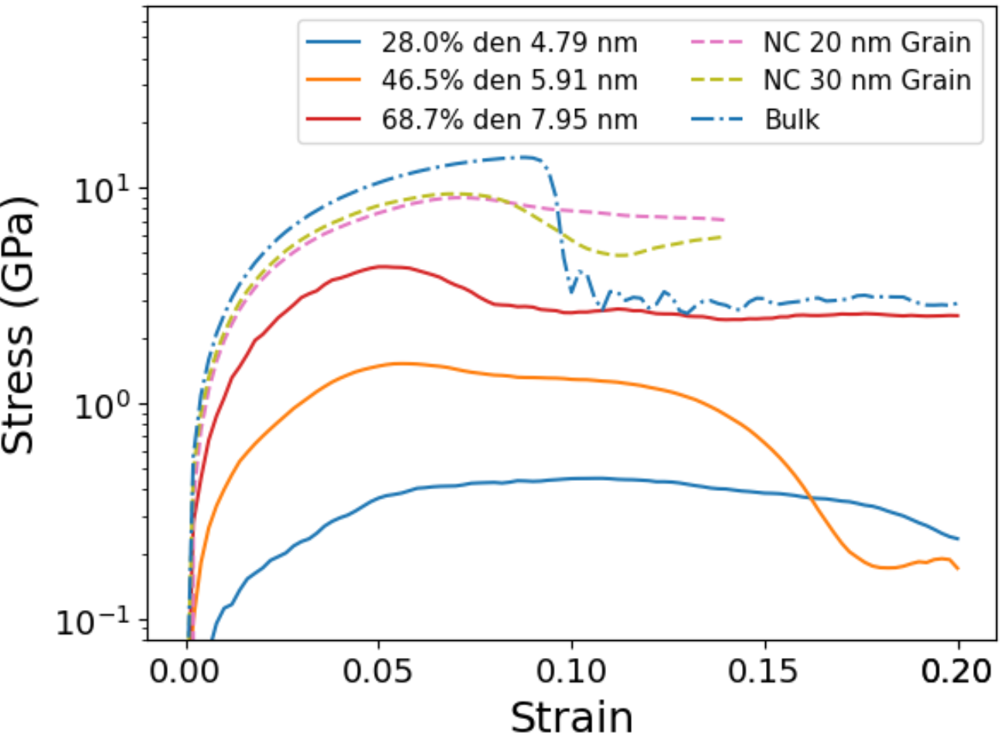
c)  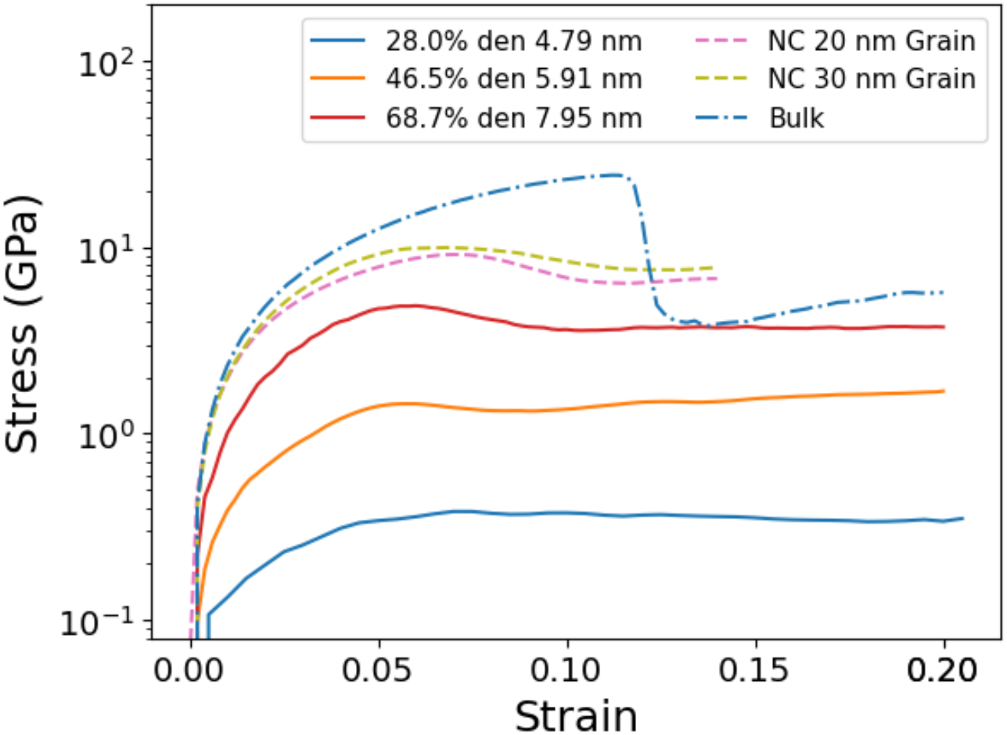 | f)  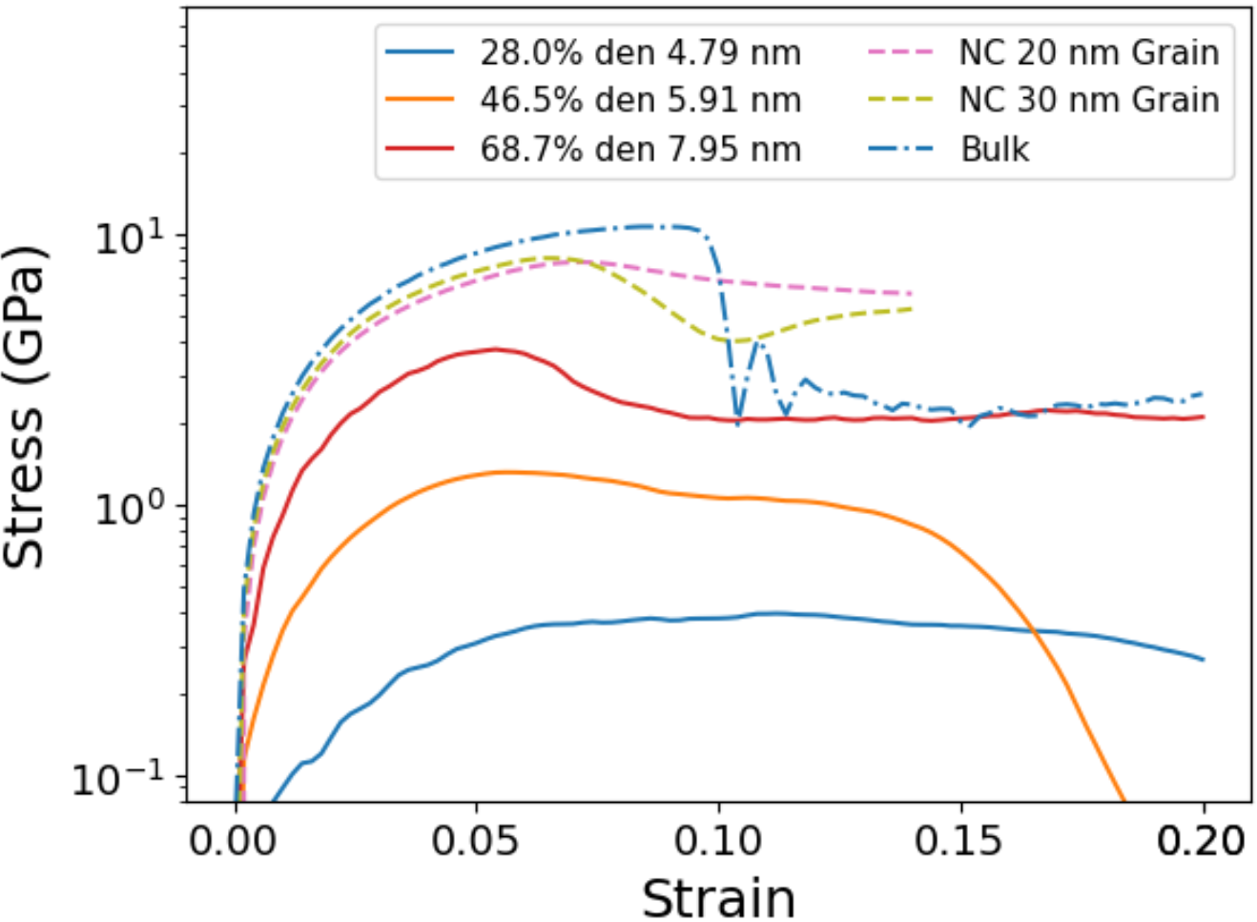
Figure S2. Stress strain curves of NbMoTaW systems under compression at (a) 298 K, (b) 600 K, (c) 1273 K and tension at (d) 298 K, (e) 600 K, (f) 1273 K. NC represents nanocrystalline systems.

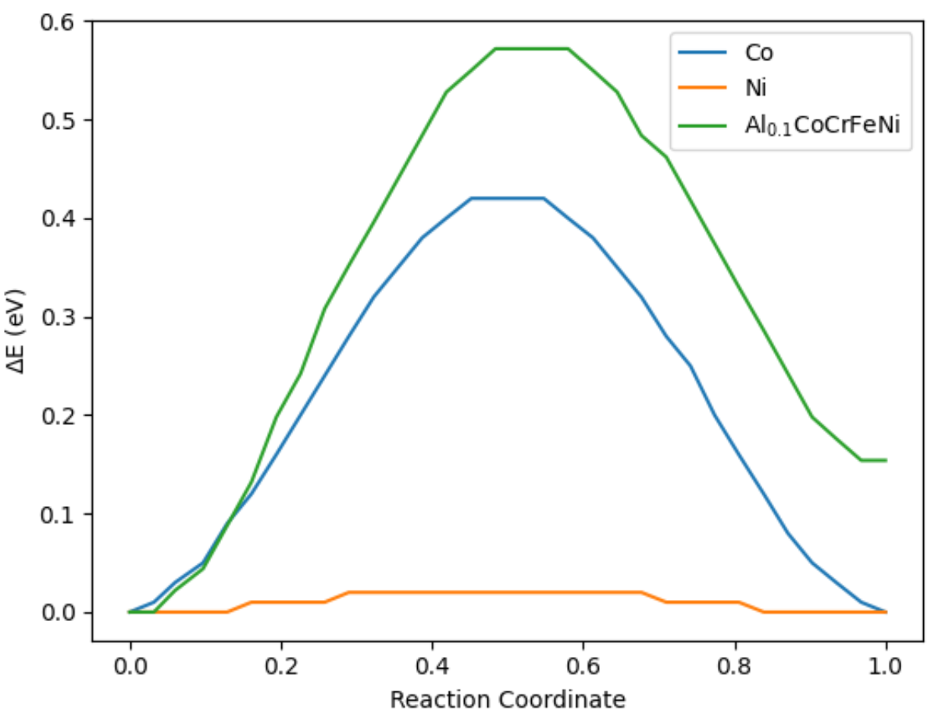

Figure S3. Potential energy landscape of Al_{0.1}CoCrFeNi, Co, and Ni in units of eV for the a/2<110>{111} edge dislocations.

a)  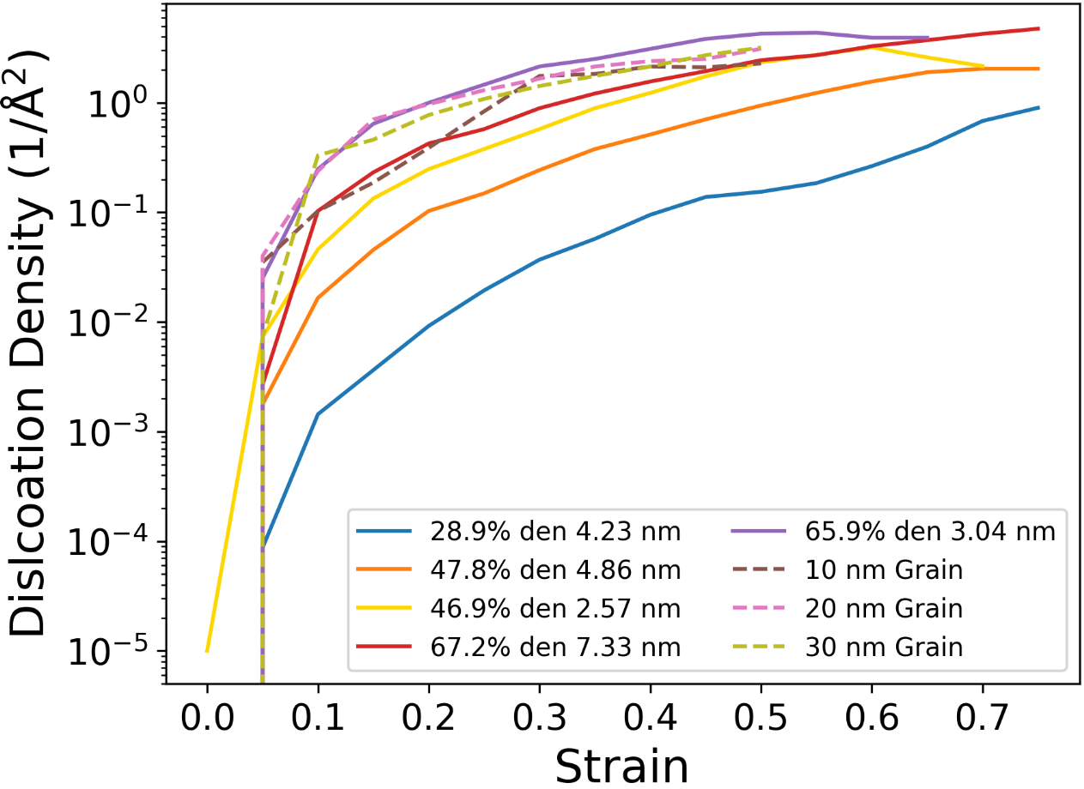 | b)  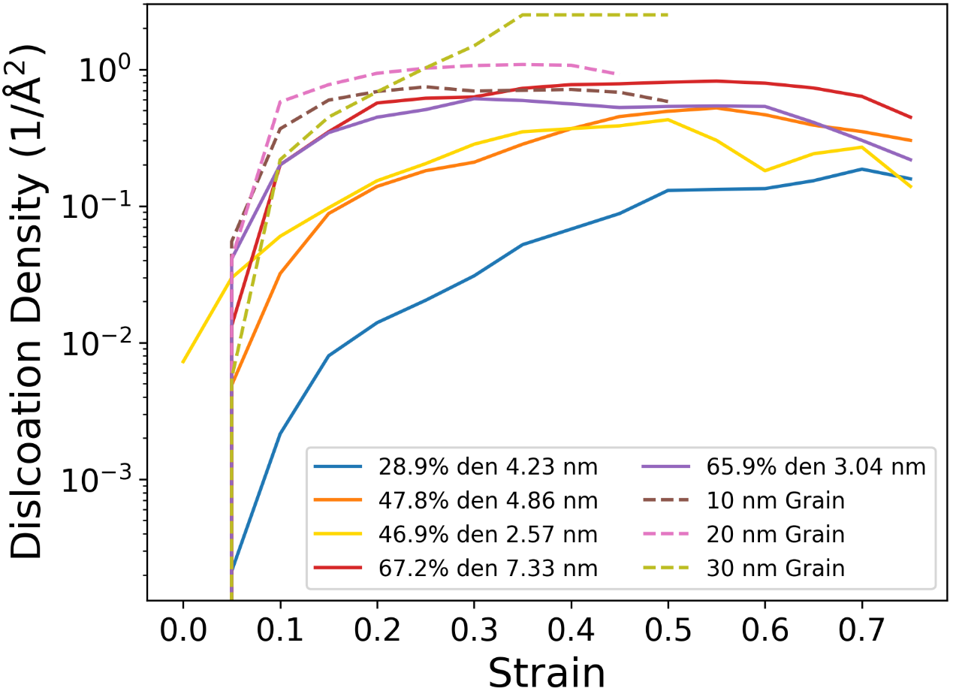
c)  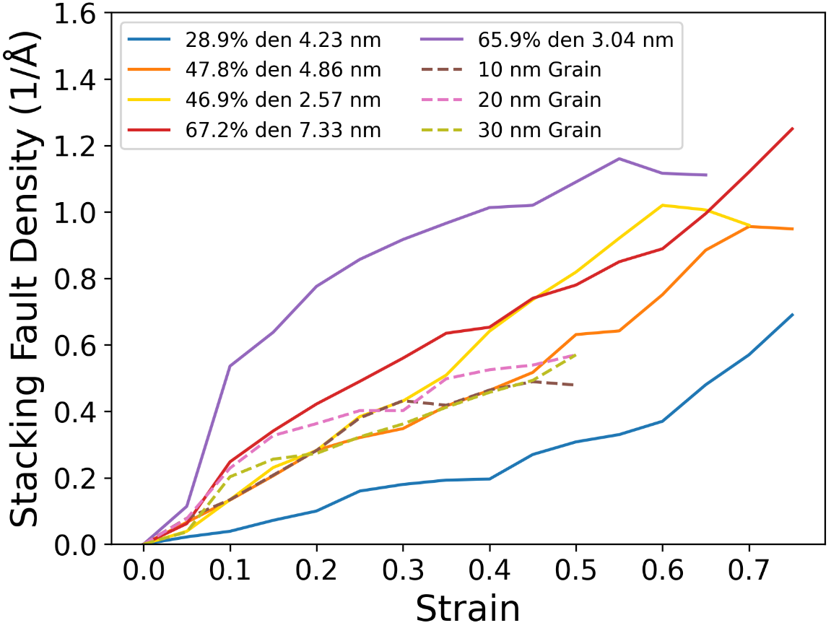 | d)  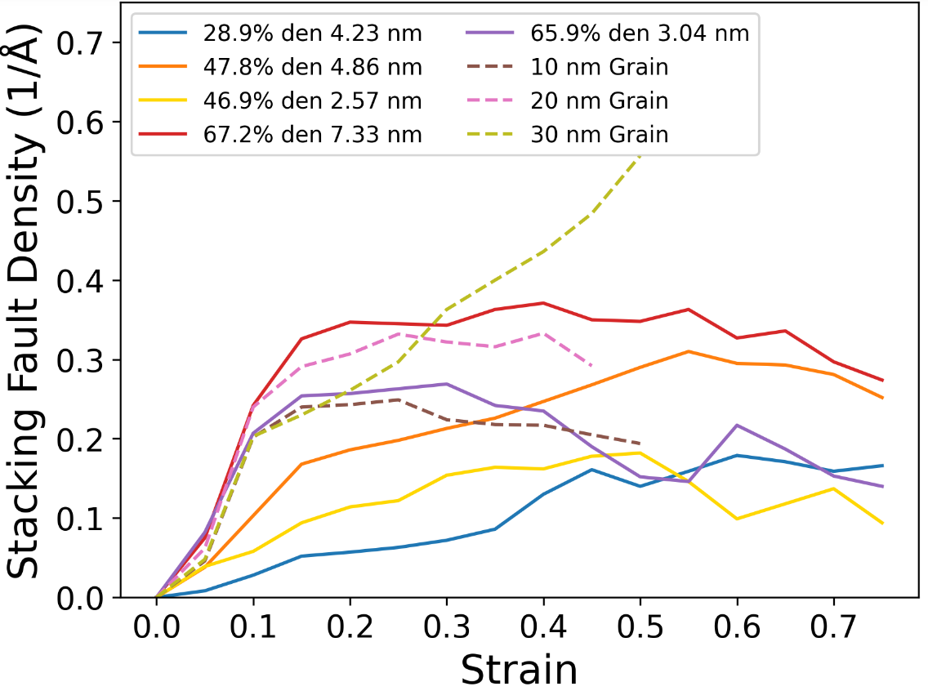
Figure S4. Dislocation concentration vs strain at 600 K (a) / 1273 K (b) and stacking fault concentration vs. strain at 600 K (c) / 1273 K (d) for the Al_{0.1}CoCrFeNi HEA systems under compression. Nanocrystalline systems are shown as dashed curves.

a)  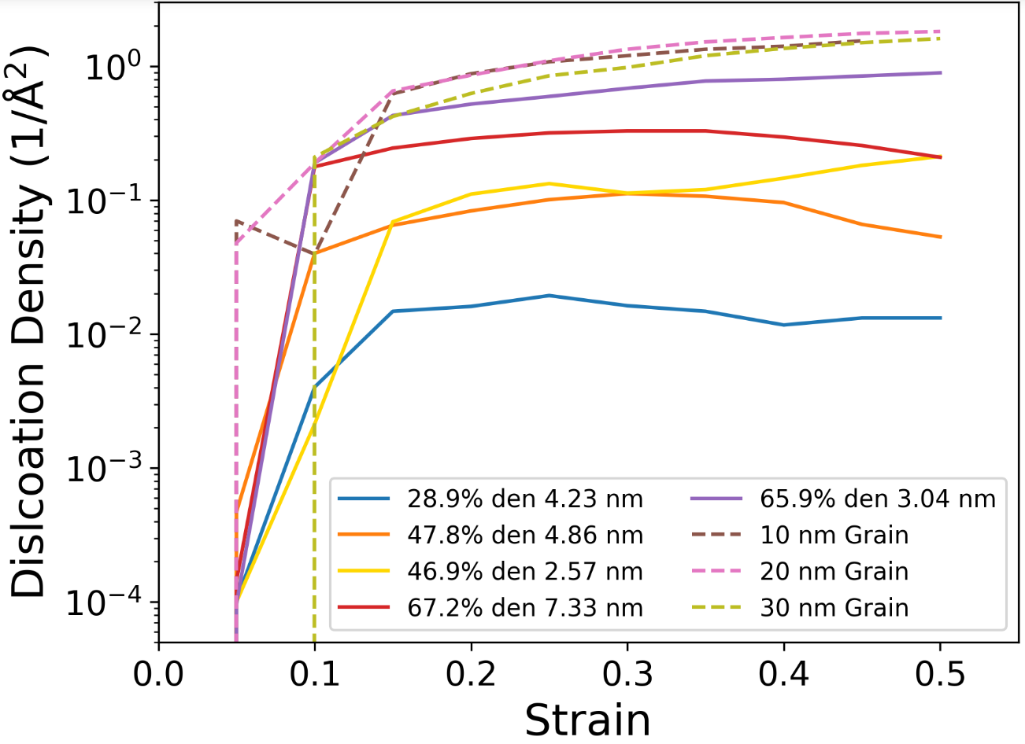 | b)  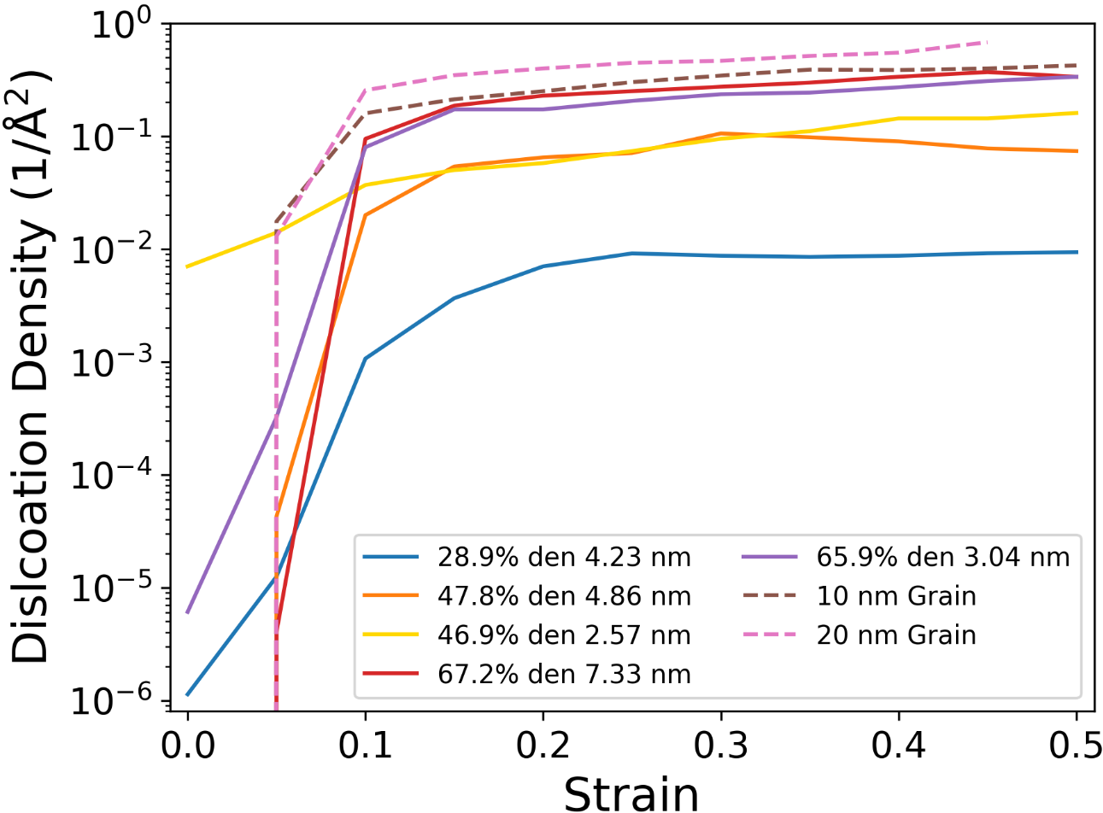
c)  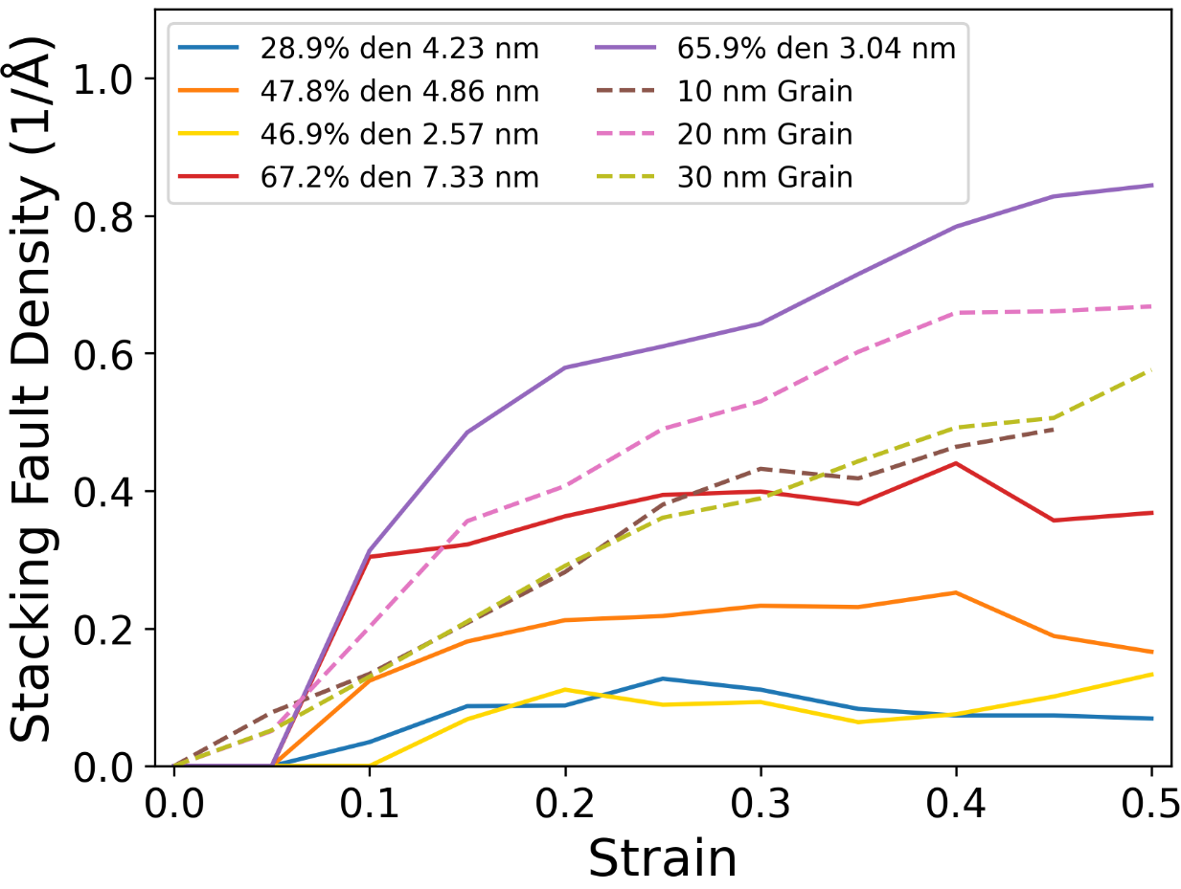 | d)  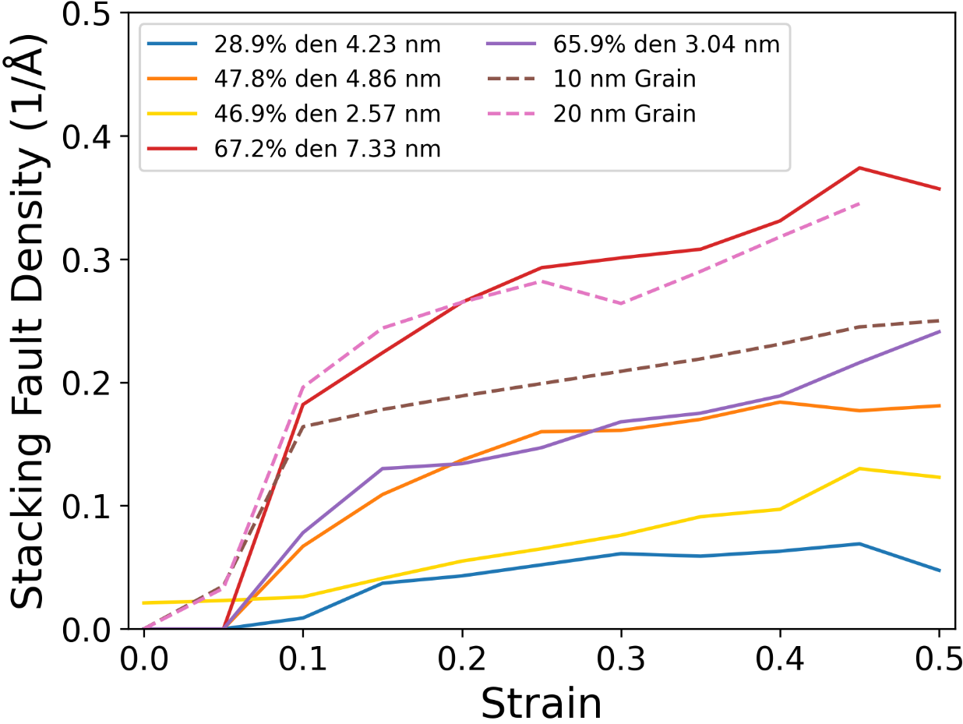
Figure S5. Dislocation concentration vs strain at 600 K (a) / 1273 K (b) and stacking fault concentration vs. strain at 600 K (c) / 1273 K (d) for the Al_{0.1}CoCrFeNi HEA systems under tension. Nanocrystalline systems are shown as dashed curves. Note the different scale of the 1273 K plots.

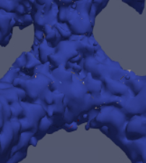 | 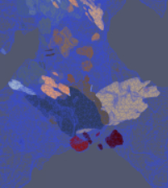
Figure S6. Display of defect pileup in the joints of the NP Al_{0.1}CoCrFeNi. The image on the left shows the surface of the NP system and the image on the right displays the defects inside the ligament that shows twin boundaries and stacking faults with different colored planes. This is the 28.9% relative density 4.23 nm ligament size nanoporous Al_{0.1}CoCrFeNi under tensile stress at 1273 K.

a)  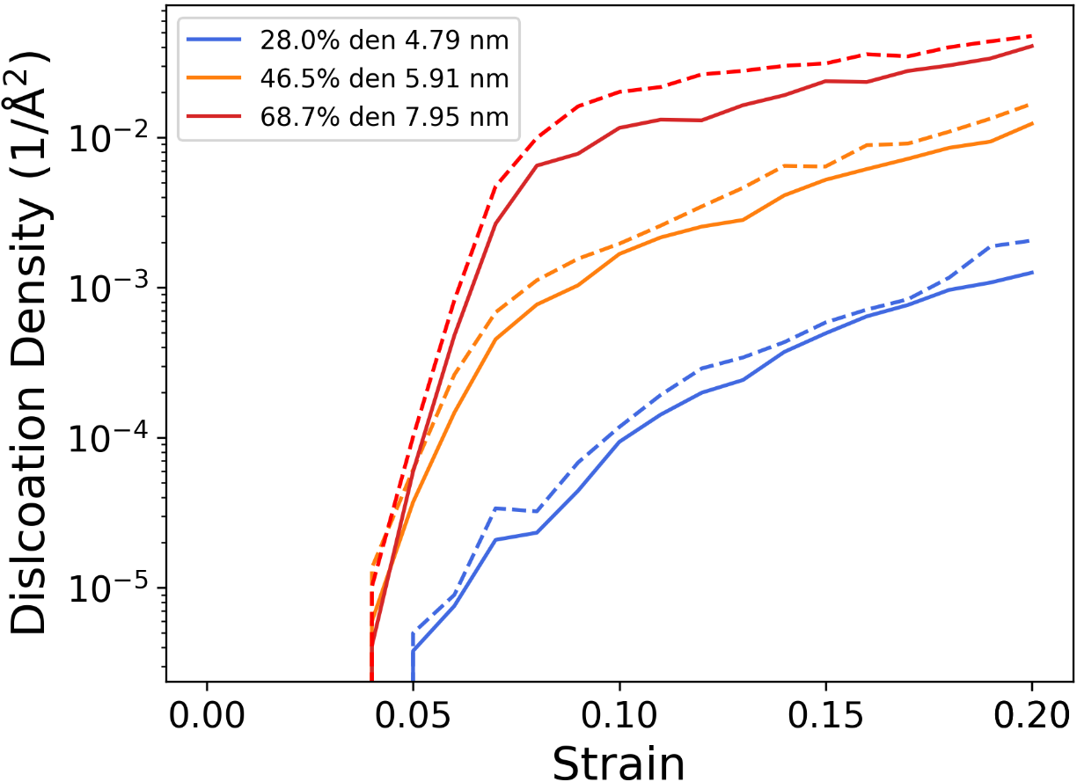 | b)  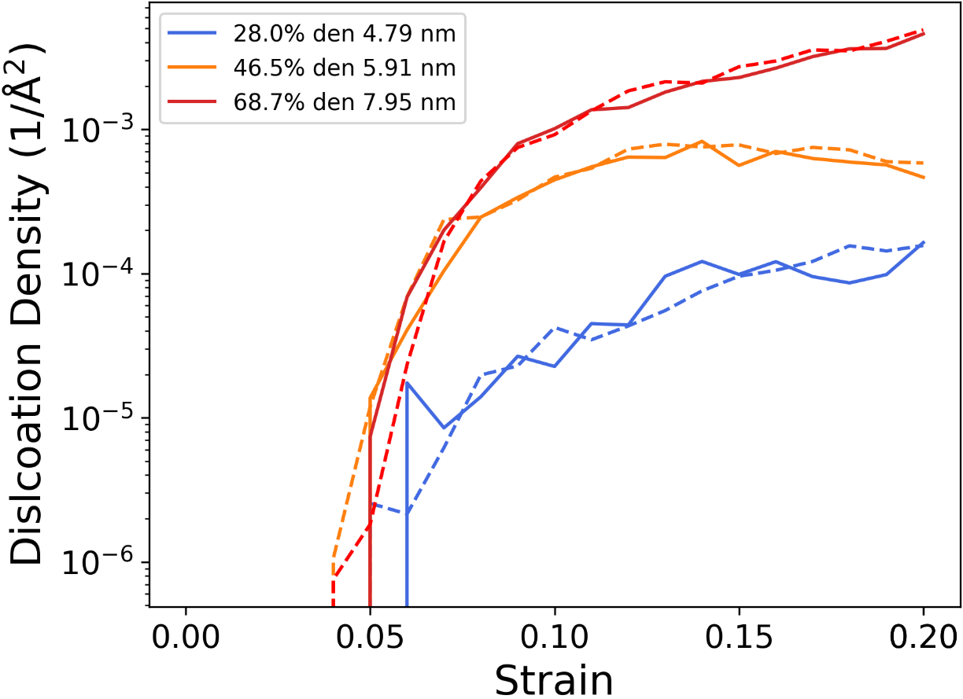
Figure S7. Defect Concentration vs. Strain curves for the NbMoTaW nanoporous systems that focus on dislocations at 600 K (solid line) and 1273 K (dashed line) for compression (a) and tension (b).

a)  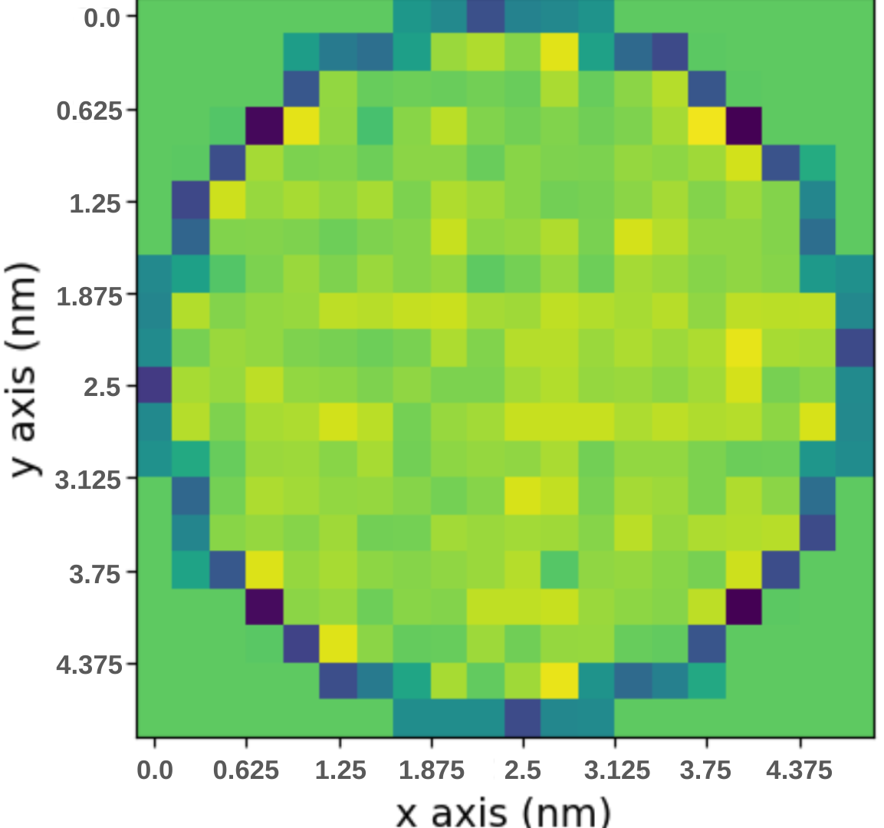 | b)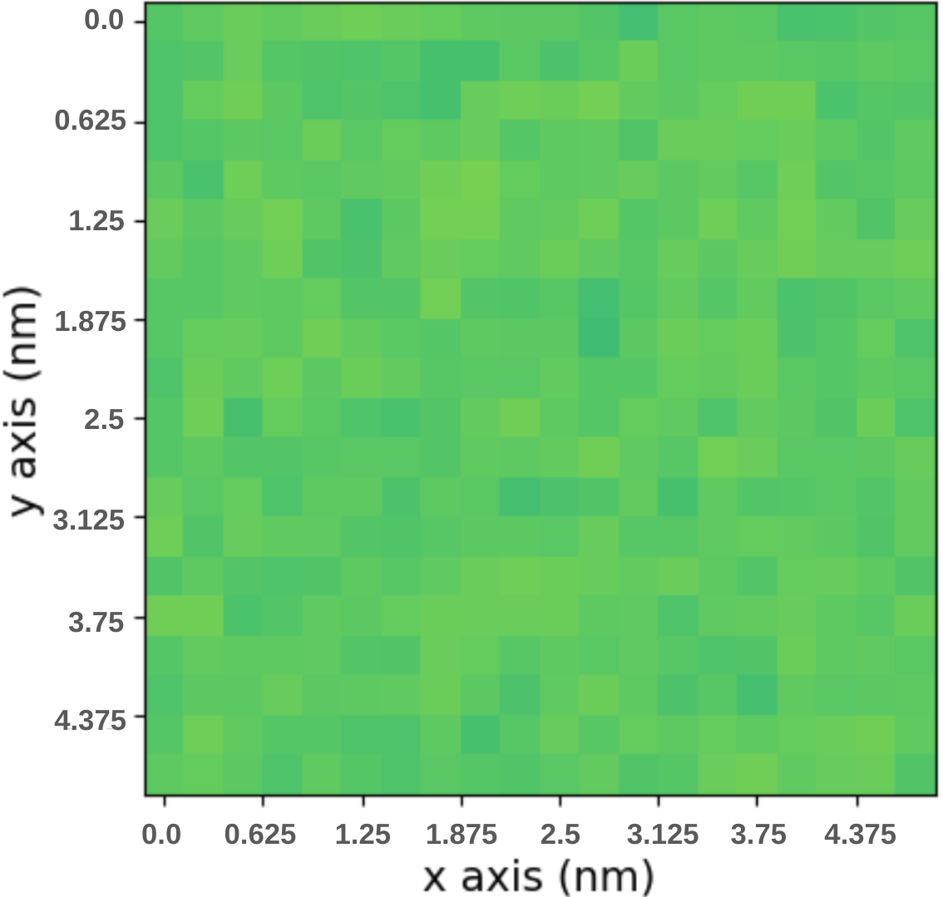 | c)  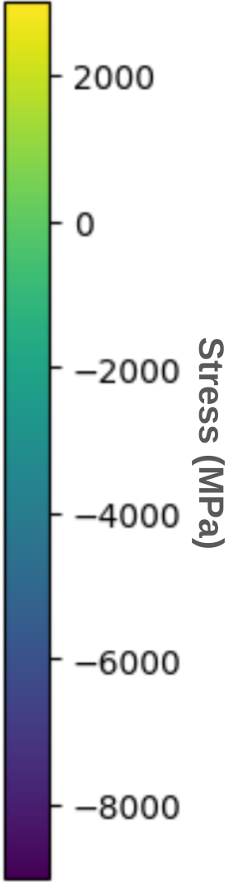
Figure S8. Internal stress of 5 nm ligament (a) and bulk (b) NbMoTaW with the heat map legend (c). 400 bins in the x and y direction are used to calculate the averaged stress in the z direction.

a)  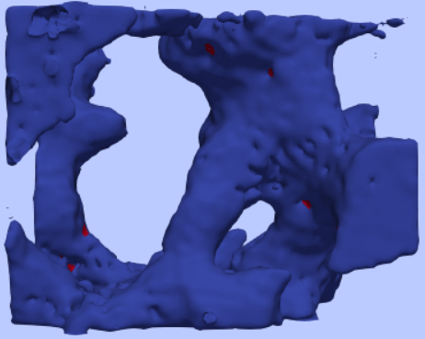 | b)  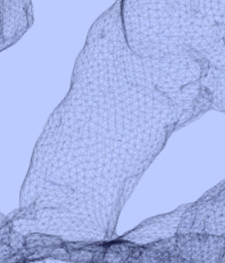
c)  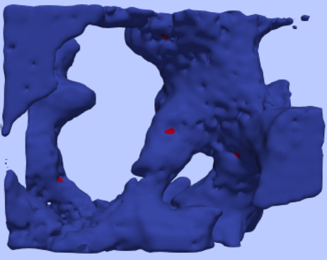 | d)  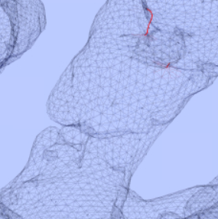
e)  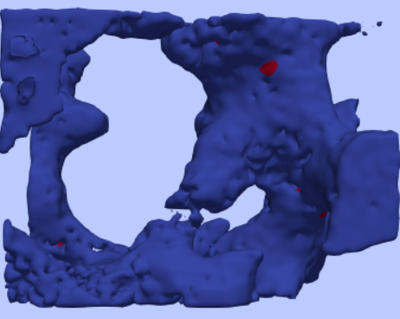 | f)  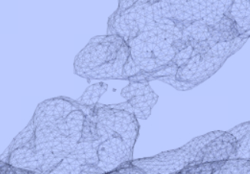
g)  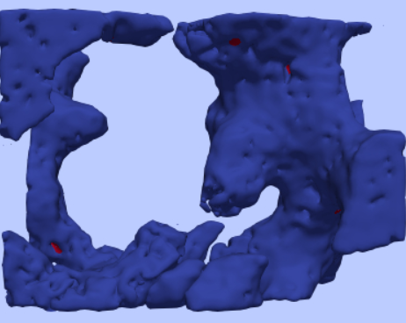 | h)  
Figure S9. The fracture process of the 28.0% relative density 4.79 nm ligament size nanoporous NbMoTaW HEA under tensile testing. This shows the surface solid mesh outlining the atomic surface and dislocations colored red in the ligament. The strain values represented are (a,b) 13.00%, (c,d) 15.00%, (e,f) 18.00%, and (g,h) 20.00%, respectively. Note: Apparent internal textures in the ligaments result from surface roughness rather than a second level of porosity. The structures reflect non-equilibrium morphologies and higher curvature typical of early-stage dealloying. No intentional bimodal pore distribution is present.

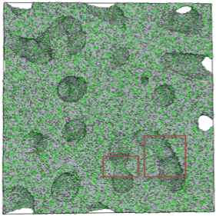 | 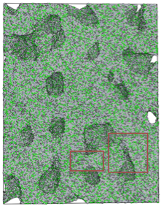 | 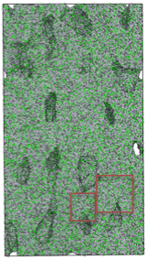
Figure S10. Simulation boxes showing the 67.2% relative density 7.33 nm Al_{0.1}CoCrFeNi nanoporous system under compression at 298 K. The red boxes show the locations of pore sites being reduced and ligaments connecting with strains of 0% (a) / 25% (b) / 50% (c).

a)  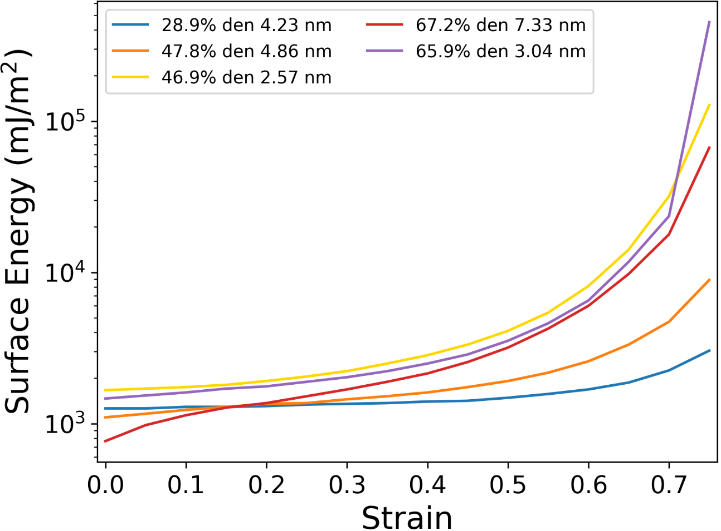 | b)  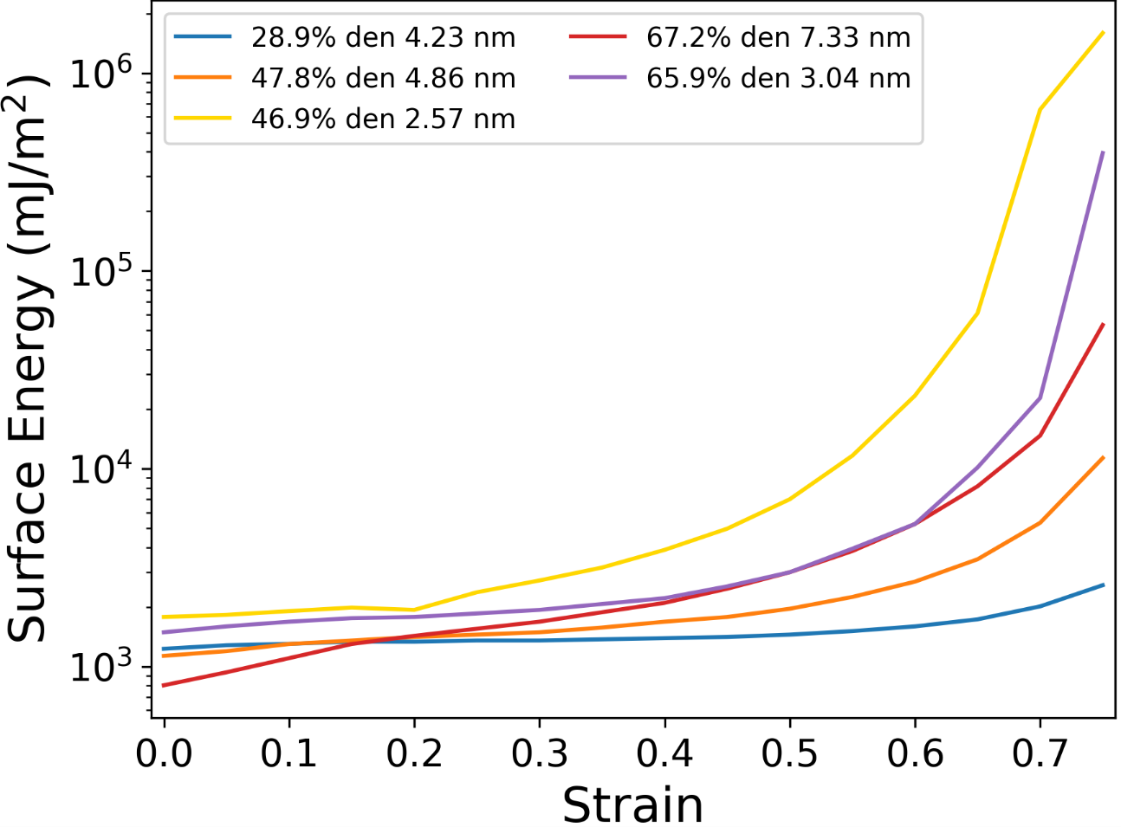
c)  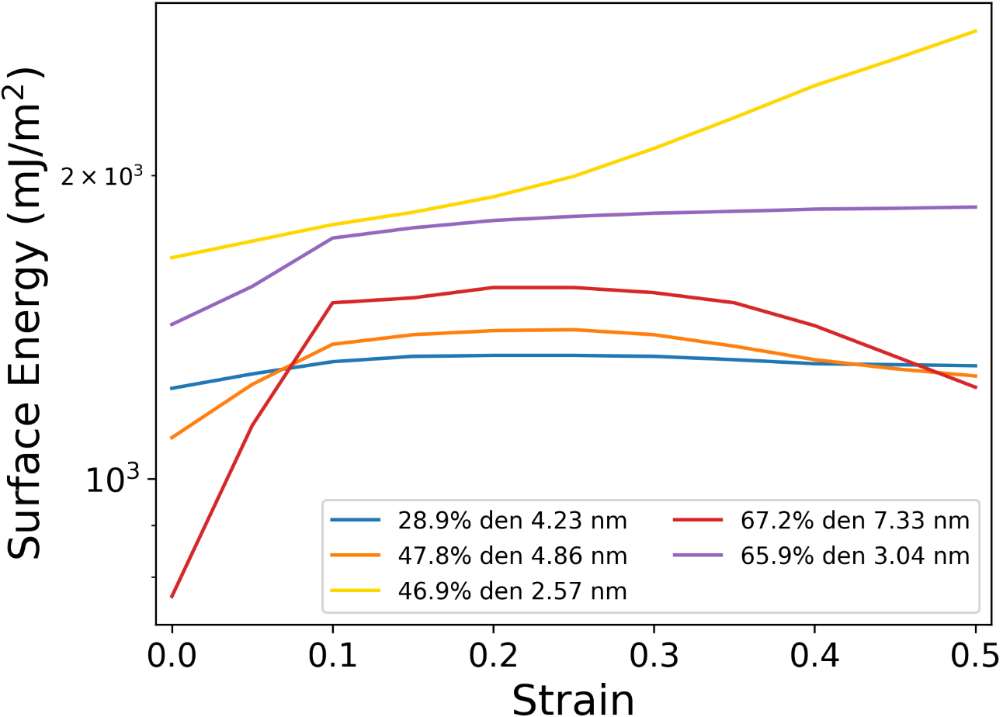 | d)  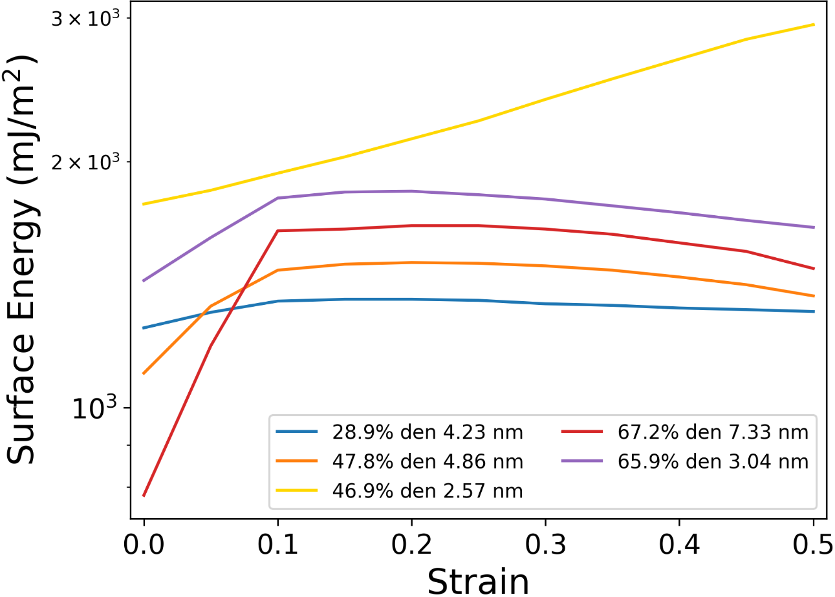
Figure S11. Surface energy vs strain of nanoporous Al_{0.1}CoCrFeNi for compression at 600 K (a) / 1273 K (b) and tension at 600 K (c) / 1273 K (d).

References:

1. Zhao, D., Wang, Y., Zhang, P. & Liang, D. Modeling and Experimental Research on Resistance Spot Welded Joints for Dual-Phase Steel. Materials 12, 1108 (2019).
2. Czerwinski, F. Current Trends in Automotive Lightweighting Strategies and Materials. Materials 14, 6631 (2021).
3. The 2020 EPA Automotive Trends Report Greenhouse Gas Emissions, Fuel Economy, and Technology since 1975. (2021).
4. El-Atwani, O. et al. Outstanding radiation resistance of tungsten-based high-entropy alloys. Sci. Adv. 5, (2019).
5. Xia, S. Q., Yang, X., Yang, T. F., Liu, S. & Zhang, Y. Irradiation Resistance in Al_{x}CoCrFeNi High Entropy Alloys. JOM 67, 2340–2344 (2015).
6. Beyerlein, I. J. et al. Radiation damage tolerant nanomaterials. Mater. Today 16, 443–449 (2013).
7. Guo, Y. et al. Study on the microstructural evolution in NbMoTaW series refractory multi-principal element alloy films by low-energy and high-flux He ions irradiation. Surf. Coat. Technol. 452, 129140 (2023).
8. Daw, M. S. & Baskes, M. I. Semiempirical, Quantum Mechanical Calculation of Hydrogen Embrittlement in Metals. Phys. Rev. Lett. 50, 1285–1288 (1983).
9. Daw, M. S. & Baskes, M. I. Embedded-atom method: Derivation and application to impurities, surfaces, and other defects in metals. Phys. Rev. B 29, 6443–6453 (1984).
10. Guillotte, M., Godet, J. & Pizzagalli, L. A fully molecular dynamics-based method for modeling nanoporous gold. Comput. Mater. Sci. 161, 135–142 (2019).
11. Chen, Y. et al. Development of the interatomic potentials for W-Ta system. Comput. Mater. Sci. 163, 91–99 (2019).
12. Stukowski, A. Visualization and analysis of atomistic simulation data with OVITO–the Open Visualization Tool. Model. Simul. Mater. Sci. Eng. 18, 015012 (2010).
13. Möller, J. J. & Bitzek, E. BDA: A novel method for identifying defects in body-centered cubic crystals. MethodsX 3, 279–288 (2016).
14. Liu, C., Yang, Y. & Xia, Z. Deformation mechanism in Al_{0.1}CoCrFeNi Σ3(111)[11̄0] high entropy alloys – molecular dynamics simulations. RSC Adv. 10, 27688–27696 (2020).
15. Sharma, A. & Balasubramanian, G. Dislocation dynamics in Al_{0.1}CoCrFeNi high-entropy alloy under tensile loading. Intermetallics 91, 31–34 (2017).
16. Forwood, C. T. & Clarebrough, L. M. Electron Microscopy of Interfaces in Metals and Alloys. (Hilger, Bristol, 1991).
17. Elder, K. L. M. et al. Grain boundary formation through particle detachment during coarsening of nanoporous metals. Proc. Natl. Acad. Sci. 118, (2021).
18. Li, X.-G., Chen, C., Zheng, H., Zuo, Y. & Ong, S. P. Complex strengthening mechanisms in the NbMoTaW multi-principal element alloy. Npj Comput. Mater. 6, 70 (2020).
19. Yang, D., Chen, B., Li, S., Ding, X. & Sun, J. Effect of local lattice distortion on the core structure of edge dislocation in NbMoTaW multi-principal element alloys and the subsystems. Mater. Sci. Eng. A 855, 143869 (2022).
20. Hirel, P. Atomsk: A tool for manipulating and converting atomic data files. Comput. Phys. Commun. 197, 212–219 (2015).
21. Worden, J. & Hin, C. Molecular Dynamics Simulation of Nanoporous Tungsten. (2023) doi:10.48550/ARXIV.2312.05227.
22. Kramer, D. & Weissmüller, J. A note on surface stress and surface tension and their interrelation via Shuttleworth’s equation and the Lippmann equation. Surf. Sci. 601, 3042–3051 (2007).
23. Biener, J. et al. Surface-chemistry-driven actuation in nanoporous gold. Nat. Mater. 8, 47–51 (2009).
24. Deng, C. & Sansoz, F. Uniaxial Compression Behavior of Bulk Nano-twinned Gold from Molecular Dynamics Simulation. MRS Proc. 1049, (2007).
25. Son, S.-B. et al. Relationship between microstructure homogeneity and bonding stability of ultrafine gold wire. Gold Bull. 44, (2011).
26. Koyanagi, J., Takase, N., Mori, K. & Sakai, T. Molecular dynamics simulation for the quantitative prediction of experimental tensile strength of a polymer material. Compos. Part C Open Access 2, 100041 (2020).
27. Saffarini, M. H., Voyiadjis, G. Z. & Ruestes, C. J. Temperature effect on nanoporous gold under uniaxial tension and compression. Comput. Mater. Sci. 200, 110766 (2021).
28. Kim, Y.-C. et al. Indentation size effect in nanoporous gold. Acta Mater. 138, 52–60 (2017).
29. Biener, J., Hodge, A. M., Hamza, A. V., Hsiung, L. M. & Satcher, J. H. Nanoporous Au: A high yield strength material. J. Appl. Phys. 97, 024301 (2005).
30. Przybilla, T. Studying the Structure and Mechanical Properties of Nanoporous Materials by Advanced Tomography and in Situ Mechanical Testing. (Friedrich-Alexander-Universität, 2019).
31. Liu, R., Gruber, J., Bhattacharyya, D., Tucker, G. J. & Antoniou, A. Mechanical properties of nanocrystalline nanoporous platinum. Acta Mater. 103, 624–632 (2016).
32. Xian, Y., Li, J., Wu, R. & Xia, R. Softening of nanocrystalline nanoporous platinum: A molecular dynamics simulation. Comput. Mater. Sci. 143, 163–169 (2018).
33. Wang, S., Shan, Z. & Huang, H. The Mechanical Properties of Nanowires. Adv. Sci. 4, 1600332 (2017).
34. Weinberger, C. R., Boyce, B. L. & Battaile, C. C. Slip planes in bcc transition metals. Int. Mater. Rev. 58, 296–314 (2013).
35. Chen, B. et al. Unusual activated processes controlling dislocation motion in body-centered-cubic high-entropy alloys. Proc. Natl. Acad. Sci. 117, 16199–16206 (2020).
36. Gibson, L. J. & Ashby, M. F. Cellular Solids: Structure and Properties. (CUP, Cambridge, 1999).

