Fig. S 1│ A XRD of the as received and 5 mins spex milled powder showing the presence of t-ZrO2 impurity, B SEM image of the 5 mins spex milled powder
Table S2│ Materials Properties for Simulation
 | Electrical conductivity (S/m) | Density (kg/m³) | Thermal conductivity (W/m.K) | Heat capacity (J/kg.K) | Surface emissivity
Graphite | 80000 | 1900 | 123 − 6.99*10⁻² *T + 1.55*10⁻⁵ *T² (298-2000K)¹ | 34.27 + 2.72*T − 9.60*10⁻⁴*T² (298-2000K)¹ | 0.9
Hexagonal boron nitride (h-BN) | 1E-10 | 2300 | 400 | 1000
Zirconium nitride (ZrN) | Figure 3 | ² | ³ | COMSOL materials library
Copper | 6E+07 | 8960 | 400 | 385 | 0.17

Equations of functions in Fig. 2:
Linear: $σ\left(T\right)=0.237×T-69.1 (298-1973 K)$
Polynomial: $σ\left(T\right)=15.45×T-0.089×T+0.00014× T^{2} (298-1973 K)$
Exponential: $σ\left(T\right)=0.66×e^{(0.00324 ×T)} (298-1973 K)$

Sigmoidal (2 Step S):
$$σ\left(T\right)=σ_{298K}+\left(σ_{1973K}-σ_{298K}\right)×(A × \frac{{\left(1+e^{(B_{1} ×(T-T_{1})}\right)}^{C} - {\left(1+e^{(B_{1}×(298-T_{1})}\right)}^{C} }{{\left(1+e^{(B_{1}×(1978-T_{1})}\right)}^{C} - {\left(1+e^{(B_{1}×(298-T_{1})}\right)}^{C}}+(1-A) × \frac{{\left(1+e^{(B_{2} ×(T-T_{2})}\right)}^{C} - {\left(1+e^{(B_{2} ×(298-T_{2})}\right)}^{C} }{{\left(1+e^{(B_{2} ×(1978-T_{2})}\right)}^{C} - {\left(1+e^{(B_{2} ×(298-T_{2})}\right)}^{C}})$$
σ_{298K}= 1.75 S/cm, σ_{1973K}= 400 S/cm, A= 0.08, B₁= −0.03, C= −0.6, B₂= −0.013 T₁= 540 K, T₂=1350K

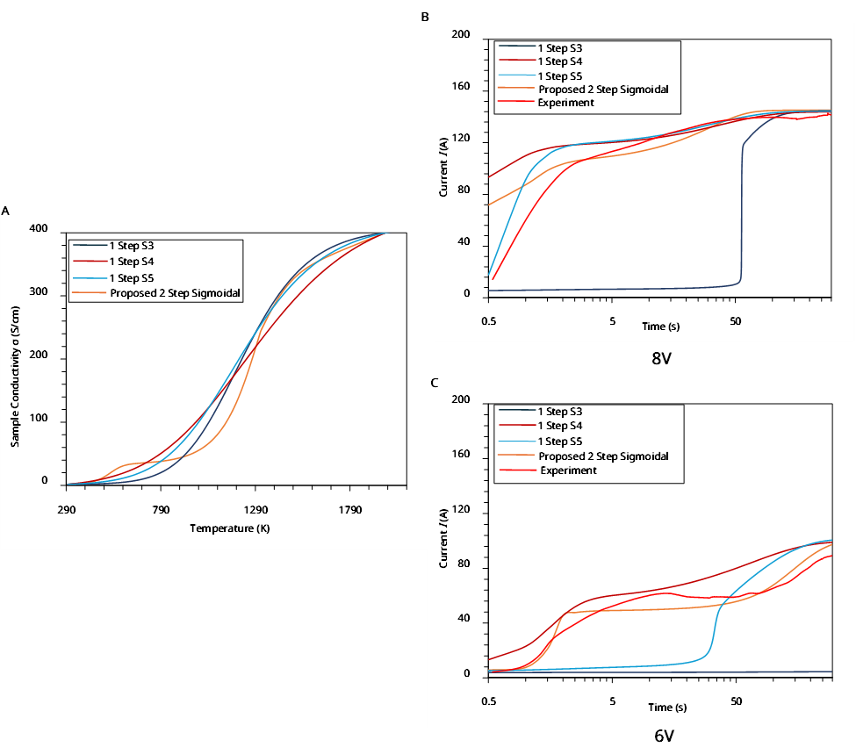
Fig. S 2│ A Possible different S shaped evolution along with the proposed 2 step sigmoidal function of sample conductivity with temperature and Current vs time for experiment and simulations for those assumptions under B 8 and C 6 V.
Fig. S 3│ Thermal conductivity vs temperature for Mo⁴ and Graphite¹

Fig. S 4│ A Schematic showing position of point 1 and 2 in the sample. Net heating power density or NHPD (calculated from subtracting heat dissipation from heat generation for unit volume in each point) and temperature vs time for point 1 and 2 using both B Mo and C graphite electrode
Fig. S 5│ Simulated temperature vs time for 6.4 mm and 3.2 mm diameter sample with 6.4 mm diameter electrodes
Fig. S 6│ A Current and voltage vs time for a 4 mm thick (6.4 mm diameter) sample FS. B SEM of the fractured sample

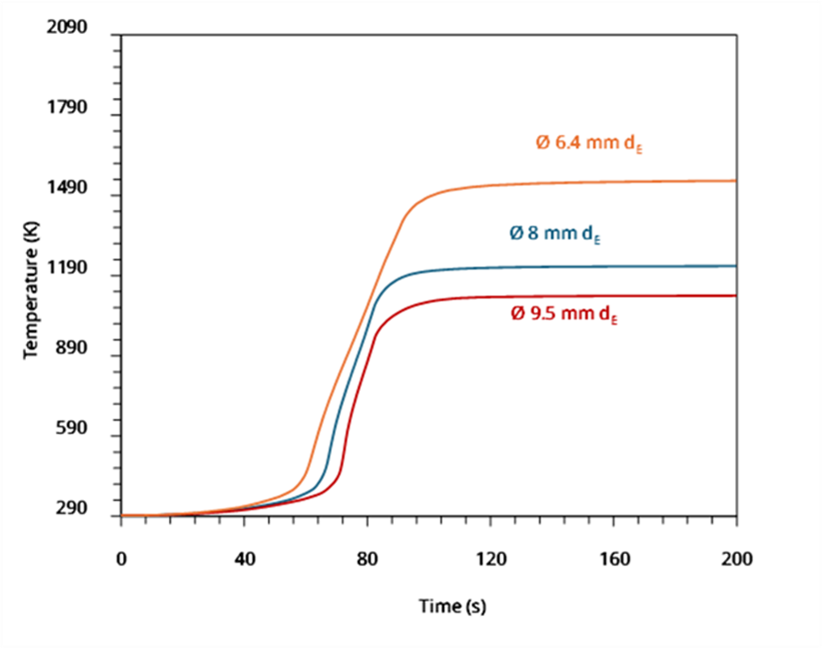
Fig. S 7│ Simulated temperature vs time for 6.4 mm diameter sample using 6.4, 8 and 9.5 mm diameter electrodes
Fig. S 8│ Simulated temperature vs time for 3.2 mm sample FS using polycrystalline ceramic wool and h-BN tube as thermal insulation

References
1. Manière, C. et al. Contact resistances in spark plasma sintering: From in-situ and ex-situ determinations to an extended model for the scale up of the process. J. Eur. Ceram. Soc. 37, 1593–1605 (2017).
2. Tang, Y. et al. Densification and mechanical properties of hot-pressed ZrN ceramics doped with Zr or Ti. J. Eur. Ceram. Soc. 33, 1363–1371 (2013).
3. Basini, V., Ottaviani, J. P., Richaud, J. C., Streit, M. & Ingold, F. Experimental assessment of thermophysical properties of (Pu, Zr)N. in Journal of Nuclear Materials vol. 344 186–190 (Elsevier, 2005).
4. Kota, S. et al. Synthesis and characterization of an alumina forming nanolaminated boride: MoalB. Sci. Rep. 6, (2016).

