Scheme (1): Suggested degradation pathway of Remdesivir affected by NaOH.

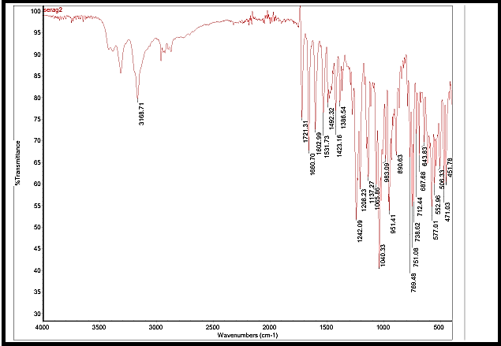
Figure (2): IR spectrum of intact Remdesivir.
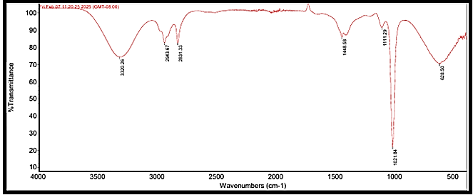
Figure (3): IR spectrum of Remdesivir degradation product.
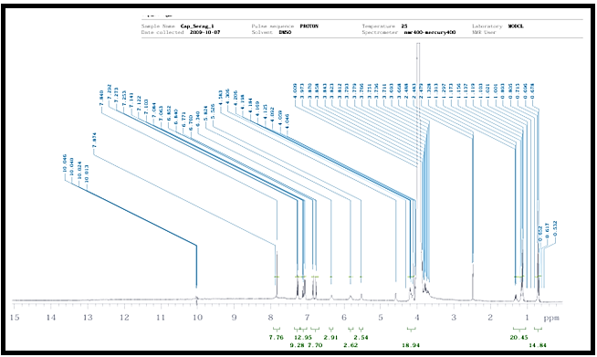
Figure (4): ¹H NMR spectrum of intact Remdesivir in (DMSO).
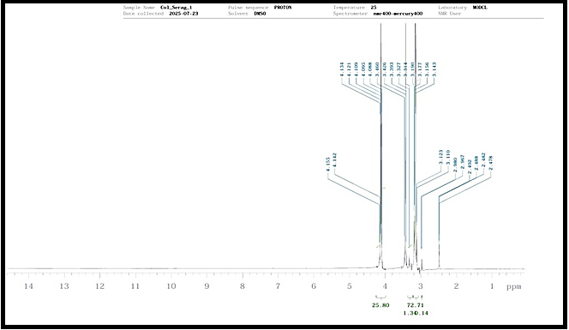

Figure (5): ¹H NMR spectrum of Remdesivir degradation product in (DMSO).

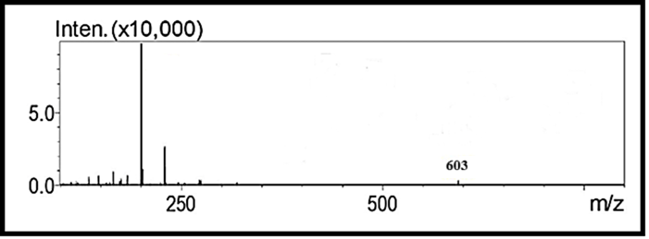
Figure (6): Mass spectrum of intact Remdesivir.
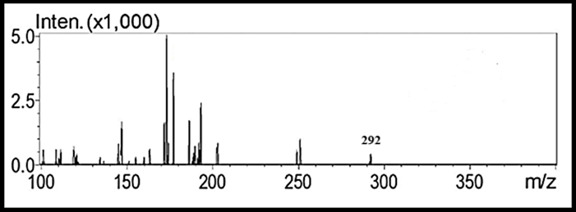
Figure (7): Mass spectrum of Remdesivir degradation product

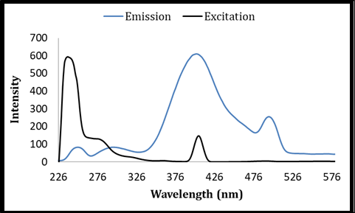
Figure (8): (A) Excitation, (B) emission spectra of Remdesivir (800 ng/ml).
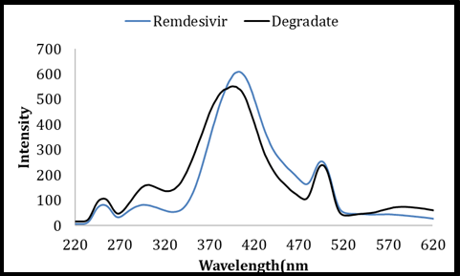
Figure (9): Emission spectra of (A) Remdesivir (800 ng/ml), (B) Remdesivir degradation product (800 ng/ml) .
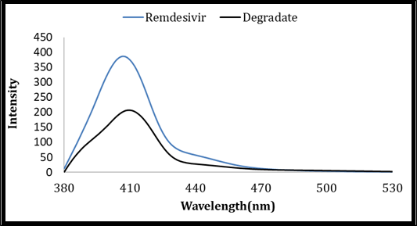
Figure (10): Synchronous fluorescence spectra of (A) Remdesivir (800 ng/ml), (B) Remdesivir degradation product (800 ng/ml) using Δλ=160 nm.
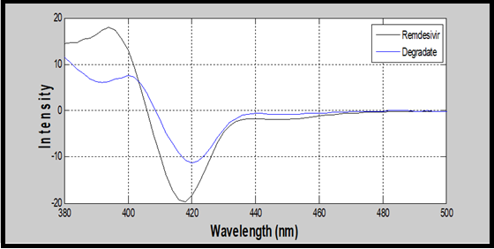

Figure (11): First derivative synchronous fluorescence spectra of (A) Remdesivir (800 ng/ml) and (B) Remdesivir degradation product (800 ng/ml).
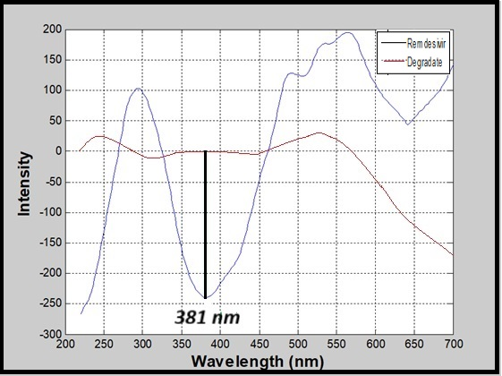
Figure (12): Wavelets synchronous fluorescence spectra of (A) Remdesivir (800 ng/ml) and (B) Remdesivir degradation product (800 ng/ml) .
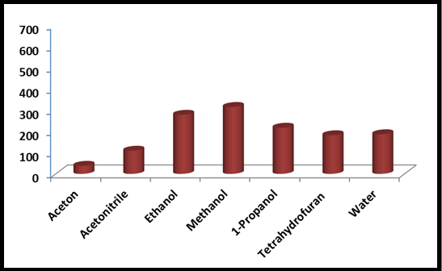
Figure (13): Effect of different diluting solvents on synchronous fluorescence intensity of Remdesivir (250 ng/ml).
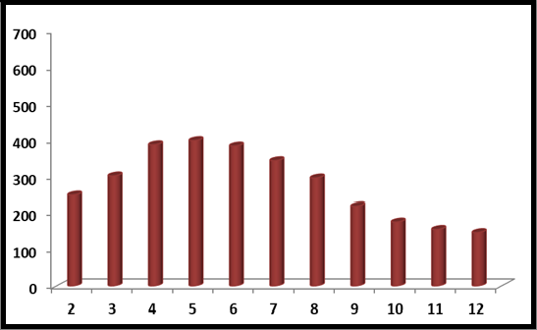
Figure (14): Effect of pH on synchronous fluorescence intensity of Remdesivir (250 ng/ml).
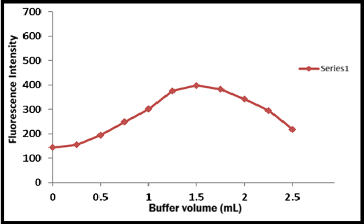
Figure (15): Effect of Britton Robinson buffer volume (pH 5) on synchronous fluorescence intensity of Remdesivir (800 ng/ml).
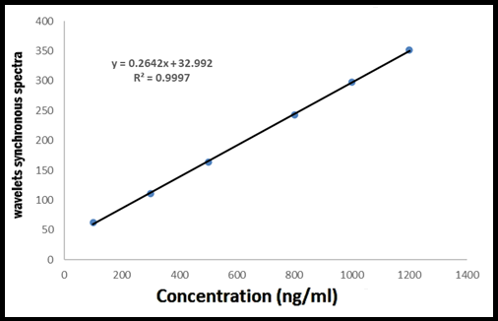
Figure (16): Calibration graph of Remdesivir by the proposed wavelets synchronous spectrofluorimetric method.

Table (1): Regression and validation data for the determination of Remdesivir by the proposed wavelets synchronous spectrofluorimetric procedure:
Parameters | Proposed method
Wavelength (nm) | 381
Linearity range (ng/ml) | 100 ─ 1200
LOD (ng/ml) | 28.234
LOQ (ng/ml) | 93.172
Regression Equation  - Slope (b)  - Intercept (a) | y ª = b x ^{b} + a  0.2642  32.992
Coefficient of determination (r²) | 0.9997
Accuracy (% R)^{c} | 100.21
Precision^{d} (% RSD)  - Repeatability  - Intermediate precision | 1.335  1.120
ª The peak amplitude of the wavelets of synchronous fluorescence spectra.
^{b} Concentration of Remdesivir in ng/ml.
^{c} Average of nine determinations (three concentrations repeated three times).
^{d} %RSD of nine determinations (three concentrations repeated three times).
^{e} Average of three determinations.

Table (2): Determination of Remdesivir in mixtures with its degradation product by the proposed wavelets synchronous spectrofluorimetric procedure:
Intact  (ng/ml) | Degradation product (ng/ml) | Intact found  (ng/ml) | %Recovery of intact
1100 | 100 | 1098.57 | 99.87
900 | 300 | 895.32 | 98.48
700 | 500 | 694.33 | 99.19
300 | 900 | 294.18 | 98.06
100 | 1100 | 101.06 | 101.06
Mean ± %RSD |  |  | 99.96±1.525

Table (3): Recovery study of Remdesivir by standard addition technique using the proposed wavelets synchronous spectrofluorimetric in Remdesivir® vials:
Pharmaceutical taken (ng/ml) | Pharmaceutical foundª (ng/ml) | Pure added (ng/ml) | Pure found^{b} (ng/ml) | Pure recovery (%R)
300 | 298.96 | 100 | 98.48 | 98.48
300 | 298.96 | 300 | 300.27 | 100.09
300 | 298.96 | 500 | 495.65 | 99.13
300 | 298.96 | 800 | 789.36 | 98.67
Mean ± %RSD |  |  |  | 99.09±0.723
ª Average of five determinations.
^{b} Average of three determinations.
Table (4): Determination of Remdesivir in Remdesivir® vials by the proposed wavelets synchronous spectrofluorimetric and reported methods:
Parameters | Proposed method | Reported method ^{[2]}
n* | 5 | 5
Mean % recovery | 98.96 | 99.89
% RSD | 0.779 | 0.6942
Variance | 0.595 | 0.482
Student’s t-test** | 2.00 (2.306) | ——
F-value** | 1.234 (6.388) | ——
* No. of experiments.
** The values in parenthesis are tabulated values of “t ” and “F ” at (P = 0.05)

