Supporting Information

Bimetallic Co-Fe Selenide with Improved Electrochemical Performance for Asymmetric Supercapacitors
Bin Xu¹, Kang Yuan¹, Huan Zheng¹, Shiyuan Cheng², Meng Guo^{1*}, Xuyang Li^{2*}
² School of Biological and Chemical Engineering, Nanyang Institute of Technology, Nanyang, 473000, China
² School of Chemistry and Pharmaceutical Engineering, Nanyang Normal University, Nanyang, 473061, China
*Correspondence: mengme2007@126.com (M. Guo); eryang1024@163.com (X. Li)

Material Characterization
A Hitachi JSM-7900F field emission scanning electron microscope (FE-SEM, Tokyo, Japan) and a Tecnai G2 F20/F30 transmission electron microscope (TEM, FEI Company, Hillsboro, OR, USA) were employed to investigate the morphological characteristics of the synthesized materials. Energy-dispersive X-ray spectroscopy (EDS, Hitachi, Tokyo, Japan) was used for analyzing the elemental composition and distribution. Powder X-ray diffraction (XRD) patterns were obtained via a Rigaku Miniflex600 diffractometer (Rigaku, Akishima, Japan) at a scanning rate of 5°·min⁻¹, and Raman spectra were measured using a LabRAM HR800 Raman spectrometer (Horiba Jobin Yvon, Longjumeau, France). The specific surface area (SSA) and pore size distribution were evaluated with an SSA-4300 analyzer (Builder, Beijing, China). Furthermore, X-ray photoelectron spectroscopy (XPS, Thermo ESCALAB 250XI, Waltham, MA, USA) equipped with an Al Kα monochromatic source was adopted to characterize the chemical states of the composite.
Fabrication of the ASC device
An ASC device was assembled using the CFS-1 composite as a positive electrode, and rGO as a negative electrode with a 3 M KOH solution as the electrolyte. To maintain charge neutrality between the two electrodes, the mass ratio of CFS-1 to rGO was determined via theoretical calculation according to Equation (1):
$$\frac{m_{+} }{m_{-}}=\frac{C_{-} V_{-}}{C_{+} V_{+}} (1)$$
where C is the specific capacitance of the electrode, m is the mass of the active material, and ΔV is the potential window of the respective electrode. Using this relation, the mass loading of
the positive and negative electrodes were set at 4 mg and 7 mg, respectively. The specific capacitance (C) of the electrodes was determined from the charge-discharge curves using the following equation:
$C=\frac{It}{mV} (2)$
where is the discharge current (A), is the mass loading of the active material (g), is the discharge time, and is the applied potential window.
The energy density (E, in Wh kg⁻¹) and power density (P, in W kg⁻¹) of the ASC device were calculated using equations (2) and (3):
$$E=\frac{C_{cell} V^{2}}{23.6} \left(3\right)$$
$$P=\frac{E3600}{t_{discharge}} \left(4\right)$$
where is the applied voltage range, is the specific capacitance of the ASC device, and is the discharge time during the galvanostatic charge-discharge (GCD) test.
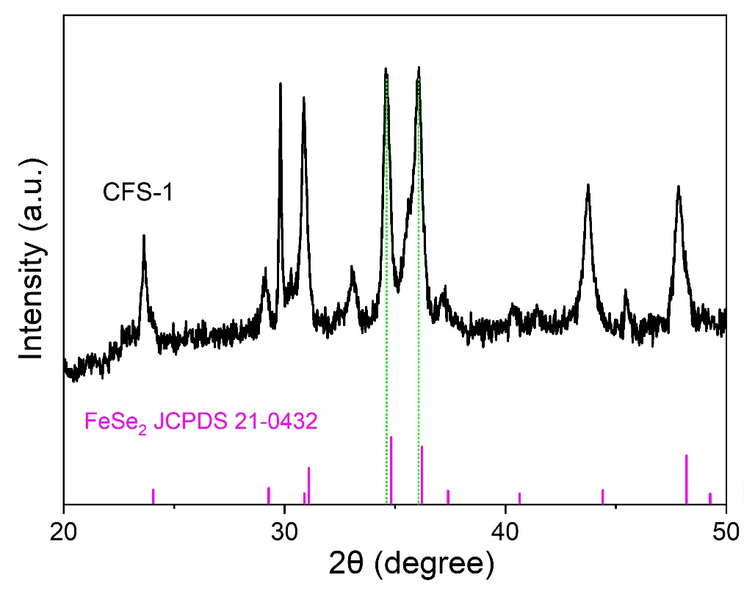
Figure S1. XRD enlarged patterns of CFS-1
Figure S2. BJH pore size distribution of CFS-1, CFS-2 and CFS-3 composites.

Figure S3. CV curves of CFS-1 composite at various sweep rates.
Figure S4. (a, b) CV curves at various sweep rates, (c,d) GCD curves at various current densities of CoSe₂ and FeSe₂ composites.
Figure S5. CV curves (30 mV s⁻¹) of CFS-1//rGO ASC device at different potential windows.

Abstract Graphics (For Table of Contents Only)