Fig S1 displays the four components of the Gaussian Mixture Model that were fit to the full MMSE data overlap on a pairwise basis (N=663). Each panel depicts two curves in the component density region, where the gray region indicates the pointwise coincidence, which is measured by the value of the integral of the minimum density (as a fraction of the total area). Components 1 and 2 (46.3%), which exhibit the greatest overlap, exhibit a significant continuity between severe and moderate impairment. The extent of moderate overlap is between Component 2 and Component 3 (27.6%), and between Component 2 and Component 4 (20.4%); non-adjacent pairs are low (1-3 (9.0%), 1-4 (5.7%), and 3-4 (1.6%)). These findings are in line with the continuous but multifaceted nature of MMSE scores in this Alzheimer cohort, with the most overlap occurring between adjacent severity elements, which you see further enhancing the overall density in Figure 3 as well as the clinical perception of overlapping cognitive stages.

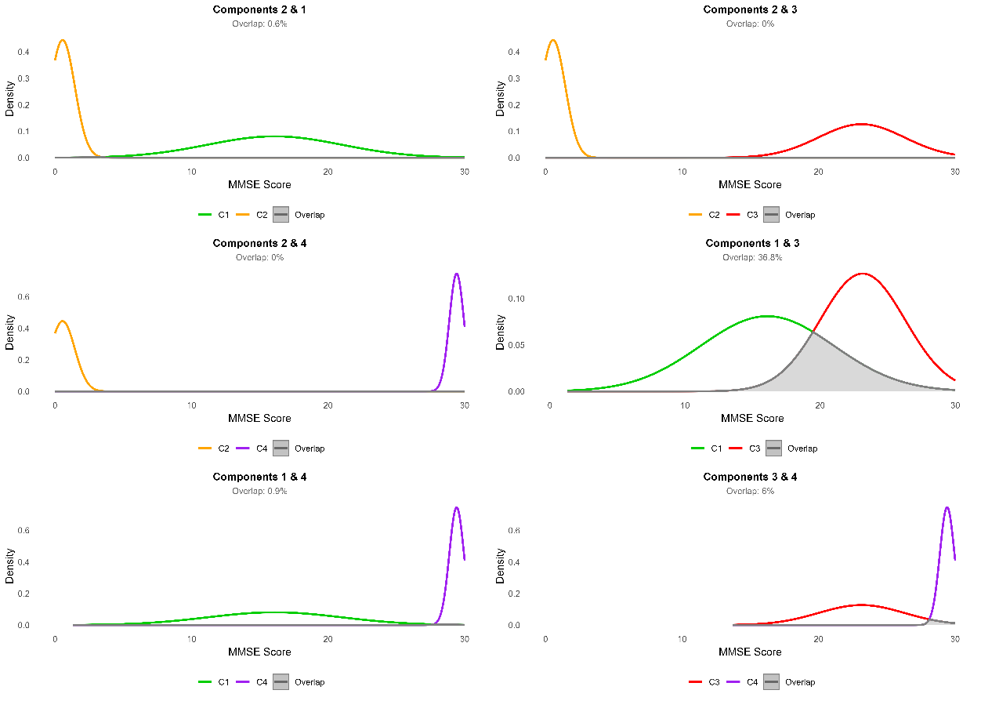

Fig S1: Pairwise Overlap Analysis of the Four-Component Gaussian Mixture Model Fitted to the Full MMSE Dataset (N = 663).
Fig S2 presents a six-panel visualization of the pairwise density overlaps among the four Gaussian components fitted to the Ranked Set Sampling (RSS) MMSE subset. Each panel displays the density curves of two components (one in red, one in cyan) with the gray shaded area indicating their overlap region. The overlap percentages, calculated as the integral of the pointwise minimum density (proportion of total area), are: Components 1 & 2 (3%), 1 & 3 (35.7%), 1 & 4 (0.1%), 2 & 3 (19.3%), 2 & 4 (8.1%), and 3 & 4 (1.2%).
Compared to the full dataset, the RSS subset exhibits dramatically reduced overlap overall, especially between non-adjacent and severe components (near zero for pairs involving Component 1), while the highest overlap occurs between Components 1 & 3 (35.7%) and Components 2 & 3 (19.7%). These results reflect the RSS-induced concentration in the moderate-to-mild range, with much clearer separation at the extremes and virtually no representation of severe impairment overlap.
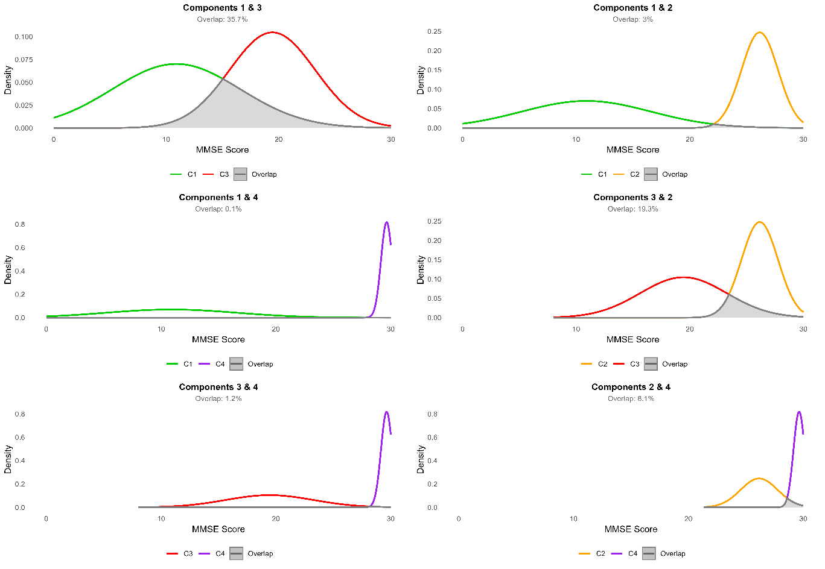
Fig S2: Pairwise Density Overlap of the Four-Component Gaussian Mixture Model Fitted to the Ranked Set Sampling MMSE Subset (N = 320).

Fig S3 shows a six-panel visualization of the pairwise density overlaps among the four Gaussian components fitted to the coreset subsample of MMSE scores. Each panel displays the density curves of two components (colored lines) with the gray shaded area representing their overlap region. The overlap percentages, computed as the integral of the pointwise minimum density (as a proportion of total area), are as follows: Components 1 & 2 (18.23%), 1 & 3 (0.73%), 1 & 4 (0%), 2 & 3 (23.17%), 2 & 4 (0.89%), and 3 & 4 (8.69%). Compared to the full dataset, the coreset sample exhibits significantly reduced overlap overall, particularly for pairs involving the extremes (near-zero overlap for Component 1 with 3 and 4, and very low for 2 & 4). The highest overlap occurs between Components 2 & 3 (23.17%), reflecting moderate continuity in the transition from moderate to mild impairment, while Components 1 & 2 retain the largest adjacent overlap (18.23%). These results indicate that coreset sampling maintains reasonable separation at the tails while preserving some transitional continuity in the central range, striking a good balance between representativeness and reduced sample size in this Alzheimer’s cohort.
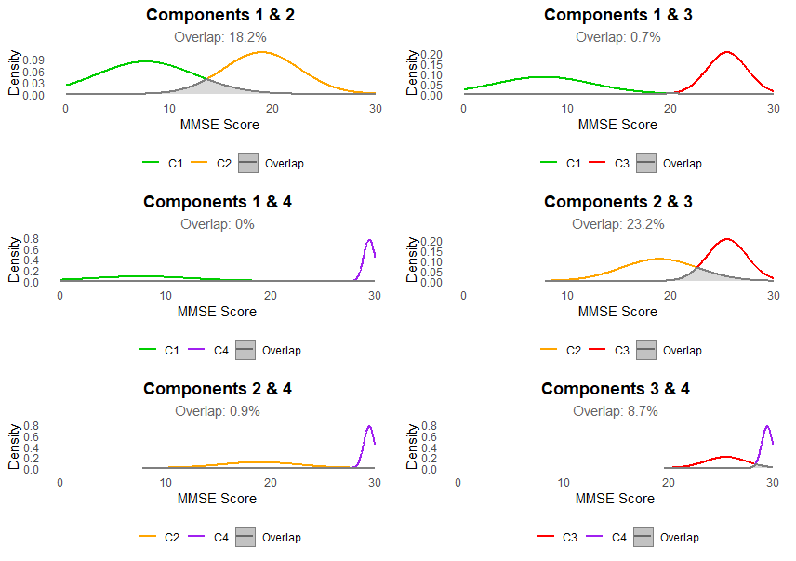
Fig S3: Pairwise Density Overlap of the Four-Component Gaussian Mixture Model Fitted to the Coreset MMSE Subsample (N = 198).

