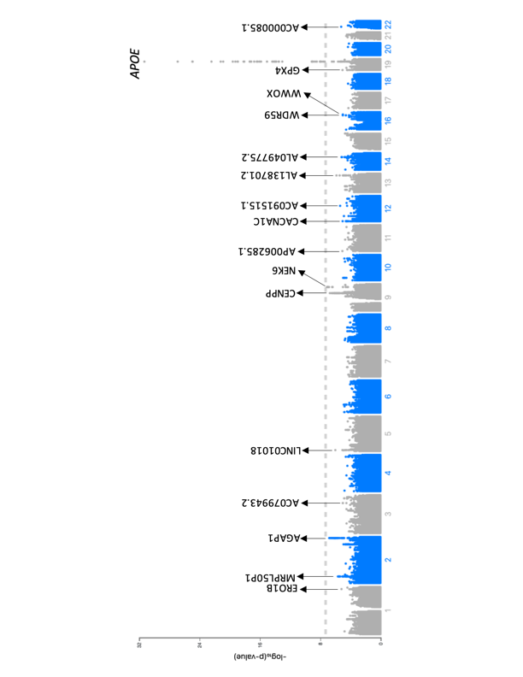

Supplementary Figure 1. Manhattan Plot displaying the meta-analysis of Colombian, Argentinian and Chilean samples. The dotted line represents the genome-wide significance level (P = 5 x 10⁻⁸). Loci designated with arrows have suggestive significance level (p = 1x10-5). Annotation is based on the closest feature.

