(A)
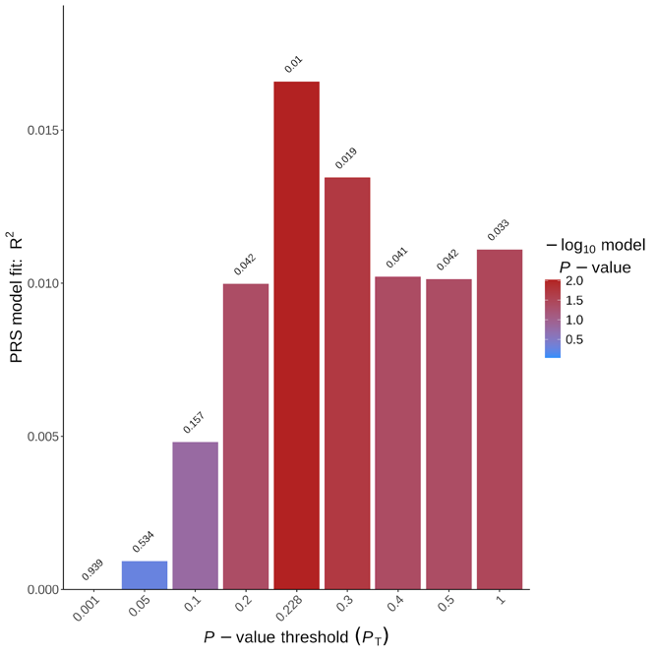

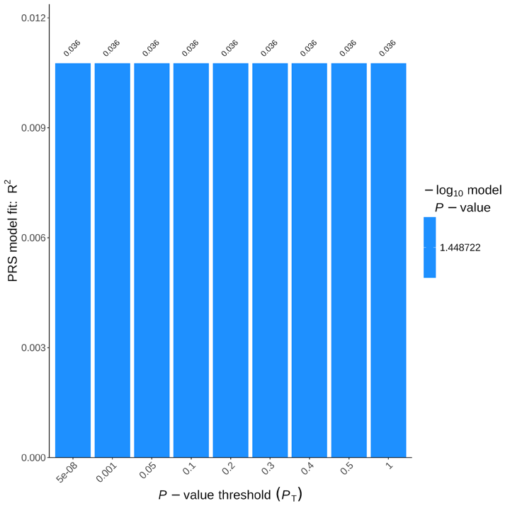
(B)

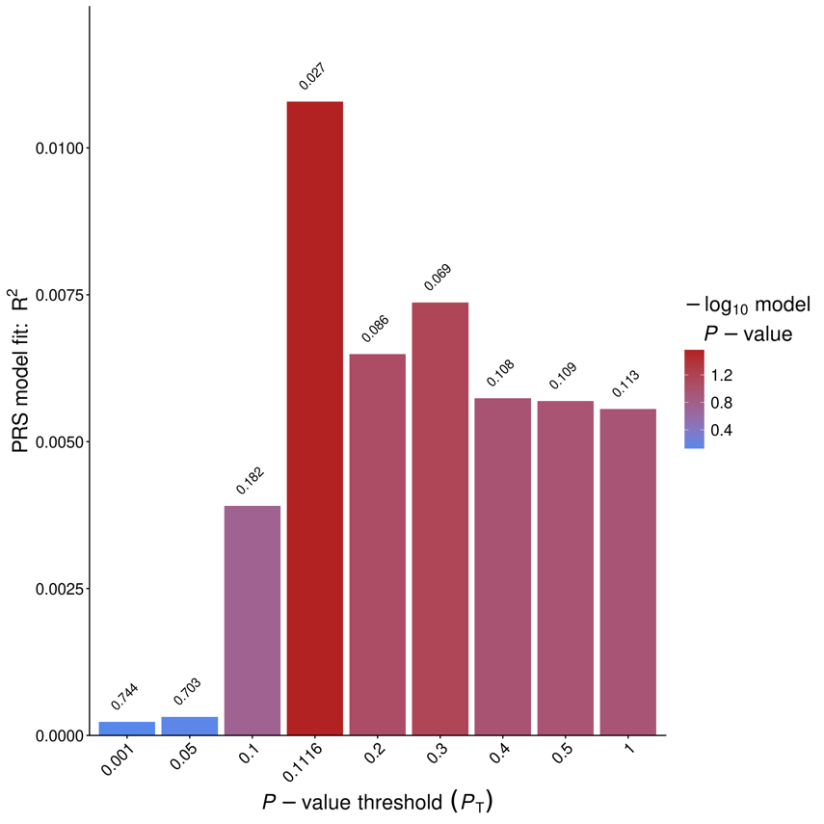
(C)

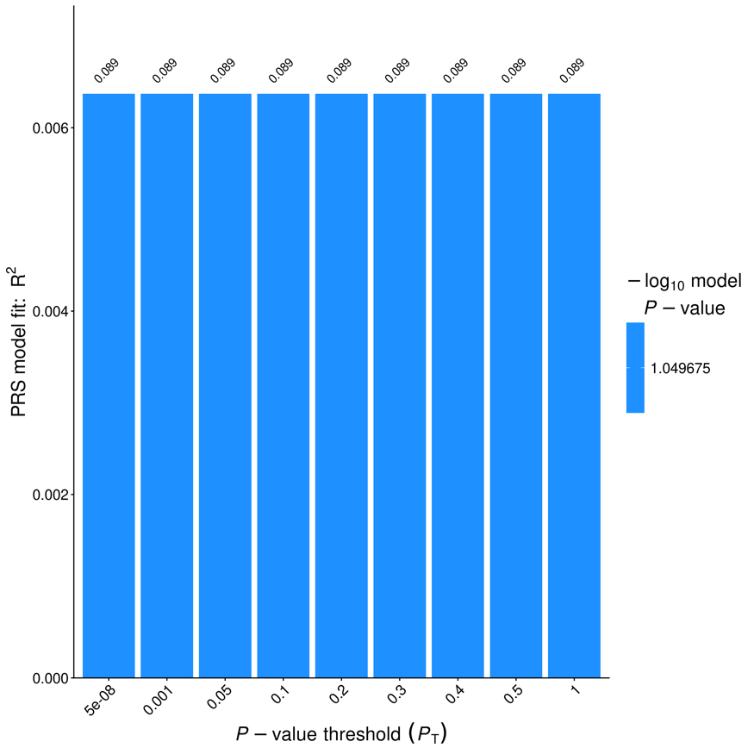
(D)

(E)

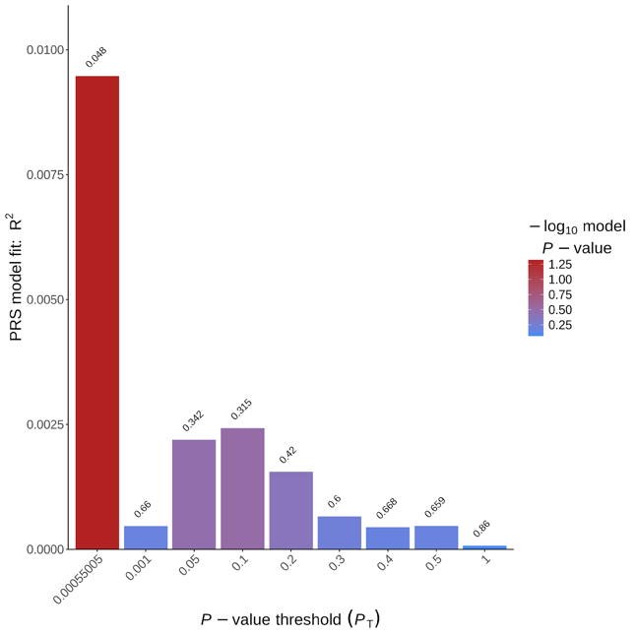

(F)
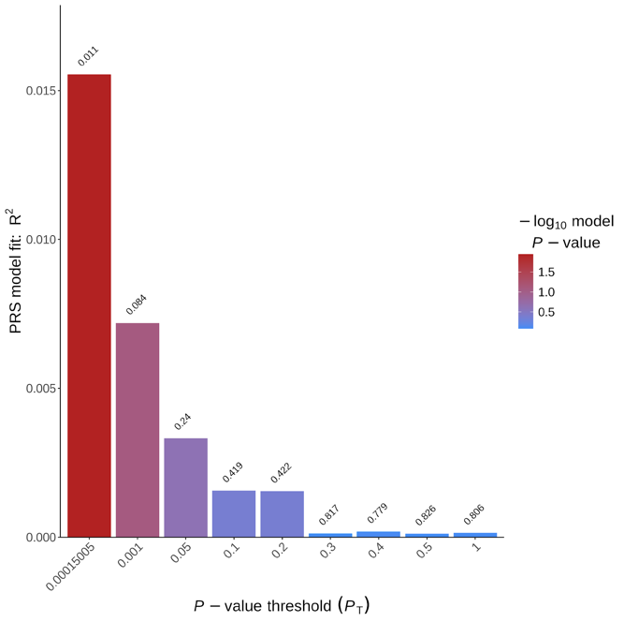

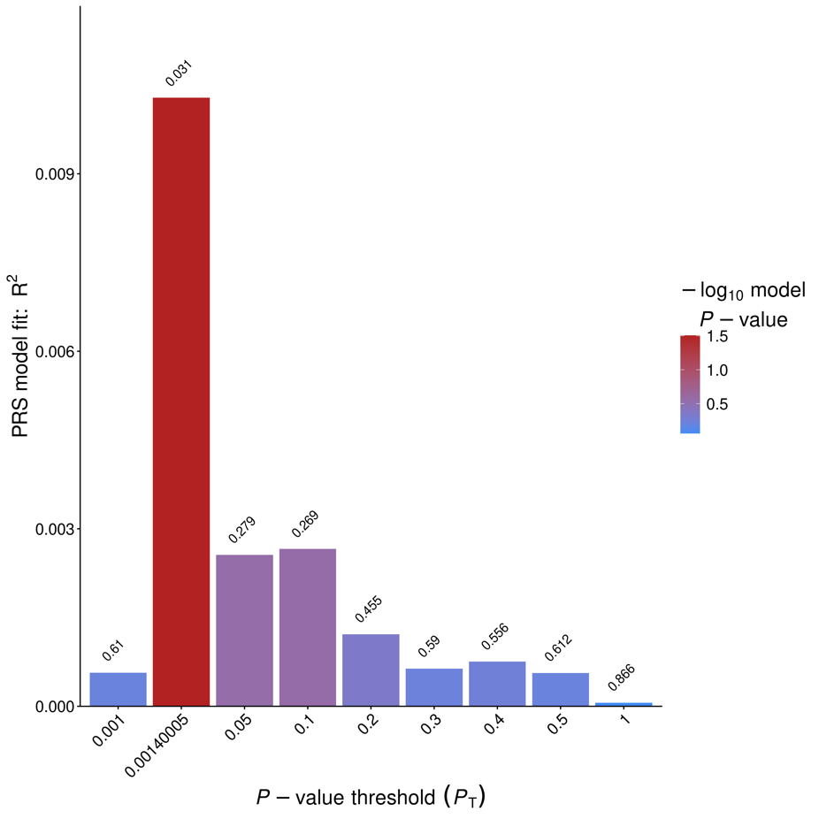
(G)

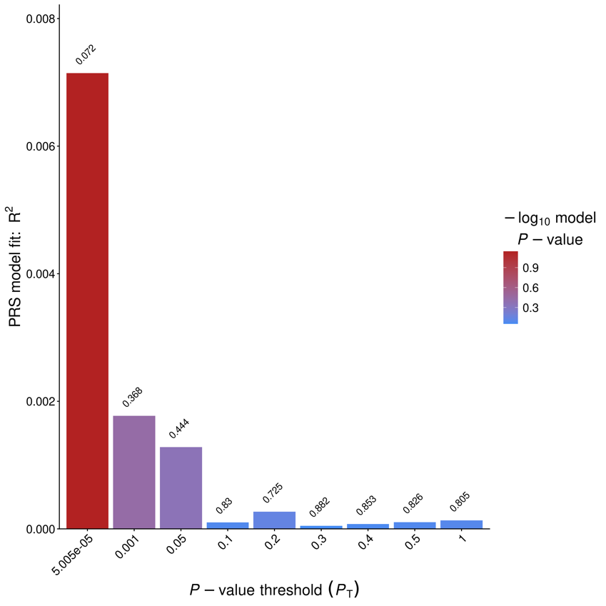
(H)

Supplementary Figure 3. Polygenic risk score (PRS) model fit (R²) across multiple P-value thresholds (PT) in the Colombian cohort. PR_{SGS-only} models are shown without APOE adjustment using ARG-CHI (A) and EADB stage I (B) as base datasets, and with adjusted for the number of alleles present for APOE-ε2 and -ε4 using ARG-CHI (C) and EADB stage I (D). PRS_{LD-pruned} models (300 kb window, 50 kb step size, r² = 0.03) are shown without APOE adjustment using ARG-CHI (E) and EADB stage I (F), and with adjusted for the number of alleles present for APOE-ε2 and -ε4 using ARG-CHI (G) and EADB stage I (H). Bar colors represent the -log₁₀ of the model P-values, and R² values indicate the proportion of the phenotypic variance explained at each threshold.

