(A)
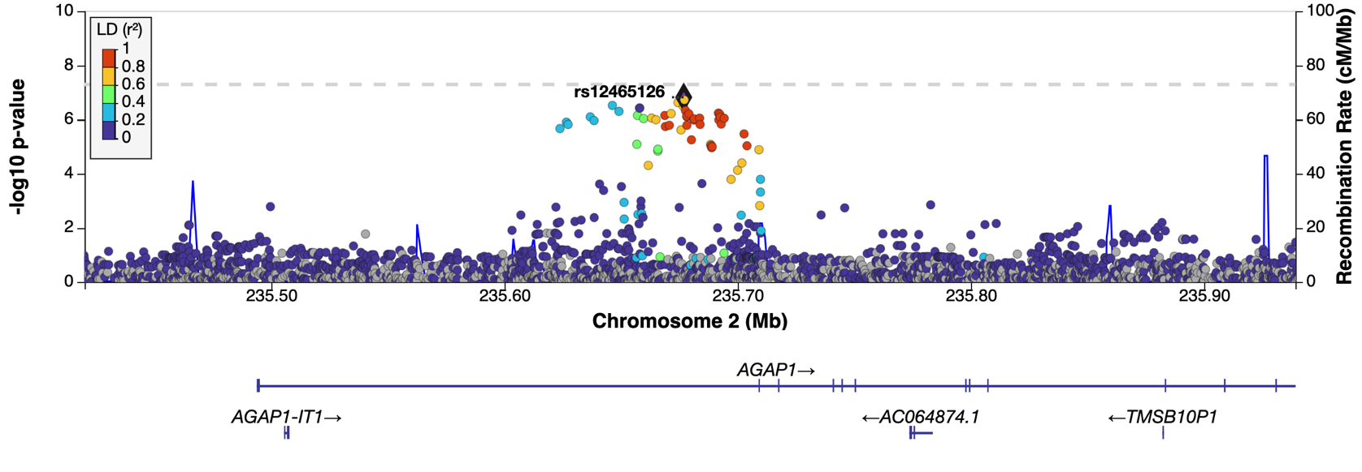

(B)
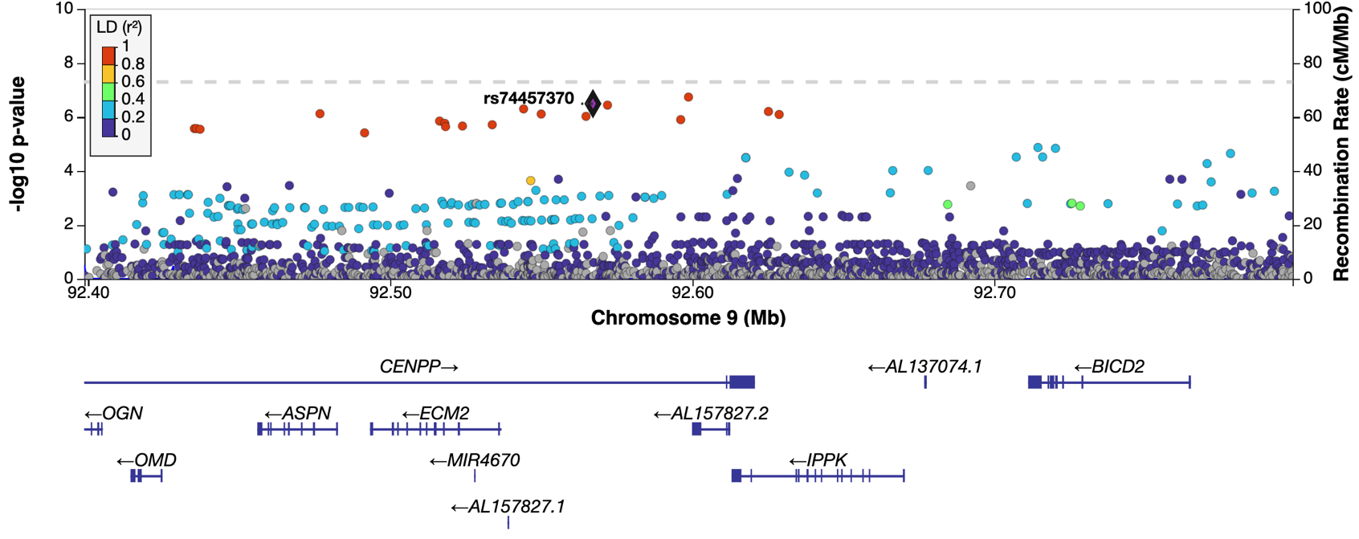

(C)
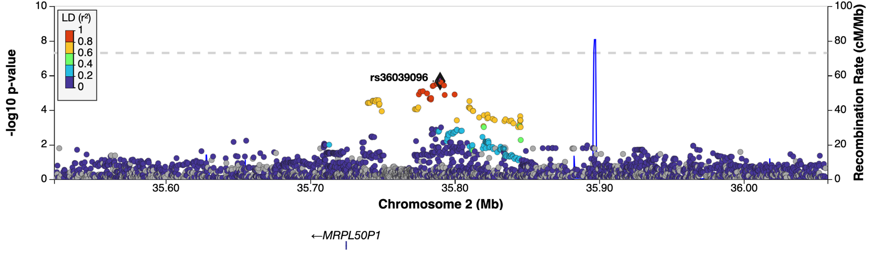

Supplementary Figure 2. Regional association plots for three loci that gain significance with the inclusion of Colombian samples. (A) AGAP1 locus with lead SNP rs12465126, (B) CENPP locus with lead SNP rs74457370 and (C) MRPL50P1 locus with lead SNP rs36039096. Points represent SNP –log₁₀P-values colored by LD (r²) with the lead variant (black diamond). Genomic coordinates are provided on the x-axis (Mb), and recombination rates (cM/Mb) are plotted on the secondary y-axis (right) to indicate local recombination hotspots. Gene annotations below each plot illustrate the structure and orientation of nearby genes.

