Intensified carotenoid accumulation in Rhodotorula mucilaginosa under Pb Stress
Supplementary Materials
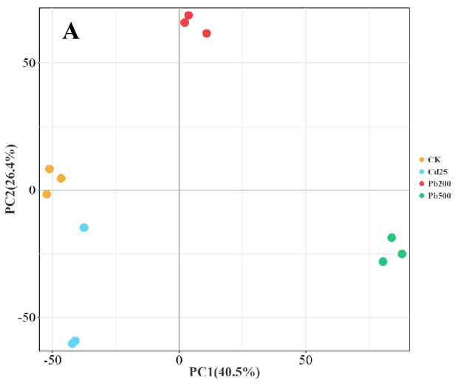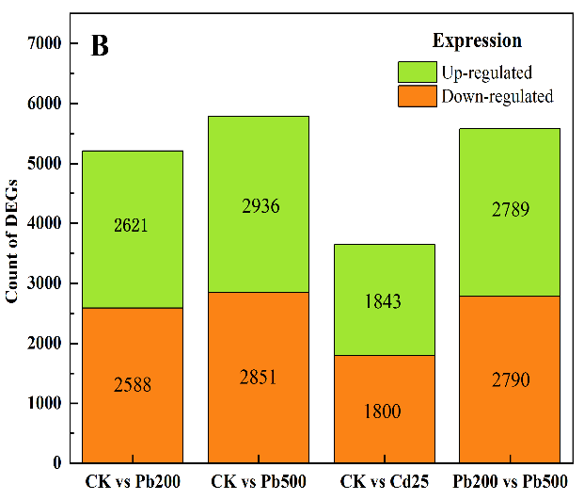
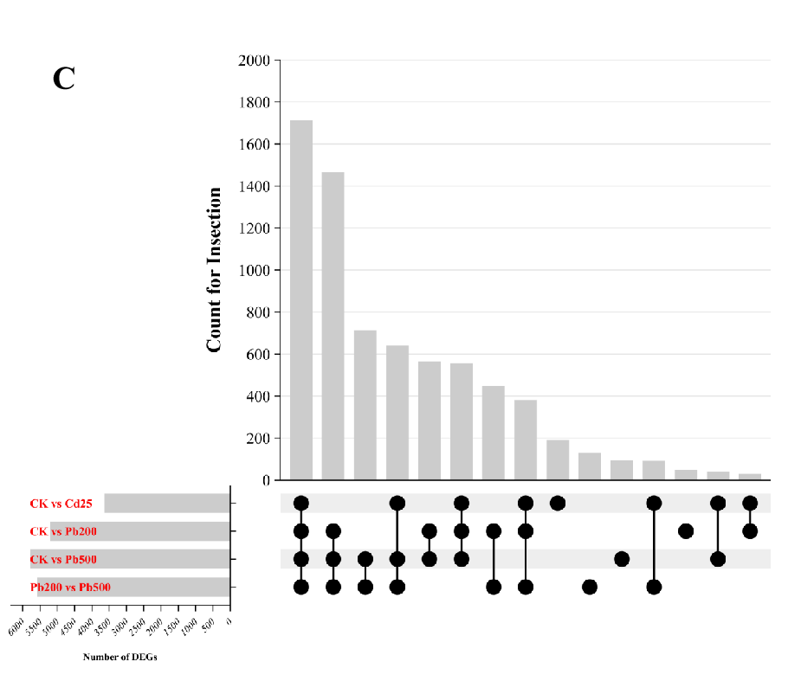
Fig. S1. Characterization of the transcriptome dataset. A: Principal component analysis of the RNA-Seq data, using normalized gene expression counts for each treatment group. Each dot represents one sample. B: Count of DEGs (Green: Up-regulated; Orange: Down-regulated). C: Upset venn plot of expressed genes in all the treatments.
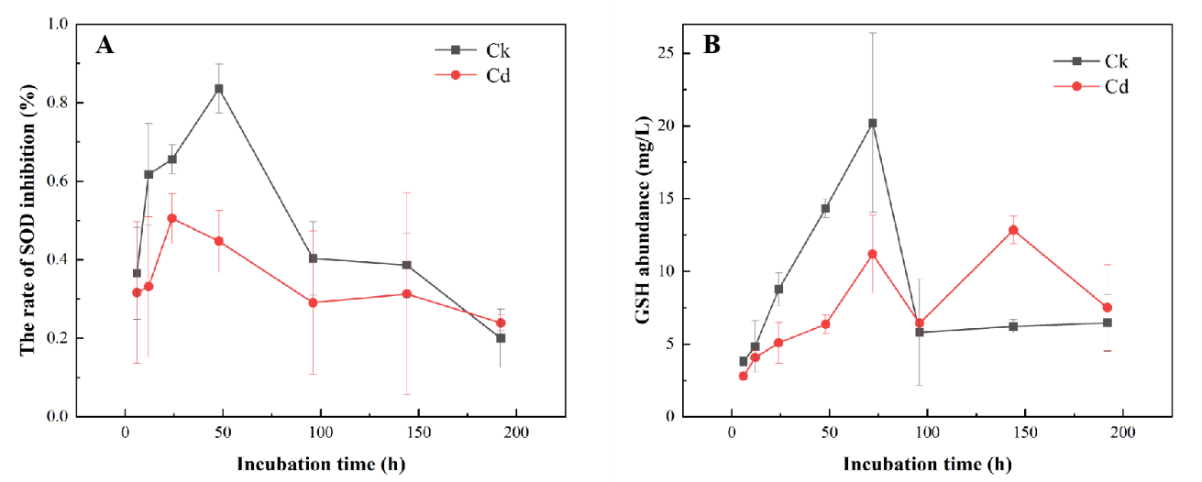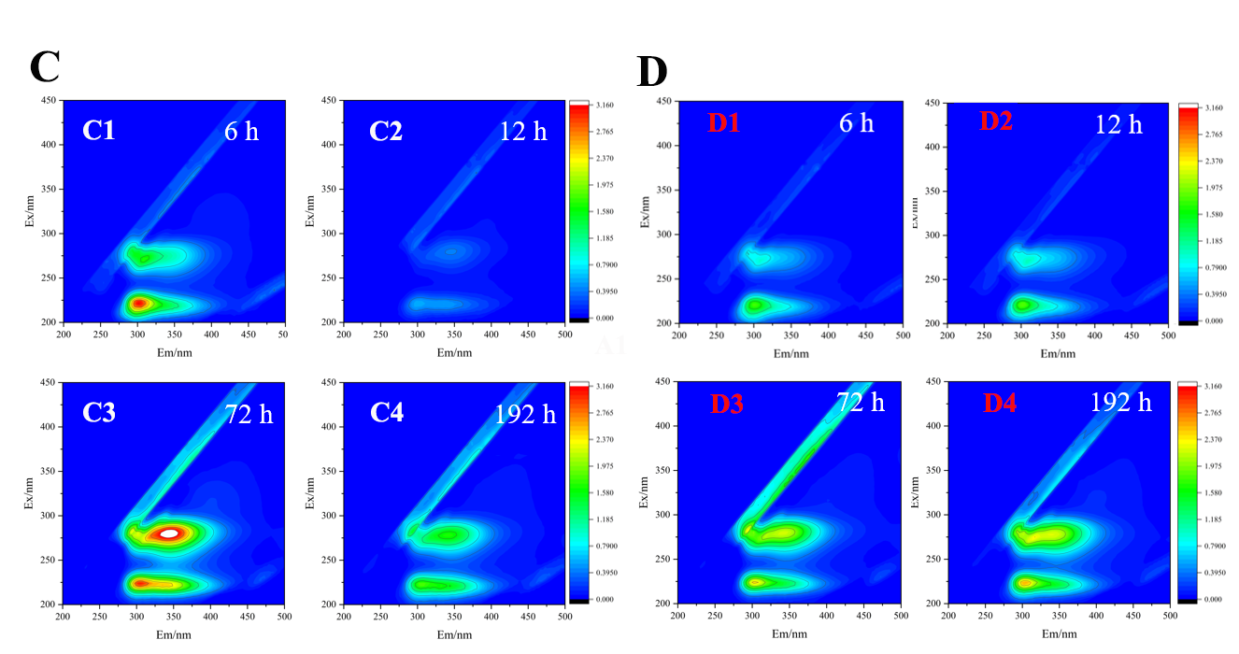
Fig. S2. Metabolites content under higher Cd(Ⅱ) stress. A: SOD enzyme relative activity (The rate of SOD inhibition). B: GSH abundance. Standard deviations are depicted, with N-5 replicates. C: Excitation-Emission-Matrix spectra of CK treatment. D: Excitation-Emission-Matrix spectra of Cd150 treatment. Lower-case letters above the bar indicate the significant differences among different treatments (p <0.05) after one-way ANOVA.

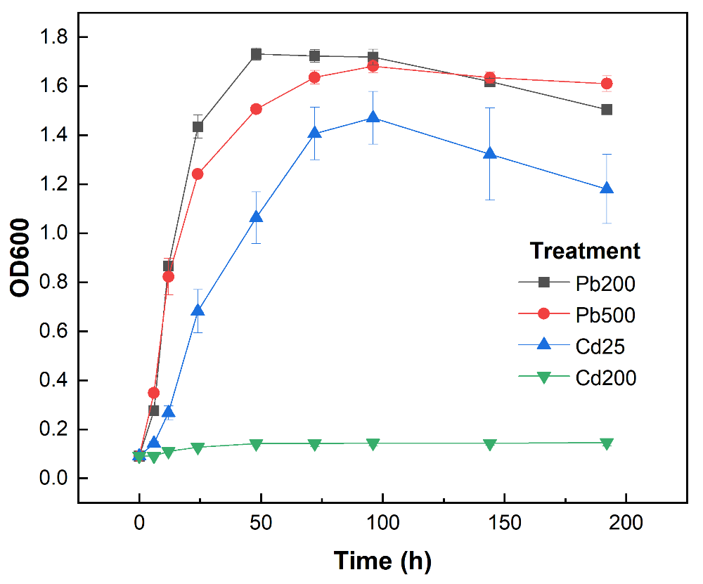
Fig. S3. Growth curve of four main treatments in our study.

Table S1. A list of all the treatments
Treatments |  | HM addition (mL) | R. mucilaginosa (mL)
Pb | CK | 0 | 1
Pb | Pb100 | 0.1 | 1
Pb | Pb200 | 0.2 | 1
Pb | Pb500 | 0.5 | 1
Pb | Pb1000 | 1.0 | 1
Pb | Pb2500 | 2.5 | 1
Cd | CK | 0 | 1
Cd | Cd25 | 0.25 | 1
Cd | Cd50 | 0.5 | 1
Cd | Cd100 | 1.0 | 1
Cd | Cd200 | 2.0 | 1

Table S2. Quality inspection results of RNA extraction
Treatments |  | Concentration (ng/μL) | Content (μg)
CK | CK_1 | 11.5 | 0.4
CK | CK_2 | 11.8 | 0.41
CK | CK_3 | 5.8 | 0.2
Pb200 | Pb200_1 | 20.8 | 0.62
Pb200 | Pb200_2 | 22.4 | 0.67
Pb200 | Pb200_3 | 15.3 | 0.46
Pb500 | Pb500_1 | 15.8 | 0.55
Pb500 | Pb500_2 | 11.9 | 0.42
Pb500 | Pb500_3 | 13.5 | 0.47
Cd25* | Cd25_1* | 47.2* | 1.65
Cd25* | Cd25_2* | 43.1* | 1.51
Cd25* | Cd25_3* | 48.5* | 1.7
Cd200# | Cd200_1# | 0.6# | 0.02
Cd200# | Cd200_2# | 0.4# | 0.01
Cd200# | Cd200_3# | 0.7# | 0.02
* Higher than average
# Lower than average
Table S3A. KEGG enrichment analysis of DEGs in four comparison groups (top 25 enriched pathways, comparison: CK vs Cd25, level1: metabolism).
KEGG Pathway | Rich Ratio | q-value
Glycolysis / Gluconeogenesis | 0.625 | 0.286
Pentose phosphate pathway | 0.720 | 0.286
Ascorbate and aldarate metabolism | 0.750 | 0.286
Glycine, serine and threonine metabolism | 0.660 | 0.286
Penicillin and cephalosporin biosynthesis | 1.000 | 0.286
Arginine and proline metabolism | 0.684 | 0.286
D-Amino acid metabolism | 1.000 | 0.286
Sulfur metabolism | 0.714 | 0.286
Metabolic pathways | 0.509 | 0.286
Biosynthesis of secondary metabolites | 0.523 | 0.286
Tyrosine metabolism | 0.667 | 0.321
Glutathione metabolism | 0.639 | 0.321
Pyruvate metabolism | 0.594 | 0.321
beta-Alanine metabolism | 0.654 | 0.388
Methane metabolism | 0.654 | 0.388
Nitrogen metabolism | 0.714 | 0.425
Arginine biosynthesis | 0.636 | 0.487
Aflatoxin biosynthesis | 0.692 | 0.487
Porphyrin metabolism | 0.650 | 0.487
Lysine degradation | 0.607 | 0.499
Carbon metabolism | 0.536 | 0.499
Amino sugar and nucleotide sugar metabolism | 0.561 | 0.501
Pentose and glucuronate interconversions | 0.632 | 0.513
Starch and sucrose metabolism | 0.579 | 0.513
Cysteine and methionine metabolism | 0.556 | 0.559

Table S3B. KEGG enrichment analysis of DEGs in four comparison groups (top 25 enriched pathways, comparison: CK vs Pb200, level1: metabolism).
KEGG Pathway | Rich Ratio | q-value
Amino sugar and nucleotide sugar metabolism | 0.912 | 0.328
Fructose and mannose metabolism | 0.923 | 0.479
Sulfur metabolism | 0.952 | 0.619
Biosynthesis of nucleotide sugars | 0.906 | 0.677
Pentose phosphate pathway | 0.920 | 0.703
Thiamine metabolism | 0.941 | 0.893
Galactose metabolism | 0.905 | 0.934
Oxidative phosphorylation | 0.828 | 0.934
Other types of O-glycan biosynthesis | 1.000 | 0.934
Sphingolipid metabolism | 0.938 | 0.934
Carbon metabolism | 0.818 | 0.958
Glycolysis / Gluconeogenesis | 0.732 | 0.998
Citrate cycle (TCA cycle) | 0.833 | 0.998
Pentose and glucuronate interconversions | 0.789 | 0.998
Ascorbate and aldarate metabolism | 0.563 | 0.998
Fatty acid biosynthesis | 0.750 | 0.998
Fatty acid elongation | 0.636 | 0.998
Fatty acid degradation | 0.718 | 0.998
Cutin, suberine and wax biosynthesis | 1.000 | 0.998
Steroid biosynthesis | 0.706 | 0.998
Ubiquinone and other terpenoid-quinone biosynthesis | 0.600 | 0.998
Arginine biosynthesis | 0.818 | 0.998
Purine metabolism | 0.803 | 0.998
Caffeine metabolism | 1.000 | 0.998
Pyrimidine metabolism | 0.784 | 0.998

Table S3C. KEGG enrichment analysis of DEGs in four comparison groups (top 25 enriched pathways, comparison: CK vs Pb500, level1: metabolism).
KEGG Pathway | Rich Ratio | q-value
Glycolysis / Gluconeogenesis | 0.732 | 0.989
Citrate cycle (TCA cycle) | 0.700 | 0.989
Fructose and mannose metabolism | 0.692 | 0.989
Galactose metabolism | 0.714 | 0.989
Fatty acid biosynthesis | 0.750 | 0.989
Cutin, suberine and wax biosynthesis | 1.000 | 0.989
Ubiquinone and other terpenoid-quinone biosynthesis | 0.733 | 0.989
Arginine biosynthesis | 0.773 | 0.989
Caffeine metabolism | 1.000 | 0.989
Pyrimidine metabolism | 0.784 | 0.989
Alanine, aspartate and glutamate metabolism | 0.689 | 0.989
Aflatoxin biosynthesis | 0.846 | 0.989
Glycine, serine and threonine metabolism | 0.700 | 0.989
Cysteine and methionine metabolism | 0.722 | 0.989
Valine, leucine and isoleucine degradation | 0.681 | 0.989
Lysine biosynthesis | 0.833 | 0.989
Lysine degradation | 0.714 | 0.989
Penicillin and cephalosporin biosynthesis | 1.000 | 0.989
Arginine and proline metabolism | 0.684 | 0.989
Tyrosine metabolism | 0.703 | 0.989
Phenylalanine metabolism | 0.789 | 0.989
Tryptophan metabolism | 0.686 | 0.989
Phenylalanine, tyrosine and tryptophan biosynthesis | 0.769 | 0.989
beta-Alanine metabolism | 0.731 | 0.989
Taurine and hypotaurine metabolism | 0.875 | 0.989

