Cryo-adapted bacterial copiotrophs from a Trans-Himalayan lake-desert ecosystem as biogeothermometers of warming and mitigators of microbiome perturbation

Sumit Chatterjee¹, Subhajit Dutta¹, Jit Ghosh¹, Swapneel Saha¹, Mahamadul Mondal¹, Jagannath Sarkar^{1,$}, Nibendu Mondal^{1,#}, and Wriddhiman Ghosh^{1,}*

Author Address:
¹ Department of Biological Sciences, Bose Institute, Kolkata, India

Present Address:
$ Faculty of Engineering and Natural Sciences, Tampere University, Finland
# Department of Microbiology and Cell Science, Fort Lauderdale Research and Education Center, University of Florida, USA

Correspondence:
* Wriddhiman Ghosh (wriman@jcbose.ac.in, wriman@rediffmail.com)

Keywords: Trans-Himalayan deserts and lakes, psychrophilic and cryophilic bacteria, climate warming, antibiosis, microbiome protection, organic matter degradation

Running title: Ecological essentials of cryo-adapted copiotrophs

Table of Contents

Supplementary Tables
(All SI tables, except S32, S33 and S34, have been given in individual sheets of an Excel Workbook named Supplementary_Dataset)
Table S1. Changes recorded in the CFU densities, and growth rates calculated therefrom, after incubating the TMA isolates (plus E. coli) at -10°C in Luria broth (for the cultures lacking increase in CFU density, i.e. growth, proportions of FDA-stained cells were recorded at the end of the incubations).
Table S2. Changes recorded in the CFU densities, and growth rates calculated therefrom, after incubating the TMA isolates (plus E. coli) at 4°C in Luria broth.
Table S3. Changes recorded in the CFU densities, and growth rates calculated therefrom, after incubating the TMA isolates (plus E. coli) at 15°C in Luria broth.
Table S4. Changes recorded in the CFU densities of the TMA isolates upon incubation in MS-acetate (MSAc) at 4°C.
Table S5. Changes recorded in the CFU densities of the TMA isolates upon incubation in MS-agar (MSAg) at 4°C.
Table S6. Changes recorded in the CFU densities of the TMA isolates upon incubation in MS-albumin (MSAl) at 4°C.
Table S7. Changes recorded in the CFU densities of the TMA isolates upon incubation in MS-benzoate (MSB) at 4°C.
Table S8. Changes recorded in the CFU densities of the TMA isolates upon incubation in MS-cellulose (MSCl) at 4°C.
Table S9. Changes recorded in the CFU densities of the TMA isolates upon incubation in MS-chitin (MSCt) at 4°C.
Table S10. Changes recorded in the CFU densities of the TMA isolates upon incubation in MS-hexadecane (MSH) at 4°C.
Table S11. Changes recorded in the CFU densities of the TMA isolates upon incubation in MS-pectin (MSP) at 4°C.
Table S12. Changes recorded in the CFU densities of the TMA isolates upon incubation in MS-starch (MSS) at 4°C.
Table S13. Changes recorded in the CFU densities of the TMA isolates upon incubation in MS-xylan (MSX) at 4°C.
Table S14. Changes recorded in the CFU densities of the TMA isolates upon incubation in MS-acetate (MSAc) at -10°C.
Table S15. Changes recorded in the CFU densities of the TMA isolates upon incubation in MS-agar (MSAg) at -10°C.
Table S16. Changes recorded in the CFU densities of the TMA isolates upon incubation in MS-albumin (MSAl) at -10°C.
Table S17. Changes recorded in the CFU densities of the TMA isolates upon incubation in MS-benzoate (MSB) at -10°C.
Table S18. Changes recorded in the CFU densities of the TMA isolates upon incubation in MS-cellulose (MSCl) at -10°C.
Table S19. Changes recorded in the CFU densities of the TMA isolates upon incubation in MS-chitin (MSCt) at -10°C.
Table S20. Changes recorded in the CFU densities of the TMA isolates upon incubation in MS-hexadecane (MSH) at -10°C.
Table S21. Changes recorded in the CFU densities of the TMA isolates upon incubation in MS-pectin (MSP) at -10°C.
Table S22. Changes recorded in the CFU densities of the TMA isolates upon incubation in MS-starch (MSS) at -10°C.
Table S23. Changes recorded in the CFU densities of the TMA isolates upon incubation in MS-xylan (MSX) at -10°C.
Table S24. Changes recorded in the CFU densities of the TMA isolates upon incubation in minimal salts (MS) solution at 4°C.
Table S25. Changes recorded in the CFU densities of the TMA isolates upon incubation in minimal salts (MS) solution at -10°C.
Table S26. Changes recorded in the CFU densities, and growth rates calculated therefrom, after incubating the TMA isolates (plus E. coli) at 28°C in Luria broth (for the cultures lacking increase in CFU density, i.e. growth, proportions of FDA-stained cells were recorded at the end of the incubations).
Table S27. Changes recorded in the CFU densities, and growth rates calculated therefrom, after incubating the TMA isolates (plus E. coli) at 37°C in Luria broth (for the cultures lacking increase in CFU density, i.e. growth, proportions of FDA-stained cells were recorded at the end of the incubations).
Table S28. Decreases in CFU densities, and corresponding negative growths, recorded for the TMA isolates upon incubation at 42°C in Luria broth (since all the cultures lacked increase in CFU density, i.e. growth, proportions of FDA-stained cells were recorded for all of them at the end of the incubations).
Table S29. Key attributes of the assembled whole genome sequences of the 15 TMA isolates shortlisted.
Table S30. Key attributes of the assembled metagenomes obtained from the weathered rock dust, lake-water, and lake-sediment samples.
Table S31. Taxonomic affiliation (up to the domain and/or phylum level) of the protein-coding sequences (CDSs) predicted within the assembled metagenomes of the weathered rock dust, lake-water, and lake-sediment samples.
Table S32. Taxonomic classification of such metagenomic reads from the rock-dust sample that corresponded to bacterial or archaeal 16S rRNA gene sequences.
Table S33. Taxonomic classification of such metagenomic reads from the lake-water sample that corresponded to bacterial or archaeal 16S rRNA gene sequences.
Table S34. Taxonomic classification of such metagenomic reads from the lake-sediment sample that corresponded to bacterial or archaeal 16S rRNA gene sequences.
Table S35. Proportions of metagenomic reads from the rock-dust, lake-water, and lake-sediment samples that individually matched sequences from the genomes of the representative TMA isolates.
Table S36. eggNOG‑based annotation of all protein-coding sequences (CDSs) identified within the genome of Arthrobacter sp. TRD_SC_6.
Table S37. eggNOG‑based annotation of all protein-coding sequences (CDSs) identified within the genome of Cryobacterium sp. TS_SC_7.
Table S38. eggNOG‑based annotation of all protein-coding sequences (CDSs) identified within the genome of Microbacterium sp. TW_SC_2.
Table S39. eggNOG‑based annotation of all protein-coding sequences (CDSs) identified within the genome of Mycetocola sp. TRD_SC_2.
Table S40. eggNOG‑based annotation of all protein-coding sequences (CDSs) identified within the genome of Paenarthrobacter sp. TRD_SC_7.
Table S41. eggNOG‑based annotation of all protein-coding sequences (CDSs) identified within the genome of Pseudarthrobacter sp. TRD_SC_9.
Table S42. eggNOG‑based annotation of all protein-coding sequences (CDSs) identified within the genome of Sanguibacter sp. TS_SC_8.
Table S43. eggNOG‑based annotation of all protein-coding sequences (CDSs) identified within the genome of Streptomyces sp. TRD_SC_5.
Table S44. eggNOG‑based annotation of all protein-coding sequences (CDSs) identified within the genome of Trichococcus sp. TS_SC_9.
Table S45. eggNOG‑based annotation of all protein-coding sequences (CDSs) identified within the genome of Flavobacterium sp. TS_SC_5.
Table S46. eggNOG‑based annotation of all protein-coding sequences (CDSs) identified within the genome of Ancylobacter sp. TW_SC_1.
Table S47. eggNOG‑based annotation of all protein-coding sequences (CDSs) identified within the genome of Acinetobacter sp. TW_SC_4.
Table S48. eggNOG‑based annotation of all protein-coding sequences (CDSs) identified within the genome of Aeromonas salmonicida TS_SC_11.
Table S49. eggNOG‑based annotation of all protein-coding sequences (CDSs) identified within the genome of Pseudomonas sp. TS_SC_3.
Table S50. eggNOG‑based annotation of all protein-coding sequences (CDSs) identified within the genome of Psychrobacter sp. TS_SC_6.
Table S51. Number of genes identified in the different TMA isolates for adaptation to low temperatures, and low as well as high temperatures.
Table S52. Number of genes identified in the rock-dust, lake-water, and lake-sediment metagenomes for adaptation to low temperatures, and low as well as high temperatures.
Table S53. Number of genes identified in the different TMA isolates under the different categories of carbohydrate-active enzymes (CAZymes).
Table S54. Number of genes identified in the analyzed metagenomes under the different categories of carbohydrate-active enzymes (CAZymes).
Table S55. Annotation details of the key genes concerned with the biosynthesis of different antibiotics, as identified within the eggNOG-based CDS catalogues of the 15 TMA isolates.
Table S56. AntiSMASH-based annotation details of the genes concerned with secondary metabolites biosynthesis, as identified within the Prodigal-based gene (ORF) catalogues of the 15 TMA isolates.
Table S57. CARD-RGI-based annotation details of the genes concerned with antibiotic resistance, as identified within the genome sequences of the 15 TMA isolates.
Table S58. Members retrieved previously from other cold/frigid habitats of the world for the genera that were currently isolated from the Tso Moriri area.
Table S59. Members retrieved previously from discrete mesic/hot habitats for the genera that were currently isolated from the Tso Moriri area.
Table S60. Minimum and maximum growth temperatures known (in the literature) thus far for the global strains of the genera that were isolated in this study from the Tso Moriri area.

Supplementary Figures
Figure S1. Flow cytometry-derived dot plots depicting what proportions of cells were stained by FDA (after 28 days of incubation) in the LB cultures of the 14 TMA isolates incapable of growing at -10°C.
Figure S2. Correlation between the proportions of divisible and metabolically-active cells across the species incapable of growing in Luria broth at (a) -10°C, (b) 28°C, (c) 37°C, or (d) 42°C.
Figure S3. Flow cytometry-derived dot plots depicting what proportions of cells were stained by FDA in the LB cultures of the isolates incapable of growing after (a) four days of incubation at 28°C, and (b) two days of incubation at 37°C.
Figure S4. Flow cytometry-derived dot plots depicting what proportions of cells were stained by FDA in the LB cultures of the 27 TMA isolates after 24 h incubation at 42°C.
Figure S5. Functional-category-wise numeral distribution of genes putatively concerned with low temperature adaptation, and low as well as high temperature adaptation, within the genomes of the 15 TMA isolates selected on a “one per genus” basis.
Figure S6. Functional-category-wise numeral distribution of genes putatively concerned with carbohydrate metabolism (encoding the different categories of carbohydrate-active enzymes), within the genomes of the 15 TMA isolates selected on a “one per genus” basis.
Figure S7. Growth temperature windows of the bacterial genera under which the different TMA isolates were classified.

Supplementary References
References used in Table S58
References used in Table S59
References used in Table S60
Supplementary Tables
Table S32. Taxonomic classification of such metagenomic reads from the rock-dust sample that corresponded to bacterial or archaeal 16S rRNA gene sequences.
Phylum (no. of 16S reads ascribed to the phylum) | Class | Genus (no. of 16S reads ascribed to the genus)
Archaea (total reads: 649)
Nitrososphaerota (644) | - | Nitrososphaera (625)
Unclassified Archaea (5) | - | -
Bacteria (total reads: 30360)
Actinobacteria / Actinomycetota (16606) | - | Rubrobacter (1028)
Actinobacteria / Actinomycetota (16606) | - | Blastococcus (803)
Actinobacteria / Actinomycetota (16606) | - | Modestobacter (395)
Actinobacteria / Actinomycetota (16606) | - | Geodermatophilus (306)
Actinobacteria / Actinomycetota (16606) | - | Solirubrobacter (223)
Actinobacteria / Actinomycetota (16606) | - | Parviterribacter (188)
Actinobacteria / Actinomycetota (16606) | - | Microlunatus (166)
Actinobacteria / Actinomycetota (16606) | - | Nocardioides (156)
Actinobacteria / Actinomycetota (16606) | - | Marmoricola (113)
Actinobacteria / Actinomycetota (16606) | - | Acidiferrimicrobium (105)
Actinobacteria / Actinomycetota (16606) | - | Pseudonocardia (73)
Actinobacteria / Actinomycetota (16606) | - | Actinoplanes (68)
Actinobacteria / Actinomycetota (16606) | - | Conexibacter (56)
Actinobacteria / Actinomycetota (16606) | - | Patulibacter (45)
Actinobacteria / Actinomycetota (16606) | - | Aquipuribacter (43)
Actinobacteria / Actinomycetota (16606) | - | Rhabdothermincola (42)
Actinobacteria / Actinomycetota (16606) | - | Auraticoccus (41)
Actinobacteria / Actinomycetota (16606) | - | Goekera (41)
Actinobacteria / Actinomycetota (16606) | - | Gaiella (33)
Actinobacteria / Actinomycetota (16606) | - | Paraconexibacter (24)
Actinobacteria / Actinomycetota (16606) | - | Baekduia (20)
Actinobacteria / Actinomycetota (16606) | - | Thalassiella (19)
Actinobacteria / Actinomycetota (16606) | - | Actinotalea (17)
Actinobacteria / Actinomycetota (16606) | - | Kribbella (16)
Actinobacteria / Actinomycetota (16606) | - | Cellulomonas (16)
Actinobacteria / Actinomycetota (16606) | - | Arthrobacter (16)
Actinobacteria / Actinomycetota (16606) | - | Angustibacter (15)
Actinobacteria / Actinomycetota (16606) | - | Desertimonas (13)
Actinobacteria / Actinomycetota (16606) | - | Euzebya (12)
Actinobacteria / Actinomycetota (16606) | - | Trujillonella (11)
Actinobacteria / Actinomycetota (16606) | - | Sporichthya (11)
Actinobacteria / Actinomycetota (16606) | - | Virgisporangium (9)
Actinobacteria / Actinomycetota (16606) | - | Couchioplanes (9)
Actinobacteria / Actinomycetota (16606) | - | Jatrophihabitans (8)
Actinobacteria / Actinomycetota (16606) | - | Iamia (8)
Actinobacteria / Actinomycetota (16606) | - | Actinomycetospora (7)
Actinobacteria / Actinomycetota (16606) | - | Motilibacter (7)
Actinobacteria / Actinomycetota (16606) | - | Actinomarinicola (7)
Actinobacteria / Actinomycetota (16606) | - | Klenkia (6)
Actinobacteria / Actinomycetota (16606) | - | Micromonospora (4)
Actinobacteria / Actinomycetota (16606) | - | Aeromicrobium (3)
Actinobacteria / Actinomycetota (16606) | - | Kocuria (3)
Actinobacteria / Actinomycetota (16606) | - | Aquihabitans (3)
Actinobacteria / Actinomycetota (16606) | - | Cutibacterium (2)
Actinobacteria / Actinomycetota (16606) | - | Quadrisphaera (2)
Actinobacteria / Actinomycetota (16606) | - | Kineococcus (2)
Actinobacteria / Actinomycetota (16606) | - | Dactylosporangium (2)
Actinobacteria / Actinomycetota (16606) | - | Oerskovia (2)
Actinobacteria / Actinomycetota (16606) | - | Mycobacterium (2)
Actinobacteria / Actinomycetota (16606) | - | Ilumatobacter (2)
Actinobacteria / Actinomycetota (16606) | - | Nakamurella (1)
Actinobacteria / Actinomycetota (16606) | - | Phytohabitans (1)
Actinobacteria / Actinomycetota (16606) | - | Catellatospora (1)
Actinobacteria / Actinomycetota (16606) | - | Lentzea (1)
Actinobacteria / Actinomycetota (16606) | - | Ornithinimicrobium (1)
Actinobacteria / Actinomycetota (16606) | - | Cryobacterium (1)
Actinobacteria / Actinomycetota (16606) | - | Cellulosimicrobium (1)
Actinobacteria / Actinomycetota (16606) | - | Georgenia (1)
Actinobacteria / Actinomycetota (16606) | - | Streptomyces (1)
Actinobacteria / Actinomycetota (16606) | - | Cryptosporangium (1)
Actinobacteria / Actinomycetota (16606) | - | Egibacter (1)
Actinobacteria / Actinomycetota (16606) | - | Collinsella (1)
Proteobacteria / Pseudomonadota (5717) | Alphaproteobacteria (4853) | Rubellimicrobium (307)
Proteobacteria / Pseudomonadota (5717) | Alphaproteobacteria (4853) | Microvirga (194)
Proteobacteria / Pseudomonadota (5717) | Alphaproteobacteria (4853) | Sphingomonas (125)
Proteobacteria / Pseudomonadota (5717) | Alphaproteobacteria (4853) | Craurococcus (56)
Proteobacteria / Pseudomonadota (5717) | Alphaproteobacteria (4853) | Roseomonas (55)
Proteobacteria / Pseudomonadota (5717) | Alphaproteobacteria (4853) | Asticcacaulis (52)
Proteobacteria / Pseudomonadota (5717) | Alphaproteobacteria (4853) | Sphingosinicella (34)
Proteobacteria / Pseudomonadota (5717) | Alphaproteobacteria (4853) | Phenylobacterium (31)
Proteobacteria / Pseudomonadota (5717) | Alphaproteobacteria (4853) | Sphingopyxis (19)
Proteobacteria / Pseudomonadota (5717) | Alphaproteobacteria (4853) | Caulobacter (18)
Proteobacteria / Pseudomonadota (5717) | Alphaproteobacteria (4853) | Devosia (16)
Proteobacteria / Pseudomonadota (5717) | Alphaproteobacteria (4853) | Bosea (11)
Proteobacteria / Pseudomonadota (5717) | Alphaproteobacteria (4853) | Terrihabitans (8)
Proteobacteria / Pseudomonadota (5717) | Alphaproteobacteria (4853) | Croceibacterium (6)
Proteobacteria / Pseudomonadota (5717) | Alphaproteobacteria (4853) | Phreatobacter (6)
Proteobacteria / Pseudomonadota (5717) | Alphaproteobacteria (4853) | Dankookia (5)
Proteobacteria / Pseudomonadota (5717) | Alphaproteobacteria (4853) | Psychroglaciecola (5)
Proteobacteria / Pseudomonadota (5717) | Alphaproteobacteria (4853) | Salinarimonas (5)
Proteobacteria / Pseudomonadota (5717) | Alphaproteobacteria (4853) | Blastomonas (4)
Proteobacteria / Pseudomonadota (5717) | Alphaproteobacteria (4853) | Novosphingobium (4)
Proteobacteria / Pseudomonadota (5717) | Alphaproteobacteria (4853) | Methylobacterium (4)
Proteobacteria / Pseudomonadota (5717) | Alphaproteobacteria (4853) | Bradyrhizobium (4)
Proteobacteria / Pseudomonadota (5717) | Alphaproteobacteria (4853) | Belnapia (3)
Proteobacteria / Pseudomonadota (5717) | Alphaproteobacteria (4853) | Parasphingopyxis (3)
Proteobacteria / Pseudomonadota (5717) | Alphaproteobacteria (4853) | Nitrobacter (3)
Proteobacteria / Pseudomonadota (5717) | Alphaproteobacteria (4853) | Crenalkalicoccus (2)
Proteobacteria / Pseudomonadota (5717) | Alphaproteobacteria (4853) | Skermanella (2)
Proteobacteria / Pseudomonadota (5717) | Alphaproteobacteria (4853) | Desertibacter (2)
Proteobacteria / Pseudomonadota (5717) | Alphaproteobacteria (4853) | Sphingobium (2)
Proteobacteria / Pseudomonadota (5717) | Alphaproteobacteria (4853) | Aureimonas (2)
Proteobacteria / Pseudomonadota (5717) | Alphaproteobacteria (4853) | Paracoccus (2)
Proteobacteria / Pseudomonadota (5717) | Alphaproteobacteria (4853) | Roseococcus (1)
Proteobacteria / Pseudomonadota (5717) | Alphaproteobacteria (4853) | Sediminicoccus (1)
Proteobacteria / Pseudomonadota (5717) | Alphaproteobacteria (4853) | Caldovatus (1)
Proteobacteria / Pseudomonadota (5717) | Alphaproteobacteria (4853) | Chakrabartia (1)
Proteobacteria / Pseudomonadota (5717) | Alphaproteobacteria (4853) | Allosphingosinicella (1)
Proteobacteria / Pseudomonadota (5717) | Alphaproteobacteria (4853) | Rhizorhabdus (1)
Proteobacteria / Pseudomonadota (5717) | Alphaproteobacteria (4853) | Enterovirga (1)
Proteobacteria / Pseudomonadota (5717) | Alphaproteobacteria (4853) | Mangrovicella (1)
Proteobacteria / Pseudomonadota (5717) | Alphaproteobacteria (4853) | Methyloceanibacter (1)
Proteobacteria / Pseudomonadota (5717) | Alphaproteobacteria (4853) | Limoniibacter (1)
Proteobacteria / Pseudomonadota (5717) | Alphaproteobacteria (4853) | Chelatococcus (1)
Proteobacteria / Pseudomonadota (5717) | Alphaproteobacteria (4853) | Limimaricola (1)
Proteobacteria / Pseudomonadota (5717) | Betaproteobacteria (535) | Nitrosomonas (68)
Proteobacteria / Pseudomonadota (5717) | Betaproteobacteria (535) | Massilia (26)
Proteobacteria / Pseudomonadota (5717) | Betaproteobacteria (535) | Ramlibacter (20)
Proteobacteria / Pseudomonadota (5717) | Betaproteobacteria (535) | Nitrosospira (13)
Proteobacteria / Pseudomonadota (5717) | Betaproteobacteria (535) | Variovorax (8)
Proteobacteria / Pseudomonadota (5717) | Betaproteobacteria (535) | Piscinibacter (5)
Proteobacteria / Pseudomonadota (5717) | Betaproteobacteria (535) | Noviherbaspirillum (4)
Proteobacteria / Pseudomonadota (5717) | Betaproteobacteria (535) | Caenimonas (3)
Proteobacteria / Pseudomonadota (5717) | Betaproteobacteria (535) | Rhizobacter (3)
Proteobacteria / Pseudomonadota (5717) | Betaproteobacteria (535) | Oxalicibacterium (2)
Proteobacteria / Pseudomonadota (5717) | Betaproteobacteria (535) | Herbaspirillum (2)
Proteobacteria / Pseudomonadota (5717) | Betaproteobacteria (535) | Aquabacterium (1)
Proteobacteria / Pseudomonadota (5717) | Betaproteobacteria (535) | Acidovorax (1)
Proteobacteria / Pseudomonadota (5717) | Betaproteobacteria (535) | Rugamonas (1)
Proteobacteria / Pseudomonadota (5717) | Deltaproteobacteria (84) | Labilithrix (5)
Proteobacteria / Pseudomonadota (5717) | Deltaproteobacteria (84) | Kofleria (2)
Proteobacteria / Pseudomonadota (5717) | Deltaproteobacteria (84) | Anaeromyxobacter (1)
Proteobacteria / Pseudomonadota (5717) | Deltaproteobacteria (84) | Simulacricoccus (1)
Proteobacteria / Pseudomonadota (5717) | Gammaproteobacteria (79) | Escherichia/Shigella (21)
Proteobacteria / Pseudomonadota (5717) | Gammaproteobacteria (79) | Aeromonas (3)
Proteobacteria / Pseudomonadota (5717) | Gammaproteobacteria (79) | Cellvibrio (2)
Proteobacteria / Pseudomonadota (5717) | Gammaproteobacteria (79) | Pseudomonas (2)
Proteobacteria / Pseudomonadota (5717) | Gammaproteobacteria (79) | Pseudoxanthomonas (2)
Proteobacteria / Pseudomonadota (5717) | Gammaproteobacteria (79) | Acinetobacter (1)
Proteobacteria / Pseudomonadota (5717) | Gammaproteobacteria (79) | Stenotrophomonas (1)
Proteobacteria / Pseudomonadota (5717) | Oligoflexia (29) | Peredibacter (25)
Proteobacteria / Pseudomonadota (5717) | Oligoflexia (29) | Oligoflexus (1)
Acidobacteriota (1784) | - | Aridibacter (183)
Acidobacteriota (1784) | - | Blastocatella (151)
Acidobacteriota (1784) | - | Gp7 (62)
Acidobacteriota (1784) | - | Gp16 (44)
Acidobacteriota (1784) | - | Gp6 (41)
Acidobacteriota (1784) | - | Gp3 (19)
Acidobacteriota (1784) | - | Brevitalea (14)
Acidobacteriota (1784) | - | Luteitalea (7)
Acidobacteriota (1784) | - | Stenotrophobacter (5)
Acidobacteriota (1784) | - | Arenimicrobium (4)
Acidobacteriota (1784) | - | Vicinamibacter (4)
Acidobacteriota (1784) | - | Bryobacter (3)
Acidobacteriota (1784) | - | Gp4 (2)
Acidobacteriota (1784) | - | Tellurimicrobium (1)
Acidobacteriota (1784) | - | Gp17 (1)
Bacteroidetes / Bacteroidota (1190) | - | Adhaeribacter (234)
Bacteroidetes / Bacteroidota (1190) | - | Segetibacter (100)
Bacteroidetes / Bacteroidota (1190) | - | Segatella (95)
Bacteroidetes / Bacteroidota (1190) | - | Rhodocytophaga (71)
Bacteroidetes / Bacteroidota (1190) | - | Flavisolibacter (42)
Bacteroidetes / Bacteroidota (1190) | - | Hymenobacter (23)
Bacteroidetes / Bacteroidota (1190) | - | Sporocytophaga (9)
Bacteroidetes / Bacteroidota (1190) | - | Spirosoma (7)
Bacteroidetes / Bacteroidota (1190) | - | Ferruginibacter (5)
Bacteroidetes / Bacteroidota (1190) | - | Leyella (5)
Bacteroidetes / Bacteroidota (1190) | - | Niveitalea (3)
Bacteroidetes / Bacteroidota (1190) | - | Flavitalea (3)
Bacteroidetes / Bacteroidota (1190) | - | Ohtaekwangia (3)
Bacteroidetes / Bacteroidota (1190) | - | Prevotellamassilia (3)
Bacteroidetes / Bacteroidota (1190) | - | Flaviaestuariibacter (2)
Bacteroidetes / Bacteroidota (1190) | - | Niastella (2)
Bacteroidetes / Bacteroidota (1190) | - | Pedobacter (2)
Bacteroidetes / Bacteroidota (1190) | - | Flavobacterium (2)
Bacteroidetes / Bacteroidota (1190) | - | Cnuella (1)
Bacteroidetes / Bacteroidota (1190) | - | Paraflavitalea (1)
Bacteroidetes / Bacteroidota (1190) | - | Paracnuella (1)
Bacteroidetes / Bacteroidota (1190) | - | Nibribacter (1)
Bacteroidetes / Bacteroidota (1190) | - | Chryseolinea (1)
Bacteroidetes / Bacteroidota (1190) | - | Hallella (1)
Bacteroidetes / Bacteroidota (1190) | - | Daejeonella (1)
Gemmatimonadota (952) | - | Roseisolibacter (208)
Gemmatimonadota (952) | - | Longimicrobium (159)
Gemmatimonadota (952) | - | Gemmatirosa (34)
Gemmatimonadota (952) | - | Gemmatimonas (27)
Armatimonadetes / Armatimonadota (369) | - | Armatimonadetes_gp4 (125)
Armatimonadetes / Armatimonadota (369) | - | Armatimonas (46)
Armatimonadetes / Armatimonadota (369) | - | Fimbriimonadia (4)
Armatimonadetes / Armatimonadota (369) | - | Fimbriimonas (4)
Armatimonadetes / Armatimonadota (369) | - | Capsulimonas (3)
Armatimonadetes / Armatimonadota (369) | - | Armatimonadetes_gp2 (1)
Planctomycetota (261) | - | Tepidisphaera (124)
Planctomycetota (261) | - | Urbifossiella (5)
Planctomycetota (261) | - | Singulisphaera (4)
Planctomycetota (261) | - | Aquisphaera (3)
Planctomycetota (261) | - | Tundrisphaera (1)
Planctomycetota (261) | - | Tautonia (1)
Chloroflexi / Chloroflexota (175) | - | Kallotenue (120)
Chloroflexi / Chloroflexota (175) | - | Tepidiforma (1)
Deinococcus-Thermus / Deinococcota (175) | - | Truepera (99)
Deinococcus-Thermus / Deinococcota (175) | - | Deinococcus (44)
Deinococcus-Thermus / Deinococcota (175) | - | Deinobacterium (2)
Firmicutes / Bacillota (43) | - | Faecalibacterium (7)
Firmicutes / Bacillota (43) | - | Ruminococcoides (3)
Firmicutes / Bacillota (43) | - | Gemmiger (2)
Firmicutes / Bacillota (43) | - | Vescimonas (2)
Firmicutes / Bacillota (43) | - | Agathobacter (2)
Firmicutes / Bacillota (43) | - | Dysosmobacter (1)
Firmicutes / Bacillota (43) | - | Niallia (1)
Firmicutes / Bacillota (43) | - | Anaerovibrio (1)
Verrucomicrobiota (152) | - | Spartobacteria_genera_incertae_sedis (98)
Verrucomicrobiota (152) | - | Akkermansia (2)
Verrucomicrobiota (152) | - | Terrimicrobium (1)
Abditibacteriota (79) | - | Abditibacterium (79)
Candidatus Saccharibacteria (63) | - | Saccharibacteria_genera_incertae_sedis (63)
Thermomicrobiota (41) | - | Sphaerobacter (4)
Thermomicrobiota (41) | - | Nitrolancea (2)
Nitrospirota (17) | - | Nitrospira (16)
Cyanobacteria (6) | - | -
Spirochaetota (6) | - | Treponema (3)
Parcubacteria (4) | - | Parcubacteria_genera_incertae_sedis (4)
Rhodothermota (2) | - | Rubrivirga (1)
Microgenomates (1) | - | Microgenomates_genera_incertae_sedis (1)
Unclassified Bacteria (2717) | - | -

Table S33. Taxonomic classification of such metagenomic reads from the lake-water sample that corresponded to bacterial or archaeal 16S rRNA gene sequences.
Phylum (no. of 16S reads ascribed to the phylum) | Class | Genus (no. of 16S reads ascribed to the genus)
Archaea (total reads: 131)
Euryarchaeota (122) | - | Methanothrix (46)
Euryarchaeota (122) | - | Methanoregula (35)
Euryarchaeota (122) | - | Methanobacterium (5)
Euryarchaeota (122) | - | Methanosarcina (2)
Euryarchaeota (122) | - | Methanospirillum (2)
Euryarchaeota (122) | - | Methanolinea (1)
Thermoproteota (6) | - | -
Pacearchaeota (3) | - | Pacearchaeota Incertae Sedis AR13 (625)
Bacteria (total reads: 35992)
Cyanobacteria / Cyanobacteriota (9505) | - | Cyanobium (3295)
Cyanobacteria / Cyanobacteriota (9505) | - | Synechococcus (690)
Cyanobacteria / Cyanobacteriota (9505) | - | Bacillariophyta (561)
Cyanobacteria / Cyanobacteriota (9505) | - | Prochlorococcus (311)
Cyanobacteria / Cyanobacteriota (9505) | - | Chlorophyta (93)
Cyanobacteria / Cyanobacteriota (9505) | - | Cryptomonadaceae (29)
Cyanobacteria / Cyanobacteriota (9505) | - | Planktothrix (6)
Cyanobacteria / Cyanobacteriota (9505) | - | Romeriopsis (5)
Cyanobacteria / Cyanobacteriota (9505) | - | Pseudanabaena (4)
Cyanobacteria / Cyanobacteriota (9505) | - | Streptophyta (2)
Cyanobacteria / Cyanobacteriota (9505) | - | Apatinema (1)
Actinobacteria / Actinomycetota (8581) | - | Rhodoluna (219)
Actinobacteria / Actinomycetota (8581) | - | Microcella (97)
Actinobacteria / Actinomycetota (8581) | - | Mycobacterium (69)
Actinobacteria / Actinomycetota (8581) | - | Aquiluna (66)
Actinobacteria / Actinomycetota (8581) | - | Desertimonas (40)
Actinobacteria / Actinomycetota (8581) | - | Ilumatobacter (25)
Actinobacteria / Actinomycetota (8581) | - | Pontimonas (21)
Actinobacteria / Actinomycetota (8581) | - | Agrococcus (10)
Actinobacteria / Actinomycetota (8581) | - | Rhabdothermincola (5)
Actinobacteria / Actinomycetota (8581) | - | Anaerosoma (2)
Actinobacteria / Actinomycetota (8581) | - | Puzihella (1)
Actinobacteria / Actinomycetota (8581) | - | Marinisubtilis (1)
Actinobacteria / Actinomycetota (8581) | - | Aquipuribacter (1)
Actinobacteria / Actinomycetota (8581) | - | Arthrobacter (1)
Actinobacteria / Actinomycetota (8581) | - | Gaiella (1)
Planctomycetota (3994) | - | Posidoniimonas (68)
Planctomycetota (3994) | - | Aureliella (17)
Planctomycetota (3994) | - | Botrimarina (8)
Planctomycetota (3994) | - | Bremerella (2)
Planctomycetota (3994) | - | Mariniblastus (2)
Planctomycetota (3994) | - | Rubripirellula (2)
Planctomycetota (3994) | - | Bythopirellula (2)
Planctomycetota (3994) | - | Lacipirellula (2)
Planctomycetota (3994) | - | Fuerstiella (2)
Planctomycetota (3994) | - | Novipirellula (1)
Planctomycetota (3994) | - | Schlesneria (1)
Proteobacteria / Pseudomonadota (3893) | Betaproteobacteria (1664) | Limnohabitans (86)
Proteobacteria / Pseudomonadota (3893) | Betaproteobacteria (1664) | Hydrogenophaga (85)
Proteobacteria / Pseudomonadota (3893) | Betaproteobacteria (1664) | Methylotenera (41)
Proteobacteria / Pseudomonadota (3893) | Betaproteobacteria (1664) | Thiobacillus (40)
Proteobacteria / Pseudomonadota (3893) | Betaproteobacteria (1664) | Variovorax (27)
Proteobacteria / Pseudomonadota (3893) | Betaproteobacteria (1664) | Polynucleobacter (27)
Proteobacteria / Pseudomonadota (3893) | Betaproteobacteria (1664) | Rhodoferax (24)
Proteobacteria / Pseudomonadota (3893) | Betaproteobacteria (1664) | Piscinibacter (21)
Proteobacteria / Pseudomonadota (3893) | Betaproteobacteria (1664) | Methylophilus (17)
Proteobacteria / Pseudomonadota (3893) | Betaproteobacteria (1664) | Bordetella (17)
Proteobacteria / Pseudomonadota (3893) | Betaproteobacteria (1664) | Orrella (16)
Proteobacteria / Pseudomonadota (3893) | Betaproteobacteria (1664) | Acidovorax (12)
Proteobacteria / Pseudomonadota (3893) | Betaproteobacteria (1664) | Propionivibrio (10)
Proteobacteria / Pseudomonadota (3893) | Betaproteobacteria (1664) | Rubrivivax (9)
Proteobacteria / Pseudomonadota (3893) | Betaproteobacteria (1664) | Sulfurimicrobium (7)
Proteobacteria / Pseudomonadota (3893) | Betaproteobacteria (1664) | Serpentinimonas (7)
Proteobacteria / Pseudomonadota (3893) | Betaproteobacteria (1664) | Sulfurisoma (6)
Proteobacteria / Pseudomonadota (3893) | Betaproteobacteria (1664) | Usitatibacter (6)
Proteobacteria / Pseudomonadota (3893) | Betaproteobacteria (1664) | Rhizobacter (6)
Proteobacteria / Pseudomonadota (3893) | Betaproteobacteria (1664) | Polaromonas (5)
Proteobacteria / Pseudomonadota (3893) | Betaproteobacteria (1664) | Achromobacter (4)
Proteobacteria / Pseudomonadota (3893) | Betaproteobacteria (1664) | Roseateles (3)
Proteobacteria / Pseudomonadota (3893) | Betaproteobacteria (1664) | Methyloversatilis (2)
Proteobacteria / Pseudomonadota (3893) | Betaproteobacteria (1664) | Gallionella (2)
Proteobacteria / Pseudomonadota (3893) | Betaproteobacteria (1664) | Malikia (2)
Proteobacteria / Pseudomonadota (3893) | Betaproteobacteria (1664) | Curvibacter (2)
Proteobacteria / Pseudomonadota (3893) | Betaproteobacteria (1664) | Formosimonas (2)
Proteobacteria / Pseudomonadota (3893) | Betaproteobacteria (1664) | Herminiimonas (2)
Proteobacteria / Pseudomonadota (3893) | Betaproteobacteria (1664) | Dechloromonas (2)
Proteobacteria / Pseudomonadota (3893) | Betaproteobacteria (1664) | Methylovorus (1)
Proteobacteria / Pseudomonadota (3893) | Betaproteobacteria (1664) | Sideroxydans (1)
Proteobacteria / Pseudomonadota (3893) | Betaproteobacteria (1664) | Aquabacterium (1)
Proteobacteria / Pseudomonadota (3893) | Betaproteobacteria (1664) | Limnobacter (1)
Proteobacteria / Pseudomonadota (3893) | Betaproteobacteria (1664) | Rhodocyclus (1)
Proteobacteria / Pseudomonadota (3893) | Alphaproteobacteria (1162) | Roseomonas (134)
Proteobacteria / Pseudomonadota (3893) | Alphaproteobacteria (1162) | Cypionkella (62)
Proteobacteria / Pseudomonadota (3893) | Alphaproteobacteria (1162) | Roseococcus (46)
Proteobacteria / Pseudomonadota (3893) | Alphaproteobacteria (1162) | Sphingorhabdus (33)
Proteobacteria / Pseudomonadota (3893) | Alphaproteobacteria (1162) | Tabrizicola (24)
Proteobacteria / Pseudomonadota (3893) | Alphaproteobacteria (1162) | Sandarakinorhabdus (13)
Proteobacteria / Pseudomonadota (3893) | Alphaproteobacteria (1162) | Erythrobacter (13)
Proteobacteria / Pseudomonadota (3893) | Alphaproteobacteria (1162) | Cereibacter (12)
Proteobacteria / Pseudomonadota (3893) | Alphaproteobacteria (1162) | Brevundimonas (10)
Proteobacteria / Pseudomonadota (3893) | Alphaproteobacteria (1162) | Pseudorhodobacter (7)
Proteobacteria / Pseudomonadota (3893) | Alphaproteobacteria (1162) | Hyphomicrobium (7)
Proteobacteria / Pseudomonadota (3893) | Alphaproteobacteria (1162) | Gemmobacter (6)
Proteobacteria / Pseudomonadota (3893) | Alphaproteobacteria (1162) | Bosea (6)
Proteobacteria / Pseudomonadota (3893) | Alphaproteobacteria (1162) | Aestuariivirga (6)
Proteobacteria / Pseudomonadota (3893) | Alphaproteobacteria (1162) | Flavimaricola (5)
Proteobacteria / Pseudomonadota (3893) | Alphaproteobacteria (1162) | Rhodoblastus (5)
Proteobacteria / Pseudomonadota (3893) | Alphaproteobacteria (1162) | Aurantiacibacter (5)
Proteobacteria / Pseudomonadota (3893) | Alphaproteobacteria (1162) | Hyphomonas (5)
Proteobacteria / Pseudomonadota (3893) | Alphaproteobacteria (1162) | Amaricoccus (4)
Proteobacteria / Pseudomonadota (3893) | Alphaproteobacteria (1162) | Octadecabacter (3)
Proteobacteria / Pseudomonadota (3893) | Alphaproteobacteria (1162) | Rhizobium (3)
Proteobacteria / Pseudomonadota (3893) | Alphaproteobacteria (1162) | Novosphingobium (3)
Proteobacteria / Pseudomonadota (3893) | Alphaproteobacteria (1162) | Devosia (2)
Proteobacteria / Pseudomonadota (3893) | Alphaproteobacteria (1162) | Xanthobacter (2)
Proteobacteria / Pseudomonadota (3893) | Alphaproteobacteria (1162) | Rhabdaerophilum (2)
Proteobacteria / Pseudomonadota (3893) | Alphaproteobacteria (1162) | Altererythrobacter (2)
Proteobacteria / Pseudomonadota (3893) | Alphaproteobacteria (1162) | Caulobacter (2)
Proteobacteria / Pseudomonadota (3893) | Alphaproteobacteria (1162) | Paracoccus (1)
Proteobacteria / Pseudomonadota (3893) | Alphaproteobacteria (1162) | Fuscovulum (1)
Proteobacteria / Pseudomonadota (3893) | Alphaproteobacteria (1162) | Hoeflea (1)
Proteobacteria / Pseudomonadota (3893) | Alphaproteobacteria (1162) | Ciceribacter (1)
Proteobacteria / Pseudomonadota (3893) | Alphaproteobacteria (1162) | Agrobacterium (1)
Proteobacteria / Pseudomonadota (3893) | Alphaproteobacteria (1162) | Methylocystis (1)
Proteobacteria / Pseudomonadota (3893) | Alphaproteobacteria (1162) | Pedomicrobium (1)
Proteobacteria / Pseudomonadota (3893) | Alphaproteobacteria (1162) | Sphingomonas (1)
Proteobacteria / Pseudomonadota (3893) | Alphaproteobacteria (1162) | Chioneia (1)
Proteobacteria / Pseudomonadota (3893) | Alphaproteobacteria (1162) | Polymorphobacter (1)
Proteobacteria / Pseudomonadota (3893) | Alphaproteobacteria (1162) | Alteraurantiacibacter (1)
Proteobacteria / Pseudomonadota (3893) | Alphaproteobacteria (1162) | Qipengyuania (1)
Proteobacteria / Pseudomonadota (3893) | Alphaproteobacteria (1162) | Muricoccus (1)
Proteobacteria / Pseudomonadota (3893) | Alphaproteobacteria (1162) | Vitreimonas (1)
Proteobacteria / Pseudomonadota (3893) | Alphaproteobacteria (1162) | Aquidulcibacter (1)
Proteobacteria / Pseudomonadota (3893) | Gammaproteobacteria (685) | Halomonas (95)
Proteobacteria / Pseudomonadota (3893) | Gammaproteobacteria (685) | Legionella (81)
Proteobacteria / Pseudomonadota (3893) | Gammaproteobacteria (685) | Vibrio (74)
Proteobacteria / Pseudomonadota (3893) | Gammaproteobacteria (685) | Thiocapsa (17)
Proteobacteria / Pseudomonadota (3893) | Gammaproteobacteria (685) | Pseudomonas (12)
Proteobacteria / Pseudomonadota (3893) | Gammaproteobacteria (685) | Cobetia (12)
Proteobacteria / Pseudomonadota (3893) | Gammaproteobacteria (685) | Methylomonas (11)
Proteobacteria / Pseudomonadota (3893) | Gammaproteobacteria (685) | Aeromonas (10)
Proteobacteria / Pseudomonadota (3893) | Gammaproteobacteria (685) | Rheinheimera (8)
Proteobacteria / Pseudomonadota (3893) | Gammaproteobacteria (685) | Escherichia/Shigella (6)
Proteobacteria / Pseudomonadota (3893) | Gammaproteobacteria (685) | Thiothrix (6)
Proteobacteria / Pseudomonadota (3893) | Gammaproteobacteria (685) | Methylobacter (5)
Proteobacteria / Pseudomonadota (3893) | Gammaproteobacteria (685) | Thiovirga (5)
Proteobacteria / Pseudomonadota (3893) | Gammaproteobacteria (685) | Shewanella (5)
Proteobacteria / Pseudomonadota (3893) | Gammaproteobacteria (685) | Halopseudomonas (4)
Proteobacteria / Pseudomonadota (3893) | Gammaproteobacteria (685) | Povalibacter (4)
Proteobacteria / Pseudomonadota (3893) | Gammaproteobacteria (685) | Stenotrophomonas (4)
Proteobacteria / Pseudomonadota (3893) | Gammaproteobacteria (685) | Alishewanella (4)
Proteobacteria / Pseudomonadota (3893) | Gammaproteobacteria (685) | Cellvibrio (4)
Proteobacteria / Pseudomonadota (3893) | Gammaproteobacteria (685) | Acinetobacter (3)
Proteobacteria / Pseudomonadota (3893) | Gammaproteobacteria (685) | Steroidobacter (3)
Proteobacteria / Pseudomonadota (3893) | Gammaproteobacteria (685) | Pseudohongiella (3)
Proteobacteria / Pseudomonadota (3893) | Gammaproteobacteria (685) | Arenimonas (3)
Proteobacteria / Pseudomonadota (3893) | Gammaproteobacteria (685) | Thiobaca (3)
Proteobacteria / Pseudomonadota (3893) | Gammaproteobacteria (685) | Methylovulum (2)
Proteobacteria / Pseudomonadota (3893) | Gammaproteobacteria (685) | Aquicella (2)
Proteobacteria / Pseudomonadota (3893) | Gammaproteobacteria (685) | Motilimonas (2)
Proteobacteria / Pseudomonadota (3893) | Gammaproteobacteria (685) | Aquirhabdus (1)
Proteobacteria / Pseudomonadota (3893) | Gammaproteobacteria (685) | Methylotuvimicrobium (1)
Proteobacteria / Pseudomonadota (3893) | Gammaproteobacteria (685) | Salmonella (1)
Proteobacteria / Pseudomonadota (3893) | Gammaproteobacteria (685) | Enterobacter (1)
Proteobacteria / Pseudomonadota (3893) | Gammaproteobacteria (685) | Yersinia (1)
Proteobacteria / Pseudomonadota (3893) | Gammaproteobacteria (685) | Thiolinea (1)
Proteobacteria / Pseudomonadota (3893) | Deltaproteobacteria (263) | Desulfomonile (39)
Proteobacteria / Pseudomonadota (3893) | Deltaproteobacteria (263) | Desulfobulbus (14)
Proteobacteria / Pseudomonadota (3893) | Deltaproteobacteria (263) | Syntrophorhabdus (10)
Proteobacteria / Pseudomonadota (3893) | Deltaproteobacteria (263) | Desulfocapsa (7)
Proteobacteria / Pseudomonadota (3893) | Deltaproteobacteria (263) | Syntrophobacter (4)
Proteobacteria / Pseudomonadota (3893) | Deltaproteobacteria (263) | Desulfatirhabdium (3)
Proteobacteria / Pseudomonadota (3893) | Deltaproteobacteria (263) | Smithella (3)
Proteobacteria / Pseudomonadota (3893) | Deltaproteobacteria (263) | Desulfocastanea (2)
Proteobacteria / Pseudomonadota (3893) | Deltaproteobacteria (263) | Desulfopila (2)
Proteobacteria / Pseudomonadota (3893) | Deltaproteobacteria (263) | Desulfofaba (2)
Proteobacteria / Pseudomonadota (3893) | Deltaproteobacteria (263) | Syntrophus (2)
Proteobacteria / Pseudomonadota (3893) | Deltaproteobacteria (263) | Aetherobacter (2)
Proteobacteria / Pseudomonadota (3893) | Deltaproteobacteria (263) | Desulfovibrio (2)
Proteobacteria / Pseudomonadota (3893) | Deltaproteobacteria (263) | Geobacter (1)
Proteobacteria / Pseudomonadota (3893) | Deltaproteobacteria (263) | Geotalea (1)
Proteobacteria / Pseudomonadota (3893) | Deltaproteobacteria (263) | Geomesophilobacter (1)
Proteobacteria / Pseudomonadota (3893) | Deltaproteobacteria (263) | Desulforhopalus (1)
Proteobacteria / Pseudomonadota (3893) | Deltaproteobacteria (263) | Syntrophobacterium (1)
Proteobacteria / Pseudomonadota (3893) | Deltaproteobacteria (263) | Fundidesulfovibrio (1)
Proteobacteria / Pseudomonadota (3893) | Deltaproteobacteria (263) | Humidesulfovibrio (1)
Proteobacteria / Pseudomonadota (3893) | Deltaproteobacteria (263) | Solidesulfovibrio (1)
Proteobacteria / Pseudomonadota (3893) | Oligoflexia (8) | Peredibacter (3)
Proteobacteria / Pseudomonadota (3893) | Oligoflexia (8) | Silvanigrella (1)
Bacteroidetes / Bacteroidota (3771) | - | Algoriphagus (928)
Bacteroidetes / Bacteroidota (3771) | - | Fluviicola (138)
Bacteroidetes / Bacteroidota (3771) | - | Flavobacterium (92)
Bacteroidetes / Bacteroidota (3771) | - | Segatella (66)
Bacteroidetes / Bacteroidota (3771) | - | Bacteroides (48)
Bacteroidetes / Bacteroidota (3771) | - | Salinirepens (42)
Bacteroidetes / Bacteroidota (3771) | - | Haliscomenobacter (35)
Bacteroidetes / Bacteroidota (3771) | - | Daejeonella (27)
Bacteroidetes / Bacteroidota (3771) | - | Aquirufa (22)
Bacteroidetes / Bacteroidota (3771) | - | Lacihabitans (14)
Bacteroidetes / Bacteroidota (3771) | - | Paludibacter (12)
Bacteroidetes / Bacteroidota (3771) | - | Flavitalea (9)
Bacteroidetes / Bacteroidota (3771) | - | Arcicella (8)
Bacteroidetes / Bacteroidota (3771) | - | Saprospira (5)
Bacteroidetes / Bacteroidota (3771) | - | Aquipluma (5)
Bacteroidetes / Bacteroidota (3771) | - | Lentimicrobium (5)
Bacteroidetes / Bacteroidota (3771) | - | Emticicia (4)
Bacteroidetes / Bacteroidota (3771) | - | Phnomibacter (4)
Bacteroidetes / Bacteroidota (3771) | - | Sediminibacterium (4)
Bacteroidetes / Bacteroidota (3771) | - | Lacibacter (4)
Bacteroidetes / Bacteroidota (3771) | - | Polaribacter (3)
Bacteroidetes / Bacteroidota (3771) | - | Brumimicrobium (2)
Bacteroidetes / Bacteroidota (3771) | - | Maribacter (2)
Bacteroidetes / Bacteroidota (3771) | - | Lewinella (2)
Bacteroidetes / Bacteroidota (3771) | - | Aurantisolimonas (2)
Bacteroidetes / Bacteroidota (3771) | - | Paraflavitalea (2)
Bacteroidetes / Bacteroidota (3771) | - | Cognataquiflexum (1)
Bacteroidetes / Bacteroidota (3771) | - | Rhodonellum (1)
Bacteroidetes / Bacteroidota (3771) | - | Sandaracinomonas (1)
Bacteroidetes / Bacteroidota (3771) | - | Lutibacter (1)
Bacteroidetes / Bacteroidota (3771) | - | Actibacter (1)
Bacteroidetes / Bacteroidota (3771) | - | Leyella (1)
Bacteroidetes / Bacteroidota (3771) | - | Parabacteroides (1)
Bacteroidetes / Bacteroidota (3771) | - | Alistipes (1)
Verrucomicrobiota (1560) | - | Spartobacteria_genera_incertae_sedis (621)
Verrucomicrobiota (1560) | - | Luteolibacter (182)
Verrucomicrobiota (1560) | - | Terrimicrobium (147)
Verrucomicrobiota (1560) | - | Subdivision3_genera_incertae_sedis (15)
Verrucomicrobiota (1560) | - | Roseibacillus (6)
Verrucomicrobiota (1560) | - | Pelagicoccus (4)
Verrucomicrobiota (1560) | - | Phragmitibacter (2)
Verrucomicrobiota (1560) | - | Oleiharenicola (2)
Verrucomicrobiota (1560) | - | Lacunisphaera (2)
Verrucomicrobiota (1560) | - | Subdivision5_genera_incertae_sedis (1)
Campylobacterota (760) | - | Sulfuricurvum (490)
Campylobacterota (760) | - | Sulfurimonas (165)
Campylobacterota (760) | - | Sulfurovum (14)
Campylobacterota (760) | - | Arcobacter (8)
Firmicutes / Bacillota (205) | - | Propionispira (34)
Firmicutes / Bacillota (205) | - | Faecalibacterium (10)
Firmicutes / Bacillota (205) | - | Lactobacillus (6)
Firmicutes / Bacillota (205) | - | Saccharofermentans (6)
Firmicutes / Bacillota (205) | - | Desulfosporosinus (6)
Firmicutes / Bacillota (205) | - | Halalkalibacterium (5)
Firmicutes / Bacillota (205) | - | Pelosinus (4)
Firmicutes / Bacillota (205) | - | Clostridium sensu stricto (3)
Firmicutes / Bacillota (205) | - | Enterococcus (2)
Firmicutes / Bacillota (205) | - | Aerococcus (2)
Firmicutes / Bacillota (205) | - | Dysosmobacter (2)
Firmicutes / Bacillota (205) | - | Lachnotalea (2)
Firmicutes / Bacillota (205) | - | Syntrophomonas (2)
Firmicutes / Bacillota (205) | - | Mitsuokella (2)
Firmicutes / Bacillota (205) | - | Anaerovibrio (2)
Firmicutes / Bacillota (205) | - | Granulicatella (1)
Firmicutes / Bacillota (205) | - | Ercella (1)
Firmicutes / Bacillota (205) | - | Gemmiger (1)
Firmicutes / Bacillota (205) | - | Desulfofarcimen (1)
Firmicutes / Bacillota (205) | - | Cryptanaerobacter (1)
Firmicutes / Bacillota (205) | - | Propionispora (1)
Firmicutes / Bacillota (205) | - | Dialister (1)
Spirochaetota (37) | - | Rectinema (13)
Spirochaetota (37) | - | Treponema (10)
Spirochaetota (37) | - | Teretinema (2)
Gemmatimonadota (35) | - | Gemmatimonas (28)
Parcubacteria (34) | - | Parcubacteria_genera_incertae_sedis (34)
Acidobacteriota (29) | - | Gp6 (6)
Acidobacteriota (29) | - | Gp7 (3)
Acidobacteriota (29) | - | Gp16 (3)
Acidobacteriota (29) | - | Gp17 (2)
Acidobacteriota (29) | - | Stenotrophobacter (1)
Acidobacteriota (29) | - | Luteitalea (1)
Chloroflexi / Chloroflexota (27) | - | Caldilinea (2)
Chloroflexi / Chloroflexota (27) | - | Roseiflexus (1)
Candidatus Saccharibacteria (25) | - | Saccharibacteria_genera_incertae_sedis (25)
Aquificota (20) | - | Hydrogenobacter (20)
Chlamydiota (10) | - | Neochlamydia (3)
Chlamydiota (10) | - | Parachlamydia (2)
Microgenomates (9) | - | Microgenomates_genera_incertae_sedis (9)
Armatimonadetes / Armatimonadota (7) | - | Armatimonadetes_gp2 (3)
Fusobacteriota (6) | - | Fusobacterium (2)
Lentisphaerota (6) | - | Victivallis (2)
Deinococcus-Thermus / Deinococcota (2) | - | -
Balneolota (1) | - | -
Elusimicrobiota (1) | - | Endomicrobium (1)
Fibrobacterota (1) | - | Chitinivibrio (1)
Latescibacteria (1) | - | Latescibacteria_genera_incertae_sedis (1)
SR1 (1) | - | SR1_genera_incertae_sedis (1)
Thermodesulfobacteriota (1) | - | -
Unclassified Bacteria (3470) | - | -

Table S34. Taxonomic classification of such metagenomic reads from the lake-sediment sample that corresponded to bacterial or archaeal 16S rRNA gene sequences.
Phylum (no. of 16S reads ascribed to the phylum) | Class | Genus (no. of 16S reads ascribed to the genus)
Archaea (total reads: 1054)
Euryarchaeota (837) | - | Methanothrix (507)
Euryarchaeota (837) | - | Methanoregula (85)
Euryarchaeota (837) | - | Methanosarcina (61)
Euryarchaeota (837) | - | Methanocella (23)
Euryarchaeota (837) | - | Methanomassiliicoccus (17)
Euryarchaeota (837) | - | Methanospirillum (9)
Euryarchaeota (837) | - | Methanobacterium (9)
Euryarchaeota (837) | - | Methanolobus (6)
Euryarchaeota (837) | - | Methanolinea (4)
Euryarchaeota (837) | - | Methanomethylovorans (3)
Euryarchaeota (837) | - | Methanosphaera (2)
Nitrososphaerota (174) | - | Nitrososphaera (167)
Pacearchaeota (22) | - | Pacearchaeota Incertae Sedis AR13 (22)
Diapherotrites (1) | - | -
Thermoproteota (1) | - | -
Woesearchaeota (1) | - | -
Unclassified Archaea (18) | -
Bacteria (total reads: 33274)
Proteobacteria / Pseudomonadota (14752) | Betaproteobacteria (10319) | Methylotenera (1785)
Proteobacteria / Pseudomonadota (14752) | Betaproteobacteria (10319) | Hydrogenophaga (1042)
Proteobacteria / Pseudomonadota (14752) | Betaproteobacteria (10319) | Rhodoferax (504)
Proteobacteria / Pseudomonadota (14752) | Betaproteobacteria (10319) | Methylophilus (311)
Proteobacteria / Pseudomonadota (14752) | Betaproteobacteria (10319) | Sideroxydans (132)
Proteobacteria / Pseudomonadota (14752) | Betaproteobacteria (10319) | Thiobacillus (126)
Proteobacteria / Pseudomonadota (14752) | Betaproteobacteria (10319) | Acidovorax (76)
Proteobacteria / Pseudomonadota (14752) | Betaproteobacteria (10319) | Ferrigenium (65)
Proteobacteria / Pseudomonadota (14752) | Betaproteobacteria (10319) | Malikia (57)
Proteobacteria / Pseudomonadota (14752) | Betaproteobacteria (10319) | Gallionella (56)
Proteobacteria / Pseudomonadota (14752) | Betaproteobacteria (10319) | Serpentinimonas (46)
Proteobacteria / Pseudomonadota (14752) | Betaproteobacteria (10319) | Simplicispira (35)
Proteobacteria / Pseudomonadota (14752) | Betaproteobacteria (10319) | Polaromonas (26)
Proteobacteria / Pseudomonadota (14752) | Betaproteobacteria (10319) | Variovorax (24)
Proteobacteria / Pseudomonadota (14752) | Betaproteobacteria (10319) | Albidiferax (22)
Proteobacteria / Pseudomonadota (14752) | Betaproteobacteria (10319) | Roseateles (19)
Proteobacteria / Pseudomonadota (14752) | Betaproteobacteria (10319) | Rubrivivax (18)
Proteobacteria / Pseudomonadota (14752) | Betaproteobacteria (10319) | Curvibacter (17)
Proteobacteria / Pseudomonadota (14752) | Betaproteobacteria (10319) | Pseudorhodoferax (16)
Proteobacteria / Pseudomonadota (14752) | Betaproteobacteria (10319) | Limnohabitans (14)
Proteobacteria / Pseudomonadota (14752) | Betaproteobacteria (10319) | Methyloradius (12)
Proteobacteria / Pseudomonadota (14752) | Betaproteobacteria (10319) | Uliginosibacterium (10)
Proteobacteria / Pseudomonadota (14752) | Betaproteobacteria (10319) | Propionivibrio (9)
Proteobacteria / Pseudomonadota (14752) | Betaproteobacteria (10319) | Sulfurisoma (6)
Proteobacteria / Pseudomonadota (14752) | Betaproteobacteria (10319) | Methyloversatilis (6)
Proteobacteria / Pseudomonadota (14752) | Betaproteobacteria (10319) | Ferribacterium (6)
Proteobacteria / Pseudomonadota (14752) | Betaproteobacteria (10319) | Deichloromonas (6)
Proteobacteria / Pseudomonadota (14752) | Betaproteobacteria (10319) | Sideroxyarcus (5)
Proteobacteria / Pseudomonadota (14752) | Betaproteobacteria (10319) | Georgfuchsia (5)
Proteobacteria / Pseudomonadota (14752) | Betaproteobacteria (10319) | Giesbergeria (4)
Proteobacteria / Pseudomonadota (14752) | Betaproteobacteria (10319) | Sulfuritalea (4)
Proteobacteria / Pseudomonadota (14752) | Betaproteobacteria (10319) | Comamonas (3)
Proteobacteria / Pseudomonadota (14752) | Betaproteobacteria (10319) | Methylobacillus (3)
Proteobacteria / Pseudomonadota (14752) | Betaproteobacteria (10319) | Sulfurimicrobium (3)
Proteobacteria / Pseudomonadota (14752) | Betaproteobacteria (10319) | Aquabacterium (2)
Proteobacteria / Pseudomonadota (14752) | Betaproteobacteria (10319) | Ramlibacter (2)
Proteobacteria / Pseudomonadota (14752) | Betaproteobacteria (10319) | Pigmentiphaga (2)
Proteobacteria / Pseudomonadota (14752) | Betaproteobacteria (10319) | Xenophilus (1)
Proteobacteria / Pseudomonadota (14752) | Betaproteobacteria (10319) | Piscinibacter (1)
Proteobacteria / Pseudomonadota (14752) | Betaproteobacteria (10319) | Pulveribacter (1)
Proteobacteria / Pseudomonadota (14752) | Betaproteobacteria (10319) | Noviherbaspirillum (1)
Proteobacteria / Pseudomonadota (14752) | Betaproteobacteria (10319) | Ferriphaselus (1)
Proteobacteria / Pseudomonadota (14752) | Betaproteobacteria (10319) | Methylovorus (1)
Proteobacteria / Pseudomonadota (14752) | Betaproteobacteria (10319) | Denitratisoma (1)
Proteobacteria / Pseudomonadota (14752) | Betaproteobacteria (10319) | Annwoodia (1)
Proteobacteria / Pseudomonadota (14752) | Betaproteobacteria (10319) | Parasulfuritortus (1)
Proteobacteria / Pseudomonadota (14752) | Betaproteobacteria (10319) | Azonexus (1)
Proteobacteria / Pseudomonadota (14752) | Deltaproteobacteria (1994) | Syntrophus (119)
Proteobacteria / Pseudomonadota (14752) | Deltaproteobacteria (1994) | Smithella (104)
Proteobacteria / Pseudomonadota (14752) | Deltaproteobacteria (1994) | Humidesulfovibrio (100)
Proteobacteria / Pseudomonadota (14752) | Deltaproteobacteria (1994) | Syntrophorhabdus (94)
Proteobacteria / Pseudomonadota (14752) | Deltaproteobacteria (1994) | Desulfuromonas (45)
Proteobacteria / Pseudomonadota (14752) | Deltaproteobacteria (1994) | Geomonas (37)
Proteobacteria / Pseudomonadota (14752) | Deltaproteobacteria (1994) | Geobacter (36)
Proteobacteria / Pseudomonadota (14752) | Deltaproteobacteria (1994) | Geomesophilobacter (31)
Proteobacteria / Pseudomonadota (14752) | Deltaproteobacteria (1994) | Oryzomonas (29)
Proteobacteria / Pseudomonadota (14752) | Deltaproteobacteria (1994) | Desulfatiglans (17)
Proteobacteria / Pseudomonadota (14752) | Deltaproteobacteria (1994) | Desulfobulbus (12)
Proteobacteria / Pseudomonadota (14752) | Deltaproteobacteria (1994) | Pelotalea (8)
Proteobacteria / Pseudomonadota (14752) | Deltaproteobacteria (1994) | Syntrophotalea (4)
Proteobacteria / Pseudomonadota (14752) | Deltaproteobacteria (1994) | Syntrophobacter (3)
Proteobacteria / Pseudomonadota (14752) | Deltaproteobacteria (1994) | Desulfocastanea (3)
Proteobacteria / Pseudomonadota (14752) | Deltaproteobacteria (1994) | Desulfomonile (2)
Proteobacteria / Pseudomonadota (14752) | Deltaproteobacteria (1994) | Solidesulfovibrio (2)
Proteobacteria / Pseudomonadota (14752) | Deltaproteobacteria (1994) | Labilithrix (2)
Proteobacteria / Pseudomonadota (14752) | Deltaproteobacteria (1994) | Geoanaerobacter (1)
Proteobacteria / Pseudomonadota (14752) | Deltaproteobacteria (1994) | Geomobilimonas (1)
Proteobacteria / Pseudomonadota (14752) | Deltaproteobacteria (1994) | Desulfovirga (1)
Proteobacteria / Pseudomonadota (14752) | Deltaproteobacteria (1994) | Desulfacinum (1)
Proteobacteria / Pseudomonadota (14752) | Deltaproteobacteria (1994) | Desulfomicrobium (1)
Proteobacteria / Pseudomonadota (14752) | Deltaproteobacteria (1994) | Cystobacter (1)
Proteobacteria / Pseudomonadota (14752) | Deltaproteobacteria (1994) | Corallococcus (1)
Proteobacteria / Pseudomonadota (14752) | Deltaproteobacteria (1994) | Minicystis (1)
Proteobacteria / Pseudomonadota (14752) | Deltaproteobacteria (1994) | Desulforegula (1)
Proteobacteria / Pseudomonadota (14752) | Deltaproteobacteria (1994) | Desulfatirhabdium (1)
Proteobacteria / Pseudomonadota (14752) | Deltaproteobacteria (1994) | Desulfurivibrio (1)
Proteobacteria / Pseudomonadota (14752) | Gammaproteobacteria (1418) | Rheinheimera (368)
Proteobacteria / Pseudomonadota (14752) | Gammaproteobacteria (1418) | Pseudomonas (220)
Proteobacteria / Pseudomonadota (14752) | Gammaproteobacteria (1418) | Aeromonas (37)
Proteobacteria / Pseudomonadota (14752) | Gammaproteobacteria (1418) | Thiovirga (20)
Proteobacteria / Pseudomonadota (14752) | Gammaproteobacteria (1418) | Alkalimonas (20)
Proteobacteria / Pseudomonadota (14752) | Gammaproteobacteria (1418) | Arenimonas (11)
Proteobacteria / Pseudomonadota (14752) | Gammaproteobacteria (1418) | Pseudohongiella (7)
Proteobacteria / Pseudomonadota (14752) | Gammaproteobacteria (1418) | Alishewanella (6)
Proteobacteria / Pseudomonadota (14752) | Gammaproteobacteria (1418) | Cobetia (5)
Proteobacteria / Pseudomonadota (14752) | Gammaproteobacteria (1418) | Povalibacter (5)
Proteobacteria / Pseudomonadota (14752) | Gammaproteobacteria (1418) | Pseudoalteromonas (4)
Proteobacteria / Pseudomonadota (14752) | Gammaproteobacteria (1418) | Shewanella (4)
Proteobacteria / Pseudomonadota (14752) | Gammaproteobacteria (1418) | Aquirhabdus (3)
Proteobacteria / Pseudomonadota (14752) | Gammaproteobacteria (1418) | Methylobacter (3)
Proteobacteria / Pseudomonadota (14752) | Gammaproteobacteria (1418) | Pseudoxanthomonas (3)
Proteobacteria / Pseudomonadota (14752) | Gammaproteobacteria (1418) | Cavicella (2)
Proteobacteria / Pseudomonadota (14752) | Gammaproteobacteria (1418) | Psychrobacter (2)
Proteobacteria / Pseudomonadota (14752) | Gammaproteobacteria (1418) | Thiobaca (2)
Proteobacteria / Pseudomonadota (14752) | Gammaproteobacteria (1418) | Thiocapsa (2)
Proteobacteria / Pseudomonadota (14752) | Gammaproteobacteria (1418) | Methylicorpusculum (2)
Proteobacteria / Pseudomonadota (14752) | Gammaproteobacteria (1418) | Nitrincola (2)
Proteobacteria / Pseudomonadota (14752) | Gammaproteobacteria (1418) | Sulfuricaulis (2)
Proteobacteria / Pseudomonadota (14752) | Gammaproteobacteria (1418) | Vibrio (2)
Proteobacteria / Pseudomonadota (14752) | Gammaproteobacteria (1418) | Thiothrix (2)
Proteobacteria / Pseudomonadota (14752) | Gammaproteobacteria (1418) | Denitrificimonas (1)
Proteobacteria / Pseudomonadota (14752) | Gammaproteobacteria (1418) | Arsukibacterium (1)
Proteobacteria / Pseudomonadota (14752) | Gammaproteobacteria (1418) | Acidibacter (1)
Proteobacteria / Pseudomonadota (14752) | Gammaproteobacteria (1418) | Methylomonas (1)
Proteobacteria / Pseudomonadota (14752) | Gammaproteobacteria (1418) | Steroidobacter (1)
Proteobacteria / Pseudomonadota (14752) | Alphaproteobacteria (727) | Devosia (59)
Proteobacteria / Pseudomonadota (14752) | Alphaproteobacteria (727) | Brevundimonas (33)
Proteobacteria / Pseudomonadota (14752) | Alphaproteobacteria (727) | Tabrizicola (27)
Proteobacteria / Pseudomonadota (14752) | Alphaproteobacteria (727) | Pedomicrobium (13)
Proteobacteria / Pseudomonadota (14752) | Alphaproteobacteria (727) | Rhizomicrobium (13)
Proteobacteria / Pseudomonadota (14752) | Alphaproteobacteria (727) | Sphingorhabdus (12)
Proteobacteria / Pseudomonadota (14752) | Alphaproteobacteria (727) | Hyphomicrobium (10)
Proteobacteria / Pseudomonadota (14752) | Alphaproteobacteria (727) | Pseudorhodobacter (10)
Proteobacteria / Pseudomonadota (14752) | Alphaproteobacteria (727) | Methyloceanibacter (9)
Proteobacteria / Pseudomonadota (14752) | Alphaproteobacteria (727) | Agrobacterium (9)
Proteobacteria / Pseudomonadota (14752) | Alphaproteobacteria (727) | Sphingomonas (9)
Proteobacteria / Pseudomonadota (14752) | Alphaproteobacteria (727) | Hyphomonas (9)
Proteobacteria / Pseudomonadota (14752) | Alphaproteobacteria (727) | Emcibacter (9)
Proteobacteria / Pseudomonadota (14752) | Alphaproteobacteria (727) | Microvirga (7)
Proteobacteria / Pseudomonadota (14752) | Alphaproteobacteria (727) | Paracoccus (7)
Proteobacteria / Pseudomonadota (14752) | Alphaproteobacteria (727) | Magnetospirillum (7)
Proteobacteria / Pseudomonadota (14752) | Alphaproteobacteria (727) | Magnetovibrio (7)
Proteobacteria / Pseudomonadota (14752) | Alphaproteobacteria (727) | Blastomonas (6)
Proteobacteria / Pseudomonadota (14752) | Alphaproteobacteria (727) | Caulobacter (5)
Proteobacteria / Pseudomonadota (14752) | Alphaproteobacteria (727) | Erythrobacter (4)
Proteobacteria / Pseudomonadota (14752) | Alphaproteobacteria (727) | Variibacter (3)
Proteobacteria / Pseudomonadota (14752) | Alphaproteobacteria (727) | Gemmobacter (3)
Proteobacteria / Pseudomonadota (14752) | Alphaproteobacteria (727) | Pararhizobium (2)
Proteobacteria / Pseudomonadota (14752) | Alphaproteobacteria (727) | Neorhizobium (2)
Proteobacteria / Pseudomonadota (14752) | Alphaproteobacteria (727) | Hoeflea (2)
Proteobacteria / Pseudomonadota (14752) | Alphaproteobacteria (727) | Pseudorhizobium (2)
Proteobacteria / Pseudomonadota (14752) | Alphaproteobacteria (727) | Mesorhizobium (2)
Proteobacteria / Pseudomonadota (14752) | Alphaproteobacteria (727) | Pseudorhodoplanes (2)
Proteobacteria / Pseudomonadota (14752) | Alphaproteobacteria (727) | Rhodoplanes (2)
Proteobacteria / Pseudomonadota (14752) | Alphaproteobacteria (727) | Pseudolabrys (2)
Proteobacteria / Pseudomonadota (14752) | Alphaproteobacteria (727) | Methylobacterium (2)
Proteobacteria / Pseudomonadota (14752) | Alphaproteobacteria (727) | Chthonobacter (2)
Proteobacteria / Pseudomonadota (14752) | Alphaproteobacteria (727) | Polymorphobacter (2)
Proteobacteria / Pseudomonadota (14752) | Alphaproteobacteria (727) | Rhodobacter (2)
Proteobacteria / Pseudomonadota (14752) | Alphaproteobacteria (727) | Roseomonas (2)
Proteobacteria / Pseudomonadota (14752) | Alphaproteobacteria (727) | Bauldia (1)
Proteobacteria / Pseudomonadota (14752) | Alphaproteobacteria (727) | Ensifer (1)
Proteobacteria / Pseudomonadota (14752) | Alphaproteobacteria (727) | Undibacter (1)
Proteobacteria / Pseudomonadota (14752) | Alphaproteobacteria (727) | Methylosinus (1)
Proteobacteria / Pseudomonadota (14752) | Alphaproteobacteria (727) | Aestuariivirga (1)
Proteobacteria / Pseudomonadota (14752) | Alphaproteobacteria (727) | Sandarakinorhabdus (1)
Proteobacteria / Pseudomonadota (14752) | Alphaproteobacteria (727) | Novosphingobium (1)
Proteobacteria / Pseudomonadota (14752) | Alphaproteobacteria (727) | Alteraurantiacibacter (1)
Proteobacteria / Pseudomonadota (14752) | Alphaproteobacteria (727) | Altererythrobacter (1)
Proteobacteria / Pseudomonadota (14752) | Alphaproteobacteria (727) | Phenylobacterium (1)
Proteobacteria / Pseudomonadota (14752) | Alphaproteobacteria (727) | Cypionkella (1)
Proteobacteria / Pseudomonadota (14752) | Alphaproteobacteria (727) | Craurococcus (1)
Proteobacteria / Pseudomonadota (14752) | Oligoflexia (29) | Bacteriovorax (15)
Proteobacteria / Pseudomonadota (14752) | Oligoflexia (29) | Peredibacter (6)
Campylobacterota (4247) | - | Sulfuricurvum (3060)
Campylobacterota (4247) | - | Sulfurimonas (347)
Campylobacterota (4247) | - | Arcobacter (202)
Campylobacterota (4247) | - | Sulfurospirillum (43)
Campylobacterota (4247) | - | Sulfurovum (16)
Campylobacterota (4247) | - | Helicobacter (1)
Bacteroidetes / Bacteroidota (3471) | - | Flavobacterium (709)
Bacteroidetes / Bacteroidota (3471) | - | Algoriphagus (52)
Bacteroidetes / Bacteroidota (3471) | - | Paludibacter (51)
Bacteroidetes / Bacteroidota (3471) | - | Lutibacter (51)
Bacteroidetes / Bacteroidota (3471) | - | Aquipluma (37)
Bacteroidetes / Bacteroidota (3471) | - | Polaribacter (23)
Bacteroidetes / Bacteroidota (3471) | - | Lentimicrobium (14)
Bacteroidetes / Bacteroidota (3471) | - | Bacteroides (12)
Bacteroidetes / Bacteroidota (3471) | - | Lacihabitans (12)
Bacteroidetes / Bacteroidota (3471) | - | Sediminibacterium (11)
Bacteroidetes / Bacteroidota (3471) | - | Fluviicola (8)
Bacteroidetes / Bacteroidota (3471) | - | Roseimarinus (7)
Bacteroidetes / Bacteroidota (3471) | - | Cognataquiflexum (6)
Bacteroidetes / Bacteroidota (3471) | - | Puteibacter (4)
Bacteroidetes / Bacteroidota (3471) | - | Alistipes (4)
Bacteroidetes / Bacteroidota (3471) | - | Kordia (4)
Bacteroidetes / Bacteroidota (3471) | - | Chryseotalea (4)
Bacteroidetes / Bacteroidota (3471) | - | Subsaxibacter (3)
Bacteroidetes / Bacteroidota (3471) | - | Phnomibacter (3)
Bacteroidetes / Bacteroidota (3471) | - | Ferruginibacter (3)
Bacteroidetes / Bacteroidota (3471) | - | Gillisia (2)
Bacteroidetes / Bacteroidota (3471) | - | Daejeonella (2)
Bacteroidetes / Bacteroidota (3471) | - | Mariniphaga (1)
Bacteroidetes / Bacteroidota (3471) | - | Maribellus (1)
Bacteroidetes / Bacteroidota (3471) | - | Sunxiuqinia (1)
Bacteroidetes / Bacteroidota (3471) | - | Breznakibacter (1)
Bacteroidetes / Bacteroidota (3471) | - | Tenuifilum (1)
Bacteroidetes / Bacteroidota (3471) | - | Williamwhitmania (1)
Bacteroidetes / Bacteroidota (3471) | - | Actibacter (1)
Bacteroidetes / Bacteroidota (3471) | - | Namhaeicola (1)
Bacteroidetes / Bacteroidota (3471) | - | Tenacibaculum (1)
Bacteroidetes / Bacteroidota (3471) | - | Aurantivirga (1)
Bacteroidetes / Bacteroidota (3471) | - | Aurantisolimonas (1)
Bacteroidetes / Bacteroidota (3471) | - | Sporocytophaga (1)
Bacteroidetes / Bacteroidota (3471) | - | Saprospira (1)
Firmicutes / Bacillota (2693) | - | Clostridium sensu stricto (265)
Firmicutes / Bacillota (2693) | - | Romboutsia (172)
Firmicutes / Bacillota (2693) | - | Turicibacter (66)
Firmicutes / Bacillota (2693) | - | Youngiibacter (65)
Firmicutes / Bacillota (2693) | - | Gracilibacter (37)
Firmicutes / Bacillota (2693) | - | Proteiniclasticum (23)
Firmicutes / Bacillota (2693) | - | Ruminiclostridium (19)
Firmicutes / Bacillota (2693) | - | Anaerosporomusa (19)
Firmicutes / Bacillota (2693) | - | Pelosinus (19)
Firmicutes / Bacillota (2693) | - | Ercella (17)
Firmicutes / Bacillota (2693) | - | Domibacillus (17)
Firmicutes / Bacillota (2693) | - | Tissierella (16)
Firmicutes / Bacillota (2693) | - | Desulfosporosinus (15)
Firmicutes / Bacillota (2693) | - | Niallia (12)
Firmicutes / Bacillota (2693) | - | Sporosarcina (11)
Firmicutes / Bacillota (2693) | - | Hydrogenispora (10)
Firmicutes / Bacillota (2693) | - | Acetivibrio (9)
Firmicutes / Bacillota (2693) | - | Saccharofermentans (8)
Firmicutes / Bacillota (2693) | - | Cellulosilyticum (7)
Firmicutes / Bacillota (2693) | - | Acetobacterium (7)
Firmicutes / Bacillota (2693) | - | Sporomusa (7)
Firmicutes / Bacillota (2693) | - | Pseudobacteroides (6)
Firmicutes / Bacillota (2693) | - | Oxobacter (6)
Firmicutes / Bacillota (2693) | - | Paenibacillus (6)
Firmicutes / Bacillota (2693) | - | Mobilitalea (5)
Firmicutes / Bacillota (2693) | - | Guopingia (5)
Firmicutes / Bacillota (2693) | - | Syntrophomonas (5)
Firmicutes / Bacillota (2693) | - | Anaerobacillus (5)
Firmicutes / Bacillota (2693) | - | Sporobacter (4)
Firmicutes / Bacillota (2693) | - | Lactobacillus (4)
Firmicutes / Bacillota (2693) | - | Desulfosporomusa (4)
Firmicutes / Bacillota (2693) | - | Terrisporobacter (3)
Firmicutes / Bacillota (2693) | - | Ruminococcus (2)
Firmicutes / Bacillota (2693) | - | Anaerobacterium (2)
Firmicutes / Bacillota (2693) | - | Blautia (2)
Firmicutes / Bacillota (2693) | - | Anaerotaenia (2)
Firmicutes / Bacillota (2693) | - | Lacrimispora (2)
Firmicutes / Bacillota (2693) | - | Anaerocolumna (2)
Firmicutes / Bacillota (2693) | - | Variimorphobacter (2)
Firmicutes / Bacillota (2693) | - | Aminipila (2)
Firmicutes / Bacillota (2693) | - | Fusibacter (2)
Firmicutes / Bacillota (2693) | - | Cohnella (2)
Firmicutes / Bacillota (2693) | - | Peribacillus (2)
Firmicutes / Bacillota (2693) | - | Anaerosinus (2)
Firmicutes / Bacillota (2693) | - | Oscillibacter (1)
Firmicutes / Bacillota (2693) | - | Ruminococcoides (1)
Firmicutes / Bacillota (2693) | - | Lawsonibacter (1)
Firmicutes / Bacillota (2693) | - | Haloimpatiens (1)
Firmicutes / Bacillota (2693) | - | Desnuesiella (1)
Firmicutes / Bacillota (2693) | - | Intestinibacter (1)
Firmicutes / Bacillota (2693) | - | Pelotomaculum (1)
Firmicutes / Bacillota (2693) | - | Dehalobacter (1)
Firmicutes / Bacillota (2693) | - | Phosphitispora (1)
Firmicutes / Bacillota (2693) | - | Enterocloster (1)
Firmicutes / Bacillota (2693) | - | Zhenhengia (1)
Firmicutes / Bacillota (2693) | - | Caecibacterium (1)
Firmicutes / Bacillota (2693) | - | Roseburia (1)
Firmicutes / Bacillota (2693) | - | Agathobacter (1)
Firmicutes / Bacillota (2693) | - | Halalkalibacter (1)
Firmicutes / Bacillota (2693) | - | Lederbergia (1)
Firmicutes / Bacillota (2693) | - | Oceanobacillus (1)
Firmicutes / Bacillota (2693) | - | Robertmurraya (1)
Firmicutes / Bacillota (2693) | - | Metabacillus (1)
Firmicutes / Bacillota (2693) | - | Psychrobacillus (1)
Firmicutes / Bacillota (2693) | - | Erysipelothrix (1)
Chloroflexi / Chloroflexota (1709) | - | Leptolinea (125)
Chloroflexi / Chloroflexota (1709) | - | Pelolinea (29)
Chloroflexi / Chloroflexota (1709) | - | Levilinea (27)
Chloroflexi / Chloroflexota (1709) | - | Anaerolinea (25)
Chloroflexi / Chloroflexota (1709) | - | Aggregatilinea (24)
Chloroflexi / Chloroflexota (1709) | - | Thermanaerothrix (17)
Chloroflexi / Chloroflexota (1709) | - | Litorilinea (5)
Chloroflexi / Chloroflexota (1709) | - | Bellilinea (3)
Chloroflexi / Chloroflexota (1709) | - | Ornatilinea (3)
Chloroflexi / Chloroflexota (1709) | - | Longilinea (2)
Chloroflexi / Chloroflexota (1709) | - | Dehalogenimonas (2)
Actinobacteria / Actinomycetota (1491) | - | Anaerosoma (124)
Actinobacteria / Actinomycetota (1491) | - | Gaiella (66)
Actinobacteria / Actinomycetota (1491) | - | Streptomyces (64)
Actinobacteria / Actinomycetota (1491) | - | Actinotalea (48)
Actinobacteria / Actinomycetota (1491) | - | Demequina (24)
Actinobacteria / Actinomycetota (1491) | - | Pseudonocardia (20)
Actinobacteria / Actinomycetota (1491) | - | Blastococcus (20)
Actinobacteria / Actinomycetota (1491) | - | Arthrobacter (17)
Actinobacteria / Actinomycetota (1491) | - | Micromonospora (17)
Actinobacteria / Actinomycetota (1491) | - | Solirubrobacter (13)
Actinobacteria / Actinomycetota (1491) | - | Mycobacterium (11)
Actinobacteria / Actinomycetota (1491) | - | Rubrobacter (9)
Actinobacteria / Actinomycetota (1491) | - | Microlunatus (7)
Actinobacteria / Actinomycetota (1491) | - | Kitasatospora (7)
Actinobacteria / Actinomycetota (1491) | - | Ilumatobacter (7)
Actinobacteria / Actinomycetota (1491) | - | Modestobacter (6)
Actinobacteria / Actinomycetota (1491) | - | Aeromicrobium (5)
Actinobacteria / Actinomycetota (1491) | - | Actinocorallia (4)
Actinobacteria / Actinomycetota (1491) | - | Actinomycetospora (4)
Actinobacteria / Actinomycetota (1491) | - | Corynebacterium (4)
Actinobacteria / Actinomycetota (1491) | - | Parviterribacter (4)
Actinobacteria / Actinomycetota (1491) | - | Baekduia (4)
Actinobacteria / Actinomycetota (1491) | - | Miltoncostaea (4)
Actinobacteria / Actinomycetota (1491) | - | Rhabdothermincola (4)
Actinobacteria / Actinomycetota (1491) | - | Nocardioides (3)
Actinobacteria / Actinomycetota (1491) | - | Mumia (3)
Actinobacteria / Actinomycetota (1491) | - | Isoptericola (3)
Actinobacteria / Actinomycetota (1491) | - | Desertimonas (3)
Actinobacteria / Actinomycetota (1491) | - | Brevibacterium (2)
Actinobacteria / Actinomycetota (1491) | - | Rhodococcus (2)
Actinobacteria / Actinomycetota (1491) | - | Conexibacter (2)
Actinobacteria / Actinomycetota (1491) | - | Fannyhessea (2)
Actinobacteria / Actinomycetota (1491) | - | Euzebya (2)
Actinobacteria / Actinomycetota (1491) | - | Marmoricola (1)
Actinobacteria / Actinomycetota (1491) | - | Cutibacterium (1)
Actinobacteria / Actinomycetota (1491) | - | Nesterenkonia (1)
Actinobacteria / Actinomycetota (1491) | - | Paeniglutamicibacter (1)
Actinobacteria / Actinomycetota (1491) | - | Pseudarthrobacter (1)
Actinobacteria / Actinomycetota (1491) | - | Agrococcus (1)
Actinobacteria / Actinomycetota (1491) | - | Actinocatenispora (1)
Actinobacteria / Actinomycetota (1491) | - | Planomonospora (1)
Actinobacteria / Actinomycetota (1491) | - | Williamsia (1)
Actinobacteria / Actinomycetota (1491) | - | Geodermatophilus (1)
Actinobacteria / Actinomycetota (1491) | - | Raoultibacter (1)
Actinobacteria / Actinomycetota (1491) | - | Actinomarinicola (1)
Actinobacteria / Actinomycetota (1491) | - | Egibacter (1)
Acidobacteriota (633) | - | Gp3 (70)
Acidobacteriota (633) | - | Gp6 (56)
Acidobacteriota (633) | - | Gp17 (55)
Acidobacteriota (633) | - | Gp16 (54)
Acidobacteriota (633) | - | Gp18 (31)
Acidobacteriota (633) | - | Gp7 (24)
Acidobacteriota (633) | - | Thermoanaerobaculum (9)
Acidobacteriota (633) | - | Geothrix (7)
Acidobacteriota (633) | - | Luteitalea (7)
Acidobacteriota (633) | - | Holophaga (6)
Acidobacteriota (633) | - | Gp19 (6)
Acidobacteriota (633) | - | Paludibaculum (4)
Acidobacteriota (633) | - | Vicinamibacter (3)
Acidobacteriota (633) | - | Gp10 (3)
Acidobacteriota (633) | - | Gp4 (2)
Acidobacteriota (633) | - | Stenotrophobacter (2)
Acidobacteriota (633) | - | Gp21 (1)
Acidobacteriota (633) | - | Gp23 (1)
Acidobacteriota (633) | - | Gp25 (1)
Verrucomicrobiota (400) | - | Subdivision3_genera_incertae_sedis (99)
Verrucomicrobiota (400) | - | Opitutus (55)
Verrucomicrobiota (400) | - | Luteolibacter (11)
Verrucomicrobiota (400) | - | Nibricoccus (9)
Verrucomicrobiota (400) | - | Lacunisphaera (5)
Verrucomicrobiota (400) | - | Alterococcus (5)
Verrucomicrobiota (400) | - | Oleiharenicola (4)
Verrucomicrobiota (400) | - | Subdivision5_genera_incertae_sedis (4)
Planctomycetota (312) | - | Anaerohalosphaera (32)
Planctomycetota (312) | - | Tepidisphaera (3)
Planctomycetota (312) | - | Limihaloglobus (1)
Cyanobacteria / Cyanobacteriota (240) | - | Bacillariophyta (204)
Cyanobacteria / Cyanobacteriota (240) | - | Streptophyta (7)
Cyanobacteria / Cyanobacteriota (240) | - | Cyanobium (4)
Cyanobacteria / Cyanobacteriota (240) | - | Pseudanabaena (1)
Spirochaetota (237) | - | Rectinema (32)
Spirochaetota (237) | - | Spirochaeta (14)
Spirochaetota (237) | - | Gracilinema (13)
Spirochaetota (237) | - | Teretinema (6)
Spirochaetota (237) | - | Treponema (3)
Spirochaetota (237) | - | Breznakiella (2)
Spirochaetota (237) | - | Thermospira (1)
Armatimonadetes / Armatimonadota (152) | - | Armatimonadetes_gp2 (128)
Armatimonadetes / Armatimonadota (152) | - | Fimbriimonas (2)
Microgenomates (70) | - | Microgenomates_genera_incertae_sedis (70)
Parcubacteria (63) | - | Parcubacteria_genera_incertae_sedis (63)
Aminicenantes (55) | - | Saccharicenans (16)
BRC1 (44) | - | BRC1_genera_incertae_sedis (44)
Chlorobiota (42) | - | Ignavibacterium (17)
Chlorobiota (42) | - | Melioribacter (6)
Latescibacteria (32) | - | Latescibacteria_genera_incertae_sedis (32)
Fibrobacterota (19) | - | Chitinispirillum (15)
Fibrobacterota (19) | - | Hallerella (3)
Candidatus Saccharibacteria (16) | - | Saccharibacteria_genera_incertae_sedis (16)
Gemmatimonadota (14) | - | Gemmatimonas (4)
Nitrospirota (14) | - | Dissulfurispira (10)
Nitrospirota (14) | - | Nitrospira (3)
Chlamydiota (13) | - | Neochlamydia (1)
Chlamydiota (13) | - | Parachlamydia (1)
Hydrogenedentes (12) | - | Candidatus Hydrogenedens (12)
SR1 (12) | - | SR1_genera_incertae_sedis (12)
Elusimicrobiota (9) | - | Endomicrobium (5)
Elusimicrobiota (9) | - | Elusimicrobium (3)
Lentisphaerota (7) | - | Oligosphaera (5)
Cloacimonetes (5) | - | Candidatus Cloacamonas (5)
Kiritimatiellota (4) | - | Pontiella (1)
Kiritimatiellota (4) | - | Tichowtungia (1)
Thermomicrobiota (4) | - | -
Calditrichota (2) | - | Caldithrix (2)
Mycoplasmatota (2) | - | Mariniplasma (1)
Balneolota (1) | - | -
Fusobacteriota (1) | - | -
Unclassified Bacteria (2496) | -

Supplementary Figures

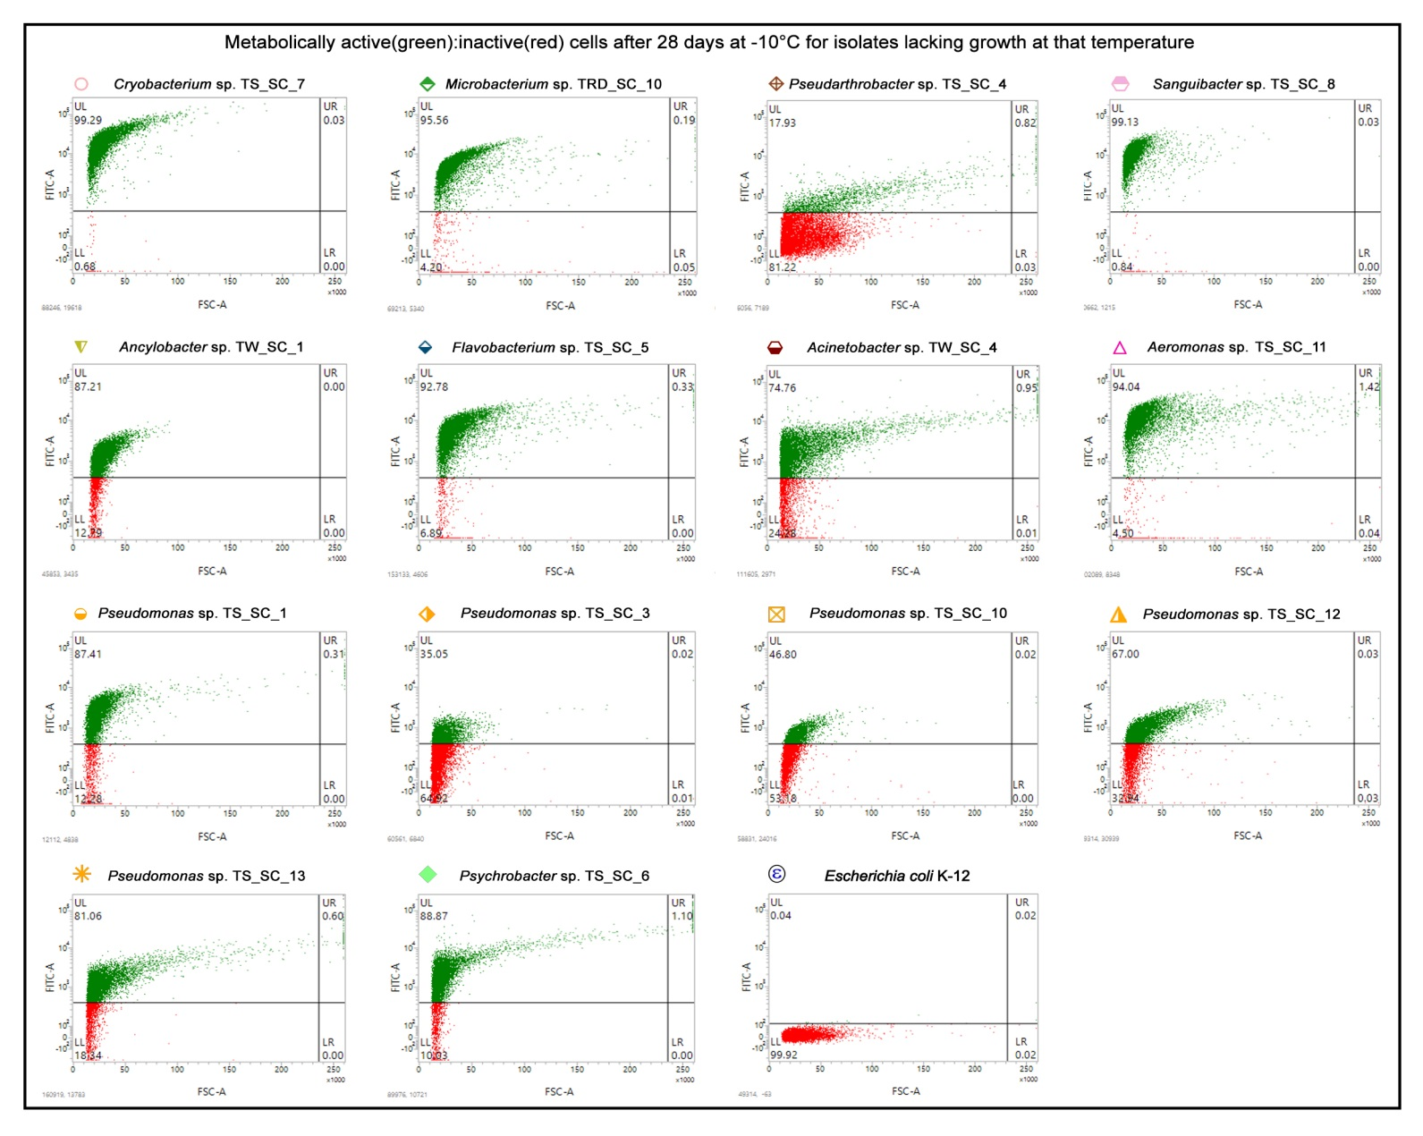
Fig. S1. Flow cytometry-derived dot plots depicting what proportions of cells were stained by FDA (after 28 days of incubation) in the LB cultures of the 14 TMA isolates incapable of growing at -10°C. In every dot plot, the levels of fluorescence recorded for 10000 randomly chosen cells have been shown as the functions of the corresponding forward scattering data, with green and red points representing FDA stained and unstained cells respectively. Each FACS experiment was repeated two more times, with deviation from the result (percentages of FDA stained and unstained cells) shown here being <2% on every occasion.

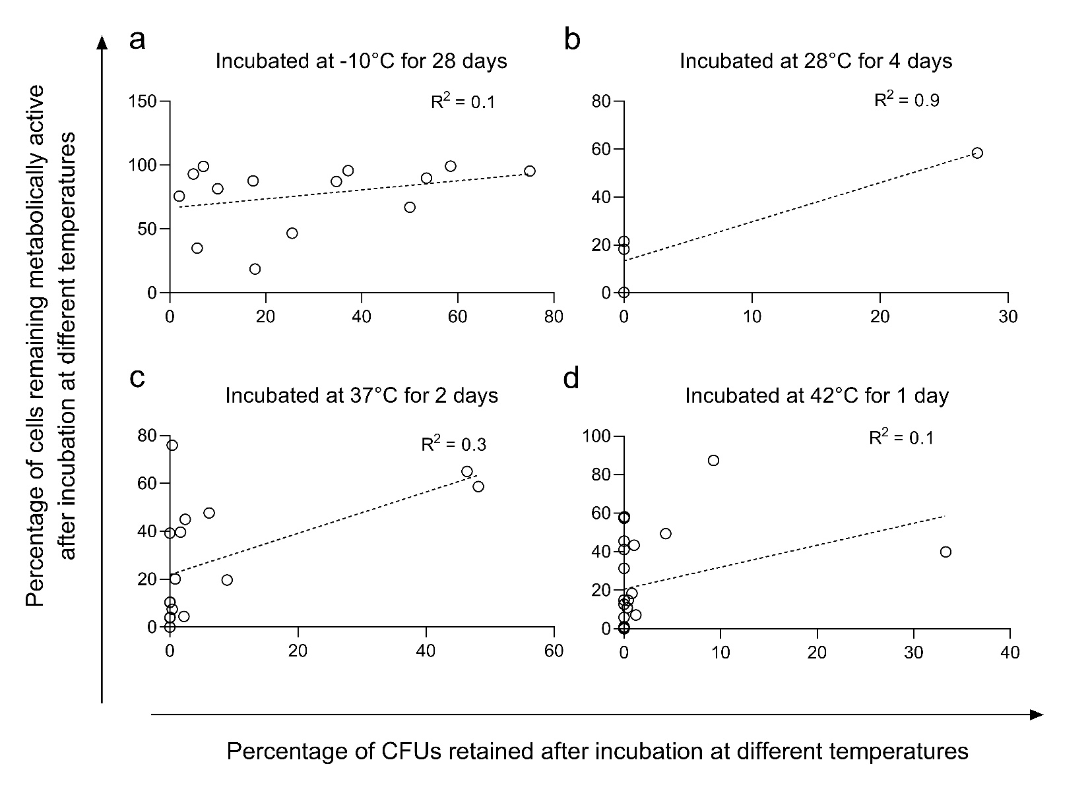
Fig. S2. Correlation between the proportions of divisible and metabolically-active cells across the species incapable of growing in Luria broth at (a) -10°C, (b) 28°C, (c) 37°C, or (d) 42°C.

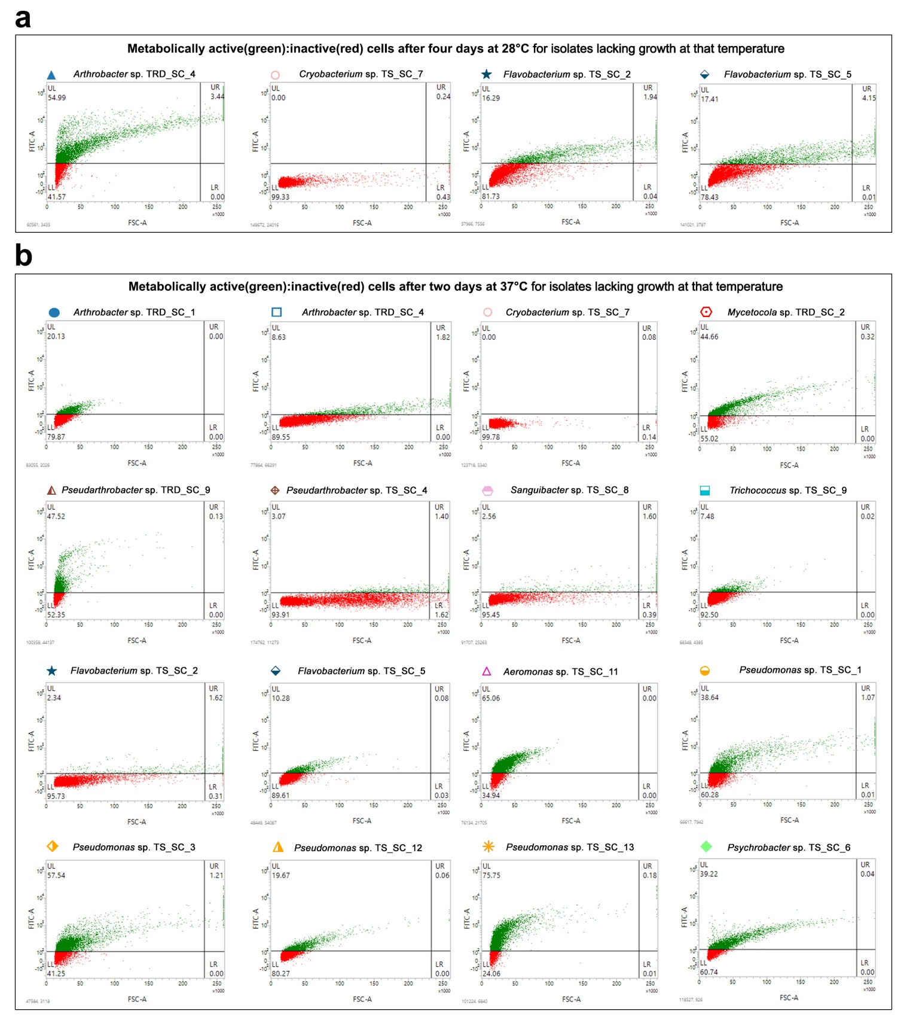
Fig. S3. Flow cytometry-derived dot plots depicting what proportions of cells were stained by FDA in the LB cultures of the isolates incapable of growing after (a) four days of incubation at 28°C, and (b) two days of incubation at 37°C. In each dot plot, the fluorescence levels recorded for 10000 randomly chosen cells have been shown as the functions of the corresponding forward scattering data, with green and red points representing FDA stained and unstained cells respectively. Each FACS experiment was repeated two more times, with deviation from the result (percentages of FDA stained and unstained cells) shown here being <2% on every occasion.
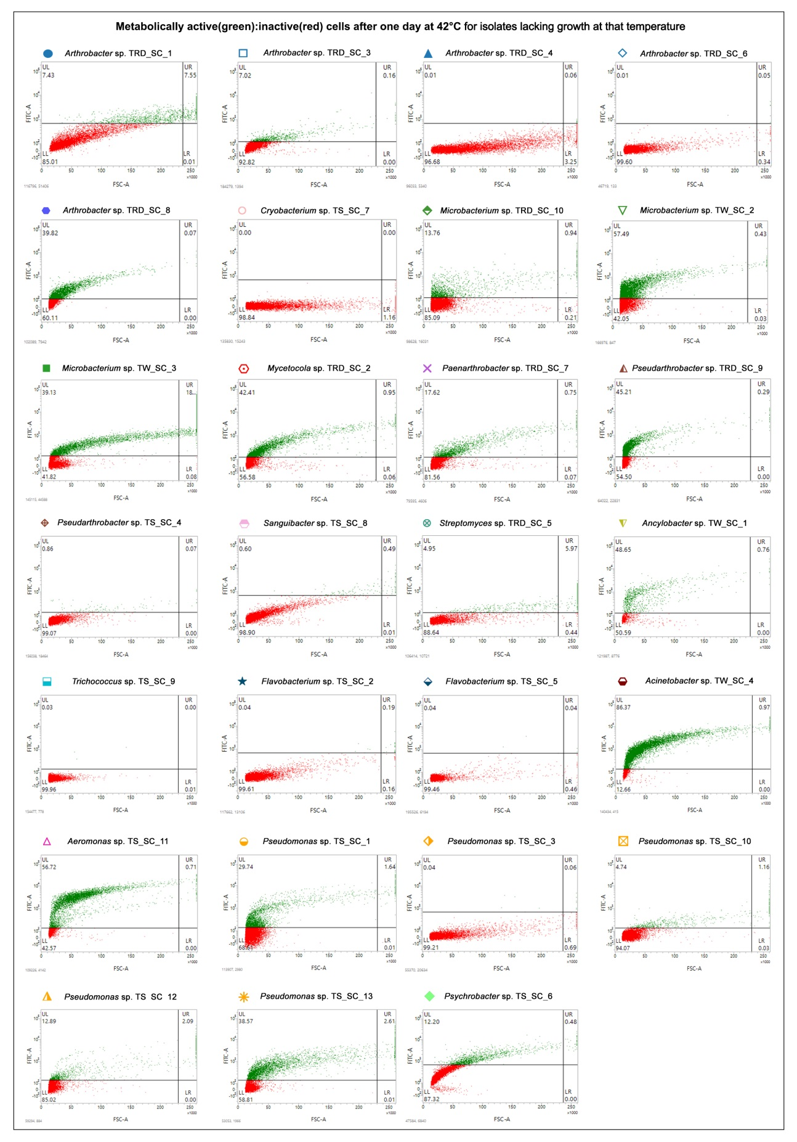
Fig. S4. Flow cytometry-derived dot plots depicting what proportions of cells were stained by FDA in the LB cultures of the 27 TMA isolates after 24 h incubation at 42°C. In each plot, the fluorescence levels recorded for 10000 randomly chosen cells have been shown as the functions of the corresponding forward scattering data, with green and red points representing FDA stained and unstained cells respectively. Each FACS experiment was repeated two more times, with deviation from the result (percentages of FDA stained and unstained cells) shown here being <2% on every occasion.
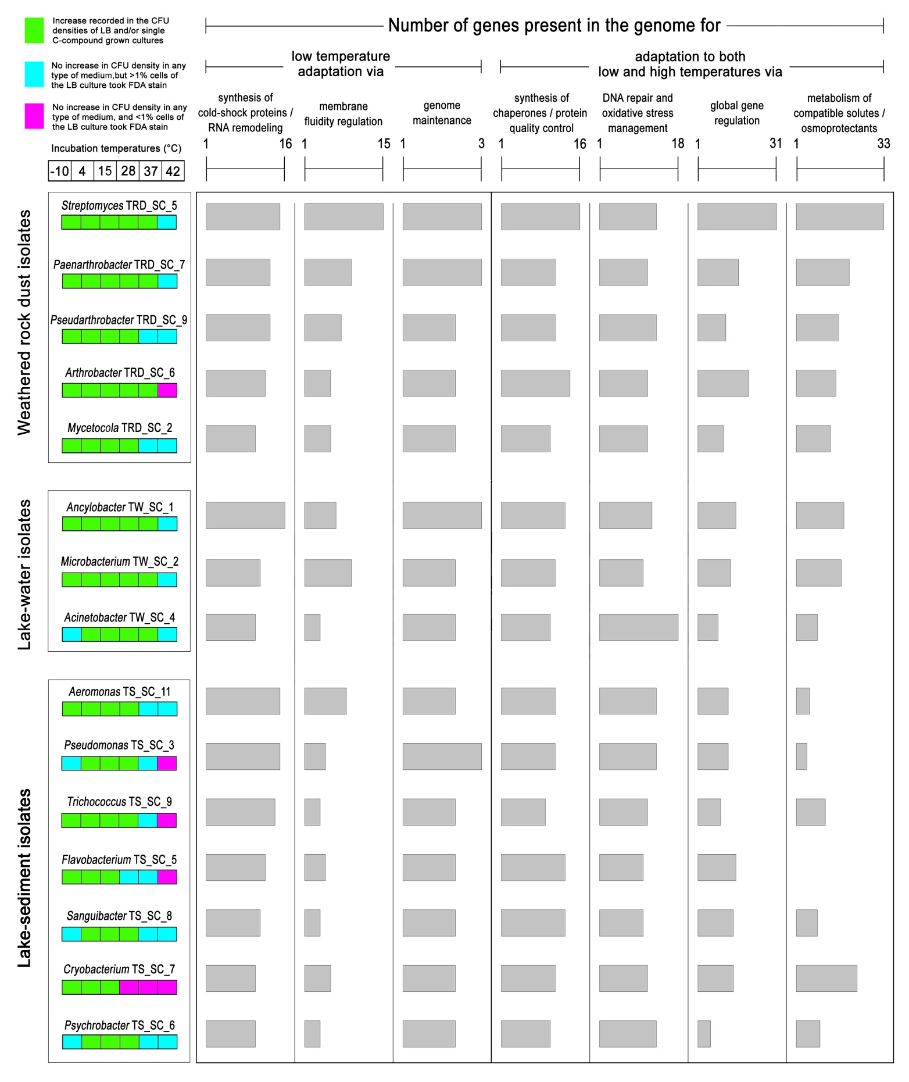
Fig. S5. Functional-category-wise numeral distribution of genes putatively concerned with low temperature adaptation, and low as well as high temperature adaptation, within the genomes of the 15 TMA isolates selected on a “one per genus” basis. Strains isolated from the weathered rock dust, lake-water, and lake-sediment are clustered in separate boxes. Below each isolate name, a box panel indicating the organism’s growth/survival phenotype at the six incubation temperatures tested has been given (the color code that has been used to fill the boxes is given at the upper left corner of the figure).
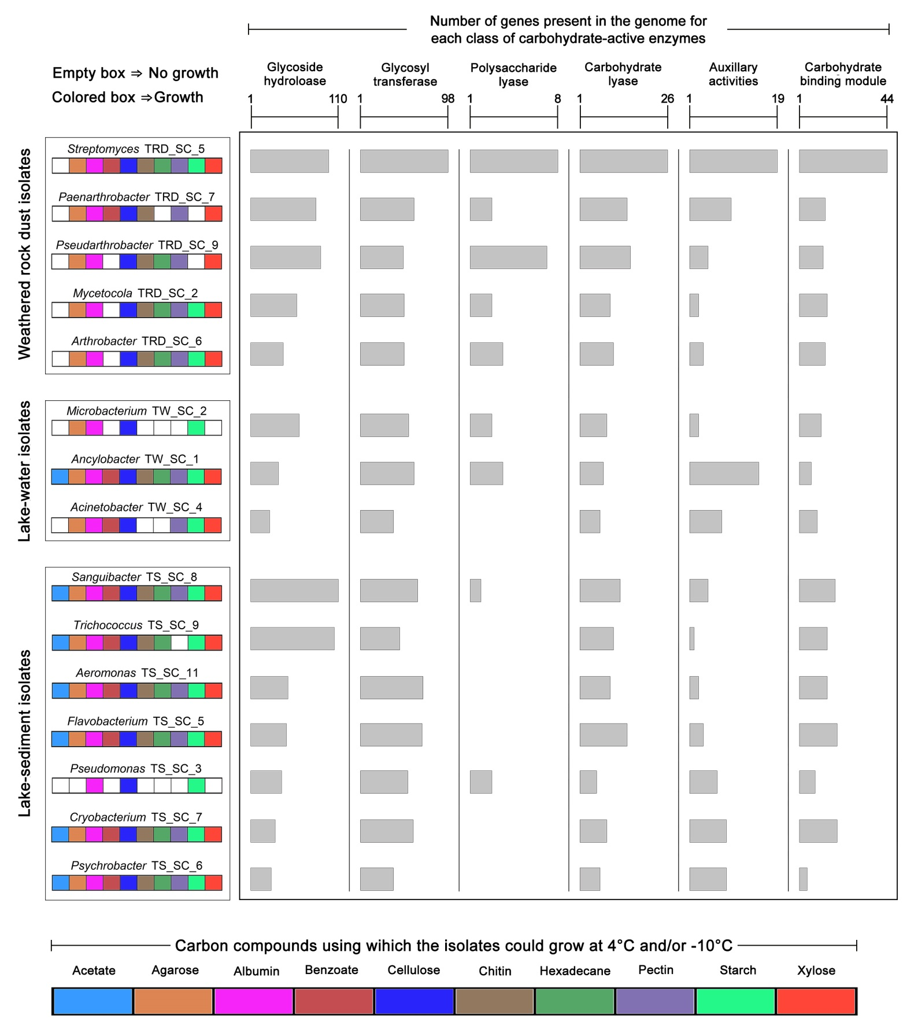
Fig. S6. Functional-category-wise numeral distribution of genes putatively concerned with carbohydrate metabolism (encoding the different categories of carbohydrate-active enzymes), within the genomes of the 15 TMA isolates selected on a “one per genus” basis. Strains isolated from the weathered rock dust, lake-water, and lake-sediment are clustered in separate boxes. Below each isolate name, a box panel indicating the organism’s ability to grow using different carbon compounds (at 4°C and/or -10°C) has been given (the color code that has been used to fill the boxes is given at the bottom of the figure).

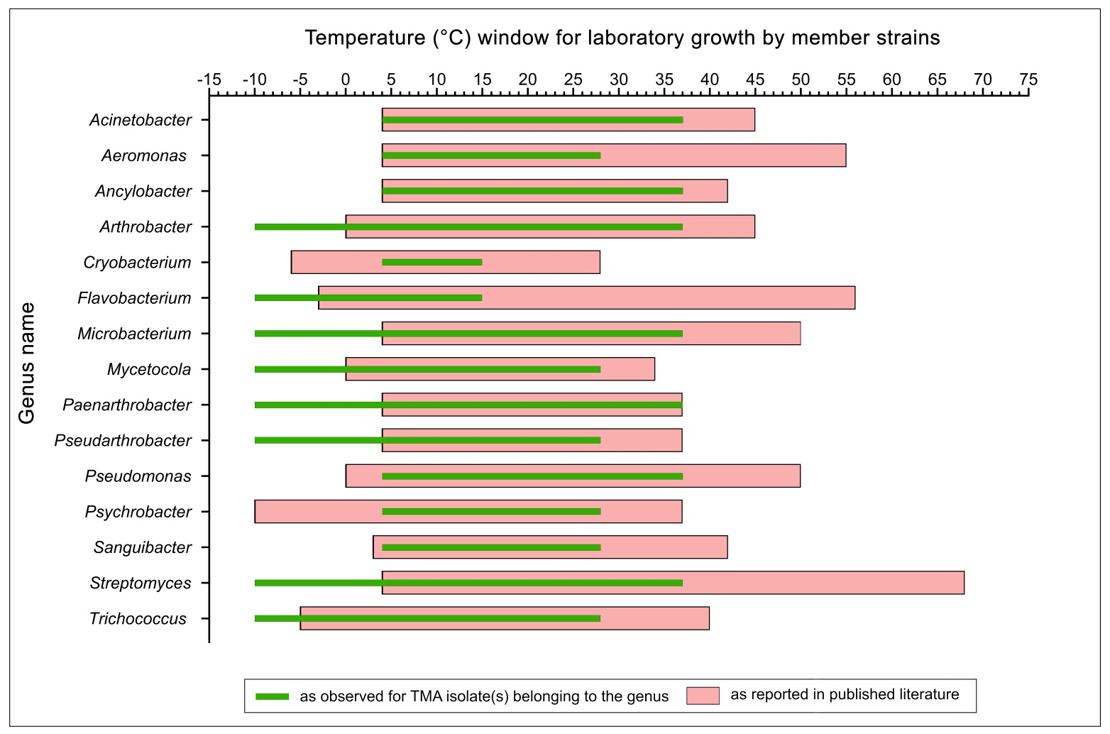
Fig. S7. Growth temperature windows of the bacterial genera under which the different TMA isolates were classified. Data obtained for the present isolates have been depicted in the context of the data available in the literature for their global relatives (see Table S60, and Supplementary References, for the detailed information).

Supplementary References
References used in Table S58
Bajerski F, Ganzert L, Mangelsdorf K et al (2011) Cryobacterium arcticum sp. nov., a psychrotolerant bacterium from an Arctic soil. Int J Syst Evol Microbiol 61:1849–1853. https://doi.org/10.1099/ijs.0.027128-0
Bakermans C, Ayala-del-Río HL, Ponder MA et al (2006) Psychrobacter cryohalolentis sp. nov. and Psychrobacter arcticus sp. nov., isolated from Siberian permafrost. Int J Syst Evol Microbiol 56:1285–1291. https://doi.org/10.1099/ijs.0.64043-0
Balcázar W, Olave J, Muñoz P, Guerrero L et al (2015) Bioprospecting glacial ice for plant growth promoting bacteria. Microbiol Res 178:48–56. https://doi.org/10.1016/j.micres.2015.05.001
Berestovskaya YY, Tourova TP, Grouzdev DS et al (2025) Cryobacterium inferilacus sp. nov., a psychrophilic ureolitic bacterium from Lake Untersee in Antarctica. Microorganisms 13:990. https://doi.org/10.3390/microorganisms13050990
Bernardet JF, Segers P, Vancanneyt M et al (1996) Cutting a Gordian knot: emended classification and description of the genus Flavobacterium. Int J Syst Bacteriol 46:128–148. https://doi.org/10.1099/00207713-46-1-128
Bowman JP, Cavanagh J, Austin JJ et al (1996) Novel Psychrobacter species from Antarctic ornithogenic soils. Int J Syst Evol Microbiol 46:841–848. https://doi.org/10.1099/00207713-46-4-841
Bowman JP, Nichols DS, McMeekin TA (1997) Psychrobacter glacincola sp. nov., a halotolerant, psychrophilic bacterium isolated from Antarctic sea ice. Syst Appl Microbiol 20:209–215. https://doi.org/10.1016/S0723-2020(97)80067-7
Bozal N, Montes MJ, Tudela E et al (2003) Characterization of several Psychrobacter strains isolated from Antarctic environments and description of Psychrobacter luti sp. nov. and Psychrobacter fozii sp. nov. Int J Syst Evol Microbiol 53:1093–1100. https://doi.org/10.1099/ijs.0.02457-0
Carr EL, Kampfer P, Patel BK et al (2003) Seven novel species of Acinetobacter isolated from activated sludge. Int J Syst Evol Microbiol 53:953–963. https://doi.org/10.1099/ijs.0.02486-0
Carrasco V, Vargas-Reyes M, Lagos-Moraga S et al (2024) Rhodococcus navarretei sp. nov. and Pseudarthrobacter quantipunctorum sp. nov., two novel actinobacterial species isolated from Antarctic soil that biosynthesize fluorescent nanoparticles. Int J Syst Evol Microbiol 74:6536. https://doi.org/10.1099/ijsem.0.006536
Dai YM, Zhang LL, Li Y et al (2018) Characterization of Trichococcus paludicola sp. nov. and Trichococcus alkaliphilus sp. nov., isolated from a high-elevation wetland, by phenotypic and genomic analyses. Int J Syst Evol Microbiol 68:99–105. https://doi.org/10.1099/ijsem.0.002464
Ganzert L, Bajerski F, Mangelsdorf K et al (2011) Arthrobacter livingstonensis sp. nov. and Arthrobacter cryotolerans sp. nov., salt-tolerant and psychrotolerant species from Antarctic soil. Int J Syst Evol Microbiol 61:979–984. https://doi.org/10.1099/ijs.0.021022-0
Ge HY, Hu YQ, Zeng YX et al (2024) Pseudomonas huanghezhanensis sp. nov. and Pseudomonas fjordensis sp. nov., two novel species isolated from seawater of Arctic Kongsfjorden in the Ny-Ålesund area, Svalbard. Int J Syst Evol Microbiol 74:006584. https://doi.org/10.1099/ijsem.0.006584
Gong C, Lai Q, Cai H et al (2020) Cryobacterium soli sp. nov., isolated from forest soil. Int J Syst Evol Microbiol 70:675–679. https://doi.org/10.1099/ijsem.0.003820
Hong SG, Lee YK, Yim JH et al (2008) Sanguibacter antarcticus sp. nov., isolated from Antarctic sea sand. Int J Syst Evol Microbiol 58:50–52. https://doi.org/10.1099/ijs.0.65031-0
Kadum H, Isa SA, Muhammad K (2024) Molecular detection of Aeromonas hydrophila from frozen fish; a food quality and safety concern. Pak J Life Soc Sci 22: 4242-4247. https://doi.org/10.57239/PJLSS-2024-22.1.00310
Kamjam M, Nopnakorn P, Zhang L et al (2019) Streptomyces polaris sp. nov. and Streptomyces septentrionalis sp. nov., isolated from frozen soil. Antonie van Leeuwenhoek 112:375–387. https://doi.org/10.1007/s10482-018-1166-x
Li J, Tian XP, Zhu TJ et al (2011) Streptomyces fildesensis sp. nov., a novel streptomycete isolated from Antarctic soil. Antonie Van Leeuwenhoek 100:537–543. https://doi.org/10.1007/s10482-011-9609-7
Liu Q, Liu H, Wen Y et al (2012) Cryobacterium flavum sp. nov. and Cryobacterium luteum sp. nov., isolated from glacier ice. Int J Syst Evol Microbiol 62:1296–1299. https://doi.org/10.1099/ijs.0.033738-0
Liu Q, Liu H, Zhang J et al (2013) Cryobacterium levicorallinum sp. nov., a psychrophilic bacterium isolated from glacier ice. Int J Syst Evol Microbiol 63:2819–2822. https://doi.org/10.1099/ijs.0.046896-0
Liu Q, Xin YH, Chen XL et al (2018a) Arthrobacter ruber sp. nov., isolated from glacier ice. Int J Syst Evol Microbiol 68:1616–1621. https://doi.org/10.1099/ijsem.0.002719
Liu Q, Xin YH, Chen XL et al (2018b) Cryobacterium aureum sp. nov., a psychrophilic bacterium isolated from glacier ice collected from the ice tongue surface. Int J Syst Evol Microbiol 68:1173–1176. https://doi.org/10.1099/ijsem.0.002647
Liu Q, Liu HC, Zhou YG et al (2019a) Genetic diversity of glacier-inhabiting Cryobacterium bacteria in China and description of Cryobacterium zongtaii sp. nov. and Arthrobacter glacialis sp. nov. Syst Appl Microbiol 42:168–177. https://doi.org/10.1016/j.syapm.2018.10.005
Liu Q, Tian JH, Liu HC et al (2019b) Cryobacterium melibiosiphilum sp. nov., a psychrophilic bacterium isolated from glacier ice. Int J Syst Evol Microbiol 69:3276–3280. https://doi.org/10.1099/ijsem.0.003620
Liu Q, Tian JH, Liu HC et al (2020) Cryobacterium ruanii sp. nov. and Cryobacterium breve sp. nov., isolated from glaciers. Int J Syst Evol Microbiol 70:1918-1923. https://doi.org/10.1099/ijsem.0.003994
Liu Q, Yang LL, Xin YH (2023) Diversity of the genus Cryobacterium and proposal of 19 novel species isolated from glaciers. Front Microbiol 14:1115168. https://doi.org/10.3389/fmicb.2023.1115168
López NI, Pettinari MJ, Stackebrandt E et al (2009) Pseudomonas extremaustralis sp. nov., a poly(3-hydroxybutyrate) producer isolated from an Antarctic environment. Curr Microbiol 59:514–519. https://doi.org/10.1007/s00284-009-9469-9
Margesin R, Schumann P, Zhang DC et al (2012) Arthrobacter cryoconiti sp. nov., a psychrophilic bacterium isolated from alpine glacier cryoconite. Int J Syst Evol Microbiol 62:397–402. https://doi.org/10.1099/ijs.0.031138-0
McCammon SA, Innes BH, Bowman JP et al (1998) Flavobacterium hibernum sp. nov., a lactose-utilizing bacterium from a freshwater Antarctic lake. Int J Syst Evol Microbiol 48:1405–1412. https://doi.org/10.1099/00207713-48-4-1405
McCammon SA, Innes BH, Bowman JP et al (2000) Taxonomy of Antarctic Flavobacterium species: description of Flavobacterium gillisiae sp. nov., Flavobacterium tegetincola sp. nov. and Flavobacterium xanthum sp. nov., nom. rev., and reclassification of [Flavobacterium] salegens as Salegentibacter salegens gen. nov., comb. nov. Int J Syst Evol Microbiol 50:1055–1063. https://doi.org/10.1099/00207713-50-3-1055
Nimkande VD, Krishnamurthi K, Bafana A (2023) Potential of Antarctic lipase from Acinetobacter johnsonii Ant12 for treatment of lipid-rich wastewater: screening, production, properties and applications. Biodegradation 34:549–566. https://doi.org/10.1007/s10532-023-10041-6
Nogi Y, Soda K, Oikawa T (2005) Flavobacterium frigidimaris sp. nov., isolated from Antarctic seawater. Syst Appl Microbiol 28:310–315. https://doi.org/10.1016/j.syapm.2005.01.001
Opazo-Capurro A, Higgins PG, Wille J, Seifert H et al (2019) Genetic features of Antarctic Acinetobacter radioresistens strain A154 harboring multiple antibiotic-resistance genes. Front Cell Infect Microbiol 9:328. https://doi.org/10.3389/fcimb.2019.00328
Park M, Kim J (2024) Arthrobacter horti sp. nov., isolated from mountain soil. Int J Syst Evol Microbiol 74:006459. https://doi.org/10.1099/ijsem.0.006459
Paun VI, Lavin P, Chifiriuc MC et al (2021) First report on antibiotic resistance and antimicrobial activity of bacterial isolates from 13,000-year old cave ice core. Sci Rep 11:514. https://doi.org/10.1038/s41598-020-79754-5
Pavlov MS, Lira F, Martinez JL et al (2020) Pseudomonas fildesensis sp. nov., a psychrotolerant bacterium isolated from Antarctic soil of King George Island, South Shetland Islands. Int J Syst Evol Microbiol 70:3255–3263. https://doi.org/10.1099/ijsem.0.004165
Pazos C, Gualoto M, Oña T et al (2025) Molecular detection of blaTEM and blaSHV genes in ESBL-producing Acinetobacter baumannii isolated from Antarctic soil. Microorganisms 13:482. https://doi.org/10.3390/microorganisms13030482
Pikuta EV, Hoover RB, Bej AK et al (2006) Trichococcus patagoniensis sp. nov., a facultative anaerobe that grows at −5 C, isolated from penguin guano in Chilean Patagonia. Int J Syst Evol Microbiol 56:2055–2062. https://doi.org/10.1099/ijs.0.64225-0
Pikuta EV, Lyu Z, Williams MD et al (2017) Sanguibacter gelidistatuariae sp. nov., a novel psychrotolerant anaerobe from an ice sculpture in Antarctica, and emendation of descriptions of the family Sanguibacteraceae, the genus Sanguibacter and species S. antarcticus, S. inulinus, S. kedieii, S. marinus, S. soli and S. suarezii. Int J Syst Evol Microbiol 67:1442–1450. https://doi.org/10.1099/ijsem.0.001838
Pindi PK, Manorama R, Begum Z et al (2010) Arthrobacter antarcticus sp. nov., isolated from an Antarctic marine sediment. Int J Syst Evol Microbiol 60:2263–2266. https://doi.org/10.1099/ijs.0.012989-0
Rakitin AL, Ermakova AY, Beletsky AV et al (2021) Genome analysis of Acinetobacter lwoffii strains isolated from permafrost soils aged from 15 thousand to 1.8 million years revealed their close relationships with present-day environmental and clinical isolates. Biology 10:871. https://doi.org/10.3390/biology10090871
Reddy GS, Pradhan S, Manorama R et al (2010) Cryobacterium roopkundense sp. nov., a psychrophilic bacterium isolated from glacial soil. Int J Syst Evol Microbiol 60:866–870. https://doi.org/10.1099/ijs.0.011775-0
Shen L, Liu Y, Yao T et al (2013) Mycetocola zhadangensis sp. nov., isolated from snow. Int J Syst Evol Microbiol 63:3375–3378. https://doi.org/10.1099/ijs.0.047159-0
Shin Y, Lee BH, Lee KE et al (2020) Pseudarthrobacter psychrotolerans sp. nov., a cold-adapted bacterium isolated from Antarctic soil. Int J Syst Evol Microbiol 70:6106–6114. https://doi.org/10.1099/ijsem.0.004505
Shivaji S, Reddy GS, Suresh K et al (2005) Psychrobacter vallis sp. nov. and Psychrobacter aquaticus sp. nov., from Antarctica. Int J Syst Evol Microbiol 55:757–762. https://doi.org/10.1099/ijs.0.03030-0
Soriano-Vargas E, Castro-Escarpulli G, Aguilera-Arreola MG et al (2010) Isolation and identification of Aeromonas bestiarum in cultured common carp (Cyprinus carpio L.) from Santa Maria Chapa de Mota, Estado de Mexico, Mexico. Vet Méx 41:111–115. https://veterinariamexico.fmvz.unam.mx/index.php/vet/article/view/256
Suzuki K, Sasaki J, Uramoto M et al (1997) Cryobacterium psychrophilum gen. nov., sp. nov., nom. rev., comb. nov., an obligately psychrophilic actinomycete to accommodate "Curtobacterium psychrophilum" Inoue and Komagata 1976. Int J Syst Bacteriol 47:474–478. https://doi.org/10.1099/00207713-47-2-474
Valenzuela-Ibaceta F, Carrasco V, Lagos-Moraga S et al (2023) Arthrobacter vasquezii sp. nov., isolated from a soil sample from Union Glacier, Antarctica. Int J Syst Evol Microbiol 73:006095. https://doi.org/10.1099/ijsem.0.006095
Van Trappen S, Mergaert J, Swings J (2003) Flavobacterium gelidilacus sp. nov., isolated from microbial mats in Antarctic lakes. Int J Syst Evol Microbiol 53:1241–1245. https://doi.org/10.1099/ijs.0.02583-0
Van Trappen S, Vandecandelaere I, Mergaert J et al (2005) Flavobacterium fryxellicola sp. nov. and Flavobacterium psychrolimnae sp. nov., novel psychrophilic bacteria from Antarctic lakes. Int J Syst Evol Microbiol 55:769–772. https://doi.org/10.1099/ijs.0.03056-0
Vodickova P, Suman J, Benesova E et al (2022) Arthrobacter polaris sp. nov., a new cold-adapted member of the family Micrococcaceae isolated from Antarctic fellfield soil. Int J Syst Evol Microbiol 72:005541. https://doi.org/10.1099/ijsem.0.005541
Wang F, Gai Y, Chen M, Xiao X (2009) Arthrobacter psychrochitiniphilus sp. nov., a psychrotrophic bacterium isolated from Antarctica. Int J Syst Evol Microbiol 59:2759–2762. https://doi.org/10.1099/ijs.0.008912-0
Xin YH, Liang ZH, Zhang DC et al (2009) Flavobacterium tiangeerense sp. nov., a cold-living bacterium isolated from a glacier. Int J Syst Evol Microbiol 59:2773–2777. https://doi.org/10.1099/ijs.0.007906-0
Yang LL, Liu HC, Liu Q et al (2021) Arthrobacter cheniae and Arthrobacter frigidicola sp. nov., isolated from a glacier. Int J Syst Evol Microbiol 71:005177. https://doi.org/10.1099/ijsem.0.005177
Yang LL, Liu HC, Xin YH (2023) Flavobacterium frigoritolerans sp. nov. and Flavobacterium shii sp. nov., isolated from glaciers on the Tibetan Plateau. Int J Syst Evol Microbiol 73:5750. https://doi.org/10.1099/ijsem.0.005750
Yin CC, Yang LL, Xin YH et al (2023) Identification of Flavobacterium algoritolerans sp. nov. and Flavobacterium yafengii sp. nov., two novel members of the genus Flavobacterium. Int J Syst Evol Microbiol 73:006072. https://doi.org/10.1099/ijsem.0.006072
Yu X, Zhang W, Zhang G et al (2022) Arthrobacter antioxidans sp. nov., a blue pigment-producing species isolated from Mount Everest. Int J Syst Evol Microbiol 72:005624. https://doi.org/10.1099/ijsem.0.005624
Zakharyuk A, Valyshev A, Plotnikov A et al (2021) Trichococcus shcherbakoviae subsp. psychrophilus subsp. nov., a psychrotolerant facultative anaerobe isolated from a cold spring. Int J Syst Evol Microbiol 71:005068. https://doi.org/10.1099/ijsem.0.005068
Zeng YX, Yu Y, Li HR et al (2015) Psychrobacter fjordensis sp. nov., a psychrotolerant bacterium isolated from an Arctic fjord in Svalbard. Antonie Van Leeuwenhoek 108:1283–1292. https://doi.org/10.1007/s10482-015-0580-6
Zeng YX, Liu Y, Yu Y et al (2016) Psychrobacter glaciei sp. nov., isolated from the ice core of an Arctic glacier. Int J Syst Evol Microbiol 66:1792–1798. https://doi.org/10.1099/ijsem.0.000939
Zhang DC, Wang HX, Liu HC et al (2006) Flavobacterium glaciei sp. nov., a novel psychrophilic bacterium isolated from the China No.1 glacier. Int J Syst Evol Microbiol 56:2921–2925. https://doi.org/10.1099/ijs.0.64564-0
Zhang DC, Wang HX, Cui HL et al (2007) Cryobacterium psychrotolerans sp. nov., a novel psychrotolerant bacterium isolated from the China No. 1 glacier. Int J Syst Evol Microbiol 57:866–869. https://doi.org/10.1099/ijs.0.64750-0
Zhang DC, Schumann P, Liu HC et al (2010) Arthrobacter alpinus sp. nov., a psychrophilic bacterium isolated from alpine soil. Int J Syst Evol Microbiol 60:2149–2153. https://doi.org/10.1099/ijs.0.017178-0
Zhang GQ, Liu Q, Liu HC et al (2019) Flavobacterium ranwuense sp. nov., isolated from glacier. Int J Syst Evol Microbiol 69:3812–3817. https://doi.org/10.1099/ijsem.0.003687
Zhang J, Yu X, Guan B et al (2022) Identification and characterization of a novel cold-adapted GH15 family trehalase from the psychrotolerant Microbacterium phyllosphaerae LW106. Fermentation 8:471. https://doi.org/10.3390/fermentation8100471
Zhang L, Ruan C, Peng F et al (2016) Streptomyces arcticus sp. nov., isolated from frozen soil. Int J Syst Evol Microbiol 66:1482–1487. https://doi.org/10.1099/ijsem.0.000907
Zhu L, Liu Q, Liu H et al (2013) Mycetocola miduiensis sp. nov., a psychrotolerant bacterium isolated from Midui glacier. Int J Syst Evol Microbiol 63:2661–2665. https://doi.org/10.1099/ijs.0.047985-0

References used in Table S59
Antunes LC, Imperi F, Carattoli A et al (2011) Deciphering the multifactorial nature of Acinetobacter baumannii pathogenicity. PLoS One 6:e22674. https://doi.org/10.1371/journal.pone.0022674
Dastager SG, Qin L, Tang SK et al (2014) Arthrobacter enclensis sp. nov., isolated from sediment sample. Arch Microbiol 196:775–782. https://doi.org/10.1007/s00203-014-1016-9
Ganbat D, Jeong GE, Oh D et al (2023) Description of Microbacterium neungamense sp. nov. isolated from a hot spring. Arch Microbiol 205:23. https://doi.org/10.1007/s00203-022-03343-5
Kampfer P, Albrecht A, Buczolits S et al (2002) Psychrobacter faecalis sp. nov., a new species from a bioaerosol originating from pigeon faeces. Syst Appl Microbiol 25:47-52. https://doi.org/10.1078/0723-2020-00099
Li FN, Zheng ZQ, Chen MS et al (2023) Ancylobacter mangrovi sp. nov., a novel endophytic bacterium isolated form mangrove plant. Syst Appl Microbiol 46:126419. https://doi.org/10.1016/j.syapm.2023.126419
Liu ZS, Wang KH, Wang XK et al (2025) Curvibacter soli sp. nov., Extensimonas soli sp. nov., Pseudarthrobacter naphthalenicus sp. nov. and Terripilifer ovatus gen. nov., sp. nov., four new species isolated from polluted soil. Int J Syst Evol Microbiol 75:6698. https://doi.org/10.1099/ijsem.0.006698
Ma Q, Lei RF, Li YQ et al (2021) Sanguibacter suaedae sp. nov., isolated from the root of Suaeda aralocaspica in north-west PR China. Int J Syst Evol Microbiol 71:005108. https://doi.org/10.1099/ijsem.0.005108
Manaia CM, Moore ER (2002) Pseudomonas thermotolerans sp. nov., a thermotolerant species of the genus Pseudomonas sensu stricto. Int J Syst Evol Microbiol 52:2203–2209. https://doi.org/10.1099/00207713-52-6-2203
Oh ET, Jeong JW, Kim SB (2024) Paenarthrobacter aromaticivorans sp. nov., a paraoxon-degrading bacterium isolated from red pepper cultivation soil. Int J Syst Evol Microbiol 74:6389. https://doi.org/10.1099/ijsem.0.006389
Saha P, Chakrabarti T (2006) Aeromonas sharmana sp. nov., isolated from a warm spring. Int J Syst Evol Microbiol 56:1905-1909. https://doi.org/10.1099/ijs.0.63972-0
Saiki T, Kimura R, Arima K (1972) Isolation and characterization of extremely thermophilic bacteria from hot springs. Agric Biol Chem 36:2357-2366. https://doi.org/10.1080/00021369.1972.10860589
Tsukamoto T, Takeuchi M, Shida O et al (2001) Proposal of Mycetocola gen. nov. in the family Microbacteriaceae and three new species, Mycetocola saprophilus sp. nov., Mycetocola tolaasinivorans sp. nov. and Mycetocola lacteus sp. nov., isolated from cultivated mushroom, Pleurotus ostreatus. Int J Syst Evol Microbiol 51:937-944. https://doi.org/10.1099/00207713-51-3-937
van Gelder AH, Aydin R, Alves MM et al (2012) 1, 3‐Propanediol production from glycerol by a newly isolated Trichococcus strain. Microb Biotechnol 5:573-578. https://doi.org/10.1111/j.1751-7915.2011.00318.x
Wang M, Cui J, Liu H et al (2023) Characterization of soil microbial biomass carbon and nitrogen in four forest types of shushan urban forest park. Forests 14:1498. https://doi.org/10.3390/f14071498
Xu LH, Tiang YQ, Zhang YF et al (1998) Streptomyces thermogriseus, a new species of the genus Streptomyces from soil, lake and hot-spring. Int J Syst Evol Microbiol 48:1089-1093. https://doi.org/10.1099/00207713-48-4-1089

References used in Table S60
Antunes LC, Imperi F, Carattoli A et al (2011) Deciphering the multifactorial nature of Acinetobacter baumannii pathogenicity. PLoS One 6:e22674. https://doi.org/10.1371/journal.pone.0022674
Bakermans C, Ayala-del-Río HL, Ponder MA et al (2006) Psychrobacter cryohalolentis sp. nov. and Psychrobacter arcticus sp. nov., isolated from Siberian permafrost. Int J Syst Evol Microbiol 56:1285–1291. https://doi.org/10.1099/ijs.0.64043-0
Dastager SG, Lee JC, Ju YJ, Park DJ, Kim CJ (2008) Cryobacterium mesophilum sp. nov., a novel mesophilic bacterium. Int J Syst Evol Microbiol 58:1241–1244. https://doi.org/10.1099/ijs.0.65650-0
Dastager SG, Qin L, Tang SK, et al (2014) Arthrobacter enclensis sp. nov., isolated from sediment sample. Arch Microbiol 196:775–782. https://doi.org/10.1007/s00203-014-1016-9
Hess E (1933) Effects of low temperatures on the growth of marine bacteria. Contrib Can Biol Fish 8:489–505. https://doi.org/10.1139/f33-034
Kallimanis A, Kavakiotis K, Perisynakis A et al (2009) Arthrobacter phenanthrenivorans sp. nov., to accommodate the phenanthrene-degrading bacterium Arthrobacter sp. strain Sphe3. Int J Syst Evol Microbiol 59:275–279. https://doi.org/10.1099/ijs.0.000984-0
Kotoučková L, Schumann P, Durnova E et al (2004) Arthrobacter nitroguajacolicus sp. nov., a novel 4-nitroguaiacol-degrading actinobacterium. Int J Syst Evol Microbiol 54:773–777. https://doi.org/10.1099/ijs.0.02923-0
Krovacek K, Faris A, Månsson I (1991) Growth of and toxin production by Aeromonas hydrophila and Aeromonas sobria at low temperatures. Int J Food Microbiol 13:165–175. https://doi.org/10.1016/0168-1605(91)90058-w
Liu Q, Liu H, Wen Y, Zhou Y, Xin Y (2012) Cryobacterium flavum sp. nov. and Cryobacterium luteum sp. nov., isolated from glacier ice. Int J Syst Evol Microbiol 62:1296–1299. https://doi.org/10.1099/ijs.0.033738-0
Loveland-Curtze J, Sheridan PP, Gutshall KR et al (1999) Biochemical and phylogenetic analyses of psychrophilic isolates belonging to the Arthrobacter subgroup and description of Arthrobacter psychrolactophilus, sp. nov. Arch Microbiol 171:355–363. https://doi.org/10.1007/s002030050722
Lyutskanova D, Ivanova V, Stoilova-Disheva M et al (2009) Isolation and characterization of a psychrotolerant Streptomyces strain from permafrost soil in spitsbergen, producing phthalic acid ester. Biotechnol Biotechnol Equip 23:1220–1224. https://doi.org/10.1080/13102818.2009.10817642
Ma Q, Lei RF, Li YQ, et al (2021) Sanguibacter suaedae sp. nov., isolated from the root of Suaeda aralocaspica in north-west PR China. Int J Syst Evol Microbiol 71:005108. https://doi.org/10.1099/ijsem.0.005108
Manaia CM, Moore ER (2002) Pseudomonas thermotolerans sp. nov., a thermotolerant species of the genus Pseudomonas sensu stricto. Int J Syst Evol Microbiol 52:2203–2209. https://doi.org/10.1099/00207713-52-6-2203
Molin G, Ternström A, Ursing J (1986) Pseudomonas lundensis, a new bacterial species isolated from meat. Int J Syst Evol Microbiol 36:339–342. https://doi.org/10.1099/00207713-36-2-339
Nie W, Zheng X, Wang S et al (2022) Genome resource of Ancylobacter pratisalsi E130T: a novel plant-growth-promoting bacterium isolated from the rhizosphere. Phytopathology 112:729–731. https://doi.org/10.1094/PHYTO-06-21-0251-A
Páčová Z, Urbanova E, Durnova E (2001) Psychrobacter immobilis isolated from foods: characteristics and identification. Czech J Food Sci 19:33–38
Paściak M, Pawlik KJ, Martynowski D, et al (2024) Discovery of a new bacterium, Microbacterium betulae sp. nov., in birch wood associated with hypersensitivity pneumonitis in woodworkers. Environ Microbiol Rep 16:e13311. https://doi.org/10.1111/1758-2229.13311
Pikuta EV, Hoover RB, Bej AK et al (2006) Trichococcus patagoniensis sp. nov., a facultative anaerobe that grows at −5 °C, isolated from penguin guano in Chilean Patagonia. Int J Syst Evol Microbiol 56:2055-2062. https://doi.org/10.1099/ijs.0.64225-0
Pikuta EV, Lyu Z, Williams MD, et al (2017) Sanguibacter gelidistatuariae sp. nov., a novel psychrotolerant anaerobe from an ice sculpture in Antarctica, and emendation of descriptions of the family Sanguibacteraceae, the genus Sanguibacter and species S. antarcticus, S. inulinus, S. kedieii, S. marinus, S. soli and S. suarezii. Int J Syst Evol Microbiol 67:1442–1450. https://doi.org/10.1099/ijsem.0.001838
Rouf MA, Rigney MM (1971) Growth temperatures and temperature characteristics of Aeromonas. Appl Microbiol 22:503–506. https://doi.org/10.1128/am.22.4.503-506.1971
Saiki T, Kimura R, Arima K (1972) Isolation and characterization of extremely thermophilic bacteria from hot springs. Agric Biol Chem 36:2357-2366. https://doi.org/10.1080/00021369.1972.10860589
van Gelder AH, Aydin R, Alves MM et al (2012) 1,3‐Propanediol production from glycerol by a newly isolated Trichococcus strain. Microb Biotechnol 5:573-578. https://doi.org/10.1111/j.1751-7915.2011.00318.x
Westerberg K, Elväng AM, Stackebrandt E et al (2000) Arthrobacter chlorophenolicus sp. nov., a new species capable of degrading high concentrations of 4-chlorophenol. Int J Syst Evol Microbiol 50:2083–2092. https://doi.org/10.1099/00207713-50-6-2083
Xu LH, Tiang YQ, Zhang YF et al (1998) Streptomyces thermogriseus, a new species of the genus Streptomyces from soil, lake and hot-spring. Int J Syst Evol Microbiol 48:1089-1093. https://doi.org/10.1099/00207713-48-4-1089
Yamahira K, Hirota K, Nakajima K et al (2008) Acinetobacter sp. strain Ths, a novel psychrotolerant and alkalitolerant bacterium that utilizes hydrocarbon. Extremophiles 12:729–734. https://doi.org/10.1007/s00792-008-0180-8
Yu L, Lai Q, Yi Z, et al (2013) Microbacterium sediminis sp. nov., a psychrotolerant, thermotolerant, halotolerant and alkalitolerant actinomycete isolated from deep-sea sediment. Int J Syst Evol Microbiol 63:25–30. https://doi.org/10.1099/ijs.0.029652-0
Zhu L, Liu Q, Liu H, et al (2013) Mycetocola miduiensis sp. nov., a psychrotolerant bacterium isolated from Midui glacier. Int J Syst Evol Microbiol 63:2661–2665. https://doi.org/10.1099/ijs.0.047985-0

