Table 1. Information of experimental materials.
Name | Relevant Parameters | Image
Cylindrical ternary lithium-ion battery | Nominal capacity:41.90Ah;  Nominal voltage:3.68V  Dimensions: 46mm in diameter and 120mm in height | 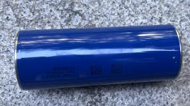
Battery shelf | Layer height: 750 mm;  height of a single shelf: 375 mm | 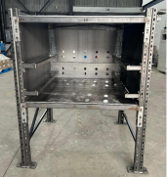
Fire sprinkler | Fast-response upright type  K-ZSTZ-161-68℃  flow rate 322 L/min | 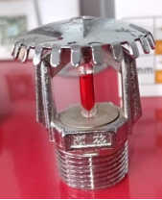
Fire sprinkler | Fast-response sidewall type  K-ZSTBS-80-68℃  flow rate 160 L/min | 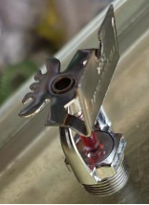

Table 2. Information of experimental equipment.
Name | Model/  Specifications Parameters | Manufacturer | Image
Camera | FDR-AX60, with approximately 8.29 million pixels | Sony Corporation | 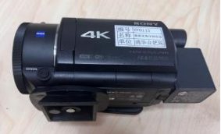
DC Regulated Power Supply | LW-22010KD/220V 10A | Longwei Instrument Co., Ltd | 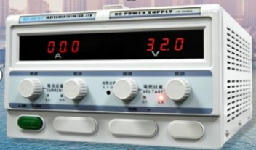
Data Acquisition System | LR8431-30 | Hioki (Japan) | 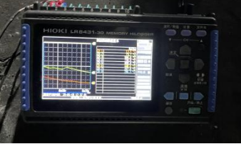
Thermocouple | Armored Type K, accuracy ±0.1℃, temperature measurement range 0~1000℃ | / | 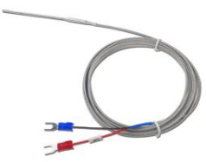
Heating Device | PI heating film, thickness 0.15±0.05mm, resistance 161.3Ω±5%, rated voltage 220V, rated power 300W | Custom-made | 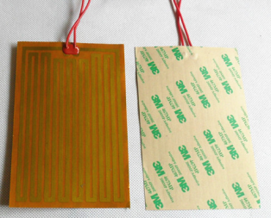

Table 3. Working Cases
Case | Heating Position | Sprinkler Arrangement | Shelf Layout | Schematic Diagram
A | Inner edge of lower tray | Top-spray sprinkler, flow rate: 322L/min | Double-layer | 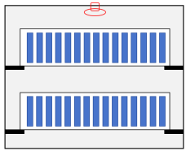
B | Center of lower tray | Top-spray sprinkler, flow rate: 322L/min | Double-layer
C | Edge of upper tray | Top-spray sprinkler, flow rate: 322L/min | Double-layer
D | Inner edge of lower tray | Side-spray sprinklers, flow rate: 160L/min | Double-layer | 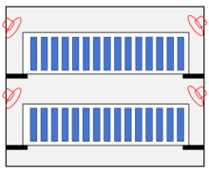
F | Center of lower tray | Side-spray sprinklers, flow rate: 160L/min | Double-layer
G | Inner edge | Top-spray sprinkler, flow rate: 322L/min | Single-layer | 