Supplementary material

Supplementary text

- Quality control of neuroimaging data
Visual inspection was performed before image data preprocessing to ensure quality. All images with motion artifacts were excluded. Our two physicians reviewed the processed neuroimaging data. When abnormalities were detected in subjects, we first identified the cause and rerun the preprocessing workflow after corrections. Key issues included poor tissue segmentation and inaccurate removal of non-brain tissue. If newly acquired preprocessed MRI images still showed problems, the subject was excluded.
Then, the Euler number is calculated for the segmented results. In the recon-all process of FreeSurfer, the tessellation step may produce holes and handles, which are saved in the ?h.orig.nofix file. The Euler number is calculated by determining the genus using the formula $x=2−2g$. A higher Euler number (less negative) indicates better quality of FreeSurfer cortical reconstruction data. Since the Euler number varies among different populations (such as adolescents and adults) and across different scanning devices and sequences, there is no fixed threshold. In this study, combining the device and common practices, -270 was chosen as the threshold.
After quality control, the study included 134 MDD patients with NSSI and 107 patients without NSSI, as detailed in Supplementary Sheet S1.

- Details of MIND gradient construction
MIND construction: As input data, we employed high-resolution mesh reconstructions of the cortical surface, generated from T1-weighted MRI scans via FreeSurfer's `recon-all` command. This surface comprises 163,842 vertices per hemisphere within the fsaverage template. Each vertex was characterized by five structural MRI features: CT, SA, Vol, MC and SD. To estimate the similarity between cortical areas, we standardized each MRI feature across all vertices and then aggregated all the MRI metrics for all vertices within each cortical area (defined by D-K 308 atlas) to form a regional multivariate distribution. Next we compiled a pairwise distance matrix using a k-nearest neighbor density algorithm to estimate the symmetrized KL divergence(known as Jeffrey’s divergence) between each pair of regional multivariate distributions. Finally, applying the formula $\text{MIND}\text{(}\text{a}\text{,}\text{b}\text{)=}\frac{\text{1}}{\text{1+}\text{KL}\text{(}\text{a}\text{,}\text{b}\text{)}}$, we transformed the KL divergence KL(a,b) for regions a and b to estimate the inter-areal MIND similarity, bounded between 0 and 1, with higher values indicating greater similarity.
MIND gradient construction: The construction of MIND gradients was preprocessed using the BrainSpace toolbox. we used each 308 × 308 MIND matrix and computed a cosine similarity matrix to capture similarities in structural connectivity profiles. Using diffusion map embedding to characterize the gradient components that explain the variance of the network in descending order. This algorithm can capable of projecting a high-dimensional network matrix into a common low dimensional space. Among them, brain regions with more connections or stronger connections are kept in close proximity, while brain regions with fewer connections or no connections are distributed further away. In this study, we used the default setting of the BrainSpace toolbox, and we followed the recommended manifold parameters, set α = 0.5 and time = 0, which kept global relations between data points in the embedded space. Next, the MIND gradient template was generated from the average MIND matrix based on both patients with NSSI and without, and the Procrustes rotation was conducted to align the individual’s MIND gradient to the template, as detailed in Supplementary Table S2.

- Detailed analysis neurotransmitter receptors by JuSpace
Firstly, we need to resample the case-control t-map obtained from GLM analysis of the regional MIND gradient to a resolution of 3mm× 3mm × 3mm. The JuSpace version number we use here is v2.0. Atlas we choose the t map that was resampled before and Study Design we choose 4) set 1 each image (Tests each image from set 1 against a null distribution). Then, we selected all PET/Neurotransmitters in the templates list (as details in Supplementary Table S3) for analysis and set the number of permutations to 10000. Finally, we select the Spearman analysis type and click the Run analysis button to proceed with the analysis.

- Validation: gene-category enrichment analysis (GCEA) with ensemble-based null models for Gene Ontology
This study employed a gene set enrichment analysis framework utilizing a spherical permutation null model generation strategy to assess the statistical significance of specific functional pathways in neuroimaging gene expression associations. Specifically, the enrichment analyses were conducted separately using the significant genes contributing to the first PLS component (PLS1+ and PLS1-) with the following procedures. First, we defined the category score as the mean loading of the genes in the category, and the loading of each gene were calculated based on Spearman correlation between regionalized gene expression profiles and PLS1 score. Secondly, spherical rotation permutations were performed to construct a null model distribution (5000 permutations). Gene loadings were recalculated using the permuted case control t-value matrix, generating a null model score distribution at the pathway level. Finally, a two-tailed test was applied to calculate the p-value of the observed pathway score relative to the permutation distribution. The Benjamini-Hochberg false discovery rate correction method was used for multiple comparison correction. The analysis results indicate that this method can effectively identify functional pathways significantly enriched in both the PLS1+ and PLS1-. Pathways with p_fdr < 0.05 demonstrate robust statistical significance (as details in Supplementary Sheet S7).

Supplementary tables

Table S1 Details of Sagittal 3D high-resolution T1-weighted images
Parameters | Details
Position | sagittal
Slices | 188
Slice Thickness | 1.0
Voxel size | 1.0mm×1.0mm×1.0mm
Read FOV | 256
Phase FOV | 230
Read Resolution | 256
Phase Resolution | 100
Phase encoding direction | A>P
Time Repetition | 6.7
Time Echo | 2.9
Flip angle | 8
Time Inversion | 950
Avarage number | 1
Bandwidth | 270
Echo Train Length | 247

Table S2 Details setting of the BrainSpace toolbox
Parameters | Details | Explain
kernel | cs | cosine similarity
approach | dm | default mapping
alignment | Procrustes | -
n_components | 1 | the number of gradient
sparsity | 90 | -
alpha | 0.5 | -
Diffusion_time | 0 | -

Table S3 Details of Neurotransmitters in Juspace
Neurotransmitter maps | Name
5HT1a_WAY_HC36.nii | 5HT1a
5HT1a_cumi_hc8_beliveau.nii | 5HT1a*
5HT1b_P943_HC22.nii | 5HT1b
5HT1b_az_hc36_beliveau.nii | 5HT1b*
5HT2a_ALT_HC19.nii | 5HT2a
5HT2a_cimbi_hc29_beliveau.nii | 5HT2a*
5HT4_sb20_hc59_beliveau.nii | 5HT4
5HT6_gsk215083_HC30_radhakrishnan2018.nii | 5HT6
A4B2_flubatine_HC30_hillmer2016.nii | A4B2
CB1_FMPEPd2_hc22_laurikainen.nii | CB1
CB1_omar_HC77_normandin2015.nii | CB1*
CBF_ASL_MRI.nii | CBF
CMRglu_fdg_HC20_castrillon2023.nii | CMRglu
COX1_ps13_HC11_kim2020.nii | COX1
D1_SCH23390_c11.nii | D1
D2_RACLOPRIDE_c11.nii | D2
D2_fallypride_hc49_jaworska.nii | D2*
DAT_DATSPECT.nii | DAT
FDOPA_f18.nii | FDOPA
GABAa5_ro154513_HC10_lukow2022.nii | GABAa5
GABAa_FLUMAZENIL_c11.nii | GABAa
GABAa_flumazenil_hc16_norgaard.nii | GABAa*
HDAC_martinostat_HC8_wey2016.nii | HDAC
KOR_ly2795050_HC28_vijay2018.nii | KOR
KappaOp_LY2795050_hc10_ShokriKojori.nii | KappaOp
M1_lsn3172176_HC24_naganawa2020.nii | M1
MOR_carfentanil_HC204_kantonen2020.nii | MOR
MOR_carfentanil_HC39_turtonen2021.nii | MOR*
MU_CARFENTANIL_c11.nii | MU
MU_carfentanil_hc39_turtonen.nii | MU*
Microglia_TSPO_pbr28_HC6_lois2018.nii | Microglia
PETatlas/NAT_MRB_c11.nii | NAT
NMDA_ge179_29hc_galovic2021.nii | NMDA
SERT_DASB_HC30.nii | SERT
SERT_MADAM_c11.nii | SERT*
SERT_dasb_hc100_beliveau.nii | SERT*
SV2A_ucbj_HC10_finnema2016.nii | SV2A
VAChT_feobv_hc18_aghourian.nii | VAChT
VAChT_feobv_hc4_tuominen.nii | VAChT*
VAChT_feobv_hc5_bedard.nii | VAChT*
VMAT2_dtbz_HC76_larsen2020.nii | VMAT2
mGluR5_abp_hc22_rosaneto.nii | mGluR5
mGluR5_abp_hc28_dubois.nii | mGluR5*
mGluR5_abp_hc73_smart.nii | mGluR5*
*Indicating that there were previous occurrences and repeated neurotransmitters

Table S4 Demographic and clinical characteristics of the subjects
Variables | NSSI (n = 134) | Non-NSSI (n = 107) | p value
Gender (M/F) | 24/110 | 38/69 | <0.01ª *
Age (years) | 15.41 ± 1.98 | 16.53 ± 2.21 | <0.01^{b} *
TIV (mm³) | 1.44×10⁶± 1.85×10⁵ | 1.48×10⁶± 1.82×10⁵ | 0.10^{b}
ICD-10 (F32.200/F32.300) | 75/59 | 44/63 | 0.03ª *
HDRS-17 | 26.57 ± 7.36 | 27.03 ± 5.71 | 0.60^{b}
ª The p value is obtained by Chi-square test.
^{b} The p value is obtained by two-sample t-test.
Data of the continuous variables are shown as mean ± SD.
Statistical differences are marked with *.
F32.2000: Severe depressive episode without psychotic symptoms.
F32.3000: Severe depressive episode with psychotic symptoms.

Table S5 global residual analysis results
statistic | value
count | 241
mean | 0.001
std | 0.076
minimum value | -0.129
maximum value | 0.129
median | 0.030
skewness | -0.143
Residual distribution: Median-Mean=2.97e-02.
Skewness (-0.14) absolute value <0.5, indicating good symmetry of distribution.
No significant outliers.

Table S6 GLM model summary
coef | std | err | t | P>|t| | 95%CI [0.025 0.975]
Intercept | -0.0781 | 0.097 | -0.810 | 0.419 | -0.268 0.112
sex[T.2] | 0.1029 | 0.103 | 0.998 | 0.319 | -0.100 0.306
age | 0.0043 | 0.006 | 0.762 | 0.447 | -0.007 0.016
age:sex[T.2] | -0.0049 | 0.006 | -0.786 | 0.433 | -0.017 0.007
TIV* | 1.486e-08 | 3.25e-08 | 0.457 | 0.648 | -4.92e-08 7.9e-08
*TIV is a covariate used for validation.

Table S7 Regional MIND gradient differences between NSSI and controls
Region | Name | Coordinates | t-value | p-value | Significance
7 | lh_caudalmiddlefrontal_part4 | -39,11,48 | 2.33 | 0.020 | *
25 | lh_inferiortemporal_part2 | -50,-60,-7 | 2.93 | 0.004 | **
47 | lh_lingual_part3 | -16,-52,-6 | -2.92 | 0.004 | **
55 | lh_middletemporal_part2 | -56,-58,2 | 1.98 | 0.049 | *
180 | rh_inferiortemporal_part2 | 51,-58,-8 | 2.33 | 0.021 | *
279 | rh_superiorparietal_part1 | 23,-81,24 | -2.70 | 0.007 | **
Note: A GLM was used to investigate regional MIND gradient alterations in NSSI group, while regressing out the effect of age, sex and age × sex. The t-statistic > 0 means controls > NSSI, and the t-statistic < 0 means controls < NSSI. All p-values survived after Cluster-FDR correction with p < 0.05. Here, * indicates p < 0.05, and ** indicates p < 0.01.

Table S8 The results of the Yeo-7 network
Network | t-value | p-value
VN | -1.054 | 0.293
SMN | 0.050 | 0.956
DAN | 1.781 | 0.076
VAN | 0.782 | 0.439
LN | 0.882 | 0.382
FPN | 0.970 | 0.334
DMN | 1.071 | 0.287

Table S9 The results of the von Economo network
Network | t-value | p-value
Prim motor | -0.552 | 0.582
Asso1 | 1.284 | 0.201
Asso2 | 0.750 | 0.453
Sec sens | -0.992 | 0.322
Prim sens | -1.012 | 0.314
Limbic | 0.700 | 0.485
Insula | 0.700 | 0.488

Table S10 Cluster statistics under different thresholds
threshold | n_clusters | regions | avg_cluster_size | median_cluster_size | coverage_percentage
5 | 5 | 6 | 1.2 | 1 | 1.948
10 | 5 | 6 | 1.2 | 1 | 1.948
15 | 5 | 6 | 1.2 | 1 | 1.948
20 | 5 | 6 | 1.2 | 1 | 1.948

Table S11 Regional MIND gradient differences of Group1 and Group2
Group1
Region | Name | Coordinates | t-value | p_fdr | Significance
25 | lh_inferiortemporal_part2 | -50,-60,-7 | 2.23 | 0.027 | *
47 | lh_lingual_part3 | -16,-52,-6 | -2.47 | 0.027 | *
180 | rh_inferiortemporal_part2 | 51,-58,-8 | 2.34 | 0.027 | *
279 | rh_superiorparietal_part1 | 23,-81,24 | -2.86 | 0.019 | *
Group2
Region | Name | Coordinates | t-value | p_fdr | Significance
7 | lh_caudalmiddlefrontal_part4 | -39,11,48 | 2.28 | 0.035 | *
25 | lh_inferiortemporal_part2 | -50,-60,-7 | 2.59 | 0.032 | *
47 | lh_lingual_part3 | -16,-52,-6 | -2.51 | 0.032 | *
198 | rh_lateralorbitofrontal_part4 | 19,30,-19 | 2.12 | 0.035 | *
279 | rh_superiorparietal_part1 | 23,-81,24 | -2.13 | 0.035 | *
Note: A GLM was used to investigate regional MIND gradient alterations in NSSI group, while regressing out the effect of age, sex and age × sex. The t-statistic > 0 means controls > NSSI, and the t-statistic < 0 means controls < NSSI. All p-values survived after Cluster-FDR correction with p < 0.05. Here, * indicates p < 0.05.

Supplementary figures
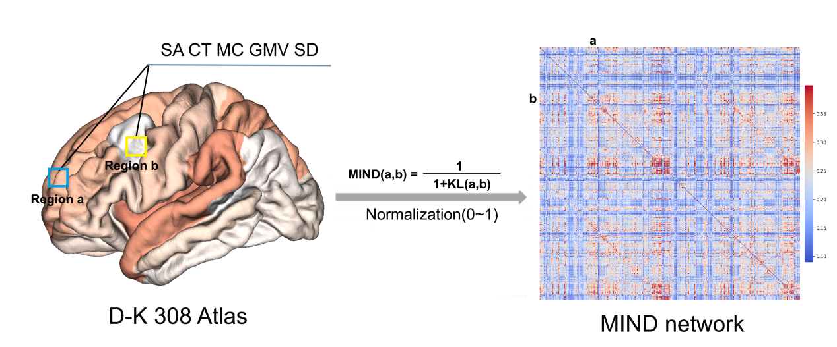
Fig. S1 Elaboration of MIND. Firstly, the surface was subdivided into 308 contiguous areas based on the D-K 308 atlas. Each area was characterized by five structural features: surface area (SA), cortical thickness (CT), mean curvature (MC), gray matter volume (GMV) and sulcal depth (SD). To estimate the similarity between cortical regions, we normalized each MRI feature across all vertices and then summarized all MRI measures across all vertices within each cortical region. Furthermore, the K-nearest neighbor density algorithm was used to compile a paired distance matrix to estimate the KL divergence between each pair of regional multivariate distributions. Finally, the KL divergence KL (a, b) of regions a and b was transformed to estimate the MIND similarity between regions. The MIND was bounded between 0 and 1, with higher values indicating greater similarity.

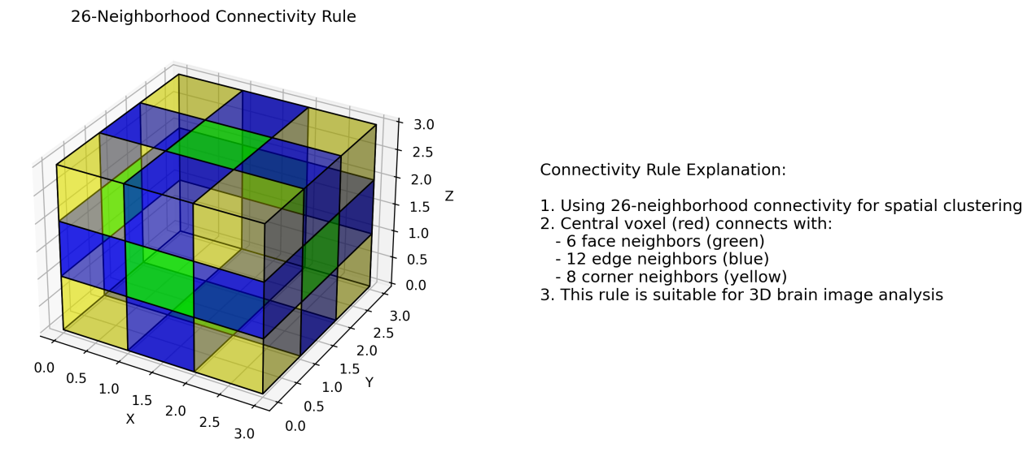
Fig. S2 Spatial cluster connectivity rule.

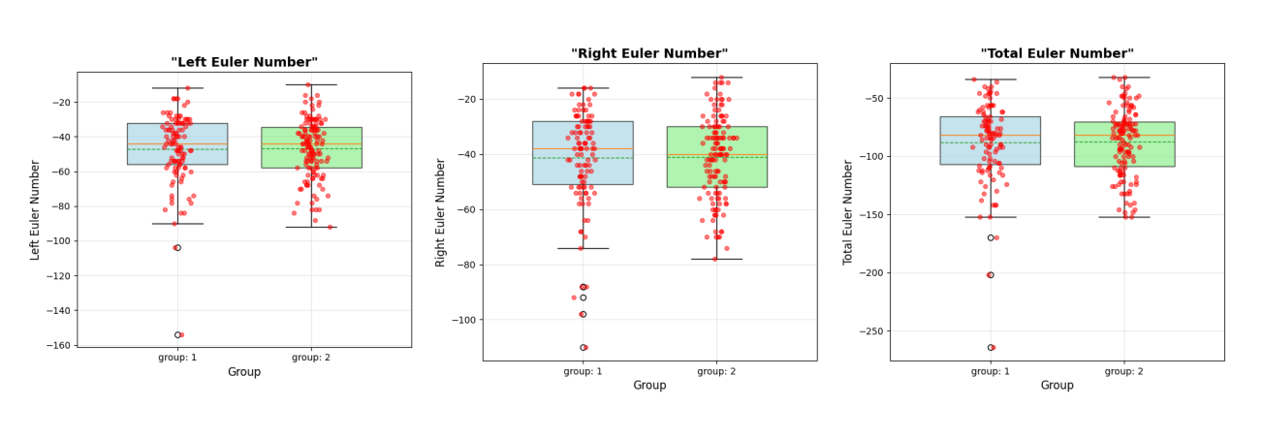
Fig. S3. Euler number box plot between two groups. Left hemisphere: Group1: mean: -46.953, standard deviation: 20.356, median: -44.000. Group2: mean: -46.881, standard deviation: 16.660, median: -44.000. The independent sample t-test results showed a t-value of -0.030 and a p-value of 0.976, with no significant difference between the two groups (p>=0.05). Right hemisphere: Group1: mean: -41.308, standard deviation: 17.836, median: -38.000. Group2: mean: -40.985, standard deviation: 14.990, median: -40.000. The independent sample t-test results showed a t-value of -0.150 and a p-value of 0.881, with no significant difference between the two groups (p>=0.05). Whole brain: Group1: mean: -88.262, standard deviation: 35.068, median: -82.000. Group2: mean: -87.866, standard deviation: 28.603, median: -82.000. The independent sample t-test results showed a t-value of -0.094 and a p-value of 0.925, with no significant difference between the two groups (p>=0.05). Group1: without NSSI, Group2: NSSI.
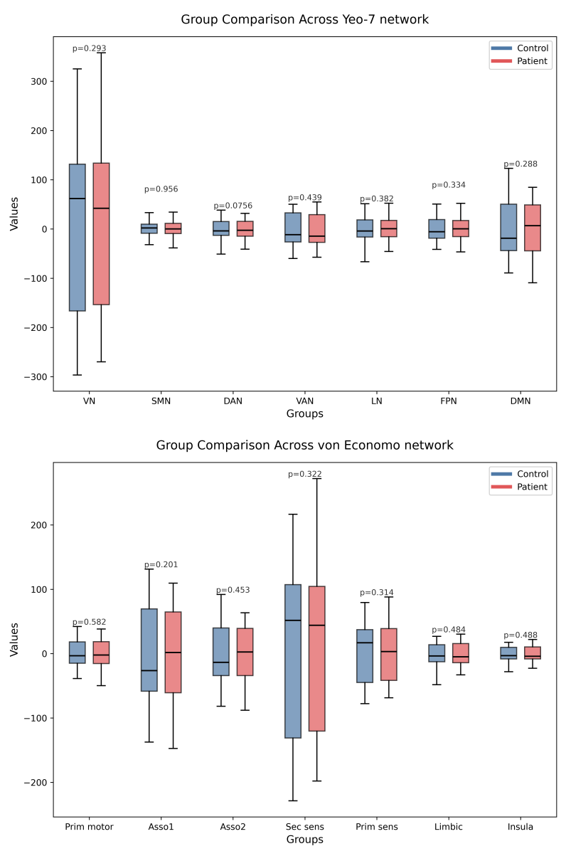
Fig. S4. Box plot of group comparision across Yeo-7 network and von Economo network. The above figure shows inter group comparison on the Yeo-7 network: blue (without NSSI) and red (NSSI) bins have different distributions in different brain networks (such as VN, SMN and DAN). Although the bins in the without NSSI group are significantly higher than those in the NSSI group, the median is similar in the VN group. Statistical significance: p=0.0756 in DAN, indicating that the difference between groups is close to statistical significance (marginal significance). No significant outliers were observed, and the data distribution is relatively stable. On the von Economo network below, we did not observe statistically significant differences. And no obvious outliers were observed, indicating a relatively stable data distribution.

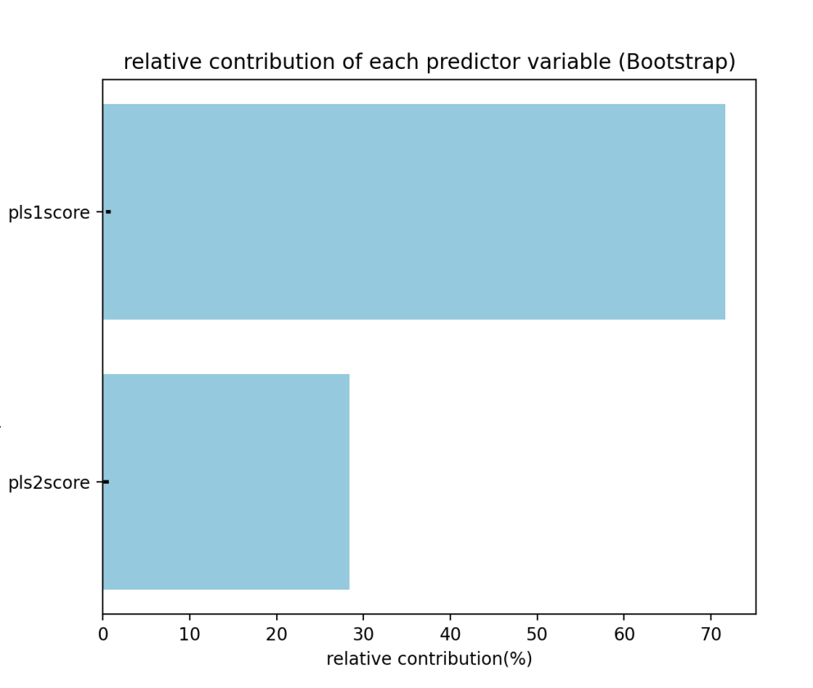
Fig. S5. Relative contribution percentage of PLS1 and PLS2. We used a mixed strategy of 10000 bootstrap samples combined with multiple linear regression to systematically evaluate the significant contribution of PLS1 and PLS2 scores to the case control t-value. First, generate 10000 subsets of data through resampling with replacement; Subsequently, a multiple linear regression model was established with case control t-value as the dependent variable and PLS1 and PLS2 scores as independent variables to obtain their independent contribution coefficients to the t-value; Finally, based on the coefficient distribution of 10000 regression results, calculate the confidence interval and p-value, and determine the contribution proportion according to the percentage of the absolute value of the standardized coefficient to the total absolute value.
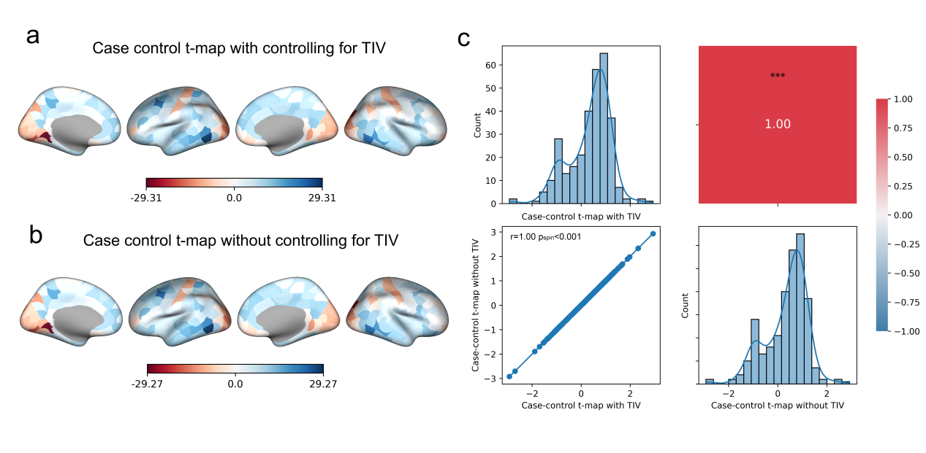
Fig. S6. Validation of TIV effect on case-control principal MIND gradient differences. a. The case-control t map with controlling for TIV. b. The case-control t map without controlling for TIV. c. The results of spatial correlation analysis between the principal MS gradient with and without controlling for TIV. P value was calculated based on spin test.

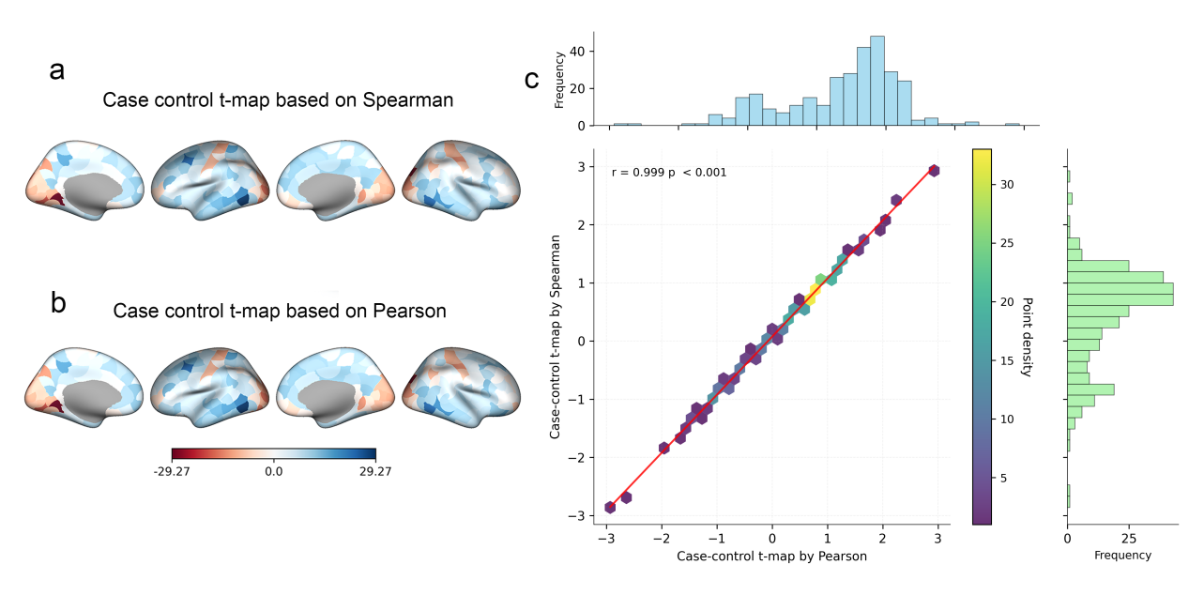
Fig. S7. The effect of different types of correlation analysis on case-control differences. A. The case-control t map of the principal MIND gradient based on Spearman’s correlation analysis. B. The case-control t map of the principal MIND gradient based on Pearson’s correlation analysis. C. The results of spatial correlation analysis between the principal MIND gradient based on Spearman’s and Pearson’s correlation analysis.

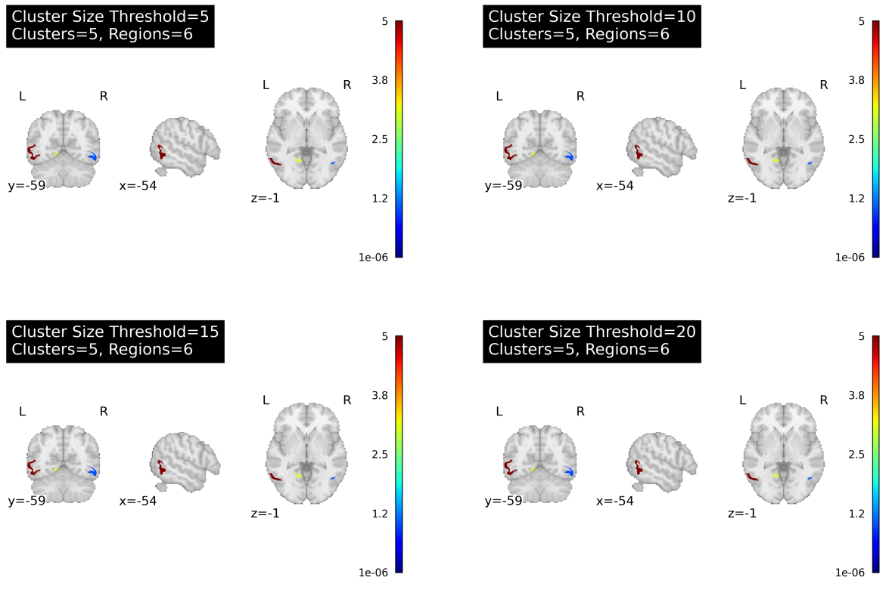
Fig. S8. Evaluating the network topology characteristics under different cluster thresholds size. It was found that the statistical results of case-control MIND Gd differences remained highly consistent at each threshold (n=5, 10, 15, 20). The clustering distribution patterns, node connection characteristics, and global topology indicators obtained from different threshold settings showed no significant statistical differences.
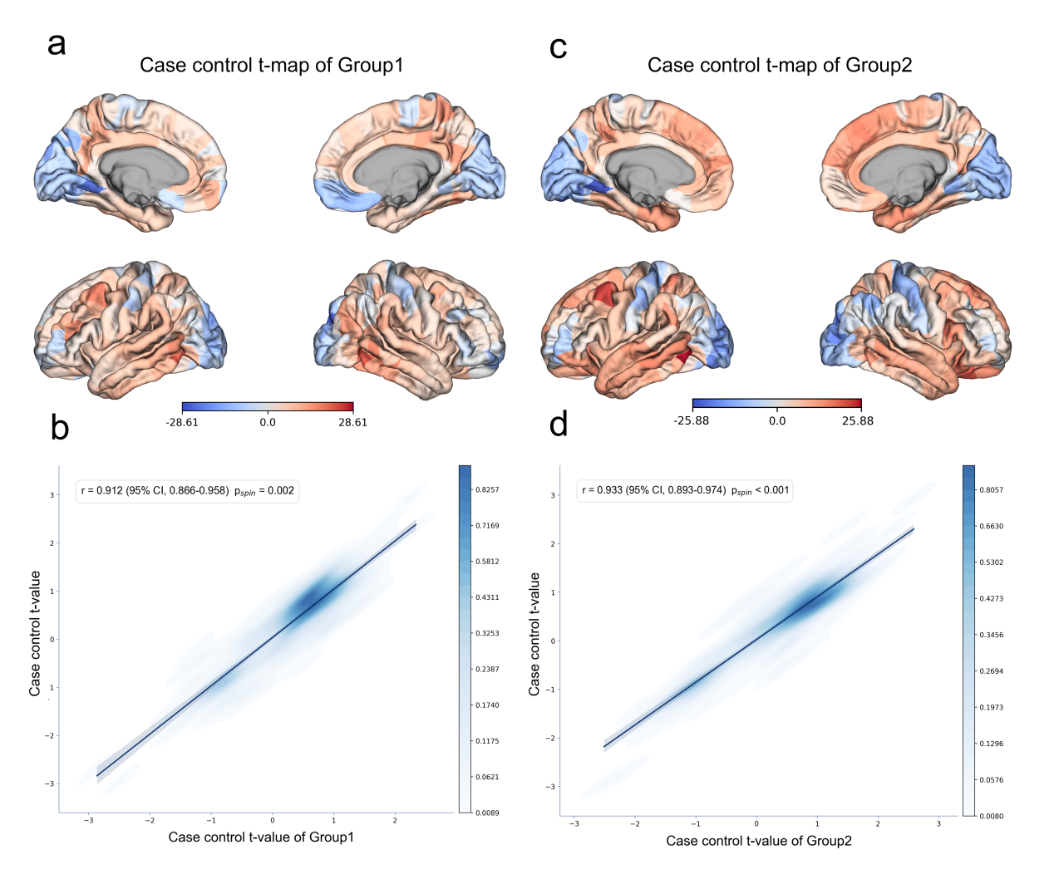
Fig. S9. Comparison of principal MIND gradient differences between NSSI subgroups and without NSSI. (a, c) Group1 revealed principal MIND gradient differents in the left inferior temporal (part2), left lingual (part3), right inferior temporal (part2) and right superior parietal (part1), while Group2 in the left caudal middle frontal (part4), left inferior temporal (part2), left lingual (part3), right lateral orbitofrontal (part4) and right superior parietal (part1), as detailed in Supplementary Table S11. Except for right lateral orbitofrontal region, the remaining brain regions in both groups overlap with those in the entire NSSI group.The overlap rates of differential regions in both two subgroups reach up to 3/5. (b, d) The case control t-map for NSSI patients displayed positive spatial correlations with that of Group1 (r =0.912, p_{spin} =0.002, spin=10000) and Group2 (r =0.933, p_{spin} <0.001, spin=10000).

