Supplemental Data

Alzheimer’s Disease Neuropathological characterization of the dog brain and relationship to biofluid biomarkers and cognitive function
Abdullatif Alsulami^{1,2}, Marika Bogdani³, Evan MacLean⁴, C. Dirk Keene³, Stephanie McGrath^{5,2}, Dog Aging Project Consortium, Caitlin S. Latimer^{3*} and Julie A. Moreno^{1,2*}
¹Department of Environmental & Radiological Health Sciences, College of Veterinary Medicine and Biomedical Sciences, Colorado State University, Fort Collins, CO, USA
²Brain Research Center, Colorado State University, Fort Collins, CO, USA
³Department of Laboratory Medicine and Pathology, University of Washington, Seattle, WA, USA
⁴Department of Psychology, College of Veterinary Medicine, University of Arizona, Tucson, USA
⁵Department of Clinical Sciences, College of Veterinary Medicine and Biomedical Sciences, Colorado State University, Fort Collins, CO, USA
*Co-corresponding authors

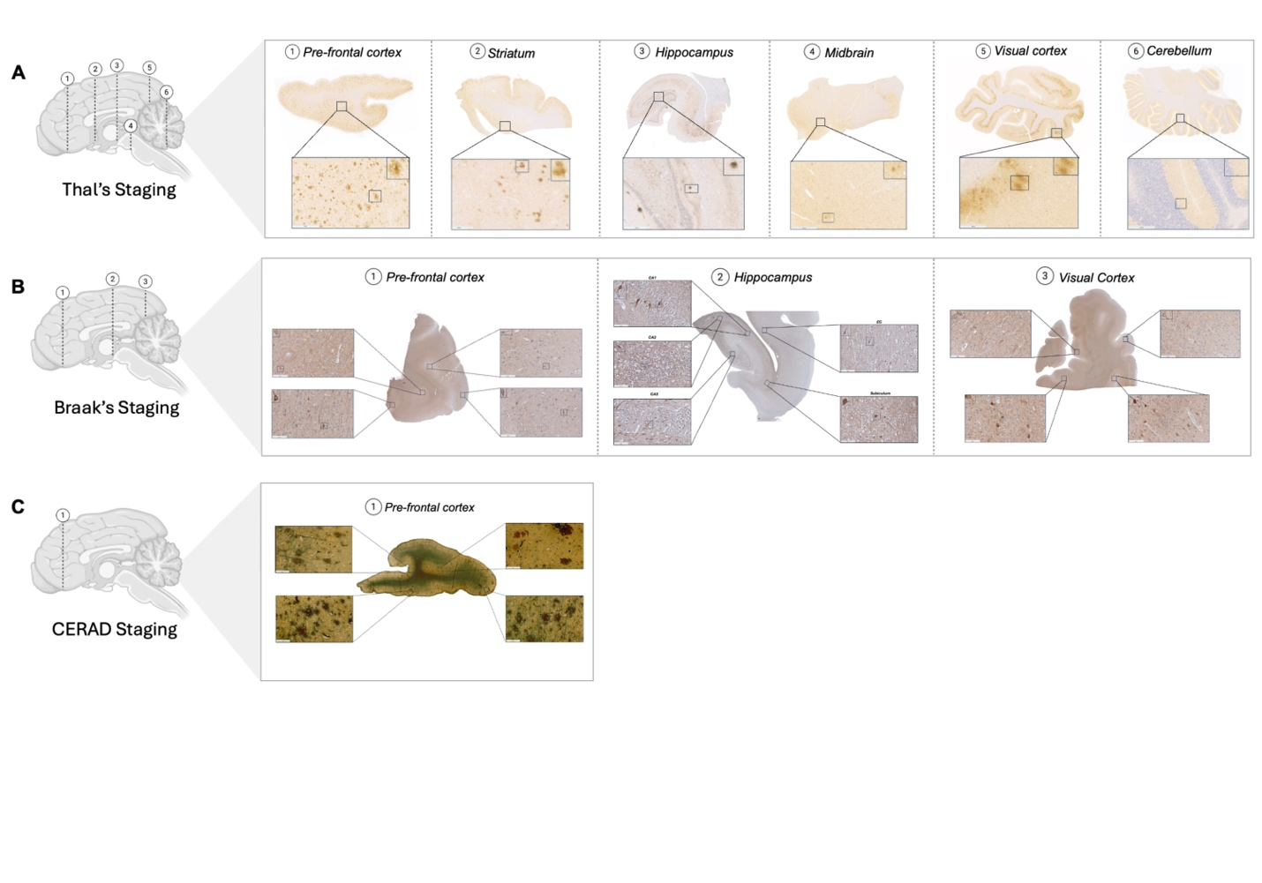
Supp Figure 1. Adapting human Alzheimer’s disease neuropathological staging system to canine brains. (A) Thal’s β-amyloid phases: representative sections of β-amyloid plaques distribution across cortical and subcortical regions in aged dogs. (B) Braak’s neurofibrillary tangles staging: representative section of phosphorylated tau-181, showing the regional progression of tau pathology in aged canines. (C) CERAD neuritic plaque scoring: Bielschowsky silver staining to evaluate the presence and density of neuritic plaques in senior dogs.

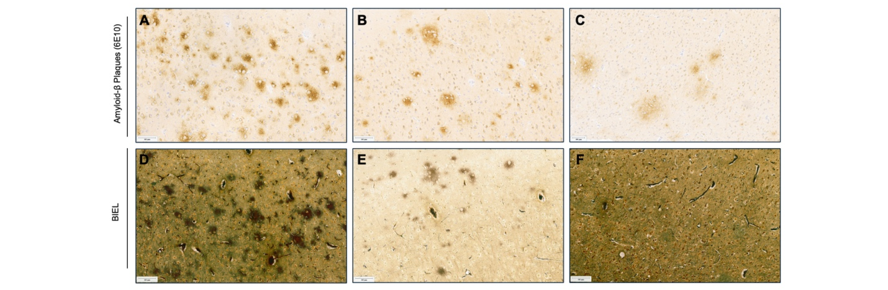

Supp Figure 2. Detection of β-amyloid plaques using immunohistochemical and silver staining in aged canine’s pre-frontal cortex. Representative images demonstrate differences in β-amyloid plaque detection using anti-β-amyloid 6E10 immunostaining (A–C) and Bielschowsky silver staining (D–F). Images from the same dog in panels (A, D) show comparative detection of compact plaques. Panels (B, E) illustrate the higher sensitivity of immunostaining in identifying diffuse, cloud-like plaques, while panels (C, F) show minimal detection of amyloid deposits with silver staining in regions of low plaque burden. Scale bar = 100μm.

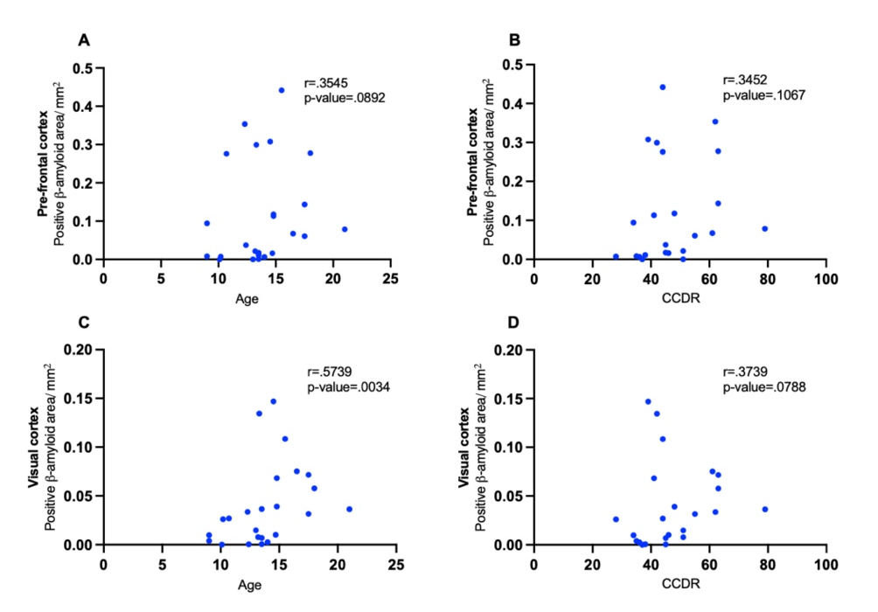

Supp Figure 3. Association between β-amyloid plaque burden with age and cognitive scores. Scatterplots showing relationships between β-amyloid plaque in the frontal cortex and age (A), and Canine Cognitive Dysfunction Rating (CCDR) scores (B), as well as β-amyloid plaque in the visual cortex and age (C) and CCDR scores (D). Spearman’s rank correlation analysis showed no significant associations between CCDR scores and β-amyloid plaque burden in either brain regions. A positive moderate to strong association was observed between β-amyloid plaque burden in the visual cortex and age.

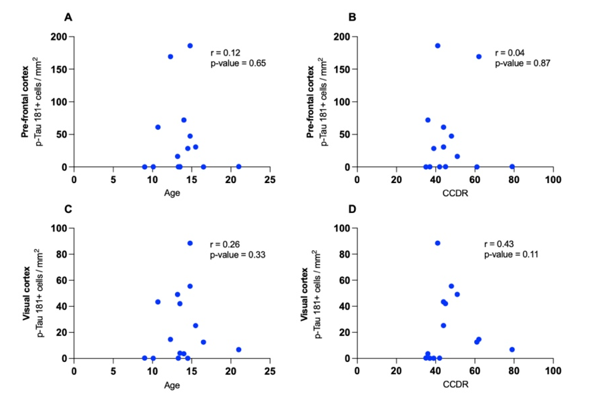
Supp Figure 4. Association between P-tau181 positive cell counts with age and cognitive scores. Scatterplots showing relationships between P-tau181counts in the frontal cortex and age (A), and Canine Cognitive Dysfunction Rating (CCDR) scores (B), as well as in the visual cortex and age (C) and CCDR scores (D). Spearman’s rank correlation analysis showed no significant associations between CCDR scores and age with P-tau181 in either brain regions.

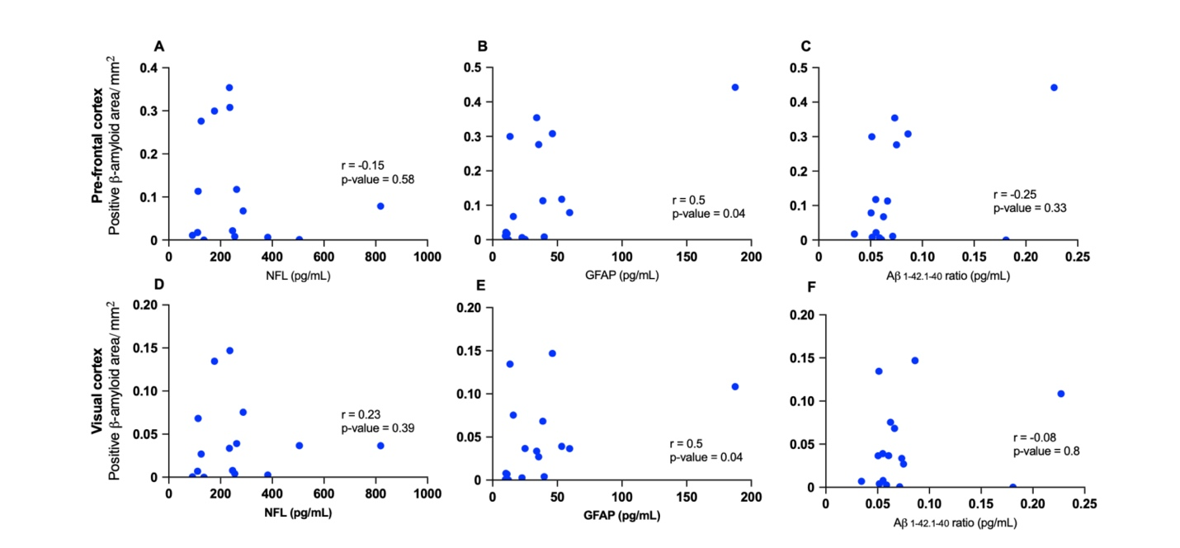
Supp Figure 5. Association between plasma NfL, GFAP, and Aβ_{1-42/1-40} ratio with β-amyloid plaque burden in aged dogs. Scatterplots show relationships between plasma neurofilament light chain (NfL) levels and β-amyloid plaque burden in the prefrontal cortex (A) and Visual cortex (B), plasma glial fibrillary acidic protein (GFAP) levels and β-amyloid plaque burden in the prefrontal cortex (C) and Visual cortex (D), and plasma Aβ_{1-42/1-40} ratio and β-amyloid plaque burden in the prefrontal cortex (E) and Visual cortex (F). Spearman’s rank correlation analysis showed a moderate association between GFAP levels and β-amyloid plaque burden in both regions.

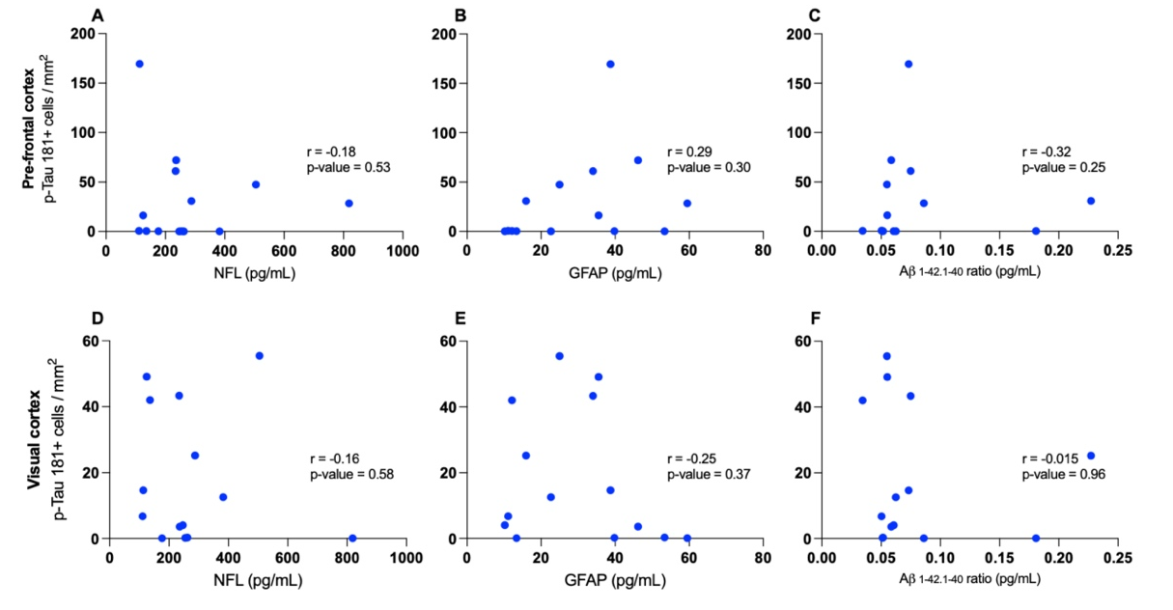

Supp Figure 6. Association between plasma NfL, GFAP, and Aβ_{1-42/1-40} ratio with P-tau181 positive cell counts in aged dogs. Scatterplots show relationships between plasma neurofilament light chain (NfL) levels P-tau181 positive counts in the prefrontal cortex (A) and Visual cortex (B), plasma glial fibrillary acidic protein (GFAP) levels and P-tau181 positive counts in the prefrontal cortex (C) and Visual cortex (D), and plasma Aβ_{1-42/1-40} ratio and P-tau181 positive counts in the prefrontal cortex (E) and Visual cortex (F). Spearman’s rank correlation analysis did not show significant associations between the biomarkers and P-tau181 positive counts in both regions.

 | Β-amyloid (Thal’s staging) |  |  |  |  |  | P-tau181 (Braak’s staging) |  |  | BIEL (CERAD)
ID | MFG | Visual cortex | Hippocampus | Striatum | midbrain | Cerebellum | Hippocampus | MFG | Visual cortex | MFG
CD 1 | + | + | + | + | - | - | + | + | + | -
CD 2 | + | - | - | - | - | - | + | + | + | -
CD 3 | + | + | + | + | - | - | - | - | + | -
CD 4 | + | + | + | + | + | - | - | - | - | -
CD 5 | + | + | + | - | - | - | - | - | - | -
CD 6 | + | + | + | + | + | - | - | - | - | -
CD 7 | + | + | + | - | - | - | - | - | - | -
CD 8 | + | - | + | - | - | - | + | - | - | -
CD 9 | + | + | + | + | - | - | + | - | - | -
CD 10 | + | + | + | + | - | - | - | - | - | -
CD 11 | + | + | + | + | - | - | + | + |  | -
CD 12 | + | + | + | - | - | - | + | + | + | -
CD 13 | + | + | + | - | - | - | - | - | - | -
CD 14 | + | + | + | + | - | - | + | - | - | -
CD 15 | + | - | - | - | - | NA | + | - | - | -
CD 16 | + | + | + | + | - | - | - | - | - | -
CD 17 | + | + | + | - | - | - | + | - | + | -
CD 18 | + | + | + | - | - | - | + | - | + | -
CD 19 | + | + | + | - | - | - | - | - | - | -
CD 20 | + | + | + | - | - | - | + | + | + | -
CD 21 | + | + | + | - | - | - | + | - | + | -
CD 22 | + | - | - | - | - | - | + | - | - | -
CD 23 | + | + | + | - | - | - | + | + | + | -
CD 24 | + | + | + | - | - | - | + | + | - | -

Supplementary Table 1. Thal’s, Braak, and CERAD assessment in aging dogs. Table summarizing neuropathological assessment across individual canine cases (CD1–CD24). Thal’s staging indicates the presence (+) or absence (–) of β-amyloid pathology across multiple brain regions (middle frontal gyrus {MFG}, visual cortex, hippocampus, striatum, midbrain, and cerebellum). Braak’s staging shows neurofibrillary tangle pathology (p-tau181 immunohistochemistry) in hippocampus, MFG, and visual cortex. CERAD neuritic plaque scores were evaluated with Bielschowsky silver staining in MFG. NA = tissue not available.

