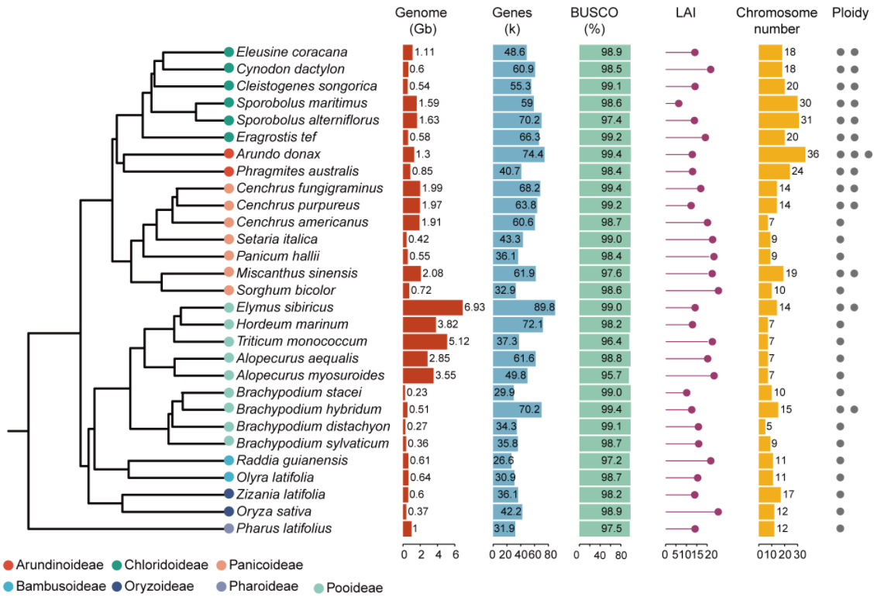

Supplementary Fig. 1. Genome characteristics of 29 representative species across 7 subfamilies in Poaceae.
Bar charts display genome size (Gb), gene number (×10³), BUSCO completeness (%), and chromosome number. Lollipop charts indicate LAI scores, with circles representing ploidy levels (one circle = diploid). Topological relationships are derived from the TimeTree database (http://timetree.org/).

Supplementary Fig. 2. Identification of 12 protochromosomes of the ancestral karyotype of BOP and PACMAD clades (ABPK).
(a) 12 chromosome-like synteny blocks (CLSBs) from Oryza sativa were defined as BOP protochromosomes, and (b) 12 CLSBs from subgenome A of Phragmites australis were defined as PACMAD protochromosomes, based on synteny comparisons with other representative genomes from each clade. (c) Karyotypes of O. sativa and P. australis subgenome A were highly similar. 12 chromosomes from O. sativa were designated as protochromosomes of the ABPK labeled ABPK1 to ABPK12. Each colored box corresponds to one of the 12 protochromosomes inferred.

Supplementary Fig. 3. Zizania latifolia karyotype (n = 17) evolved from the ABPK genome (n = 12) via whole-genome duplication, followed by seven EEJs and one RCT.

Supplementary Fig. 4. Karyotype evolution from ABPK (n = 12) to species in the Olyreae tribe through complex chromosomal rearrangements.
Both Olyra latifolia (a) and Raddia guianensis (b) (n = 11) share the ABPK_10+12_NCF event. Subsequently, O. latifolia additionally experienced five RCTs, while R. guianensis underwent two RCTs, one EEJ, and one fission event (marked by a purple dashed ellipse).

Supplementary Fig. 5. The ancestral karyotype of the Brachypodieae tribe (ABK) was reconstructed using Brachypodium stacei as an example.
(a, b) Karyotype evolution from ABPK to ABK via two NCF events (ABPK_8+10_NCF and ABPK_9+12_NCF) and one RCT event (ABPK_(9+12_NCF)+11_RCT). Fused chromosomes are assigned to new colors in panel (b).

Supplementary Fig. 6. Shared chromosome fusions in the Brachypodieae tribe.
The allotetraploid origin of Brachypodium hybridum is confirmed by five chromosome fusions shared between subgenome A (n = 5) and Brachypodium distachyon. In contrast, no fusions are shared between B. distachyon and subgenome B (n = 10). In addition, subgenome A shares the ABK_5+10_EEJ fusion with the Brachypodium sylvaticum genome. Checkmarks indicate support for the shared fusion events, while crossemarks indicate a lack of support.

Supplementary Fig. 7. Chromosome fusion events in Brachypodium hybridum and its subgenome phasing.
Based on the dot plot between Brachypodium stacei (n = 10), Brachypodium distachyon (n = 5) and Brachypodium hybridum (n =15), the distribution of best homologous genes (red dots) and shared fusion breakpoints indicate that tetraploid B. hybridum genome can be divided into two subgenomes (A and B). Subgenome A shares 4 NCFs and one EEJ with B. distachyon. Checkmarks indicate support for the shared fusion events.

Supplementary Fig. 8. Reconstruction of ancestral karyotype APTK and its translocation variant ATK.
(a) Evolution from ABPK (n = 12) to APTK (n = 7) through four NCF events (ABPK_3+11_NCF, ABPK_4+7_NCF, ABPK_6+8_NCF, and ABPK_5+10_NCF) and one EEJ event (ABPK_9+12_EEJ). (b) The APTK genome was altered by a reciprocal translocation (APTK_1+6_RCT) towards the ATK genome. (c) The APTK_1+6_RCT event is only shared across Triticeae tribe (Triticum monococcum, Elymus sibiricus, and Hordeum marinum). Checkmarks indicate support for the shared fusion events, while crossemarks indicate a lack of support.
Supplementary Fig. 9. The genome of Alopecurus myosuroides is derived from the ancestral APTK genome formed by a reciprocal translocation (APTK_1+4_RCT).

Supplementary Fig. 10. Different fusion breakpoints on the same protochromosomes indicate similar, but distinct chromosomal rearrangements.
(a) reciprocal translocations in Triticeae species derived from the ancestral ATK genome. (b) Conserved fusion breakpoints for ATK_4+5_RCT are shared between Elymus sibiricus and Triticum monococcum, as indicated by checkmarks. The ATK_4+6_RCT events in E. sibiricus and Aegilops umbellulata involve the same protochromosomes but different fusion breakpoints, as denoted by crossemarks. Checkmarks indicate support for the shared fusion events, while crossemarks indicate a lack of support.

Supplementary Fig. 11. NCFs characterized the construction of ancestral karyotype within the Panicoideae subfamily.
(a) Identification of two NCFs (ABPK_3+10_NCF and ABPK_7+9_NCF) in the evolution from the ABPK (n = 12) to the APEK (n = 10). (b) Karyotype reduction from APEK (n = 10) to APAK (n = 9) via APEK_8+9_NCF. (c) APEK_8+9_NCF event is only shared across Paniceae tribe (Panicum hallii and Panicum miliaceum). Checkmarks indicate support for the shared fusion events, while crossemarks indicate a lack of support.

Supplementary Fig. 12. chromosome fusions Inferred from APEK to Miscanthus sinensis.
(a) Protochromosomes of the APEK genome are shared with the subgenome A. (b) Subgenome B underwent one NCF event (APEK/4_7/NCF).

Supplementary Fig. 13. A shared reciprocal translocation in Setaria species.
The APAK_3+7_RCT event is shared across both Setaria species.

Supplementary Fig. 14. Karyotype evolution and chromosome fusion events from the APAK genome to the allotetraploid Cenchrus fungigraminus.
(a) Inferred chromosome fusions from the 9-protochromosome APAK genome to the 7-chromosome C. fungigraminus subgenome. (b) Both C. fungigraminus subgenomes share one NCF event (APAK_3+6_NCF). (c) Different fusion breakpoints on the same protochromosomes indicate independent chromosomal rearrangements.

Supplementary Fig. 15. NCF events shaped the karyotype evolution in the Chloridoideae subfamily.
Two NCFs (ABPK_2+10_NCF and ABPK_6+9_NCF) are shared across Chloridoideae subfamily (Eragrostis tef, Cleistogenes songorica, Cynodon dactylon, and Eleusine coracana).

Supplementary Fig. 16. Chromosomal rearrangements in species of the tribe Cynodonteae that evolved from the ACK.
(a) The allotetraploid Cleistogenes songorica exhibits asymmetric subgenome evolution. Subgenome A retains the intact ACK structure, while subgenome B underwent two RCT events. (b) One NCF event (ACK_3+10_NCF) was shared between the two Cynodon dactylon subgenomes. (c) Both subgenomes of Eleusine coracana underwent the ACK_9+10_NCF event.

Supplementary Fig. 17. Pairwise karyotype comparisons of fused chromosomes between subgenomes (A and B) of Sporobolus maritimus and subgenomes (C and D) of Sporobolus alterniflorus identified chromosome fusion events.
Four chromosome fusion events (ACK_4+9_NCF, ACK_6+8_NCF, ACK_5+10_NCF, and ACK_2+3_RCT) were shraed across all subgenomes. Subgenomes A and B shared two chromosome fusions (ACK_4+6_NCF and ACK_1+10_NCF) with subgenome C. Subgenome D underwent a unique chromosome fusion (ACK_4+10_NCF).

Supplementary Fig. 18. Comparison of non-Poaceae species with the fusion breakpoint (APHK_1/APHK_7 and ABPK_1/ABPK_7) revealed no shared collinear blocks.
A 200-gene segment (100 genes per side, marked in red and blue) flanking each fusion breakpoint was compared with Ananas comosus and Juncus effusus. No syntenic blocks were detected near the fusion breakpoints in either species.

Supplementary Fig. 19. Pairwise comparisons of subgenome karyotypes within allotetraploid Cenchrus purpureus and Cenchrus fungigraminus.

Supplementary Fig. 20. Coverage depth of Cenchrus fungigraminus (a) and Cenchrus purpureus (b) chromosomes by mapping 150-mer sequences from Cenchrus americanus.

Supplementary Fig. 21. The distribution of sequence divergence rates of transposable elements (TE) of subgenomes A and B in Cenchrus fungigraminus.
The TE content segregation between subgenomes A and B indicated the events of diploid progenitor divergence (~9.5 mya) and merger (~2.9 mya) in tetraploid C. fungigraminus.

Supplementary Fig. 22. Sub-subgenome phasing of paleotetraploid Sporobolus species using the ACK genome as a reference.
Following the initial identification of subgenomes, homoeologous block pairs within each subgenome were further partitioned. The genomes of Sporobolus alterniflorus and Sporobolus maritimus were dissected into four sub-subgenomes, respectively.

Supplementary Fig. 23. Phylogenetic relationships among the sub-subgenomes based on collinear genes from homologous blocks associated with each of the 10 chromosomes in Eragrostis tef subgenome A.
The numbers above the branches indicate the concordance percentage between gene-based and chromosome-scale trees; the numbers below the branches represent the local posterior probabilities calculated by ASTRAL. The pie charts at the nodes represent the frequencies of three gene tree topologies (q1, q2 and q3) calculated in ASTRAL.

Supplementary Fig. 24. Distribution of sequence divergence rates of transposable elements (TE) in the subgenomes of Sporobolus species.
(a) The TE content segregation between subgenomes A and B indicated the events of diploid progenitor divergence (~2.6 mya) and merger (~0.5 mya) in tetraploid Sporobolus maritimus. (b) The TE content segregation between subgenomes C and D indicated the events of diploid progenitor divergence (~4.3 mya) and merger (~0.9 mya) in tetraploid Sporobolus alterniflorus.

Supplementary Fig. 25. The near-chromosome-level Sporobolus maritimus genome was subjected to subgenome phasing using subphaser.
(a, c) Partial chromosomes exhibit ambiguous subgenome assignment, and red dashed ellipses highlight regions with large-scale homoeologous exchanges, likely reflecting scaffold ordering errors caused by high sequence similarity between homoeologous chromosomes rather than genuine biological recombination events (b, d) Following manual repositioning of scaffolds, the optimized genome assembly achieved correct subgenome partitioning. (a-b) Unsupervised hierarchical clustering (the horizontal color bar at the top of the axis indicates to which subgenome the k-mer is specific; the vertical color bar on the left of the axis indicates the subgenome to which the chromosome is assigned. The heat map indicates the Z-scaled relative abundance of k-mers. The larger the Z-score, the higher the relative abundance of a k-mer. (c-d) Chromosomal characteristics. From outer to inner circles (1–7): (1) subgenome assignments based on the k-means algorithm. (2) Significant enrichment of subgenome-specific k-mers. The same color as the subgenome indicates significant enrichment for those subgenome-specific k-mers. White areas are not significantly enriched. (3) Normalized proportion (relative) of subgenome-specific k-mers. (4–5) Count (absolute) of each subgenome-specific k-mer set. (6) Density of long terminal repeat retrotransposons (LTR-RTs). If the colour is consistent with the subgenome, it indicates that LTR-RTsare enriched for those subgenome-specific k-mers. Gray indicates non-specific LTR-RTs. (7) Homoeologous blocks. All statistics (2–6) are computed in sliding windows of 1 Mb.

Supplementary Fig. 26. Subgenome phasing with SubPhaser in the Sporobolus alterniflorus genome.
(a) Unsupervised hierarchical clustering (the horizontal color bar at the top of the axis indicates to which subgenome the k-mer is specific; the vertical color bar on the left of the axis indicates the subgenome to which the chromosome is assigned. The heat map indicates the Z-scaled relative abundance of k-mers. The larger the Z-score, the higher the relative abundance of a k-mer. (b) Chromosomal characteristics. From outer to inner circles (1–7): (1) subgenome assignments based on k-means algorithm. (2) Significant enrichment of subgenome-specific k-mers. The same color as the subgenome indicates significant enrichment for those subgenome-specific k-mers. White areas are not significantly enriched. (3) Normalized proportion (relative) of subgenome-specific k-mers. (4–5) Count (absolute) of each subgenome-specific k-mer set. (6) Density of long terminal repeat retrotransposons (LTR-RTs). If the color is consistent with the subgenome, it indicates that LTR-RTs are significantly enriched to those subgenome-specific k-mers. Gray indicates non-specific LTR-RTs. (7) Homoeologous blocks. All statistics (2–6) are computed in sliding windows of 1 Mb.

