Miscellaneous File Not for Publication:

Fig.SS1 analysis of PCR production
M: 1kb DNA Marker, 1: CDC15 amplified from MC15 (about 2.9 kb)

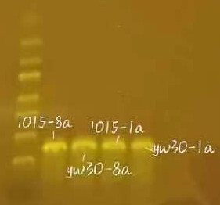

Fig.SS2 PCR products of mutant (yw30) and wild-type (1015) CDC15 genes (for sequencing)
Primers 8a and 1a are located close to each other upstream and downstream of the CDC15 gene.

Fig.SS3 Alignment of CDC15 among MT, WT and S288C

A:

B:
B

Fig.SS4 DNA and protein sequences of mutant(A) and wild-type(B)

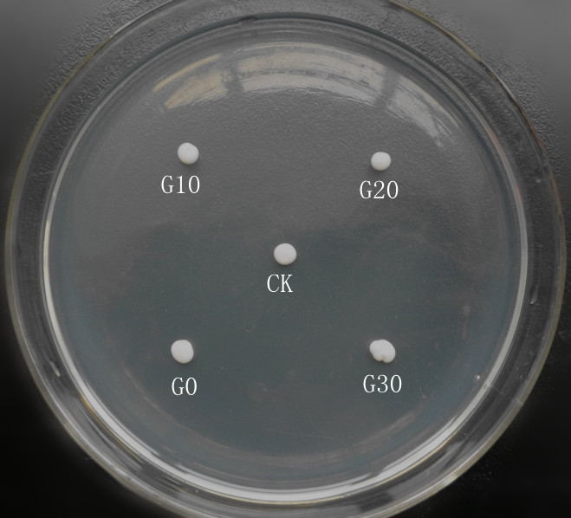

Fig.SS5 Growth of the yeasts on YPD plate.
CK: MF01(WT) ; generation 0 (G0), generations 10 (G10), 20 (G20), and 30 (G30) : MF01-CDC15.

Fig. SS6 The morphology of WT and MT under a microscope.
WT: MF01; MT:MF01-CDC15.

Fig.SS7 Survival of mutant strains (G0, G10, G20, G30) and wild-type (WT) after 10-minute heat shock at 50°C (A), 52°C (B), and 54°C (C).

Overnight cells were cultured to the logarithmic phase and inoculated at 1% (v/v) into 10% YPD medium (prepared with 10% dextrose instead of the standard 2%, while other components remained identical to conventional YPD). After 8–10 hours of incubation, 1 mL of culture was collected, centrifuged to pellet cells, and washed twice with sterile water. The cells were resuspended in an equal volume of sterile water, counted, and equal numbers of cell were exposed to heat shock at different temperatures. After treatment, 100 μL of each suspension was spread onto YPD agar plates and incubated at 30℃ for 2–3 days to assess their growth.

Fig.SS8 Relative respiration intensity (RRI) of mutant strains at different passages (G0, G10, G20, G30)
The RRI was measured according to the reference^{[4]} with modifications. Equal numbers of cells in the logarithmic phase were washed twice with sterile water, resuspended in YPD medium containing 0.5 mg TTC/mL, and incubated at 180 r/min for 8 h. Subsequently, 3 mL culture was centrifuged at 12,000 rpm (5 min) to pellet the cells. The pellet was treated with an equal volume of 95% ethanol (v/v), followed by vortexing for 10 min. After centrifugation, the supernatant's optical density was measured at 480 nm (OD480). RRI was calculated as: (OD480,sample)/(OD480,WT) × 100.

Fig.SS9 Reducing sugar from sucrose (A, C) and from molasses (B, D) fermentation broth
The data shown represent the mean ± SD of two or three independent biological replicates.

Fig.SS10 Total sugar subjected to hydrolysis from sucrose (A) and from molasses (B) fermentation broth
The total sugar content was estimated based on the reducing sugar content before and after hydrolysis, as shown in Fig. SS9.

Fig.S11 Morphological characteristics of cell cultured with and without trehalose

Representative micrographs were captured during growth curves determination using Countstar BioFerm IY1200 (one was randomly selected from two parallel cultures). Strain (WT, MT) and culture temperature (30 °C, 37 °C, 41 °C) are labeled above and on the left of the figure, respectively. Trehalose-supplemented cultures are denoted by "-T". This image only displays cells at 8 hours of cultivation.

