Supplementary material
Study on Impurity Content and Thermal Stability of Dicalcium Phosphate Dihydrate Prepared by Neutralization Method
Xueke Wang¹, Jiakai Cui¹, Wenwen Nie¹, Kejun Qian¹, Xufan Wang¹, Kaiyuan Lu¹, Changsong Wang^{1*}
¹ State Key Laboratory of Materials-Oriented Chemical Engineering, College of Chemical Engineering, Nanjing Tech University, Nanjing 210009, PR China.
* Corresponding author: wcs@njtech.edu.cn (C. S, Wang)

S1. Characterization of Samples.
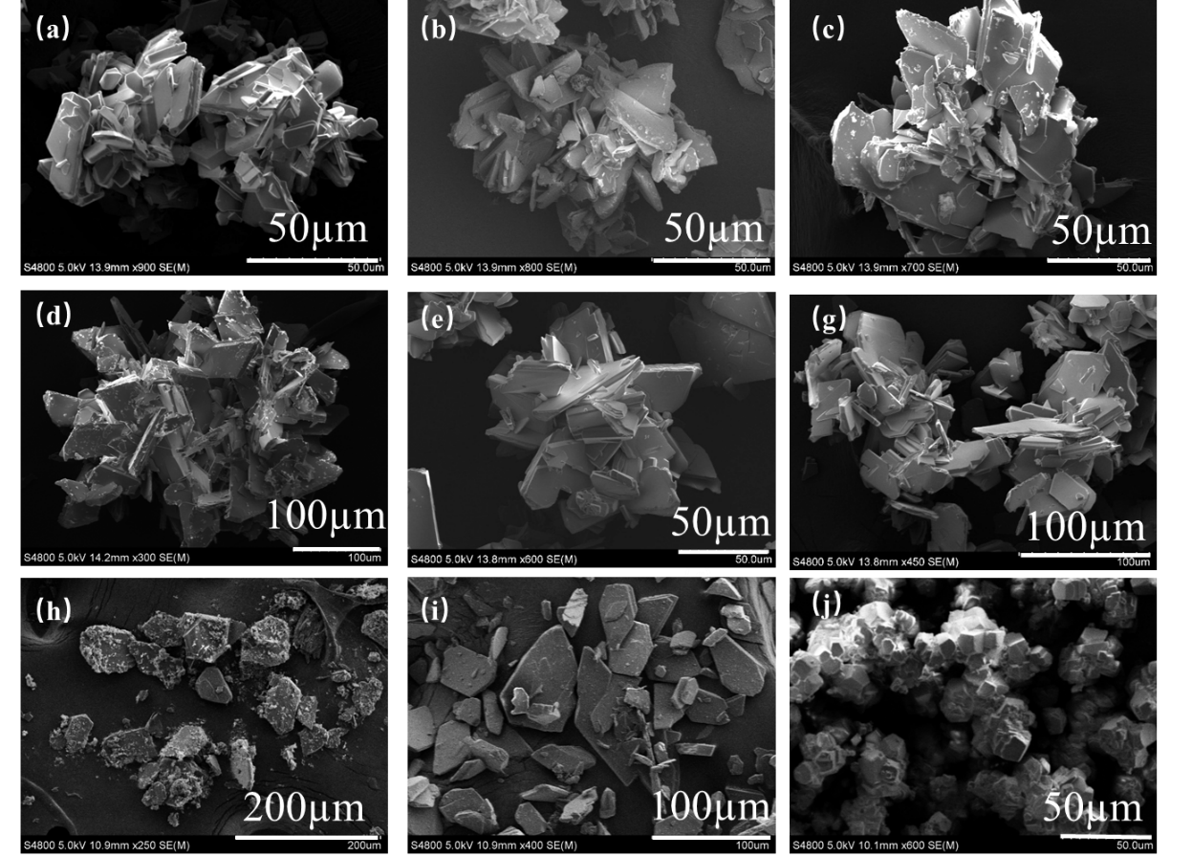
Fig. S1.1 Morphology images of samples M1-M8(a-i) and CaCO₃(j)
When the reaction temperature was below 60°C, the obtained samples all exhibited flake-like agglomerates. At a reaction temperature of 60°C, the resulting sample as well as the commercially available sample both showed relatively dispersed flakes, with sample M7 containing a higher amount of fragmented crystals. The calcium carbonate used in the experiments appeared as aggregated, blocky cubes with relatively uniform particle size.
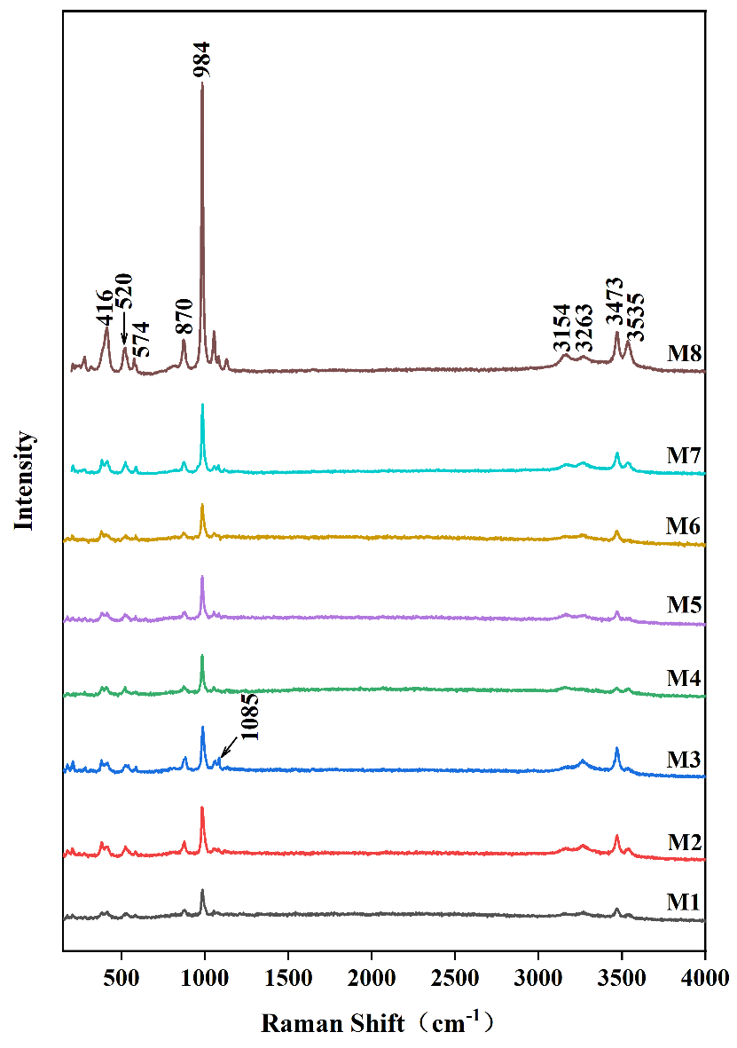
Figure S1.2 Raman spectra of samples M1-M8
The peak at 984 cm⁻¹ corresponds to the symmetric stretching vibration (ν₁) of the PO₄³⁻ group. This peak is sharp and intense, indicating a highly ordered and homogeneous crystalline environment for the phosphate groups in M1. The two distinct sharp peaks at 3154 cm⁻¹ and 3263 cm⁻¹ are attributed to the symmetric and asymmetric stretching vibrations of the crystal water (O–H) in DCPD. Peaks in the 400-600 cm⁻¹ region correspond to the bending vibration modes of PO₄³⁻. The overall Raman spectra of M2 and M3 are similar to that of M1. However, the emergence of a shoulder near 1053 cm⁻¹ is noteworthy. This position is very close to the characteristic Raman peak of calcite-type CaCO₃ (typically a strong ν₁ band around 1086 cm⁻¹). This shoulder is faintly visible in M2 and becomes significantly more pronounced in M3, confirming that the CaCO₃ impurity content increases as the reaction time decreases.As the reaction temperature rises from 45 °C (M4) to 60 °C (M7), the main peak at 984 cm⁻¹ broadens considerably and shifts slightly toward a higher wavenumber. This suggests that the local chemical environment of the PO₄³⁻ group becomes less uniform, a characteristic feature of the coexistence of DCPD and DCPA phases. The ν₁ vibration frequency of PO₄³⁻ in DCPA differs from that in DCPD, leading to peak overlap and broadening. In the spectra of M4-M7, the shoulder near 1053 cm⁻¹ remains observable, confirming that CaCO₃ residue persists even at elevated reaction temperatures.The spectrum of M8 shows obvious broadening of the main peak at 984 cm⁻¹, and the intensity of the O–H peaks is markedly lower than in M1. No distinct shoulder near 1053 cm⁻¹ appears in its spectrum, indicating the absence of CaCO₃ residue.
S2. Quantification of Individual Component Contents in the Product.
$$\begin{aligned}W_{CaCO_{3}}+W_{DCPD}+W_{DCPA}=1\#\left(S1\right)\end{aligned}$$
$$\begin{aligned}\frac{W_{DCPD}*m}{172.09}*45+\frac{W_{DCPD}*m}{136.09}*9=W_{total}*m\#(S2)\end{aligned}$$
where $W_{CaCO_{3}}$ is the mass fraction of CaCO₃, $W_{DCPD}$ is the mass fraction of DCPD, $W_{DCPA}$ is the mass fraction of DCPA, m is the total mass of the sample in the alumina crucible, 172.09 is the relative molecular mass of DCPD, 136.09 is the relative molecular mass of DCPA, and $W_{total}$ is the total mass loss of DCPD and DCPA, i.e., the mass loss of the impurity-containing sample before 500 °C. The value 45 corresponds to the relative molecular mass of 2.5 mol of water molecules, representing the mass loss when 1 mol of DCPD is completely converted to Ca₂P₂O₇, while 9 corresponds to the relative molecular mass of 0.5 mol of water molecules, representing the mass loss when 1 mol of DCPA is completely converted to Ca₂P₂O₇.
S3. Analysis of Commercially Available Samples.
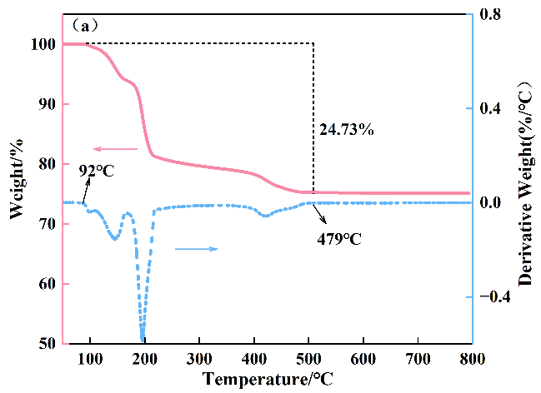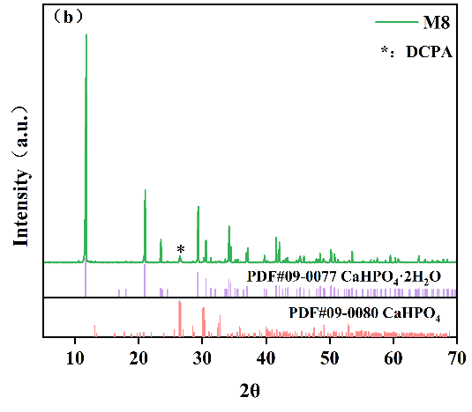
Fig. S3.1 TG curve (a) and XRD pattern (b) of the commercially available sample (M8)

The TG curve of the commercial sample is shown in Fig. S3(a). Decomposition began upon heating to 92 °C and completed at 479 °C, with a total mass loss of 24.73 wt.%, which is lower than the theoretical value of 26.15 wt.%. No further mass loss was observed above 500 °C. Based on the TG analysis discussed earlier, this indicates that sample M8 contains DCPA impurities but no residual calcium carbonate. Using Equations (3) and (4), the mass fractions of DCPD and DCPA in sample M8 were further calculated to be 91.47 wt.% and 8.53 wt.%, respectively.
Correspondingly, the XRD pattern of the commercial sample in Fig. S3(b). shows a distinct peak at 26.5°, which is attributed to DCPA, while the remaining peaks match well with those of pure DCPD. This further confirms the presence of a small amount of DCPA impurity in the sample.
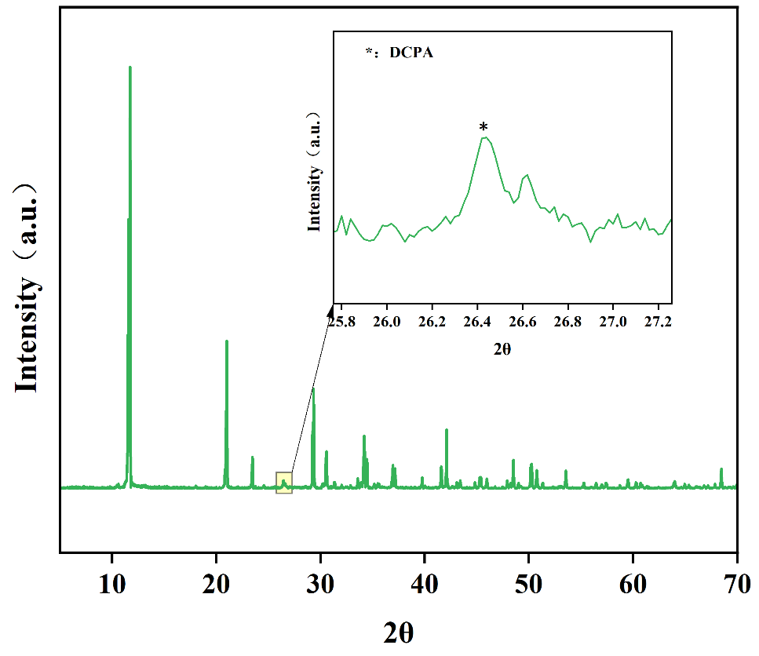
Fig. S3.2 XRD pattern of M8 after drying at 60°C for 24 h
After drying the commercially available sample at 60°C for 24 h, a distinct peak corresponding to DCPA appeared at 26.5°, indicating that the commercial sample also exhibits relatively low stability.

