Supplementary Data

Table S1: Microbiological analysis of MEs of selected snails
Sample 1
Specification | Values | Measure unit
Gram + | 0 | CFU
Gram - | 0 | CFU
Fungi | 0 | CFU
Yeast | 0 | CFU
Sample 2
Gram + | 0 | CFU
Gram - | 0 | CFU
Fungi | 0 | CFU
Yeast | 0 | CFU

Sample1: H. aspersa; Sample 2: E. desertorum; CFU: Colony forming unit

Table S2: Sequence of designed primers for Tgfβ1 and Vegf-A genes
Gene | Forward primer (5′-3′) | Reverse primer (5′-3′
GAPDH | ATGACTCTACCCACGGCAAG | CTGGAAGATGGTGATGGGTT
Tgfβ1 | CTGAACCAAGGAGACGGAAT | GGTTCATGTCATGGATGGTG
Vegf-A | GTCCTCACTTGGATCCCGACA | CCTGGCAGGCAAACAGACTTC

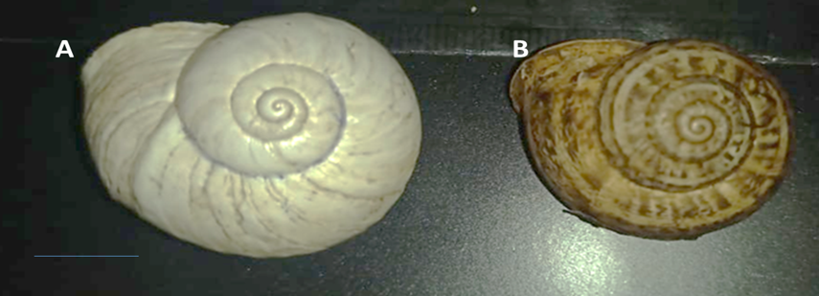

Fig (S1): Shells of both collected snails
(A) Desert snail Eremina desertorum (Forsskål, 1775): Helicidae (family), Helicinae Rafinesque, 1815 (subfamily), Gastropoda Pulmonata (class), Mollusca (phylum).
(B) Garden snail Helix aspersa (Müller, 1774): Helicidae (family), Helicinae Rafinesque, 1815 (subfamily), Gastropoda Pulmonata (class), Mollusca (phylum).

