Appendix
Table A1: Random effect regression.
 | Trust in Government
Rural * Incidents from 2010-2015 at the LGA level | -0.000743**  (0.000313)
The sum of Incidents from 2010-2015 at LGA level | 0.000202  (0.000256)
Control variables | Yes
State fixed effect | Yes
Random effect | YES
Clusters in LGA. | YES
N | 4068
Standard errors in parentheses *p<0.10,**p<0.05,***p<0.01. (1) is a simple LPM regression with a random effect.

Table A2: Interaction between rural and state conflict.
 | Trust in the government to do a better job.
 | 1 | 2 | 3
Rural * Incidents from 2010-2015 at the STATE level | -0.000186  (0.000153) | -0.000202  (0.000128) | -0.000223  (0.000255)
The sum of Incidents from 2010-2015 at STATE level | -0.0000839  (0.000148)
STATE Fixed effect | NO | YES | NO
LGA Fixed effect | NO | NO | YES
Clusters in LGA. | YES | YES | YES
N | 4068 | 4068 | 4068
R-sq |  |  | 0.007
Standard errors in parentheses *p<0.10,**p<0.05,***p<0.01. . (1) is a simple LPM regression without a fixed effect. Model (2) contains a STATE fixed effect and the sum of Incidents from 2010-2015 at the STATE level. Model (3) contains an LGA fixed effect but excludes the sum of Incidents from 2010-2015 at the STATE level.

Chart A1: Incidents by States from 2010 to 2015
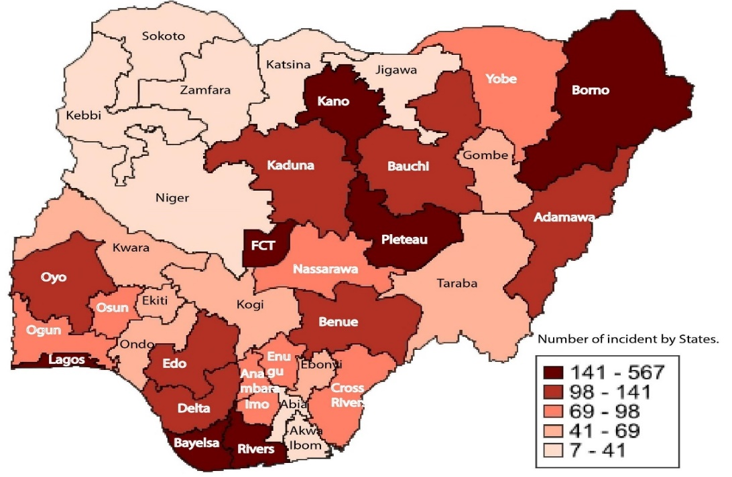

Source: (ACLED,2023). Design: by Author.
Table A3. Mean comparison across non-attritors and attritors.
Variable | Non-Attritors | Attritors | Mean.diff
 | Mean | Mean
Sector (rural=0, urban =1) | 0.3201 | 0.3216 | -0.0015
Number of people in the household | 5.9069 | 4.1784 | 1.728***
Total consumption per capita | 153129.5 | 179562.5 | -26433.0**
Sex of household head (female =0, male=1) | 0.8525 | 0.8647 | -0.0120
Agricultural household (NO = 0, YES = 1) | 0.6430678 | 0.5490196 | 0.0940***
Does a member of this household own land that was not cultivated? (NO = 0, YES = 1) | 0.1165 | 0.1118 | 0.0048
Does the household head still live in this Household?  (NO = 0, YES = 1) | 1 | 0.0019 | 0.998***
Did any household member receive any regular income from savings? (NO = 0, YES = 1) | 0.0211 | 0.0157 | 0.0055
Did any member receive any regular income from rental property? (NO = 0, YES = 1) | 0.0495 | 0.0588 | -0.0092
Did any household member receive any regular income of any type? (NO = 0, YES = 1) | 0.0516 | 0.0333 | 0.0183
Households moved between wave 1 and wave 3 post-harvest (NO = 0, YES = 1) | 0.0703 | 0.0843 | -0.0140
Have you been faced with a situation when you did not have food? (NO = 0, YES = 1) | 0.1903 | 0.2314 | -0.0411*
Has anyone in the household member been deceased since 2013? (NO = 0, YES = 1) | 0.1062 | 0.5333 | -0.427***
Do you ever collect firewood? (NO = 0, YES = 1) | 0.6039 | 0.0606 | -0.0020
Did you have a generator you use in this household? (NO = 0, YES = 1) | 0.2898 | 0.2529 | 0.0369
Observation | 4,068 | 510
Statistically significant at levels * p<0.05, ** p<0.01, *** p<0.001

